# Pros and Cons of SQL LLM App

This document outlines the advantages and disadvantages of using a SQL LLM (Language Model) application for generating SQL queries based on natural language inputs. The aim is to evaluate its effectiveness and identify potential challenges in real-world applications.

## Pros

* 1. **Natural Language Understanding:** The LLM can interpret and understand user queries in natural language, making it user-friendly for individuals without extensive SQL knowledge.
* 2. **Efficiency**: The app can quickly generate complex SQL queries, saving users time and effort in writing SQL code from scratch.
* 3. **Consistency**: The LLM can maintain a consistent query style and structure, reducing variability in SQL query generation.

## Cons

* 1. **Schema Dependency**: The LLM's effectiveness relies on the accuracy of the database schema it was instructed on. If the schema changes or is not correctly represented, the generated queries may fail. **We have to change the prompt instruction based on DB Schema**
* 2. Limited Context Understanding: The LLM may **struggle with complex queries that require context beyond the immediate question, leading to incorrect or incomplete SQL**.
* 3. **Error Handling**: If the generated SQL queries reference non-existent columns or tables, it can lead to runtime errors, which may not be easily diagnosed by the user.
* Example Screenshot on failing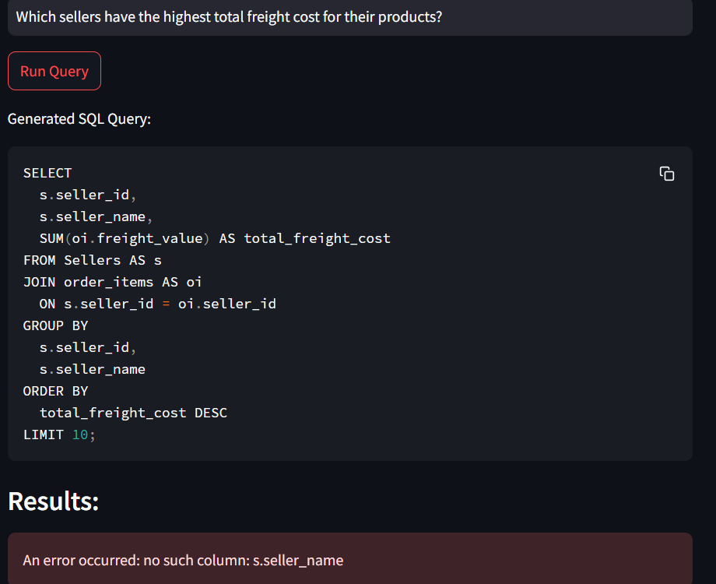
* 4. **Performance**: Depending on the implementation, there may be performance concerns when processing large datasets or executing complex queries.

## Conclusion

The SQL LLM app presents a compelling solution for generating SQL queries through natural language processing. While it offers **several advantages in terms of user-friendliness and efficiency,** **it is essential to consider its limitations, particularly concerning schema dependency and error handling.**