Sales Insights Story

# 1. Introduction

This project presents an in-depth analysis of the 'Sample - Superstore' dataset using Power BI/Tableau. The primary goal is to extract actionable insights from sales data across various dimensions such as Region, Category, Segment, and Time.

# 2. Overview Dashboard

The Overview Dashboard provides a holistic view of overall performance, including total sales, total profit, and average discount. Key performance indicators (KPIs) are presented for easy comprehension.

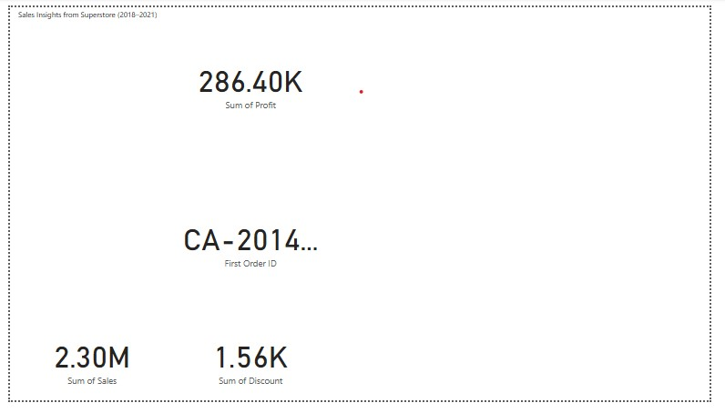

# 3. Sales Trend Over Time

This visualization shows the sales trend across months and years. A steady increase can be noticed during the holiday seasons indicating a seasonal pattern.

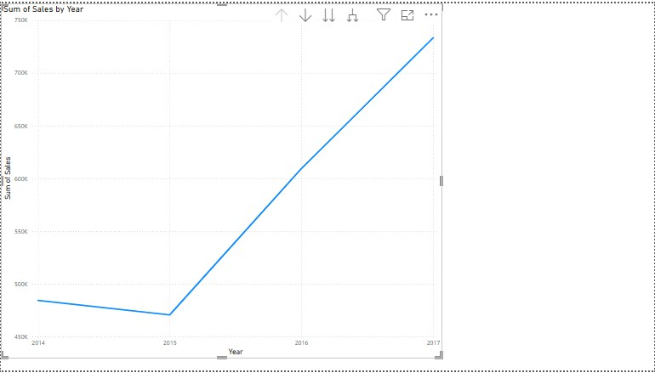

# 4. Profitability Analysis

Profitability analysis uncovers regions or categories that might have high sales but low profit margins. This dashboard emphasizes where the business is earning the most vs. where it incurs losses.

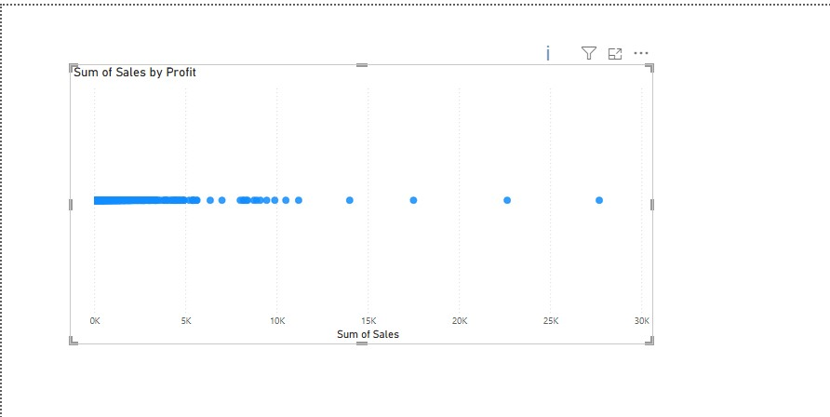

# 5. Regional Performance

This section highlights regional sales and profit distributions. It assists in identifying high-performing regions as well as those needing strategic attention.

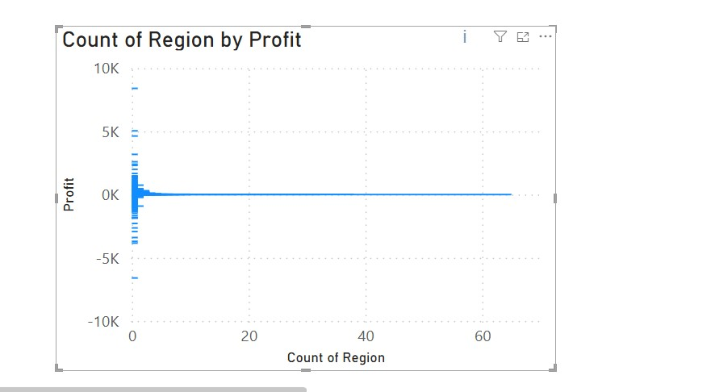

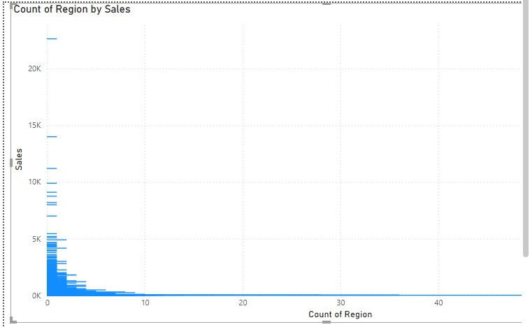

# 6. Segment Analysis

Segment-wise analysis helps understand which customer segment drives the most revenue and profit. It also provides a comparison across different market segments.

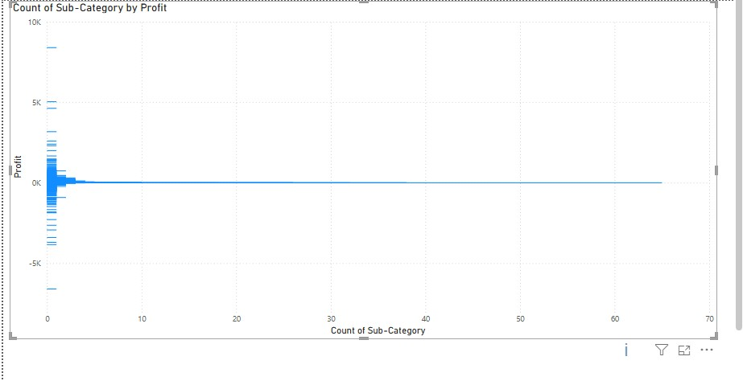

# 7. Category Insights

Top-performing and loss-making categories are analyzed here. This helps in product-level decision-making.

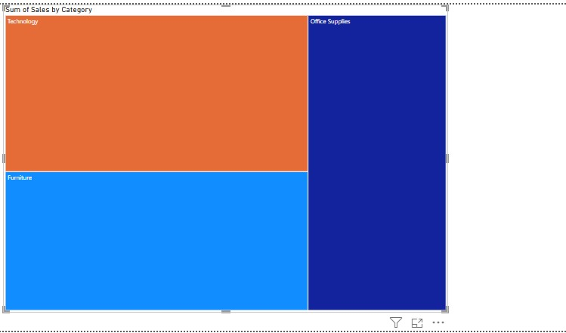

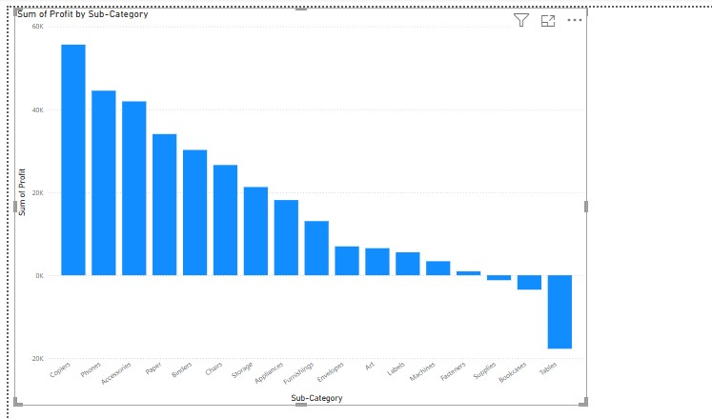

# 8. Profit-to-Sales Ratio

This visual showcases how efficiently sales convert to profit, identifying product lines or regions with strong or weak profit margins.

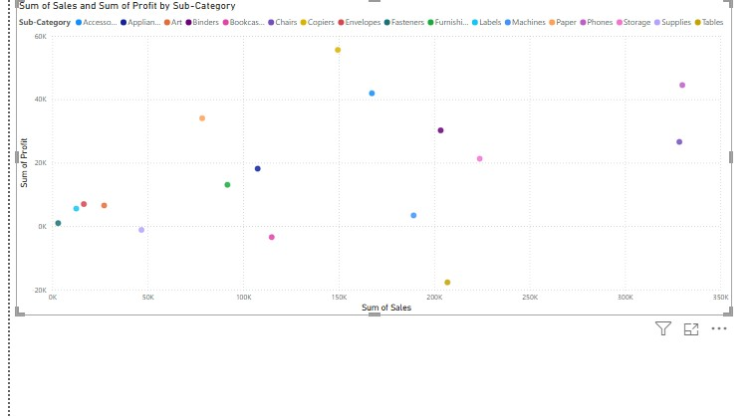

# 9. Summary of Trends

The trend analysis over the dataset’s timeline gives insights into seasonal performance. These trends help in forecasting and planning for inventory, staffing, and promotional activities.

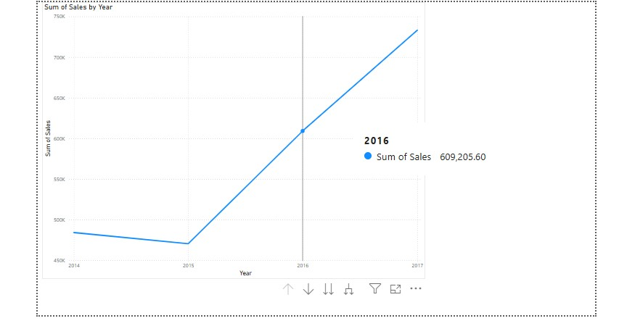

# 10. Conclusion

This comprehensive sales analysis helps stakeholders understand the underlying patterns and key drivers of sales and profit. It provides a foundation for data-driven decision-making to enhance business growth and profitability.