

**MINI PROJECT ON C**

**ADVANCE MATH TABLES**

**Submitted: Naveen Kumar Nandyala**

**Stepin-105314**

**Contents**

* Introduction
* Description
* Problem statement
* Design
* Requirements
* Test plan
* Test cases
* Sample Output
* Conclusion

**Introduction:**

* The object of the project is to create an application that can calculate math table.
* This project of “ADVANCE MATH TABLE” of gives us the complete information about the table. We can enter which table we want to practice.
* We can enter the answers for the table which it asks if we enter wrong answer it will tell that the answer was wrong and gives the right answer.

**Description:**

* The object of the project is to create an application that can calculate math table. The Math Table using ‘C’ application is created to make student’s maths skills better.
* The application or program created from this project includes the option like to enter the user name, option to practice table, option to choose table for practice, option to check whether answer is right or wrong and correct it, show the number of wrong and right answer, and finally option to practice again.

**problem statement:**

* This study will support and manage the students to learn tables easily it will makes the students especially kids to learn tables very easily.
* Now a days children are addicted to the mobile phones and laptops, so it’s the good way to learn tables for kids.

**Design :**

Please enter your name

Do you want to practices some tables?

yes

No

Which table u can practice

But you will have to do extra tomorrow!

If choose any table press the enter

For example7 *1=7 press enter if show the correct ab

And 7*2=13 press the enter if show the wrong and correct to 7*2=14 and show

The completion of the table it ask for do you want to continue

End

**Requirements:**

**Software Requirements:**

* MinGW Compiler
* Code::Blocks IDE v20.03

**Operating System:**

* Windows OS
* Ubuntu

**Test** **plan** :

* The resources here required are gcc compiler or any ide of C to develop and build the code.
* To check if the program menu displays all options correctly
* To check if the program taking input as a number and display which number you have taken
* To check if the user  enter invalid number or not
* To check whether the output is giving the table
* To check whether, when you enter the wrong answer it shows the right answer or not
* To check whether after the completion of the table it asks for do you want to continue

**Test Cases:**

* Testing involves the design of test cases that validate that the internal program logic is functioning properly.

**Test Case 1:** To  enter the user name and the function is user name created or not check it display.

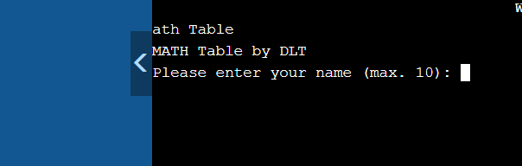

Expected output : create the user name and showing to the display

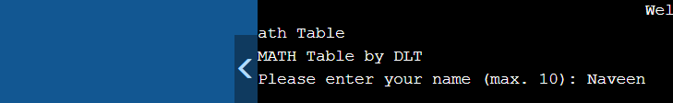

**Test Case 2 :** do you want to practice some tables yes or No and enter the information to check the display and enter the yes we can practice which table can practice the asking to the display

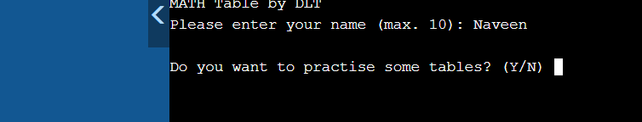

Expected output :



**Test Case 3:** To check the display and enter the No we can see the program completed in the display

Expected output :

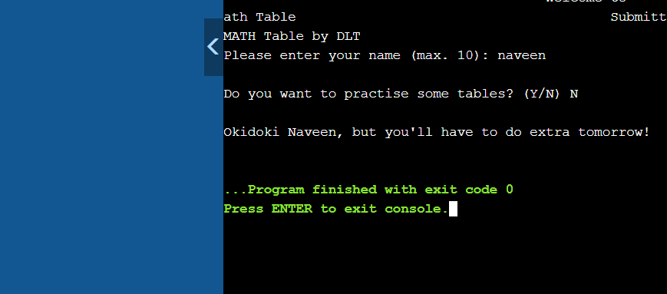

**Test Case 4:**

* To check if the program taking input as a number and display which number you have taken
* To check whether, when you enter the wrong answer it shows the right answer or not

Expected output :

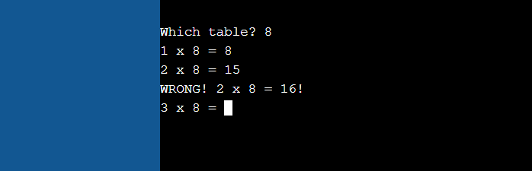

**Test Cases 5:**

* To check whether after the completion of the table it asks for do you want to continue

Expected output :

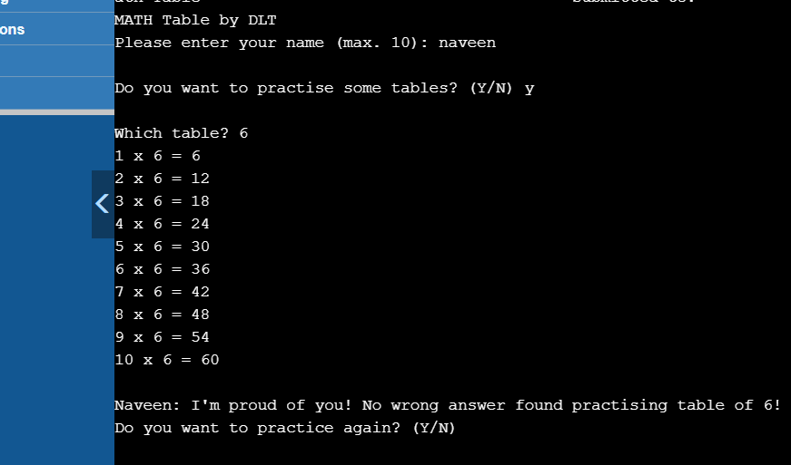

**SAMPLE Output:**

* The expected output of this project is to get the table of the specific number so that the Kids will learn the table easily and very effectively

**Conclusion:**

* The Advance Math table allows the students to learn table and can rectify there mistakes while learning tables.
* If they got wrong it will show the correct one.