KAKINADA INSTITUTE OF ENGINEERING & TECHNOLOGY (KIET GROUP)
C4GT Hub | Team 1
Reusable Notification Service
Component-Level Architecture Package
C4GT Hub | C4GT – Team 1
Davuluri Bala Veera Venkata Bhavani Sankar (Team Lead)
Kolamuri Bhavya Sri | Mallipudi Satya Krupa
Bolisetti Jyothi Swarupa | Siri Bhuvaneswari
Panasa Rajini | Dasari Naveen Kumar
Mamidala Govind | Sabbisetty Anjana Lakshmi Asritha
Project Mentor: G. Sai Varshitha | IT / Industry Mentor: L. Krishna Deepika Mam
October 2026

Team Contributions & Scope Ownership.

Document Section & Scope | Assigned Contributor
Project Management, System Integration, & Architecture Review | Davuluri Bala Veera Venkata Bhavani Sankar (Team Lead)
System Context & High-Level Design (HLD) | Mamidala Govind
Low-Level Design (LLD) & Component Architecture | Sabbisetty Anjana Lakshmi Asritha
Runtime Flow & API Submission Endpoints | Kolamuri Bhavya Sri
Status, Detail, & Callback APIs | Mallipudi Satya Krupa
Component Responsibilities & Data Ownership | Panasa Rajini
Key Data Models & State Machine | Dasari Naveen Kumar
Dependencies & External Systems | Bolisetti Jyothi Swarupa
Failure Scenarios, Extensibility, & Security | Siri Bhuvaneswari

Contents
1. Overview 4
1.1 Purpose and context 4
The design in brief 4
2. Architecture Diagrams 5
2.1 System context 5
2.4 Internal Component Architecture 7
2.5 Runtime Flow 8
3. Component Responsibilities and Data Ownership 9
3.1 Component responsibility table 9
3.2 Data ownership 10
3.3 Why the core must not depend on provider details 11
4. API and Interface Definition 11
4.1 API conventions 11
4.2 Endpoint summary 11
4.3 submit a notification 12
4.4 GET /v1/notifications/{id}/status 13
4.5 GET /v1/notifications/{id} 13
4.6 Provider callback API 13
4.7 Internal interfaces 14
4.8 Provider-neutral channel contract 14
5. Key Data Models 16
5.1 Entity diagram 16
5.2 Model details 16
5.3 Notification states 17
5.4 How the data behaves 18
6. Dependency Diagram and Explanation 18
6.1 Dependency diagram 18
6.2 Unnecessary coupling and Prevention 19
6.3 External dependencies, and what happens when each fails 19
7. Failure and Edge-Case Scenarios 20
7.1 Failure scenarios 20
8. Extensibility: How Would We Add a New Channel? 23
8.1 What changes and what does not 23
8.2 Steps to Add a New Channel 24
8.3 What this does not claim 25
9. Security, Privacy and Observability 25
10. Self-Review, Trade-offs and Open Questions 26
10.1 Review against the assignment questions 26
10.2 Known Trade-offs 26
10.3 Open Questions 26
11 Notifications Used in the Antenatal Follow-Up System 27
11.1 Purpose 27
11.2 Notification Type 27
11.3 Integration with the Notification Service 28
11.4 Privacy and Safety Considerations 28

1. Overview

1.1 Purpose and context
This document describes the architecture of a proposed reusable Notification Service that allows authorised applications to send notifications through WhatsApp, SMS, and email. It is a design document: nothing described here should be considered built or deployed unless explicitly confirmed. It is written so that a developer who was not part of the team discussions can understand what the service must do, how its components work together, and how notifications are processed, delivered, tracked, and retried.
In one sentence: the Notification Service accepts notification requests from authorised applications and manages their delivery through WhatsApp, SMS, and email. The calling application specifies what message to send and who should receive it. The service handles validation, templates, channel selection, asynchronous processing, retries, delivery tracking, and reporting.
Core design boundary: The service manages notification delivery. The calling application remains responsible for its business decisions and the information it asks the service to communicate.

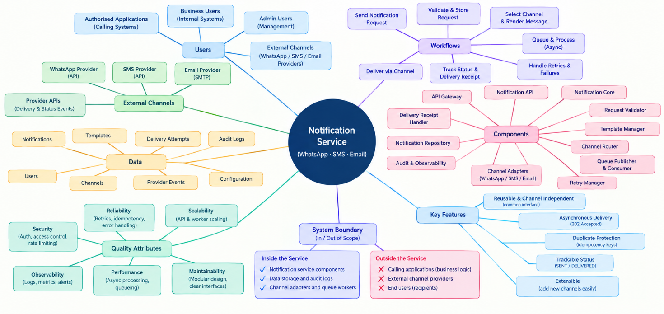

System overview - notification requests, processing components, data, delivery channels, quality attributes, and boundaries.

The design in brief
One reusable service. Authorised applications use a common service to send notifications instead of implementing separate delivery logic for WhatsApp, SMS, and email.
Three delivery channels. Channel adapters connect the service to WhatsApp, SMS, and email providers through a common NotificationChannel interface.
Asynchronous delivery. The service validates and stores a valid request, then returns 202 Accepted. Background workers process the notification and handle delivery.
Reliable processing. A queue separates request acceptance from delivery. Retry handling uses backoff, jitter, attempt limits, and a delivery window to manage temporary failures.
Independent channel handling. The Channel Router selects the appropriate adapter, allowing a channel to be added or changed without rewriting the core notification logic.
Trackable notification history. Notification records, delivery attempts, provider events, and audit information help authorised users understand the status and history of each notification.
Duplicate protection. keys and provider event identifiers help prevent duplicate processing when requests or delivery events are received more than once.
Clear delivery status. SENT means the provider has accepted the notification; DELIVERED means delivery has been confirmed by the provider.
Security and privacy. The API Gateway checks incoming requests, while access controls and careful logging help protect recipient information and message content.
Observable and maintainable. Audit records, logs, metrics, and delivery status make it easier to monitor failures, investigate issues, and maintain the service.
The service is designed as a modular monolith, with the API and background worker roles able to scale independently. This keeps the initial architecture manageable while allowing request processing and notification delivery to handle different workloads.

2. Architecture Diagrams

2.1 System context
The Notification Service is shown as one system. Calling applications connect to it using HTTPS REST APIs. The service sends messages through WhatsApp, SMS, and email providers. Providers send delivery updates back through webhooks. Provider credentials are stored in a secret manager, while logs and metrics go to a monitoring platform.
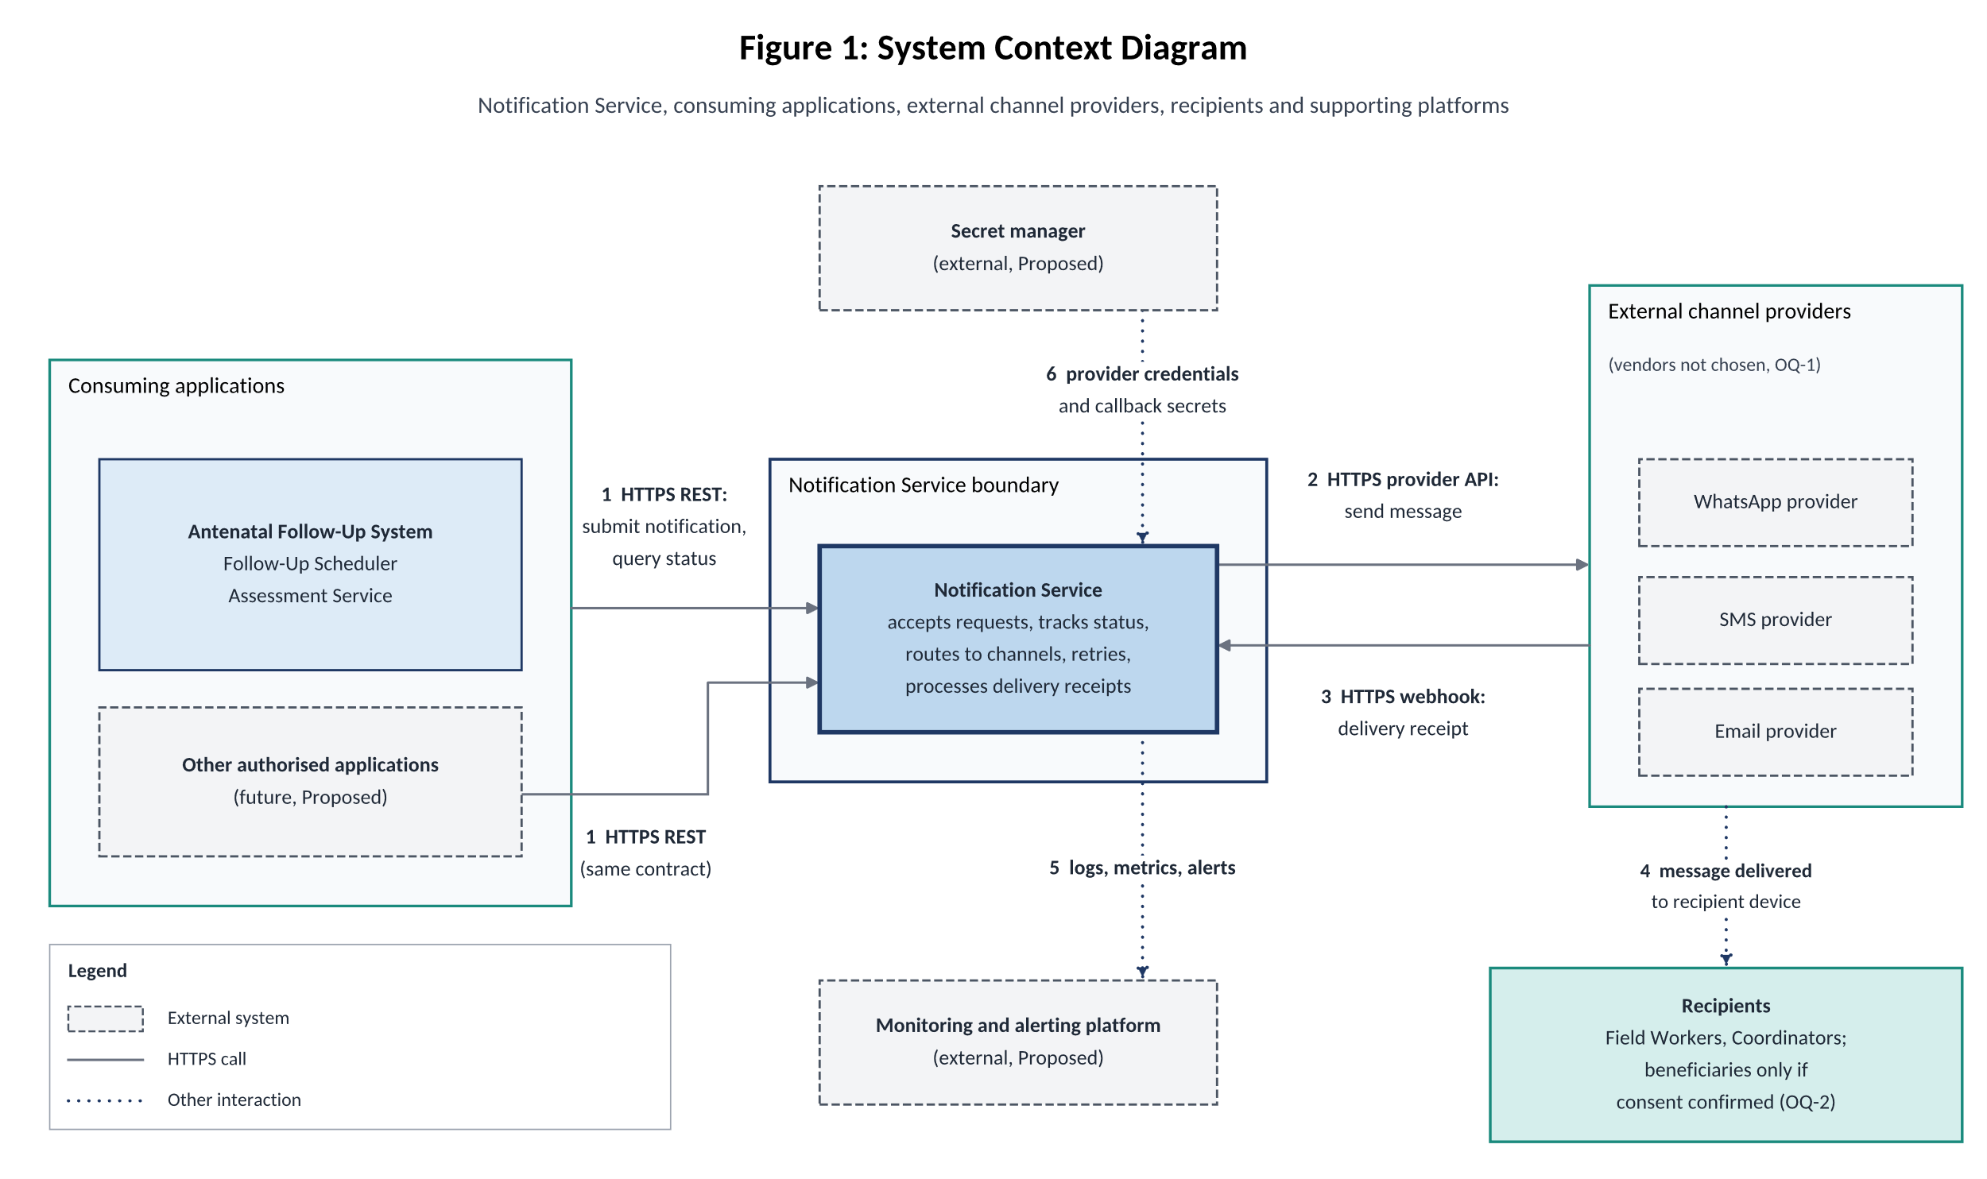
Figure 1. System context: the Notification Service, its callers, providers and supporting platforms.

2.2 High-Level Design Architecture
The HLD shows the Notification Service as a set of major building blocks. It answers three questions: what are the big parts, where are the boundaries between them, and how does a request travel? Interface operations and internal helpers are deliberately left to the LLD.
Architectural style. The service is a modular monolith: one deployable artifact, split into modules with clear interfaces. It runs in two process roles, an API role and a Worker role, which can be scaled independently. Request acceptance and delivery are separated by a database outbox and a message queue.

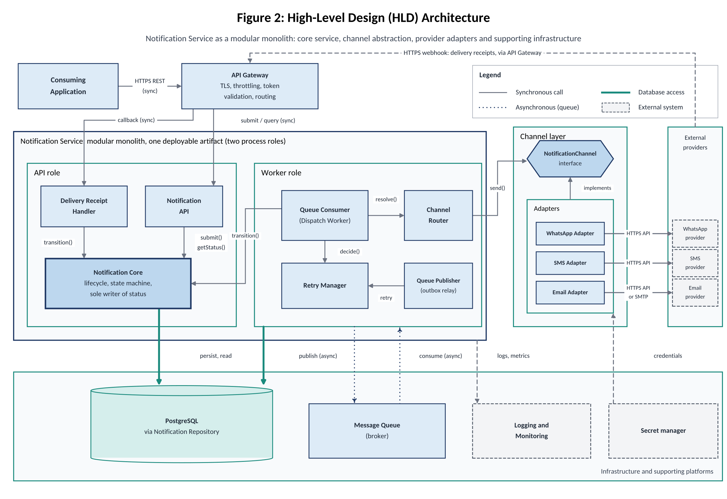
Figure 2. High level design Component architecture, grouped into entry, application, persistence, dispatch and channel layers.
Rules enforced by this structure
Group | Building blocks | Role
Client layer | Consuming application | Submits notifications and reads status over HTTPS REST
Entry layer | API Gateway (platform) | TLS, throttling, token validation; routes API calls and provider callbacks
API role | Notification API, Notification Core, Delivery Receipt Handler | Accept and validate requests, own the notification lifecycle and status, process delivery receipts
Worker role | Queue Publisher, Queue Consumer (Dispatch Worker), Retry Manager, Channel Router | Relay accepted work to the queue, dispatch it, decide retries, select the channel
Channel layer | NotificationChannel interface; WhatsApp, SMS and Email Adapters | Provider-neutral contract and the only provider-specific code
Infrastructure | PostgreSQL (via Notification Repository), Message Queue, Logging and Monitoring, Secret manager | Persistence, buffering of background work, observability, credentials
External providers | WhatsApp, SMS and email providers | Deliver messages and return receipts as webhooks

2.3 Low-Level Design Architecture
The LLD opens the building blocks of the HLD. Figure 4 groups components into the API process role, the shared modules and the worker process role. Each arrow is labelled with the interface operation being called. Thick teal arrows are database access through the Notification Repository, dotted arrows are queue publish and consume, dashed arrows are interface implementation or the provider callback. Audit and Observability receives events from every component and is omitted so that no line has to be drawn from every box.

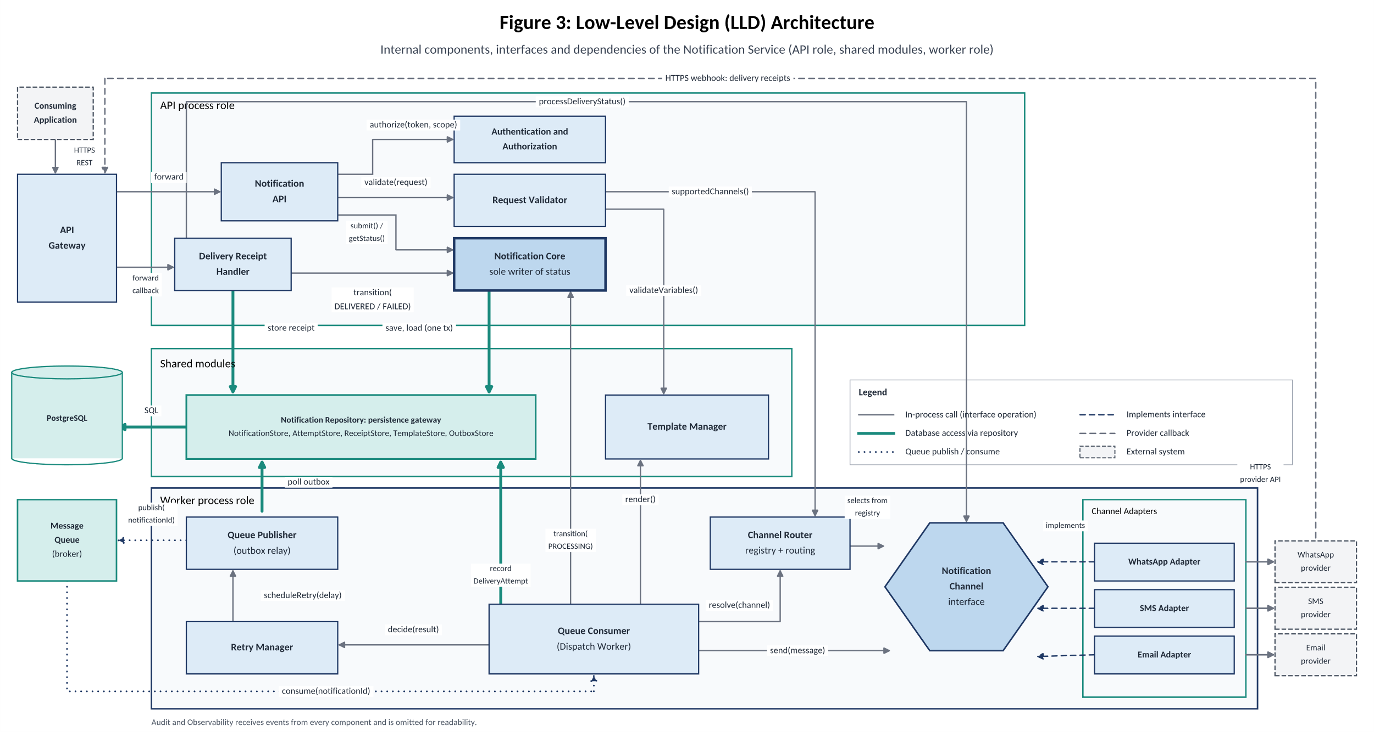
Figure 2. Low level design Component architecture

Component | Key operations in Figure 4 | Calls
Notification API | forward, authorize(token, scope), validate(request), submit() / getStatus() | Authentication and Authorization, Request Validator, Core
Request Validator | validateVariables(), supportedChannels() | Template Manager, Channel Router
Notification Core | save, load (one transaction), transition() | Notification Repository
Delivery Receipt Handler | transition(DELIVERED / FAILED), processDeliveryStatus(), store receipt | Core, NotificationChannel, Repository
Queue Consumer | transition(PROCESSING), render(), resolve(channel), send(message), decide(result), record DeliveryAttempt | Core, Template Manager, Channel Router, NotificationChannel, Retry Manager, Repository
Retry Manager | scheduleRetry(delay) | Queue Publisher
Queue Publisher | poll outbox, publish(notificationId) | Repository, Message Queue
Adapters | implement NotificationChannel; HTTPS provider API | External providers
Channel selection. The Channel Router holds a registry that maps each channel type to its adapter. Adapters register at start-up. The Request Validator uses supportedChannels() when a request arrives, and the Queue Consumer uses resolve(channel) at dispatch time.
Provider boundary. Core, the consumer and the receipt handler know only the NotificationChannel interface. They never reference a concrete adapter, and adapters never call Core or the database (rules R2 and R3).

2.4 Internal Component Architecture
Figure 5 isolates the part of the design that makes channels replaceable. On the left is the provider-neutral core service. In the middle is the channel abstraction: the Channel Router, the NotificationChannel interface and the shared types (NotificationMessage, SendResult, DeliveryStatusUpdate, ErrorCategory). On the right are the provider-specific adapters, each with its own private dependency on a provider SDK. Provider error codes and payload formats stay inside the adapter and reach the rest of the system only as the shared types. Adapters register themselves with the router at start-up and never log recipient addresses or message bodies.

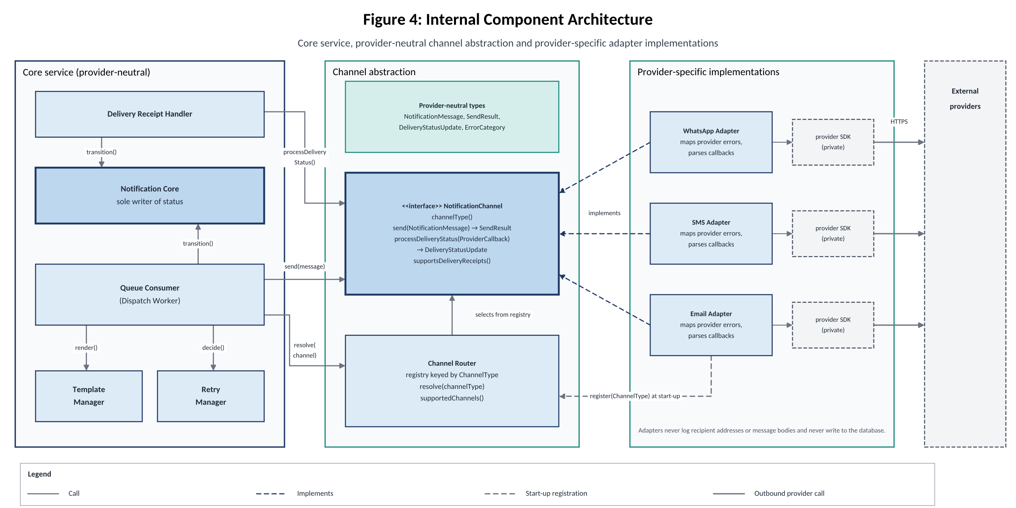
Figure 4. Intenal Component architecture
2.5 Runtime Flow
Figure 6 follows one successful notification. Messages 1 to 7 are the synchronous request path: the request is authorised, validated and checked for the request, notification (QUEUED), outbox entry and record are committed in one transaction, and the caller receives 202 Accepted. Messages 8 to 19 are asynchronous: the outbox entry is published to the queue, the consumer claims the notification and creates a DeliveryAttempt, the Channel Router resolves the adapter, and the adapter calls the provider. The attempt result and the move to SENT are saved in one transaction, and the queue message is acknowledged only afterwards, so a crash causes redelivery, not loss. Messages 20 to 23 show the caller reading the status. The later delivery receipt follows the callback path described in Section 4.6.
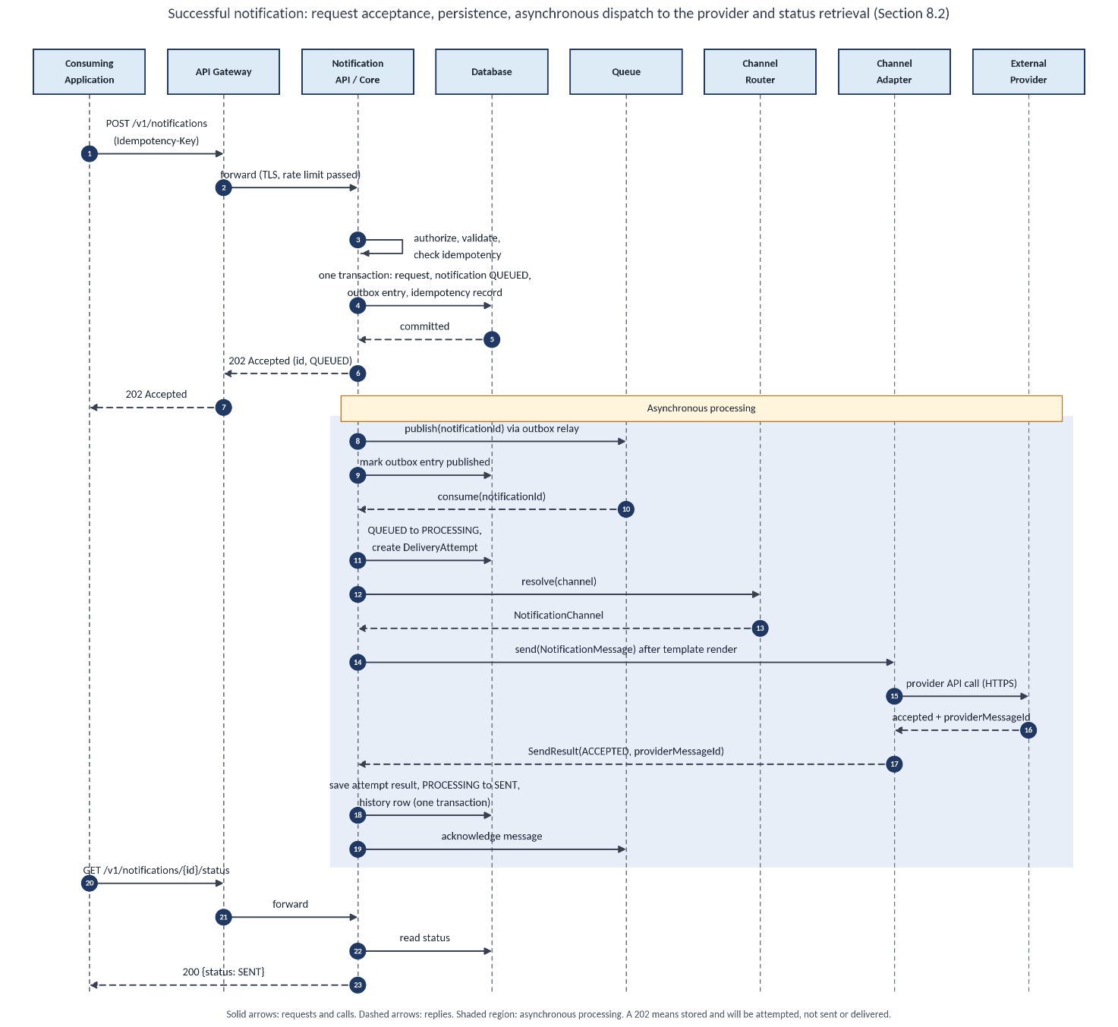

Figure 5. Sequence of a successful notification, from submission to confirmed delivery.

3. Component Responsibilities and Data Ownership

3.1 Component responsibility table
Each component has one clear job. The last column lists what it must not do, which is what keeps boundaries clean.
Component | Responsibility | Data it owns | Depends on | Must NOT
API Gateway (platform) | Single entry point: TLS, throttling, token validation, routing of API and callback paths. | Routing and rate-limit configuration | Notification API, Receipt Handler | Hold business rules or notification data
Notification API | Expose REST endpoints. Map HTTP requests to Core calls and shape responses and error bodies. | None | Authentication and Authorization, Request Validator, Core | Persist data or call providers
Authentication and Authorization | Identify the calling application and check its scopes (notifications:send, notifications:read). | Client registrations (IDs, scopes) | Gateway token check, client configuration | Handle end-user identity
Request Validator | Check schema, field rules, channel enabled, recipient format, template exists, variables match the template schema. | None | Template Manager, Channel Router | Authenticate, persist, check
Notification Core | Run the lifecycle: check, create request and notification, enforce the state machine, write status and history. | NotificationRequest, Notification, StatusHistory, Record | Notification Repository, Audit and Observability | Use HTTP, call providers, render text, decide retries
Template Manager | Store versioned templates per channel and locale. Validate variables. Render the message body at send time. | NotificationTemplate | Notification Repository | Choose a channel or deliver
Channel Router | Hold the registry of channel type to implementation, and the routing configuration (enabled channels). | RoutingConfiguration | NotificationChannel interface only | Know provider details, retry, change status
Notification Repository | Persistence gateway: transactions, optimistic locking, field-level encryption. Stores on behalf of the owning component. | None (no business meaning) | PostgreSQL | Contain business rules or make transition decisions
Queue Publisher (outbox relay) | Copy outbox rows to the queue at least once. Schedule delayed retries. | OutboxEntry | Repository, Message Queue | Decide whether to retry
Queue Consumer (Dispatch Worker) | Claim a notification, render, resolve the channel, call send(), record the attempt, apply the retry decision, acknowledge. | DeliveryAttempt | Core, Template Manager, Router, Retry Manager, interface | Contain provider logic or retry numbers
Retry Manager | Classify a send result and return a decision: retry with delay, fail permanently, exhausted, or pause the channel. Keep circuit-breaker state. | None persisted (policy configuration) | Configuration only | Send messages or persist data
NotificationChannel and Adapters (WhatsApp, SMS, Email) | Turn the common message into a provider request, call the provider, map results and errors to common categories, parse and verify callbacks. | None (credentials come from the secret manager) | Provider API or SDK (private) | Retry, persist, change status, render templates
Delivery Receipt Handler | Expose the callback endpoint. Verify authenticity, parse via the adapter, deduplicate, match to the attempt, request a transition. | ProviderDeliveryReceipt | Interface, Repository, Core | Send messages or schedule retries
Audit and Observability | Structured logs without sensitive data, metrics, traces, alerts, append-only audit records. | AuditRecord | Repository, monitoring platform | Make business decisions; logging failure must never fail a notification

3.2 Data ownership
Rule: one entity, one writer. Other components read an entity only through its owner’s interface, never by touching its tables. The Notification Repository performs the storage on the owner’s behalf but owns nothing.
Entity | Only writer (owner) | Others may
NotificationRequest | Notification Core | Read through Core
Record | Notification Core | Nothing
Notification (including status) | Notification Core | Ask for a transition through Core.transition(); read through Core
NotificationStatusHistory | Notification Core | Read through Core (details endpoint)
NotificationTemplate | Template Manager | Validate and render through Template Manager
DeliveryAttempt | Queue Consumer | Read through Core; Receipt Handler finds an attempt by provider message ID
ProviderDeliveryReceipt | Delivery Receipt Handler | Nothing
OutboxEntry | Queue Publisher | Core inserts rows inside its transaction; only the publisher marks them published
RoutingConfiguration | Channel Router (administrator managed) | Read only
ClientRegistration | Authentication and Authorization | Read only
AuditRecord | Audit and Observability | Append through the audit interface
Provider credentials and callback secrets | Secret manager (external) | Adapters read at start-up; nobody writes

3.3 Why the core must not depend on provider details
- Change isolation. Providers change APIs, pricing and SDK versions. If Core imported them, every change would force retesting of lifecycle logic.
- Replaceability. Switching an SMS vendor must be an adapter change only.
- Independent teams. One team builds Core against the interface with a fake adapter while another builds a real adapter. This is the two-teams test.
- Testability. Core and retry behaviour can be tested with a simulated adapter that returns every error category, with no real provider.
- Contained vocabulary. Provider status codes and payload formats stay inside the adapter and reach the rest of the system only as the common result types.
The Notification Service provides REST APIs for applications to submit notifications and check their status. Internal interfaces allow service components to communicate with each other. The provider callback API receives delivery updates from WhatsApp, SMS, and email providers.

4. API and Interface Definition

4.1 API conventions
- Base path: /v1
- Format: JSON over HTTPS.
- Timestamps: UTC in ISO 8601 format.
- Authentication: Bearer token with notifications:send or notifications:read permissions.
- Request tracking: X-Request-Id identifies a request in responses and logs.
- Error format: All API errors use a common structure.
Example error response:
{
"error": {
"code": "VALIDATION_FAILED",
"message": "Invalid recipient phone number",
"requestId": "req-7c1e"
}
}

4.2 Endpoint summary
Method | Endpoint | Purpose | Success
POST | /v1/notifications |  | 202
  submit a notification
GET | /v1/notifications/{id}/status | Check notification status | 200
GET | /v1/notifications/{id} | View notification details and history | 200
POST | /v1/provider- callbacks/{channel} | Receive delivery updates | 200

The first three endpoints use application authentication. The callback endpoint verifies the provider's signature.

4.3 submit a notification
Endpoint: POST /v1/notifications
This API accepts a notification request, validates it, stores it, and places it in the delivery workflow. It returns 202 Accepted without waiting for actual delivery.

Request fields
Field | Req. | Validation rule
channel | Yes | WHATSAPP, SMS, or EMAIL
templateCode | Yes | Approved template identifier
recipient | Yes
  Recipient type and phone number or email address
locale | No | Message language; defaults to en
variables | No | Values used to fill the template
priority | No | NORMAL by default or HIGH
correlationRef | No | Optional reference supplied by the calling application

Example request and response
POST /v1/notifications
Key: 9d2f6e1a-52c4-4a7b-8e0c-1f3b7a90c411

{
"channel": "SMS",
"recipient": {
"type": "PHONE",
"address": "+91XXXXXXXXXX"
},
"templateCode": "REMINDER_DUE",
"locale": "en",
"variables": {
"refCode": "R-48213",
"dueDate": "2026-11-03"
},
"priority": "NORMAL",
"correlationRef": "ref-48213"
}

HTTP/1.1 202 Accepted
{
"notificationId": "3f6c0a52-8d1e-4b7a-9c35-0e7d2a1b6f44",
"status": "QUEUED",
"channel": "SMS",
"createdAt": "2026-10-24T09:15:02Z"
}

validation
The caller must provide an Key to prevent duplicate requests.
- Same key and same request: return the original response.
- Same key with different request data: return 409 Conflict.
- Invalid request: reject it before storing the notification.
- Concurrent requests with the same key: allow only one request to create the notification.
The key is unique per client for 24 hours.

4.4 GET /v1/notifications/{id}/status
Endpoint: GET /v1/notifications/{id}/status
Returns the current status of a notification.
{
"notificationId": "3f6c0a52-8d1e-4b7a-9c35-0e7d2a1b6f44",
"status": "SENT",
"channel": "SMS",
"deliveryConfirmed": false,
"updatedAt": "2026-10-24T09:15:07Z"
}

- QUEUED: Waiting for processing.
- SENT: The provider accepted the message.
- DELIVERED: Delivery was confirmed by the provider.
- FAILED: Delivery failed, according to the applicable failure rules.
deliveryConfirmed is true only when the status is DELIVERED.
The API returns 404 when the notification does not exist or does not belong to the calling client. This prevents unauthorised users from discovering other clients' notifications.

4.5 GET /v1/notifications/{id}
Endpoint: GET /v1/notifications/{id}

Returns the notification's current status, delivery attempts, and status history.

Recipient addresses are masked. Message content and template variables are not returned, helping protect sensitive information.

The endpoint uses the same authentication and access rules as the status API.

4.6 Provider callback API
Endpoint: POST /v1/provider-callbacks/{channel}
This endpoint receives delivery updates from WhatsApp, SMS, and email providers.
- Authentication: Verify the provider's signature or shared secret.
- Validation: Check the channel and callback format.
- Duplicate protection: Store a unique provider event ID to prevent processing the same event twice.
- Successful response: Return 200 OK for new, duplicate, or not-yet-matched events.
- Invalid signature: Return 401 and log the event safely.
- Invalid callback: Return 400.
- Unknown channel: Return 404.
- Rate limit exceeded: Return 429.
- Storage unavailable: Return 503 so the provider can retry.
When supported by the provider, reject callbacks whose timestamps fall outside the configured five-minute tolerance.

4.7 Internal interfaces
Internal interfaces define how the service's components communicate. They are not public HTTP endpoints.
Interface | Responsibility
NotificationCore | Create notifications, retrieve details, and update status
TemplateManager | Validate template variables and generate messages
ChannelRouter | Select the correct channel adapter
NotificationChannel | Send messages and process provider delivery updates
RetryManager | Decide whether a failed attempt should be retried
QueuePublisher | Publish notifications for background processing
Repository Stores | Store notifications, attempts, receipts, templates, and queued events
AuditSink | Record important system events

How the interfaces work together
- The Notification API sends a validated request to NotificationCore.
- The core stores the notification and schedules background processing.
- The Queue Consumer retrieves the notification.
- The Template Manager prepares the message.
- The Channel Router selects the appropriate adapter.
- The adapter sends the message through the external provider.
- The Retry Manager handles retryable failures.
- The Receipt Handler processes delivery updates and updates notification status.

4.8 Provider-neutral channel contract
All channel adapters implement the same NotificationChannel interface. This allows the core service to send notifications without depending on provider-specific classes.

interface NotificationChannel {
ChannelType channelType();

SendResult send(NotificationMessage message);

DeliveryStatusUpdate processDeliveryStatus(
ProviderCallback callback
);

boolean supportsDeliveryReceipts();
}

Each adapter provides the same basic operations for WhatsApp, SMS, or email.
Common send results
Result | Meaning | Action
ACCEPTED | Provider accepted the request | Record provider acceptance
FAILED | Sending failed with a known outcome | Apply the mapped error policy
UNKNOWN | The outcome cannot be confirmed | Check provider status if supported before retrying

The adapter must return within a bounded timeout, set to 10 seconds by default. A timeout after the request was sent is treated as an unknown outcome, not an automatic failure.
Adapters must not log recipient addresses or message bodies, and they must not write directly to the database.

Common error handling
Error category | Meaning | Action
TEMPORARY | Network or provider failure | Retry within configured limits
RATE_LIMITED | Provider has limited requests | Retry after the specified delay
UNKNOWN_OUTCOME | Provider acceptance is uncertain | Check status if supported before retrying
PERMANENT_RECIPIENT | Invalid recipient or channel opt-out | Do not retry
PERMANENT_CONTENT | Invalid or rejected message content | Do not retry
PROVIDER_CONFIG | Invalid credentials or provider account issue | Pause affected delivery and alert administrators

All adapters map provider-specific errors into these common categories. Shared contract tests verify that the mappings behave consistently.

5. Key Data Models

5.1 Entity diagram
Figure 4 shows the main data entities used by the Notification Service and how they relate to each other. It is a logical data model that explains the data structure without specifying SQL tables or database implementation details. 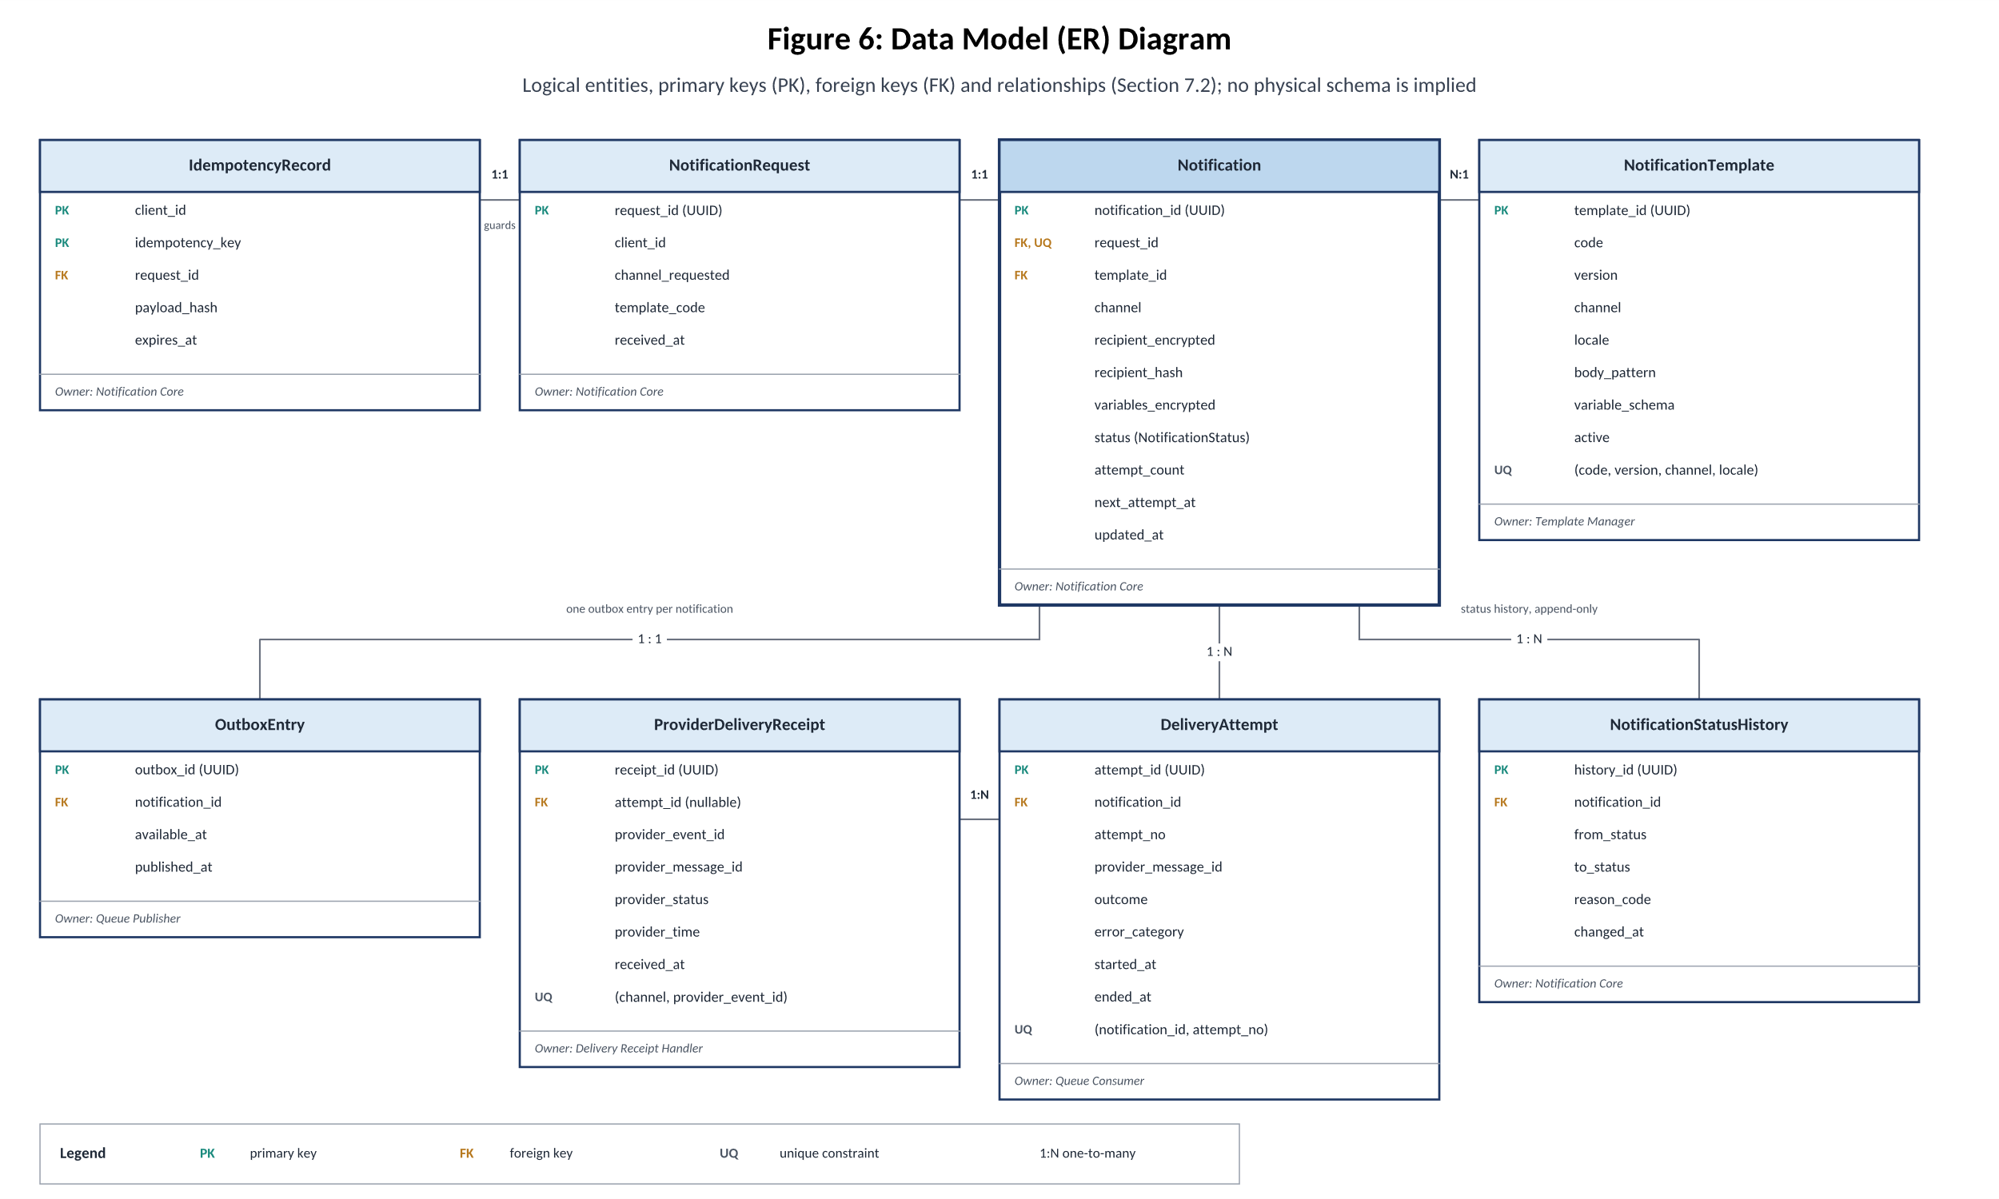
Figure 6. Entity relationship diagram with keys and relationships.

5.2 Model details
Model | Important fields | Owner | Integrity rules
NotificationRequest | request_id, client_id, channel_requested, template_code, received_at | Notification Core | Created only after validation; immutable
Record | (client_id, key), request_id, payload_hash, expires_at | Notification Core | Composite key unique; hash decides replay or 409; expires after 24 hours
Model | Important fields | Responsibility | Key rules
NotificationRequest | request_id, client_id, channel, template_code, received_at | Notification Core | Created only after validation; immutable.
Record | client_id, key, request_id, payload_hash, expires_at | Notification Core | Prevents duplicate requests; expires after 24 hours.
Notification | notification_id, channel, recipient, status, attempt_count, next_attempt_at | Notification Core | Status changes follow approved transitions; recipient data is encrypted.
NotificationStatusHistory | history_id, notification_id, from_status, to_status, changed_at | Notification Core | Every status change is recorded and never overwritten.
NotificationTemplate | template_id, code, version, channel, locale, body_pattern | Template Manager | Template versions are unique and remain unchanged once used.

5.3 Notification states
A notification moves through seven states during processing. The Notification Core controls all status changes to keep the workflow consistent.
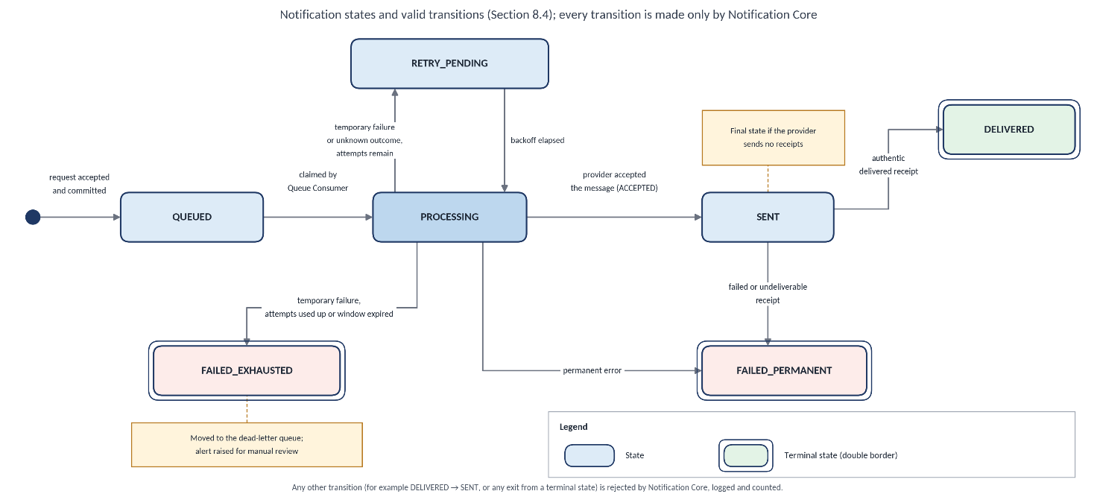

Figure 7. Notification state-transition diagram. Double borders mark terminal states.

State | Meaning | Leaves to | Terminal
QUEUED | Stored, waiting for a worker | PROCESSING | No
PROCESSING | A worker holds the claim and an attempt is open | SENT, RETRY_PENDING, FAILED_PERMANENT, FAILED_EXHAUSTED | No
SENT | Provider accepted the message; delivery is unconfirmed | DELIVERED, FAILED_PERMANENT | Only if the provider sends no receipts
DELIVERED | Provider confirmed delivery to the device or mail server | none | Yes
RETRY_PENDING | Temporary failure or unknown outcome; waiting for the backoff | PROCESSING | No
FAILED_PERMANENT | Will not be retried: permanent recipient or content error, unavailable template or channel, or a failed receipt | none | Yes
FAILED_EXHAUSTED | Attempts or the delivery window used up; moved to the dead-letter queue and alerted | none | Yes
Every other transition (for example DELIVERED to SENT, or any exit from a terminal state) is refused by Core, logged and counted.

5.4 How the data behaves
Delivery attempts: Each processing attempt is recorded. If a worker crashes, a recovery process identifies the unfinished attempt and schedules appropriate recovery.
Status history: Every status change creates a history record in the same database transaction.
Duplicate prevention: Unique keys and conditional worker claims prevent duplicate requests, attempts, provider events, and concurrent processing.
Delivery receipts: Provider receipts are stored before status updates. If a receipt arrives before its attempt can be matched, it is stored and matched later.
Sensitive data: Recipient addresses and template variables are encrypted. A keyed hash supports recipient lookup without exposing the original address. Rendered message bodies are generated at send time rather than stored.

6. Dependency Diagram and Explanation

6.1 Dependency diagram
Figure 6 shows how the Notification Service components depend on each other. Arrows point from a component to the component it uses.
The NotificationChannel interface separates the core service from provider-specific adapters. The core depends on the interface, while WhatsApp, SMS, and email adapters implement it. This allows providers to change without changing the core logic.
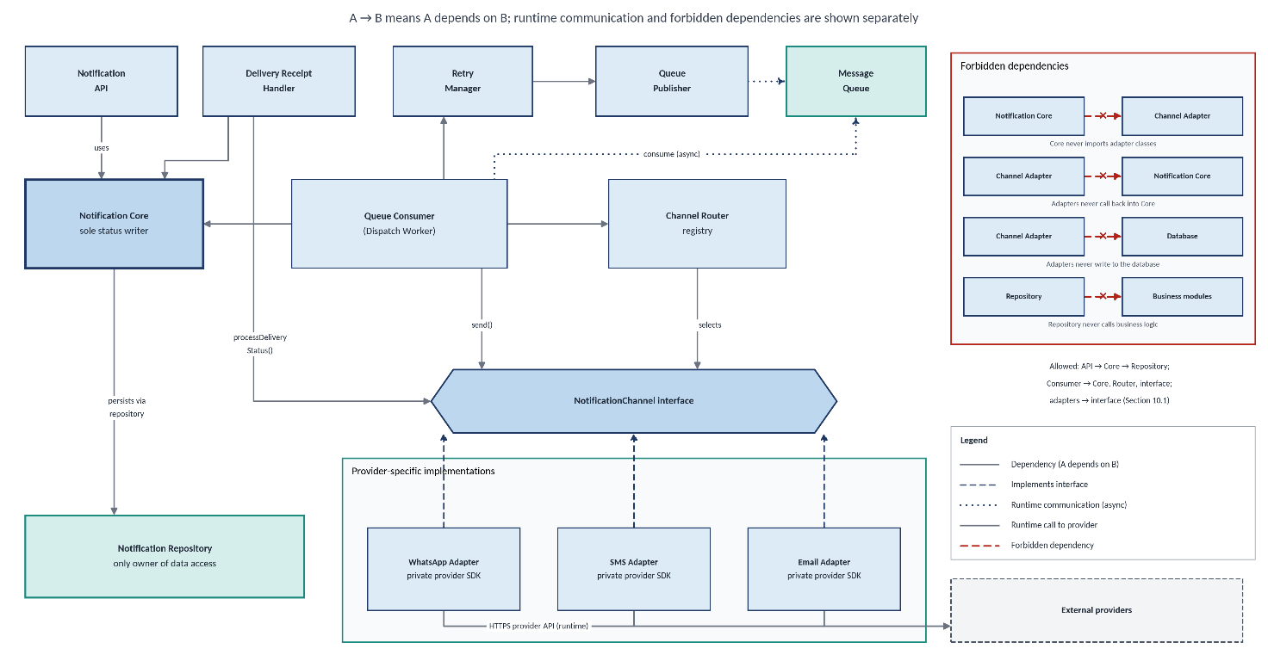

Figure 8. Dependency diagram: allowed directions, the channel interface, and forbidden dependencies.
Type | Rule
Allowed | The API uses the Core and Repository. The Queue Consumer uses the Core, Template Manager, Channel Router, Retry Manager, and channel interface. The Receipt Handler uses the Core and channel interface. Adapters use the interface and their own provider SDKs.
Forbidden | The Core must not depend on provider adapters or SDKs. Adapters must not access the Core, database, or queue directly. The Repository must not depend on business modules. Components must not modify data owned by other components.

6.2 Unnecessary coupling and Prevention
Coupling means one component depends too heavily on another. The following rules keep components independent and easier to maintain.

Possible coupling | How it is avoided
Core and provider SDKs | Use the common NotificationChannel interface.
Core and message queue | Use the Outbox pattern. Only queue-related components communicate with the broker.
Message content and channel logic | Store templates by channel and locale. The Core passes variables instead of building message text.
Calling applications and providers | Return a notification ID and provider-independent statuses.
Provider receipts and business logic | Adapters verify and parse provider callbacks into a common format.
Shared database access | Each entity has one owner, and other components access it through the appropriate Repository.
Adding new channels | Use a channel registry and configuration instead of hard-coding channels in the Core.

6.3 External dependencies, and what happens when each fails
The Notification Service depends on external providers and infrastructure. The following table explains what happens when each dependency fails.

Dependency | Purpose | What happens if it fails
WhatsApp, SMS, and email providers | Send notifications and return delivery updates. | Temporary failures are retried with backoff. Repeated failures can open the channel circuit breaker. Messages that exceed the delivery window become FAILED_EXHAUSTED.
PostgreSQL | Store notification data and delivery history. | New requests return 503 Service Unavailable and are not accepted. Callbacks return 503 so providers can retry. Workers do not acknowledge messages before processing is safely recorded.
Message queue | Dispatch notifications asynchronously. | The stored Outbox entry remains available for publishing. The publisher retries, and an alert is raised if the oldest unpublished entry exceeds five minutes.
API Gateway | Handle secure access, routing, and rate limits. | New requests and callbacks cannot enter through the gateway. Providers may retry callbacks, while already queued work can continue.
Secret manager | Provide provider credentials and signing secrets. | Credential or rotation problems trigger alerts. Workers that cannot start securely do not claim messages.
Monitoring platform | Collect logs, metrics, and alerts. | Notification processing continues where possible. Logging and metrics must not block delivery.

7. Failure and Edge-Case Scenarios
The Notification Service accepts valid requests first and delivers them asynchronously. Once a request is safely stored, temporary provider or queue failures must not cause it to be lost. Every retry has a limit, and each failure is handled according to its type.

Nine failure scenarios are covered below, including invalid requests, provider failures, retries, duplicate requests, and database problems.

7.1 Failure scenarios
ID | Scenario | System response | Retry? | Data consistency and recovery
F1 | Invalid request : malformed data, invalid recipient, unknown template, or disabled channel. | Return 400 or 422 with error details. Do not store the request. | No. The caller must correct and resubmit it. | No notification data is written. Logs record validation rules, not sensitive values.
F2 | Provider unavailable : repeated temporary errors or configuration problems. | Open the channel circuit breaker and pause new sends through that channel. Test recovery after 60 seconds. | Yes, after recovery and within configured limits. | Messages remain queued or pending retry. Expired messages become FAILED_EXHAUSTED, and an alert is raised.
F3 | Provider timeout: no response arrives before the send timeout. | Mark the attempt as UNKNOWN. Check the provider using a stable sendKey if supported; otherwise, retry according to policy. | Yes, within configured limits. | Record the attempt and status change in one transaction. A stable key reduces duplicate sends but cannot guarantee their prevention.
F4 | Partial failure: the provider accepts a message, but the worker crashes before saving the result. | Leave the queue message unacknowledged. On redelivery, recovery identifies the unfinished attempt and schedules a retry. Version checks prevent two workers from processing the same claim. | Yes, within configured limits. | A duplicate send is possible. Provider lookup and sendKey help reduce duplicates, and suspected duplicates are counted.
F5 | Queue unavailable: the message broker cannot be reached. | Keep the notification in the database Outbox. Retry publishing with backoff and process the backlog when the queue recovers. | Yes. | The notification remains QUEUED until published. Duplicate publishing is handled safely by the worker claim rules.
F6 | Duplicate submission: the caller repeats a request because of a timeout, retry, or double-click. | For the same key and payload, return the original response. For the same key with different data, return 409 Conflict. | Not applicable. | Only one request and notification are created per key within the 24-hour period.
F7 | Retries exhausted : the maximum attempts are reached or the delivery window expires. | Set the status to FAILED_EXHAUSTED, move the message to the dead-letter queue, and raise an alert. | No automatic retry. Manual review is required. | Keep the final status and complete attempt history.
F8 | Duplicate or late callback: a provider repeats an event or sends updates late or out of order. | Return 200 for duplicate events without changing the status. Store unmatched receipts for later matching. Ignore invalid status transitions. | Not applicable. | Keep receipts as append-only records. Prevent status from moving backwards.
F9 | Database unavailable : the database cannot be reached or a transaction fails. | Return 503 for new requests and callbacks. Workers must not acknowledge messages before processing is safely recorded. | Yes. Callers retry with the same key; queue messages are redelivered. | Transactions prevent partial database updates. Raise an alert and resume processing when the database recovers.
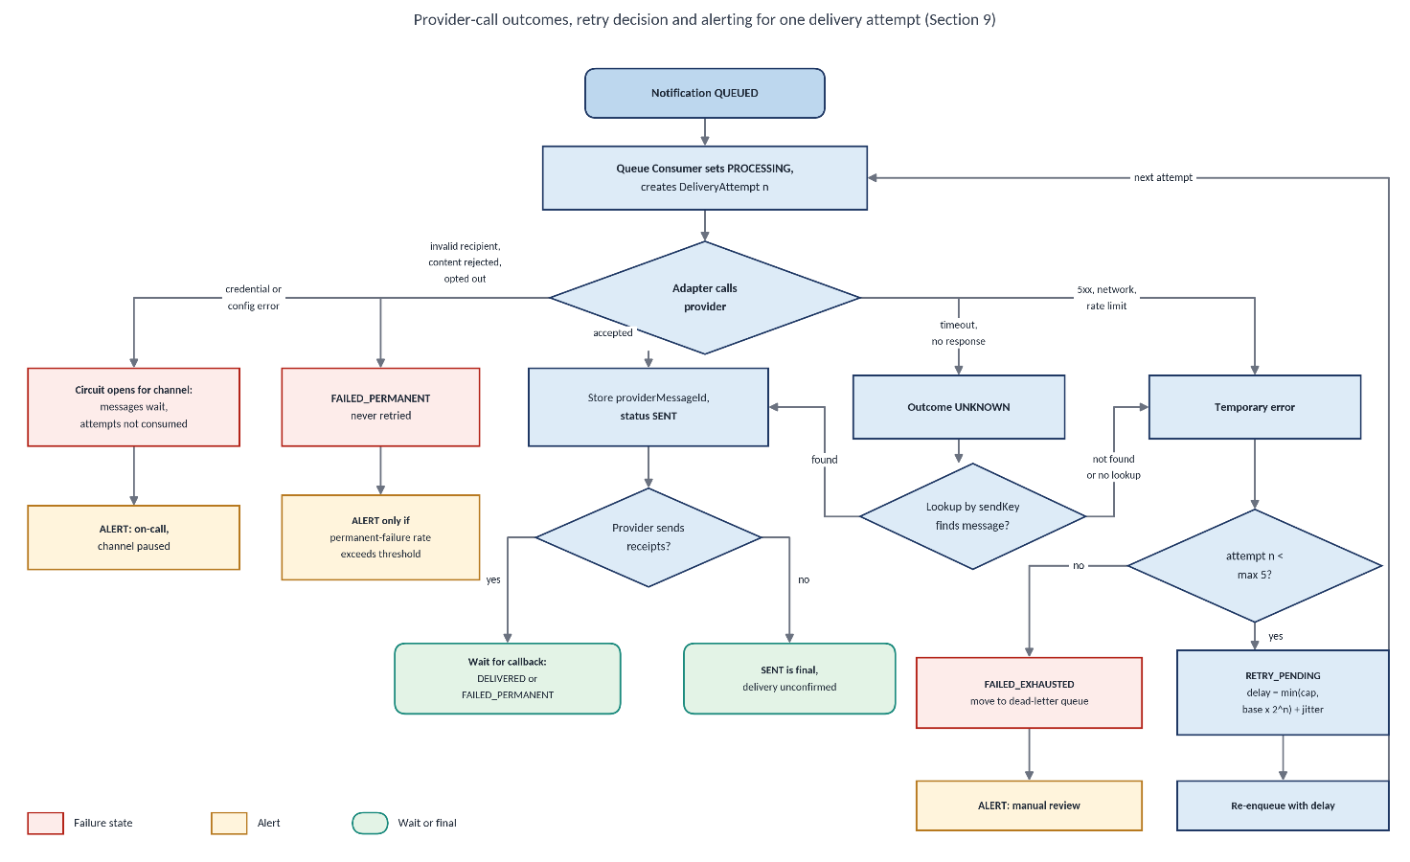

Figure 9: Failure-handling and retry flow showing success, temporary failure, permanent failure, and exhausted retries.Retry Limits
Retries are allowed only while the maximum attempt count has not been reached and the delivery window remains open. Every retry is controlled by an attempt limit and a time limit.

The following values are proposed defaults and can be changed through configuration.

Parameter | Proposed value | Purpose
Maximum attempts | 5 total: 1 initial attempt and 4 retries | Prevent endless retries.
Retry backoff | 1, 5, 15, and 60 minutes | Increase the wait between attempts.
Jitter | ±20% | Spread retries to avoid sending too many requests at once.
Provider retry delay | Use retryAfterSeconds when it specifies a longer delay. | Respect provider rate limits.
Delivery window | 24 hours from acceptance | Stop delivery attempts after the allowed period.
Send timeout | 10 seconds per provider call | Prevent workers from waiting indefinitely.
Circuit breaker | Open after 5 consecutive temporary or configuration failures on a channel. | Pause sending through an unhealthy channel.
Recovery probe | After 60 seconds | Check whether the provider is available again.
Dead-letter queue | Retain messages until reviewed; alert on every entry. | Support investigation and manual recovery.

The Notification Service is designed to support new channels without changing its main processing logic. For example, a Push Notification channel can be added by implementing the existing NotificationChannel interface and updating the configuration.

8. Extensibility: How Would We Add a New Channel?

8.1 What changes and what does not
Figure 8 shows how a new Push Notification channel can be added. Grey components remain unchanged, while green dashed components represent additions.
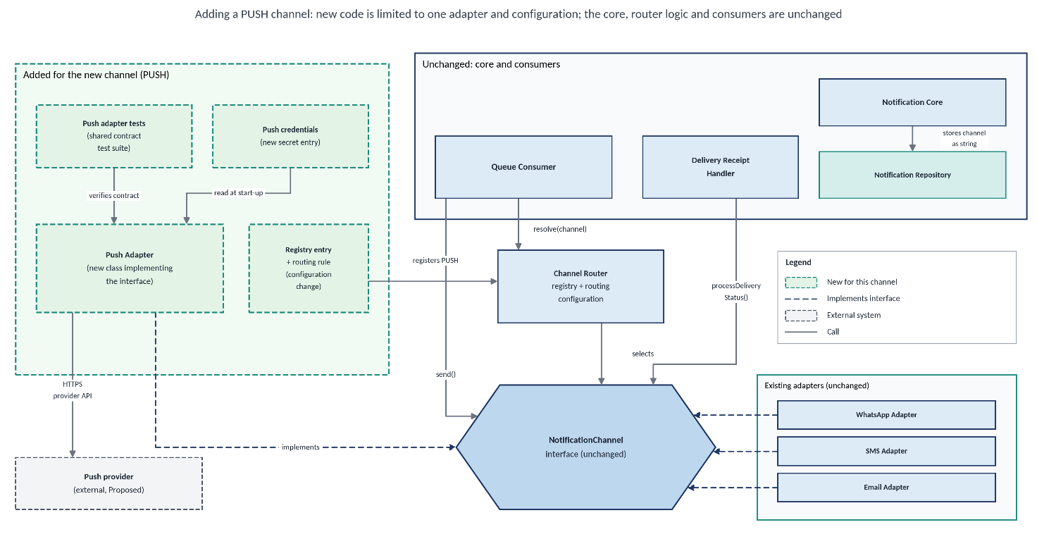

Figure 10. Adding a new channel: one adapter implementing the existing interface, plus configuration.
Unchanged | Added or updated
Notification Core and state machine | New adapter implementing NotificationChannel
Status and data models | Channel registry entry and routing configuration
Queue Publisher and Queue Consumer | Provider credentials in the secret manager
Retry Manager and Delivery Receipt Handler | Templates for the new channel
Notification Repository | Contract tests and provider sandbox tests
Existing WhatsApp, SMS, and email adapters | Dashboard panel and alert thresholds
Existing notification workflow | New channel value in the public API validation list

8.2 Steps to Add a New Channel
- Select a provider: Check whether it supports delivery receipts, sending, and message-status lookup.
- Create the adapter: Implement NotificationChannel, including error mapping and callback handling. Keep provider-specific logic inside the adapter.
- Run tests: Execute the shared contract tests and provider sandbox tests. Check timeouts, error handling, and exception handling.
- Configure credentials: Store provider credentials securely in the secret manager and connect them through configuration.
- Register the channel: Add it to the channel registry, routing configuration, and public channel validation list.
- Create templates: Add the required message templates for each supported locale.
- Update monitoring: Add dashboard panels and alert thresholds for the new channel.
- Release safely: Deploy the channel in a disabled state. Enable it through configuration after testing and verification.

8.3 What this does not claim
- Adding a standard channel does not automatically support every new messaging feature.
- New recipient types: If Push Notifications require device tokens instead of phone numbers or email addresses, document the necessary public API changes.
- Different messaging features: Two-way chat or attachment support may require a versioned update to the channel interface.
- Scheduled notifications: Supporting scheduled delivery may require changes to the processing workflow and state model.
- Automatic channel fallback: Sending through another channel after a failure requires additional routing rules and state handling. It is outside the initial scope.

9. Security, Privacy and Observability
These security and monitoring measures apply to all components of the Notification Service.
Authentication and Authorisation
- Each application has its own identity and permissions to send or read notifications.
- Applications can access only their own notifications.
- Provider callbacks are verified using provider signatures.
Transport and Storage Security
- TLS protects data during communication between components.
- Database and message broker connections are secured.
- Stored data is encrypted, including recipient addresses and template variables.
Secrets Management
- Provider credentials, callback secrets and encryption keys are stored securely in a secret manager.
- Secrets are never logged or stored in the database.
- Secrets can be rotated without changing the application code.
Rate Limiting
- API requests are limited for each application.
- Excess requests receive a 429 response with a Retry-After header.
- Per-recipient limits prevent excessive messages to the same phone number or email address.
Minimal Message Content
- Templates use generic messages and reference IDs.
- Message bodies are not stored.
- Logs and error messages must not contain personal or sensitive information.
Consent and Opt-Out
- The calling application is responsible for obtaining user consent.
- If a provider reports that a recipient has opted out, the notification is treated as a permanent failure.
Audit
- Append-only audit records track notification submissions, status changes, configuration changes and administrative actions.
- Existing audit records cannot be modified or deleted through normal application operations.
Metrics and Alerts
The service monitors:
- Accepted and failed notifications by channel.
- Dispatch delays and retry attempts.
- Queue depth and dead-letter messages.
- Outbox processing delays and circuit-breaker status.
- Rejected callbacks and duplicate notification attempts.
- Database errors and sustained delivery failures.

10. Self-Review, Trade-offs and Open Questions

10.1 Review against the assignment questions
Clear interfaces: REST APIs, the NotificationChannel interface, and internal interfaces are defined. Testing them with separate development teams is still pending.
Independent Core: The Notification Core uses a common interface and does not directly depend on provider adapters or SDKs.
Clear data ownership: Each entity has one owner, and the Core manages notification status changes. The Repository handles data storage.
Failure handling: Provider, queue, database, worker, gateway, and callback failures are covered. Multiple simultaneous failures need further analysis.
Future changes: New channels can be added through adapters and configuration. Two-way messaging and scheduled delivery require additional design changes.

10.2 Known Trade-offs
Modular monolith: Modules share one release cycle and database. The worker can be separated later because components communicate through defined interfaces.
Outbox pattern: Adds a database table and a small dispatch delay but helps prevent accepted notifications from being lost.
At-least-once processing: Improves reliability but allows a small risk of duplicate messages during certain failures.
Design-only status: The architecture is proposed, not implemented or tested. No messaging provider has been integrated yet.

10.3 Open Questions
OQ-1: Provider selection. Which WhatsApp, SMS, and email providers will be used? Do they support delivery receipts, sending, or message lookup?
OQ-2: Recipient and consent management. Who receives notifications, who manages consent and opt-outs, which languages are required, and is a suppression list needed?
OQ-3: Data retention. How long should notification records, status history, and delivery receipts be retained?
OQ-4: Message queue. Is the existing queue sufficiently durable, or is a dedicated broker required?
OQ-5: Expected traffic. What are the expected daily notification volume and peak traffic? This affects worker capacity, rate limits, and broker selection.
OQ-6: Retry configuration. Are the retry limits, delivery window, and circuit-breaker settings appropriate? These proposed values need review before implementation.

11 Notifications Used in the Antenatal Follow-Up System

11.1 Purpose
This section explains the different notifications used in the Antenatal Follow-Up System. These notifications help pregnant women and mothers receive important updates and reminders about registration, health check-ups, health camps, doctor consultations, medicines, and follow-up visits.
The Notification Service sends these messages through configured channels such as WhatsApp, SMS, and email.

11.2 Notification Type
The following table describes the proposed notification types and their intended purpose.

No. | Notification Type | Description
1 | Registration Confirmation | Confirms that the pregnant beneficiary has been successfully registered in the system.
2 | Upcoming Antenatal Check-Up Reminder | Reminds the beneficiary about an upcoming antenatal check-up.
3 | Check-Up Due Today | Informs the beneficiary that her scheduled antenatal check-up is due today.
4 | Missed Appointment Reminder | Reminds the beneficiary to contact the field worker to reschedule a missed appointment.
5 | Overdue Follow-Up Reminder | Notifies the beneficiary when a scheduled follow-up has not been completed within the expected timeframe.
6 | Upcoming Health Camp Announcement | Provides information about an upcoming health camp, including its date, time, location, and available services.
7 | Health Camp Reminder | Reminds the beneficiary about an upcoming health camp to help her plan attendance.
8 | Doctor Consultation Booking Confirmation | Confirms the date and time of a scheduled doctor consultation.
9 | Online Consultation Details and Reminder | Shares the relevant online meeting link and consultation details and reminds the beneficiary before the appointment.
10 | Medicine and Supplement Reminder | Reminds the beneficiary to follow medicine or IFA/calcium supplement instructions provided by her healthcare professional.
11 | Supplement Refill Reminder | Reminds the beneficiary to check her remaining supplement supply and request a refill when required.
12 | Referral Follow-Up Reminder | Reminds the beneficiary to follow up with the relevant health facility after receiving a referral.
13 | Health-Facility Visit Reminder | Provides a reminder about a planned visit to a hospital or clinic.
14 | Next Antenatal Visit Confirmation | Confirms the date of the next antenatal visit following the previous assessment.
15 | Post-Delivery Follow-Up Reminder | Reminds the mother about a scheduled post-delivery check-up.

11.3 Integration with the Notification Service
The Antenatal Follow-Up System initiates notification requests through the Notification Service API when specific events or scheduled activities require communication with a beneficiary.
The Notification Service validates incoming requests, accepts valid notifications for processing, routes messages through the configured communication channel, and tracks delivery status. It also applies the configured retry policies when delivery attempts fail.
The calling application determines when a notification is required and supplies the relevant message details. The Notification Service manages the delivery process without requiring the calling application to communicate directly with individual notification providers.

11.4 Privacy and Safety Considerations
- Beneficiary communications must comply with applicable consent and privacy requirements.
- Sensitive personal and health information must be protected during message processing and delivery.
- Online consultation links and other private meeting details must be shared only with authorised recipients.
- Notification messages provide information and reminders; they do not diagnose medical conditions or replace guidance from qualified healthcare professionals.

