**SIMULATION AND ANALYSIS OF DYNAMIC ROUTING**

**OVER STATIC ROUTING**

*Report* *submitted* *to* *the* *SASTRA* *Deemed* *to* *be* *University* *as* *the* *requirement* *for* *the* *course*

**CSE302:** **COMPUTER** **NETWORKS**

*Submitted* *by*

**NAGURU NAVEEN KUMAR REDDY**

**(Reg.** **No.:** **124003192,** **B.Tech** **Computer** **Science** **&** **Engineering)**

**AUGUST 2022**



**SCHOOL** **OF** **COMPUTING**

**THANJAVUR,** **TAMIL** **NADU,** **INDIA** **–** **613** **401**



**SCHOOL** **OF** **COMPUTING**

**THANJAVUR** **–** **613** **401**

**Bonafide** **Certificate**

This is to certify that the report titled “**SIMULATION AND ANALAYSIS OF DYNAMIC ROUTING OVER STATIC ROUTING**” submitted as a requirement for the course, **CSE302:** **COMPUTER** **NETWORKS** for B.Tech. is a bonafide record of the work done by **Shri.** **NAGURU NAVEEN KUMAR REDDY** **(Reg.** **No.124003192** **,** **B.Tech** **Computer** **Science** **&** **Engineering**) during the academic year 2022-23,in the School of Computing.

Project Based Work *Viva* *voc*e held on

**Examiner** **1**

**Examiner** **2**

**LI** **ST** **OF** **FIGURES**

|  |  |  |
| --- | --- | --- |
| **Figure** **No.** | **Title** | **Page** **No.** |
| 1.1 | Routing Table | 2 |
| 1.2 | Types of Routing | 4 |
| 1.3 | Static Routing | 5 |
| 1.4 | Dynamic Routing | 7 |
| 1.5 | Working of dynamic Routing | 8 |
| 1.6 | Types of Dynamic Routing | 9 |
| 1.7 | Working of dynamic routing | 11 |
| 1.8 | Working of Link-State routing | 12 |
| 1.9. | OSPF Hello protocol and database exchange | 15 |
| 1.10. | Splitting an OSPF AS into areas | 16 |
| 2.1. | Topology for static vs dynamic | 17 |
| 2.2. | Network used for static vs dynamic routing | 19 |

**ABBREVIATIONS**

EGP Exterior Gateway Protocol

IGR Interior Gateway Routing

OSPF Open Shortest Path First

DV Distance Vector Protocol

LS Link State Routing Protocol

IPv4 Internet Protocol version 4

IPv6 Internet Protocol version 6

CPT Cisco Packet Tracer

**ABSTRACT**

The recent exponential increase of network communications has made a thorough understanding of the routing process necessary. To be more precise, information (packet) routes are stored on a device known as a router, which is in charge of ensuring the best possible transmission of information (packets) from the source to the destination using routing protocols and routing algorithms, which work together to search for and select the best path. Today's network connection would be impossible without routing protocols, which are crucial for direction, commitment to send visitors quickly, and how the discussion is carried out in the router to send the packets from source to end (destination).

In contemporary communication networks, the routing protocol is becoming increasingly important. Each routing protocol has a distinct level of performance. Each of them has a unique architecture, adaptability, route processing latency, and convergence capabilities in terms of the performance of the routing protocol.

The Exterior Gateway Protocol (EGP) and Interior Gateway Routing are two of the various classes of routing protocols (IGR). A routing protocol might be dynamic or static, distance-vector or link-state, but it's crucial to pick the proper one among the available options.

When the network design is straightforward, static routing protocols are utilised, and when the complexity of the architecture rises, dynamic routing methods. Many different dynamic routing protocols are in use today. The distance-vector routing protocols, like RIP, which employ the Bellman-Ford algorithm, the link-state routing protocols, like OSPF, which employ the Dijkstra algorithm, and a hybrid type of routing protocol, like EIGRP, which employs the Dual algorithm, are the three categories of dynamic routing protocols. It is crucial to choose the best routing protocol for a specific network because every set of routing protocols has advantages and disadvantages of their own for a given network.

In this project, we'll concentrate on the differences between the static and dynamic routing protocols, including Open Shortest Path First (OSPF), Distance Vector Protocol (DV), and Link State Protocol (LS). These routing methods are described in detail later in this study. Within small and big topologies, we'll look at traits including throughput, traffic routing, and packet loss. We will collect simulation results for the selected routing protocols using NS2, Cisco Packet Tracer then compare performance to identify the optimum routing protocol for a specific network layout.

**KEYWORDS:** Routing protocol, Network topology, Packet loss, Throughput.

|  |  |  |
| --- | --- | --- |
| **TABLE** **OF** **CONTENTS** | | |
| **Chapter** **No.** | **Title** | **Page**  **No.** |
|  | Bonafide Certificate | ii |
|  | List of Figures | iii |
|  | Abbreviations | iv |
|  | Abstract | v |
| 1 | Introduction | 1 |
| 2 | Implementation | 17 |
| 3 | Merits and Demerits | 20 |
| 4 | Source Code | 21 |
| 5 | Snapshots | 28 |
| 6 | Analysis and obeservations | 33 |
| 7 | Conclusion and Future Plans | 37 |
| 8 | References | 38 |

**1.** **INTRODUCTION**

**1.1.** **Background**

Computer communication networks are expanding quickly each day in the current day. The provision of services like file transfer, print sharing, video streaming, and phone conferencing is made easier by communication technologies. A global network of connected computer networks is known as the Internet. Internet is now a key component of communication networks. In order to transfer packets across the Internet, routing protocols are employed in computer communication networks, which are based on technology that provides the necessary technological infrastructure. Routing protocols outline the information-dissemination methods by which routers connect with one another. The router can help in choosing the routes between two nodes because it is already familiar with the nearby networks.

Numerous routing protocols of different kinds are in use today. Static Routing Protocol and Dynamic Routing Protocol have always been regarded as the two leading routing protocols for real-time applications. When a router uses a manually specified routing entry rather than data from dynamic routing traffic, this is known as static routing. On the other hand, dynamic routing protocols are used to exchange routing information between routers in a dynamic manner, as their name implies. Dynamic routing protocols like DV, LS, and OSPF are used in real networks to communicate network topology to nearby routers. There are many different static and dynamic routing protocols available, but choosing the right one is crucial for routing performance. The right choice of routing protocol is dependent on several parameters. In this thesis, we implement two routing protocols, namely DV, LS and OSPF, and further do performance evaluation for real-time applications.

**1.2.** **Routing and Routing Protocol**

Before knowing what a routing protocol is we shold know what is a router and why we need routing protocol.

**1.2.1. Router**

An actual or virtual device known as a router is used to transmit data between two or more packet-switched computer networks. The Internet Protocol address (IP address) of the destination is examined by a router, which then determines the optimal path for the data packet to take to get there.

One typical kind of gateway is a router. At each point of presence on the internet, it is situated where two or more networks converge. A single packet may be sent by hundreds of routers as it travels from one network to the next on its way to its destination. Routers are connected to the network layer in the Open Systems Interconnection paradigm (Layer 3).

In order to find the appropriate next hop for a packet, a router looks at the destination IP address in the packet header and compares it to a routing table. Data forwarding instructions to specific network destinations are listed in routing tables, sometimes in relation to other factors like cost. They essentially consist of a set of computational algorithms that determine the optimum way to send traffic to a specific IP address.

When a router can't discover a better way to forward a packet, routing table will frequently specify a default route, which it will employ. For instance, the typical home office router routes all outbound traffic to its internet service provider using a single default route (ISP). There are two types of routing tables: static (manually established) and dynamic. Based on network activity, dynamic routers automatically update their routing tables and communicate with other devices via routing protocols.

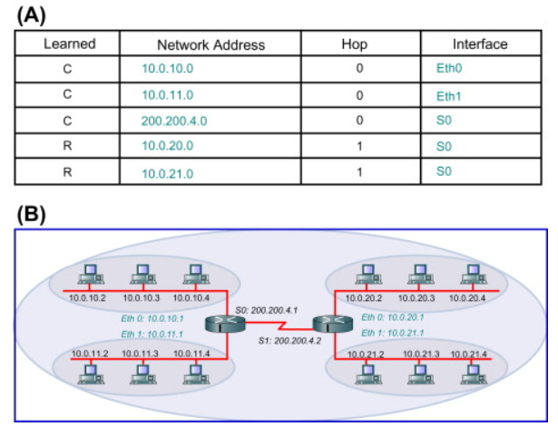

Fig. 1.1.Routing Table

**1.2.2.** **What is Routing and Why Routing?**

The act of transporting a data packet from its source to its destination is known as routing in networking. Circuit-switched networks and computer networks are just two examples of the many networks to which routing principles can be used. A router is a specialised device that typically handles routing.

An essential component of the internet is routing, in which the router chooses the routes that Internet Protocol (IP) packets take to get from one place to another. Routing tables, which keep track of the routes to various network destinations, are often used as the basis for the routing procedure carried out by a router to direct forwarding. A routing table is comparable to a train timetable, which passengers use to determine which train to board. Similar operations are performed by routing tables, but for network paths rather than for trains. These tables may be created with the use of routing protocols, defined by an administrator, or discovered by analysing network activity.

In the increasingly complicated network environment, this implies that the router has taken on the role of the major control point and is now in charge of monitoring, efficiency, service quality, and security, among other characteristics that enable networks to be more valuable. You may manage the network if you manage the routers. This is true in a static network, of course, but is even more true in the usual scenario of a business today that is undergoing rapid change and is transitioning to entirely IP-based services.

Now as we have some basic idea about what a router and what routing is we will dive deep into our routing protocols.

**1.2.3.Routing Protocol**

A routing protocol outlines the manner in which routers interact with one another to share data that enables them to choose routes between nodes in a computer network. Data packets are sent via the internet's networks from router to router until they reach their destination computer. Routers are responsible for guiding traffic on the internet. Algorithms for routing choose a specified path. Each router only has prior knowledge of the networks that are immediately connected to it. This information is distributed throughout the network through a routing system, initially among close neighbours. In this method, routers learn about the network's topology. What gives the Internet its fault tolerance and high availability is the capacity of routing protocols to dynamically adapt to changing situations, such as disabled connections and components, and route data around barriers.

The specific traits of routing protocols include how they avoid routing loops, how they choose preferred routes, how they use hop cost information, how long it takes them to reach routing convergence, how scalable they are, and other things like relay multiplexing and cloud access framework parameters. To distribute uncompromised networking gateways to permitted ports, additional characteristics like multilayer interfacing may also be used. The additional advantage of this is that routing protocol loop problems are avoided.

There are two main types of routing protocols:

1. STATIC ROUTING PROTOCOL
2. DYNAMIC ROUTING PROTOCOL

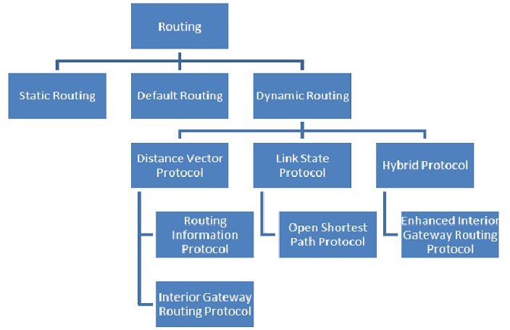

Fig. 1.2.Types of Routing

**1.3. Types of Routing Protocols**

**1.3.1. Static Routing Protocol**

When a router utilises a manual configuration routing entry rather than a dynamic entry, it uses a static routing method then it is called Static Routing.

A network administrator may manually configure static routes in a variety of circumstances by adding entries to the routing table. It is not always doable. Static routes are fixed and remain the same regardless of network changes or reconfigurations.

Routing that is static and dynamic can coexist. In order to maximise routing effectiveness and offer fallbacks in the case that dynamic routing information cannot be transmitted, they are typically utilised on routers. When no other routes are available, static routing is used to set a default route as a point of exit from the router. Small networks with one or two routes often employ static routing. As a result of not wasting a link on the exchange of dynamic routing information, this is frequently more effective. In situations where a dynamic route is not available, static routing is frequently employed as a complement to dynamic routing. From one routing protocol to another, routing information is transferred with the use of static routing.

**Working condition**

Below is a step-by-step explanation of how the Static Routing Algorithm functions.

In step 1,For each network in the internetwork, the routing table must be kept up to date for the static router to operate properly.

In step 2, hosts are set up on a network so that the IP address of the local router interface corresponds to their default gateway address.

In step 3,when a host has to transmit a packet to another network, it first sends the packet to the neighbourhood router, which then examines its routing table and chooses the best route to take.

In Step 4, static routers are more challenging to manage than dynamic routers, but they may be more secure because the administrator has more control over the router's settings.

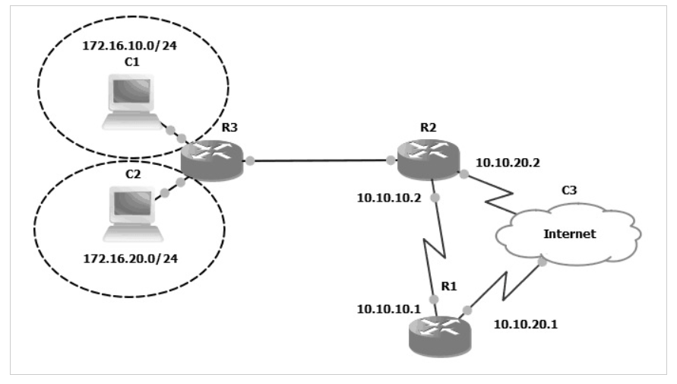 Fig. 1.3. Static Routing

## Advantages of Static Routing:

**1. Predictability**

Static routing follows a relatively predictable route to its destination. There won't be any adjustments to the router even if the network's layout and design change. Users are always aware of the path's location.

**2. Network Overheads**

Static routing has virtually minimal overheads compared to dynamic routing. As a result, overhead is not imposed on routers and network lines.

**3. Configurations**

Compared to a large network, setting up a small network is quite simple. To enable each router to connect to its corresponding network segment, the network administrator just needs to make changes to each router. The router is not directly connected to these network parts.

**4. Resource Requirement**

Static routing uses a remarkably small amount of resources. Here, additional resources like CPU and RAM are not required.

**5. Bandwidth**

Static routing doesn't require any CPU processing time for communication. As a result, it puts less strain on the router CPU. Because of this, they use less bandwidth than a dynamic routing approach.

**Disadvantages of Static Routing**

**1. Maintenance**

Network configuration is only simpler while the network is small; as the network's size rises, so does its complexity. Large numbers of routes, particularly in static topologies, can be extremely time-consuming to administer.

**2. Updates**

A large network's route updating procedure is recognised to be challenging, in addition to route maintenance. It was necessary to update each route separately as well as in the proper order. There would be issues with internet connectivity if the routes were modified incorrectly.

**3. Redundancy**

Static routing does not automatically update in the event of a failure. Routes must be manually modified by users in order to direct data flow in a different direction.

**4. Input Errors**

  Since static routing is manually configured, it is susceptible to input errors. Errors may come from mistakes, most likely. Network administrators are capable of making errors when configuring routing protocols or network data.

**5. Protocol Support**

When using static routes, routing protocols lack the freedom of independence. It never gives routes that are set up using the dynamic routing protocol more favour.

**1.3.2. Dynamic Routing Protocol**

A router can transmit data through a variety of different routes and arrive at its destination depending on the state of the communication circuits at the time of transmission using a technique known as dynamic routing.

Dynamic routers are intelligent enough to choose the best route for data based on the network's current state at that moment. The dynamic router will utilise its algorithm (in which they employ routing protocols to acquire and share knowledge on the present path among them) and it will re-route the previous network across another network in real-time if one section of the network fails to move data forward. And the main feature of Dynamic Routing is this incredible power and functionality to alter paths in real-time over the network by sharing status among them. A couple of the protocols used for dynamic routing include RIP and OSPF (open shortest path first).

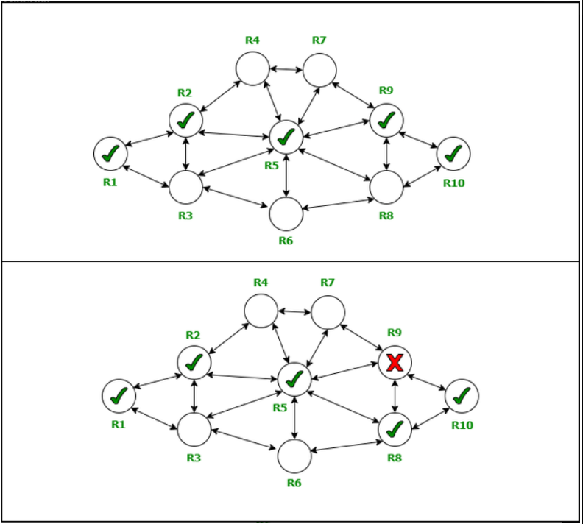

Fig. 1.4. Dynamic routing

## Working of Dynamic Routing:

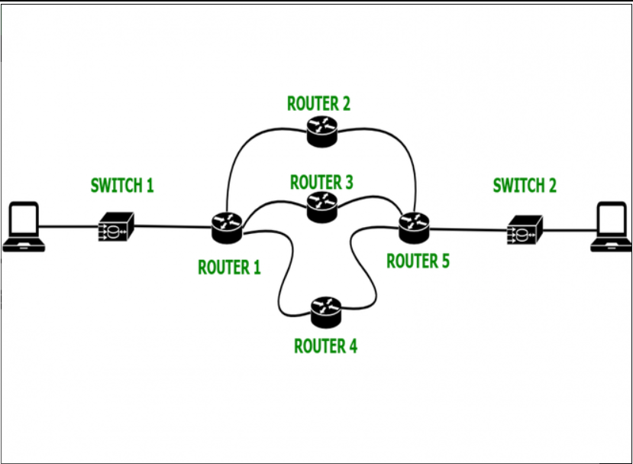

Fig. 1.5. working of dynamic routing

**Step 1:** One router in the network needs to be installed with a routing protocol (a protocol that specifies how information will be shared between routers and how they will connect with each other to share/distribute information between nodes on a network).

**Step-2:**The initial routing table of the router containing router information is accessed manually, and from there it proceeds automatically with the aid of a dynamic routing algorithm to create the routing tables for the remaining routers in the network.

**Step-3:**The routing information is then shared among the routers, ensuring that information is always delivered to its destination even if the network goes down or a router is unable to function properly or share information with other routers to which it islinked.  
**Step-4:** The presence of hosts allows for the comparison of the default gateway address to the IP addresses of the nearby router.

**Types of dynamic routing protocols:**

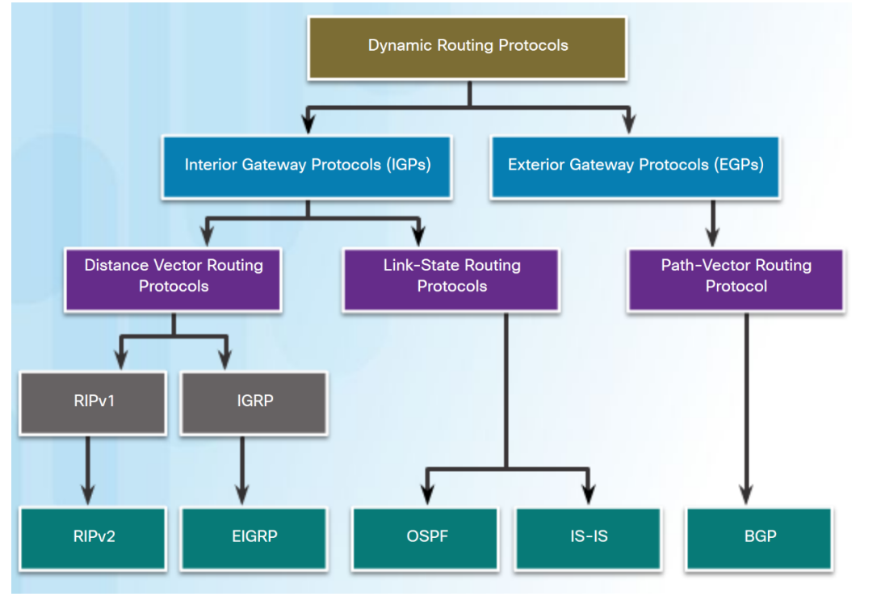

Fig. 1.6. Types of Dynamic Routing

**Interior gateway protocol:**

An autonomous system's gateways (often routers) can exchange routing table information via an inner gateway protocol (IGP), also known as an interior routing protocol (for example, a system of corporate local area networks). The routing of network-layer protocols like IP can then be done using this routing information.

The two types of interior gateway protocols are distance-vector routing protocols and link-state routing protocols. Open Shortest Path First (OSPF), Routing Information Protocol (RIP), Intermediate System to Intermediate System (IS-IS), and Enhanced Interior Gateway Routing Protocol are some particular instances of IGPs (EIGRP).

**Exterior gateway protocol:**

From the middle of the 1980s to the middle of the 1990s, the Exterior Gateway Protocol (EGP) was a routing protocol used to link various independent systems on the Internet until being replaced by Border Gateway Protocol (BGP).

Now that the routing protocols have been categorised, we will talk about the dynamic protocols we used in this experiment, primarily the Distance Vector Algorithm and Link State Algorithm in NS2 and OSPF in CISCO PACKET TRACER.

**1.3.3. Distance Vector Routing Protocol**

The Bellman-Ford algorithm, also known as the Ford Fulkerson method, or the distant vector routing protocol, is used to determine a path. A distance-vector protocol uses the data gathered by the neighbouring router to determine the distance and direction of the vector for the subsequent hop. The topology must be monitored, and any changes must be communicated to surrounding devices.

The distance vector routing technique, also known as the Bellman-Ford algorithm or the Ford Fulkerson algorithm, is used to determine the shortest path between two network nodes. Based on distance or hops as its key parameter to define an ideal path, the routing protocol is used to determine the best route from source to destination. The distance vector refers to the separation between the established node and its neighbours, whilst the routing specifies the routes there.

The Distance Vector Routing Algorithm (DVR) chooses the best route from source to destination by exchanging routing table information with other routers in the network and keeping it up to date.

The Bellman-Ford algorithm is defined as dx(y)=minv{c(x,v)+dv(y)}

Where, dx(y)= The least distance from x to y

c(x,v)=Node x’s cost from each of its neighbour v

dv(y)=Distance to each node from initial node

minv=selecting shortest node

Take into account a situation in which the distant vector routing technique is used and all routers are configured. Every router in the network will communicate the distance with the router next to it. All of the data is gathered from nearby routers. An ideal distance is determined and recorded in the routing table using the information provided by each router. In this manner, the remote vector routing protocol is used to determine the best path.

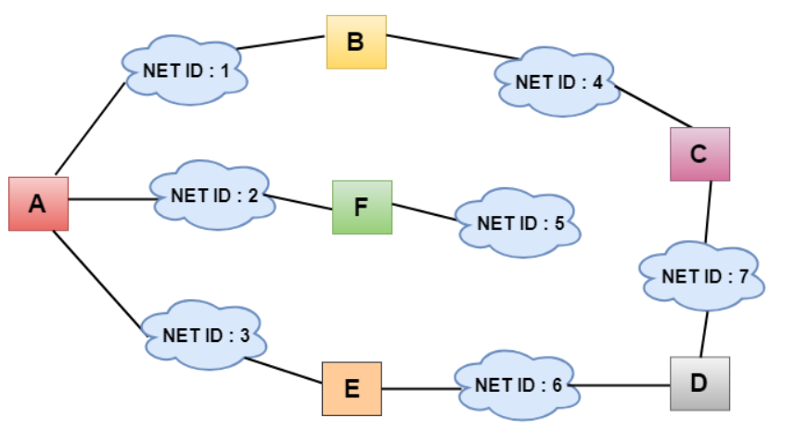

Fig. 1.7. Working of dynamic routing

**1.3.3. Link State Routing Protocol**

Every router uses the internal Link State Routing Algorithm protocol to communicate with and learn about other routers on the network. Every router computes its routing table using the distributed link state routing method.

A router can create its routing table using knowledge of the network topology. Now, a router uses a shortest path computation algorithm, such Dijkstra's algorithm, together with the topological knowledge to create the routing table. Each router builds a routing table that is shared with the other routers in the network, enabling faster and more dependable data transmission.

With the other routers in the inter-network, a router does not send its whole routing table. It solely transmits data about its neighbours. This information, together with details on all of the routers it is directly linked to and the cost of the connection, is broadcast by a router. Flooding is the phrase used to describe the process of transmitting information about a router's neighbours. Except for its neighbours, a router transmits data to all other routers in the inter-network. Each router that gets the data duplicates it and transmits copies to all of its neighbours. The information is shared throughout the network's interconnected routers in this fashion.This information exchange only occurs when there is a change in the information. Hence, the link state routing algorithm is effective.

## Phases of Link State Routing

Reliable Flooding: As mentioned, a router uses the flooding mechanism to distribute its information. The gathering and transmission of neighbourhood information takes place in this initial stage. The initial state and the final state are the two parts of the first phase, which is reliable flooding.

* + Initial State: Each router learns the neighbours' connection costs in the initial stage of reliable flooding.
  + Final State: Each router knows the details of the complete router network (graph) the end state of the reliable floods.

1. Route Calculation: The cheapest, most efficient paths to each router are determined in the second phase, which is also known as route calculation, by each router using the shortest path computation algorithm, such as Dijkstra's algorithm.

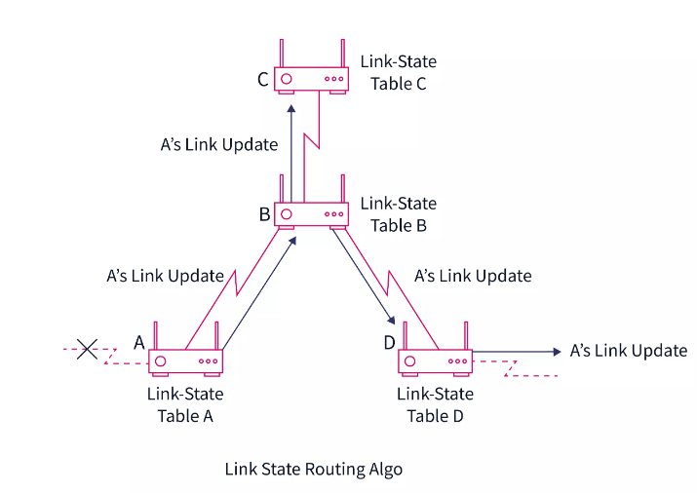

Fig. 1.8. Working of Link-State routing

## Features of Link State Routing Algorithm

Let us now discuss the various features of the link state routing algorithm.

1. Link state packet: The information about the routing information is contained in the link state packet, a small data packet.
2. Link state database: The link state database is used to store information about a router's neighbours and the cost of a connection.
3. Shortest path computation algorithm: The Dijkstra Algorithm is used to determine the shortest path or the best path to reach a specific router, as was previously stated.
4. Routing table: The list of all paths and interfaces is contained in a routing table.

Now as we came to know the two most important types of dynamic routing protocols now we will try to distinguish them.

**Distance Vector vs Link State :**

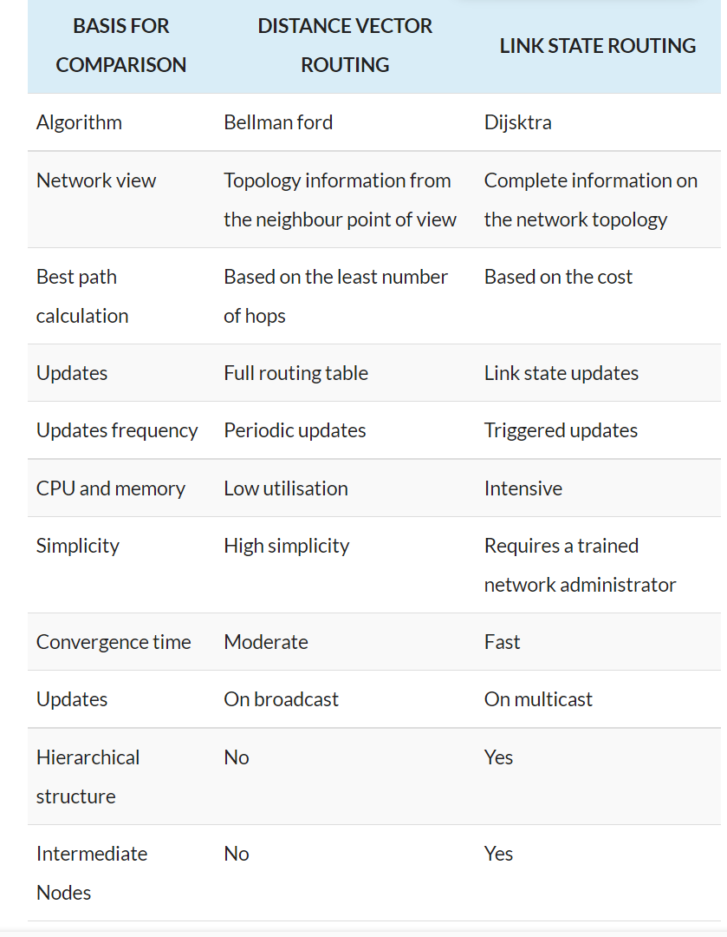

Now the last but not least the OSPF routing prootcol is used to analyse against the static routing protocol.

**1.3.4.Open Shortest Path First**

The Shortest Path First (SPF) algorithm serves as the foundation for the link-state routing protocol known as Open Shortest Path First (OSPF), which was created for IP networks. An inside gateway protocol is OSPF (IGP).

## In an OSPF network, each router or system maintains a link-state database that is identical and contains information on the topology of the area. Link-state advertisements (LSAs), which each router or system in the area receives from every other router or system in the same area as well as LSAs it makes on its own, are used to create each system's link-state database. An LSA is a packet that includes data on neighbours and path expenses. Each router or system computes a shortest-path spanning tree with itself as the root using the SPF method based on the link-state database.

## OSPF Hello protocol and link-state database exchange

In an OSPF network, routers or other devices first check that their interfaces are operational before sending out Hello packets via their OSPF interfaces to find neighbours. Routers or other systems with interfaces to the shared network are referred to as neighbours. After that, to create adjacencies, nearby routers or systems share their link-state databases.

The procedure for finding neighbours and creating adjacencies for two systems in the 9.7.85.0 subnet is shown in the following figure. Each system connects to the shared subnet 9.7.85.0 through an OSPF interface (interface 9.7.85.1 for system A and interface 9.7.85.2 for system B). Area 1.1.1.1 is the home of subnet 9.7.85.0.

**EXSTART phase**

The link-state database exchange starts with this. Who is the master and who is the subordinate are negotiated between the two systems.

**EXCHANGE phase**

To learn which LSAs each system's link-state database does not contain, the two systems exchange Database Description packets. The retransmission list contains the LSAs that each system has saved outside of its link-state database.

**LOADING phase**

When the EXCHANGE phase is complete, each system sends Link State Request packets to its neighbour (the other system in this case), asking for all of the LSAs that were saved in the retransmission list to be sent to it. The LSAs are returned in Link State Update packets as the neighbor's response to the request.

**FULL phase**

Adjacency is established between the two systems once they have finished exchanging LSAs and synchronised their link-state databases.

Each router or system in the area regularly sends an LSA to share its adjacencies or to report a status change after adjacencies have been established between all the routers or systems in the region. Routers or other systems in the area can learn about changes in the area topology and update their link-state databases as necessary by comparing the established adjacencies with the LSAs.

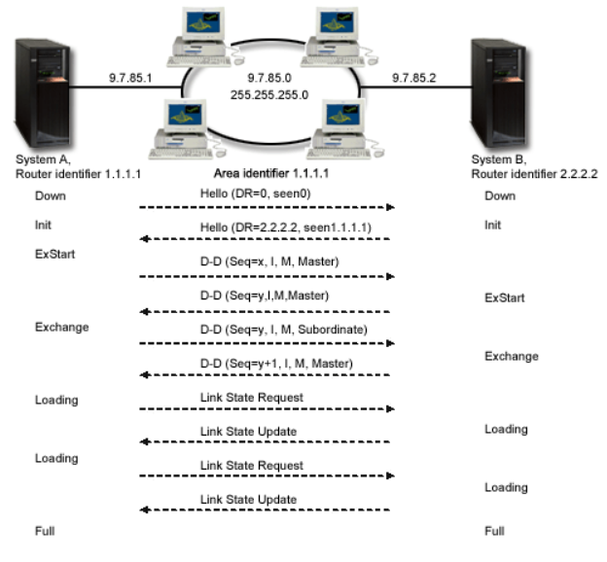

Fig. 1.9. OSPF Hello protocol and database exchange

**Designated router and backup designated router**

Using the Hello protocol, the routers in a multiaccess OSPF network with at least two associated routers choose a primary designated router and a secondary designated router. (A multiaccess network is a network that enables simultaneous connections and communications from various devices.)

The chosen router creates LSAs for the entire multiaccess network, distributes the LSAs to the other routers, and chooses which routers should be placed next to one another. The selected router is close to all of the other routers in the network. Both the amount of network traffic and the size of the link-state database for this network are reduced by the specified router. The only difference between the backup designated router and the others is that the backup designated router needs to create adjacencies with every router in the network (including the designated router). When the primary designated router fails, the backup designated router takes over as the designated router. The 9.7.85.0 subnet in Figure 1.8 is a broadcast network. As a result, using the Hello protocol, the routers in the 9.7.85.0 subnet choose a primary designated router and a secondary designated router. The designated router in this case is system A, while the backup designated router is system B.

**Splitting an OSPF AS into areas**

In contrast to RIP, OSPF may function in a hierarchy. The AS is the topmost organisation in the hierarchy. An AS is a collection of networks that are managed by the same entity and use the same routing protocol. Areas that are connected to one another by routers can be created within an AS. Groups of connected hosts and contiguous networks make up a region. An area's topology is hidden from entities outside of it. The link-state database of all routers in a region is the same. Less routing traffic and a smaller link-state database per area are made possible by distinct area topologies.

A router known as an area border router is one that sits on the edge of OSPF areas and links them to the main network. The link-state databases for each area are kept separate by an area border router, which has multiple interfaces to various areas.

Two areas—region 1.1.1.1 and area 2.2.2.2—are set up in the following figure. System B is an area border router with interfaces attached to areas 1.1.1.1 and 2.2.2.2, respectively, at 9.7.85.2 and 9.5.104.241, respectively. Two link-state databases, one for each area, are present in System B. Through interface 9.7.85.2, System B establishes adjacencies with Systems A and C in Area 1.1.1.1 and with System D in Area 2.2.2.2 through Interface 9.5.104.241.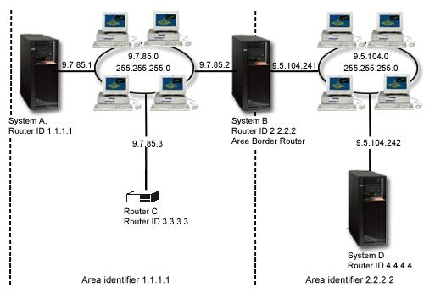

Figure 1.10. Splitting an OSPF AS into areas

**2.** **IMPLEMENTATION**

The breakdown of the project's implementation, from setting up the topologies to adjusting various protocol and simulation settings, will be covered in this section. We will give the results of the simulation and contrast the three routing methods' performance in the sections that follow.

**2.1 Static vs Dynamic in NS2**

In order to compare Static, Dynamic routing protocols I used NS2 to implement two small topologies and several large topologies.

**2.1.1.Topologies**

I initially put into practise the simple topology in Figure, which consists of 6 routers connected to their neighbours. I chose this topology due to its simplicity and also because we wanted to examine how it would react if a link failure were to be implemented between two routers. Routes will be modified and routing databases updated when this failure happens. In order to make sure that this topology behaves as predicted once the link fails, we will examine the routes from it.

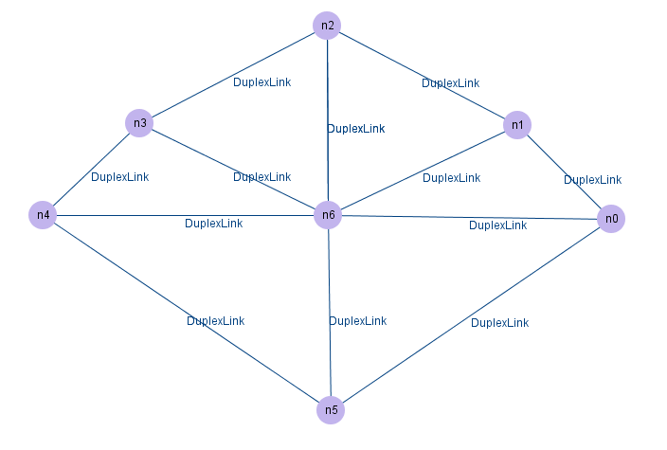

Figure 2.1. Topology for static vs dynamic

Then, using the ring topology, I was able to analyse how the routing protocols behaved as the number of nodes increased. I did this by looking at the throughput, packet loss, packet transmitted, and rcvd % within the simulation's allotted period. To determine the precise difference between static and dynamic routes as well as the trend of packet delivery, I examined important measures including throughput and the proportion of packets delivered. To determine the differences between the respected protocols' static and dynamic routing paths, I used link failure situations in the chosen topologies. In this simple topology, I've used DV routing to represent the dynamic protocol, and in the ring topology, I've used LS routing.

**2.2 Static vs Dynamic in Cisco Packet Tracer**

Before going into the implementation let us have a brief idea what is a cisco packe tracer.

**What is Cisco Packet Tracer ?**

Cisco's simulation tool is called Cisco Packet Tracer. In addition to testing and simulating abstract networking principles, it may be used to build complex network typologies. It serves as a learning environment for networking, and the experience is very similar to that of computer networks.

Additionally, they offer their services in Russian, German, Spanish, and French. Students may build complex and enormous networks with Packet Tracer, which is frequently not practical with physical hardware due to cost constraints. The operating systems Linux, Windows, MacOS, Android, and iOS all support Packet Tracer.

To build simulated network topologies, users of Packet Tracer can drag and drop routers, switches, and other network components. Cisco claims that practising networking is the best way to learn it. The protocols are only implemented in software, hence this programme cannot replace hardware routers or switches. However, this utility also includes a large variety of other networking devices in addition to Cisco hardware.

Here in the Cisco Packet Tracer I have built a network which is used to find the routing and performance analysis of static and dynamic routing protocols.

**Pre Configuration of the the network used :**

1. Configure end devices and connect them to switch

2. Connect the switch to a router, say router 0 and following the same with other routers and end devices.

3. Configure the end devices and their corresponding with router with appropriate IP address that resemble that they belong to same Site .

4. Let the network be named as Home, and the router as router 0.

5. Repeat the above steps and name the network as Branch office .

6. Configure a router, naming it as Internet Service Provider (ISP), with unique IP address that don’t resemble the previous routers’ IP address

7. Connect the routers with IP address, that shall separate the outgoing path from the home and branch office networks’ IP addresses.

8. Further, connect a similar network with couple of networks, naming them public area-1, public area-2, public area-3 etc.

9. Configure the end devices’ default gateway address as IP address of their corresponding site router.

10. Configure the OSPF/Static protocol in routers that shall identify the other peer’s IP address .

I have used the similar network for both static and dynamic protocols to show the exact difference between static and dynamic protocols.The network is given below in the figure.

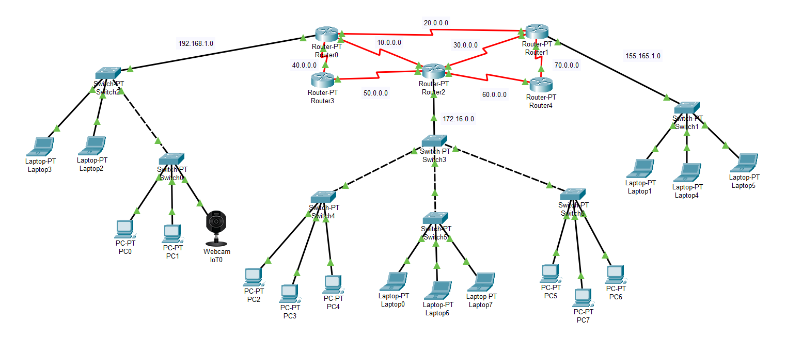

Figure 2.2. Network used for static vs dynamic routing

Here using the above network, I have simulated the static and dynamic routing protocols in the cisco packet tracer and have observed the routes taken by the respective protocols while the link disruption between the routers and analysed the reasons for the paths they have taken during link disruption.

The results of the simulation and analysis of the static vs dynamic routing protocols are given in detail in the upcoming sections and from those we can come to a conclusion on static vs dynamic routing protocols in different networks and the better routing protocol from the both on basing different parameters.

**3.MERITS** **AND** **DEMERITS**

**3.1 Static Routing Advantages and Disadvantages**

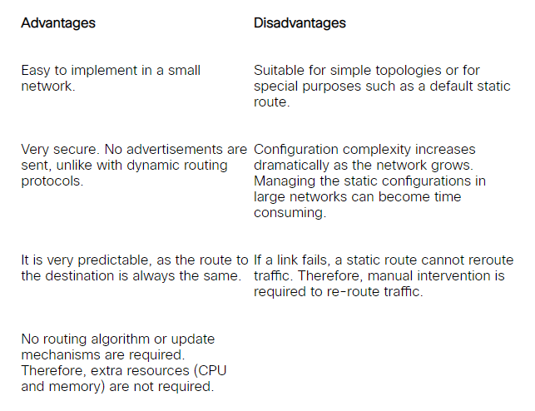

**3.2 Dynamic Routing Advantages and Disadvantages**

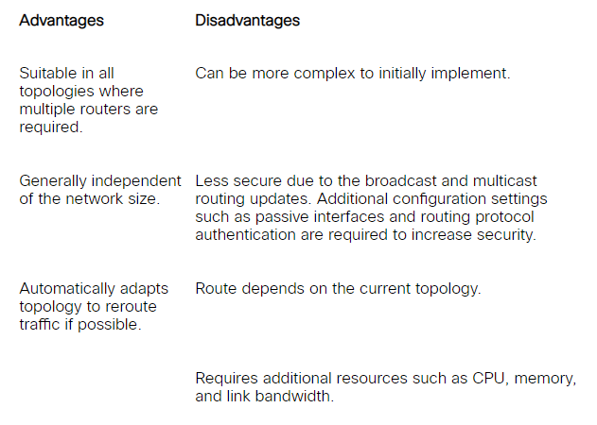

**4.** **SOURCE** **CODE**

**4.1.Code for the simple Topology:**

#Create a simulator object  
    set ns [new Simulator]  
     
     
    #creation of Trace and namfile  
    set tracefile [open [routing.tr](http://routing.tr/) w]  
    $ns trace-all $tracefile  
     
    #Creation of Network Animation file  
    set namfile [open Routing.nam w]  
    $ns namtrace-all $namfile  
     
    #Tell the simulator to use dynamic routing  
    $ns rtproto DV  
     
     
    #Define a 'finish' procedure  
    proc finish {} {  
            global ns namfile  
            $ns flush-trace  
        #Close the trace file  
            close $namfile  
        #Execute nam on the trace file  
            exec nam Routing.nam &  
            exit 0  
    }  
     
    #Create 7 nodes  
    set n0 [$ns node]  
    set n1 [$ns node]  
    set n2 [$ns node]  
    set n3 [$ns node]  
    set n4 [$ns node]  
    set n5 [$ns node]  
    set n6 [$ns node]  
     
    #Createlinks between nodes  
    $ns duplex-link $n0 $n1 1.5Mb 10ms DropTail  
    $ns duplex-link $n1 $n2 1.5Mb 10ms DropTail  
    $ns duplex-link $n2 $n3 1.5Mb 10ms DropTail  
    $ns duplex-link $n3 $n4 1.5Mb 10ms DropTail  
    $ns duplex-link $n4 $n5 1.5Mb 10ms DropTail  
    $ns duplex-link $n5 $n0 1.5Mb 10ms DropTail  
    $ns duplex-link $n0 $n6 0.5Mb 10ms DropTail  
    $ns duplex-link $n6 $n3 1.5Mb 10ms DropTail  
    $ns duplex-link $n5 $n6 1.5Mb 10ms DropTail  
    $ns duplex-link $n6 $n2 1.5Mb 10ms DropTail  
    $ns duplex-link $n4 $n6 1.5Mb 10ms DropTail  
    $ns duplex-link $n6 $n1 1.5Mb 10ms DropTail  
  
    $ns queue-limit $n0 $n6 5  
  
    #Give node position (for NAM)  
    $ns duplex-link-op $n0 $n1 orient right-up  
    $ns duplex-link-op $n1 $n2 orient up  
    $ns duplex-link-op $n2 $n3 orient left-up  
    $ns duplex-link-op $n3 $n4 orient left-down  
    $ns duplex-link-op $n4 $n5 orient down  
    $ns duplex-link-op $n5 $n0 orient right-down  
    $ns duplex-link-op $n0 $n6 orient up  
    $ns duplex-link-op $n6 $n3 orient up  
    $ns duplex-link-op $n5 $n6 orient right-up  
    $ns duplex-link-op $n6 $n2 orient right-up  
    $ns duplex-link-op $n4 $n6 orient right-down  
    $ns duplex-link-op $n6 $n1 orient right-down  
     
    $n0 color red  
    $n1 color darkmagenta  
    $n2 color darkmagenta  
    $n3 color green  
    $n4 color darkmagenta  
    $n5 color darkmagenta  
    $n6 color darkmagenta  
  
    #Create a UDP agent and attach it to node n(0)  
    set udp0 [new Agent/UDP]  
    $ns attach-agent $n0 $udp0  
     
    # Create a CBR traffic source and attach it to udp0  
    set cbr0 [new Application/Traffic/CBR]  
    $cbr0 set packetSize_ 500  
    $cbr0 set interval_ 0.005  
    $cbr0 attach-agent $udp0  
     
    #Create a Null agent (a traffic sink) and attach it to node n(3)  
    set null0 [new Agent/Null]  
    $ns attach-agent $n3 $null0  
     
    #Connect the traffic source with the traffic sink  
    $ns connect $udp0 $null0   
     
    #Schedule events for the CBR agent and the network dynamics  
    $ns at 0.5 "$cbr0 start"  
    $ns rtmodel-at 1.0 down $n0 $n6  
    $ns rtmodel-at 1.5 down $n1 $n2  
    $ns rtmodel-at 2.0 down $n6 $n3  
    $ns rtmodel-at 2.5 down $n6 $n2     
    $ns rtmodel-at 3.0 down $n5 $n4  
    $ns rtmodel-at 3.5 down $n1 $n6  
    $ns rtmodel-at 4.0 up $n0 $n6  
    $ns rtmodel-at 4.0 up $n6 $n3  
  
    $ns at 4.5 "$cbr0 stop"  
    #Call the finish procedure after 5 seconds of simulation time  
    $ns at 5.0 "finish"  
     
    #Run the simulation  
    $ns run

**4.2. Code for the Ring Topology with variable nodes:**

 #Dynaming and Static networking

# Variable no of nodes  
    set val(nn) 150;  
    #Create a simulator object  
    set ns [new Simulator]  
     
     
    #creation of Trace and namfile  
    set tracefile [open Routing.tr w]  
    $ns trace-all $tracefile  
     
    #Creation of Network Animation file  
    set namfile [open Routing.nam w]  
    $ns namtrace-all $namfile  
     
     
    #Tell the simulator to use dynamic routing  
    $ns rtproto LS  
     
    #Define a 'finish' procedure  
    proc finish {} {  
            global ns namfile  
            $ns flush-trace  
        #Close the trace file  
            close $namfile  
        #Execute nam on the trace file  
            exec nam Routing.nam &  
            exit 0  
    }  
     
    #Create nodes  
    for {set i 0} {$i < $val(nn)} {incr i} {  
            set n($i) [$ns node]  
    }  
     
     
    #Create links between the nodes  
    for {set i 0} {$i < $val(nn)} {incr i} {  
            $ns duplex-link $n($i) $n([expr ($i+1)%$val(nn)]) 1Mb 10ms DropTail  
    }  
     
    #Create a UDP agent and attach it to node n(0)  
    set udp0 [new Agent/UDP]  
    $ns attach-agent $n(0) $udp0  
     
    # Create a CBR traffic source and attach it to udp0  
    set cbr0 [new Application/Traffic/CBR]  
    $cbr0 set packetSize_ 500  
    $cbr0 set interval_ 0.005  
    $cbr0 attach-agent $udp0  
     
    #Create a Null agent (a traffic sink) and attach it to node n(3)  
    set null0 [new Agent/Null]  
    $ns attach-agent $n(3) $null0  
     
    #Connect the traffic source with the traffic sink  
    $ns connect $udp0 $null0   
     
    #Schedule events for the CBR agent and the network dynamics  
    $ns at 0.5 "$cbr0 start"  
    $ns rtmodel-at 1.0 down $n(1) $n(2)  
    $ns rtmodel-at 2.0 up $n(1) $n(2)  
    $ns rtmodel-at 1.0 down $n(2) $n(3)  
    $ns rtmodel-at 2.0 up $n(2) $n(3)  
    $ns at 4.5 "$cbr0 stop"  
    #Call the finish procedure after 5 seconds of simulation time  
    $ns at 5.0 "finish"  
     
    #Run the simulation  
    $ns run

**4.3. awk code for analysis:**

BEGIN {  
recvdSize = 0  
Initial_Time=0  
startTime = 0.5  
stopTime = 5.0  
sent_pckt=0  
sent_pckt1=0  
drpd_pckt1=0  
drpd_pckt=0  
rcvd_pckt=0  
}  
  
{  
event = $1  
time = $2  
source = $3  
pkt_size = $6  
destination = $4  
  
if (event == "s") {  
if (time < startTime) {  
startTime = time  
}  
}  
if(event=="+"&& source==0){  
sent_pckt1++  
}  
if(event=="+"&& destination==3){  
sent_pckt++  
}  
if(event=="r"&& destination==3){  
rcvd_pckt++  
}  
if(event=="d"&& destination==3){  
drpd_pckt1++  
}  
if(event=="d"){  
drpd_pckt++  
}  
if (event == "r") {  
if (time > stopTime) {  
stopTime = time  
}  
recvdSize += pkt_size  
}  
}  
  
END {  
printf("Sent Packets to node 3 are '%d'",sent_pckt)  
printf("\nReceived packets at node 3 are '%d'",rcvd_pckt)  
printf("\nDropped packets towards node 3 are '%d'",drpd_pckt1)  
printf("\nTotal Sent Packets to nodes are '%d'",sent_pckt1)  
printf("\nReceived Packet Percentage is:'%.2f%'",(rcvd_pckt/sent_pckt1)*100)  
printf("\nDropped packets are:'%d'",drpd_pckt)  
printf("\nPacket Drop percentage is:'%.4f%' ",(drpd_pckt/sent_pckt1)*100)  
printf("\nPacket loss is : '%d'",sent_pckt1-rcvd_pckt-drpd_pckt)  
printf("\nAverage Throughput[kbps] = '%.4f'\nStartTime=%.2f\nStopTime=%.2f\n",(recvdSize/(stopTime-startTime))*(8/1000),startTime,stopTime)  
  
}

**5.** **SNAPSHOTS**

**5.1. Dynamic Topology :**

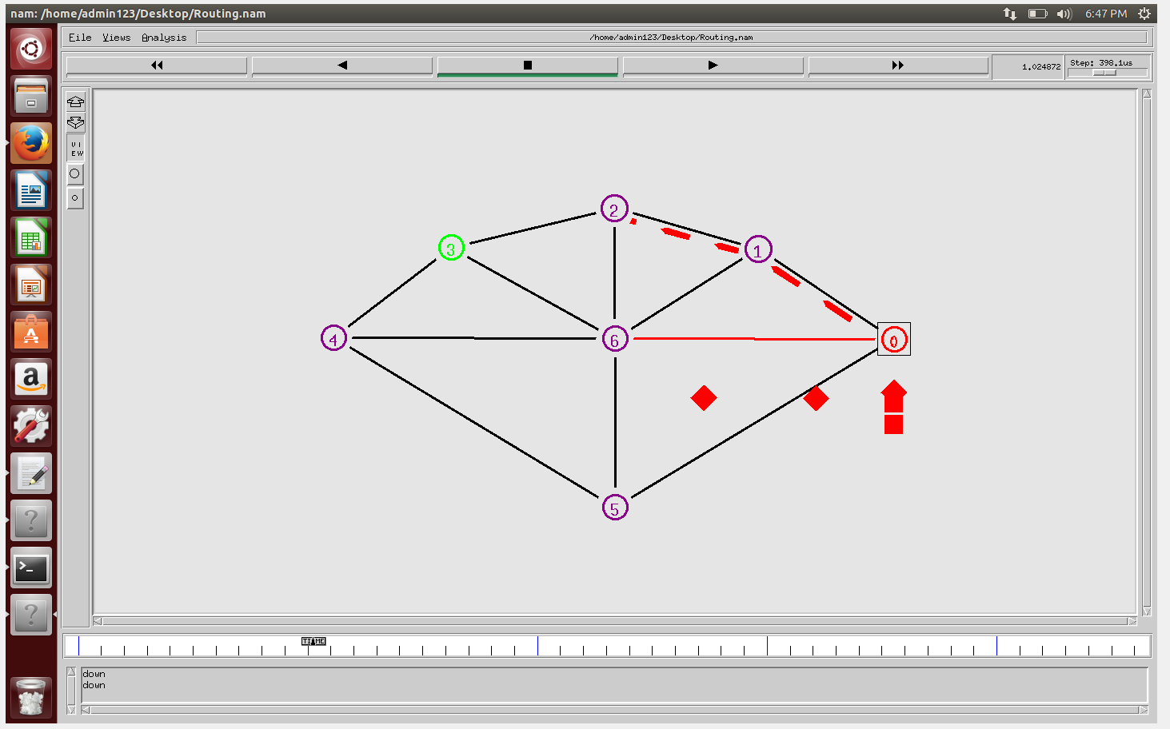

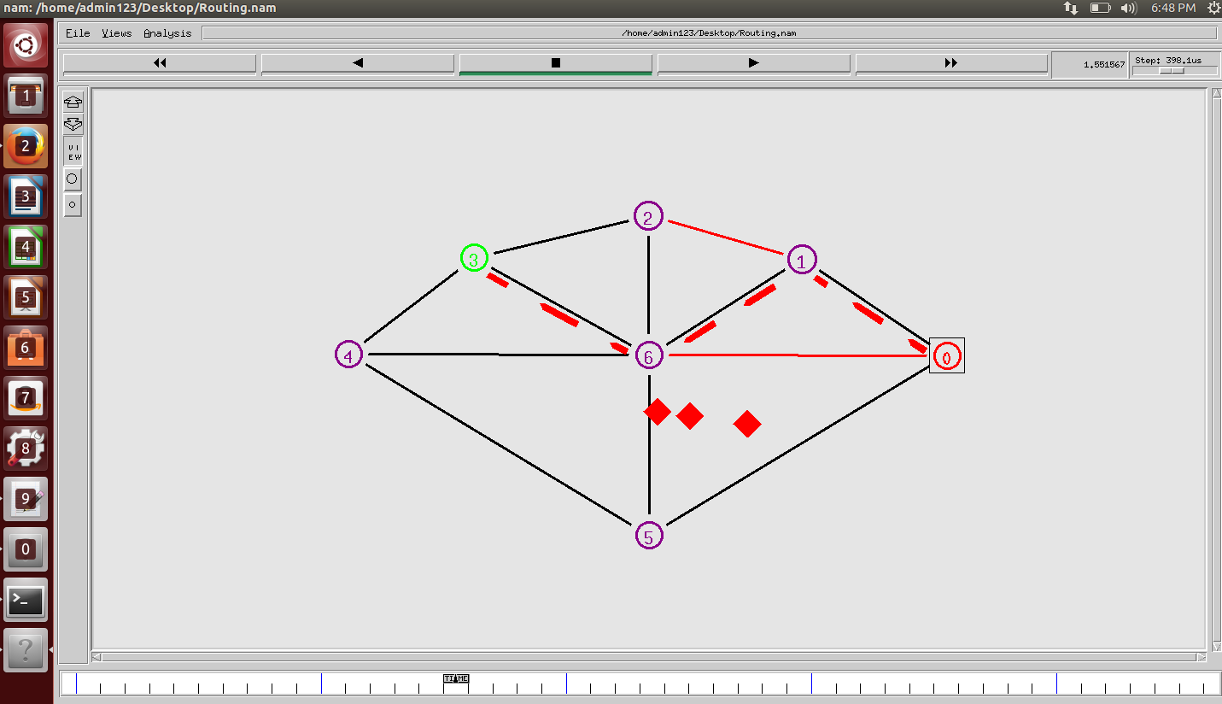

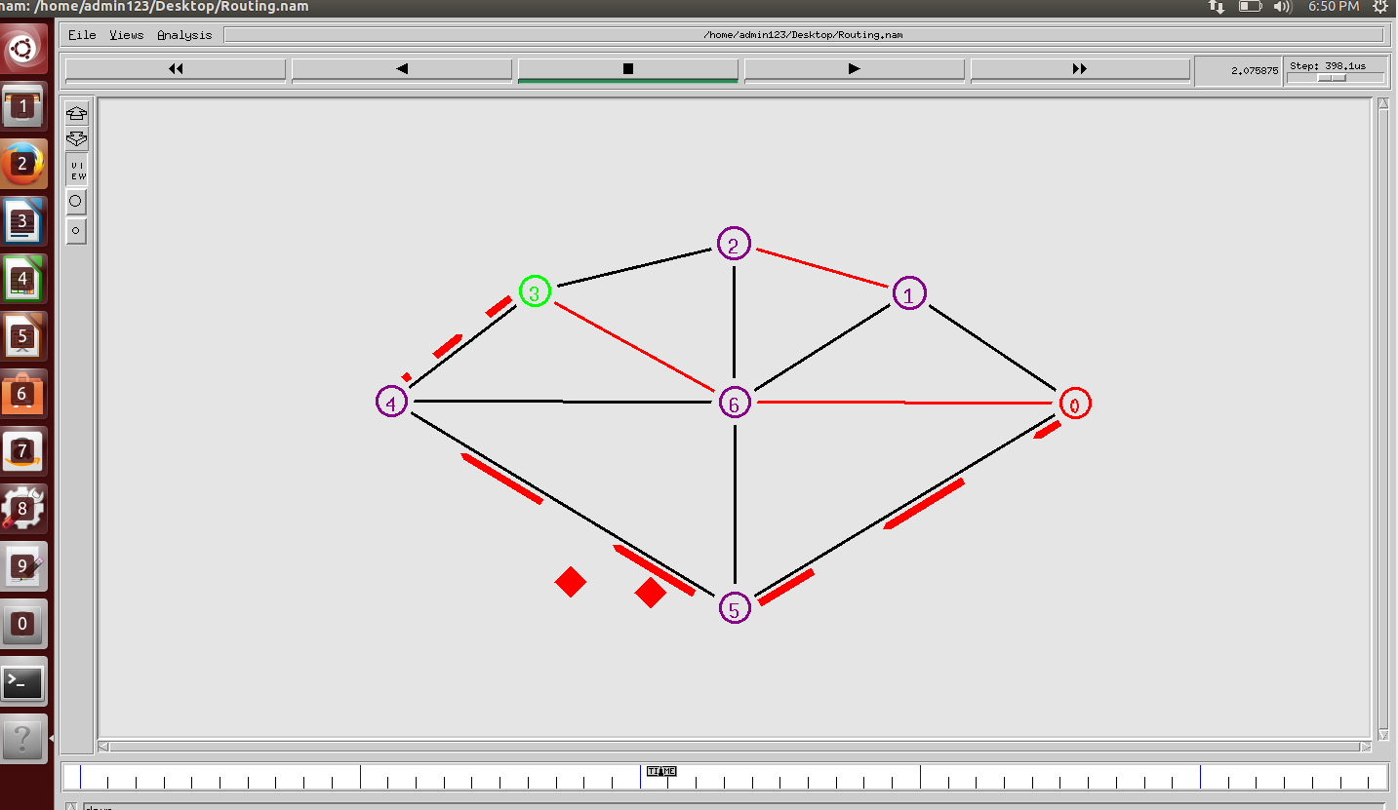

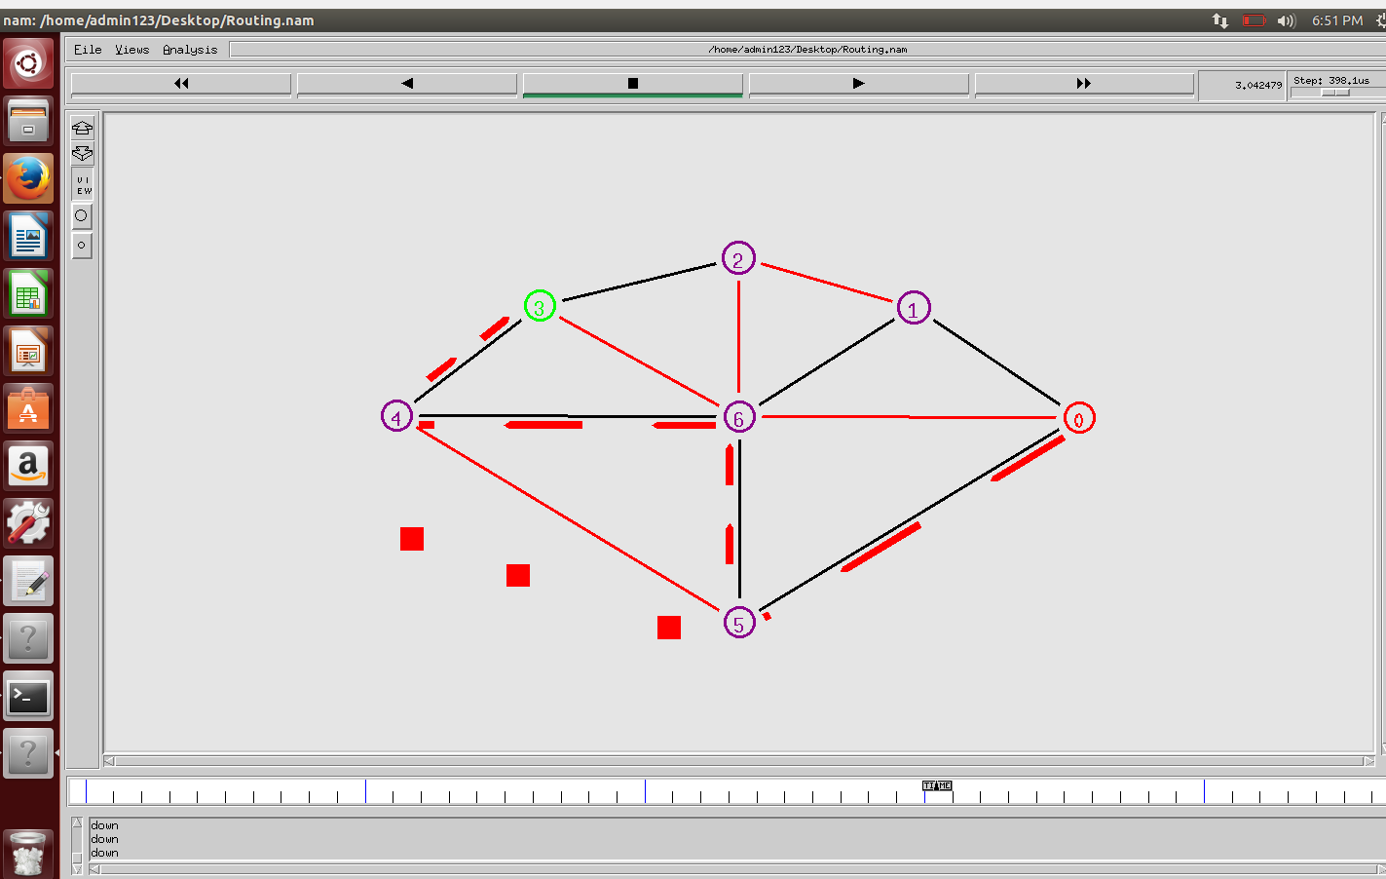

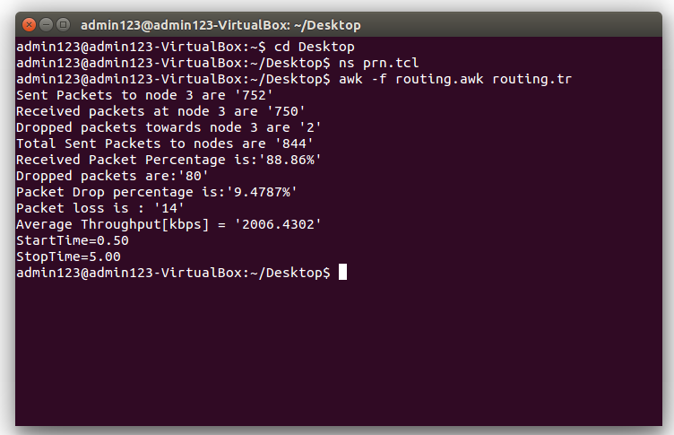

**5.2. Static Topology**

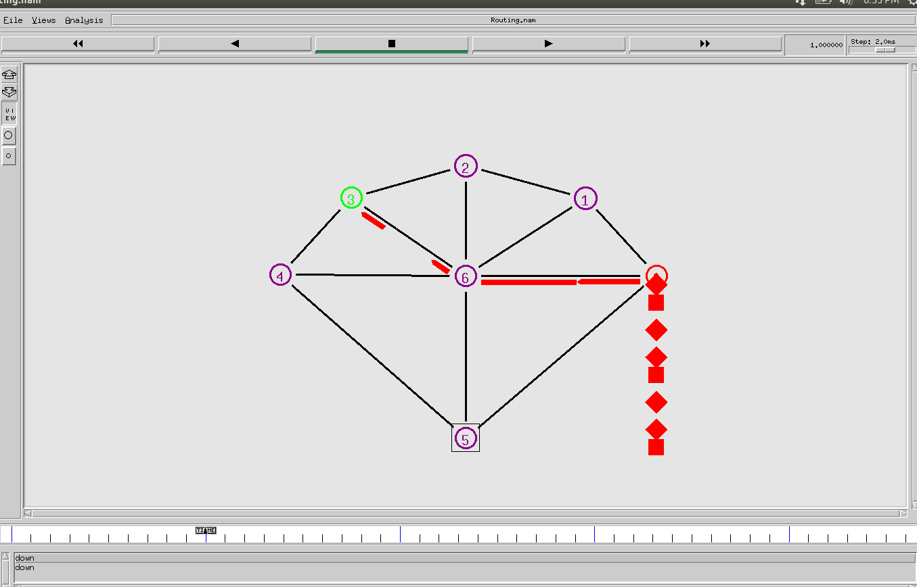

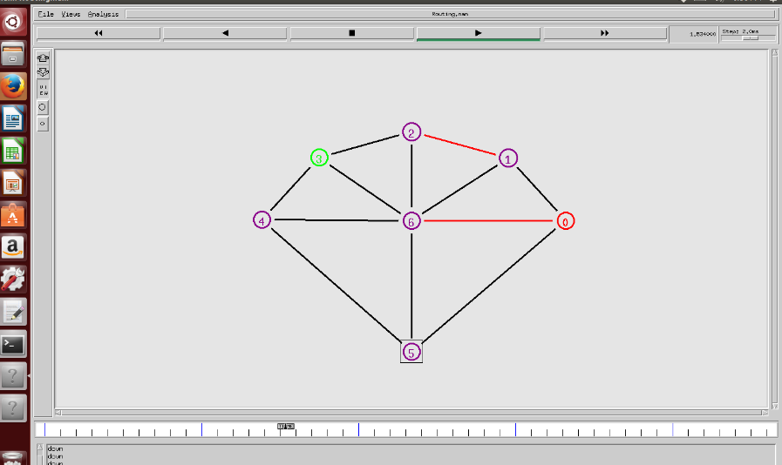

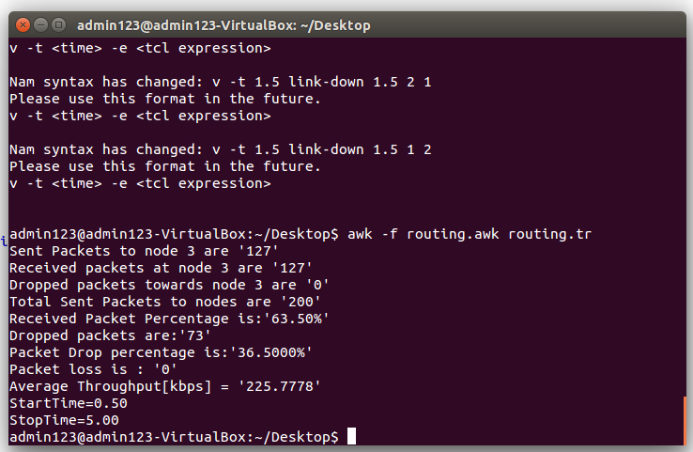

**5.3. OSPF routing in Cisco Packet Tracer**

**Without and with link disruption :**

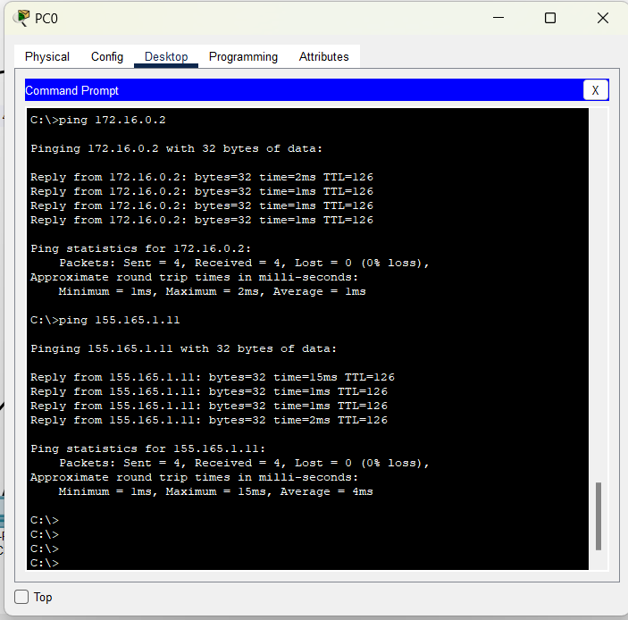

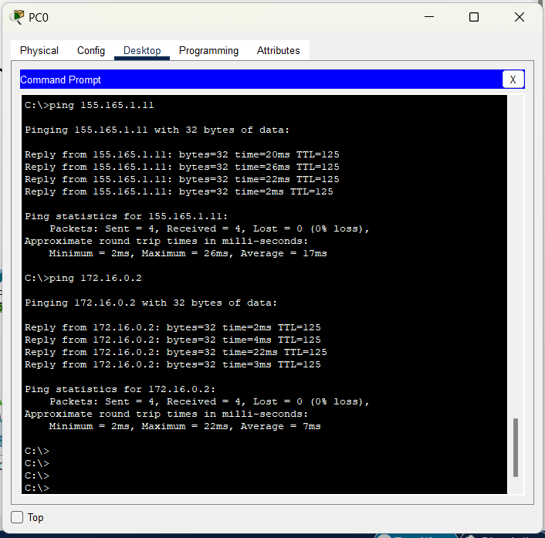

**5.4.Static routing in Cisco Packet Tracer**

**Without and with link disruption :**

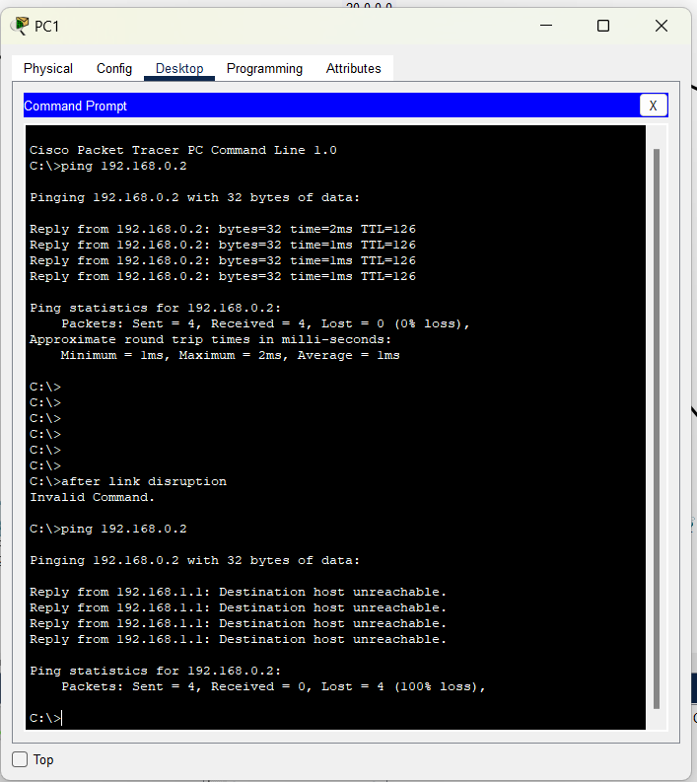

**6.ANALYSIS AND OBSERVATIONS**

**6.1.Anaysis of variable nodes with link disruption in NS2 :**

**Dynamic Routing:**

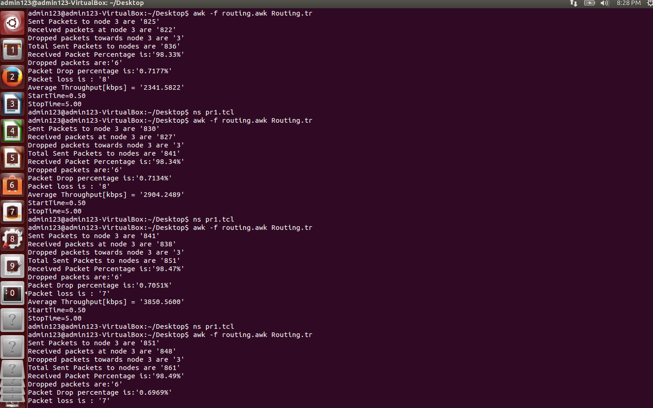

**Static Routing :**

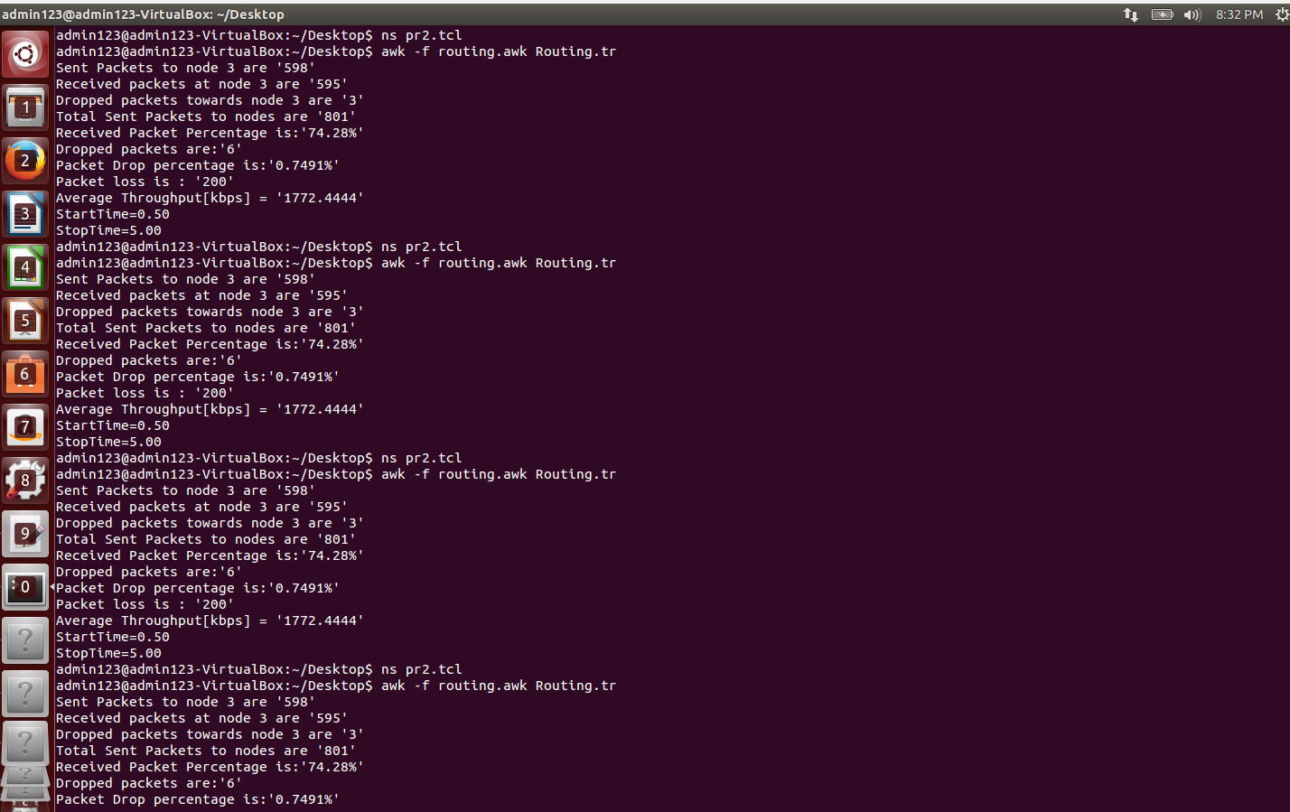

**6.2.Dynamic vs Static :**

**Dynamic ( LS routing )**

|  |  |  |  |  |  |  |  |  |
| --- | --- | --- | --- | --- | --- | --- | --- | --- |
| **No .of Nodes** | **7** | **10** | **15** | **20** | **30** | **50** | **80** | **100** |
| **Packets Sent** | **836** | **841** | **851** | **861** | **881** | **921** | **981** | **1019** |
| **Packet Rcvd** | **822** | **827** | **838** | **848** | **868** | **703** | **763** | **802** |
| **% pckt rcvd** | **98.33** | **98.34** | **98.47** | **98.491** | **98.52** | **76.33** | **77.78** | **78.70** |
| **Avg Throughput** | **2341.58** | **2904.24** | **3850.56** | **4807.53** | **6753.92** | **7848.96** | **8732.58** | **9531.41** |
| **Dropped pkt** | **6** | **6** | **6** | **6** | **6** | **211** | **211** | **212** |
| **Packet loss** | **8** | **8** | **7** | **7** | **7** | **7** | **7** | **5** |

**Static Routing**

|  |  |  |  |  |  |  |  |  |
| --- | --- | --- | --- | --- | --- | --- | --- | --- |
| **No .of Nodes** | **7** | **10** | **15** | **20** | **30** | **50** | **80** | **100** |
| **Packets Sent** | **801** | **801** | **801** | **801** | **801** | **801** | **801** | **801** |
| **Packet Rcvd** | **595** | **595** | **595** | **595** | **595** | **595** | **595** | **595** |
| **% pckt rcvd** | **74.28** | **74.28** | **74.28** | **74.28** | **74.28** | **74.28** | **74.28** | **74.28** |
| **Avg Throughput** | **1772.44** | **1772.44** | **1772.44** | **1772.44** | **1772.44** | **1772.44** | **1772.44** | **1772.44** |
| **Dropped pkt** | **6** | **6** | **6** | **6** | **6** | **211** | **211** | **212** |
| **Packet loss** | **200** | **200** | **200** | **200** | **200** | **200** | **200** | **200** |

**Graphical Representation of dynamic vs static routing**

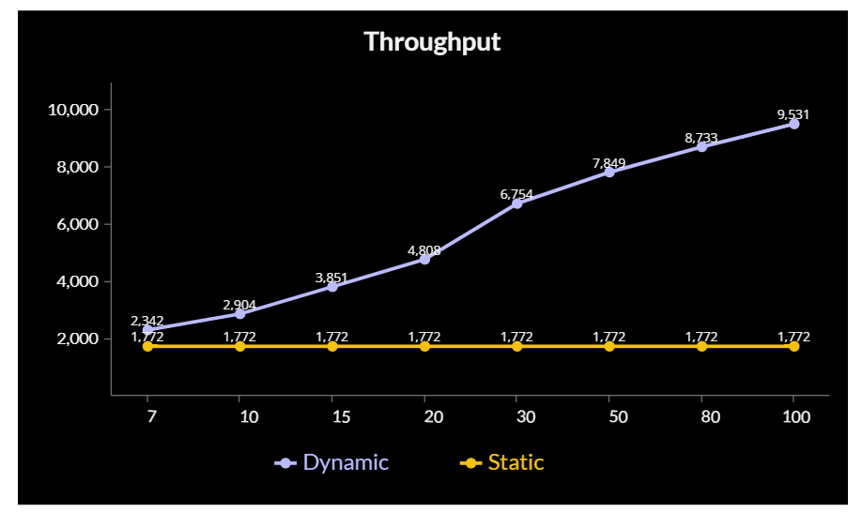

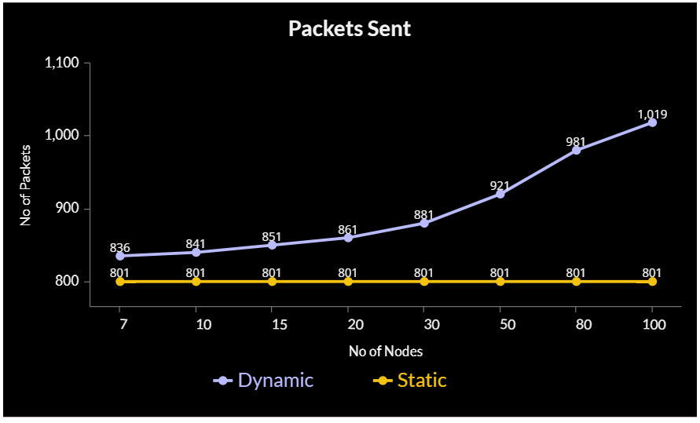

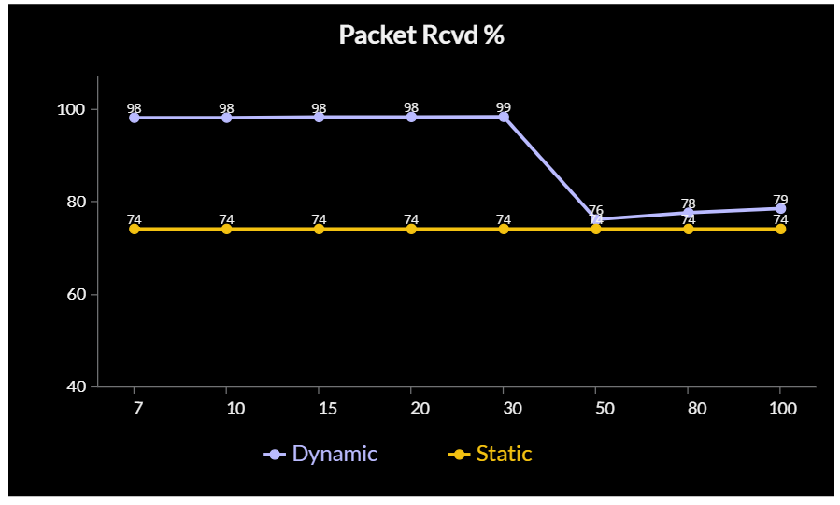

**6.** **CONCLUSION** **AND** **FUTURE** **PLANS**

My findings showed that for all instances, dynamic routing had the fastest convergence time. Due to bandwidth efficiency, static networks performed better during initial convergence than OSPF for static networks, but static was unable to outperform dynamic during link disruption. It should be noted that after a link failed in the network I built in CPT, OSPF had a quicker time to convergence.

Given that OSPF includes an early detection mechanism for changes in the network, similar to DV,LS, this conclusion makes logical. For network topologies, OSPF's overall convergence time was excellent. According to my predicted results, our results for the huge ring topologies were the most precise. Dynamic was still the fastest in this situation, whereas static was unable to deliver packets across multiple routes at all. While dynamic routing outperforms static routing in terms of throughput, packets transmitted, and packet received %, static routing does have its own capacity advantages, which is why most small networks utilise static routing and some real-time networks combine both static and dynamic routing.

As a result, dynamic is the greatest routing protocol since it offers the best convergence and backup routing options in any situation. As demonstrated by our huge ring topology, when LS and DV are compared, the former is preferable for large topologies while the latter is only appropriate for small networks.

The size of the network topology was the only variable in our investigation outside the routing protocol. The addition of metrics for the interfaces, such as cost, bandwidth, distance, bit error rate (BER), and delay, can be considered a future development or improvement for this project. To compare the performance of these routing protocols, different network topologies (in terms of size, routers, and links used) can be built. The most complex routing protocol is OSPF, thus  more effort might be spent studying it to determine the values of the parameters that should be adjusted to ensure that it operates at its best. Another option is to employ actual network topologies, such as those found in corporate offices, university campuses, or networks with a greater network size, while also changing network elements, such as interfaces, to match the scenario that is being studied.

**7.** **REFERENCES**

https://www.techtarget.com/searchnetworking/definition/router

https://www.oreilly.com/library/view/junos-enterprise-routing/9780596514426/pr02s02.html#:~:text=At%20the%20simplest%20level%2C%20routing,into%20a%20hierarchical%20network%20structure.

https://www.tutorialspoint.com/what-are-static-routing-algorithms-in-computer-networks

https://www.hitechwhizz.com/2020/11/5-advantages-and-disadvantages-drawbacks-benefits-of-static-routing.html

https://www.geeksforgeeks.org

https://www.scaler.com/topics/computer-network

https://www.firewall.cx/networking-topics/routing/ospf-routing-protocol/1110-ospf-operation-basic-advanced-concepts-ospf-areas-roles-theory-overview.html

https://www.subnet-calculator.com/subnet.php?net_class=C

https://www.wikipedia.org/

https://www.cisco.com/c/en_in/index.html