Frontend Development with React.js

Project Documentation format.

CookBook: Your Virtual Kitchen Assistant

## 1. Introduction

**Project Title:** CookBook: Your Virtual Kitchen Assistant

**Team Members:**   
 Team Leader Name:**NAVEEN KUMAR S [nn281689@gmail.com]**

Team Member Name:**BHARATH KUMAR R [rkrr8087@gmail.com]**

Team Member Name:**BOOPATHY A [boopathisakthi10313@gmail.com]]**

Team Member Name:**PRANAV BALAJI P A [pranavbalaji37@gmail.com]**

Team Member Name: **GUNA SHEKAR P [guna29733@gmail.com]**

## 2. Project Overview

**Purpose:**

The CookBook application is designed to simplify meal preparation by offering a virtual kitchen assistant.

Users can browse, save, and manage their favorite recipes with detailed instructions and ingredient lists.

**Features:**

- Extensive Recipe Library with Search & Filter Options

- Step-by-Step Cooking Instructions

- Bookmark Feature for Favorite Recipes

- Light/Dark Mode for Enhanced Visual Comfort

- Responsive Design for Optimal Viewing on All Devices

- Ingredient Checklist for Easy Shopping and Preparation

## 3. Architecture

**Component Structure:**

**App.js** — Root component managing layout and routes

**Header.js** — Navigation bar with search functionality

**RecipeList.js** — Displays categorized recipe cards

**RecipeCard.js** — Individual card displaying recipe details

**RecipeDetails.js** — Detailed view of selected recipe

**Footer.js** — Provides additional resources and links

**State Management:** Context API

**Routing:** React Router

## 4. Setup Instructions

**Prerequisites:**

- Node.js (v18 or higher)

- npm or yarn

**Installation:**

1. Clone the Repository:  
 `git clone https://github.com/Naveen8946/UNM1487_BCA_COOKBOOK.git

2. Install Dependencies:  
 `npm install`

3. Create .env file:  
 `REACT_APP_RECIPE_API_KEY=your_api_key_here`

4. Run the Application:  
 `npm start`

## 5. Folder Structure

/src

├── /components

│ ├── Header.js

│ ├── RecipeList.js

│ ├── RecipeCard.js

│ ├── RecipeDetails.js

│ └── Footer.js

├── /pages

│ ├── Home.js

│ ├── Categories.js

│ └── Bookmarks.js

├── /assets

│ ├── images

│ ├── icons

│ └── styles

├── /utils

│ ├── api.js

│ ├── helpers.js

│ └── constants.js

├── App.js

├── index.js

## 6. Running the Application

**Frontend Server Command:**`npm start`

## 7. Component Documentation

**Key Components:**

**Header:** Provides navigation and search functionality

**RecipeList:** Displays available recipes categorized by type

**RecipeCard:** Displays individual recipe details

**RecipeDetails**: Offers step-by-step instructions

**Reusable Components:**

**Button Component**: Used for actions like 'View Recipe' or 'Bookmark'

**Modal Component:** Displays detailed recipe information

## 8. State Management

**Global State:** Managed via Context API

**Local State:** Managed using React’s `useState()`

## 9. User Interface

- Clean and intuitive layout optimized for smooth navigation

- Mobile-first design for seamless browsing

- Elegant Light/Dark mode toggle for improved accessibility

## 10. Styling

**CSS Frameworks/Libraries:** Tailwind CSS

**Theming:** Integrated light/dark mode

## 11. Testing

**Testing Strategy:**

Jest for unit testing

React Testing Library for component testing

**Code Coverage:** Ensured high test coverage with Jest reports

## 12. Screenshots or Demo

**Screenshots:**

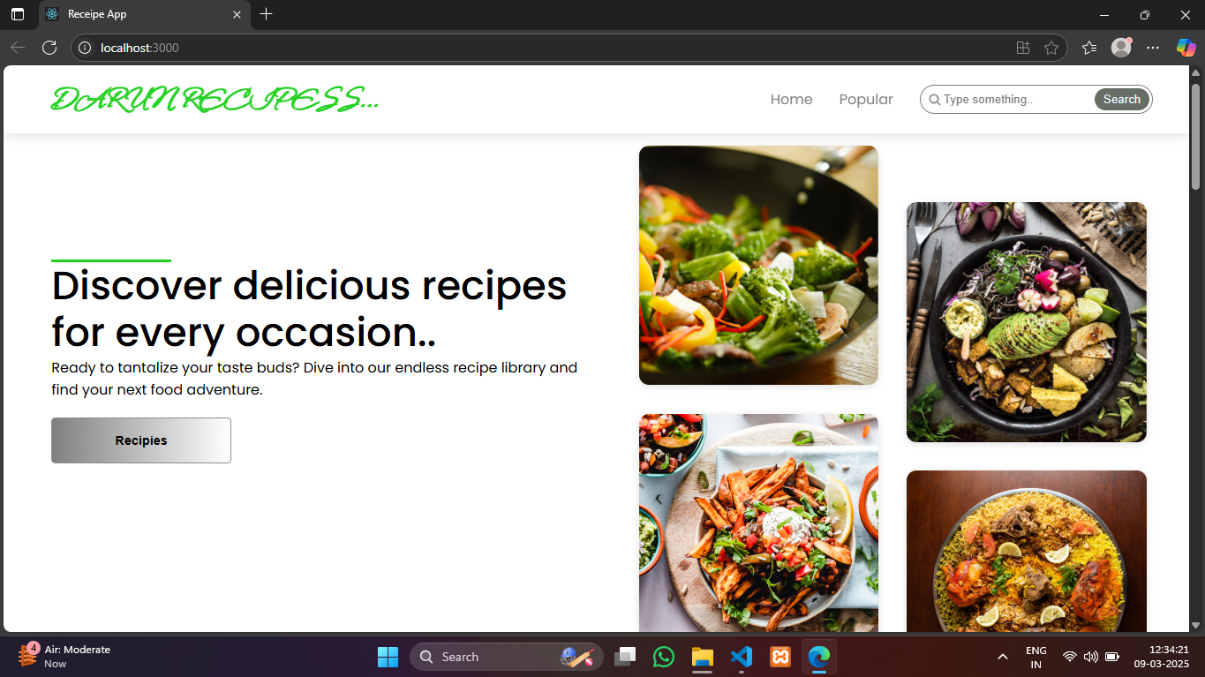

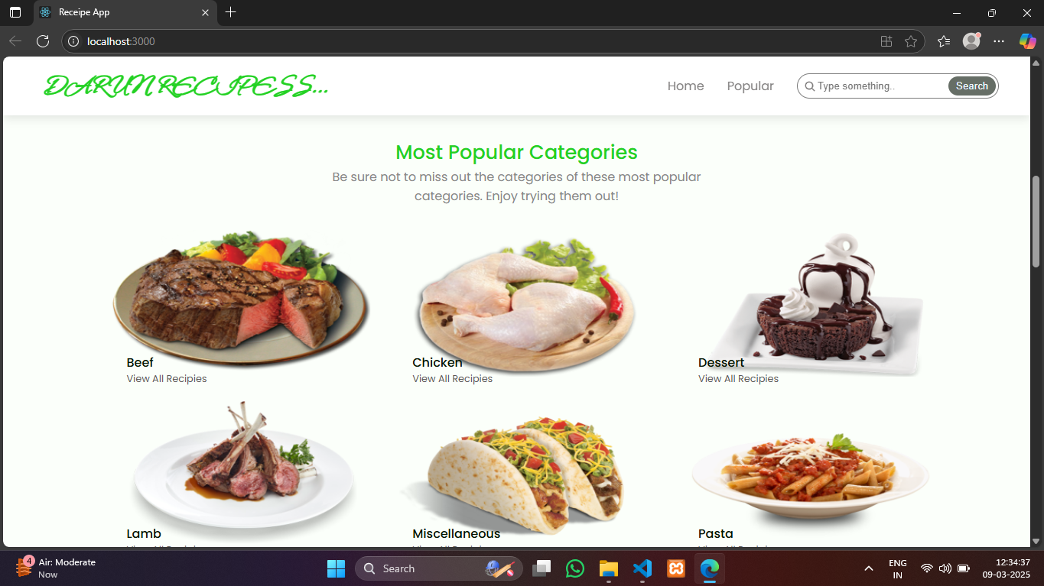

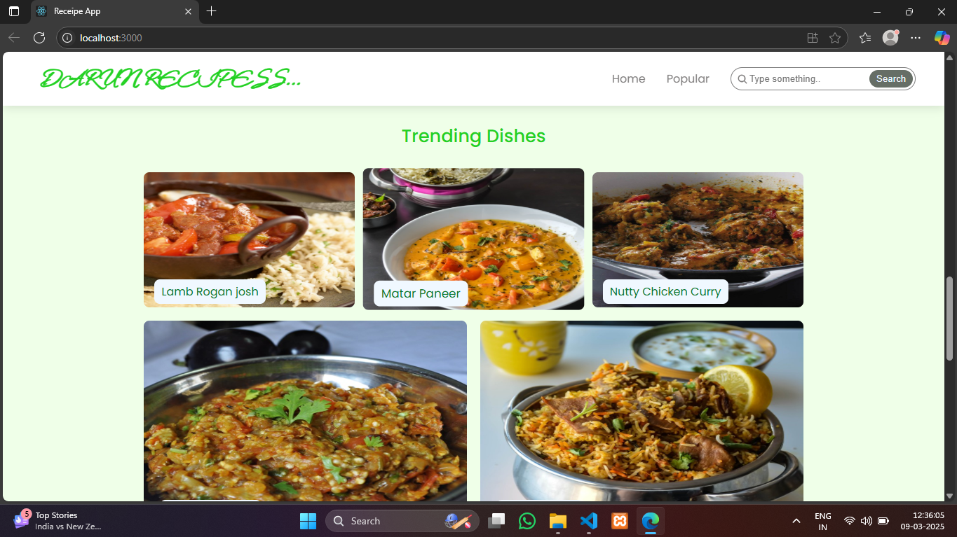

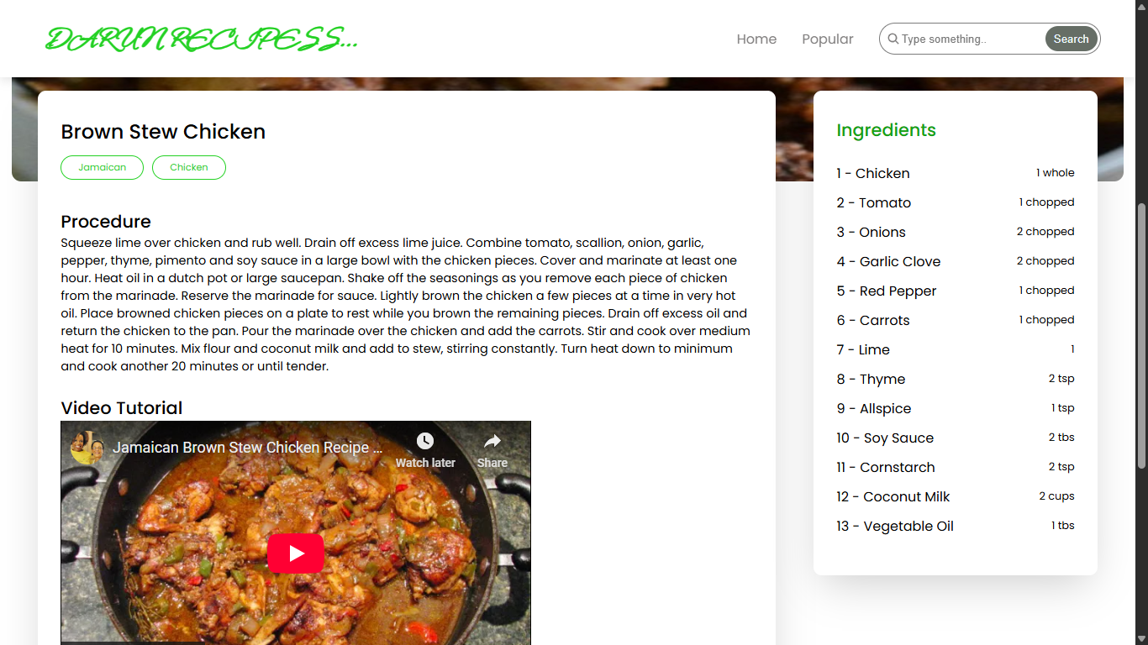

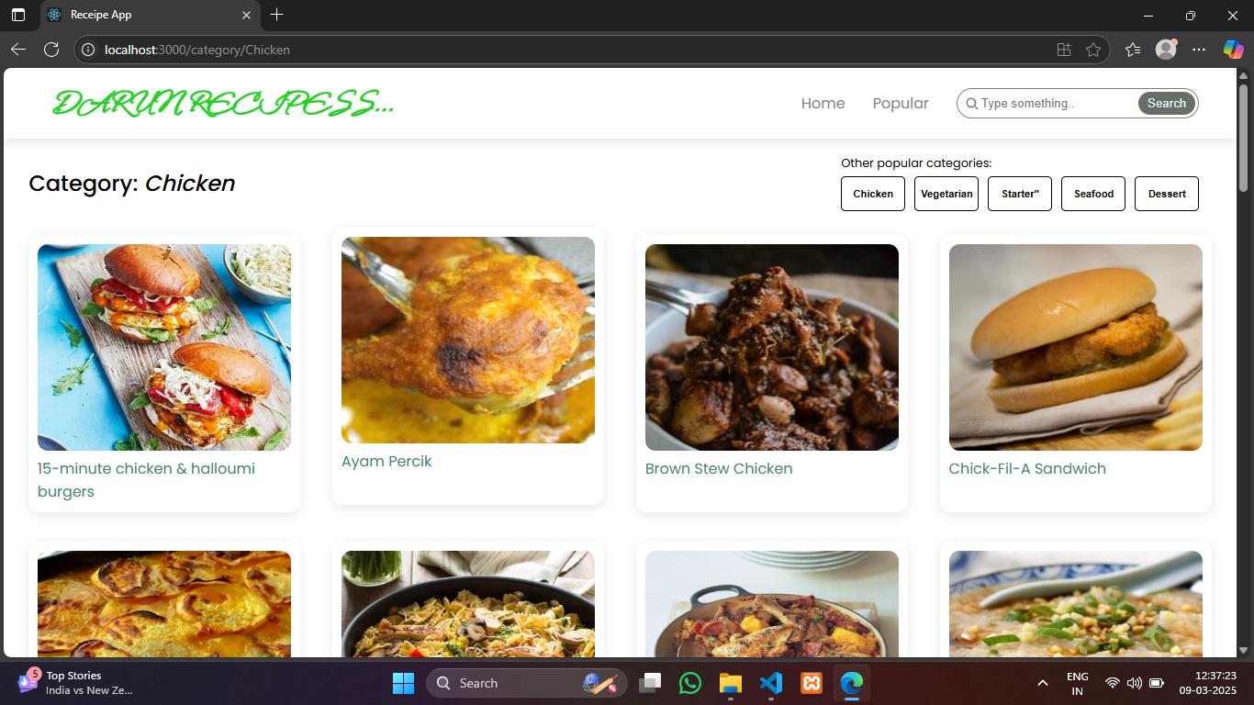

**Link:https://drive.google.com/drive/folders/1KvnCM_ZwoHkmzSMjtON4L2VY5rRwEVBI?usp=sharing**

## 13. Known Issues

- Certain API endpoints may experience delays during peak traffic

- Ingredient checklist feature may require further optimization

## 14. Future Enhancements

- AI-Based Recipe Suggestions

- User Authentication for personalized recipe collections

- Integration with Grocery Shopping Platforms

- Offline Mode for accessing saved recipes