Heart Disease UCI
End-to-End MLOps Pipeline
Project Report
Data → Orchestration → Tracking → Serving → Monitoring

Student name | [ YOUR NAME ]
Student ID | [ YOUR ID ]
Course | AI/ML Cloud — MLOps (AIMLCZG523), Assignment 01
Dataset | UCI Heart Disease (Cleveland) — 303 records × 14 attributes
Repository | [ YOUR GIT REPO URL ]
Demo video | [ YOUR VIDEO LINK ]
Date | [ DD MMM YYYY ]

Table of Contents
1. Introduction and Problem Statement | 3
2. Dataset and Feature Description | 3
3. System Architecture | 3
4. Repository Structure | 4
5. Exploratory Data Analysis (Task 1) | 5
6. Model Development (Task 2) | 5
7. Experiment Tracking with MLflow (Task 3) | 6
8. Packaging and Reproducibility (Task 4) | 7
9. CI/CD and Automated Testing (Task 5) | 7
10. Containerization (Task 6) | 7
11. Kubernetes Deployment (Task 7) | 8
12. Monitoring and Logging (Task 8) | 8
13. How to Run | 9
14. Results, Limitations and Future Work | 9
Appendix — Screenshot Checklist | 10

1. Introduction and Problem Statement
This project builds a complete, production-style MLOps system around a clinical binary-classification problem: predicting the presence of heart disease from patient attributes in the UCI Cleveland dataset. The emphasis is deliberately on the engineering system around the model — reproducible data preparation, tracked experimentation, a versioned model registry, a served prediction API, automated testing and delivery, containerised packaging, orchestrated deployment, and runtime monitoring — rather than on model accuracy alone.
The target variable is derived from the original multi-class attribute (0–4) and collapsed to a binary label: 0 = no disease, 1 = disease present. The dataset is well balanced (164 negative / 139 positive), so accuracy is a reasonable headline metric, complemented by precision, recall, F1, and ROC-AUC.

2. Dataset and Feature Description
The dataset contains 13 predictor attributes and one target. Features fall into two groups that are treated differently during preprocessing. Numeric features are median-imputed then standardised; categorical/discrete features are most-frequent-imputed then one-hot encoded.
Attribute | Description | Type
age | Age in years | numeric
sex | 1 = male, 0 = female | categorical
cp | Chest pain type (0–3) | categorical
trestbps | Resting blood pressure (mm Hg) | numeric
chol | Serum cholesterol (mg/dl) | numeric
fbs | Fasting blood sugar > 120 mg/dl (1/0) | categorical
restecg | Resting ECG results (0–2) | categorical
thalach | Maximum heart rate achieved | numeric
exang | Exercise-induced angina (1/0) | categorical
oldpeak | ST depression induced by exercise | numeric
slope | Slope of peak exercise ST segment (0–2) | categorical
ca | Major vessels coloured by fluoroscopy (0–4) | categorical
thal | Thalassemia (0–3) | categorical
target | 1 = heart disease present, 0 = absent | label

3. System Architecture
The system is organised as a set of containerised components connected by a clear data and control flow. Figure 1 shows the full pipeline: raw data is pulled from the UCI source and processed by a Prefect-orchestrated data pipeline; a training pipeline tunes and evaluates candidate models and registers the best one in MLflow; the FastAPI serving layer (with an optional dedicated model service) exposes predictions; Prometheus and Grafana provide monitoring; and a Streamlit dashboard gives an operational view. Docker Compose and Kubernetes wrap the whole system.
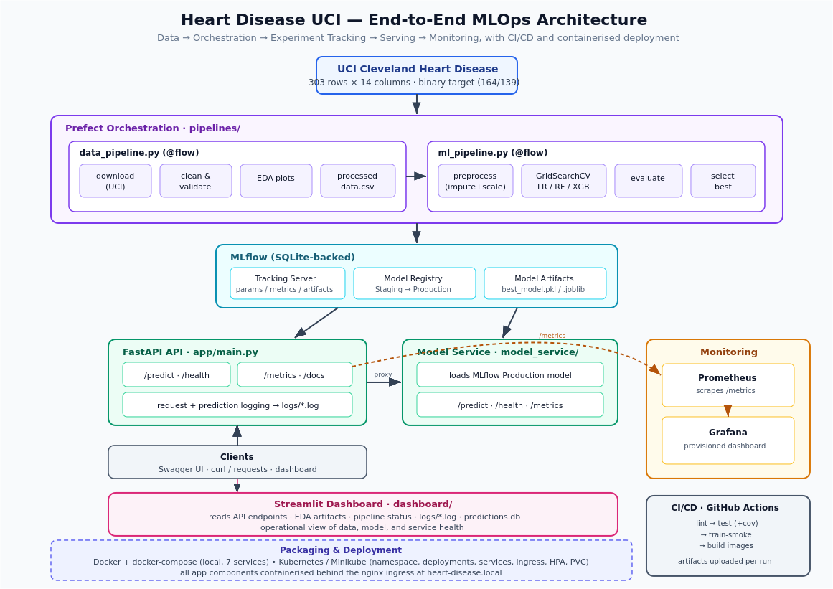
Figure 1. End-to-end MLOps architecture (data → orchestration → tracking → serving → monitoring).

4. Repository Structure
The repository is organised by concern, keeping pipelines, serving, monitoring, and deployment cleanly separated:
aiml_assignment/
|- app/ FastAPI serving app (main.py, schemas.py)
|- model_service/ Dedicated inference service (MLflow Production model)
|- pipelines/ Prefect flows: data_pipeline.py, ml_pipeline.py
|- dashboard/ Streamlit operational dashboard
|- tests/ pytest: data + model-code unit tests
|- monitoring/ Prometheus config + Grafana provisioning & dashboard
|- k8s/ Kubernetes manifests (deploy, svc, ingress, hpa, pvc)
|- scripts/ deploy_minikube.sh
|- docs/ architecture.svg
|- artifacts/ EDA outputs, processed data, pipeline_status.json
|- models/ best_model.pkl, model.joblib
|- .github/workflows/ci.yml CI/CD pipeline
|- Dockerfile API image
|- docker-compose.yml Full local stack (7 services)
|- download_dataset.py Standalone dataset downloader
|- requirements.txt Pinned dependencies
|- REPORT / this document

5. Exploratory Data Analysis (Task 1)
EDA is performed as a Prefect task inside pipelines/data_pipeline.py, and all figures are written to artifacts/eda/. The key analyses and findings are:
- Class balance — the target is close to balanced, so no resampling is applied and accuracy is a fair primary metric.
- Missing values — a few '?' values in ca and thal are treated as NA and handled by imputers rather than row-dropping.
- Univariate distributions — per-feature histograms show age, thalach, chol, and trestbps are approximately continuous, while cp, slope, ca, and thal are discrete.
- Correlation structure — cp, thalach, oldpeak, ca, and thal are among the strongest correlates of the target.
- Bivariate view — pairplots and boxplots show clear class separation on thalach and oldpeak.
Overall, the dataset is clean and balanced, missingness is minimal and imputable, and several features carry clear predictive signal — consistent with the strong ROC-AUC obtained during modelling.
[ SCREENSHOT PLACEHOLDER ]
EDA — Correlation Heatmap
Capture: artifacts/eda/correlation_heatmap.png (the feature correlation heatmap).
Figure 2. EDA — Correlation Heatmap
[ SCREENSHOT PLACEHOLDER ]
EDA — Class Balance
Capture: artifacts/eda/class_balance.png (target class distribution bar chart).
Figure 3. EDA — Class Balance

6. Model Development (Task 2)

6.1 Preprocessing
Preprocessing is a single ColumnTransformer wrapped with each estimator into a scikit-learn Pipeline. This guarantees that the exact same transformation is applied at training and inference — the fitted preprocessor travels with the model in the serialized pipeline, eliminating training/serving skew.

6.2 Models and Hyperparameter Search
Three candidate models — Logistic Regression, Random Forest, and XGBoost — are trained and tuned with GridSearchCV (5-fold cross-validation, scoring on F1). A stratified 70/30 train/test split is used, giving a held-out test set of 91 records (49 negative, 42 positive).

6.3 Results
All metrics below are computed on the held-out test set:
Model | Accuracy | Precision (1) | Recall (1) | F1 (1) | ROC-AUC
Logistic Regression | 0.86 | 0.82 | 0.88 | 0.85 | 0.94
Random Forest | 0.82 | 0.78 | 0.86 | 0.82 | —
XGBoost | 0.80 | 0.79 | 0.79 | 0.79 | —

Best model: Logistic Regression — selected automatically by highest F1 (0.851) with ROC-AUC 0.943 (recorded in artifacts/pipeline_status.json). It is persisted to models/best_model.pkl and models/model.joblib and registered in MLflow. With only ~300 rows and largely linear clinical signals, a regularised linear model generalises better than the higher-variance tree ensembles. The 0.88 recall on the positive class is clinically desirable — the model misses relatively few true heart-disease cases.
[ SCREENSHOT PLACEHOLDER ]
Model — Confusion Matrix (Logistic Regression)
Capture: artifacts/eda/confusion_matrix_logisticregression.png.
Figure 4. Model — Confusion Matrix (Logistic Regression)
[ SCREENSHOT PLACEHOLDER ]
Model — ROC Curve (Logistic Regression)
Capture: artifacts/eda/roc_curve_logisticregression.png.
Figure 5. Model — ROC Curve (Logistic Regression)

7. Experiment Tracking with MLflow (Task 3)
Every training run logs to MLflow from pipelines/ml_pipeline.py:
- Parameters — model type and the best hyperparameters from GridSearchCV.
- Metrics — accuracy, precision, recall, F1, and ROC-AUC.
- Artifacts — the serialized pipeline plus EDA and evaluation plots.
- Model registry — the best pipeline is registered under HeartDiseaseUCIModel and promoted to the Production stage, which the model service loads.
MLflow is configured with a SQLite backend store (sqlite:///mlruns/mlflow.db), which is required for the model-registry features (stage transitions and aliases) to function.
[ SCREENSHOT PLACEHOLDER ]
MLflow — Experiment Runs
Capture: MLflow UI: the runs comparison showing the three models and their metrics.
Figure 6. MLflow — Experiment Runs
[ SCREENSHOT PLACEHOLDER ]
MLflow — Model Registry
Capture: MLflow UI: HeartDiseaseUCIModel with a version in the Production stage.
Figure 7. MLflow — Model Registry

8. Packaging and Reproducibility (Task 4)
Dependencies are fully pinned in requirements.txt. This is not cosmetic: the committed model artifacts were serialized with scikit-learn 1.7.2 / numpy 1.26.4 / pandas 2.2.3 (confirmed from the MLflow run metadata). A model pickle can only be reloaded safely by a compatible scikit-learn version, so these pins are what allow the committed model to deserialize in a fresh container without retraining. If the model is retrained under a different scikit-learn, the pin is bumped to match.
The pins are grouped by concern (core ML stack, tracking/orchestration, API, monitoring, dashboard, testing) so the file is self-documenting. A standalone download_dataset.py provides an argument-driven way to fetch and clean the dataset independently of the orchestrated flow.

9. CI/CD and Automated Testing (Task 5)
CI/CD is implemented in .github/workflows/ci.yml as a staged pipeline:
- lint — flake8 fails on real errors and produces a non-blocking style report.
- test — pytest with coverage; the coverage report is uploaded as a build artifact.
- train-smoke — trains the models on the committed dataset using a SQLite MLflow store (fully offline) and asserts a model artifact is produced; the trained model is uploaded as an artifact.
- validate-fastapi-imports — imports the FastAPI app to catch import-time breakage.
- build-and-package — builds the API and model-service Docker images, saves them as artifacts, and optionally pushes to a registry when credentials are configured.
Tests cover both required layers. The data-processing test mocks the network so CI is deterministic and never depends on the UCI archive being reachable. The model-code test verifies that the preprocessing transformer preserves all rows, imputes missing values, and standardises numeric features, and that the evaluation function returns bounded, well-formed metrics.
[ SCREENSHOT PLACEHOLDER ]
CI/CD — GitHub Actions Run
Capture: GitHub Actions: a completed pipeline run with all jobs green.
Figure 8. CI/CD — GitHub Actions Run

10. Containerization (Task 6)
The application is containerised with a Dockerfile (API) and model_service/Dockerfile, and the entire system is orchestrated by docker-compose.yml, which brings up seven services:
Service | Purpose | Port
api | FastAPI prediction API | 8000
model-service | MLflow Production model server | 8001
prefect | Prefect orchestration server | 4200
mlflow | MLflow tracking + registry (SQLite) | 5010 → 5000
prometheus | Metrics scraping | 9090
grafana | Dashboards | 3000
dashboard | Streamlit operational UI | 8501

[ SCREENSHOT PLACEHOLDER ]
Docker — Running Services
Capture: terminal output of `docker compose ps` showing all services up.
Figure 9. Docker — Running Services

11. Kubernetes Deployment (Task 7)
Kubernetes manifests in k8s/ deploy the stack to a local Minikube cluster:
- namespace + configmap — isolate resources in the heart-disease namespace with shared environment configuration.
- deployment — three Deployments (api with 2 replicas, model-service, dashboard) with liveness/readiness probes and resource requests/limits. The api Deployment mounts a PersistentVolumeClaim at /workspace/logs for durable request/prediction logs.
- service + ingress — expose the API at / and the dashboard at /dashboard on heart-disease.local via nginx ingress.
- hpa — Horizontal Pod Autoscaler on the API (1–3 replicas, target 70% CPU).
Deployment is a single command — bash scripts/deploy_minikube.sh — which builds all three images inside Minikube's Docker daemon, enables the ingress and metrics-server addons, applies every manifest, waits for rollouts, and prints the access URLs.
[ SCREENSHOT PLACEHOLDER ]
Kubernetes — Cluster State
Capture: terminal output of `kubectl get pods,svc,ingress,hpa -n heart-disease`.
Figure 10. Kubernetes — Cluster State
[ SCREENSHOT PLACEHOLDER ]
Kubernetes — Swagger via Ingress
Capture: browser at http://heart-disease.local/docs served through the ingress.
Figure 11. Kubernetes — Swagger via Ingress

12. Monitoring and Logging (Task 8)
Monitoring has two complementary layers. For metrics, both the API and model-service expose Prometheus metrics at /metrics via prometheus-fastapi-instrumentator. Prometheus scrapes them, and Grafana auto-provisions a Prometheus datasource and a dashboard with panels for total requests, request rate, p50/p95/p99 latency, error rate, request rate by endpoint, and requests by status code.
For logging, the API writes structured logs via middleware: every request is logged to logs/api.log and every prediction to logs/prediction.log. These are the exact files the Streamlit dashboard surfaces in its API Logs and Prediction Logs panels, giving an end-to-end operational view.
[ SCREENSHOT PLACEHOLDER ]
Monitoring — Grafana Dashboard
Capture: Grafana: the Heart Disease API monitoring dashboard with live panels.
Figure 12. Monitoring — Grafana Dashboard
[ SCREENSHOT PLACEHOLDER ]
Monitoring — Streamlit Logs
Capture: Streamlit dashboard: the API/prediction logs or prediction-history panel.
Figure 13. Monitoring — Streamlit Logs

13. How to Run
Local stack via Docker Compose:
docker compose up --build
# API / Swagger : http://localhost:8000/docs
# MLflow : http://localhost:5010
# Prometheus : http://localhost:9090
# Grafana : http://localhost:3000 (anonymous viewer)
# Dashboard : http://localhost:8501
Train or refresh the model:
python pipelines/data_pipeline.py # download + EDA + processed data
python pipelines/ml_pipeline.py # train, evaluate, register best model
Kubernetes (Minikube):
bash scripts/deploy_minikube.sh
# then add '<minikube ip> heart-disease.local' to /etc/hosts
Example prediction request:
curl -X POST http://localhost:8000/predict \
-H 'Content-Type: application/json' \
-d '{"age":53,"sex":1,"cp":3,"trestbps":140,"chol":233,"fbs":0,
"restecg":0,"thalach":150,"exang":0,"oldpeak":2.3,
"slope":0,"ca":0,"thal":1}'

14. Results, Limitations and Future Work
Summary. The system delivers an automatically-selected Logistic Regression model (accuracy 0.86, F1 0.85, ROC-AUC 0.943) served through a documented, monitored, containerised API with reproducible training, experiment tracking, CI/CD, and a one-command Kubernetes deployment.
Limitations. The Cleveland dataset is small (303 records), so metrics carry meaningful variance and the model should not be read as clinically validated. The MLflow and Prefect servers run as single instances, and the Grafana dashboard reflects only serving-side telemetry (no data-drift metrics yet).
Future work. Add data-drift and prediction-distribution monitoring; introduce a scheduled retraining trigger via Prefect deployments; extend the test suite toward the API endpoints with a TestClient; and add model explainability (e.g. SHAP) to the dashboard.

Appendix — Screenshot Checklist
Replace each placeholder in this document with your own captured evidence:
- EDA: correlation heatmap and class-balance chart
- Model: confusion matrix and ROC curve (Logistic Regression)
- MLflow: experiment run comparison and model registry (Production)
- CI/CD: GitHub Actions run with all jobs green
- Docker: docker compose ps
- Kubernetes: kubectl get pods,svc,ingress,hpa -n heart-disease
- Ingress: Swagger UI at http://heart-disease.local/docs
- Monitoring: Grafana dashboard and Streamlit logs panel

