 Curriculum Vitae

Naveen Das

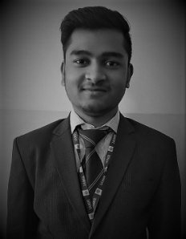

**Add**:- E-717/C,Sec-11, Pratap Vihar,

Ghaziabad UP. 201009

Mobile No:- +91-8448953175

Email: naveendas8900@gmail.com

# Career Objective

To seek an opportunity to contribute my education in a position with a growing and dynamic firm working for the accomplishment of goal set by the firm through constant value addition to self.

Academic Qualification

|  |  |  |  |  |
| --- | --- | --- | --- | --- |
| **Course/ Degree** | **Board/University** | **Stream** | **Passing Year** | **Divison** |
| HIGH SCHOOL | CBSE BOARD | - | 2017 | FIRST |
| INTERMEDIATE | CBSE BOARD | SCIENCE | 2019 | SECOND |
| BCA | CCSU | - | PURSUING  (2019-2022) | - |

Experience Summary

* Fresher

Skills

* C++
* HTML
* CSS
* DIGITAL MARKETING
* SASS
* GITHUB

|  |
| --- |
| Portfolio |

* Click on the link below or Scan the QRcode to visit my portfolio and to see my projects.

<https://naveenhere.github.io/NaveenIsHere.in/> 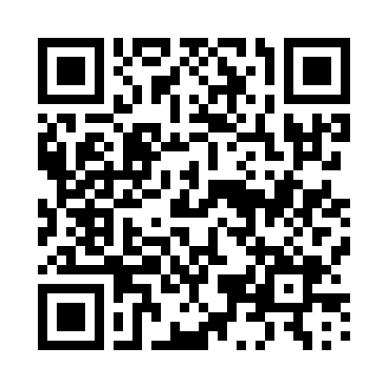

Interests

* Drawing.
* Learning.
* Online Surfing.

Personal Information

* Father’s Name : Lt. Meghnath Das
* Date of birth : 08-08-2000
* Marital Status : Unmarried
* Gender : Male
* Languages Knowledge : Hindi, English, & Bengali
* Nationality : Indian
* Soft Skills : Smart working, Goal Oriented & Innovative.

Declaration

I hereby certify that all the information recorded above is true up to my knowledge and I should be held responsible in any case of incorrectness of the provided information.

Date : ______________

Place : Ghaziabad

*(NAVEEN DAS)*