EX No:1b | EDA DATA CLEANING

AIM

To perform Exploratory Data Analysis (EDA) on the Global Superstore Dataset by examining the dataset structure, dimensions, data types, statistical characteristics, missing values, category-wise and region-wise sales and profit distributions, product-wise sales patterns, temporal sales trends, correlation analysis, and exporting the cleaned dataset for further analysis.

ALGORITHM
- Import the required libraries such as Pandas, NumPy, and Matplotlib.
- Load the Global Superstore Dataset into a Pandas DataFrame.
- Display the first five and last five records of the dataset.
- Display the dataset information, shape, column names, and data types.
- Generate descriptive statistical information for numerical attributes.
- Identify the number of missing values in each column.
- Remove blank rows and duplicate records from the dataset.
- Perform data cleaning and standardization on the required categorical and numerical attributes.
- Convert Order Date and Ship Date into datetime format.
- Analyze sales and profit across different categories.
- Analyze sales and profit across different regions.
- Analyze sales across different markets.
- Analyze sales and profit across different sub-categories.
- Analyze the top products based on sales.
- Analyze sales and profit trends over time using Order Date.
- Calculate and analyze the correlation between numerical attributes.
- Create visualizations for the analyzed data.
- Export the cleaned dataset into CSV, Excel, and JSON formats.
- Display a confirmation message after successful file creation.

CODE
import os
import pandas as pd
import numpy as np
import matplotlib.pyplot as plt
path = "/content/Global_Superstore2(1).csv"

print("Dataset path:", path)
df = pd.read_csv(path, encoding="latin1")
print("\nFirst 5 rows:")
display(df.head())
print("\nLast 5 rows:")
display(df.tail())
print("\nDataset Information:")
df.info()
print("\nDataset Shape:")
print(df.shape)
print("\nColumn Names:")
print(df.columns.tolist())
print("\nData Types:")
print(df.dtypes)
print("\nStatistical Description:")
display(df.describe())
print("\nMissing Values:")
display(df.isnull().sum())
df = df.dropna(how="all")
df = df.drop_duplicates()
print("\nDataset after removing blank rows and duplicates:")
print(df.shape)
df["Order Date"] = pd.to_datetime(
df["Order Date"],
dayfirst=True,
errors="coerce"
)
df["Ship Date"] = pd.to_datetime(
df["Ship Date"],
dayfirst=True,
errors="coerce"
)
print("\nMissing values after date conversion:")
display(df.isnull().sum())
print("\nCategory-wise Sales:")
category_sales = (
df.groupby("Category")["Sales"]
.sum()
.sort_values(ascending=False)
)
display(category_sales)
print("\nCategory-wise Profit:")
category_profit = (
df.groupby("Category")["Profit"]
.sum()
.sort_values(ascending=False)
)
display(category_profit)

print("\nRegion-wise Sales:")
region_sales = (
df.groupby("Region")["Sales"]
.sum()
.sort_values(ascending=False)
)
display(region_sales)
print("\nRegion-wise Profit:")

region_profit = (
df.groupby("Region")["Profit"]
.sum()
.sort_values(ascending=False)
)

display(region_profit)

print("\nMarket-wise Sales:")

market_sales = (
df.groupby("Market")["Sales"]
.sum()
.sort_values(ascending=False)
)

display(market_sales)

print("\nSub-Category-wise Sales:")

subcategory_sales = (
df.groupby("Sub-Category")["Sales"]
.sum()
.sort_values(ascending=False)
)

display(subcategory_sales)

print("\nSub-Category-wise Profit:")

subcategory_profit = (
df.groupby("Sub-Category")["Profit"]
.sum()
.sort_values(ascending=False)
)

display(subcategory_profit)

print("\nTop 10 Products by Sales:")

top_products = (
df.groupby("Product Name")["Sales"]
.sum()
.sort_values(ascending=False)
.head(10)
)

display(top_products)

print("\nSales Trend by Date:")

sales_trend = (
df.groupby("Order Date")["Sales"]
.sum()
.sort_index()
)
display(sales_trend.head())

print("\nProfit Trend by Date:")
profit_trend = (
df.groupby("Order Date")["Profit"]
.sum()
.sort_index()
)
display(profit_trend.head())

print("\nCorrelation Matrix:")

correlation = df.corr(numeric_only=True)
display(correlation)
plt.figure(figsize=(8, 5))
category_sales.plot(kind="bar")

plt.title("Category-wise Sales")
plt.xlabel("Category")
plt.ylabel("Total Sales")
plt.xticks(rotation=0)
plt.show()
plt.figure(figsize=(10, 5))

region_sales.plot(kind="bar")

plt.title("Region-wise Sales")
plt.xlabel("Region")
plt.ylabel("Total Sales")
plt.xticks(rotation=45)
plt.show()
plt.figure(figsize=(10, 5))
subcategory_sales.plot(kind="bar"
plt.title("Sub-Category-wise Sales")
plt.xlabel("Sub-Category")
plt.ylabel("Total Sales")

plt.xticks(rotation=45)
plt.show()
plt.figure(figsize=(12, 5))
plt.plot(
sales_trend.index,
sales_trend.values
)

plt.title("Sales Trend Over Time")
plt.xlabel("Order Date")
plt.ylabel("Sales")

plt.xticks(rotation=45)

plt.show()

plt.figure(figsize=(12, 5))

plt.plot(
profit_trend.index,
profit_trend.values
)

plt.title("Profit Trend Over Time")
plt.xlabel("Order Date")
plt.ylabel("Profit")

plt.xticks(rotation=45)

plt.show()
plt.figure(figsize=(8, 5))
category_profit.plot(kind="bar")
plt.title("Category-wise Profit")
plt.xlabel("Category")
plt.ylabel("Total Profit")

plt.xticks(rotation=0)

plt.show()

df.to_csv(
"Global_Superstore_Cleaned.csv",
index=False
)

df.to_excel(
"Global_Superstore_Cleaned.xlsx",
index=False
)

df.to_json(
"Global_Superstore_Cleaned.json",
orient="records",
indent=4
)

print("\nCSV, Excel and JSON files created successfully.")

OUTPUT

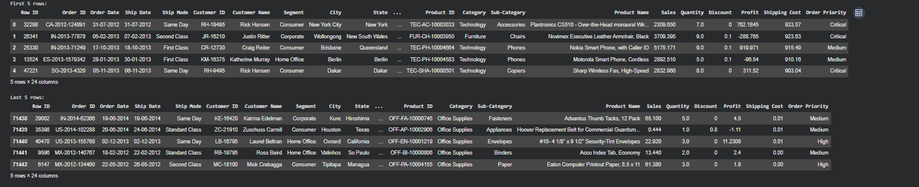

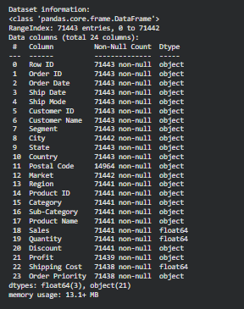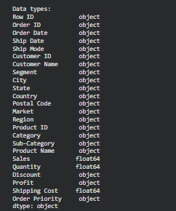

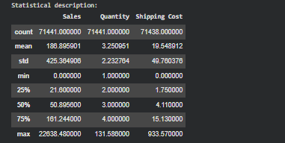

RESULT:

Thus, the Global Superstore Dataset was successfully analyzed using Pandas and NumPy. The dataset structure, dimensions, data types, statistical characteristics, missing values, and profit, sub-category performance, time-based trends, delivery duration, profit margin, and correlations were analyzed successfully.

