Ex.no:2 | EDA-DATA IMPORT AND EXPORT

Aim:
To inspect the features of the Global Superstore Dataset, detect null values and duplicate records, analyze categorical and numerical attributes, and export the dataset into CSV, Excel, JSON, and SQLite database formats.
Algorithm:
- Import Pandas and SQLite libraries.
- Load the Global Superstore CSV dataset.
- Display the first and last five records.
- Display dataset information, shape, columns, data types, and statistics.
- Check missing and duplicate values.
- Analyze Market, Region, and Category-wise sales.
- Calculate Delivery Days and Profit Margin.
- Export the dataset to CSV, Excel, and JSON.
- Store the dataset in a SQLite database.
Program:
import csv
import pandas as pd
import numpy as np
import sqlite3

path="/content/Global_Superstore2(2).csv"
df = pd.read_csv(
path,
encoding="latin1",
engine="python",
sep=",",
on_bad_lines='skip'
)

# Converting appropriate columns to numeric after loading
numeric_columns=[
"Row ID","Postal Code","Sales","Quantity",
"Discount","Profit","Shipping Cost"
]

for col in numeric_columns:
df[col]=pd.to_numeric(df[col],errors="coerce")

print("First 5 rows:")
display(df.head())

print("Last 5 rows:")
display(df.tail())

print("Dataset information:")
df.info()

print("\nShape:")
print(df.shape)

print("\nColumns:")
print(df.columns.tolist())

print("\nData types:")
print(df.dtypes)

print("\nStatistical description:")
display(df.describe())

print("\nMissing values:")
display(df.isnull().sum())

print("\nDuplicate rows:")
print(df.duplicated().sum())

print("\nMarket-wise Sales:")
display(df.groupby("Market")["Sales"].sum().sort_values(ascending=False))

print("\nRegion-wise Sales:")
display(df.groupby("Region")["Sales"].sum().sort_values(ascending=False))

print("\nCategory-wise Sales:")
display(df.groupby("Category")["Sales"].sum().sort_values(ascending=False))

df["Order Date"]=pd.to_datetime(df["Order Date"],errors="coerce")
df["Ship Date"]=pd.to_datetime(df["Ship Date"],errors="coerce")

df["Delivery_Days"]=(df["Ship Date"]-df["Order Date"]).dt.days

print("\nDelivery Days:")
display(df[["Order ID","Order Date","Ship Date","Delivery_Days"]].head())

df["Profit_Margin"]=np.where(
df["Sales"]!=0,
(df["Profit"]/df["Sales"])*100,
0
)

print("\nProfit Margin:")
display(df[["Order ID","Sales","Profit","Profit_Margin"]].head())

df.to_csv("global_superstore_data.csv",index=False)
df.to_excel("global_superstore_data.xlsx",index=False)
df.to_json("global_superstore_data.json",orient="records",indent=4,date_format="iso")

conn=sqlite3.connect("global_superstore.db")
df.to_sql("global_superstore",conn,if_exists="replace",index=False)
conn.close()

print("\nCSV, Excel, JSON and SQLite files created successfully.")

Output:

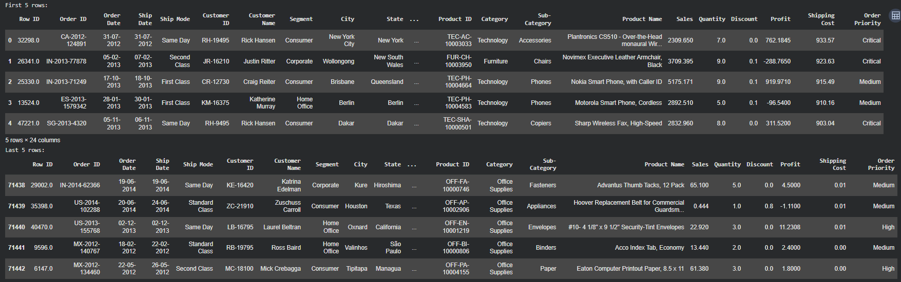

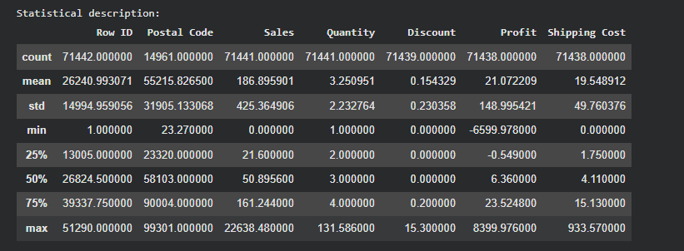
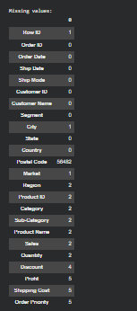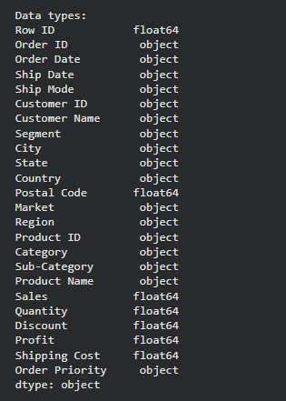
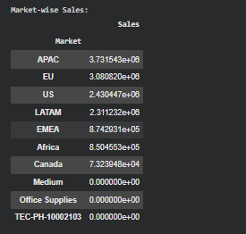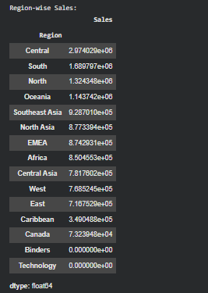

Result:

