Ex.no:5b | DATA VISUALIZATION USING MATPLOTLIB –  SALES DATA

AIM

To visualize and analyze the Global Superstore dataset using Line Chart, Bar Chart, and Pie Chart with Matplotlib to understand sales trends, market-wise comparisons, and category-wise sales distribution.

ALGORITHM

Step 1: Import Pandas and Matplotlib libraries.

Step 2: Load the Global Superstore dataset into a DataFrame.

Step 3: Group the sales data according to year and calculate the total sales for each year.

Step 4: Plot the yearly sales using a Line Chart to observe variations in sales over time.

Step 5: Group the dataset according to market and calculate the total sales for each market.

Step 6: Plot the market-wise sales using a Bar Chart to compare sales across different markets.

Step 7: Select the major product categories and calculate their sales proportions.

Step 8: Plot the category-wise sales distribution using a Pie Chart.

Step 9: Add suitable titles, axis labels, legends, and display the visualizations.

CODE
import csv
import pandas as pd
import matplotlib.pyplot as plt

path="/content/Global_Superstore2(2).csv"

with open(path,"r",encoding="latin1",newline="") as file:
reader=csv.reader(file)
rows=list(reader)

df=pd.DataFrame(rows[1:],columns=rows[0])

df["Sales"]=pd.to_numeric(df["Sales"],errors="coerce")
df["Order Date"]=pd.to_datetime(df["Order Date"],errors="coerce")

year_sales=df.groupby(df["Order Date"].dt.year)["Sales"].sum()

plt.figure(figsize=(10,5))
plt.plot(year_sales.index,year_sales.values,marker="o")
plt.title("Sales by Year")
plt.xlabel("Year")
plt.ylabel("Total Sales")
plt.grid(True)
plt.tight_layout()
plt.show()

market_sales=df.groupby("Market")["Sales"].sum().sort_values(ascending=False)

plt.figure(figsize=(12,6))
plt.bar(market_sales.index,market_sales.values)
plt.title("Sales by Market")
plt.xlabel("Market")
plt.ylabel("Total Sales")
plt.xticks(rotation=45)
plt.tight_layout()
plt.show()

category_sales=df.groupby("Category")["Sales"].sum().sort_values(ascending=False)

plt.figure(figsize=(8,8))
plt.pie(
category_sales.values,
labels=category_sales.index,
autopct="%1.1f%%"
)
plt.title("Sales Distribution by Category")
plt.show()

OUTPUT
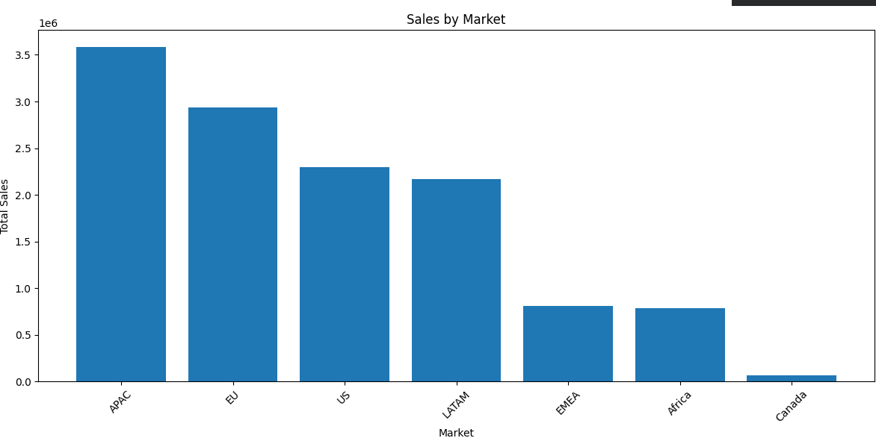
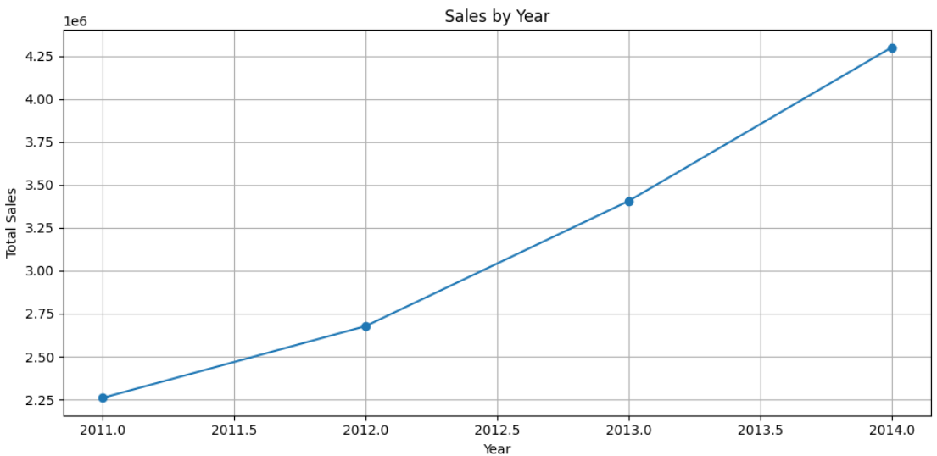

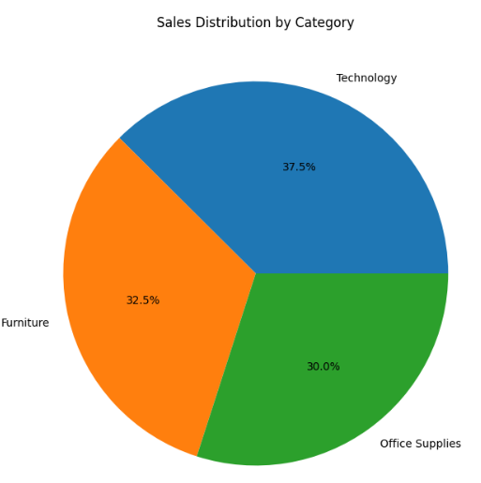

RESULT

