Ex.no:7b | DATA VISUALIZATION USING TABLEAU – GLOBAL SUPERSTORE DATASET

Aim

To connect, analyze, visualize, and create an interactive dashboard using Tableau with the Global Superstore Dataset to analyze sales trends, market-wise sales, category-wise sales, profit, and regional performance.

Software Requirements

• Tableau Desktop / Tableau Public
• Microsoft Excel
• CSV Dataset
• Windows Operating System

Theory

Tableau is a powerful Business Intelligence (BI) and Data Visualization tool used to create interactive dashboards and reports.

The dataset includes:
- Order Date
- Ship Date
- Market
- Region
- Category
- Sub-Category
- Product Name
- Sales
- Quantity
- Discount
- Profit
- Shipping Cost
- Segment
- Ship Mode

Tableau Architecture

Global Superstore Dataset

↓

Data Connection

↓

Worksheets

↓

Visualizations

↓

Dashboard

↓

Story

Learning Outcomes

After completing this experiment, students will be able to:

✓ Connect the Global Superstore Dataset to Tableau

✓ Create worksheets using dimensions and measures

✓ Generate different charts and visualizations

✓ Analyze sales trends over time

✓ Compare sales across markets and regions

✓ Analyze category-wise and sub-category-wise sales distribution

✓ Apply filters and parameters

✓ Create calculated fields

✓ Build interactive dashboards

✓ Create stories for Global Superstore sales analysis

Sample Dataset

Global Superstore Dataset

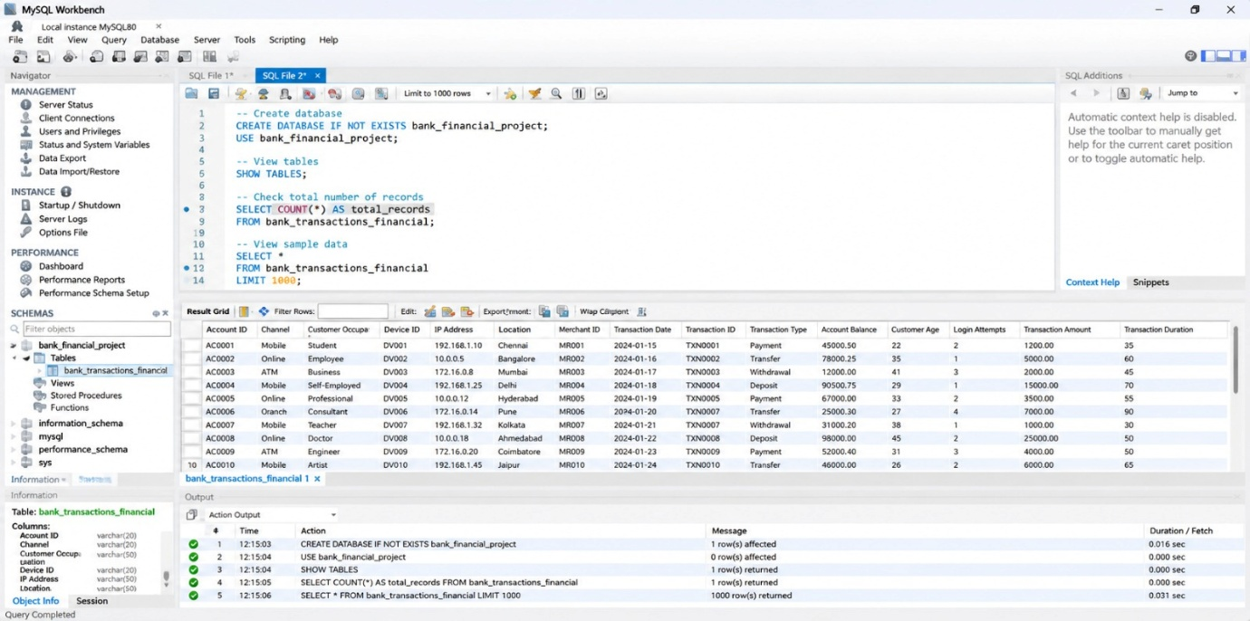

The actual GTD contains a much larger number of records and columns.

Algorithm 1 – Connecting Data Source

Step 1

Open Tableau Desktop.

Step 2

Select Connect.

Step 3

Choose Text File.

Step 4

Browse and select Global_Superstore2(2).csv.

Step 5

Open the dataset.

Step 6

Verify the imported fields such as:
- Order Date
- Ship Date
- Market
- Region
- Category
- Sales
- Quantity
- Profit

Algorithm 2 – Creating Worksheet

Step 1

Open Sheet 1.

Step 2

Drag Market to Rows.

Step 3

Drag Sales to Columns.

Step 4

Select Bar Chart from Show Me.

Step 5

Enable Show Mark Labels.

Step 6

Sort the markets in descending order based on Sales.

Step 7

Add the title Market-wise Sales.

Output

Worksheet created successfully.

Interpretation

The bar chart compares total sales across different markets and identifies the markets generating the highest and lowest sales.

Algorithm 3 – Bar Chart Creation

Objective

To compare sales across different categories.

Step 1

Drag Category → Rows.

Step 2

Drag Sales → Columns.

Step 3

Select Bar Chart from Show Me.

Step 4

Enable Show Mark Labels.

Step 5

Sort the categories in descending order.

Output

Category-wise Sales Bar Chart

Interpretation

The bar chart helps identify categories generating higher and lower sales.

Algorithm 4 – Pie Chart Creation

Objective

To analyze the distribution of sales based on different categories.

Step 1

Drag Category to the view.

Step 2

Select Pie Chart from Show Me.

Step 3

Drag Sales to Angle.

Step 4

Drag Category to Color.

Step 5

Enable Show Labels.

Output

Sales by Category Pie Chart

Interpretation

The pie chart shows the contribution of different categories to total sales.

This follows the same Pie Chart procedure used in the reference file, with Category and Sales replacing Food Item and Waste Amount.

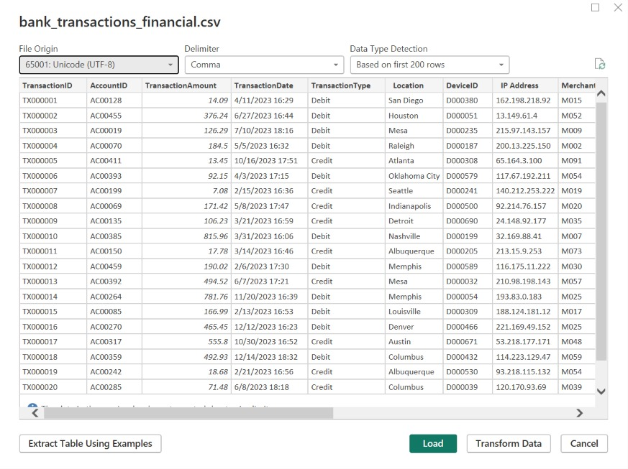

Algorithm 5 – Line Chart Creation

Objective

To analyze the trend of sales over time.

Step 1

Drag Order Date → Columns.

Step 2

Drag Sales → Rows.

Step 3

Select Line Chart.

Step 4

Enable data labels if required.

Step 5

Analyze the sales trend over different dates.

Output

Sales Trend Over Time

Interpretation

The line chart shows how sales change over time and helps identify increasing, decreasing, peak, and low sales periods.

The reference uses the same five-step structure for its time-trend line chart.

Algorithm 6 – Creating Calculated Field

Objective

To calculate the profit margin from sales and profit.

Step 1

Select:

Analysis → Create Calculated Field

Step 2

Enter the field name:

Profit Margin

Step 3

Enter the formula:

([Profit] / [Sales]) * 100

Step 4

Click OK.

Output

Sales Profit Profit Margin

2309.65 762.18 33.00%

3709.40 -288.76 -7.78%

5175.17 919.97 17.78%

Interpretation

The calculated field determines the percentage of sales retained as profit and helps identify profitable and loss-making sales.

The reference creates a calculated field using the same Analysis → Create Calculated Field workflow.

Algorithm 7 – Applying Filters

Objective

To analyze sales for a specific market.

Step 1

Drag Market to the Filters shelf.

Step 2

Select the required market.

Step 3

Click Show Filter.

Step 4

Select a market such as APAC.

Step 5

Observe the updated charts.

Example

Filter: Market = APAC

Output

The visualizations display only sales records belonging to the selected market.

Interpretation

The Market filter allows users to focus on a particular market and perform detailed sales analysis.

Algorithm 8 – Creating Parameter

Objective

To dynamically display products based on a user-defined minimum sales value.

Step 1

Select:

Create Parameter

Step 2

Specify the parameter name:

Minimum Sales

Step 3

Set the data type as:

Float

Step 4

Set the required minimum value.

Step 5

Create a calculated field using the parameter.

Formula

[Sales] >= [Minimum Sales]

Example

Minimum Sales = 10000

Output

The visualization displays records where Sales is greater than or equal to the selected value.

Interpretation

The parameter allows users to dynamically identify high-sales records based on a selected threshold.

This is the direct Global Superstore equivalent of the reference's Minimum Waste Amount parameter.

Algorithm 9 – Dashboard Creation

Objective

To create an interactive Global Superstore Sales Analysis Dashboard.

Step 1

Create multiple worksheets.

Step 2

Select:

Dashboard → New Dashboard

Step 3

Drag the required worksheets into the dashboard.

Step 4

Arrange the charts clearly.

Step 5

Add filters for:
- Market
- Region
- Category
- Sub-Category
- Segment
- Ship Mode

Step 6

Add the Minimum Sales parameter.

Step 7

Add appropriate titles and labels.

Dashboard Analysis

Total Sales

Sum of Sales.

Total Profit

Sum of Profit.

Total Quantity

Sum of Quantity.

Average Discount

Average of Discount.

Interpretation

The dashboard provides a consolidated view of sales, profit, product categories, markets, and sales trends and allows users to interactively analyze the data using filters and parameters.

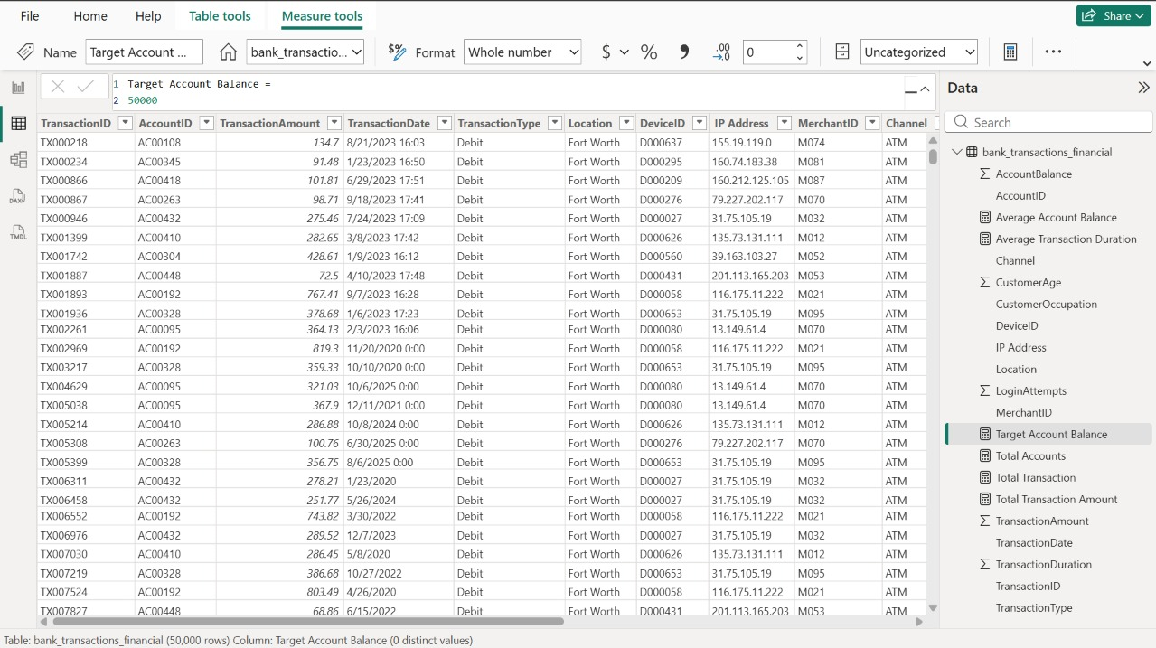

Algorithm 10 – Story Creation

Objective

To present the analysis of sales and business performance through a sequence of visual insights.

Step 1

Create the required worksheets.

Step 2

Create the Global Superstore Sales Analysis Dashboard.

Step 3

Select:

Story → New Story

Step 4

Add the dashboard and required worksheets as story points.

Step 5

Arrange the story points in a logical sequence.

Step 6

Present the findings.

Example Story

Story Point 1 – Overall Sales Analysis

Displays total sales, total profit, total quantity, and average discount.

Story Point 2 – Sales Trend Over Time

Shows how sales change across different dates.

Story Point 3 – Market-wise Sales Analysis

Compares sales generated across different markets.

Story Point 4 – Category-wise Sales Analysis

Shows which categories contribute the most to total sales.

Story Point 5 – Regional Sales Analysis

Compares sales across different regions.

Story Point 6 – Final Sales Analysis

Summarizes the major patterns and observations obtained from the dataset.

This follows the six-story-point structure in the reference.

Example Story

Story Point 1

Overall Sales Analysis

Displays total sales, total profit, total quantity, and average discount.

Story Point 2

Sales Trend Over Time

Shows how sales change across different dates.

Story Point 3

Market-wise Sales Analysis

Compares sales generated across different markets.

Story Point 4

Category-wise Sales Analysis

Shows which categories contribute the most to total sales.

Story Point 5

Region-wise Sales Analysis

Compares sales amounts across different regions.

Story Point 6

Final Sales Analysis

Summarizes the major patterns and observations obtained from the dataset.

Applications

Sales Management

Analysis of sales, profit, quantity, and product performance.

Market Analysis

Identification of markets generating high and low sales.

Demand Planning

Analysis of sales and quantity patterns for better business planning.

Business Intelligence

Interactive visualization and dashboard-based sales analysis.

Decision Making

Identification of high-performing markets, regions, and product categories for better operational planning.

Profitability Analysis

Monitoring profit and identifying opportunities to improve business performance.

Data Analytics

Interactive visualization and exploratory analysis of Global Superstore sales patterns.

Result

