Ex.no:6b | DATA VISUALIZATION USING POWER BI

AIM

To visualize and analyze the Global Superstore dataset using Line Chart, Bar Chart, and Pie Chart to understand sales trends, market-wise comparisons, and category-wise sales distribution.

ALGORITHM

Step 1: Import Pandas and Matplotlib libraries.

Step 2: Load the Global Superstore dataset into a DataFrame.

Step 3: Group the sales data according to Year and calculate the total sales for each year.

Step 4: Plot the yearly sales using a Line Chart to observe variations in sales across different years.

Step 5: Group the dataset according to Market and calculate the total sales for each market.

Step 6: Plot the market-wise sales using a Bar Chart to compare sales across different markets.

Step 7: Select the major Category categories and calculate their sales proportions.

Step 8: Plot the category-wise sales distribution using a Pie Chart.

Step 9: Add suitable titles, axis labels, legends, and display the visualizations.

CODE
import pandas as pd
import matplotlib.pyplot as plt

df=pd.read_csv(
"/content/Global_Superstore2(2).csv",
encoding="latin1",
low_memory=False
)
year_sales=df.groupby(
pd.to_datetime(df["Order Date"]).dt.year
)["Sales"].sum()
plt.figure(figsize=(10,5))
plt.plot(
year_sales.index,
year_sales.values
)
plt.title("Sales by Year")
plt.xlabel("Year")
plt.ylabel("Total Sales")
plt.xticks(rotation=45)
plt.grid(True)
plt.tight_layout()
plt.show()
market_sales=df.groupby(
"Market"
)["Sales"].sum()
plt.figure(figsize=(12,6))
plt.bar(
market_sales.index,
market_sales.values
)
plt.title("Sales by Market")
plt.xlabel("Market")
plt.ylabel("Total Sales")
plt.xticks(rotation=45,ha="right")
plt.tight_layout()
plt.show()
category_sales=df.groupby(
"Category"
)["Sales"].sum()
top_categories=category_sales.sort_values(
ascending=False
).head(3)
plt.figure(figsize=(8,8))
plt.pie(
top_categories.values,
labels=top_categories.index,
autopct="%1.1f%%"
)
plt.title("Top 3 Categories by Sales")
plt.show()

OUTPUT

LINE CHART
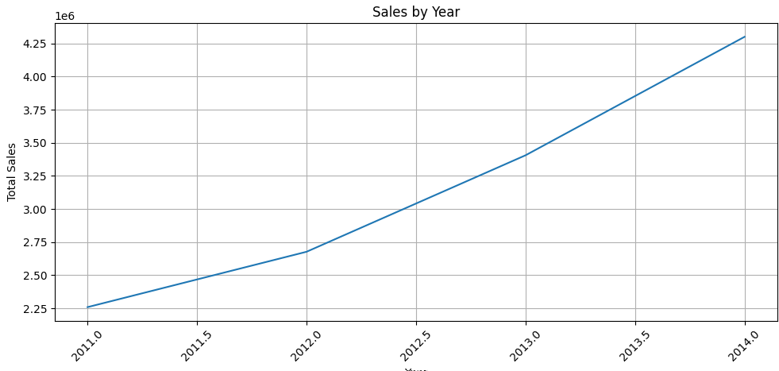

BAR CHART
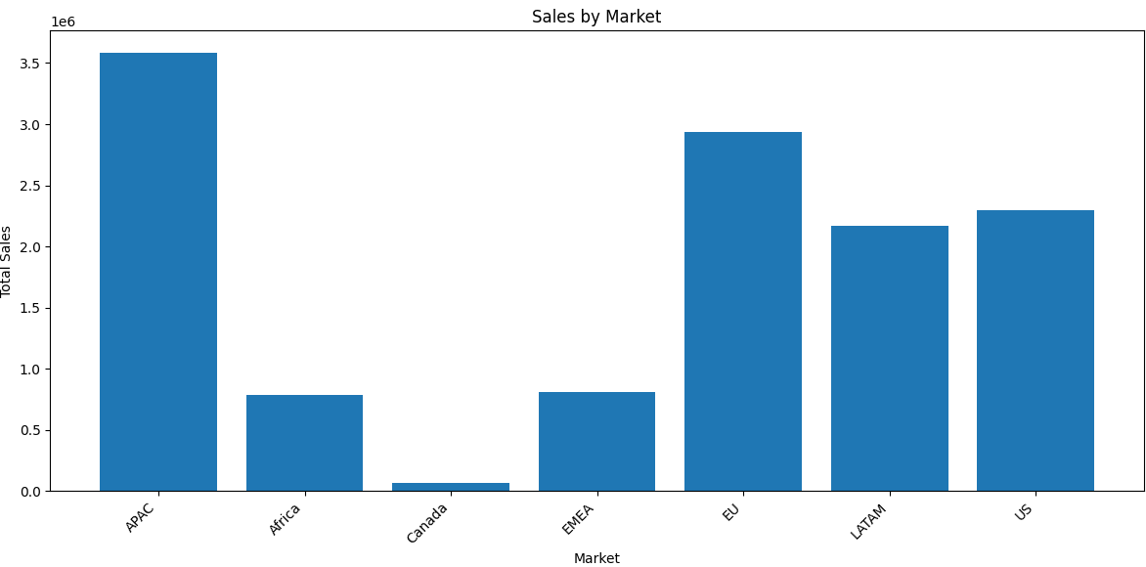
PIE CHART
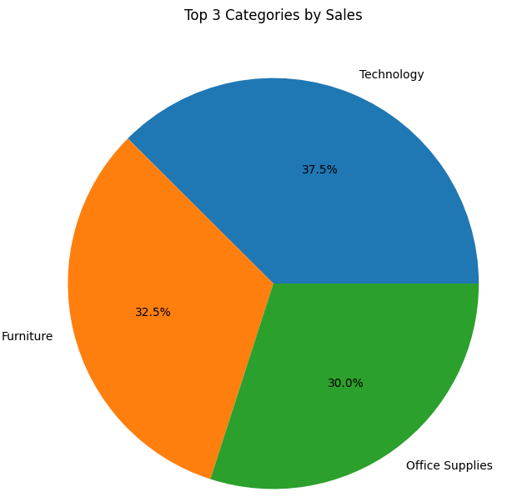

RESULT

