Ex.no:4b | EXPLORATORY DATA ANALYSIS (EDA) – DATA INSPECTION, FILTERING, STATISTICAL ANALYSIS AND CORRELATION

AIM

To perform data inspection, filtering, sorting, grouping, aggregation, descriptive statistical analysis, and correlation analysis on the Global Superstore dataset using Pandas and to visualize the analytical results using Matplotlib.

ALGORITHM
Algorithm 1: Dataset Inspection
- Import the Global Superstore dataset.
- Display the first few records of the dataset.
- Check the dimensions of the dataset.
- Display the data types of the attributes.
- Generate a statistical summary of the numerical attributes.
Algorithm 2: Filtering Data
- Select the required attribute such as Sales or Quantity.
- Specify a suitable filtering condition.
- Apply the condition to the dataset.
- Display the filtered records.
Algorithm 3: Sorting Data
- Select the attribute to be sorted such as Sales or Profit.
- Apply the sort_values() function.
- Specify the sorting order.
- Display the sorted dataset.
Algorithm 4: Statistical Analysis
- Select the required numerical attribute such as Sales.
- Calculate the mean.
- Calculate the median.
- Calculate the mode.
- Calculate the standard deviation.
- Display the calculated statistical measures.
Algorithm 5: Grouping and Aggregation
- Select a categorical attribute such as Market, Region, or Category.
- Apply the groupby() function.
- Select the required numerical attribute such as Sales or Profit.
- Calculate an aggregate measure such as mean or sum.
- Display the grouped results.
Algorithm 6: Correlation Analysis
- Select the required numerical attributes such as Sales, Quantity, Discount, Profit, and Shipping Cost.
- Apply the corr() function.
- Generate the correlation matrix.
- Analyze the correlation coefficient between the selected attributes.
- Visualize the relationship using an appropriate graph.

CODE
import csv
import pandas as pd
import numpy as np
import matplotlib.pyplot as plt
import seaborn as sns
path="/content/Global_Superstore2(2).csv"
with open(path,"r",encoding="latin1",newline="") as file:
reader=csv.reader(file)
rows=list(reader)
df=pd.DataFrame(rows[1:],columns=rows[0])
numeric=["Row ID","Postal Code","Sales","Quantity","Discount","Profit","Shipping Cost"]
for col in numeric:
df[col]=pd.to_numeric(df[col],errors="coerce")
print("Dataset Loaded Successfully")
print("\nFirst 5 Records")
print(df.head())

print("\nLast 5 Records")
print(df.tail())
print("\nShape of Dataset")
print(df.shape)
print("Rows =",df.shape[0])
print("Columns =",df.shape[1])
print("\nData Types")
print(df.dtypes)
print("\nDataset Info")
df.info()
high_sales=df[df["Sales"]>10000]
print("\nRecords with Sales Greater Than 10000")
print(high_sales[["Order ID","Product Name","Category","Sales","Profit"]].head(10))
high_quantity=df[df["Quantity"]>10]
print("\nRecords with Quantity Greater Than 10")
print(high_quantity[["Order ID","Product Name","Quantity","Sales","Profit"]].head(10))
sorted_df=df.sort_values(by="Sales",ascending=False)
print("\nTop Records by Sales")
print(sorted_df[["Order ID","Product Name","Category","Sales","Profit"]].head(10))
top10=sorted_df.head(10)
plt.figure(figsize=(10,5))
plt.bar(range(len(top10)),top10["Sales"])
plt.xticks(range(len(top10)),top10["Product Name"],rotation=90)
plt.xlabel("Product")
plt.ylabel("Sales")
plt.title("Top 10 Products by Sales")
plt.tight_layout()
plt.show()
print("\nMean Sales =")
print(df["Sales"].mean())
print("\nMedian Sales =")
print(df["Sales"].median())
print("\nMode Sales =")
print(df["Sales"].mode().head())
print("\nStandard Deviation =")
print(df["Sales"].std())
print("\nMinimum Sales =")
print(df["Sales"].min())
print("\nMaximum Sales =")
print(df["Sales"].max())
print("\nDescriptive Statistics")
print(df[["Sales","Quantity","Discount","Profit","Shipping Cost"]].describe())
group=df.groupby("Market")["Sales"].mean().sort_values(ascending=False)
print("\nAverage Sales by Market")
print(group)
group.plot(kind="bar",figsize=(8,5))
plt.xlabel("Market")
plt.ylabel("Average Sales")
plt.title("Average Sales by Market")
plt.xticks(rotation=45)
plt.tight_layout()
plt.show()
summary=df.groupby("Market").agg({
"Sales":"mean",
"Profit":"mean",
"Quantity":"mean"
})
print("\nMarket-wise Aggregation")
print(summary)
numeric_df=df.select_dtypes(include=np.number)
corr=numeric_df.corr()
print("\nCorrelation Matrix")
print(corr)
plt.figure(figsize=(10,7))
sns.heatmap(corr,annot=False,cmap="coolwarm")
plt.title("Global Superstore Correlation Heatmap")
plt.show()
plt.figure(figsize=(7,5))
plt.scatter(df["Quantity"],df["Sales"])
plt.xlabel("Quantity")
plt.ylabel("Sales")
plt.title("Quantity vs Sales")
plt.show()
plt.figure(figsize=(7,5))
plt.hist(df["Sales"].dropna(),bins=30)
plt.xlabel("Sales")
plt.ylabel("Frequency")
plt.title("Distribution of Sales")
plt.show()
plt.figure(figsize=(7,5))
sns.boxplot(x=df["Sales"].dropna())
plt.title("Sales Boxplot")
plt.xlabel("Sales")
plt.show()
print("\nCategory Counts")
print(df["Category"].value_counts())
print("\nUnique Markets")
print(df["Market"].unique())
print("\nUnique Regions")
print(df["Region"].unique())
print("\nUnique Categories")
print(df["Category"].unique())
print("\nTop 10 Categories by Sales")
category_sales=df.groupby("Category")["Sales"].sum().sort_values(ascending=False)
print(category_sales.head(10))
print("\nSales by Market")
market_sales=df.groupby("Market")["Sales"].sum().sort_values(ascending=False)
print(market_sales)
print("\nTop 10 Sub-Categories by Sales")
subcategory_sales=df.groupby("Sub-Category")["Sales"].sum().sort_values(ascending=False).head(10)
print(subcategory_sales)
print("\nMost Common Ship Modes")
print(df["Ship Mode"].value_counts())
df.to_csv("global_superstore_eda.csv",index=False)
df.to_excel("global_superstore_eda.xlsx",index=False)
df.to_json("global_superstore_eda.json",orient="records",indent=4)
print("\nCSV, Excel and JSON files exported successfully.")

print("\n==============================================")
print("EXPERIMENT COMPLETED SUCCESSFULLY")
print("==============================================")
print("Dataset Shape :",df.shape)
print("Missing Values :",df.isnull().sum().sum())
print("Total Records :",len(df))
print("Total Sales :",df["Sales"].sum())
print("Total Profit :",df["Profit"].sum())
print("Average Sales :",df["Sales"].mean())
print("Number of Markets :",df["Market"].nunique())
print("Number of Regions :",df["Region"].nunique())
print("Number of Categories :",df["Category"].nunique())
print("Number of Sub-Categories :",df["Sub-Category"].nunique())
print("Correlation Matrix Generated")
print("==============================================")

OUTPUT:
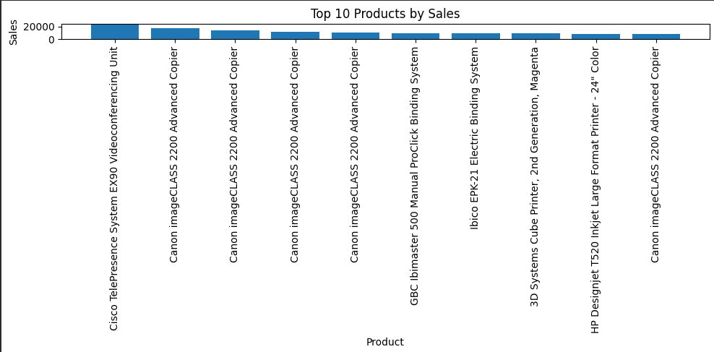
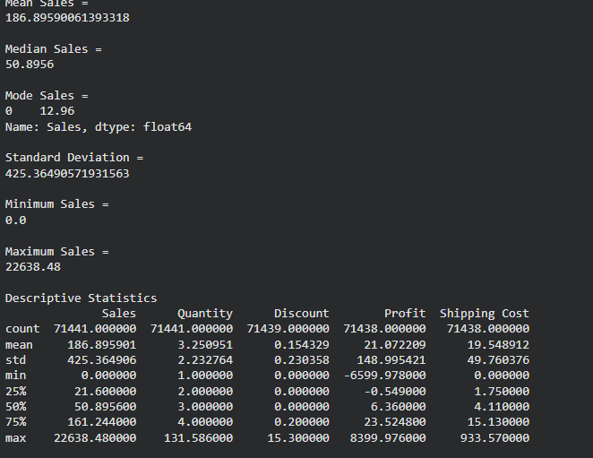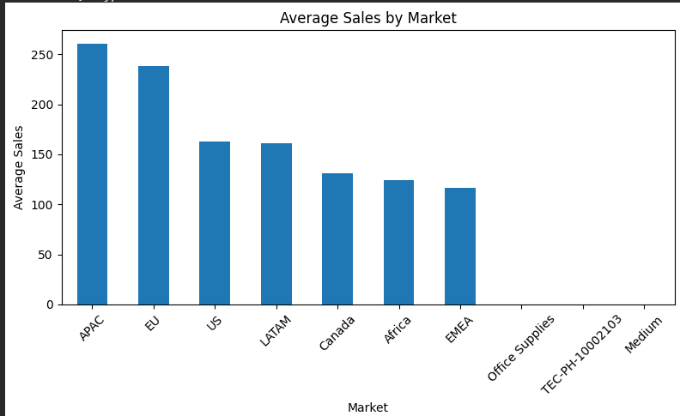

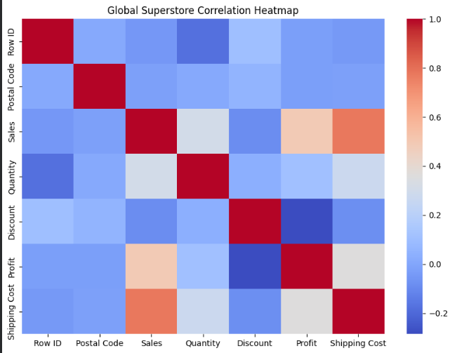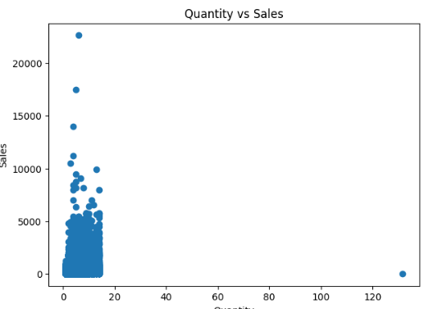

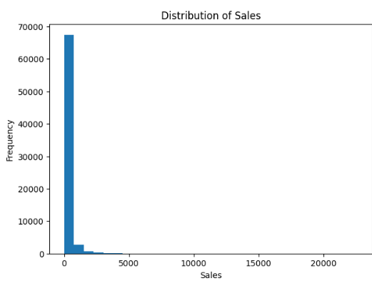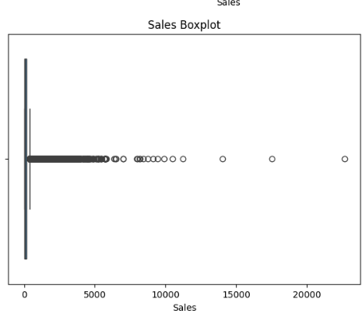

RESULT:

