Ex.no:8 | MINI PROJECT – FINANCIAL DATA ANALYTICS

Aim:

To clean, transform, store, and analyze bank transaction data using Python, MySQL, Power BI, and Tableau to derive meaningful insights into transaction trends, transaction types, transaction channels, customer demographics, account balances, customer occupations, login attempts, and geographical transaction distribution.

Algorithm:

- Load the bank transaction dataset from the CSV file using Pandas.
- Examine the dataset and identify missing values, duplicate records, and incorrect data types.
- Clean the dataset by handling missing values and removing duplicate records.
- Convert the transaction date column into the appropriate date-time format.
- Standardize column names for easier analysis.
- Create useful derived fields such as customer age groups and transaction date components.
- Store the cleaned and transformed dataset in a MySQL database.
- Connect the cleaned dataset to Power BI and Tableau.
- Create measures for total accounts, total transactions, total transaction amount, average account balance, and target account balance.
- Create interactive visualizations for transaction trends, transaction types, transaction channels, customer occupations, geographical distribution, and customer age.
- Create Power BI and Tableau dashboards using cards, charts, slicers, filters, maps, and KPI/gauge visualizations.
- Analyze the dashboards to identify important financial and customer transaction patterns.
- Generate meaningful insights from the analysis.
- • End the process.

Architecture:

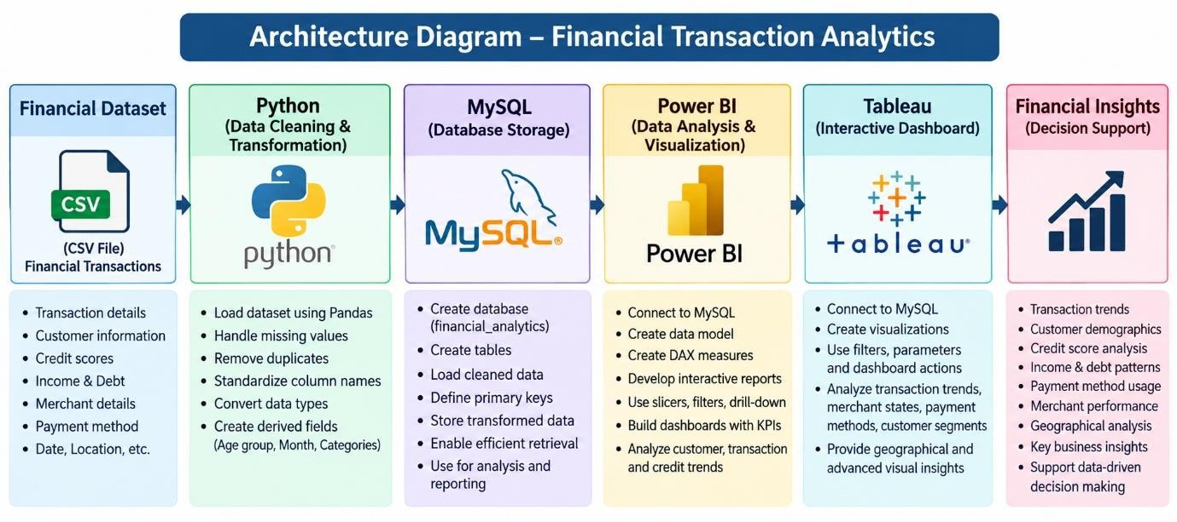

Program:

Python – Data Cleaning & Transformation

import pandas as pd
from sqlalchemy import create_engine

df = pd.read_csv("bank_transactions_financial.csv")

bank = df.copy()

bank.drop_duplicates(inplace=True)

print("Original Shape:", df.shape)
print("After Removing Duplicates:", bank.shape)

print(bank.info())

print(bank.isnull().sum())

# Handle missing values
categorical_columns = [
"Transaction Type",
"Channel",
"Customer Occupation",
"Location",

"Device ID",
"Merchant ID"
]

for col in categorical_columns:
if col in bank.columns:
bank[col] = bank[col].fillna("Unknown")

# Fill numerical missing values

numeric_columns = [
"Account Balance",
"Customer Age",
"Login Attempts",
"Transaction Amount",
"Transaction Duration"
]

for col in numeric_columns:
if col in bank.columns:
bank[col] = bank[col].fillna(bank[col].median())

# Convert date column

bank["Transaction Date"] = pd.to_datetime(
bank["Transaction Date"],
errors="coerce”

# Create transaction year

bank["Transaction Year"] = bank["Transaction Date"].dt.year

# Create transaction month

bank["Transaction Month"] = bank["Transaction Date"].dt.month

# Create age group

bank["Age Group"] = pd.cut(
bank["Customer Age"],
bins=[0, 18, 30, 40, 50, 60, 100],
labels=[
"Below 18",
"18-30",
"31-40",
"41-50",
"51-60",
"60+"])

# Standardize column names

bank.columns = (
bank.columns
.str.lower()
.str.strip()
.str.replace(" ", "_")
)

# Display dataset information

print("Original Shape:", df.shape)
print("Cleaned Shape:", bank.shape)

print(bank.head())

MySQL – Database and Data Loading
MySQL Command Prompt:

net start MySQL80
mysql -u root -p
CREATE DATABASE IF NOT EXISTS bank_transactions_analytics;
USE bank_transactions_analytics;

MySQL
CREATE DATABASE IF NOT EXISTS financial_analytics; USE financial_analytics;

Python/Jupyter
username = "root"
password = "YOUR_MYSQL_PASSWORD"
host = "localhost"
port = 3306

# Connect to MySQL database db_engine = create_engine(
f"mysql+pymysql://{username}:{password}@{host}:{port}/bank_transactions_analytics"
)
# Load cleaned data into MySQL bank.to_sql(
"bank_transactions",
con=db_engine,
if_exists="replace",
index=False,
chunksize=5000
)

print("Data loaded successfully into MySQL.")
#Verify
pd.read_sql(
"SELECT COUNT(*) AS total_rows FROM bank_transactions",
db_engine)
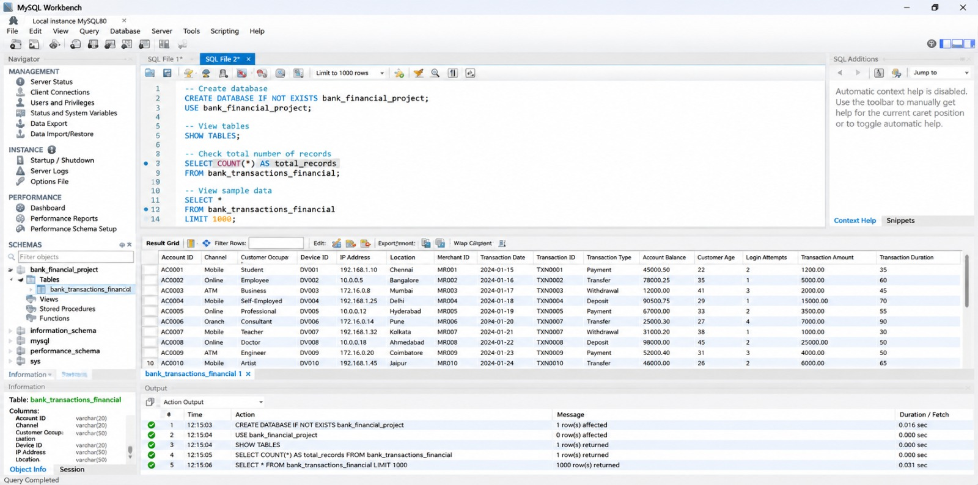

- Power BI – DAX Measures Total Accounts= DISTINCTCOUNT(bank_transactions_financial[Account ID])
Total Transaction =
COUNTROWS(bank_transactions_financial)
Total Transaction Amount =
SUM(bank_transactions_financial[Transaction Amount])
Average Account Balance =
AVERAGE(bank_transactions_financial[Account Balance])
Average Transaction Amount =
AVERAGE(bank_transactions_financial[Transaction Amount])
Average Customer Age =
AVERAGE(bank_transactions_financial[Customer Age])
Average Login Attempts =
AVERAGE(bank_transactions_financial[Login Attempts])

Power Bi Dashboard
Created visuals in Power Bi in separate sheets and created a dashboard

Output:

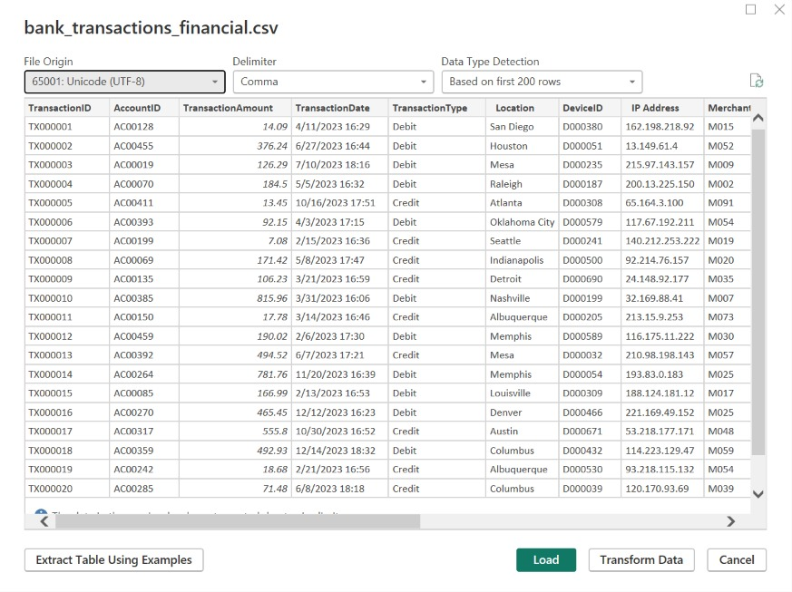

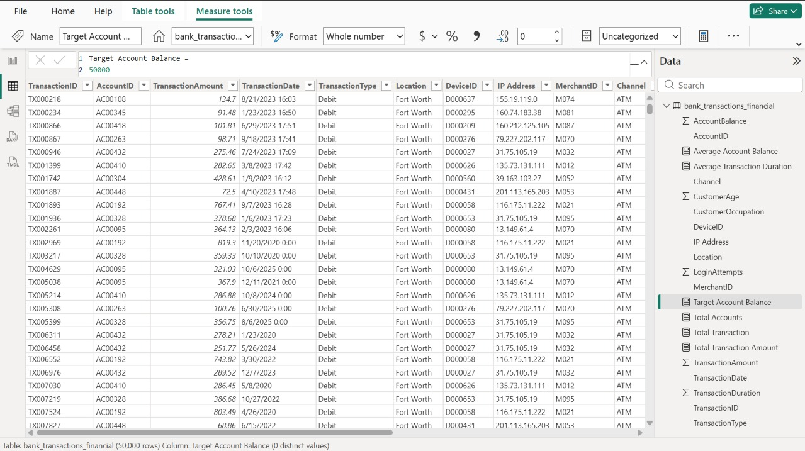

Data Visualization Using Power BI
The financial dataset was imported into Power BI Desktop to create interactive visualizations for analyzing transaction trends, customer demographics, credit scores, debt patterns, and merchant performance.
Visualization 1 — Total Accounts: Card
Displays the total number of accounts in the dataset.
Visualization 2 — Total Transactions: Card
Displays the total number of transactions recorded in the dataset.
Visualization 3 — Average Account Balance: Card
Displays the average account balance across the available customer accounts.
Visualization 4 — Total Transaction Amount: Card
Displays the total monetary value of all transactions.
Visualization 5 — Target Account Balance: Gauge
Shows the account-balance value against the target account-balance measure.
Visualization 6 — Monthly Transaction Trend: Line Chart
Shows the variation in the number of transactions over transaction dates and helps identify transaction activity trends over time.
Visualization 7 — Transaction Type Distribution: Donut Chart
Displays the distribution of transactions according to transaction type.
Visualization 8 — Total Transaction Amount by Channel: Column Chart
Compares the total transaction amount across different transaction channels.
Visualization 9 — Average Account Balance by Occupation: Bar Chart
Compares the average account balance of customers belonging to different occupations.
Visualization 10 — Geographical Transaction Distribution: Map
Displays transaction activity geographically using location and transaction count.
Visualization 11 — Transaction Date Filter: Slicer
Allows the user to filter the dashboard based on transaction date.
Visualization 12 — Transaction Type Filter: Slicer
Allows the user to select a particular transaction type and dynamically filter the dashboard.

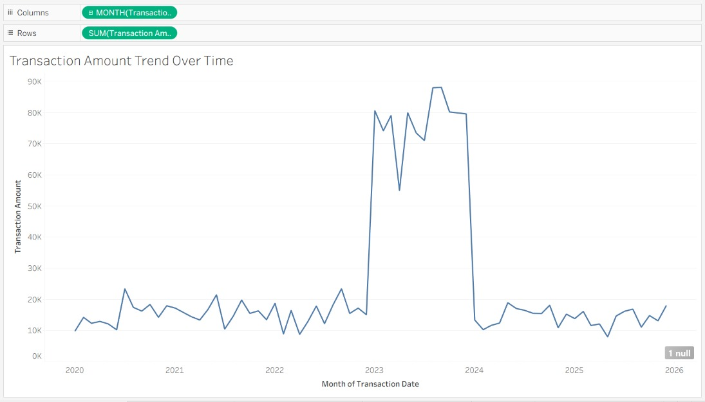

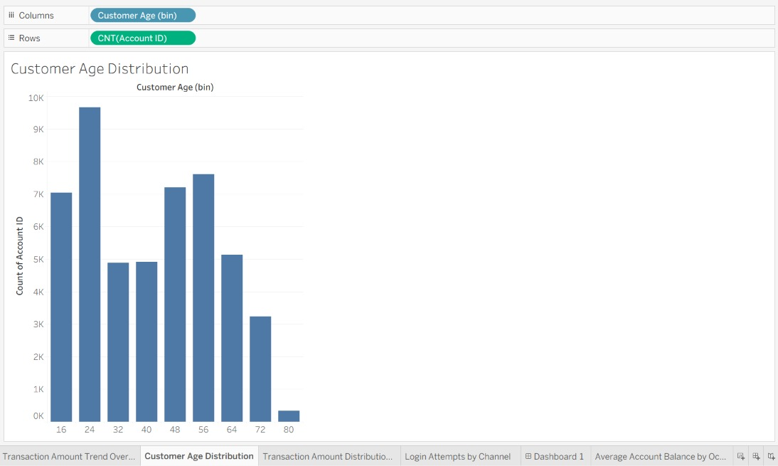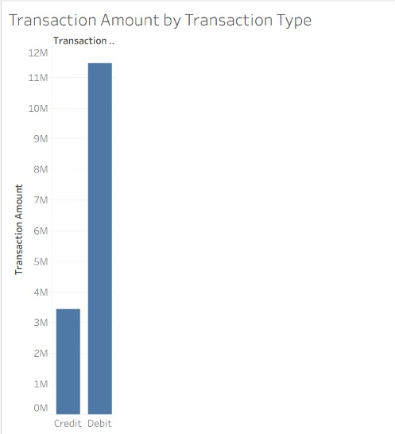
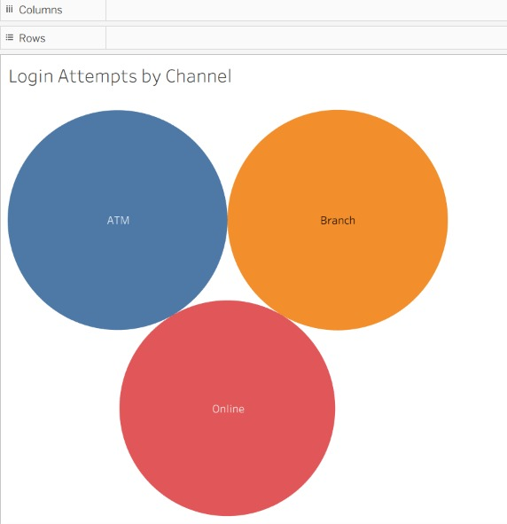

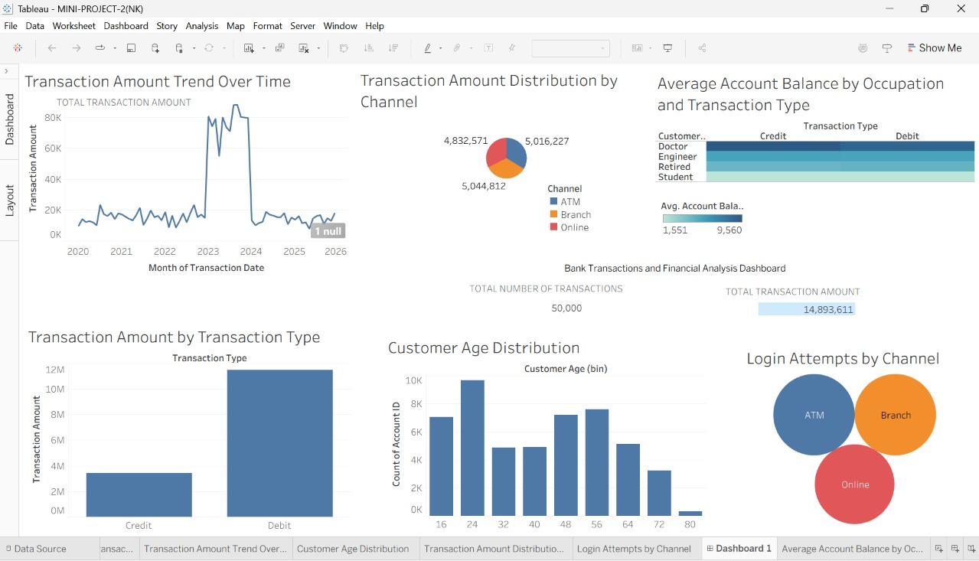
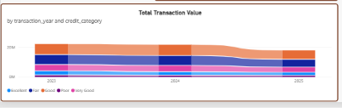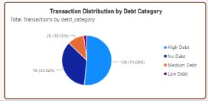

FINANCIAL ANALYSIS POWER BI DASHBOARD

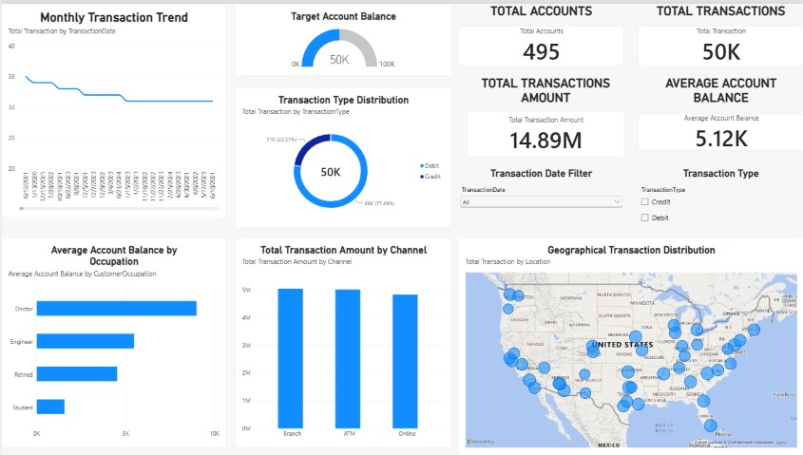

Tableau Dashboard
Created visuals in Tableau in separate sheets and created a dashboard

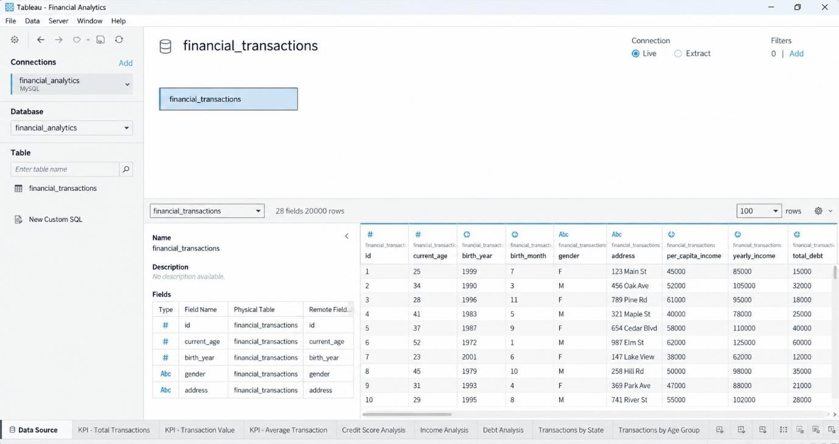

KPI
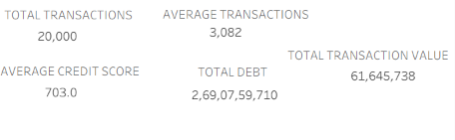

Result:

