9. ReactJS-HOL

App.js
import './App.css';

export const players = [
{ name: 'Rohit Sharma', score: 90 },
{ name: 'Virat Kohli', score: 70 },
{ name: 'MS Dhoni', score: 80 },
{ name: 'Hardik Pandya', score: 60 },
{ name: 'KL Rahul', score: 36 },
{ name: 'Ravindra Jadeja', score: 86 },
{ name: 'Suryakumar Yadav', score: 76 },
{ name: 'Shubmun Gill', score: 35 },
{ name: 'Sheryas Iyer', score: 89 },
{ name: 'Ishan Kisan', score: 83 },
{ name: 'Ruturaj Gaikwad', score: 27 },
{ name: 'Rishab Pant', score: 72 },
{ name: 'Axar Patel', score: 75 },
];
const playersUnder70 = []
const T20Players = ['First Player', 'Second Player', 'Third Player'];
const RanjiTrophyPlayers = ['Fourth Player', 'Fifth Player', 'Sixth Player'];
export const IndianPlayers = [...T20Players, ...RanjiTrophyPlayers];
function App() {

return (
<>
<h1>List Of Players</h1>
<ul>
{players.map((item) => (
<li key={item.name}>
Mr {item.name} <span>{item.score}</span>
</li>
))}
</ul>
</>
)
}

function AppUnder70() {
return (
<>
<h1>List Of Players Under 70</h1>
<ul>
{players.map((item) => {
if(item.score < 70) {
playersUnder70.push(item);
}}
)}
{playersUnder70.map((item) => (
<li key={item.name}>
Mr {item.name} <span>{item.score}</span>
</li>
))}
</ul>
</>
);
}

function OddFunction({ players }) {
const [first, , third, , fifth] = players;

return (
<div>
<h2>Odd Players</h2>
<ul>
<li>{first.name} {first.score}</li>
<li>{third.name} {third.score}</li>
<li>{fifth.name} {fifth.score}</li>
</ul>
</div>
);
}

function EvenFunction({ players }) {
const [, second, , fourth, sixth] = players;

return (
<div>
<h2>Even Players</h2>
<ul>
<li>{second.name} {second.score}</li>
<li>{fourth.name} {fourth.score}</li>
<li>{sixth.name} {sixth.score}</li>
</ul>
</div>
);
}

function DisplayIndianPlayers() {
return (
<div>
<h2>List of Indian Players Merged</h2>
<ul>
{IndianPlayers.map((player, idx) => (
<li key={idx}>{player}</li>
))}
</ul>
</div>
);
}
export default App;
export { App, AppUnder70 };
export { OddFunction };
export { EvenFunction };
export { DisplayIndianPlayers };

Index.js
import React from 'react';
import ReactDOM from 'react-dom/client';
import './index.css';
import App, { AppUnder70, OddFunction,players,EvenFunction, DisplayIndianPlayers } from './App';

const root = ReactDOM.createRoot(document.getElementById('root'));
const showList = false;

if (showList) {
root.render(
<React.StrictMode>
<App />
<AppUnder70 />

</React.StrictMode>
);
}
else{root.render(
<React.StrictMode>

<OddFunction players = {players} />
<EvenFunction players = {players} />
<DisplayIndianPlayers />
</React.StrictMode>
);}

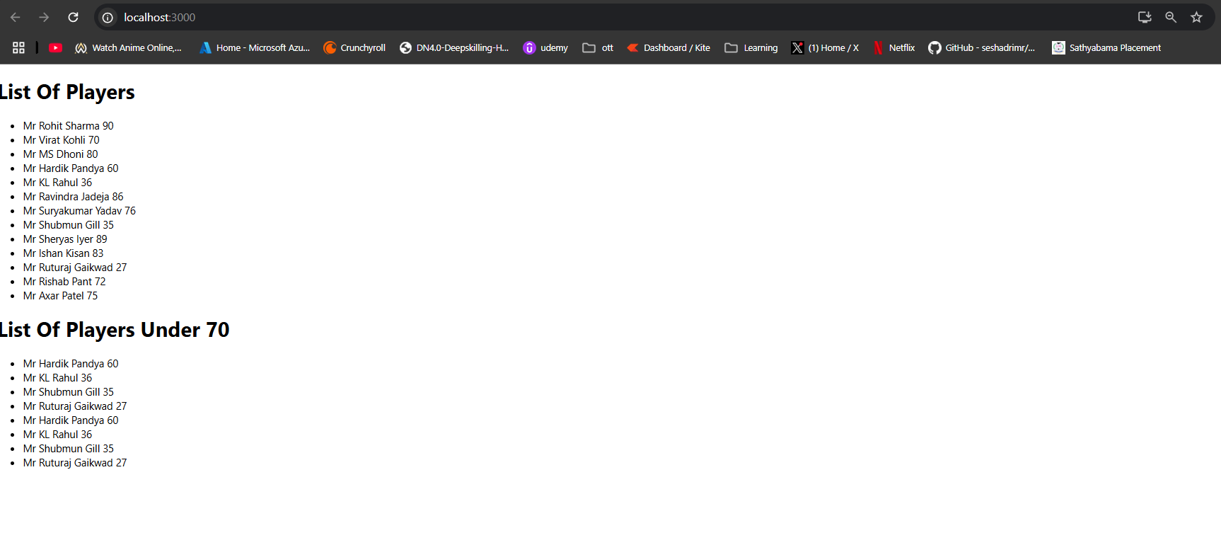
Flag is true
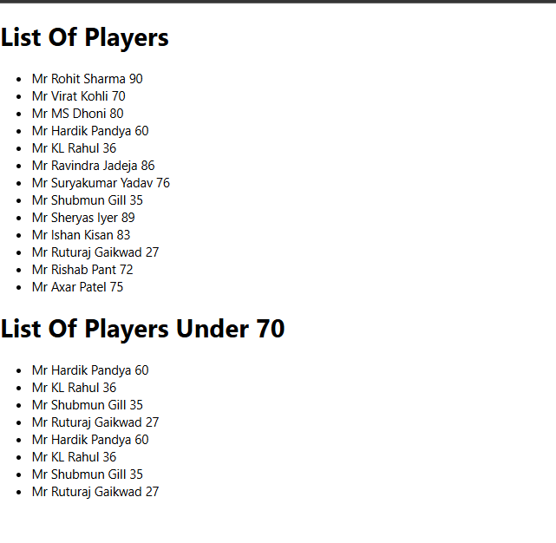
Flag is False
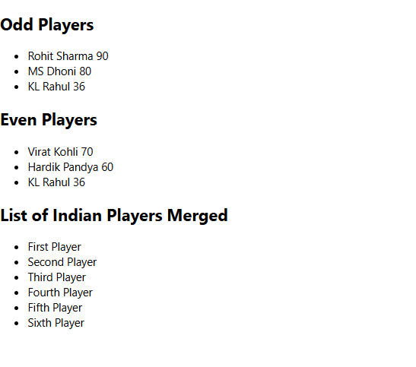

10. ReactJS-HOL
import './App.css';

const heading = "Office Space";
const offices = [
{
Name: "DBS",
Rent: 50000,
Address: "Chennai",
sr: "https://images.unsplash.com/photo-1506744038136-46273834b3fb?auto=format&fit=crop&w=400&q=80"
},
{
Name: "Google",
Rent: 65000,
Address: "Bangalore",
sr: "https://images.unsplash.com/photo-1464983953574-0892a716854b?auto=format&fit=crop&w=400&q=80"
},
{
Name: "Microsoft",
Rent: 55000,
Address: "Hyderabad",
sr: "https://images.unsplash.com/photo-1515378791036-0648a3ef77b2?auto=format&fit=crop&w=400&q=80"
}
];

function getRentClass(rent) {
return rent <= 60000 ? "textRed" : "textGreen";
}

function App() {
return (
<div style={{ padding: "40px" }}>
<h1>{heading}, at Affordable Range</h1>
{offices.map((ItemName, idx) => (
<div key={idx} style={{ marginBottom: "40px" }}>
<img src={ItemName.sr} width="300px" height="200px" alt="Office Space" style={{ objectFit: "cover" }} />
<h2>Name: {ItemName.Name}</h2>
<h3 className={getRentClass(ItemName.Rent)}>Rent: Rs. {ItemName.Rent}</h3>
<h3>Address: {ItemName.Address}</h3>
</div>
))}
</div>
);
}

export default App;

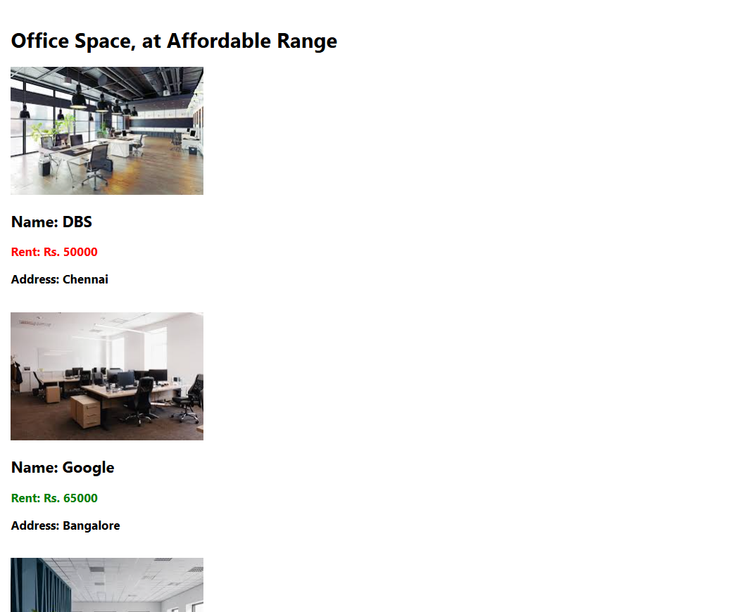

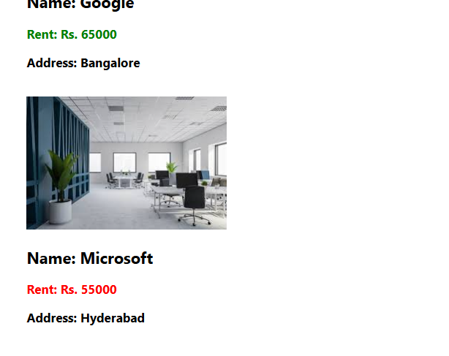

11. ReactJS-HOL
import './App.css';
import React, { useState } from 'react';

function App() {
const [count, setCount] = useState(0);
const [amount, setAmount] = useState('');

const handleAmountChange = (event) => {
const value = event.target.value;
if (!isNaN(value)) {
setAmount(value);
}
};
const increment = () => {
setCount(prev => prev + 1);
sayHello();
};

const decrement = () => {
setCount(prev => prev - 1);
};
const sayHello = () => {
alert('Hello Mate.');
};
const sayWelcome = () =>{
alert('Welcome');
}

const handlePress = (event) => {
alert('i was clicked');
}
const handleSubmit = () => {
const number = parseFloat(amount);
const conversionRate = 80;
const convertedAmount = number * conversionRate;
alert(`Converting to euro amount is : ${convertedAmount}`);
}
return (
<div>
<p>{count}</p>
<div><button onClick={increment}>Increment</button></div>
<div><button onClick={decrement}>Decrement</button></div>
<div><button onClick={sayWelcome}>Say Welcome</button></div>
<div><button onClick={handlePress}>Click Me</button></div>
<div>
<h1 style={{color : "green",fontSize: 50 }}>Curency Convertor</h1>
<label for="Amount">Amount: <input type="text" value={amount} onChange={handleAmountChange} style={{marginLeft:30} }></input></label>

<div><label>Curency</label>
<select name="Currency" id="currency" style={{boxSizing: "border-box", width: 200, height: 30,marginLeft:30}}>
<option value="euro">Euro</option>
<option value="inr">Inr</option>
</select></div>
<button onClick={handleSubmit}>Submit</button>
</div>

</div>
);
}

export default App;

Increment button is pressed
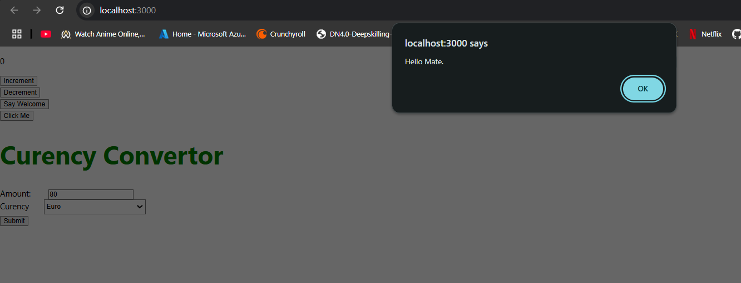
Decrement button is pressed
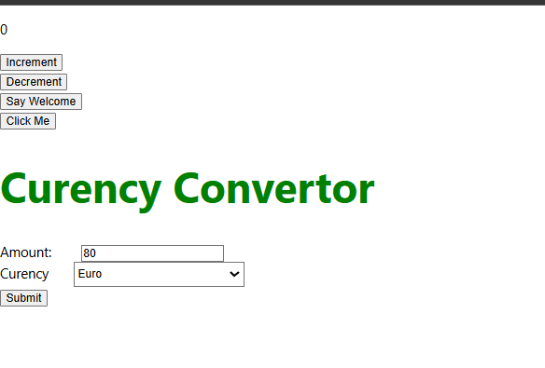

Say welcome button is pressed
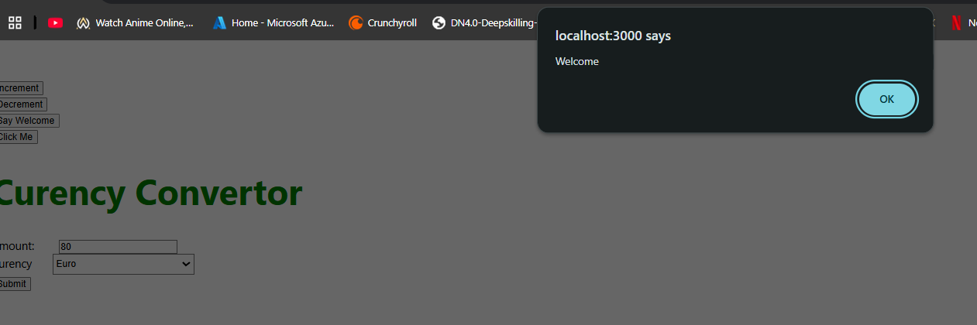
Click me button is pressed

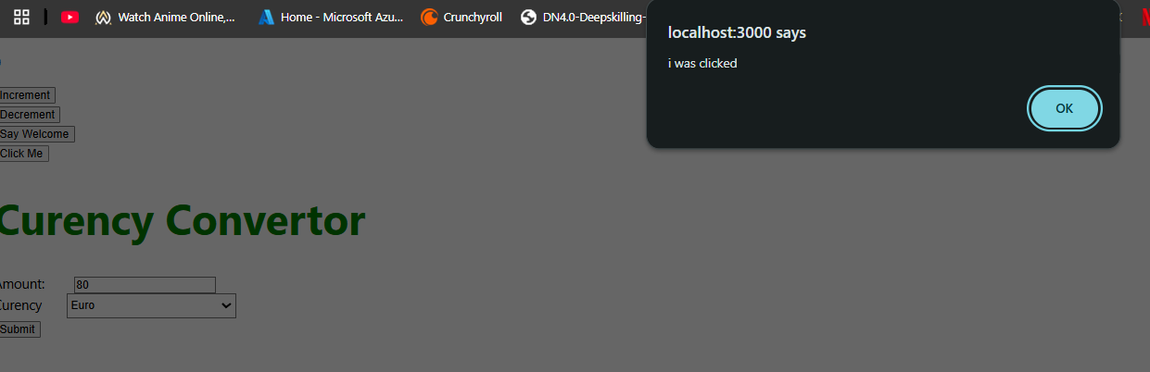
Submit button is pressed
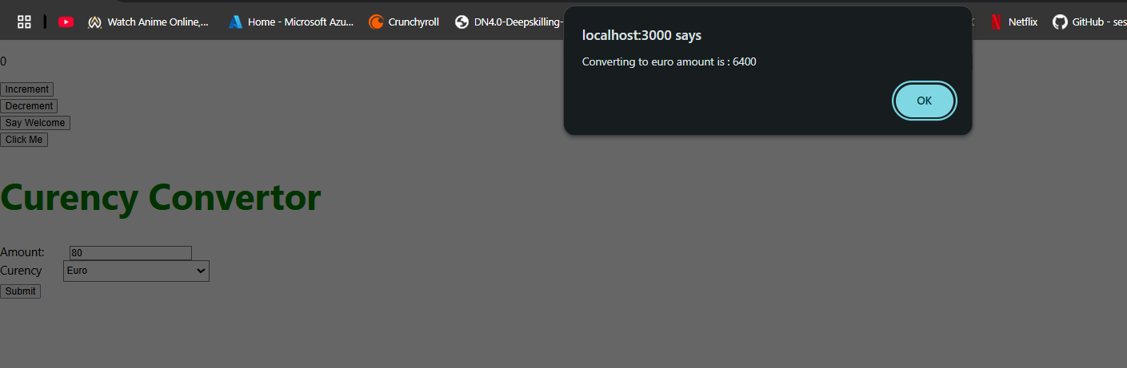

12. ReactJS-HOL
import React from 'react';
import './App.css';

const GuestPage = ({onLogin}) =>{
return(
<div style={{textAlign: 'center', marginTop: '50px'}}>
<h1>Please Sign Up</h1>
<button onClick={onLogin} >Login</button>
</div>
)
}
const UserPage = ({onLogout}) =>{
return(
<div style={{textAlign: 'center', marginTop: '50px'}}>
<h1>Welcome Back</h1>
<button onClick={onLogout} >Logout</button>
</div>
)
}
function App() {
const [isLoggedIn, setIsLoggedIn] = React.useState(false);

const handleLogin = () => {
setIsLoggedIn(true);
};

const handleLogout = () => {
setIsLoggedIn(false);
};
return (
<div>
{isLoggedIn ? (
<UserPage onLogout={handleLogout} />
) : (
<GuestPage onLogin={handleLogin} />
)}
</div>
);
}

export default App;

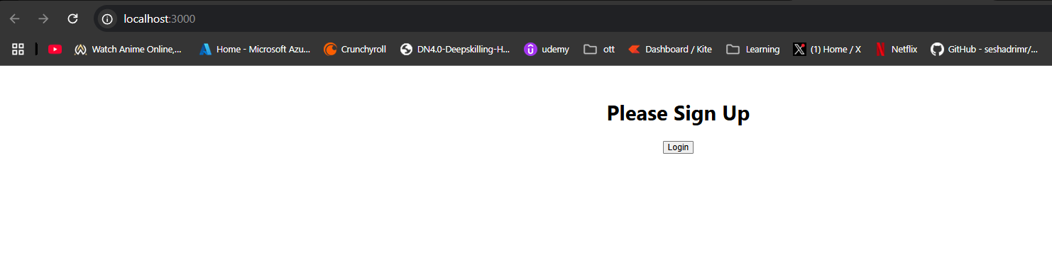
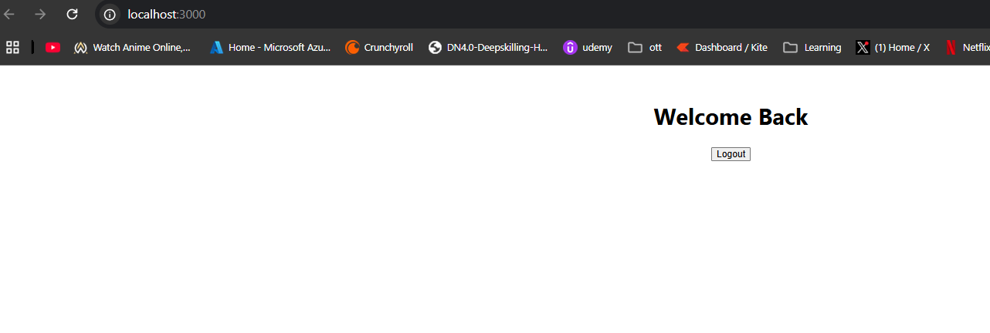

13. ReactJS-HOL
import React, { useState } from 'react';
import './App.css';

const courseData = [
{ id: 'c1', name: 'Angular', date: '4/5/2021' },
{ id: 'c2', name: 'React', date: '6/3/202021' },
];

const bookData = [
{ id: 'b1', bname: 'Master React', price: 670 },
{ id: 'b2', bname: 'Deep Dive into Angular 11', price: 800 },
{ id: 'b3', bname: 'Mongo Essentials', price: 450 },
];

const blogData = [
{ id: 'bl1', title: 'React Learning', author: 'Stephen Biz', content: 'Welcome to learning React!' },
{ id: 'bl2', title: 'Installation', author: 'Schewzdenier', content: 'You can install React from npm.' },
];
const CourseDetails = ({ courses }) => {
return (
<div >
<h2 >Course Details</h2>
{courses.length > 0 && (
<ul>
{courses.map((course) => (
<li key={course.id}>
<h3>{course.name}</h3>
<p>{course.date}</p>
</li>
))}
</ul>
)}
</div>
);
};

const BookDetails = ({ books }) => {
return (
<div>
<h2>Book Details</h2>

<ul>
{books.map((book) => (
<li key={book.id}>
<h3>{book.bname}</h3>
<p>Price: {book.price}</p>
</li>
))}
</ul>

</div>
);
};

const BlogDetails = ({ blogs }) => {
const renderBlogPosts = () => {
switch (blogs.length) {
case 0:
return <p >No blog posts found.</p>;
default:
return (
<ul>
{blogs.map((blog) => (
<li key={blog.id} className="mb-4">
<h3 >{blog.title}</h3>
<p>by {blog.author}</p>
<p>{blog.content}</p>
</li>
))}
</ul>
);
}
};
return (
<div>
<h2>Blog Details</h2>
{renderBlogPosts()}
</div>
);
}
function App() {
const [activeComponent, setActiveComponent] = useState('books'); // Default to books

const renderComponent = () => {
if (activeComponent === 'books') {
return <BookDetails books={bookData} />;
} else if (activeComponent === 'blogs') {
return <BlogDetails blogs={blogData} />;
} else if (activeComponent === 'courses') {
return <CourseDetails courses={courseData} />;
}
return <div>Select a component to display.</div>;
};

return (
<div>
<h1>Blogger App</h1>
<div>
<button
onClick={() => setActiveComponent('courses')}
style={{ backgroundColor: activeComponent === 'courses' ? '#3b82f6' : '#e5e7eb', color: activeComponent === 'courses' ? 'white' : '#1f2937' }}
>
Show Courses
</button>
<button
onClick={() => setActiveComponent('books')}
style={{ backgroundColor: activeComponent === 'books' ? '#3b82f6' : '#e5e7eb', color: activeComponent === 'books' ? 'white' : '#1f2937' }}
>
Show Books
</button>
<button
onClick={() => setActiveComponent('blogs')}
style={{ backgroundColor: activeComponent === 'blogs' ? '#3b82f6' : '#e5e7eb', color: activeComponent === 'blogs' ? 'white' : '#1f2937' }}
>
Show Blogs
</button>
</div>

<div>
{renderComponent()}
</div>
</div>
);
}

export default App;

