**TRIP PLANNER**

**SUBJECT : Discrete Structures**

PROJECT REPORT

SUBMITTED BY  :

NAMAN GUPTA : 2K19/IT/085

NAVEEN KUMAR : 2K19/IT/087

Ms Swati Sharda,



DEPARTMENT OF INFORMATION TECHNOLOGY

DELHI TECHNOLOGICAL UNIVERSITY

(Formerly Delhi College ofEngineering) Bawana Road,

 Delhi - 110042

NOVEMBER, 2020

DELHI TECHNOLOGICAL UNIVERSITY

(Formerly Delhi College of Engineering)

Bawana Road, Delhi-110042

**CANDIDATE’S DECLARATION**

We NAMAN GUPTA 2K19/IT/085 and NAVEEN KUMAR 2K19/IT/087 hereby  declare that the work presented in this project titled “TRIP PLANNER”, submitted to the B.Tech. (INFORMATION TECHNOLOGY) Delhi Technological University, Delhi for the award of the *Bachelor of Technology* degree in (INFORMATION TECHNOLOGY) , is our original work and done under the guidance of Ms Swati Sharda. We have not plagiarized or submitted the same work for the award of any other degree. November,2020

PLACE:DELHI NAMAN GUPTA 2K19/IT/085

    NAVEEN KUMAR 2K19/IT/087

DEPARTMENT OF INFORMATION TECHNOLOGY

DELHI TECHNOLOGICAL UNIVERSITY

(Formerly Delhi College of Engineering)

Bawana Road, Delhi-110042

**CERTIFICATE**

I hereby certify that the project dissertation titled “TRIP PLANNER” which is submitted by NAMAN GUPTA (2K19/IT/085) and NAVEEN KUMAR (2K19/IT/087) in Information Technology, Delhi Technological University, Delhi in partial fulfilment of the requirement for the completion of the third semester of their degree, is a record of the project work carried out by the students under my supervision. To the best of my knowledge, this work has not been submitted in part or full for any other project

Place: Delhi

Date: 29 th November 2020

                                                                         Ms Swati Sharda

                                                                         Supervisor

Department of Information Technology

Delhi Technological University

 ( Formerly Delhi College of Engineering)

Bawana Road, Delhi- 110042

**Acknowledgement**

We would like to convey our heartfelt thanks to our supervisor Ms Swati Sharda for her ingenious ideas, tremendous help and cooperation.

We are extremely grateful to our friends who gave valuable suggestions and guidance for completion of our project.

The cooperation and healthy criticism came handy and useful with them. Finally, We would like to thank all the above-mentioned people once again.

Department of Information Technology

Delhi Technological University

( Formerly Delhi College of Engineering)

Bawana Road, Delhi- 110042

**Abstract**

There's a large country famous for its tourist attractions but travel in the country is quite expensive as compared to most of its neighbouring countries .Despite having amazing tourist attractions, very less number of people visit the country because of the expensive travel which affects the tourism business of the country.

This problem can be solved if we could write an algorithm that gives us the cheapest path covering all the places ,the user wants to travel.

We have used undirected complete graph and weight of an edge is the cost required to travel between the two vertices connected through that edge.​

**FRONT-END:**

HTML

CSS  
BOOTSTRAP

**BACK-END:**

NODE JS

**DATABASE USED**:

MONGODB

**Index**

1. Problem Statement
2. Solution
3. Data structures and concepts used
4. Features And UI
5. Links to Code and Bibliography
6. Scope for Improvement

**PROBLEM STATEMENT:**

There's a large country famous for its tourist attractions but travel in the country is quite expensive as compared to most of its neighbouring countries .Despite having amazing tourist attractions, very less number of people visit the country because of the expensive travel which affects the tourism business of the country.

**SOLUTION TO THE PROBLEM**

This problem can be solved if we could write an algorithm that gives us the cheapest path covering all the places ,the user wants to travel.

We have used undirected complete graph and weight of an edge is the cost required to travel between the two vertices connected through that edge.​

**WHY IS THE GRAPH IS A COMPLETE GRAPH (WHY THERE'S AN EDGE B/W EACH PAIR OF DISTINCT VERTICES)?​**

The graph represents all the tourist places in the country and not the exact map of the country. So, each tourist place is reachable from all the other tourist places and that's why the graph used is a complete graph (K17)​

**CONCEPTS USED:**

1.Graph Theory

2.Minimum cost hamiltonian path

3.Recursion with memoization

4.Bit Masking

**FEATURES AND UI**

We have created a website as a solution to the problem stated above.One has to log in with his/her id in order to use the website.If the user does not already have an id ,he/she will have to register first.

Landing page of the website looks like:



LogIn Page :



Once the user has logged in, dashboard will be accessible to the user



**Features:**

**User can view all the tourist places**

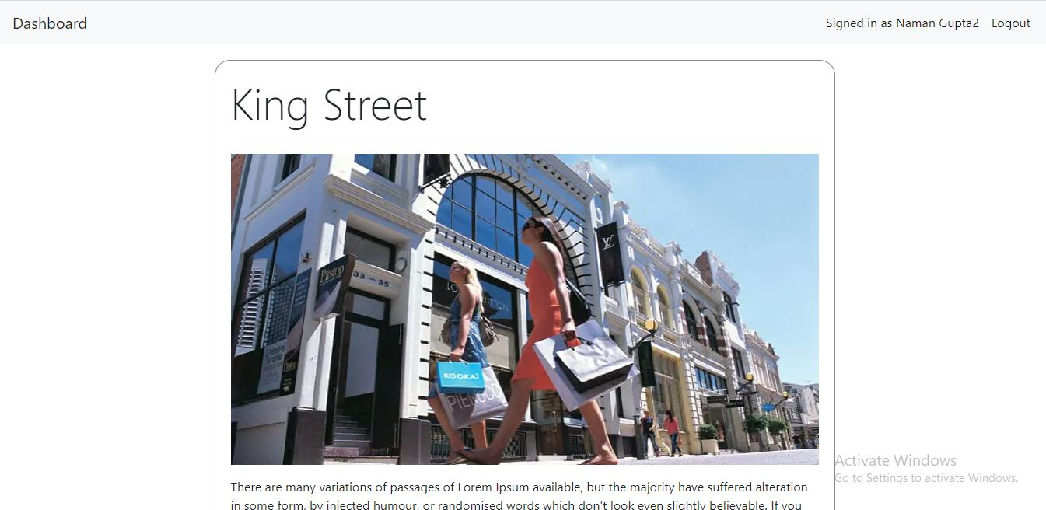

**User can plan his trip by selecting all the places he wishes to visit and the starting location of his journey**

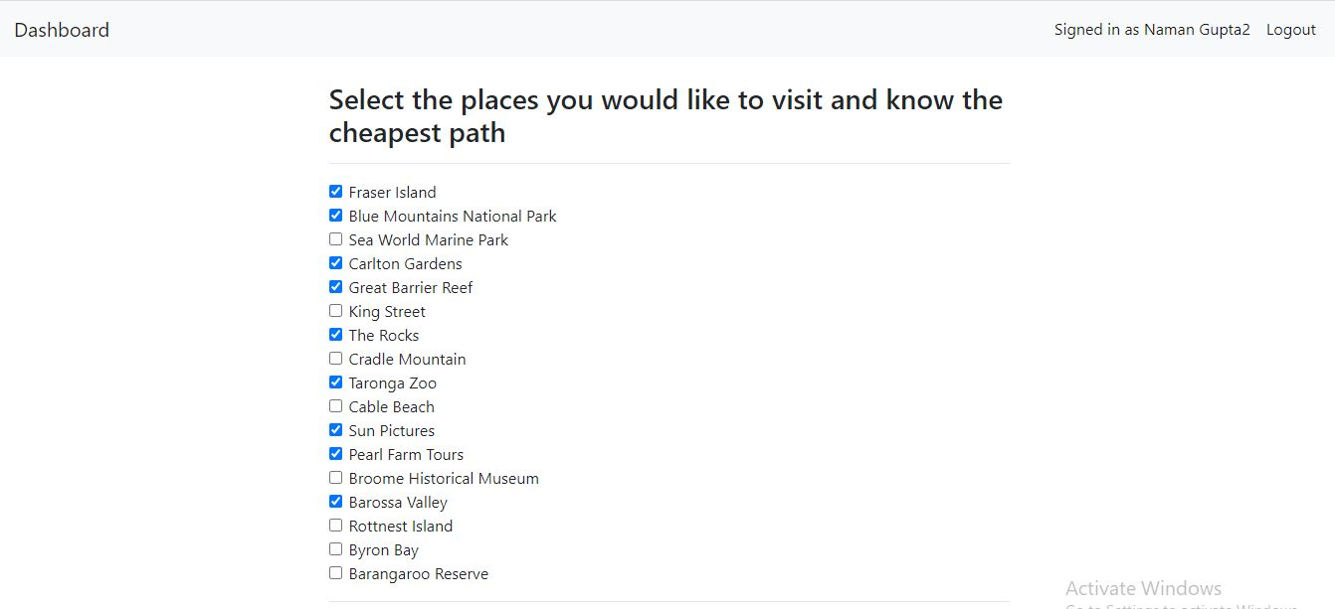



Shortest path covering all the places user wants to visit starting from the place he selected will be shown to the user

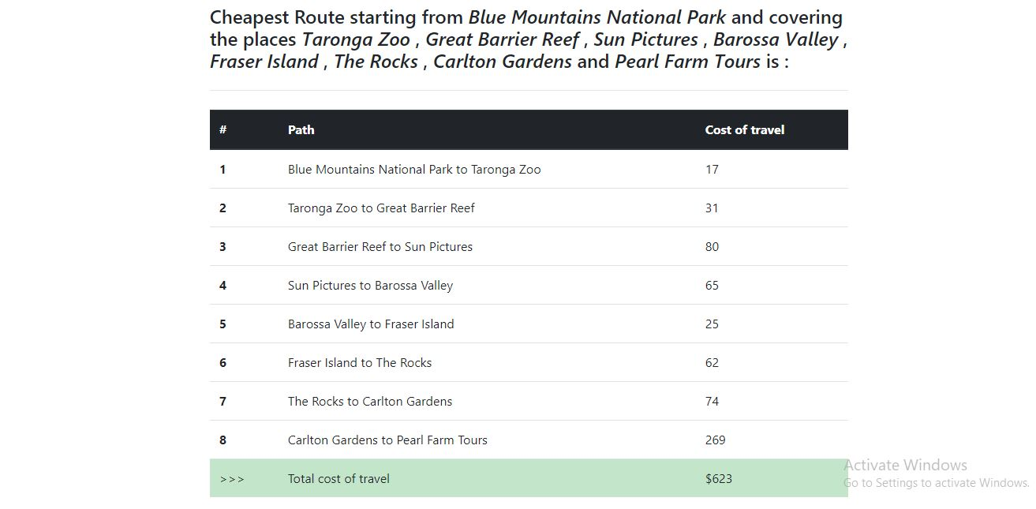

**There is a history section where the user can see the plans he has made using the website**

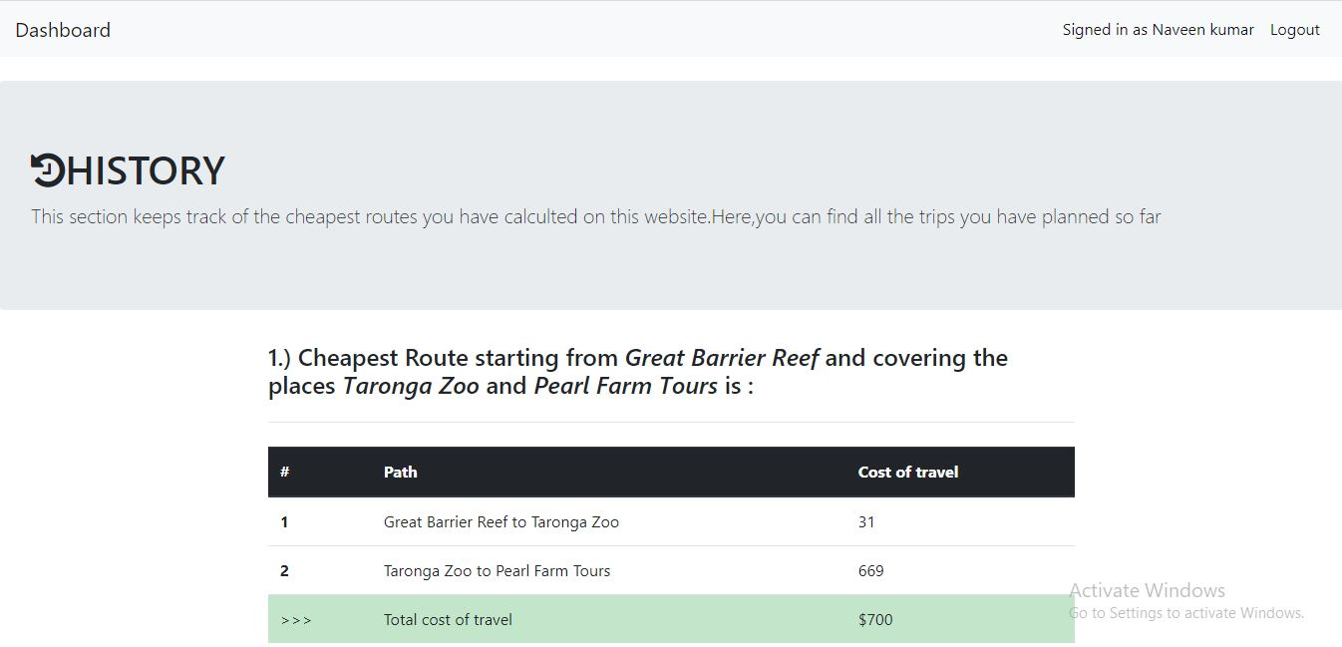

**Link to Code**

[**https://github.com/NaveenKumar519/Trip-planner**](https://github.com/NaveenKumar519/Trip-planner)

**Bibliography**

**1.**[**https://getbootstrap.com/docs/4.0/getting-started/introduction/**](https://getbootstrap.com/docs/4.0/getting-started/introduction/)

**2.**[**https://nodejs.org/en/docs/**](https://nodejs.org/en/docs/)

**3.**[**https://www.geeksforgeeks.org/**](https://www.geeksforgeeks.org/)

**Scope for Improvement**

We have considered imaginary places in our graphs and the weights of edges between the vertices are also imaginary.We can use real life locations instead of hard coding the graph.If not for a country but we can do it for places in Delhi like Red Fort,India Gate etc.We can obtain locations from the map using some API then we can dynamically build the graph and find the hamiltonian path.