**22. The Company ABC runs with employees with several departments. The Organization manager had all the mobile numbers of employees. Assume that you are the manager and need to verify the valid mobile numbers because there may be some invalid numbers present. Implement a LEX program to check whether the mobile number is valid or not.**

**AIM:** To implement a LEX program to check whether the mobile number is valid or not.

**PROGRAM:**

%{

#include <stdio.h>

%}

%%

[6-9][0-9]{9} { printf("Valid Mobile Number: %s\n", yytext); }

[0-9]+ { printf("Invalid Mobile Number: %s\n", yytext); }

.|\n { /* Ignore other characters */ }

%%

int main()

{

printf("Enter mobile numbers (press Ctrl+D to stop):\n");

yylex();

return 0;

}

**OUTPUT:  
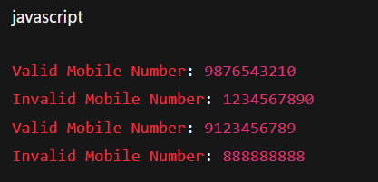**

**23. Implement Lexical Analyzer using LEX or FLEX (Fast Lexical Analyzer).  The program should separate the tokens in the given C program and display with appropriate caption.**

**AIM:** To implement lexical analyser using LEX or FLEX

**PROGRAM:**

%{

#include <stdio.h>

%}

%%

"#include"<[^>]+> { printf("Header File: %s\n", yytext); }

"int"|"void"|"char"|"float"|"return" { printf("Keyword: %s\n", yytext); }

[0-9]+ { printf("Number: %s\n", yytext); }

[a-zA-Z_][a-zA-Z0-9_]* { printf("Identifier: %s\n", yytext); }

\".*\" { printf("String: %s\n", yytext); }

"="|"+"|"-"|"*"|"/" { printf("Operator: %s\n", yytext); }

";" { printf("Semicolon: %s\n", yytext); }

"{" { printf("Left Brace: %s\n", yytext); }

"}" { printf("Right Brace: %s\n", yytext); }

"(" { printf("Left Parenthesis: %s\n", yytext); }

")" { printf("Right Parenthesis: %s\n", yytext); }

[ \t\n]+ { /* ignore whitespace */ }

. { /* ignore other characters */ }

%%

int main()

{

yylex();

return 0;

}

**OUTPUT:**

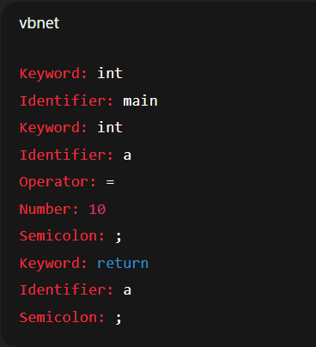

**24. In a class, an English teacher was teaching the vowels and consonants to the students.  She says “Vowel sounds allow the air to flow freely, causing the chin to drop noticeably, whilst consonant sounds are produced by restricting the air flow”. As a class activity the students are asked to identify the vowels and consonants in the given word/sentence and count the number of elements in each.  Write an algorithm to help the student to count the number of vowels and consonants in the given sentence.**

**AIM:** To write an algorithm to help the student count the number of vowels and consonants.

**PROGRAM:**

%{

#include <stdio.h>

int vowels = 0;

int consonants = 0;

%}

%%

[aeiouAEIOU] { vowels++; }

[a-zA-Z] { consonants++; }

.|\n { /* ignore other characters */ }

%%

int main(int argc, char *argv[])

{

if(argc > 1)

yyin = fopen(argv[1], "r"); // Read input file

else

yyin = stdin; // Read from keyboard

yylex();

printf("Number of vowels = %d\n", vowels);

printf("Number of consonants = %d\n", consonants);

return 0;

}

**OUTPUT:**

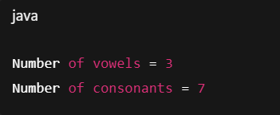

**25. Keywords are predefined, reserved words used in programming that have special meanings to the compiler. Keywords are part of the syntax and they cannot be used as an identifier. In general there are 32 keywords. The prime function of Lexical Analyser is token Generation. Among the 6 types of tokens, differentiating Keyword and Identifier is a challenging issue. Thus write a LEX program to separate keywords and identifiers.**

**AIM:** To write a LEX program to separate keywords and identifiers.

**PROGRAM:**%{

#include <stdio.h>

%}

// List of some common C keywords (you can expand up to 32)

KEYWORD int|float|char|double|void|return|if|else|for|while|do|switch|case|break|continue|default

%%

{KEYWORD} { printf("Keyword: %s\n", yytext); }

[a-zA-Z_][a-zA-Z0-9_]* { printf("Identifier: %s\n", yytext); }

[ \t\n]+ { /* ignore whitespace */ }

. { /* ignore other characters */ }

%%

int main(int argc, char *argv[])

{

if(argc > 1)

yyin = fopen(argv[1], "r"); // Read input C file

else

yyin = stdin; // Read from keyboard

yylex();

return 0;

}

**OUTPUT:  
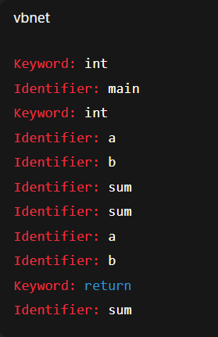**

**26. Write a LEX program to recognise numbers and words in a statement. Pooja is a small girl of age 3 always fond of games. Due to the pandemic, she was not allowed to play outside. So her mother designs a gaming event by showing a flash card. Pooja has to separate the numbers in one list and words in another list shown in the flash card.**

**AIM:** To write a LEX program to recognise numbers and words in a statement.

**PROGRAM:**%{

#include <stdio.h>

%}

%%

[0-9]+ { printf("%s ", yytext); } // Print numbers

[a-zA-Z]+ { printf("%s ", yytext); } // Print words

[ \t\n]+ { /* ignore whitespace */ }

. { /* ignore other characters */ }

%%

int main(int argc, char *argv[])

{

printf("Words and Numbers in statement:\n");

yylex();

printf("\n");

return 0;

}

**OUTPUT:**

