**27. Write a LEX program to identify and count positive and negative numbers.**

**AIM:** To write a LEX program to identify and count positive and negative numbers.

**PROGRAM:**

%{

#include <stdio.h>

int positive = 0, negative = 0;

%}

%%

[-][0-9]+ { negative++; printf("Negative: %s\n", yytext); }

[0-9]+ { positive++; printf("Positive: %s\n", yytext); }

[ \t\n]+ { /* ignore whitespace */ }

. { /* ignore other characters */ }

%%

int main(int argc, char *argv[])

{

if(argc > 1)

yyin = fopen(argv[1], "r"); // Read input file

else

yyin = stdin; // Read from keyboard

yylex();

printf("\nTotal Positive Numbers = %d\n", positive);

printf("Total Negative Numbers = %d\n", negative);

return 0;

}

**OUTPUT:**

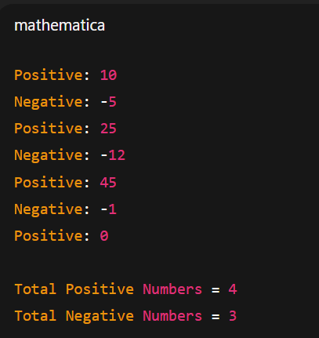

**28. A networking company wants to validate the URL for their clients. Write a LEX program to implement the same.**

**AIM:** To write a LEX program to implement a networking company wants to validate the URL for their clients

**PROGRAM:**

%{

#include <stdio.h>

%}

%%

(http|https)://[a-zA-Z0-9.-]+\.[a-zA-Z]{2,4}(/[a-zA-Z0-9._/-]*)? {

printf("Valid URL: %s\n", yytext);

}

.|\n { printf("Invalid URL\n"); }

%%

int main()

{

printf("Enter a URL: ");

yylex();

return 0;

}

**OUTPUT:**

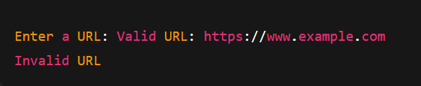

**29. School management wants to validate DOB of all students. Write a LEX program to implement it.**

**AIM:** To write a LEX program for a school management to validate DOB of all students.

**PROGRAM:**

%{

#include <stdio.h>

%}

%%

(0[1-9]|[12][0-9]|3[01])/(0[1-9]|1[0-2])/(19|20)[0-9]{2} {

printf("Valid DOB: %s\n", yytext);

}

.|\n { printf("Invalid DOB\n"); }

%%

int main()

{

printf("Enter DOB (DD/MM/YYYY): ");

yylex();

return 0;

}

**OUTPUT:  
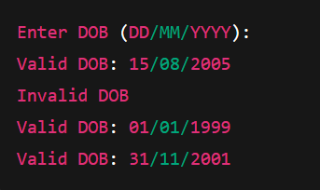**

**30. Write a LEX program to check whether the given input is digit or not.**

**AIM:** To write a LEX program to check whether the given input is digit or not.

**PROGRAM:**

%{

#include <stdio.h>

%}

%%

[0-9] { printf("%s is a digit\n", yytext); }

. { printf("%s is NOT a digit\n", yytext); }

\n { /* ignore newline */ }

%%

int main()

{

printf("Enter input: ");

yylex();

return 0;

}

**OUTPUT:**

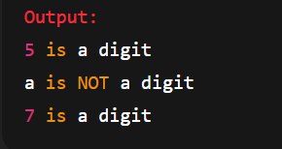

**31. A School student was asked to do basic mathematical operations. Implement a LEX program to implement the same.**

**AIM:** To implement a LEX program for a school student to do basic mathematical operations.

**PROGRAM:**%{

#include <stdio.h>

#include <stdlib.h>

int num1, num2;

char op;

%}

%%

[0-9]+ {

if(num1 == -1) num1 = atoi(yytext);

else num2 = atoi(yytext);

}

[+\-*/] { op = yytext[0]; }

\n {

if(op == '+') printf("%d + %d = %d\n", num1, num2, num1+num2);

else if(op == '-') printf("%d - %d = %d\n", num1, num2, num1-num2);

else if(op == '*') printf("%d * %d = %d\n", num1, num2, num1*num2);

else if(op == '/') printf("%d / %d = %.2f\n", num1, num2, (float)num1/num2);

num1 = -1; num2 = -1; op = 0;

}

[ \t]+ { /* ignore whitespace */ }

. { printf("Invalid character: %s\n", yytext); }

%%

int main()

{

num1 = -1; num2 = -1;

printf("Enter expressions like 10 + 5 (one per line, Ctrl+D to stop):\n");

yylex();

return 0;

}

**OUTPUT:  
