DSA0601 – Data Handling and Visualization
Slot D | CO1 – AT3
Name: S. Naveen Kumar
Roll No: 34 Reg. No.: 192425176

Q.1 Color Scales for Multi Variable Data

1.1 Problem Statement
An environmental monitoring agency has collected climate data from 20 major Indian cities (Temperature, Humidity, Rainfall and Air Quality Index). The task is to design a visualization that uses appropriate colour scales, to select a suitable palette and to justify its effectiveness for interpretation and accessibility.

1.2 Design Approach
Four variables with four different units (°C, %, mm and an index) must be compared across 20 cities. Two complementary views were designed, both using the same perceptually uniform palette.
Variable | Visual channel | Reason
Temperature, Humidity, Rainfall, AQI (heat map) | Cell colour (viridis, min–max scaled per column) plus printed value | Scaling each column to 0–1 lets unlike units share one colour scale; printed values give exact readings.
Humidity / Temperature (bubble chart) | x-position / y-position | Position on a common scale is the most accurately decoded channel.
Rainfall (bubble chart) | Bubble area | Area scaling keeps perceived size proportional to the value.
AQI (bubble chart) | Colour (reversed viridis) | Darker colour = worse air quality, which matches intuition.

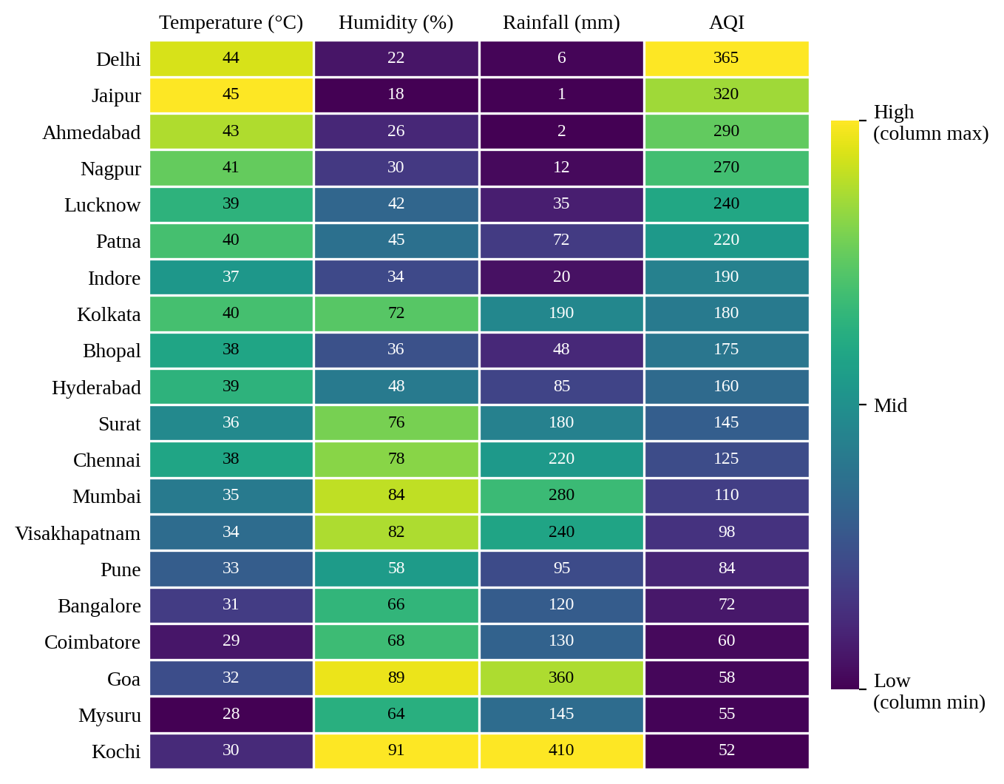
Figure 1.1: Heat map of the four variables for 20 cities (cities sorted by AQI, highest at top).
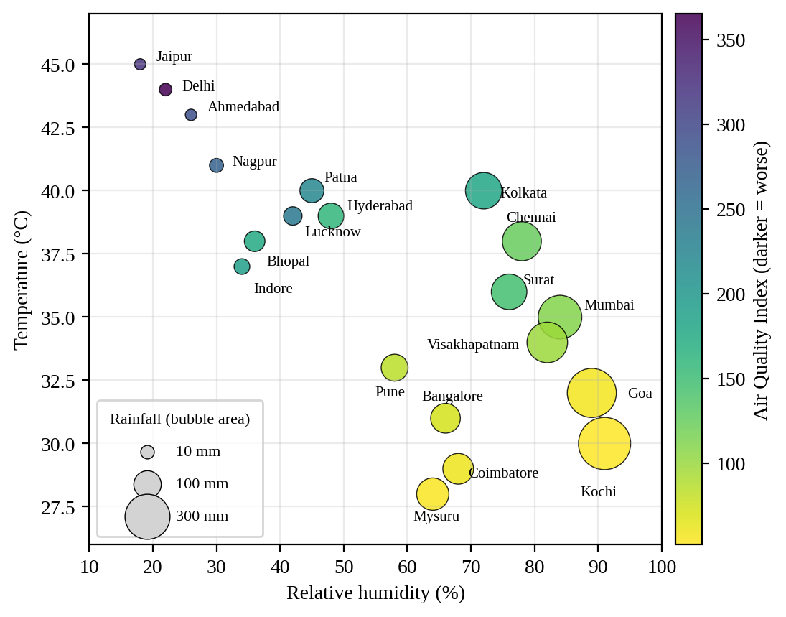
Figure 1.2: Temperature vs. humidity, with bubble area showing rainfall and colour showing AQI.

1.3 Choice of Colour Palette and Justification
- Sequential palette, not diverging: none of the variables has a natural midpoint, so a single-direction (low to high) scale is the correct choice.
- Viridis: it is perceptually uniform (equal data steps look like equal colour steps), so it does not create false boundaries as the rainbow/jet map does.
- Accessible: viridis stays distinguishable for the common forms of colour-vision deficiency and still reads correctly when printed in greyscale, because its lightness changes monotonically.
- Redundant encoding: numbers are printed in every heat-map cell, and the text colour switches between white and black to keep contrast high on both dark and light cells.
- Ordering: sorting cities by AQI turns the heat map into a readable gradient instead of a random patchwork.

1.4 Interpretation
The sorted heat map shows a clear pattern. Hot, dry cities such as Delhi (AQI 365, 44 °C, 6 mm), Jaipur, Ahmedabad and Nagpur have the worst air quality, while wet coastal cities such as Kochi, Goa, Mumbai and Coimbatore have the lowest AQI (52–110). Across the 20 cities, AQI has a strong positive correlation with temperature (r = 0.94) and negative correlations with humidity (r = −0.85) and rainfall (r = −0.73), while humidity and rainfall are strongly related to each other (r = 0.93). This is a statistical association from 20 observations and does not by itself prove causation.

Question 2. Multi -Aesthetic Data

2.1 Problem Statement
A multinational retail company has collected annual sales information from 20 branches. The visualization must simultaneously represent Sales, Profit, Number of Customers, Product Category and Region, using suitable aesthetic mappings and an appropriate scale transformation wherever necessary.

2.2 Aesthetic Mappings and Scale Transformations
Variable | Aesthetic | Scale / justification
Sales | x-position | Log10 scale. Sales range from 180,000 to 1,250,000, so a log axis spreads out the many low-sales branches that would otherwise be crowded at the left.
Profit | y-position | Linear scale. Two branches have negative profit (B3, B11), so a log scale is impossible; a dashed break-even line at 0 marks losses.
Customers | Bubble area | Area-proportional (square-root radius) scaling, so a branch with twice the customers looks twice as big, not four times.
Product category | Colour | Colour-blind-safe Okabe–Ito palette (qualitative, because categories have no order).
Region | Point shape | Shape is the correct channel for a nominal variable and works in black-and-white print.

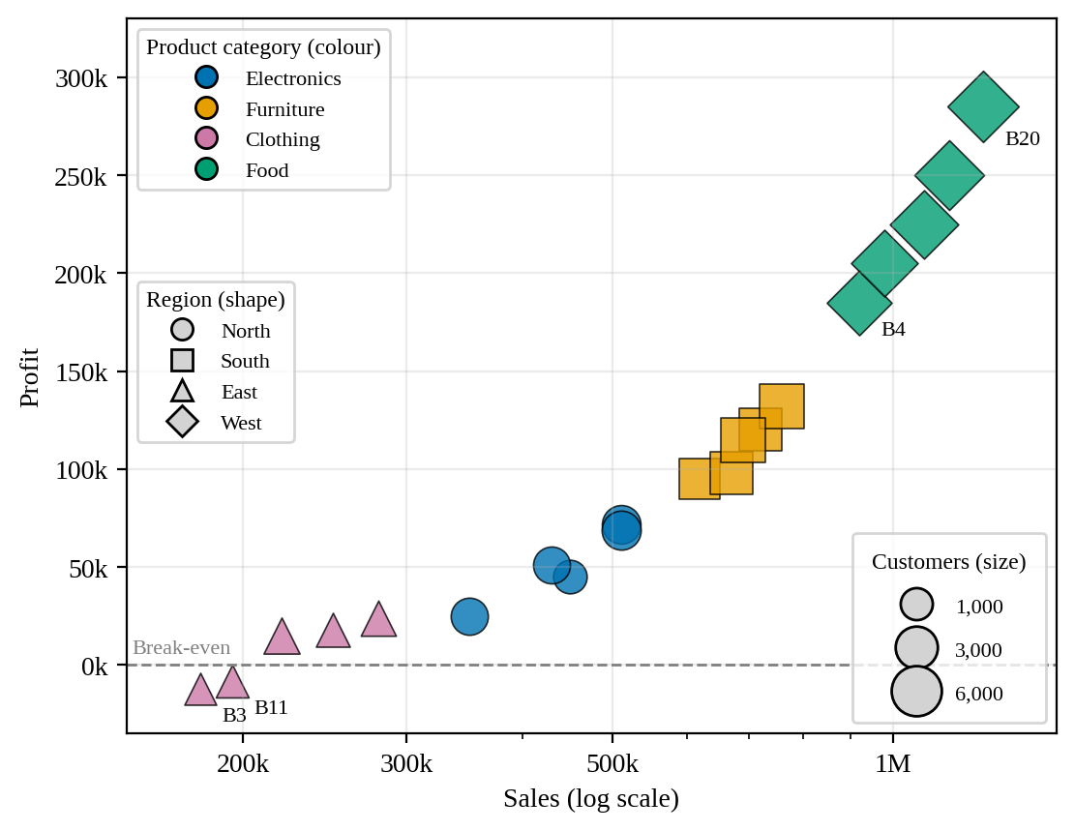
Figure 2.1: Branch performance: Sales (log) vs. Profit, sized by customers, coloured by category, shaped by region.

2.3 Design Choice and Interpretation
A scatter (bubble) plot was chosen because the main question is how profit relates to sales across branches, and position on two aligned axes is the most accurate way to show this. The remaining three variables are added as secondary aesthetics so that no information is lost.
- Sales and profit rise together. Food branches (all West: B4, B8, B12, B16, B20) are the top performers, with sales of 920,000–1,250,000, profit of 185,000–285,000, the most customers and an average margin of about 21%.
- Furniture (South) follows with an average margin of about 16%, then Electronics (North) at about 11%.
- Clothing (East) is the weakest category, with an average margin of only about 2.4%, and it contains the only loss-making branches, B3 (−12,000) and B11 (−8,000).
- Customer count grows with sales, so the bubbles get larger toward the upper right.
In this dataset every region sells exactly one category (North = Electronics, South = Furniture, East = Clothing, West = Food), so colour and shape carry the same grouping. This redundancy is deliberate: it improves accessibility and keeps the chart readable in greyscale, and it would still separate the two variables if a branch ever sold a different category.

Question 3.Cartesian vs Polar Coordinates

3.1 Problem Statement
Monthly electricity generation (Coal, Gas, Solar, Wind, Hydro) is given for a year. Visualizations are to be built with Cartesian and with Polar coordinates, the two compared, and the more suitable coordinate system for analysis chosen and explained.

3.2 Visualizations
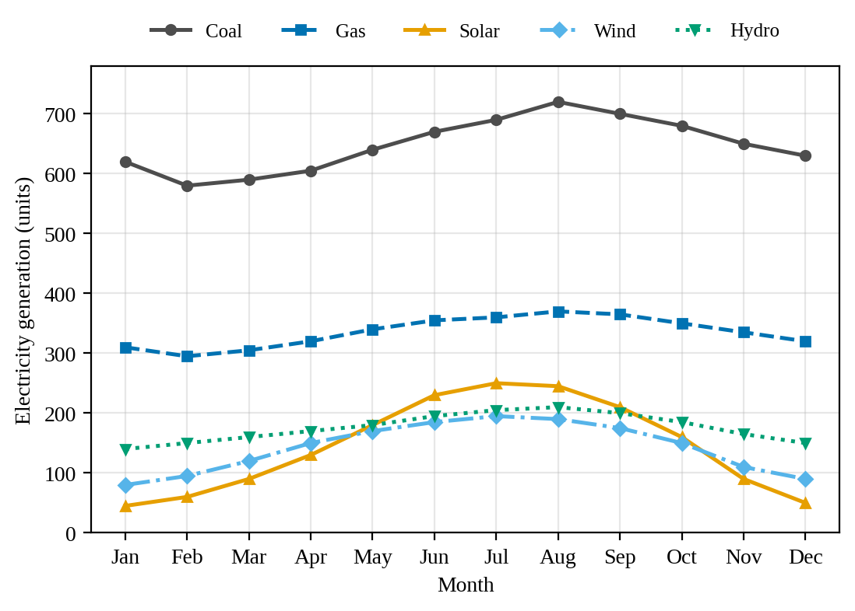
Figure 3.1: Cartesian coordinates: monthly generation by source (line chart).
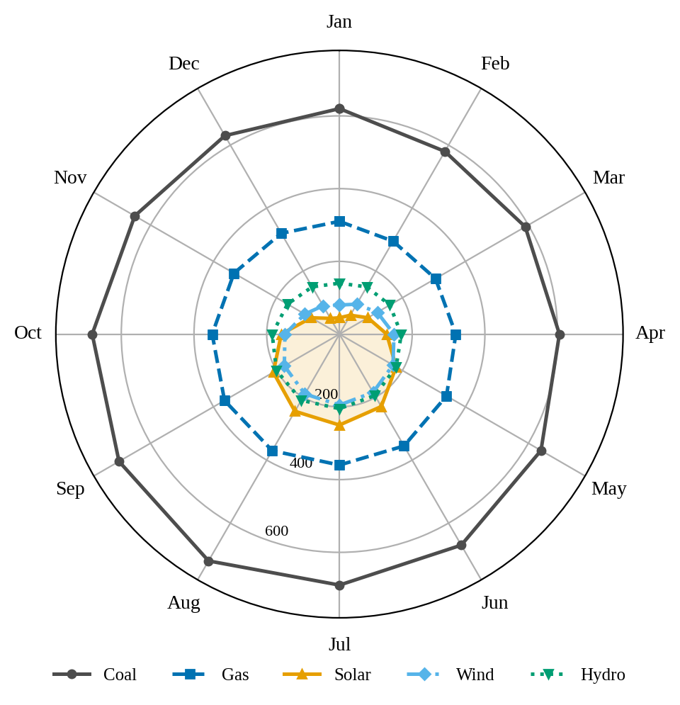
Figure 3.2: Polar coordinates: the same data with months as angles and generation as radius.

3.3 Comparison of the Two Coordinate Systems
Criterion | Cartesian (Fig. 3.1) | Polar (Fig. 3.2)
Reading exact values | Easy: position along a common, aligned axis. | Harder: values must be judged from radial distance and curved gridlines.
Comparing sources | Lines are separated clearly; gaps are easy to compare. | Small sources (Solar, Wind, Hydro) bunch near the centre and overlap.
Showing the yearly cycle | Shows trend but does not show that December is followed by January. | Natural for cyclic data: the loop shows the annual rhythm.
Visual distortion | None: equal differences look equal. | Area near the outer ring is exaggerated, so Coal looks far larger than it is.
Labelling and scale | Simple linear y-axis. | Radial labels collide with the data.

3.4 Decision and Explanation
The Cartesian coordinate system provides better analytical support for this dataset, and it is the one that should be used to answer analysis questions. The main tasks (finding the peak month, comparing the size of each source and measuring seasonal swings) depend on judging positions along one aligned scale, which people do far more accurately than judging angles and radial distances. The polar chart is still useful as a supporting view, because the data repeat every 12 months and the loop makes that cycle visible.
What the Cartesian chart shows:
- Coal is the dominant source in every month (580–720 units), peaking in August.
- Solar is the most seasonal source: it rises from 45 units in January to 250 in July, about 5.5 times. Wind also peaks in July (195) and is lowest in January (80).
- Hydro varies least, from 140 to 210 units, and Gas from 295 to 370.
- Total generation peaks in August (1,735 units) and is lowest in February (1,180 units), so the summer peak is driven by Coal together with the rise in Solar, Wind and Hydro.

Question 4.Integrated Capstone Design

4.1 Problem Statement
Data for twenty publicly listed companies (Revenue, Profit Margin, Market Capitalisation, Employee Count and Industry Sector) must be combined into an integrated visualization that uses suitable aesthetic mappings, coordinate systems, scales and colour palettes, with minimum perceptual bias.

4.2 Design Approach
Five variables are too many for one clean two-dimensional plot, so an integrated figure of two coordinated panels was used. Both panels share one legend, and each sector keeps the same colour and shape in both, so a company can be followed from one panel to the other. Together they show all five variables.
Variable | Panel (a): profitability vs. size | Panel (b): workforce vs. value
Revenue | x-position (log scale) | Bubble area
Profit margin | y-position (linear, %) | –
Market capitalisation | Bubble area | y-position (log scale)
Employees | – | x-position (log scale)
Sector | Colour + shape | Colour + shape

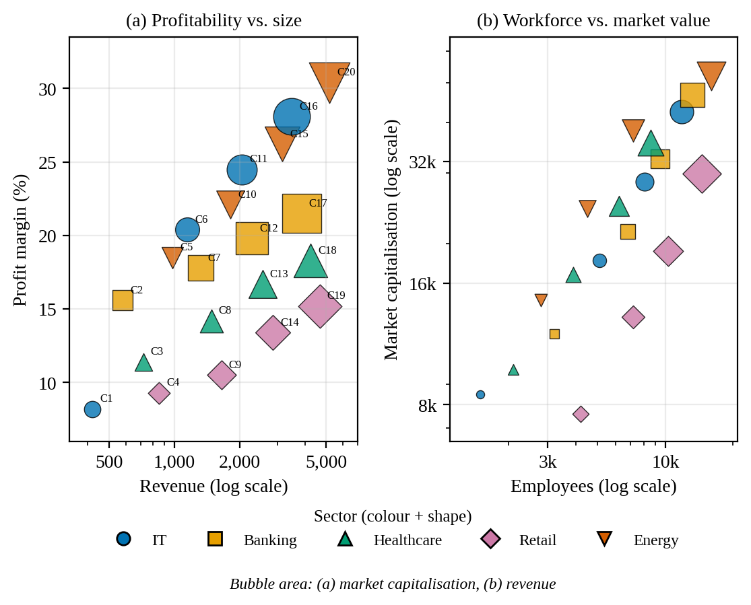
Figure 4.1: Integrated view of 20 listed companies (C1–C20) coloured by sector.

4.3 Design Justification
- Scales: Revenue, Employees and Market Capitalisation span more than a ten-fold range, so log axes are used to avoid squeezing small companies into one corner. Profit margin is a bounded percentage and stays linear.
- Coordinate system: Cartesian, because the aim is to compare values and relationships, not cyclic position.
- Palette: a qualitative, colour-blind-safe Okabe–Ito palette for the five sectors, plus a different marker shape per sector so it still works in greyscale.
- Minimising bias: bubble area (not radius) is proportional to the value; the legend is shared; companies are labelled directly (C1–C20); there is no 3D, no dual axis and only light gridlines; and the axis ranges leave room so that no bubble is cut off.

4.4 Interpretation
- Larger companies earn higher margins: the margin rises with revenue (r = 0.58), and within IT it climbs from 8.2% (C1) to 28.1% (C16).
- Energy has the highest average margin (about 24%) and C20 leads in revenue (5,200), margin (30.4%) and market capitalisation (52,000).
- Retail has the lowest average margin (about 12%) and the largest average workforce (about 9,050 employees). In panel (b) the Retail diamonds sit below the other sectors, meaning that for the same headcount they have a lower market value.
- Market capitalisation tracks revenue (r = 0.88), margin (r = 0.84) and employees (r = 0.83), and revenue is closely tied to employee count (r = 0.91).

Appendix: R Code (ggplot2)
The figures above were produced with a plotting script in Python; the equivalent R (ggplot2) code with the same design choices is given below, since the exercise is to be done in R. It has not been run in this environment, so please run it once in RStudio and adjust the output size if needed.

Setup
library(ggplot2); library(dplyr); library(tidyr); library(patchwork); library(scales)
th <- theme_minimal(base_family = "serif", base_size = 12)

Question 1
q1 <- read.csv(text = "City,Temp,Humidity,Rainfall,AQI
Delhi,44,22,6,365
Mumbai,35,84,280,110
Chennai,38,78,220,125
Kolkata,40,72,190,180
Hyderabad,39,48,85,160
Bangalore,31,66,120,72
Pune,33,58,95,84
Ahmedabad,43,26,2,290
Jaipur,45,18,1,320
Lucknow,39,42,35,240
Bhopal,38,36,48,175
Patna,40,45,72,220
Goa,32,89,360,58
Kochi,30,91,410,52
Nagpur,41,30,12,270
Indore,37,34,20,190
Surat,36,76,180,145
Visakhapatnam,34,82,240,98
Coimbatore,29,68,130,60
Mysuru,28,64,145,55")

long <- q1 %>% pivot_longer(-City, names_to = "Variable", values_to = "Value") %>%
group_by(Variable) %>%
mutate(Scaled = (Value - min(Value)) / (max(Value) - min(Value))) %>% ungroup()
long$City <- factor(long$City, levels = rev(q1$City[order(-q1$AQI)]))
long$Variable <- factor(long$Variable, levels = c("Temp", "Humidity", "Rainfall", "AQI"))

ggplot(long, aes(Variable, City, fill = Scaled)) +
geom_tile(colour = "white", linewidth = 0.6) +
geom_text(aes(label = Value, colour = Scaled < 0.55), size = 3) +
scale_colour_manual(values = c("black", "white"), guide = "none") +
scale_fill_viridis_c(option = "D", breaks = c(0, 0.5, 1), labels = c("Low", "Mid", "High")) +
scale_x_discrete(position = "top") + labs(x = NULL, y = NULL, fill = "Scaled value") + th

ggplot(q1, aes(Humidity, Temp, size = Rainfall, colour = AQI, label = City)) +
geom_point(alpha = 0.85) + geom_text(colour = "black", size = 3, vjust = -1.4, check_overlap = TRUE) +
scale_colour_viridis_c(option = "D", direction = -1) + scale_size_area(max_size = 12) +
labs(x = "Relative humidity (%)", y = "Temperature (°C)") + th

Question 2
q2 <- read.csv(text = "Branch,Region,Category,Sales,Profit,Customers
B1,North,Electronics,450000,45000,1200
B2,South,Furniture,620000,95000,2500
B3,East,Clothing,180000,-12000,980
B4,West,Food,920000,185000,4200
B5,North,Electronics,350000,25000,1800
B6,South,Furniture,720000,120000,3000
B7,East,Clothing,250000,18000,1250
B8,West,Food,1080000,225000,5200
B9,North,Electronics,510000,72000,2100
B10,South,Furniture,670000,98000,3300
B11,East,Clothing,195000,-8000,1100
B12,West,Food,980000,205000,4700
B13,North,Electronics,430000,51000,1750
B14,South,Furniture,760000,132000,3600
B15,East,Clothing,280000,24000,1450
B16,West,Food,1150000,250000,5600
B17,North,Electronics,510000,69000,2200
B18,South,Furniture,690000,115000,3900
B19,East,Clothing,220000,15000,1600
B20,West,Food,1250000,285000,6100")

ggplot(q2, aes(Sales, Profit, colour = Category, shape = Region, size = Customers)) +
geom_hline(yintercept = 0, linetype = "dashed", colour = "grey50") +
geom_point(alpha = 0.8) +
scale_x_log10(labels = comma) + scale_y_continuous(labels = comma) +
scale_colour_manual(values = c(Electronics="#0072B2", Furniture="#E69F00", Clothing="#CC79A7", Food="#009E73")) +
scale_shape_manual(values = c(North = 16, South = 15, East = 17, West = 18)) +
scale_size_area(max_size = 9) + th

Question 3
q3 <- data.frame(Month = month.abb,
Coal = c(620,580,590,605,640,670,690,720,700,680,650,630),
Gas = c(310,295,305,320,340,355,360,370,365,350,335,320),
Solar = c(45,60,90,130,180,230,250,245,210,160,90,50),
Wind = c(80,95,120,150,170,185,195,190,175,150,110,90),
Hydro = c(140,150,160,170,180,195,205,210,200,185,165,150))
long3 <- pivot_longer(q3, -Month, names_to = "Source", values_to = "Units")
long3$Month <- factor(long3$Month, levels = month.abb)

p <- ggplot(long3, aes(Month, Units, colour = Source, group = Source, linetype = Source)) +
geom_line(linewidth = 1) + geom_point(size = 2) + ylim(0, 780) +
scale_colour_manual(values = c(Coal = "#4D4D4D", Gas = "#0072B2", Solar = "#E69F00",
Wind = "#56B4E9", Hydro = "#009E73")) + th
p # Cartesian version
p + coord_polar() # Polar version

Question 4
q4 <- read.csv(text = "Company,Sector,Revenue,ProfitMgn,Employees,MarketCap
C1,IT,420,8.2,1500,8500
C2,Banking,580,15.6,3200,12000
C3,Healthcare,720,11.4,2100,9800
C4,Retail,850,9.3,4200,7600
C5,Energy,980,18.5,2800,14500
C6,IT,1150,20.4,5100,18200
C7,Banking,1320,17.8,6800,21500
C8,Healthcare,1480,14.2,3900,16800
C9,Retail,1650,10.5,7200,13200
C10,Energy,1820,22.1,4500,24500
C11,IT,2050,24.5,8100,28500
C12,Banking,2280,19.8,9500,32500
C13,Healthcare,2550,16.7,6200,24800
C14,Retail,2840,13.4,10300,19200
C15,Energy,3150,26.2,7200,38200
C16,IT,3480,28.1,11800,42500
C17,Banking,3860,21.5,13200,46800
C18,Healthcare,4250,18.3,8600,35600
C19,Retail,4680,15.2,14500,29800
C20,Energy,5200,30.4,16000,52000")

pal <- c(IT = "#0072B2", Banking = "#E69F00", Healthcare = "#009E73", Retail = "#CC79A7", Energy = "#D55E00")
shp <- c(IT = 16, Banking = 15, Healthcare = 17, Retail = 18, Energy = 25)

a <- ggplot(q4, aes(Revenue, ProfitMgn, colour = Sector, shape = Sector, size = MarketCap, label = Company)) +
geom_point(alpha = 0.8) + geom_text(colour = "black", size = 2.5, vjust = -1.5) +
scale_x_log10(labels = comma) + scale_size_area(max_size = 10, guide = "none") +
labs(title = "(a) Profitability vs. size", y = "Profit margin (%)") + th
b <- ggplot(q4, aes(Employees, MarketCap, colour = Sector, shape = Sector, size = Revenue)) +
geom_point(alpha = 0.8) + scale_x_log10(labels = comma) + scale_y_log10(labels = comma) +
scale_size_area(max_size = 10, guide = "none") +
labs(title = "(b) Workforce vs. market value", y = "Market capitalisation") + th
(a + b) + plot_layout(guides = "collect") &
scale_colour_manual(values = pal) & scale_shape_manual(values = shp) & theme(legend.position = "bottom")

