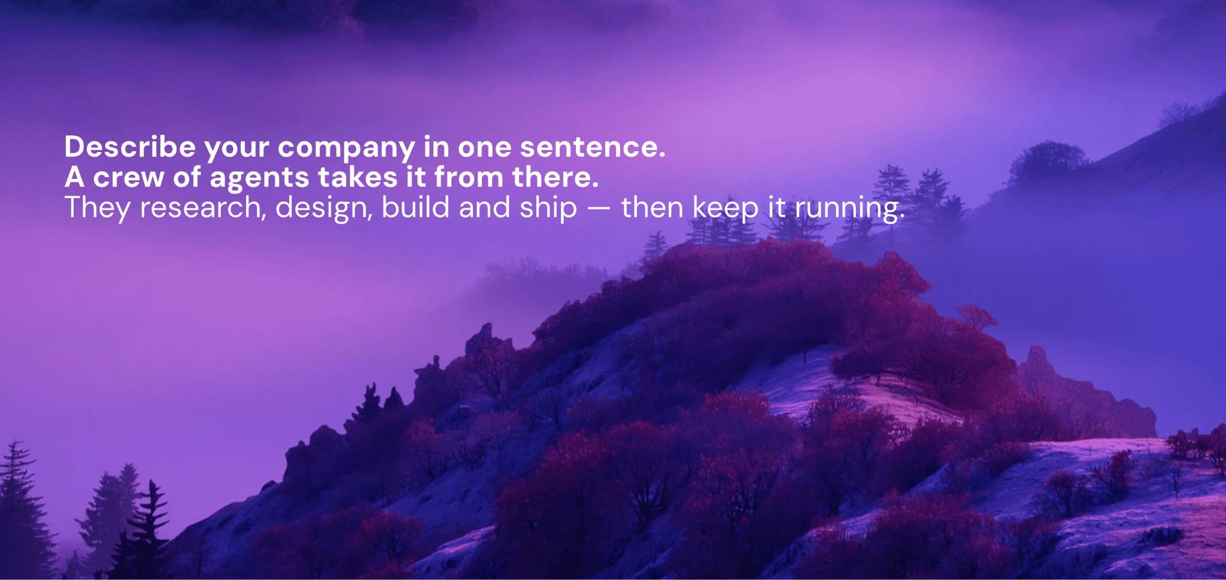

- Here you can see an em dash after the “Ship” right ? please do remove that use the small dash there “-”

- In the below image you can see the Rearch, Design, Build, Ship instead of that empty boxes please do make like the below given ascii 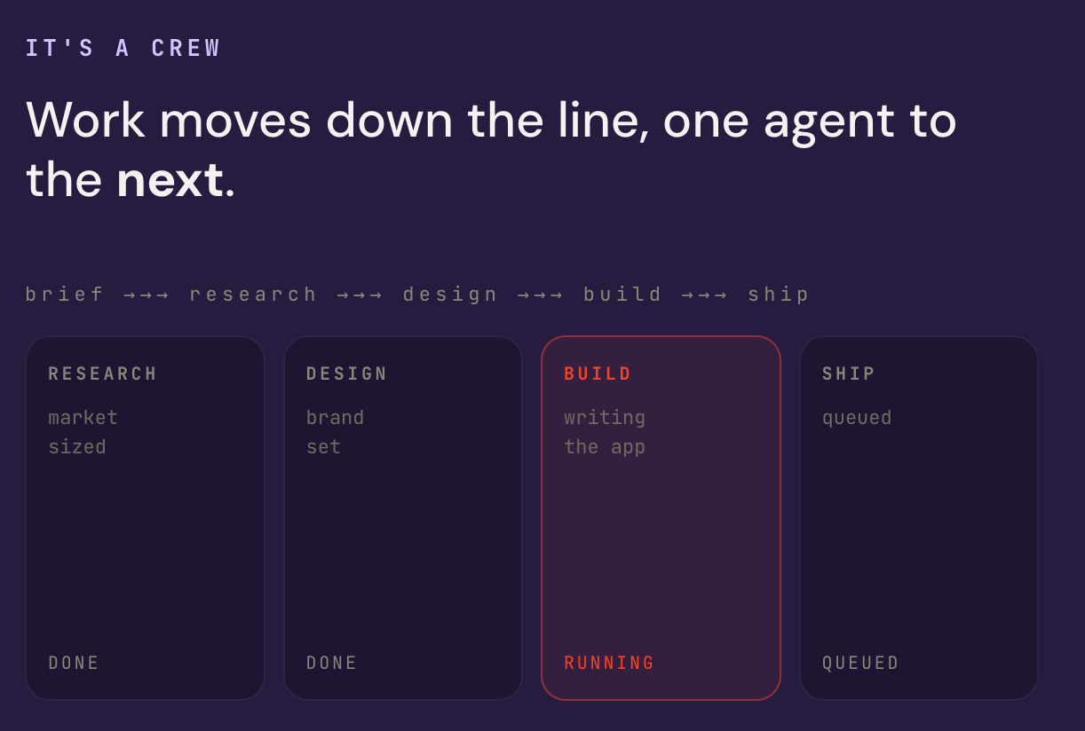

Like this below given design where those bar of orange will be increasing accordingly
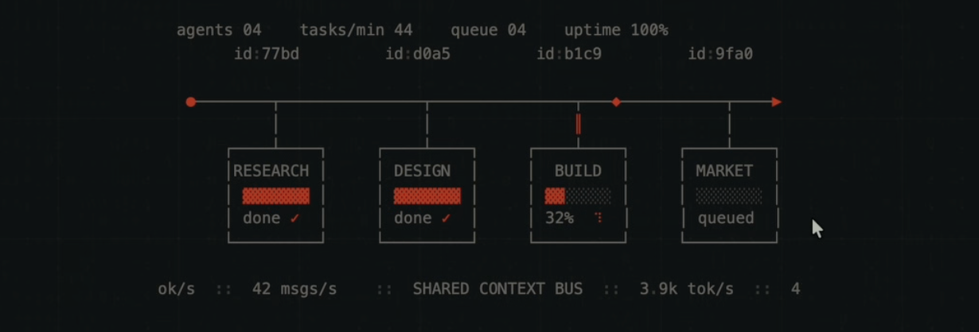

- Write “Build a company in one sentence.” instead of this text -
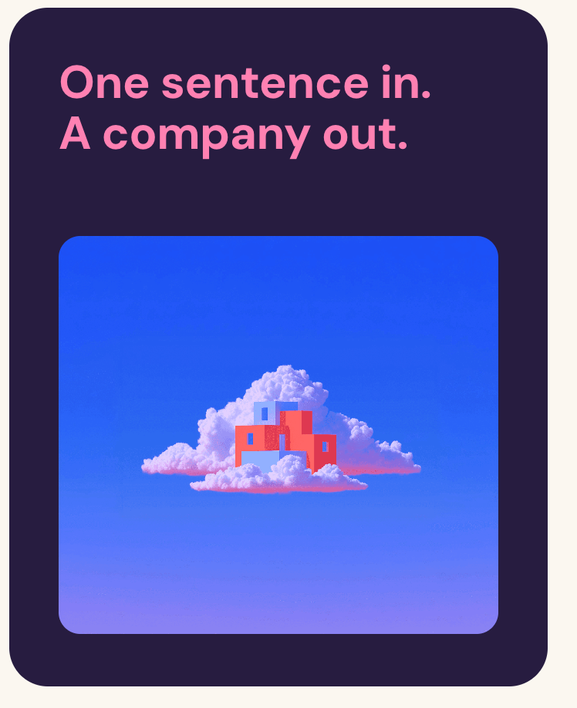

- 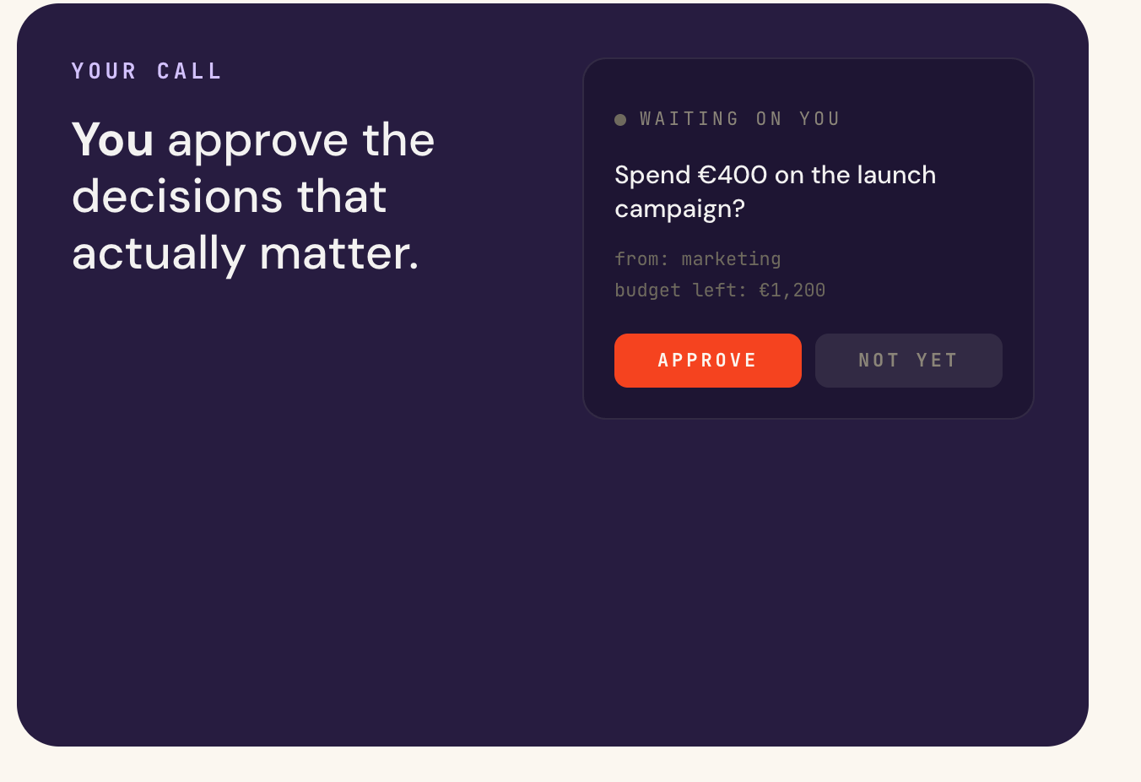

Please do bring that message box in the bottom right corner instead of top right corner please

- You can make the better spacing between the texts cos i feel like all are close
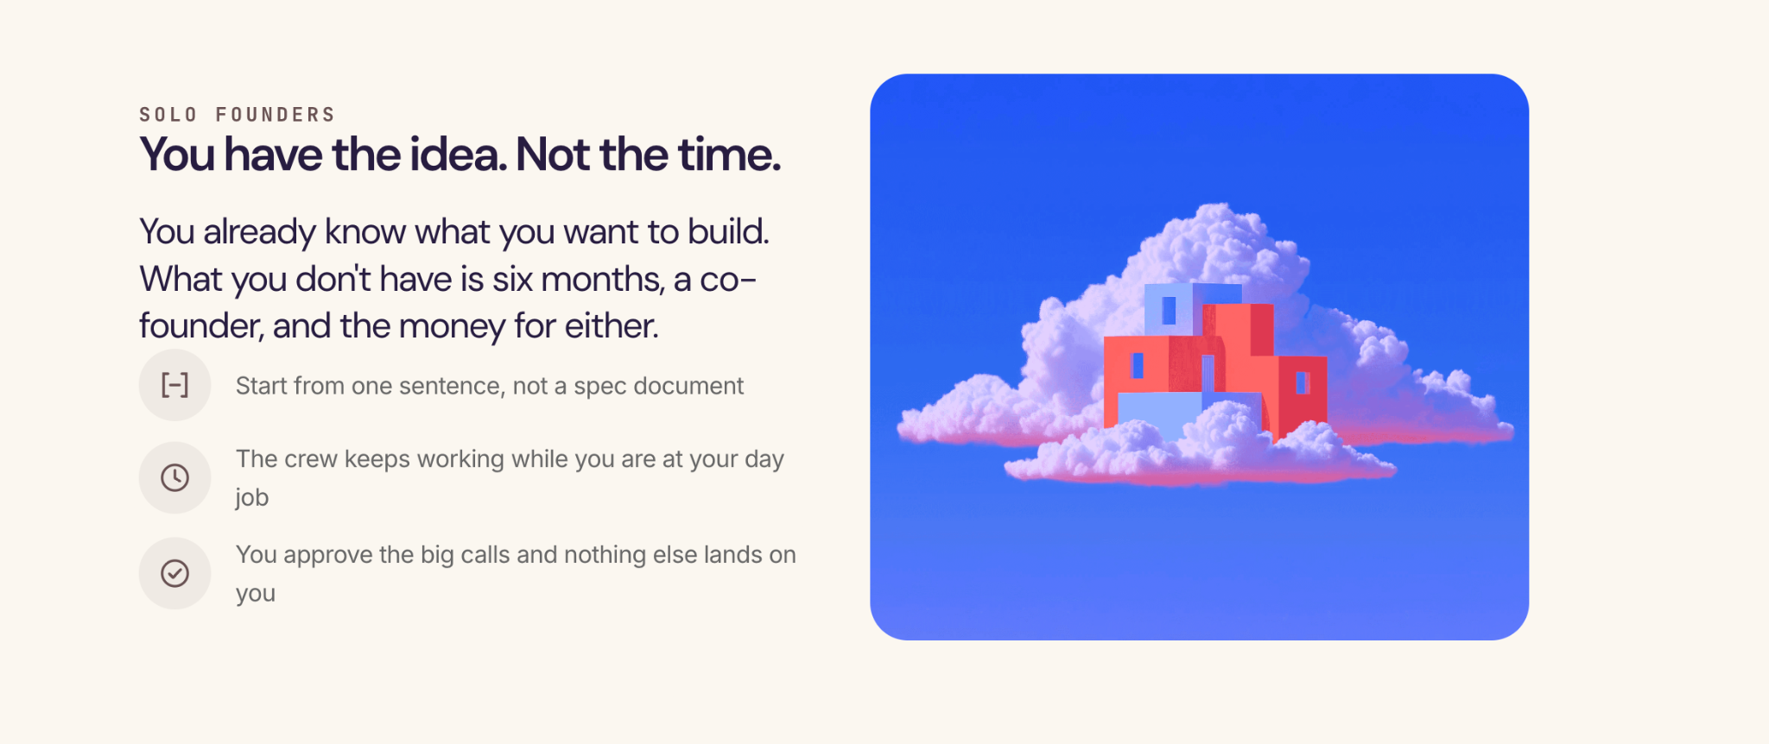
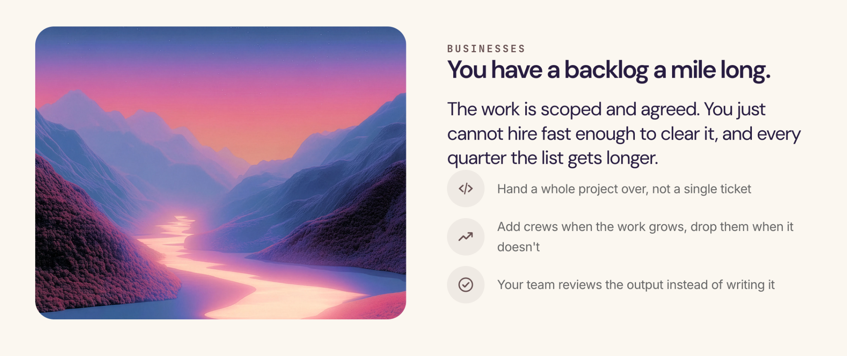

- About this there must be a section saying meet our team - so please right before those image ill attach the team names, logos and places where they worked accordingly and provide it to u in chat
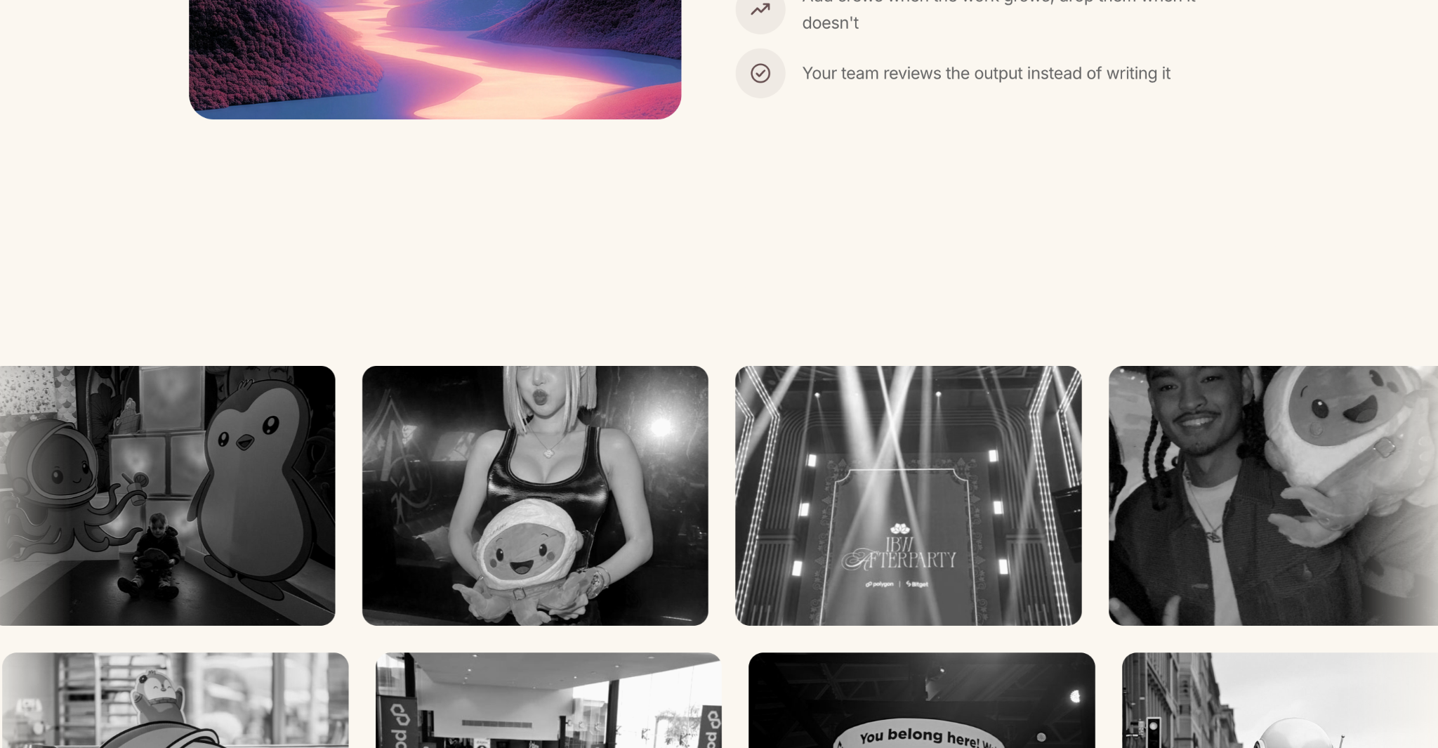

- Bring the cloud a bit lower and the text a bit must be front of it overlapping accordingly
