apan jo time table bna rhe hai usme jaha tak lagta hai ki ye ye chij teacher ko fill karni pdegi jiske bad
time table create hoga, sabhi classes ke names.
majorly 4 classes hai bas:
B.Tech
Bca
Mca

In sabhi ke years:
4 years (3 batches in total) [first year is in applied]
3 years (3 batches in total)
2 years (2 batches in total)

Subjects:
Robotics and AI BTAI-702 <- is type se names milenge mostly aagar direct sir copy paste bhi karte hai to: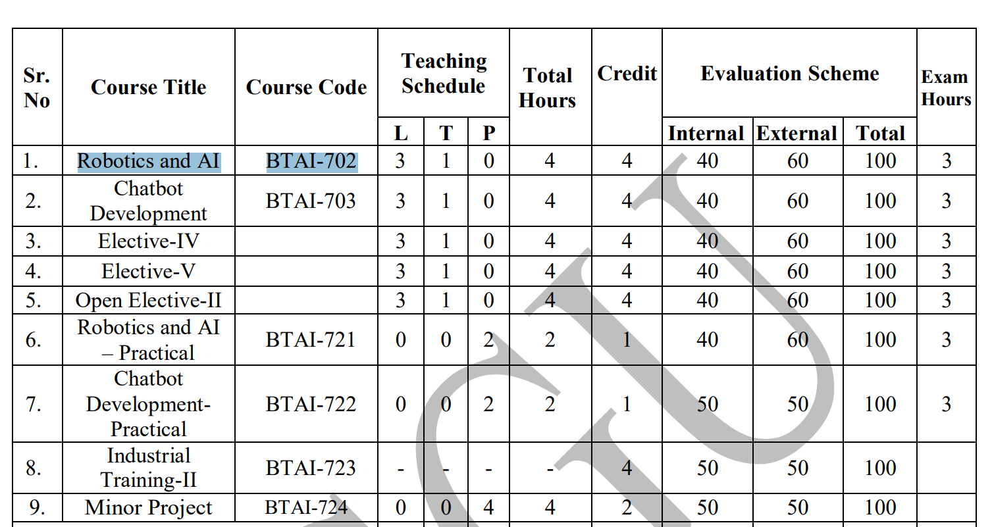

Apan isko 2 groups me break kar lenge, jisse ki subject name alag ho jaye and apa easily return kar sake:
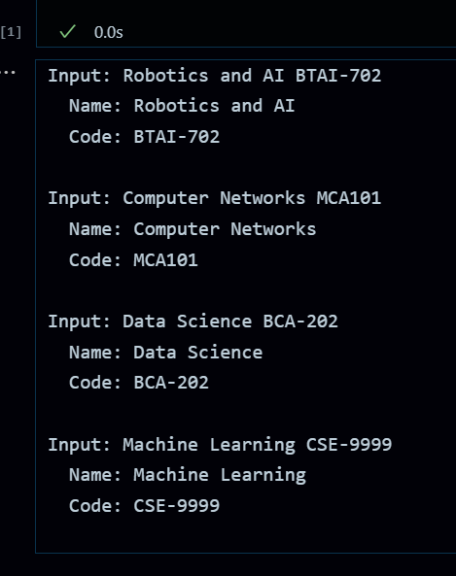
Real code is returned in testing.ipynb cell 1 (random_work branch)
BTAI-721 -> isko string bna ke slice kar lenge [0: -3], jisse apne pass 721 aa jayega subject code ka, and isse ek new column generate karenge vo ho jayegi apni subject ID (S721) is type se instead of giving 1,2,3,4,5. but agar ye sahi nhi hai to we’ll stick with 1,2,3…
ek subject ke name se mostly apne ko ye sabh mil jayega:
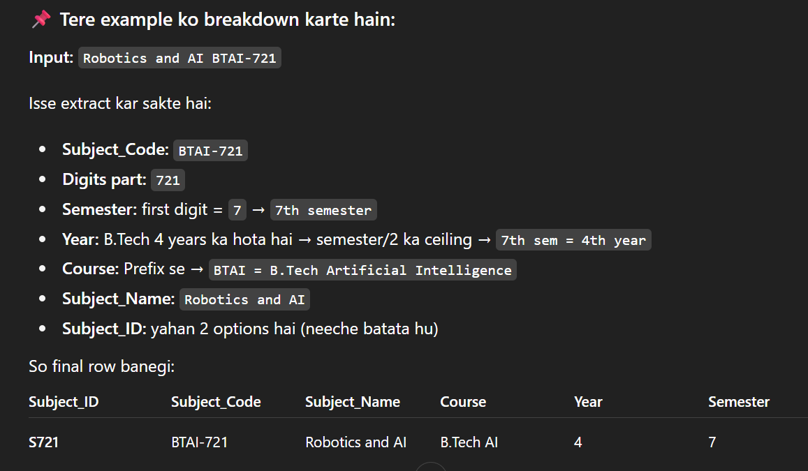
Uppar vali key me thodi problem and clash ho sakta hai isliye ye updated hai:
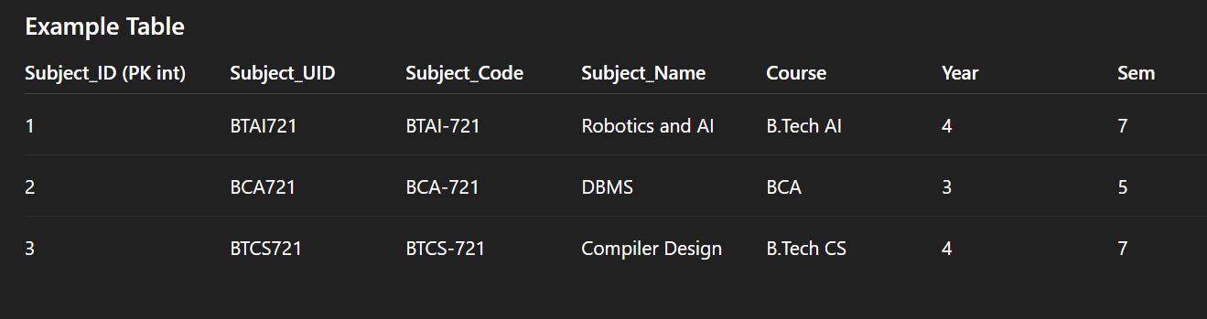
Highfen hta denge (-) BTAI721 is type se

Lecture_Type,Hours_Per_Week:

4 hrs to fix rahenge per lecture ke and lab ke 2 hrs, yani ki agar theory hai to daily me usko dalna hai 1 hr, ya maximum 2 daal sakte hai jab agar apne pass shortage hota ho teachers ka, ya clash hota ho, ya fir agar compact me bola gya ho kuch classes ke timetable ho, taki jin classes ka timetable compact bola gya hai unke timetable me fast packup ho jaye and jisme nhi bola matlab ki vo expended category me aa jayega to usme apan 2 lectures bhi daal sakte hai ek hi subject ke. Fallback case kaho isko ya normal case.
Ye to tha cp-sat based and ml based
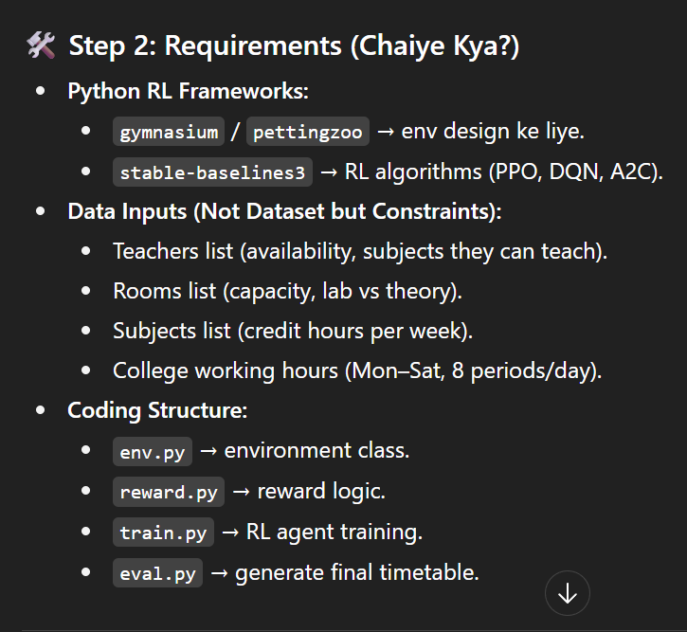
ye idea mai soch rha huki teachers ke timetables lelenge jitne hai sabhi, students ke, uske bad RL me constraints bna ke feed in kar denge

