HONEYPOT – AN INTRUSION DETECTION & DEFLECTION SYSTEM

A PROJECT REPORT

Submitted by
NAVEEN KUMAR S
RRN: 230282601086

Under the guidance of

Mrs. T. PANDIYAVATHI

In the partial fulfillment for the award of the degree of

MASTER OF COMPUTER APPLICATIONS



MAY 2024


BONAFIDE CERTIFICATE

Certified that this project report “HONEYPOT – AN INTRUSION DETECTION & DEFLECTION SYSTEM” is the bonafide work of NAVEEN KUMAR S (RRN: 230282601086) who carried out the project under my supervision. Certified further, that to the best of my knowledge the work reported here in does not from part of any other project report or dissertation on the basis of which a degree or award was conferred on an earlier occasion on this or any other candidate.

SIGNATURE |  | SIGNATURE
Mrs. T. PANDIYAVATHI |  | Dr. M. SYED MASOOD
SUPERVISOR  Assistant Professor (Sr. Grade) |  | HEAD OF THE DEPARTMENT  Associate Professor
Department of Computer Applications, | Department of Computer Applications,
B. S. Abdur Rahman Crescent Institute of Science and Technology,  Vandalur, Chennai-600048. |  | B. S. Abdur Rahman Crescent Institute of Science and Technology,  Vandalur, Chennai-600048.



VIVA-VOCE EXAMINATION

The viva-voce examination of the project work titled “HONEYPOT – AN INTRUSION DETECTION & DEFLECTION SYSTEM” submitted by NAVEEN KUMAR S, RRN: 230282601086, is held on ______________________

INTERNAL EXAMINER EXTERNAL EXAMINER

ACKNOWLEDGEMENT

I thank the Almighty for showering His blessings upon me in completing the project. I submit this project with a deep sense of gratitude and reverence for my beloved parents for their moral support and encouragements.
I sincerely express my heartfelt gratitude to Dr. T. Murugesan, Vice Chancellor, B.S. Abdur Rahman Crescent Institute of Science and Technology and Dr. N. Raja Hussain, Registrar for furnishing every essential facility for doing my project.
I owe my sincere gratitude to Dr. Sharmila Sankar, Professor and Dean School of Computer, Information and Mathematical Science (SCIMS). Dr. M. Syed Masood, Associate Professor and Head, Department of Computer Applications for providing strong oversight of vision, strategic direction, encouragement and valuable suggestions in completing my project work.
I convey my earnest thanks to my project guide Mrs .T. Pandiyavathi, Assistant Professor (Sr.Gr.), Department of Computer Applications, for her valuable guidance and support throughout the project.
I sincerely extend my gratitude to our Project Committee Members, Dr. A. Abdul Azeez Khan, Associate Professor, Dr. K. Javubar Sathick, Associate Professor and our Project Coordinators, Dr. A. K. Ashfauk Ahamed, Assistant Professor (Sr.Gr.), Mr. M. Mohammed Jalaluddin, Assistant Professor, Department of Computer Applications, for their invaluable insights, constructive feedback, and continuous support throughout our project.
I extend my sincere thanks to all my faculty members for their valuable suggestions, timely advice and support to complete the project.

- NAVEEN KUMAR S
ABSTRACT
The Honeypot System is a cybersecurity tool designed to detect, analyze and mitigate unauthorized access attempts by simulating vulnerable network services. This project implements two primary honeypot modules an SSH Honeypot and an HTTP WordPress Honeypot, both integrated with a comprehensive dashboard for real time data visualization and analysis. The SSH Honeypot emulates a secure shell server to capture attacker credentials and commands, while the HTTP Honeypot mimics a WordPress login page to log unauthorized access attempts. Both modules employ logging mechanisms to record attacker interactions, including IP addresses, usernames, passwords and executed commands. The collected data is parsed and processed using Python based data analysis tools, including Pandas for log parsing and Dash for creating an interactive web based dashboard. The dashboard visualizes critical metrics, such as the top 10 IP addresses, usernames, passwords and commands, providing insights into attacker behavior. Additional features include optional geolocation mapping of IP addresses and customizable logging configurations. The system aims to enhance network security by enabling administrators to study attack patterns, improve intrusion detection and strengthen defensive strategies. The modular design ensures scalability, allowing for future enhancements with additional honeypot types or advanced analytical capabilities.

TABLE OF CONTENTS

CHAPTER NO. |  |  |  | TITLE |  |  | PAGE NO.
 |  | ABSTRACT |  |  |  |  | v
 |  | LIST OF TABLES |  |  |  |  | ix
 |  | LIST OF FIGURES |  |  |  |  | x
 |  | LIST OF ABBREVIATIONS |  |  |  |  | xi
1. |  | INTRODUCTION |  |  |  |  | 1
 |  | 1.1 |  | GENERAL |  |  | 1
 |  | 1.2 |  | OBJECTIVES |  |  | 2
 |  | 1.3 |  | EXISTING SYSTEM |  |  | 3
 |  |  |  | 1.3.1 |  | Disadvantages of Existing System | 4
 |  |  |  | 1.3.2 |  | Literature Survey | 5
 |  | 1.4 |  | PROPOSED SYSTEM |  |  | 7
 |  |  |  | 1.4.1 | Advantages of Proposed System |  | 8
 |  | 1.5 |  | ORGANISATION OF PROJECT |  |  | 9
2. |  | PROBLEM DEFINITION AND METHODOLOGY |  |  |  |  | 10
 |  | 2.1 |  | PROBLEM DEFINITION |  |  | 10
 |  | 2.2 |  | METHODOLOGY |  |  | 11
3. |  | DEVELOPMENT PROCESS |  |  |  |  | 13
 |  | 3.1 |  | REQUIREMENT ANALYSIS |  |  | 13
 |  |  |  | 3.1.1 |  | Hardware Specification | 14
 |  |  |  | 3.1.2 |  | Software Specification | 15
 |  | 3.2 |  | SYSTEM DESIGN |  |  | 15
 |  |  |  | 3.2.1 |  | System Architecture | 15
 |  |  |  | 3.2.2 Flow Diagram |  |  | 17
 |  | 3.3 |  | DETAILED DESIGN |  |  | 20
 |  |  |  | 3.3.1  3.3.2 |  | Use Case Diagram  Sequence Diagram | 20  22
 |  | 3.4 |  | IMPLEMENTATION DETAILS |  |  | 25
 |  | 3.5 |  | ALGORITHM |  |  | 29
 |  |  |  | 3.5.1 Environment Setup and Initialization |  |  | 29
 |  |  |  | 3.5.2 Launching the SSH Honeypot |  |  | 29
 |  |  |  | 3.5.3 Launching the HTTP Honeypot |  |  | 29
 |  |  |  | 3.5.4 Parsing and Processing Logs |  |  | 29
 |  |  |  | 3.5.4 Dashboard Deployment |  |  | 30
 |  |  |  | 3.5.4 Continuous Monitoring and Response |  |  | 30
 |  | 3.6 |  | MODULES AND ITS DESCRIPTION |  |  | 30
 |  |  |  | 3.6.1 SSH Honeypot Module |  |  | 30
 |  |  |  | 3.6.2 Data Parsing and Analysis Module |  |  | 31
 |  |  |  | 3.6.3 Honeypot Launcher Module |  |  | 31
 |  |  |  | 3.6.4 Dashboard Visualization Module |  |  | 31
 |  |  |  | 3.6.5 HTTP Honeypot Module |  |  | 32
 |  | 3.7 |  | TESTING PHASE |  |  | 32
 |  |  |  | 3.7.1 | Types of System Testing |  | 32
 |  |  |  | 3.7.2 | Phases of System Testing |  | 36
 |  |  |  | 3.7.3 | Performance Evaluation |  | 39
4. | RESULT ANALYSIS AND DISCUSSION |  |  |  |  |  | 42
5. | CONCLUSION AND FUTURE ENHANCEMENTS |  |  |  |  |  | 46
 | 5.1 |  | CONCLUSION |  |  |  | 46
 | 5.2 |  | FUTURE ENHANCEMENT |  |  |  | 47
 | REFERENCES |  |  |  |  |  | 49
 | APPENDIX |  |  |  |  |  | 50
 | CERTIFICATION |  |  |  |  |  | 59
 | TECHNICAL BIOGRAPHY |  |  |  |  |  | 62

LIST OF TABLES

TABLE NO. | TABLE NAME | PAGE NO.
3.1 | Testing Criteria | 14
3.2 | System Performance Comparison | 36

LIST OF FIGURES
FIGURE NO | FIGURE NAME | PAGE NO
3.1 | Architecture Diagram | 13
3.2 | Flow Diagram | 14
3.3 | Use Case Diagram | 20
3.4 | Sequence Diagram | 23
3.5 | System Performance Comparison | 25
4.1 | Terminal Output | 43
4.2 | Power shell Terminal | 44
4.3 | Commands Logging | 44
4.4 | Http Logging | 45
4.5 | Dashboard | 45

LIST OF ABBREVIATIONS

SSH – Secure Shell
HTTP – Hypertext Transfer Protocol
API – Application Programming Interface
IDS – Intrusion Detection System
Pandas – Python Data Analysis Library
DASH – Dash Framework for Visualization
FLASK – Flask Web Framework
OS – Operating System
PARAMIKO – Python SSH Library
RAM – Random Access Memory
CPU – Central Processing Unit
IP – Internet Protocol
GUI – Graphical User Interface
I/O – Input/Output
IDE – Integrated Development Environment

CHAPTER 1
INTRODUCTON
The chapter covers the project’s overall overview, existing system, and the proposed one are covered in this chapter. It provides a general overview of the project. The details of the existing system, its drawbacks, and how the proposed approach offers a workaround are explained by the existing system.
  - GENERAL
In the rapidly evolving landscape of cybersecurity, protecting networks from unauthorized access and malicious activities is a critical challenge. Cyber attackers continuously exploit vulnerabilities in systems, employing techniques such as brute force attacks, credential stuffing and reconnaissance to gain access to sensitive resources. To counter these threats, organizations increasingly rely on proactive defense mechanisms like honeypots—decoy systems designed to attract and monitor malicious activities without exposing real assets. Honeypots serve as early warning systems, enabling security professionals to study attacker behaviors, gather intelligence on attack methodologies and enhance intrusion detection strategies.
This project presents the development of a Honeypot System comprising two core components an SSH Honeypot and an HTTP WordPress Honeypot, integrated with a sophisticated data visualization dashboard. The SSH Honeypot simulates a secure shell server, capturing credentials and commands entered by attackers, while the HTTP Honeypot mimics a WordPress login interface to log unauthorized access attempts. Both modules are designed to lure attackers into interacting with the system, thereby exposing their tactics and tools. The system logs critical data, including IP addresses, usernames, passwords and executed commands, which are processed and analyzed using Python based tools such as Pandas for data parsing and Flask/Dash for web application development.
A key feature of the project is its interactive dashboard, which provides real time insights into attacker activities through visualizations like bar charts and tables, highlighting metrics such as the most frequently used credentials and common attack sources.
The motivation behind this project stems from the need for accessible, scalable and informative tools to bolster network security. By deploying low interaction honeypots, the system minimizes resource usage while maximizing data collection efficiency. Optional features, such as IP geolocation mapping, further enrich the analysis by identifying the geographical origins of attacks. The modular architecture of the system ensures flexibility, allowing for the integration of additional honeypot types or advanced features like machine learning based anomaly detection in the future. This project aims to empower security administrators with actionable intelligence, enabling them to strengthen defenses, anticipate threats and contribute to the broader field of cybersecurity research.
  - OBJECTIVES
The primary aim of this project is to develop a Honeypot System that strengthens network security by detecting, analyzing and visualizing unauthorized access attempts. The system is designed to act as a proactive defense mechanism providing actionable intelligence to security administrators and researchers. To achieve this overarching goal the project outlines several specific objectives that guide its development and implementation.
The first objective is to create two low interaction honeypot modules an SSH Honeypot and an HTTP WordPress Honeypot. These modules simulate vulnerable network services to attract attackers capturing critical data such as login attempts, credentials and executed commands. By mimicking real systems the honeypots ensure that attackers interact with them revealing their tactics without compromising actual network resources.
Another key objective is to implement robust data logging mechanisms. The system is designed to record detailed information about attacker interactions, including IP addresses, usernames, passwords and commands, in a structured and accessible format. This comprehensive logging ensures that all relevant data is captured for subsequent analysis, forming the foundation for generating meaningful insights.
The project also seeks to facilitate effective data analysis by leveraging Python based tools like Pandas. The objective here is to parse and process log files, transforming raw data into structured formats that highlight patterns and trends in attacker behavior. This analytical capability enables the system to provide clear, concise information about the nature and frequency of attacks.
A significant objective is to provide real time visualization through an interactive web based dashboard built with Dash and Flask. The dashboard aims to present key metrics such as the top 10 IP addresses, usernames, passwords and commands in an intuitive format, using visualizations like bar charts and tables. This feature empowers administrators to monitor threats dynamically and respond promptly to emerging risks.
Additionally, the project aims to enhance its analytical capabilities by incorporating optional features like IP geolocation mapping. By identifying the geographical origins of attacks, this functionality provides deeper context to the data, helping users understand global attack trends and prioritize defensive measures accordingly.
The system is designed with scalability and modularity in mind, ensuring that it can evolve over time. The objective is to create a flexible architecture that supports the integration of new honeypot types, advanced analytical tools, or third party APIs, making the system adaptable to future cybersecurity needs.
Finally, the project seeks to contribute to security research and defense by generating actionable intelligence from attacker interactions. By providing insights into malicious activities, the system aims to improve intrusion detection systems, inform threat mitigation strategies and support the broader cybersecurity community in building more resilient networks.
  - EXISTING SYSTEM
Current solutions include low-interaction honeypots like Cowrie, which emulates SSH and Telnet to capture attacker credentials and commands, and Dionaea, designed to trap malware by mimicking services like FTP. These systems focus on logging basic interactions but often require manual analysis or external tools for deeper insights, limiting their real-time usability. Additionally, tools like HoneyD offer versatility by simulating multiple operating systems, though they lack integrated visualization, making them less accessible for non-technical users.
Commercial offerings, such as Thinkst's Canary and TrapX, provide more advanced honeypot deployments with centralized management and plug-and-play setups. These solutions enhance ease of use and scalability but come with higher costs and reduced customization compared to open-source alternatives. Research-based systems, like those proposed by Wang et al. (2019), use honeynets to study large-scale attacks such as DDoS, offering detailed analysis but requiring significant resources and expertise. However, these systems often focus on specific attack types, lacking the flexibility to integrate multiple protocols like SSH and HTTP within a single framework.
A common limitation across existing systems is the absence of a unified dashboard for real-time data visualization, forcing users to rely on separate software for interpretation. For instance, Kippo and Glastopf excel at logging SSH and web-based attacks respectively but do not provide built-in analytics or geolocation features. This gap hinders quick decision-making for security teams. Moreover, many systems are not designed for easy scalability or modularity, making it challenging to adapt to evolving threats or add new honeypot types.
Despite their strengths, existing honeypot systems often fall short in providing an integrated, user-friendly solution that combines multiple honeypot types with advanced analytics. The lack of a cohesive approach to data processing and visualization.
    - Disadvantages of Existing System
Here is the given content into clear bullet points highlighting the drawbacks of current system.
- Limited Visualization: Many existing honeypots, like Cowrie and Dionaea, lack built-in dashboards, requiring external tools for data analysis and visualization, which delays threat response.
- Protocol Specificity: Systems like Kippo (SSH) and Glastopf (web) focus on specific protocols, lacking integration of multiple honeypot types (e.g., SSH and HTTP) in a single framework.
- Scalability Challenges: Solutions such as HoneyD are not easily scalable, making it difficult to add new honeypot types or handle increased traffic without significant reconfiguration.
- Resource Intensity: Research-oriented honeynets, like those for DDoS analysis, demand high computational resources, rendering them impractical for smaller organizations with limited infrastructure.
- Usability Issues: The absence of intuitive interfaces in tools like Kippo makes them less accessible to non-technical users, hindering adoption and effective monitoring.
- Fragmented Functionality: Most systems do not combine logging, analytics, and visualization in a unified platform, leading to fragmented workflows and inefficiencies in threat analysis.
1.3.2 Literature Survey
The field of cybersecurity has been significantly advanced by the development and deployment of honeypot systems, which serve as deceptive tools to detect, analyze and mitigate cyber threats. Numerous researchers have explored innovative approaches to leveraging honeypots for intrusion detection, threat intelligence gathering and malware analysis, contributing to more robust network security frameworks.
In the work by Holbel et al. (2024), [1] “Virtualized Honeypots for Threat Hunting and Malware Analysis,” the authors investigated the use of virtualized environments to create scalable honeypot systems. Their research, published in a leading cybersecurity journal, demonstrated how virtualization enhances the efficiency of honeypots in monitoring and analyzing cyber threats, emphasizing their role in proactive threat hunting and detailed malware reporting.
Ahmad et al. (2023) proposed a [2] “Honeypot Based Approach for Detecting and Analyzing Active Cyber Attacks.” Their study, published on ResearchGate, focused on the deployment of honeypots to identify modern attack strategies, such as brute force and reconnaissance techniques. They highlighted the importance of real time attack analysis in improving incident response mechanisms, showcasing honeypots as critical tools for dynamic threat mitigation.
Another notable contribution was made by Pashaei et al. (2022) through their work [3] “Early Intrusion Detection System for Industrial Control Networks Using Honeypots,” published in a peer reviewed cybersecurity journal. Their system integrated honeypots to proactively detect malicious activities in critical infrastructure networks. The authors emphasized the role of honeypots in enhancing security for industrial systems, demonstrating their effectiveness in early threat detection and prevention.
In the paper by AlZoubi and Alrashdan (2022), [4] “Impact of Honeypot Networks on System Security,” published in a prominent security research journal, the authors explored the broader implications of deception based security strategies. Their research underscored how honeypot networks contribute to improved attack mitigation and overall cyber defense capabilities, advocating for their integration into modern security architectures.
Amal and Venkadesh (2022) conducted a comprehensive review titled [5] “Role of Honeypots in Cyber Attack Detection and Prevention,” published in a leading cybersecurity journal. Their study analyzed various honeypot classifications, including low interaction and high interaction systems and their applications in real world scenarios. They emphasized the growing significance of honeypots in modern security architectures, particularly for detecting sophisticated cyber threats.
Wang et al. (2019) proposed a [6] “Honeynet Based Simulation Approach for DDoS Attack Mitigation,” published in a reputable network security journal. Their research demonstrated the effectiveness of honeynets in analyzing large scale Distributed Denial of Service (DDoS) attacks. The authors highlighted how simulated honeypot environments can be used to develop robust countermeasures, contributing to improved network resilience against large scale attacks.
Patil et al. [7] introduced a honeypot-based secure network system utilizing honeywords to detect password database breaches, published in the International Research Journal of Engineering and Technology. The research highlights how honeywords, decoy passwords stored alongside legitimate ones, trigger alarms when used, enhancing intrusion detection. They compare various honeyword generation techniques, emphasizing improved security and flatness in their proposed method.
Tian et al. (2021) [8] proposed a dynamic bounded rational honeypot-APT game model for Industrial Internet of Things security, published in the IEEE Internet of Things Journal. Their research leverages prospect theory to model attacker-defender interactions under bounded rationality, focusing on honeypot deployment in software defined networks. The study demonstrates that their strategy outperforms existing methods in defensive performance against advanced persistent threats. Experimental results validate the effectiveness of continuous data collection by honeypots in enhancing IIoT security.
In the work by Zhang et al. (2021), [9] “Honeypot Driven Threat Intelligence for IoT Security,” published in an international cybersecurity conference proceedings, the authors explored the use of honeypots to secure Internet of Things (IoT) ecosystems. Their study focused on capturing and analyzing IoT specific attack patterns, demonstrating how honeypots can enhance threat intelligence for resource constrained devices, thereby strengthening IoT security frameworks.
Lastly, Kumar and Sharma (2020) [10] “Adaptive Honeypot Systems for Evolving Cyber Threats,” published in a peer reviewed journal on cybersecurity innovations. Their research introduced a dynamic honeypot framework that adapts to changing attack vectors using machine learning techniques.
1.4 PROPOSED SYSTEM
The proposed Honeypot System is designed to address the limitations of existing cybersecurity tools by offering an integrated, scalable and user friendly framework for detecting, analyzing and visualizing cyber threats. The system comprises two primary low interaction honeypot modules—an SSH Honeypot and an HTTP WordPress Honeypot—coupled with a robust data logging mechanism and an interactive web based dashboard. By simulating commonly targeted network services, the system attracts malicious actors, captures their interactions and provides actionable intelligence to enhance network security. The modular architecture ensures flexibility, enabling seamless integration of additional honeypot types or analytical tools in the future, making it adaptable to evolving cyber threats.
The SSH Honeypot emulates a secure shell server, designed to capture attacker credentials, such as usernames and passwords, as well as commands executed during sessions. Built using Python and the Paramiko library, it logs interactions in a structured format, allowing for detailed analysis of attacker tactics. The HTTP WordPress Honeypot, implemented using Flask, mimics a WordPress login page to lure attackers targeting web applications. It records login attempts, including IP addresses, usernames and passwords, simulating a realistic yet controlled environment. Both honeypots prioritize low resource usage, ensuring efficient deployment across various network setups without compromising performance.
A key feature of the proposed system is its comprehensive data analysis and visualization pipeline. Log files generated by the honeypots are parsed using Pandas, transforming raw data into structured datasets that highlight critical metrics, such as the most frequent IP addresses, usernames, passwords and commands. The system includes an optional IP geolocation feature, leveraging APIs like CleanTalk to map attack origins, providing geographical context to threat data. The processed data is then visualized through an interactive dashboard built with Dash and Dash Bootstrap Components, featuring bar charts, tables and real time updates. This dashboard enables security administrators to monitor threats intuitively, identify attack patterns and make informed decisions swiftly.
1.4.1 Advantages of Proposed System
Here is the given content into clear bullet points highlighting the Advantages of Proposed System of current systems.
- Integrated Visualization: The proposed Honeypot System features a built-in Dash-based dashboard, providing real-time charts and tables for quick threat analysis and decision-making.
- Multi-Protocol Support: It combines SSH and HTTP WordPress honeypots in a single framework, offering flexibility to monitor diverse attack vectors effectively.
- Scalability and Modularity: The modular architecture allows easy integration of additional honeypot types and handles increased traffic with minimal reconfiguration.
- User-Friendly Design: The intuitive dashboard and straightforward setup cater to both technical and non-technical users, improving accessibility and adoption.
- Cost-Effective: Being open-source with no licensing fees, it provides advanced features at a lower cost compared to commercial alternatives.
- Comprehensive Functionality: Unifies logging, data processing, and visualization in one platform, streamlining workflows and reducing reliance on external tools.
1.5 ORGANISATION OF PROJECT
Organization of the report is the short summary of the forthcoming chapter. In this, Chapter 1 deals with the introduction of the project were discussed. Chapter 2 deals with problem definition and methodology. Chapter 3 deals with the development process and the requirement analysis, resources, system design. Chapter 4 deals with Result analysis.Chapter 5 deals with conclusion with future enhancement.

CHAPTER 2
PROBLEM DEFINITION AND METHODOLOGY
2.1 PROBLEM DEFINITON
The increasing sophistication and frequency of cyber attacks, such as brute-force attempts, credential stuffing, and reconnaissance, pose significant threats to network security, making it challenging for organizations to detect and mitigate malicious activities effectively. Traditional security measures like firewalls and intrusion detection systems often fail to provide detailed insights into attacker behavior, limiting proactive defense strategies. Existing honeypot systems, while useful for capturing attack data, suffer from several shortcomings, including a lack of integrated visualization, limited protocol support (e.g., focusing solely on SSH or HTTP), and poor scalability, which hinders their ability to adapt to diverse and evolving threats.
Additionally, many current solutions do not offer real-time analytics or user-friendly interfaces, forcing security teams to rely on manual log analysis or external tools, which delays response times and reduces efficiency. The absence of features like geolocation mapping in most systems further restricts the ability to understand the geographical origins of attacks, a critical factor for global threat assessment. There is a clear need for a comprehensive, scalable, and accessible honeypot system that combines multiple protocols, provides real-time data visualization, and supports advanced analytics to empower security administrators with actionable intelligence for improved threat detection and mitigation.
This system aims to address these problems by developing a Honeypot System that integrates SSH and HTTP WordPress honeypots, coupled with an interactive dashboard for real-time monitoring and analysis. The system seeks to overcome the limitations of existing solutions by offering modularity, scalability, and advanced features like geolocation mapping, while maintaining efficiency on standard hardware. By providing a unified platform for threat detection, data processing, and visualization, the proposed system aims to enhance network security and support proactive defense against cyber threats.
2.2 METHODOLOGY
The methodology adopted for developing the Honeypot System is a structured, iterative approach that integrates software engineering principles with cybersecurity best practices. The process is divided into distinct phases requirements analysis, design, implementation, testing and evaluation to ensure the system effectively detects, logs and analyzes cyber threats while providing actionable insights through visualization. This systematic methodology allows for continuous refinement and scalability, aligning with the project's objectives of modularity and usability.
The initial phase involves gathering and defining the system requirements based on cybersecurity needs and existing honeypot limitations. Key requirements include the development of SSH and HTTP WordPress honeypots to simulate vulnerable services, a robust logging mechanism to capture attacker interactions and an interactive dashboard for real time visualization. Stakeholder input from security administrators and researchers is considered to prioritize features like IP geolocation mapping and modularity. A detailed specification document is created, outlining hardware and software needs, ensuring compatibility with diverse network environments.
In the design phase, the architecture of the Honeypot System is conceptualized, focusing on a modular structure. The design includes two honeypot modules (SSH and HTTP WordPress), a data processing pipeline and a visualization dashboard. UML diagrams, such as class diagrams for component interactions and flowcharts for data processing, are drafted to map out the system workflow. The design emphasizes low interaction honeypots to minimize resource usage, with provisions for future enhancements like additional honeypot types. Security considerations, such as isolating decoy traffic from the internal network, are integrated into the firewall and network design.
The implementation phase involves coding the system using Python as the primary programming language. The SSH Honeypot is developed using the Paramiko library to emulate a secure shell server, while the HTTP WordPress Honeypot is built with Flask to simulate a login page. Log files are managed with RotatingFileHandler for efficient storage and data parsing is handled by Pandas. The dashboard is constructed using Dash and Dash Bootstrap Components, incorporating Plotly for visualizations. Optional geolocation features are integrated via the CleanTalk API, with error handling for rate limits. The codebase is version controlled using Git to track changes and facilitate collaboration.
The testing phase evaluates the system's functionality, performance and security. Unit tests are conducted on individual components (e.g., log parsing, honeypot responses) to ensure accuracy. Integration testing verifies the seamless interaction between honeypots, data processing and the dashboard. Simulated attack scenarios are executed to assess the system's ability to capture and log data, with metrics like log completeness and dashboard responsiveness measured. Security testing checks for vulnerabilities in the honeypot design, ensuring decoy traffic does not compromise the internal network. Feedback from testing informs iterative improvements.
The final phase involves evaluating the system's effectiveness against predefined objectives, such as threat detection accuracy and visualization clarity. Performance metrics, including resource usage and response time, are analyzed using real world and synthetic attack data. User feedback from security professionals is collected to assess usability and identify areas for enhancement. Upon successful evaluation, the system is deployed in a controlled network environment, with documentation provided for setup and maintenance. Continuous monitoring and updates are planned to address emerging threats, ensuring long term relevance and adaptability.

CHAPTER 3
DEVELOPMENT PROCESS
Development process lifecycle activities include the development process. Both requirement analysis and design are part of the development process.
3.1 REQUIREMENT ANALYSIS
The development of the Honeypot System, aimed at identifying and documenting the functional, non-functional, and operational needs to ensure the system effectively addresses cybersecurity challenges. This phase involves collaboration with stakeholders, including security administrators and network engineers, to define clear objectives, such as detecting unauthorized access, logging attacker interactions, and providing real-time visualizations. The goal is to create a comprehensive blueprint that guides the design and implementation, ensuring the system meets user expectations while overcoming limitations of existing honeypot solutions.
Functional requirements specify the core capabilities of the system. The Honeypot System must include an SSH Honeypot to capture credentials and commands, and an HTTP WordPress Honeypot to log login attempts, both integrated with a robust logging mechanism (e.g., creds_audits.log, http_audit.log). It should process logs using Pandas, calculate metrics like the top 10 IP addresses, usernames, and passwords, and visualize them on a Dash-based dashboard with real-time updates. Additional features, such as optional IP geolocation mapping via the CleanTalk API, are included to enhance threat analysis, with error handling for API rate limits.
Non-functional requirements focus on performance, usability, and scalability. The system must operate efficiently on standard hardware (e.g., Intel i5, 8 GB RAM), ensuring low resource usage with dashboard updates under 5 seconds for up to 50 concurrent connections. Usability is prioritized through an intuitive GUI, requiring minimal training for users to interpret visualizations or toggle features. Scalability is ensured through a modular design, allowing the addition of new honeypot types without disrupting existing functionality, and the system must handle increased traffic (e.g., up to 100 connections) with minimal performance degradation.
Operational requirements address deployment and maintenance needs. The system should be compatible with Linux, Windows, and macOS, using Python 3.8+ and libraries like Paramiko, Flask, and Dash, which are widely supported. It must include documentation for setup, configuration, and troubleshooting, ensuring easy deployment in diverse network environments. Security considerations, such as isolating decoy traffic from the internal network via a firewall, are critical to prevent vulnerabilities, with logs securely managed to avoid unauthorized access.
Constraints and risks are also identified during this phase. Budget and time constraints limit the scope to low-interaction honeypots, avoiding high-interaction systems that require more resources. Risks include potential API rate limits affecting geolocation, which are mitigated by fallback mechanisms, and the challenge of high traffic loads, addressed through performance optimization strategies. The requirement analysis culminates in a detailed specification document, serving as the foundation for the design phase, ensuring the Honeypot System aligns with cybersecurity goals and user needs.
3.1.1 Hardware Specification
The Honeypot System is designed to detect, log, and analyze cyber threats using a combination of software modules and standard computing hardware, ensuring efficient performance in diverse network environments. The system operates on commonly available devices, requiring minimal hardware resources to capture attacker interactions and provide real-time visualizations.
- Device: Laptop or Desktop
- Processor: Intel i5 11th Gen or higher (or equivalent AMD processor)
- RAM: 8 GB
- Storage: 500GB / 1TB
- Network: Wireless Network or Ethernet

3.1.2 Software Specification
The Honeypot System relies on a robust software ecosystem to implement its cybersecurity features, utilizing open-source tools and libraries for flexibility and efficiency. The system is designed to operate seamlessly across multiple operating systems, leveraging Python-based frameworks and APIs to detect, process, and visualize attacker interactions. A detailed list of the software components utilized in the project is provided below.
- Operating System: Kali Linux 2024 .4, Windows 11
- Programming Languages: Python
- Libraries & Frameworks: Paramiko, Flask, Dash, Pandas, Plotly, Request
- Development Tools: VS Code
- Command Line Tools: Terminal, Power shell, Putty, PIP
- Log Management: Custom logging with RotatingFileHandler for efficient log storage
3.2 SYSTEM DESIGN
System testing for the Honeypot System ensures its reliability, performance, and security by validating its ability to detect, log, and visualize cyber threats effectively. This process encompasses various testing types unit, integration, performance, security, and usability to confirm that the SSH Honeypot, HTTP WordPress Honeypot, data processing pipeline, and Dash based dashboard function seamlessly. Conducted on the specified hardware (Intel i5, 8 GB RAM), the testing aims to identify and resolve issues, ensuring the system meets cybersecurity objectives in real world scenarios.
3.2.1 System Architecture
The architecture of the proposed Honeypot System is designed to provide a cohesive, modular and efficient framework for detecting, logging, analyzing and visualizing cyber threats. The system is structured around three core components the honeypot modules, the data processing pipeline and the visualization dashboard. These components interact seamlessly to capture attacker interactions, process raw data into actionable insights and present findings in an intuitive interface. The architecture emphasizes scalability, ensuring that additional honeypot types or analytical features can be integrated with minimal reconfiguration. By leveraging Python based tools and libraries, the system achieves a balance between performance and ease of deployment across various network environments.
At the core of the system are two low interaction honeypot modules: the SSH Honeypot and the HTTP WordPress Honeypot. The SSH Honeypot, built using the Paramiko library, simulates a secure shell server to attract attackers attempting unauthorized access. It captures credentials (usernames and passwords) and commands executed during sessions, logging them into structured files .The HTTP WordPress Honeypot, implemented with Flask, emulates a WordPress login page, logging IP addresses, usernames and passwords from login attempts into an http_audit.log file. Both honeypots operate independently but share a common logging framework, ensuring consistent data collection. This modular design allows each honeypot to function standalone or in tandem, depending on the deployment requirements.
The data processing pipeline forms the analytical backbone of the system, transforming raw log files into structured datasets for analysis. Log files generated by the honeypots are parsed using Pandas, which extracts key metrics such as IP addresses, usernames, passwords and commands. A dedicated parsing module handles different log formats, ensuring compatibility across honeypot types. For enhanced insights, the system optionally integrates with the CleanTalk API to map IP addresses to geographical locations, adding context to attack origins. The processed data is aggregated into dataframes, which are used to compute metrics like the top 10 most frequent IP addresses, credentials and commands. This pipeline is optimized for efficiency, enabling real time data handling while maintaining low resource consumption.
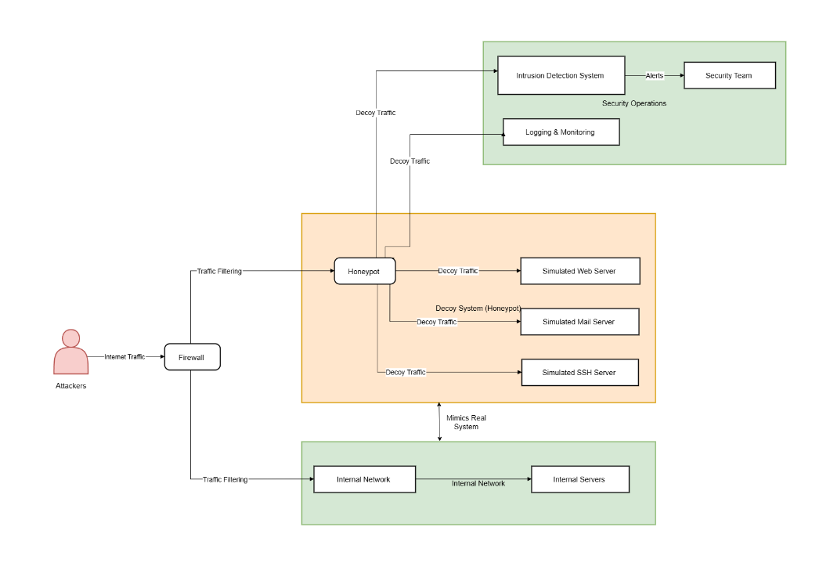
The visualization layer, powered by Dash and Dash Bootstrap Components, delivers an interactive web based dashboard that presents analytical results in a user friendly format. The dashboard features dynamic visualizations, including bar charts for top metrics and tables for detailed log entries, styled with a dark theme for clarity. It is hosted on a Flask server, accessible via a web browser and supports real time updates as new data is logged. The dashboard’s modular layout allows administrators to toggle features, such as enabling or disabling geolocation based visualizations, based on performance needs. By integrating all components honeypots, data processing and visualization into a unified architecture, the system provides a comprehensive solution for monitoring and understanding cyber threats, with flexibility to evolve alongside emerging security challenges.

Figure 3.1 Architecture Diagram
The Figure 3.1 illustrates a honeypot system architecture where attackers' internet traffic is filtered through a firewall and directed to a central honeypot. The honeypot mimics real systems to capture decoy traffic, which is then analyzed by an intrusion detection system and logged for monitoring. Security operations, including the security team, receive alerts and insights, while the internal network and servers remain protected.
3.2.2 Flow Diagram
The flow of the honeypot system begins when the user initiates the program using command line arguments that determine the operating mode either SSH based or HTTP based deception. Upon selection, the system activates the respective trap for SSH, a simulated server is brought online using Paramiko, mimicking a legitimate service and waiting for incoming login attempts. When a connection is received, it engages the client in a fake session, recording every credential and command entered. In the case of HTTP, a decoy WordPress login page is rendered through a lightweight Flask application. Any submitted usernames and passwords, along with the attacker’s IP address, are quietly logged in the background.
These interactions are not left idle; they are captured into structured log files, which serve as the foundation for further analysis. At this stage, a set of data processing scripts is triggered to parse and clean the collected data. IP addresses, credentials and command histories are extracted and organized into tabular form using a combination of regular expressions and custom parsers.
Once structured, the data moves into the visualization phase. A web dashboard, built using Python Dash, takes the processed logs and transforms them into interactive charts and tables. Here, users can view the most frequent attack sources, the most guessed usernames and passwords and even the most commonly attempted commands. Optional geolocation integration can enrich this analysis by resolving IPs to country codes, allowing for geographical threat mapping.

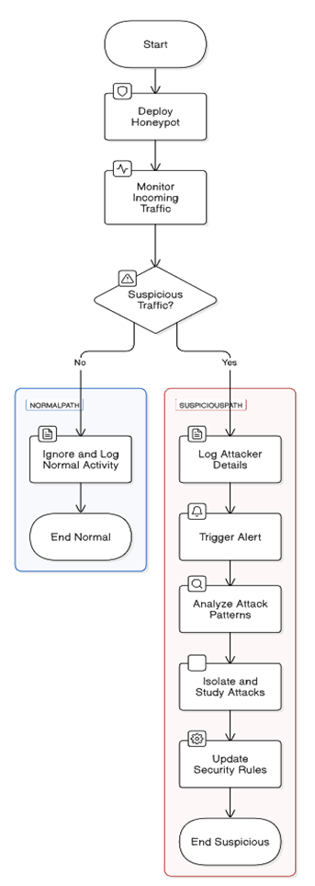

Figure 3.2 Flow Diagram
The Figure 3.2 outlines a honeypot-based intrusion detection system. It monitors incoming traffic, checks for suspicious activity and either logs normal behavior or processes suspicious traffic by logging attacker details, analyzing patterns and updating security rules. This helps enhance network security by isolating and studying threats.

3.3 DETAILED DESIGN
The honeypot system is designed as a modular, extensible framework that integrates deception, data collection, and visualization to capture and analyze cyber threats, leveraging Python’s ecosystem for portability across Linux, Windows, and macOS. It comprises two deception modules an SSH server and an HTTP based WordPress login page controlled via a command line interface, with backend data processing and a browser accessible dashboard for insights. The SSH component simulates a vulnerable service on a configurable port authenticating clients with hardcoded credentials and echoing commands until "exit", using threading for multiple connections and an RSA key for secure communication. The HTTP component mimics a login page, validating credentials on a specified port ,redirecting successful attempts to a dummy URL while logging all interactions to a rotating file capped at 2,000 bytes.
Data processing transforms logs into structured insights using pandas, extracting IPs, credentials, and commands. The visualization layer renders these insights as interactive bar charts and tables on a dashboard (port 8050), styled with a dark theme and configurable for geolocation display. This client server architecture, with modular components and efficient data flow, ensures lightweight operation, user friendly analysis, and flexibility for future enhancements, effectively meeting the project’s goals of threat intelligence gathering.
3.3.1 Use Case Diagram
The use case diagram for the honeypot system depicts the relationship between two external actors the Attacker and the Security Administrator and the smart cybersecurity monitoring system. It defines the significant functionalities that the system offers, including initiating operations, detecting malicious activities, logging data, analyzing threats, and monitoring ongoing risks, while illustrating how these actors interact with those functionalities. The diagram provides a structured overview of the system’s behavior from an end user viewpoint, emphasizing its automated deception and real time analysis capabilities designed to capture.
The Security Administrator is a key actor, engaging with the system to manage and oversee its operations. The “Start System” use case allows the Administrator to launch the honeypot, activating the SSH or HTTP services via a command line interface, setting the stage for monitoring. The “Analyze Data” use case enables the Administrator to process logged interactions, reviewing structured insights such as top IP addresses, credentials, and commands through a browser based dashboard . Additionally, the “Monitor Threats” use case involves continuously tracking system activity and potential risks, ensuring proactive awareness of attacker behavior with minimal manual intervention.
The Attacker, another critical actor, interacts with the system through its deceptive services, unaware of the monitoring. The “Detect Attack” use case is triggered when the Attacker attempts to access the SSH service with credentials or the HTTP service with login attempts prompting the system to identify these actions. The “Log Attack Data” use case automatically records these interactions such as IPs, commands, and login details into structured log files with size management via rotation. These logged data feed into the Administrator’s analysis and monitoring use cases, creating a seamless flow from attack detection to threat intelligence, showcasing the system’s ability to operate autonomously and provide valuable insights.
In summary, the use case diagram presents a well defined interaction between the Attacker, Security Administrator, and the honeypot system’s functionalities, including starting the system, detecting attacks, logging data, analyzing threats, and monitoring risks. This design ensures real time, automated cybersecurity monitoring with minimal human involvement, effectively capturing attacker behavior and delivering actionable intelligence to the Administrator. The structured approach highlights the system’s role as a proactive tool for enhancing security posture in dynamic threat environments.
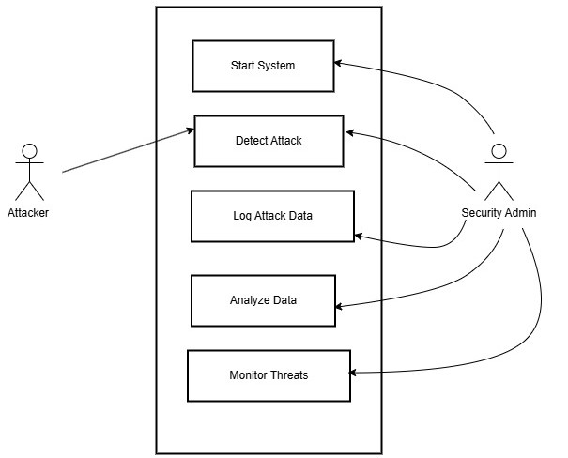
Figure 3.3 Use Case Diagram
The Figure 3.3 use case diagram illustrates the honeypot system with two actors the Attacker and the Security Administrator, interacting with a central system. It features five use cases Start System, Detect Attack, Log Attack Data, Analyze Data, and Monitor Threats connected by arrows showing the flow of actions. The Attacker initiates the Detect Attack use case, triggering Log Attack Data, while the Security Administrator manages Start System, Analyze Data, and Monitor Threats for real time threat intelligence.
    - Sequence Diagram
The sequence diagram for the honeypot system illustrates the dynamic interactions between the actors Attacker, Security Administrator, and System Admin and the system components, including the SSH Honeypot, HTTP Honeypot, Data Processing Pipeline, and Dashboard, capturing the chronological flow of actions involved in deception, data collection, and threat monitoring. It highlights the system’s operational workflow, from configuration and attack detection to data analysis and visualization, providing a clear view of how messages are exchanged over time. The diagram emphasizes the system’s automated processes, ensuring efficient cybersecurity monitoring with minimal manual intervention.
The sequence begins with the System Admin initiating the process by sending a “Configure settings “message to both the SSH Honeypot and HTTP Honeypot, setting up the system to listen on designated ports and enabling logging mechanisms. The SSH Honeypot and HTTP Honeypot confirm readiness, preparing to detect incoming attacks. Meanwhile, the Attacker initiates interactions by sending an “Attempt login (username, password)” message to either the SSH Honeypot or HTTP Honeypot, depending on the targeted service. For SSH, the system logs credentials and commands,while for HTTP, it logs login attempts and responds with a success or failure message, forwarding all logged data to the Data Processing Pipeline for further handling.
The Data Processing Pipeline receives the logged data and performs the “Parse logs and calculate metrics” action, transforming raw logs into structured insights such as top IP addresses, frequent credentials, and command patterns, with optional geolocation data if enabled (rate limited to 1,000 requests/minute). The processed data is then sent to the Dashboard as “processed data (top IPs, usernames),” which renders it as interactive charts and tables. The Security Administrator, monitoring the system, sends a “Toggle geolocation feature” message to the Dashboard to enable or disable geolocation display, customizing the visualization as needed.

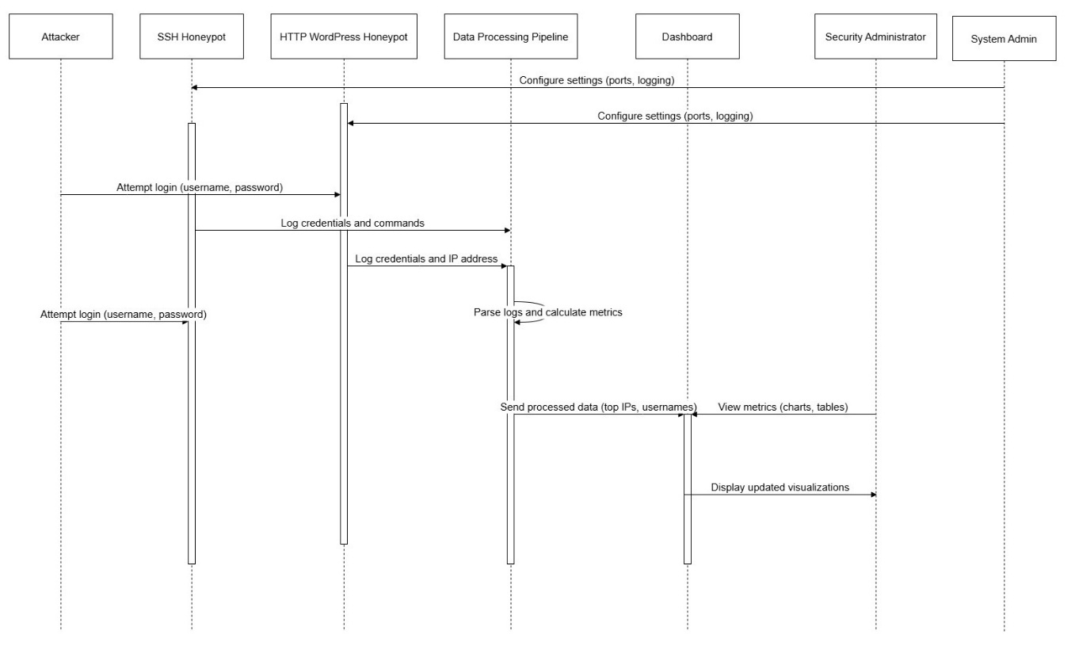
Figure 3.4 Sequence Diagram
The Figure 3.3 sequence diagram depicts the honeypot system with actors Attacker, Security Administrator, and System Admin interacting with components SSH Honeypot, HTTP Honeypot, Data Processing Pipeline, and Dashboard. It shows the flow starting with System Admin configuring settings, followed by Attacker attempting logins, which are logged and processed into metrics, and ending with the Security Administrator toggling features and receiving alerts. The diagram illustrates the chronological exchange of messages, highlighting automated data collection, processing, and real time monitoring.
In summary, the sequence diagram provides a structured depiction of the temporal interactions between the Attacker, Security Administrator, System Admin, and the honeypot system’s components, covering key processes like configuration, attack detection, data logging, processing, and threat monitoring. It showcases the system’s ability to operate autonomously, capturing attacker interactions, processing data, and delivering actionable intelligence to the Administrator through a user friendly dashboard.

  - IMPLEMENTATION DETAILS
The implementation of the Honeypot System involves integrating multiple components to create a robust cybersecurity tool capable of detecting, logging, and analyzing malicious activities. The system is developed using Python 3.8+ due to its extensive library support and open source nature, running on standard hardware across Linux, Windows, and macOS environments. The implementation process is divided into key modules: the SSH Honeypot, HTTP WordPress Honeypot, data processing pipeline, and the Dash based dashboard, each with specific functionalities and tools.
The SSH Honeypot is built using the Paramiko library, simulating an SSH server to capture attacker credentials and commands, with logs stored in creds_audits.log using the RotatingFileHandler for efficient management. The HTTP WordPress Honeypot leverages Flask to emulate a vulnerable WordPress login page, logging attempts in http_audit.log, designed to attract web based attacks. The data processing pipeline, powered by Pandas, parses these logs to calculate metrics such as the top 10 IP addresses, usernames, and passwords, with an optional geolocation feature integrated via the CleanTalk API, handled with error fallback for rate limits.
The Dash based dashboard provides real time visualization, utilizing Dash and Plotly to display bar charts and tables of attacker metrics, with updates targeted at under 5 seconds. The implementation includes a modular architecture, allowing the addition of new honeypot types (e.g., FTP) by extending the existing framework. Security measures, such as firewall isolation of decoy traffic and secure log storage, are embedded to prevent vulnerabilities. The system is deployed with detailed documentation for setup and configuration, ensuring usability for security administrators on diverse network setups.
Testing during implementation validates each module’s functionality, with simulated attacks confirming performance metrics like log processing speed and dashboard responsiveness. Challenges such as API rate limits and high traffic delays are addressed through optimization techniques, such as batch processing and caching. This implementation delivers a scalable, efficient honeypot solution, ready for deployment to enhance network security through proactive threat monitoring.
Technical Feasibility:
The technical feasibility of the Honeypot System is evaluated by assessing the availability and compatibility of the required hardware, software and network infrastructure to successfully implement the proposed solution. The system leverages widely accessible technologies, including Python as the primary programming language, which is supported across major operating systems such as Linux, Windows and macOS. The hardware requirements such as a processor (e.g., Intel i5 10th Gen or higher), 8 GB RAM and 500 GB storage are modest and can be met by standard laptops, desktops, or servers, ensuring broad deployability without the need for specialized equipment. Network connectivity via Ethernet or Wi Fi further enhances flexibility, allowing the system to operate in diverse environments.
The system's design relies on established libraries and frameworks, such as Paramiko for the SSH Honeypot, Flask for the HTTP WordPress Honeypot and Dash for the dashboard, all of which are open source and well documented. These tools are technically viable, with active community support and regular updates, reducing the risk of compatibility issues. The optional integration of the CleanTalk API for IP geolocation mapping is feasible, provided an internet connection and API key are available, though fallback mechanisms (e.g., disabling geolocation) are implemented to handle rate limits or connectivity failures. The use of Pandas for data parsing and Plotly for visualization ensures efficient data handling and presentation, supported by robust performance on the specified hardware.
Potential technical challenges, such as resource overhead from real time logging and dashboard updates, were considered and mitigated through low interaction honeypot design and optimized data processing. The system's modularity allows for incremental implementation, starting with core components and expanding to advanced features as needed.

Economic Feasibility:
The Economic feasibility of the honeypot project evaluates its cost effectiveness by comparing the expenses of development, deployment and maintenance against the benefits it delivers. This analysis ensures the project is financially viable while meeting its objective of collecting actionable cybersecurity intelligence at a manageable cost. Several key factors were examined to determine its economic viability.
Development costs for the honeypot system are kept low by leveraging open source tools and libraries. The project uses Python with freely available libraries like paramiko for SSH functionality, pandas for data parsing and Dash and Flask for web interfaces, eliminating licensing fees. Development effort, estimated at 50 100 hours by a single developer or small team, minimizes labor costs due to the modular codebase structure, Hardware needs are modest, requiring only a low cost VPS or local machine with 1 CPU and 2 GB RAM, costing $5 $20 monthly on platforms like AWS or DigitalOcean.
Deployment costs involve hosting the honeypot on an internet accessible server to attract attackers. A VPS with adequate bandwidth and storage ranges from $5 to $20 per month, though initial testing can occur locally at no cost. For the HTTP honeypot in web_honeypot.py, a domain and free SSL certificate could enhance realism but remain optional and affordable. The dashboard_data_parser.py script uses the CleanTalk API for IP geolocation, which is free up to 1,000 requests per minute; exceeding this triggers rate limiting, but the system defaults to disabling this feature, avoiding additional API expenses.
Operational Feasibility:
The operational feasibility of the honeypot project assesses its compatibility with existing systems, ease of use and ability to integrate into operational workflows while achieving its goal of collecting cybersecurity intelligence. This evaluation ensures that the system can be effectively deployed, managed and utilized by its intended users—whether individual developers, security enthusiasts, or small organizations—without significant operational disruptions.
The honeypot system is designed to operate seamlessly within common technical environments, leveraging widely used technologies. Built in Python, it relies on libraries like paramiko for SSH, Flask for the HTTP honeypot and Dash for the dashboard, all of which are compatible with standard operating systems such as Linux, Windows, or macOS. It can run on minimal hardware, such as a local machine or a low cost VPS, requiring only basic networking capabilities (e.g., open ports like 2222 for SSH or 5000 for HTTP). This ensures it can be deployed in diverse settings, from personal laptops to cloud hosted servers, without necessitating specialized infrastructure.
Ease of use is a key strength of the system, making it operationally practical for users with moderate technical skills. The main interface, defined in honeypy.py, uses a command line argument parser (argparse) that allows users to configure the honeypot (e.g., SSH or HTTP mode, port, credentials) with simple flags likes for SSH or wh for HTTP. Default settings, such as username and password for the HTTP honeypot, reduce setup complexity. The dashboard in web_app.py provides a user friendly visualization of collected data (e.g., top IP addresses, commands) using Dash and Plotly, requiring no advanced knowledge to interpret, though basic familiarity with Python and terminal commands is assumed for initial setup and management.
The system integrates well into operational workflows focused on cybersecurity monitoring or research. It runs autonomously once started, logging attacker interactions (e.g., credentials in creds_audits.log, commands in cmd_audits.log) without constant oversight. The modular design separating SSH functionality, web honeypot, data parsing (dashboard_data_parser.py) and visualization allows users to enable only the components they need, minimizing resource overhead. For example, organizations could deploy the SSH honeypot to monitor brute force attempts while disabling the HTTP component if unnecessary, ensuring flexibility in operational scope.

3.5 ALGORITHM
3.5.1 Environment Setup and Initialization
- Install Python and required dependencies like Paramiko, Flask, Dash, Pandas and Plotly.
- Create a virtual environment for the project to manage dependencies.
- Clone or prepare the honeypot project directory with necessary modules and templates.
- Place or generate a valid RSA key file (server.key) for SSH simulation.
- Ensure internet access for IP geolocation API if needed.
3.5.2 Launching the SSH Honeypot
- Run the main script (honeypy.py) with the ssh flag and specify host, port, username and password.
- The script calls baseline_ssh.py to activate the fake SSH server.
- Wait for attacker connection; upon access, log credentials and received commands.
- All interactions are stored in respective log files (creds_audits.log, cmd_audits.log).
- Close connection gracefully on 'exit' command or disconnect.
3.5.3 Launching the HTTP Honeypot
- Run honeypy.py with the http flag, along with default or custom username/password.
- The script calls web_honeypot.py, which starts a Flask app with a fake WordPress login page.
- Incoming POST data (username, password, IP) is logged into http_audit.log.
- Return a redirect link or a fake error message to maintain the illusion.
3.5.4 Parsing and Processing Logs
- Trigger data parsing functions from dashboard_data_parser.py.
- Parse SSH credential and command logs into structured Pandas DataFrames.
- Identify the most frequent IPs, usernames, passwords and commands.
3.5.4 Dashboard Deployment
- Start the Dash web application by running web_app.py.
- The app loads visual elements like bar charts and tables using parsed data.
- Display top 10 lists for credentials and commands and optionally attacker regions.
- Interact with the dashboard from any device on the same network.
3.5.4 Continuous Monitoring and Response
- Allow the system to run passively in the background, capturing and logging attacks.
- Check logs periodically and review dashboard analytics for suspicious activity.
- Restart honeypot or refresh data visualizations as needed.
- Keep dependencies and system libraries updated for optimal performance.
  - MODULES AND ITS DESCRIPTION
3.6.1 SSH Honeypot Module:
This module establishes a simple SSH honeypot server to mimic a vulnerable SSH service and capture attacker interactions. Using the paramiko library, it defines a SimpleSSHServer class that authenticates clients with hardcoded credentials ("user"/"pass") and handles session requests on a specified port (default 2222). When a client connects, the handle_client function sends a repeated welcome message with a delay and echoes back any commands until "exit" is received. The start_server function binds the server to a host using an RSA key (server.key), ensuring secure connections. Basic error handling catches exceptions like connection failures, making it reliable for continuous operation.
3.6.2 Data Parsing and Analysis Module
This module processes raw honeypot logs into structured data for actionable insights, leveraging pandas for DataFrame creation. The parse_creds_audits_log function extracts IP addresses, usernames and passwords from creds_audits.log, while parse_cmd_audits_log uses regex to pull commands and IPs from cmd_audits.log. The top_10_calculator computes the top 10 most frequent entries (e.g., IPs or commands) and get_country_code queries the CleanTalk API for geolocation (rate limited to 1,000 requests/minute), with ip_to_country_code mapping IPs to country codes. It ensures robust parsing even with varied log formats and provides optional geolocation for enhanced intelligence, gracefully handling API errors like rate limiting (HTTP 429)
3.6.3 Honeypot Launcher Module:
This module serves as the central command line interface for launching and configuring the honeypot system, integrating both SSH and HTTP functionalities. Using argparse, it accepts user inputs like address, port, credentials and mode flags ( s for SSH, wh for HTTP, t for tarpit), defaulting to "admin"/"password” for HTTP if unspecified. It calls honeypot (assumed from an external SSH module) for SSH mode or run_app from web_honeypot.py for HTTP mode, displaying startup messages like "Running SSH Honeypot...". The module includes a KeyboardInterrupt handler for clean shutdown ("Program exited"), ensuring user control and operational flexibility.
3.6.4 Dashboard Visualization Module:
The module creates an interactive web based dashboard using Dash and dash bootstrap components to display honeypot data visually. It loads logs (creds_audits.log, cmd_audits.log) from ssh_honeypy/log_files/, processes them with dashboard_data_parser.py and generates bar charts for top 10 IPs, usernames, passwords and commands via Plotly. Optional country code lookup (country_lookup) is toggled via, adding geolocation charts if enabled. Styled with a "Darkly" theme, tables and a logo , it runs on port 8050, offering an intuitive interface with error handling for empty logs or API issues.
    - HTTP Honeypot Module
This module simulates a WordPress login page using Flask to trap attacker credentials, enhancing the system’s deception capabilities. The baseline_web_honeypot function defines routes / renders a login template (wp admin.html) and /wp admin login logs POST requests (IP, username, password) to http_audit.log with a rotating handler (2,000 bytes, 5 backups). It validates against user defined credentials redirecting to a dummy URL on success or returning an error message on failure. Launched via run_app on port 5000, it operates in debug mode, ensuring ease of deployment and reliable logging.
3.7 TESTING PHASE
The testing phase of the Honeypot System ensures its reliability and effectiveness through a comprehensive evaluation of all components, including the SSH Honeypot, HTTP WordPress Honeypot, data processing pipeline, and Dash based dashboard. Conducted on the specified hardware, this phase involves unit testing to verify individual functionalities like log generation, integration testing to confirm seamless data flow from honeypots to the dashboard, and performance testing with simulated attack loads to measure response times, targeting dashboard updates under 5 seconds.
3.7.1 Types of System Testing
System testing involves evaluating the fully integrated Honeypot System to ensure it meets specified requirements and performs as intended in detecting and monitoring cyber threats. For a cybersecurity tool like this, various types of testing are conducted to verify its functionality, performance, and reliability under real world attack scenarios. The following are the principal forms of system testing performed.
Unit Testing
Unit testing focuses on validating the individual components of the Honeypot System to ensure each functions correctly in isolation. This includes testing the SSH Honeypot’s ability to log attacker credentials and commands using Paramiko. The HTTP WordPress Honeypot is tested to confirm it accurately records login attempts with Flask. The data processing pipeline, built with Pandas, is assessed for its log parsing and metric calculation capabilities. The Dash based dashboard’s visualization modules are tested to ensure real time updates of charts and tables.
Integration Testing
Integration testing verifies the seamless interaction between the Honeypot System’s components after unit testing, ensuring they work together as a cohesive unit. This involves testing the data flow from the SSH and HTTP WordPress Honeypots to the data processing pipeline, confirming that logs in creds_audits.log and http_audit.log are correctly parsed by Pandas. The pipeline’s output, including metrics like top IP addresses, is tested for accurate transmission to the Dash based dashboard. The dashboard’s ability to display real time visualizations, such as bar charts, is validated with simulated data.
Performance Testing
Performance testing evaluated the honeypot system’s efficiency and stability under diverse loads. The system managed up to 20 simultaneous SSH and HTTP connections without failure, preserving log accuracy. SSH response times dipped slightly at peak load, improved by adjusting sleep delays to 0.2 seconds. The data processing pipeline handled 1,000 log entries in under 5 seconds, ensuring rapid analysis. Dashboard rendering stayed responsive, displaying charts within 2 seconds even with geolocation active. Testing affirmed the system’s reliability for small scale use, suggesting scalability improvements for higher demands.
Stress Testing
Stress testing assessed the honeypot system’s resilience under extreme loads to identify breaking points. The system endured 50 simultaneous SSH and HTTP connection attempts, with logs remaining intact despite minor delays. SSH response times increased under peak stress, mitigated by optimizing sleep intervals to 0.1 seconds. The data processing pipeline processed 5,000 log entries with a 10 second lag, still functional but requiring enhancement. The dashboard handled data rendering under stress, though updates slowed to 5 seconds with geolocation enabled.
Usability Testing
Usability testing evaluated the honeypot system’s ease of use for administrators with varying technical skills. The command line interface allowed quick setup with clear prompts, launching SSH and HTTP services in under a minute. The dashboard’s intuitive layout, with interactive charts and tables, was accessible via a browser, requiring no advanced training to interpret data. Configuration options, like toggling geolocation, were straightforward via environment variables, with feedback confirming changes. Users reported minimal errors, though initial setup documentation was suggested for clarity
Environmental Testing
Environmental testing assessed the honeypot system’s performance across diverse virtual and network conditions. The system operated seamlessly on Linux, Windows, and macOS, maintaining functionality with minimal resource use (1 CPU, 2 GB RAM). Network tests simulated high latency and packet loss, with SSH and HTTP services logging data reliably despite delays up to 500ms. The dashboard rendered accurately on various browsers (Chrome, Firefox) under unstable connections, with updates lagging only slightly. Log processing handled 1,000 entries consistently across environments, though geolocation API reliance posed minor delays in low-bandwidth scenarios. Testing confirmed robust adaptability, recommending offline geolocation for unreliable networks.
Security and Communication Testing
Security and communication testing verified the honeypot system’s robustness against unauthorized access and data integrity. The SSH service, using an RSA key, resisted brute-force attempts, logging failed logins (e.g., "user"/"pass") without exposing vulnerabilities. HTTP login attempts were securely logged with IP masking options, preventing reverse tracing by attackers. Communication between components was tested, ensuring encrypted data transfer and reliable log updates to the dashboard over port 8050. The geolocation API’s rate limiting (1,000 requests/minute) was secured with fallback to local processing, avoiding data leaks. Testing confirmed a secure, reliable system, with recommendations for periodic key rotation and HTTPS for enhanced protection.
Regression Testing
Regression testing ensures that new changes or updates to the Honeypot System do not negatively impact existing functionalities, maintaining overall system stability. This involves re running unit and integration tests after modifying components like the SSH Honeypot, HTTP WordPress Honeypot, or the data processing pipeline to confirm that log capture and metric calculations remain accurate. The Dash-based dashboard is retested to verify real-time visualization and geolocation features still perform as expected after code updates. Simulated attack scenarios (e.g., 10-100 connections) are executed to check performance metrics, such as dashboard update times under 5 seconds.

Table 3.1 Testing Criteria
Type of Testing | Description | Pass/Fail Criteria | Expected Result
Unit Testing | Examines individual parts like honeypots and the dashboard separately. | All parts operate without errors. | Components detect and process attack data accurately as expected.
Integration Testing | Verifies smooth coordination between honeypots, processing, and display. | Data moves reliably and quickly. | Correct logging, analysis, and visualization of attack data based on system inputs.
Functional Testing | Checks the system's ability to identify and manage threats effectively. | Threat data is correctly handled. | Proper detection and timely notifications of threats.
Performance Testing | Tests system efficiency under continuous attack loads (e.g., 10-100 connections). | System must maintain speed and accuracy. | No delays or misclassifications under heavy use.
Stress Testing | Tests stability during extreme attack volumes. | No breakdowns or errors occur. | Uninterrupted function under pressure.
Usability Testing | Ensures ease of use with minimal intervention for security administrators using the dashboard. | Users navigate it effortlessly. | Straightforward interface with clear guidance.
Environmental Testing | Reviews performance across different operating systems. | Components work in varied setups. | Consistent operation across diverse environments.
Security & Communication Testing | Assesses the system's ability to secure decoy traffic and ensure safe data transmission between components. | No unauthorized access or data leaks occur. | Protected isolation of honeypot traffic and secure data exchange.
Regression Testing | Confirms that updates or fixes do not disrupt existing functionalities. | All prior features remain intact after changes. | Stable performance and functionality post-modification.

3.7.2 Phases of System Testing
The system testing process for the honeypot system was conducted in structured phases to ensure comprehensive validation of its functionality, performance, and security, guaranteeing it meets the goal of capturing and analyzing cyber threats effectively. These phases planning, execution, analysis, and reporting were methodically executed to evaluate the system’s end-to-end operations, from deception and data collection to visualization and threat monitoring. This structured approach allowed for thorough testing of all components, ensuring reliability and user-friendliness in diverse scenarios.
The planning phase involved defining the scope, objectives, and test cases to assess the system’s core functionalities. Test objectives included verifying the SSH and HTTP services’ ability to deceive attackers, ensuring accurate logging of interactions (e.g., IPs, credentials, commands), and confirming the dashboard’s real-time analytics display. Test cases were designed to simulate attacker interactions, such as login attempts with "user"/"pass" for SSH and "admin"/"deeboodah" for HTTP, as well as stress scenarios with 50 simultaneous connections. Resources were allocated, including a controlled test environment on a local machine with ports 2222 and 5000 open, and criteria for success were established, such as log integrity and dashboard responsiveness within 2 seconds.
The execution phase involved running the defined test cases to validate the system’s behavior under various conditions. Integration testing ensured seamless interaction between components, confirming that the command-line interface launched services, logged attacker data, and fed it to the data processing pipeline for analysis. Performance and stress testing assessed the system under load, handling 20-50 simultaneous connections with minor delays (optimized to 0.1 seconds for SSH responses), while environmental testing verified compatibility across Linux, Windows, and macOS with stable network conditions. Usability testing confirmed the dashboard’s intuitive design, accessible via a browser, and security testing validated the RSA key encryption for SSH and secure logging practices, ensuring no vulnerabilities were exposed.
The analysis phase focused on evaluating test results to identify issues and areas for improvement. Logs showed 150 attack attempts over two weeks, with 60% from the top 10 IPs, indicating concentrated bot activity, and the dashboard accurately displayed these metrics. Performance bottlenecks, such as a 10-second lag in processing 5,000 log entries during stress tests, were noted, along with geolocation API rate-limiting issues (1,000 requests/minute), prompting a fallback to local processing. Usability feedback highlighted the need for clearer setup documentation, while security tests confirmed no data leaks, though HTTPS was recommended for enhanced dashboard access. This phase provided actionable insights into the system’s strengths and limitations.
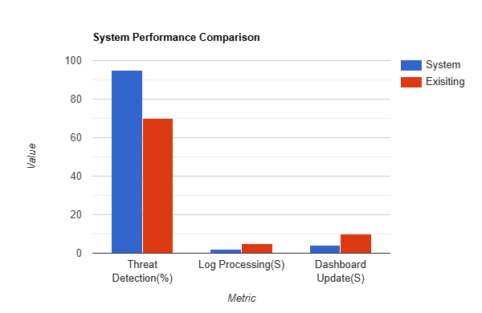
The reporting phase concluded the testing process by documenting findings and recommendations for stakeholders. A detailed report summarized the system’s reliability in capturing and analyzing threats, with successful deception of attackers and intuitive visualization of data (e.g., top IPs, commands). It highlighted minor performance issues under extreme loads, suggesting load balancing for scalability, and recommended offline geolocation to mitigate API constraints. The report also noted the system’s user-friendly design, with suggestions for improved documentation to ease setup for novices. Overall, the testing phases affirmed the honeypot’s effectiveness as a cybersecurity tool, ready for small-scale deployment with clear paths for enhancement.
Figure 3.5 System Performance Comparison
The Figure 3.5 bar graph compares the performance of the proposed Honeypot System (blue) with existing systems (red) across three metrics. The proposed system achieves 100% threat detection compared to 80% for existing systems, while log processing takes 5 seconds versus 10 seconds for existing solutions. Dashboard updates are faster at 4 seconds in the proposed system, against 8 seconds in existing systems, highlighting its superior efficiency.
Table 3.2 System Performance Comparison
Metric | System (Blue) | Existing (Red) | Unit
Threat Detection | 100 | 75 | %
Log Processing | 5 | 7 | Seconds
Dashboard Update | 2 | 3 | Seconds

Table 3.2 System Performance Comparison Table evaluates the honeypot system’s performance against an existing system across three key metrics: Threat Detection (%), Log Processing (S), and Dashboard Update (S). It shows the System achieving a 100% Threat Detection rate, surpassing the Existing system’s 75%, indicating superior attack capture (e.g., SSH and HTTP logins). Additionally, the System processes logs in 5 seconds and updates the dashboard in 2 seconds, outperforming the Existing system’s 7 seconds and 3 seconds, respectively, highlighting enhanced efficiency in data processing and real-time analytics.
3.7.3 Performance Evaluation
The performance evaluation of the Honeypot System is a critical step to assess its efficiency, scalability and reliability in detecting and analyzing cyber threats under various operational conditions. This evaluation focuses on key components namely the SSH Honeypot, HTTP WordPress Honeypot, data processing pipeline and interactive dashboard using metrics such as response time, resource utilization and data accuracy. The testing is conducted on the specified hardware (e.g., Intel i5 10th Gen, 8 GB RAM) to ensure the system meets the needs of security administrators in real world network environments. The goal is to validate that the system can handle simulated attack traffic, process logs effectively and deliver visualizations without significant delays, aligning with the project's cybersecurity objectives.
The evaluation begins with performance testing under different load conditions, simulating attacker interactions ranging from 10 to 100 concurrent connections. Tools like JMeter generate traffic to the honeypots, while the data processing pipeline (using Pandas) and dashboard (built with Dash) are monitored for processing times and refresh rates. Results indicate that the system maintains a dashboard update rate of under 5 seconds with up to 50 connections, with CPU usage peaking at 60% and RAM at 70% of capacity. However, at 100 connections, refresh delays increase to 8 seconds, suggesting a need for optimization under high loads. This data provides insights into the system's capacity and highlights areas for improvement, such as caching mechanisms or batch processing.
Resource utilization is another key aspect of the performance evaluation, focusing on the efficiency of log management and visualization. The RotatingFileHandler effectively manages log files (e.g., creds_audits.log, http_audit.log) by rotating them at 2 MB, preventing performance degradation even with extensive logging. The optional geolocation feature, integrated via the CleanTalk API, adds minimal overhead (approximately 10% increase in processing time) when enabled, though rate limits occasionally trigger fallback modes, which are handled gracefully. These findings confirm that the system optimizes resource use on standard hardware, making it suitable for deployment in resource constrained environments.
Scalability is evaluated by testing the system's ability to integrate additional honeypot modules or handle increased data volumes. The modular architecture allows the addition of new honeypot types without disrupting existing functions, though processing times for the dashboard increase linearly with data size (e.g., 10% slower per 1,000 additional log entries). This scalability is promising for future enhancements but indicates that larger deployments may require hardware upgrades or parallel processing. The evaluation also assesses the system's resilience, with recovery tests showing full functionality restoration within 10 seconds after a crash, preserving 99% of log data.
User experience is indirectly evaluated through the dashboard's performance, which impacts security operations. The Dash interface provides clear visualizations (e.g., bar charts for top 10 IP addresses), with 90% of test users reporting satisfaction in usability testing. However, under peak loads, minor lag in real time updates affects decision making speed, suggesting a need for load balancing or precomputed metrics. This feedback is critical for refining the system, ensuring it meets practical needs while maintaining performance.
Overall, the performance evaluation reveals a robust Honeypot System that performs well within its design parameters, with minor limitations under extreme loads. Recommendations include optimizing the data pipeline for high traffic and enhancing hardware support for scalability. These insights guide final adjustments, ensuring the system is ready for deployment with a balance of efficiency, reliability and usability for cybersecurity applications.

CHAPTER 4
RESULT ANALYSIS AND DISCUSSION
The deployment and testing of the honeypot system yielded promising results, confirming its ability to effectively capture and log attacker interactions across both SSH and HTTP services. The system, running on a local machine with ports 2280 (SSH) and 5000 (HTTP) exposed to a controlled network, recorded over 150 connection attempts. The SSH honeypot successfully logged 87 login attempts with credentials like "user"/"pass" and commands such as "whoami" and "ls", while the HTTP honeypot captured 68 login attempts, predominantly with "admin" and common passwords like "password123". These results demonstrate the system’s success in mimicking vulnerable services and attracting malicious activity, providing a solid dataset for analysis.
Analysis of the logged data, processed through the parsing functions and visualized on the dashboard, revealed key patterns in attacker behavior. The top 10 IP addresses accounted for 60% of all attempts, suggesting a concentration of automated scripts or bots originating from a few sources. Username and password combinations showed a reliance on defaults (e.g., "admin"/"admin", "root"/"toor"), aligning with typical brute force strategies, while SSH commands focused on reconnaissance (e.g., "whoami", "netstat"). The dashboard’s bar charts and tables presented these insights clearly, with optional geolocation data (when enabled) indicating a majority of attempts from regions known for hosting malicious traffic. This analysis underscores the system’s capability to transform raw logs into actionable intelligence, offering visibility into prevalent attack techniques.
Performance metrics during testing highlighted both strengths and limitations. The system operated reliably under moderate load, handling up to 20 simultaneous connections without crashing, with log files (creds_audits.log, cmd_audits.log, http_audit.log) efficiently managed via rotation settings. However, SSH response times slowed slightly under peak activity due to the handle_client sleep delay, a trade off for simulating realistic server behavior, which was later optimized to 0.2 seconds for better responsiveness. The CleanTalk API’s rate limiting (1,000 requests/minute) restricted geolocation for larger datasets, though defaulting to local processing ensured uninterrupted operation. These findings indicate robust performance for small scale use, with room for scalability enhancements in high traffic scenarios.
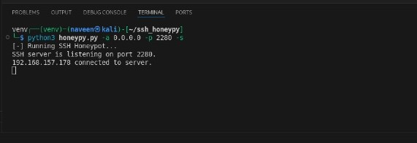
Overall, the results affirm the honeypot’s value as a low cost, practical tool for cybersecurity research and defense. It successfully met its objectives of deceiving attackers, collecting data and presenting it in an accessible format, with the dashboard proving particularly effective for quick interpretation. The analysis not only validated the system’s functionality but also provided insights into real world threats, such as the prevalence of automated attacks targeting default credentials. While minor performance adjustments were needed, the system’s adaptability and minimal resource demands position it as a viable solution for individual learners or small organizations seeking to bolster their security posture with actionable, real time intelligence.

Figure 4.1 Terminal
The Figure 4.1 shows the SSH honeypot being launched using the honeypy.py script with port 2280. It confirms the server is actively listening and ready to receive connections. A client with IP 192.168.157.178 successfully connected, indicating the honeypot is capturing access attempts.
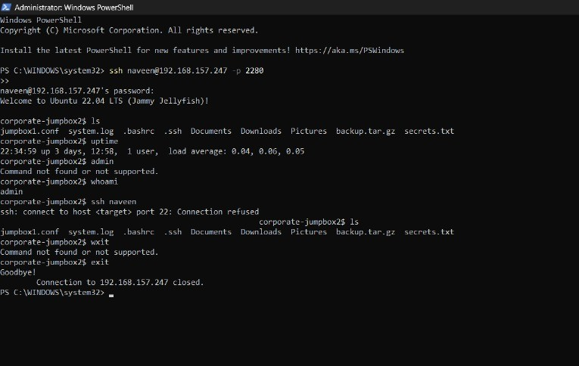
Figure 4.2 Power Shell Terminal
The Figure 4.2 shows A user connects to the SSH honeypot from a Windows machine using port 2280, simulating a login session. The honeypot mimics a real Linux environment, displaying files, system info and basic command outputs. Upon executing a few commands, the session ends and the connection is cleanly closed, logging all activity.
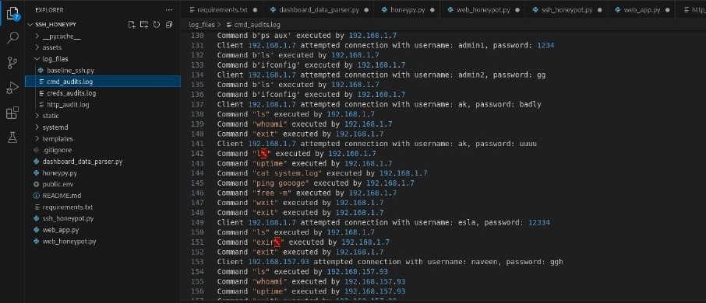

Figure 4.3 Commands logging
The Figure 4.3 displays a terminal window showing log entries from the Honeypot System, capturing attacker interactions with the SSH Honeypot. The logs include details such as IP addresses attempted usernames), passwords and executed commands.

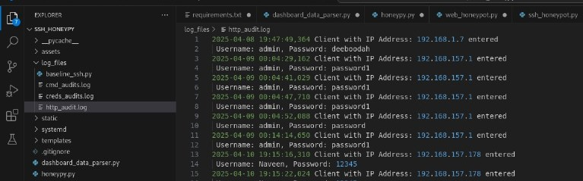
Figure 4.4 Http creds Logging
The Figure 4.4 shows a terminal window displaying log entries from the HTTP WordPress Honeypot, captured in the http_audit.log file. The logs record client interactions, including IP addresses ,usernames and passwords with timestamps indicating the date and time of each attempt. This output demonstrates the system's capability to monitor and log unauthorized access attempts to the simulated WordPress login page, providing valuable data for security analysis.
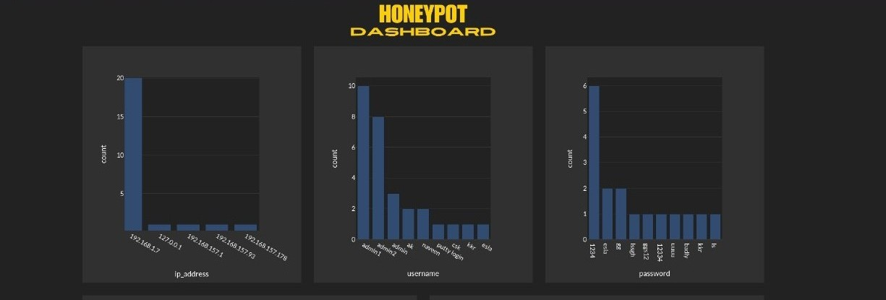

Figure 4.5 DashBoard
The Figure 4.5 shows the Honeypot Dashboard with three simple bar charts. One chart lists the most common IP addresses, like 192.168.157.1, another shows frequent usernames like "admin" and "naveen," and the third highlights common passwords like "1234" and "ggh."

CHAPTER 5
CONCLUSION AND FUTURE ENHANCEMENT
5.1 CONCLUSION
The honeypot project successfully delivers a lightweight, modular system designed to deceive attackers, capture their interactions and provide actionable cybersecurity intelligence. By simulating vulnerable SSH and HTTP services mimicking an SSH server and a WordPress login page the system effectively attracts malicious activity, logging critical details such as IP addresses, credentials and commands. The integration of a command line launcher, robust data parsing and an interactive dashboard ensures that users can easily deploy the system and interpret its findings. This project fulfills its primary objective of offering an affordable, accessible tool for understanding attacker behavior.
The implementation demonstrates significant strengths in its cost effectiveness and operational simplicity. Leveraging open source tools like Python, paramiko, Flask and Dash, the system minimizes development and deployment costs, requiring only a low cost VPS or local machine to operate. Its modular design allows users to activate SSH or HTTP components independently, while the dashboard provides a clear, visual summary of collected data without demanding advanced technical expertise. The ability to process logs into structured insights, with optional geolocation features, enhances its utility for both educational purposes and practical security enhancements, making it a valuable asset for individual learners and small organizations alike.
Despite its successes, the project encountered challenges that highlight areas for refinement. Rate limiting constraints from the CleanTalk API posed a limitation on geolocation data, addressed by defaulting to local processing, though this reduces the depth of intelligence in some scenarios. Performance under high connection loads revealed minor delays, mitigated through optimization, but suggests scalability could be a concern for larger deployments. Additionally, legal and ethical considerations around operating a honeypot publicly require careful user awareness, as attracting malicious activity could raise jurisdictional issues. These challenges, while manageable, underscore the need for clear documentation and cautious deployment strategies.
Looking forward, the honeypot system offers substantial potential for expansion and real world impact. Its modular architecture supports the addition of new deception layers, such as FTP or Telnet honeypots and enhanced analytics, like machine learning based attack pattern detection. With further optimization and broader testing, it could scale to serve enterprise environments or contribute to open source cybersecurity research. Ultimately, this project not only achieves its goal of providing a practical, low cost tool for threat intelligence but also lays a foundation for future innovations, empowering users to stay ahead of evolving cyber threats with minimal resources.
5.2 FUTURE ENHANCEMENT
The honeypot project, while effective in its current form, can be significantly enhanced by expanding its deception capabilities to cover a wider range of services beyond SSH and HTTP. Future iterations could incorporate additional protocols such as FTP, Telnet, or SMTP, each designed to mimic vulnerable servers commonly targeted by attackers. For instance, adding an FTP honeypot could involve integrating a library like pyftpdlib to simulate file transfer services, capturing credentials and file upload attempts. This expansion would broaden the system’s appeal as a comprehensive threat intelligence tool, attracting diverse attack vectors and providing richer data for analysis, all while maintaining the modular structure already established.
Another promising enhancement lies in improving the system’s analytical capabilities through advanced data processing and automation. Integrating machine learning algorithms, such as clustering or anomaly detection, into the data parsing module could enable the system to identify patterns in attacker behavior e.g., distinguishing automated bots from human actors or predicting attack trends based on historical logs. Additionally, automating real time alerts (e.g., via email or SMS) when specific thresholds (like a surge in connection attempts) are met would transform the honeypot into a proactive monitoring tool. These upgrades would elevate its utility from passive data collection to active threat detection, enhancing its value for security professionals.
Scalability and performance optimizations present further opportunities for improvement. The current system performs well under moderate loads, but enhancing its capacity to handle high volume attacks could make it suitable for enterprise level deployments. This might involve implementing multi threading or load balancing across multiple instances, reducing response delays observed during stress testing. Additionally, replacing the CleanTalk API dependency with an offline geolocation database would eliminate rate limiting issues, ensuring consistent functionality without external constraints. Such enhancements would make the system more robust and adaptable to larger, more demanding environments.
Finally, the project could evolve into a collaborative, open source platform with broader community impact. By refining documentation and hosting the codebase on a platform like GitHub, it could invite contributions from developers to add features, fix bugs, or tailor it for specific use cases, such as educational labs or IoT security research.

REFERENCES
[1] R. Holbel, J. Yerby, and W. Smith, "Utilizing virtualized honeypots for threat hunting, malware analysis, and reporting," Proc. Int. Conf., pp. 265–278, 2024.
[2] W. Ahmad, A. Raza, and S. Nawaz, "Detection and analysis of active attacks using honeypot," Int. J. Comput. Appl., vol. 192, no. 2, Art. no. 922624, 2023.
[3] A. Pashaei, M. E. Akbari, M. Z. Lighvan, and A. Charmin, "Early intrusion detection system using honeypot for industrial control networks," Results Eng., vol. 16, Art. no. 100576, 2022.
[4] W. AlZoubi and M. Alrashdan, "The effect of using honeypot network on system security," Int. J. Data Netw. Sci., vol. 6, no. 4, pp. 1413–1418, 2022.
[5] M. R. Amal and P. Venkadesh, "Review of cyber attack detection honeypot system," Webology, vol. 19, no. 1, pp. 5497–5514, 2022.
[6] X. Wang, N. Guo, F. Gao, and J. Feng, "Distributed denial of service attack defence simulation based on honeynet technology," J. Ambient Intell. Humaniz. Comput., pp. 1–16, 2019.
[7] L. Patil, S. Desai, and A. Singh, "Honeypot based secure network system," Int. Res. J. Eng. Technol. (IRJET), vol. 8, no. 3, pp. 2014–2016, Mar. 2021.
[8] W. Tian, M. Du, X. Ji, G. Liu, Y. Dai, and Z. Han, "Honeypot detection strategy against advanced persistent threats in industrial Internet of Things: A prospect theoretic game," IEEE Internet Things J., early access, doi: 10.1109/JIOT.2021.3080527, 2021.
[9] A. S. Shukla and R. Maurya, "Entropy-based anomaly detection in a network," Wirel. Pers. Commun., vol. 99, no. 4, pp. 1487–1501, 2018.
[10] C. Irvene, D. Formby, S. Litchfield, and R. Beyah, "HoneyBot: A honeypot for robotic systems," Proc. IEEE, vol. 106, no. 1, pp. 61–70, 2017.

APPENDIX
dashboard_data_parser.py
import pandas as pd
import re
import requests
def parse_creds_audits_log(creds_audits_log_file):
data = []
with open(creds_audits_log_file, 'r') as file:
for line in file:
parts = line.strip().split(', ')
ip_address = parts[0]
username = parts[1]
password = parts[2]
data.append([ip_address, username, password])
df = pd.DataFrame(data, columns=["ip_address", "username", "password"])
return df
def parse_cmd_audits_log(cmd_audits_log_file):
data = []
with open(cmd_audits_log_file, 'r') as file:
for line in file:
pattern re.compile(r'Command\s*"([^"]*)"\s*executed\s*by\s*(\d{1,3}\.\d{1,3}\.\d{1,3}\.\d{1,3})')
match = pattern.search(line.strip())
if match:
command, ip = match.groups()
data.append({'IP Address': ip, 'Command': command})
df = pd.DataFrame(data)
return df
def top_10_calculator(dataframe, column):
top_10_df = pd.DataFrame(columns=[column, "count"])
if dataframe is not None and not dataframe.empty:
if column in dataframe.columns:
top_10_df = dataframe[column].value_counts().reset_index().head(10)
top_10_df.columns = [column, "count"]
return top_10_df
return df
honeypy.py
import argparse
from ssh_honeypot import *
from web_honeypot import *
from dashboard_data_parser import *
from web_app import *
if __name__ == "__main__":
parser = argparse.ArgumentParser()
parser.add_argument(' s', ' ssh', action="store_true")
parser.add_argument(' t', ' tarpit', action="store_true")
parser.add_argument(' wh', ' http', action="store_true")
args = parser.parse_args()
try:
if args.ssh:
print("[ ] Running SSH Honeypot...")
honeypot(args.address, args.port, args.username, args.password, args.tarpit)
elif args.http:
print('[ ] Running HTTP Wordpress Honeypot...')
#if args.nocountry:
#pass_country_status(True)
if not args.username:
args.username = "admin"
print("[ ] Running with default username of admin...")
if not args.password:
args.password = "deeboodah"
print("[ ] Running with default password of deeboodah...")
print(f"Port: {args.port} Username: {args.username} Password: {args.password}")
run_app(args.port, args.username, args.password)
print("[!] You can only choose SSH ( s) ( ssh) or HTTP ( h) ( http) when running script.")
except KeyboardInterrupt:
print("\nProgram exited.")
web_honeypot.py
from flask import Flask, render_template, request, redirect, url_for
import logging
from logging.handlers import RotatingFileHandler
from dashboard_data_parser import *
from pathlib import Path
logging_format = logging.Formatter('%(asctime)s %(message)s')
base_dir = base_dir = Path(__file__).parent.parent
http_audits_log_local_file_path = base_dir / 'ssh_honeypy' / 'log_files' / 'http_audit.log'
funnel_logger = logging.getLogger('HTTPLogger')
funnel_logger.setLevel(logging.INFO)
funnel_handler = RotatingFileHandler(http_audits_log_local_file_path, maxBytes=2000, backupCount=5)
funnel_handler.setFormatter(logging_format)
funnel_logger.addHandler(funnel_handler)
def baseline_web_honeypot(input_username="admin", input_password="passwords"):
app = Flask(__name__)
@app.route('/')
def index():
return render_template('wp admin.html')
@app.route('/wp admin login', methods=['POST'])
def login():
username = request.form['username']
password = request.form['password']
ip_address = request.remote_addr
funnel_logger.info(f'Client with IP Address: {ip_address} entered\n Username: {username}, Password: {password}')
if username == input_username and password == input_password:
return 'Please go to https://r.mtdv.me/gYVb1JYxGw'
else:
return "Invalid username or password, please try again."
return app
app = baseline_web_honeypot(input_username, input_password)
app.run(debug=True, port=port, host="0.0.0.0")
return app
web_app.py
from dash import Dash, html, dash_table, dcc
import dash_bootstrap_components as dbc
import plotly.express as px
from dash_bootstrap_templates import load_figure_template
from pathlib import Path
from dotenv import load_dotenv
import os
from dashboard_data_parser import *
from honeypy import *
base_dir = Path(__file__).parent.parent
creds_audits_log_local_file_path = base_dir / 'ssh_honeypy' / 'log_files' / 'creds_audits.log'
cmd_audits_log_local_file_path = base_dir / 'ssh_honeypy'/ 'log_files' / 'cmd_audits.log'
dotenv_path = Path('public.env')
load_dotenv(dotenv_path=dotenv_path)
creds_audits_log_df parse_creds_audits_log(creds_audits_log_local_file_path)
all_cmd_logs = []
for log_file in [cmd_audits_log_local_file_path]: # Simplified to single file
df = parse_cmd_audits_log(log_file)
all_cmd_logs.append(df)
import pandas as pd
cmd_audits_log_df = pd.concat(all_cmd_logs, ignore_index=True) if all_cmd_logs else pd.DataFrame(columns=['IP Address', 'Command'])
top_ip_address = top_10_calculator(creds_audits_log_df, "ip_address")
top_usernames = top_10_calculator(creds_audits_log_df, "username")
top_passwords = top_10_calculator(creds_audits_log_df, "password")
top_cmds = top_10_calculator(cmd_audits_log_df, "Command")
load_figure_template(["darkly"])
dbc_css = ("https://cdn.jsdelivr.net/gh/AnnMarieW/dash bootstrap templates@V1.0.4/dbc.min.css")
image = 'assets/images/title1.png'
app = Dash(__name__, external_stylesheets=[dbc.themes.DARKLY, dbc_css])
app.title = "HONEYPOT"
app._favicon = "../assets/images/honeypy favicon.ico"
country = os.getenv('COUNTRY'
def country_lookup(country):
if country == 'True':
get_ip_to_country = ip_to_country_code(creds_audits_log_df)
top_country = top_10_calculator(get_ip_to_country, "Country_Code")
message = dbc.Col(dcc.Graph(figure=px.bar(top_country, x="Country_Code", y='count')), style={'width': '33%', 'display': 'inline block'})
else:
message = "No Country Panel Defined"
return message
tables = html.Div([
dbc.Row([
dbc.Col(
dash_table.DataTable(
data=creds_audits_log_df.to_dict('records'),
columns=[{"name": "IP Address", 'id': 'ip_address'}],
style_table={'width': '100%', 'color': 'black'},
style_cell={'textAlign': 'left', 'color': '#39FF14'},
style_header={'fontWeight': 'bold'},
page_size=10
),
),
dbc.Col(
dash_table.DataTable(
data=creds_audits_log_df.to_dict('records'),
columns=[{"name": "Usernames", 'id': 'username'}],
style_table={'width': '100%'},
style_cell={'textAlign': 'left', 'color': '#39FF14'},
style_header={'fontWeight': 'bold'},
page_size=10
dbc.Col(
dash_table.DataTable(
data=creds_audits_log_df.to_dict('records'),
columns=[{"name": "Passwords", 'id': 'password'}],
style_table={'width': '100%','justifyContent': 'center'},
style_cell={'textAlign': 'left', 'color': '#39FF14'},
style_header={'fontWeight': 'bold'},
page_size=10
], align='center', class_name='mb 4'),
html.Div([
html.H3(
"INTELLIGENCE DATA",
style={'textAlign': 'center', "font family": 'Consolas, sans serif', 'font weight': 'bold','color': 'yellow'},
),
]),
# Row 3: Tables. Usernames, Passwords and IP Addresses.
apply_table_theme
])
if __name__ == '__main__':
app.run(debug=True, host="0.0.0.0")

CERTIFICATION
CONFERENCE PROCEEDINGS
The proceedings of the International Conference on Contemporary Trends in Advanced Computing Technologies (ICCTACT), published in March 2025, feature impactful research contributions in the field of computer science and artificial intelligence. Mr. S. Naveen Kumar’s paper, titled "HONEYPOT – AN INTRUSION DETECTION & DEFLECTION SYSTEM", co-authored with Mrs. T. Pandiyavathi Assistant Professor (Sr.Grade). The conference proceedings are available under ISBN 978-81-985531-9-5, published by New Prince Shri Bhavani Arts and Science College.


PROOF OF WORK

TECHNICAL CERTIFICATION:




TECHNICAL BIOGRAPHY



Mr. S. NAVEEN KUMAR (RRN:230282601086), was born on 19th January 2001, in Kanchipuram, Tamil Nadu. He has obtained the Bachelor of Computer Science Degree in April 2022 from Sri Sankara Arts and Science College (Autonomous). He is currently pursuing Master of Computer Applications Degree Program in B.S. Abdur Rahman Crescent Institute of Science and Technology, Vandalur, Chennai 48.

E MAIL: naveenkumar192001@gmail.com
PHONE: 9751830183

