**Calculator**

(Documentation)

Project Name:- Calculator

Project Developer :- Priya Naveen

Objectives of Project:-

* Calculator to perform operations like
* Addition
* Substraction
* Multiplication
* Division
* And Finally close the Calculator.

Sprint

One sprint taken

And its time period is 3 weeks 15 worling days

|  |  |
| --- | --- |
| ConFig | Value |
| Sprint Start | 16/03/2022 |
| Sprint End | 01/04/2022 |
| Daily Hours | 9 |
| Focus Factor | 95% |
| No. Weeks | 3 |
| Working Days | 15 |
| Work Hours | 135 |
| Available WH | 99 |

|  |  |  |
| --- | --- | --- |
| Name | Role | Contribution |
| Priya Naveen | FSD | 100% |
| Priya Naveen | QA | 100% |
| Priya Naveen |  |  |

|  |  |  |  |  |
| --- | --- | --- | --- | --- |
| Story Name | Story Points | Hours For Fed | Hours For Bed | Hours For QA |
| As the Hr Manager I want | 13 | 30 | 2 | 22 |
| As a Manager | 13 | 70 |  |  |
| As a User | 8 |  | 2 | 20 |

Features :-

* Calculator to perform operations like
* Addition
* Substraction
* Multiplication
* Division

And Finally close the Calculator

Algorithm:-

Step1:- Start

Step2:- Create package

Step3:- Create class Calculator

Step4:- create a main method.

Step5:- create scanner to take inputs from user.

Step6:- create a while loop and switch cases.

Step7:- case + to add two numbers

Step8:- case - to subtract two numbers

Step9:- case * to multiplying two numbers

Step12:- case / to division two numbers

Step13:- case c to stop calculator

Step14:- create default to incase wrong input

Step14:- End

FlowChart:-

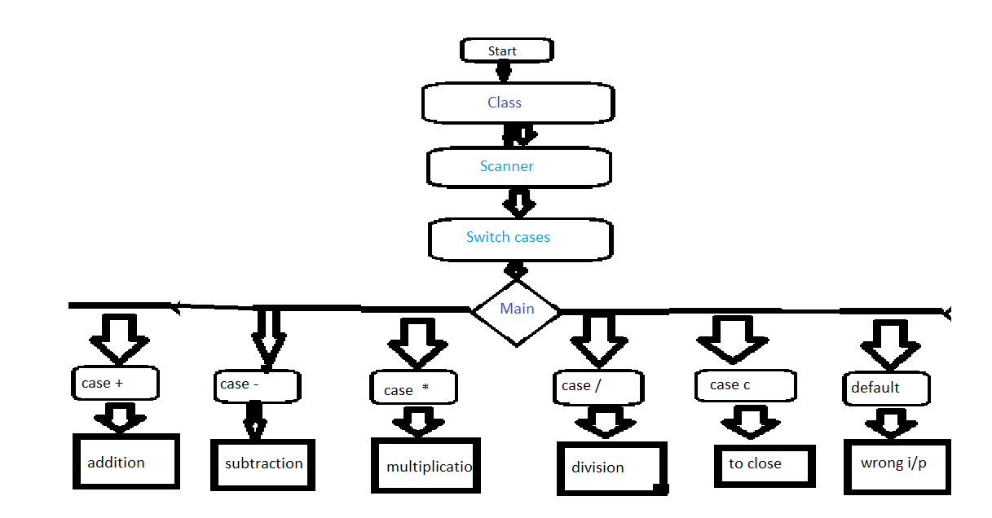

CoreConepts Used in the Project:-

Java classes, methods, variables, ,Loops, cases etc.

Unique selling Point:-

“Speed & Accuracy Matters here, The Next Speed”