**LockedMe.com**

(Documentation)

Project Name:- Lockedme.com

Project Developer :- Priya Naveen

Objectives of Project:-

* Retrieving the file names in an ascending order
* Business-level operations:
  + Option to add a user specified file to the application
  + Option to delete a user specified file from the application
  + Option to search a user specified file from the application
  + Navigation option to close the current execution context and return to the main context
* Option to close the application

Sprint

One sprint taken

And its time period is 3 weeks 15 worling days

|  |  |
| --- | --- |
| ConFig | Value |
| Sprint Start | 16/03/2022 |
| Sprint End | 01/04/2022 |
| Daily Hours | 9 |
| Focus Factor | 95% |
| No. Weeks | 3 |
| Working Days | 15 |
| Work Hours | 135 |
| Available WH | 99 |

|  |  |  |
| --- | --- | --- |
| Name | Role | Contribution |
| Priya Naveen | FSD | 100% |
| Priya Naveen | QA | 100% |
| Priya Naveen |  |  |

|  |  |  |  |  |
| --- | --- | --- | --- | --- |
| Story Name | Story Points | Hours For Fed | Hours For Bed | Hours For QA |
| As the Hr Manager I want | 13 | 30 | 2 | 22 |
| As a Manager | 13 | 70 |  |  |
| As a User | 8 |  | 2 | 20 |

Features :-

Retrieving the file names in an ascending order. Business-level operations:

Option to add a user specified file to the application. Option to delete a user specified file from the application. Option to search a user specified file from the application

Navigation option to close the current execution context and return to the main context. Option to close the application

Algorithm:-

Step1:- Start

Step2:- Create package

Step3:- Create class **Lockedme**

Step4:- In this class create four methods for to create a file,delete a file,to search file

And display files with throws keyword.

Step5:- Taken a static variable to store the file address.

Step6:- create a main method.

Step7:- create scanner to take inputs from user.

Step8:- create a while loop and switch cases.

Step9:- case1 to call files displaying method

Step10:- case 2 to call the file creating method

Step11:- case 3 to call the file searching method

Step12:- case 4 to call the files deletion method

Step13:- create default to incase wrong input

Step14:- End

FlowChart:-

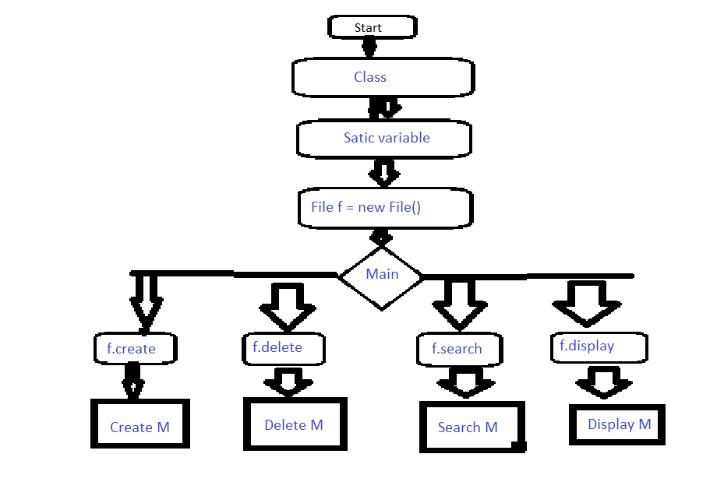

CoreConepts Used in the Project:-

Java classes, methods, variables, Exception handing ,Loops, cases etc.

Unique selling Point:-

“Quality Matters here, The Next Quality”