SKELETON DETAILS --TWITTER CLONE

1. Database Design

2. Interfaces, Classes, Methods

3. My Functionalities and ScreenShots

The Skeleton was developed on MVC5, EntityFramework and SQL Server ,Jquery and CSS.

The following are the tables.

DATA BASE

* **New Table:** [tblUser]

|  |  |  |  |  |
| --- | --- | --- | --- | --- |
| Column Name | Data Type | Allow Nulls? | Default Value | Description |
| UserId | Int Primary key(PrimaryKey) | N | Identity |  |
| UserName | NVarchar(15) | N |  |  |
| Password | NVarchar(10) | N |  |  |
| EmailId | NVarchar(40) | N |  |  |
| Date | Datetime | N | DateTime.Now() |  |

* **New Table:** [tblUserProfile]

|  |  |  |  |  |
| --- | --- | --- | --- | --- |
| Column Name | Data Type | Allow Nulls? | Default Value | Description |
| Id | Int | N | Identity |  |
| FullName | NVarchar(10) | N |  |  |
| UserId | Int(40)FK Reference tblUser(PK) | N |  |  |
| DateOfBirth | Date | Y |  |  |
| Proffession | Varchar(30) | Y |  |  |

* **New Table:** [tblTweet]

|  |  |  |  |  |
| --- | --- | --- | --- | --- |
| Column Name | Data Type | Allow Nulls? | Default Value | Description |
| EamilId | NVarchar(10) FK Reference tblUser(PK) | N |  |  |
| Tweet | NVarchar(240) | N |  |  |
| DateOfBirth | Date | Y |  |  |
|  |  |  |  |  |

* **New Table:** [tblLinks]

|  |  |  |  |  |
| --- | --- | --- | --- | --- |
| Column Name | Data Type | Allow Nulls? | Default Value | Description |
| UserId | Int FK Reference tblUser(PK) | N |  |  |
| FollowerUserId | Int FK Reference tbUser(PK) | N |  |  |
| FollowingUserId | Int FK Reference tbUser(PK) | Y |  |  |
|  |  |  |  |  |

Stored Procedure:

GetUsers: sp_getAllUsers()

Sp_getUserById()

Sp_GetFollower(By UserId)

Sp_GetFollowed(By UserId)

Sp_GetTweets(By UserId)

Classes

User Class:

[DataMember]

public int UserId { get; set; }

[DataMember]

public string UserName { get; set; }

[DataMember]

public string Password { get; set; }

[DataMember]

public string EmailId { get; set; }

[DataMember]

public DateTime Date { get; set; }

Class :UserProfile

[DataMember]

public int Id { get; set; }

[DataMember]

public string FullName { get; set; }

[DataMember]

public string UserId { get; set; }

[DataMember]

public Date DateOfBirth { get; set; }

[DataMember]

public string Proffession { get; set; }

Class: Tweet

[DataMember]

public int Id { get; set; }

[DataMember]

public string EmailId { get; set; }

[DataMember]

public string Tweet { get; set; }

[DataMember]

public Date DateOfBirth { get; set; }

Class: Links

[DataMember]

public int UserId { get; set; }

[DataMember]

public int FollowerUserId { get; set; }

[DataMember]

public int FollowingUserId { get; set; }

Interfaces:

Interface for Authorization and Authentication

The Following are the mothods:

Authenticate(string EamilId, string password);

CreateUser();

DoesUserExist(string EamilId);

GetCurrentUser();

IsAuthenticated { get; }

Login();

Login(string EmailId);

Logout();

int UserId { get; set; }

UserInterface

Follow();

This method is used to follow the users we need to assign the follower emaild.

UnFollow();

GetAllFor(string UserName);

GetBy(string username);

Create();

GetFollowerCount()

GetFollowedCount()

Anlysis:

The initial Idea is developing a twitter clone. For this I have used MVC5 with SQL Server as back end.

First the User should Register So I have used Register Method.

Once the user is registered then he can search the users available depending on the name or emailId.

Then clicking on the Follow he will be followed by the current User.

He can tweet by clicking the Tweet button on his homepage.

The followers count and the following count can be available by using the GetFollowers() and GetFollowing() methods.

The tweets can be made available using GetAll() method

The Links() Method is used to get the followers and following information.

Flowchart

TimeLine

Where Tweets are displayed

Tweets

SearchForFollower

Using EmailId or Name

FillsBasicProfileInfo

Register

MySkeleton Functionalities:

The following are the functionalities I have done :

1.Registration of the user.(The user registers by using Email ,Name and Password)

2.Logout(He can Logout of the System)

3.LogIn

4.Search (User can be )

5.Tweet

6.TimeLine display (Just a basic view of all the users will be displayed)

USER REGISTRATION FORM

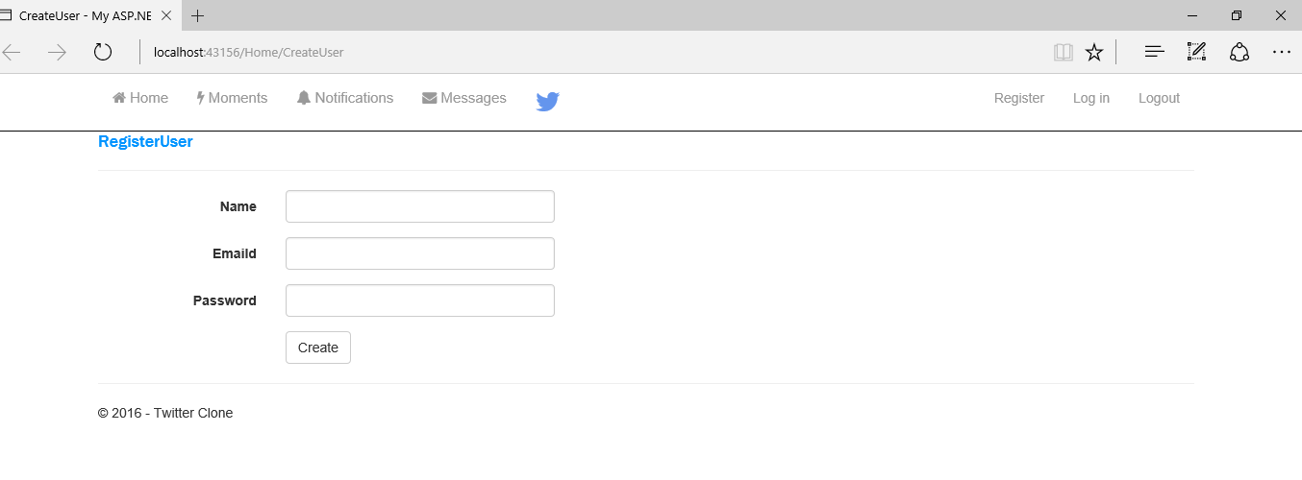

USER LOGIN FORM

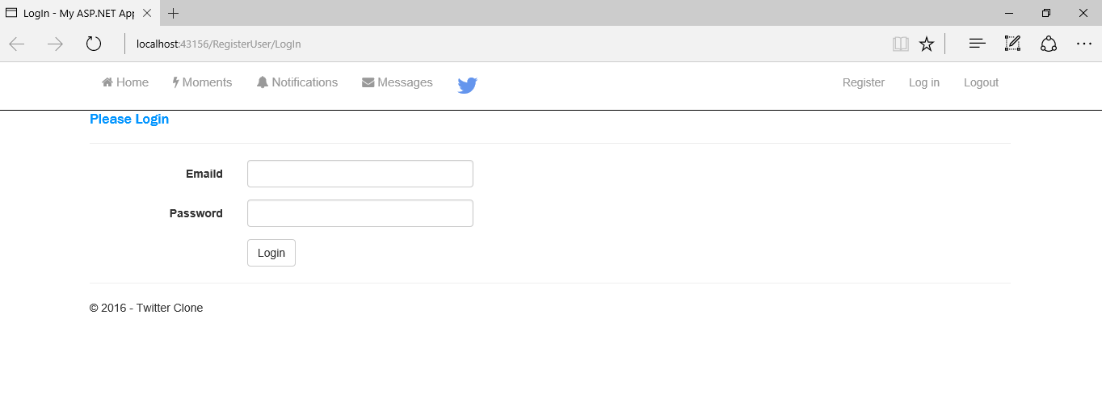

USER TIMELINE PAGE SAMPLE

