GIT

1)git config user.name

=>It will check the git that it does have user name right now.

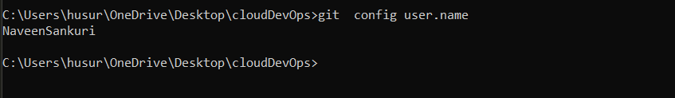

2)git config –global user.name “Naveen”

=>if git doesn’t have a user name then we provide one with the above command

3)git config user.email

=>It will check the git that it does have user email right now.

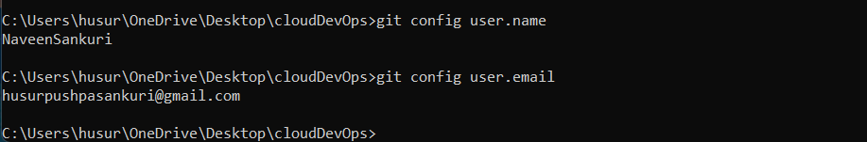

4)git config –global user.email “Naveen@gmail.com”

=>if git doesn’t have a user name then we provide one with the above command

🡪the above 4 command we tell git that who we are because of commiting our work with our detail will knows that that work belongs to us.

🡪Some Command line commands

$ls

=>it list all contents of a present working directory

$ls –l

=>it will long list all contents of a present working directory

$open . (for linux) / start . (for windows)

=>it will opens the current folder

$open f1 (for linux) / start f1/

=>it will open the folder f1 which is present in current folder.

$ls f1

=>it list the contents of f1 directory which is present in current working directory.

=? If we are doing ls command to open x1 folder which is present in f1 folder/directory that which is present in current working directory

==$ls f1/x1

$pwd

=>it shows present working directory

🡪while you use cd (folder) we can use some starting letters of folder name than type Tab button which may auto type the remaining name of that directory.

$cd ..

=>it helps us make backsout one directory

$touch s1.txt

=>it will create a text file with a name s1.txt in the current working directory

=>we can also create multiple files at a time using (touch s1.txt s2.txt . . . .)

=? What if we have to create a file with name j1.txt in another folder/directory f1 which is actually present in present working directory

==$touch f1/j1.txt

$mkdir f1

=>it creates a directory name f1 in present working directory

$rm s1.txt

=>it removes the file s1.txt

$rmkdir f1

=>it removes an empty f1 directory

=? What if we have non-empty directory than how to delete it

== we use –rf (recurcive, forcefully) properties

== $rmkdir –rf f1

5)git status

=>it gives information on current status of git repository and its contents

Git Repository

it is like a tracking device which holds versions of particular project or a file.

We have to initialize the git repo to track our folder in which we are creating git repo to track that folder.

To do that we use >>git init

=>more importantly please don’t try to do >>git init in nested folder of a already initialized git repo folder/directory because git can’t understand that which folder has to track of and it make no sense sooo, don’t do it.

So, check first by using >>git status weather a .git is initialized or not. If not it gives you a fatal error.

=>and also don’t try to do >>git init at ur c drive location because you don’t need to track of your computer.