- Expert panel
- Dr Kirthika change to
Kirthiga Prakash
Counselling Psychologist, mental health expert
- Need to add images of experts
When we touch the expert detailed expert data should pop up
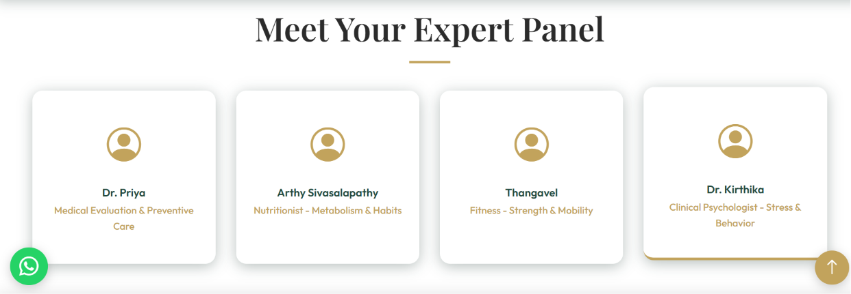
Dr. Preyeamvadha R
Main line: Pediatrician | Researcher | Healthy Longevity Advocate
Pop up content-
With over 15 years of clinical experience in pediatrics, neonatology, and developmental medicine, Dr. Preyeamvadha combines clinical expertise with research in genetics, metabolism, obesity, aging, and preventive medicine. As an Associate Professor, researcher, and author, she is passionate about making evidence-based longevity science accessible and practical for everyone.
Supporting your healthy longevity journey through:
Educate – Simplifying the latest longevity science into practical, evidence-based strategies for everyday life.
Evaluate – Assessing your healthspan through comprehensive anthropometric measurements, vital parameters, functional assessments, and biochemical biomarkers.
Personalize – Developing an individualized longevity profile with targeted recommendations to promote healthy aging and long-term well-being.
Mrs. Kirthiga Prakash
Main line: Counselling Psychologist | Mental health expert
With over 9 years of experience in counselling psychology, Mrs. Kirthiga Prakash specializes in fostering emotional well-being, resilience, and positive behavioural change. Having conducted 200+ workshops across Tamil Nadu, she combines psychological expertise with practical guidance to help individuals build healthier minds and healthier lives.
Supporting your healthy longevity journey through:
Understand – Helping you recognize emotional patterns, stress triggers, and the connection between mental well-being and healthy aging.
Strengthen – Building emotional resilience, healthy coping strategies, and effective communication skills for everyday life.
Empower – Providing personalized guidance and practical techniques to support lasting behavioural change and lifelong mental wellness.
Ms. Arthy Sahitya S
Main line: Clinical Nutritionist | Integrative Hormone Health Coach
With over 5 years of clinical experience, Ms. Arthy Sahitya specializes in personalized nutrition, metabolic health, and hormone wellness. Having guided 1,000+ clients across India, the UK, and the USA, she combines evidence-based nutrition with practical, sustainable lifestyle strategies to help individuals achieve lasting health and healthy aging.
Supporting your healthy longevity journey through:
Assess – Evaluating your dietary habits, nutritional gaps, metabolic health, and lifestyle patterns to understand your unique nutritional needs.
Nourish – Helping you build a sustainable, personalized approach to nutrition that supports energy, metabolic health, muscle health, and hormonal balance.
Transform – Providing practical, evidence-based nutrition strategies that empower lifelong healthy eating habits and long-term well-being.

- Health-conscious individuals who want to age well – Add this ref below
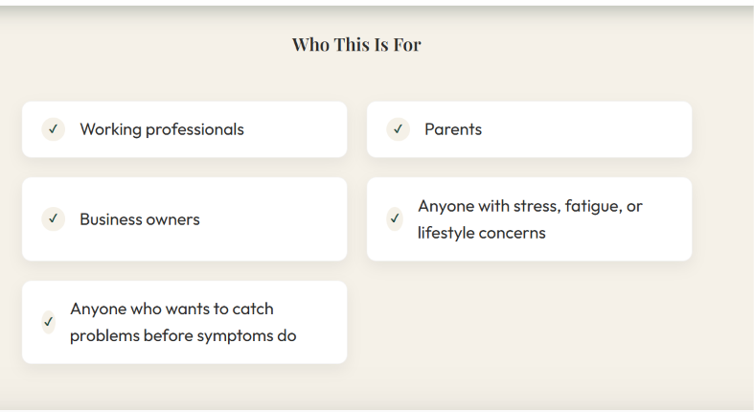
- 
Comprehensive Health Assessment
Worth ₹7,000+
Your investment special price
₹4,999

Launch Offer

₹4,999
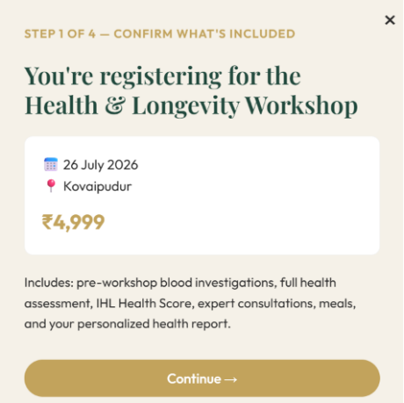
Highlight- Includes pre workshop…

