# Module-1: Foundation of LLMs and Generative AI

Here’s a comprehensive overview of the evolution of major language models – each representing a distinct philosophy in architecture, openness, reasoning and multimodality. These models have shaped the 2025 AI landscape across enterprise research and consumer domains.

## Evolution of Language Models

### GPT (OpenAI)

**Progression:** GPT-1 🡪 GPT-2 🡪 GPT-3 🡪 GPT-4 🡪 GPT-4o

**Highlights:**

GPT3: 175B parameters, few-shot learning

GPT-4: Multimodal (text + Image), 128k context window

GPT-4o: Real-time capabilities, improved latency, voice + vision integration

**Strengths:**

General purpose reasoning, stronger developer ecosystem, plugin support

**Use-Cases:** Coding, writing, tutoring, enterprise automation

### PaLM / Gemini (Google DeepMind)

**Progression:** PaLM 🡪 PaLM 2 🡪 Gemin 1 🡪 Gemini 2.5 Pro

**Highlights:**

Gemini 2.5 Prop: 1M token context, Deep Think mode for parallel reasoning

Native Multimodal processing (Text, Image, Audio and Video)

**Strengths:**

Google ecosystem integration, workspace productivity, video understanding

**Use-Cases:**

Research, document analysis, creative generation, enterprise workflows

### LLaMA (Meta)

**Progression:** LLaMA 🡪 LLaMA 2 🡪 LLaMA3 🡪 LLaMA4

**Highlights:**

LLaMA 4: Mixture-of-Experts (MoE), multimodal variants (Scout, Maverick)

Open weights, optimized for fine-tuning and private deployment

**Strengths:**

Open-source flexibility, multilingual support, cost-efficient scaling

**Use-Cases:**

Custom enterprise models, academic research, agentic systems

### Claude (Anthropic)

**Progression:** Claude 1 -> Claude 2 🡪 Claude 3 🡪 Claude 4

**Highlights:**

Claude 4 Opus: 1M Context, top-tier coding and reasoning

Constitutional AI for safety and alignment

**Strengths:** Long-context handling, ethical design, agentic tool use

**Use-cases:** Legal analysis, compliance, autonomous agents, technical writing

### DeepSeek (China)

**Progression:** DeepSeek R1 🡪 DeepSeek V3

**Highlights:**

Mixture-of-Experts architecture (671B total, 37B active per query)

Competitive performance at fraction of cost

**Strengths:** Technical reasoning, cost-efficiency, open-source availability

**Use-Cases:** Coding, STEM research, academic deployment

### Grok (xAI)

**Progression:** Grok1 🡪 Grok2 🡪 Grok3

**Highlights:**

Real-time integration with X (Formerly Twitter)

Specialized modes: Think Mode, DeepSearch, Big Brain Mode

**Strengths:** Truth-seeking philosophy, edgy tone, real-time data access

**Use-Cases:** Current Events, Coding, Mathematical reasoning, Informal Q&A

#### Comparative Snapshot

|  |  |  |  |  |  |
| --- | --- | --- | --- | --- | --- |
| **Model** | **Context Window** | **Multimodal** | **Open Source** | **Agentic Capabilities** | **Safety Focus** |
| GPT-4o | 128k | ✅ | ❌ | ⚠️ (limited) | ⚠️ |
| Gemini 2.5 | 1M | ✅ | ❌ | ⚠️ (emerging) | ✅ |
| LLaMA 4 | 10M (Scout) | ✅ | ✅ | ⚠️ (customizable) | ⚠️ |
| Claude 4 | 1M | ✅ | ❌ | ✅ (tool use, memory) | ✅ |
| DeepSeek R1 | 37B active | ❌ | ✅ | ⚠️ (efficient agents) | ⚠️ |
| Grok 3 | 1M | ✅ | ❌ | ✅ (real-time tools) | ⚠️ |

## Architecture breakdown:

Transformer:

At it’s core, a Transformer is a type of neural network designed to process sequential data, like text, more efficiently and effectively than previous architectures (such as RNNs). It was introduced in the groundbreaking 2017 paper “Attention is All you Need” by Google Brain Researchers.

Key Innovation of Transformers for LLMs:

The power of transformers in generative LLMs stems from a few critical innovations:

1. Self-Attention Mechanism: This is the heart of the transformer, unlike RNNs that process words one by one, the self-attention mechanism allows the model to consider all words in the input sequence simultaneously. For each word, it calculates how much “attention” it should pay to every other word in the sentence. This means it can identify relationships and dependencies between words, even if they are far apart in the sequence. For example, in the sentence “The dog chased the cat because it was hungry”, the self-attention mechanism can understand that “it” refers to” dog”, even though they are separated by other words. This ability to capture long-range dependencies is vital for understanding context and generating coherent text.
2. Parallel Processing: Because self-attention allows the model to process all part of the input sequence concurrently, Transformers are highly parallelizable. This is a massive advantage over RNNs, which process information sequentially. Parallel processing significantly speeds up training times, making it feasible to train models on truly massive datasets (Billions of words or more) and with Billions of parameters. This scalability is what enables the creation of “Large” Language Models.
3. Positional Encoding: While self-attention allows parallel processing, it loses the inherent sequential order of words. To address this, Transformers incorporate “Positional Encodings” which are numerical representations added to the work embeddings to provide information about each word’s position in the sequence. This ensures the model understands the order and relative position of words, which is crucial for grammatical correctness and meaning (e.g., “hot dog” vas “dog hot”)
4. Encoder-Decoder Structure (in some variations)

Encoder: The encoder part of a Transformer processes the input sequence and transforms it into a rich, contextualized numerical representation. It uses multiple layers of self-attention and feed-forward neural networks top refine this representation.

Decoder: The decoder then takes this encoded representation and generate the output sequence, typically one word (or “token”) at a time. It also uses self-attention (often “masked” to prevent it from looking at future words during generation) and attention to the encoder’s output. While the original Transformer paper proposed and encoder-decoder architecture, many generative LLMs (like the GPT series) primarily use a decoder-only architecture, where the entire model is focused on predicting the next token in a sequence.

## Why are Transformers essential for Generative LLMs?

**Understanding Context:** The self-attention mechanism allows LLMs to develop a deep understanding of the context of words within a sentence or even across long passages. This is crucial for generating text that is coherent, relevant and grammatically correct.

**Generating Coherent Text:** By learning relationships between words and phrases, Transformers enable LLMs to predict the most probable next word in a sequence, leading to fluid and natural-sounding text generation.

**Scalability:** The parallel processing capability is paramount. It allows researchers to train models with an unprecedented number of parameters on colossal datasets, leading to models that exhibit remarkable capabilities in language understanding and generation.

**Versatility:** Beyond just text generation, the Transformer architecture has proven incredibly versatile, finding applications, in machine translation, text summarization, question answering and even multimodal AI tasks (like generating images from text)

In essence, Transformers provide the robust and scalable architecture that allows Large Language Models to learn intricate patterns from massive amounts of text data, enabling them to generate human-like text, answer questions, translate languages, and perform a wide array of natural language processing tasks. They are the engine driving the recent revolution in generative AI.

## Pre-Training vs Fine-Tuning vs Instruction-Tuning

In the world of LLMs, the terms “pre-training”, fine-tuning” and “instructional-training” describes different stages or approaches to training these powerful models. They represent a progression from general language understanding to highly specialized and user-friendly behaviour.

### Pre-Training (The Foundation):

**Analogy:** Think of pre-training as giving a student a massive, uncurated library of all human knowledge (books, articles, websites, code etc.,) and telling them: “Read everything, and learn how language works – how words connect, grammar, facts, common patterns, and different writing styles. Don’t worry about specific tasks yet, just understand the underlying structure of text”

**Process:**

**Data:** Extremely vas and diverse datasets (trillions of words/tokens) from the internet, books, code etc., This data is largely unlabelled.

**Objective:** The primary objective is usually a self-supervised learning task, most commonly:

Casual Language Modelling (CLM): Predicting the next word in a sequence (e.g.,, as in GPT models). The model tries to complete sentences.

Masked Language Modelling (MLM): Predicting masked-out words within a sentence (e.g., as in BERT models). The model learns context from both directions.

**Result:** A “base-model” that has a broad understanding of language, facts, common sense, and various writing styles. It can generate coherent text, but it’s not yet optimized for specific instructions or conversational turns. It’s a generalist.

**Resources:** Extremely computationally expensive, requiring massive GPU clusters and months of training time. This is why only large organizations can typically “pre-train” LLMs from scratch.

**Example of Base Model Behaviour (Pre-trained only):**

If you asked an early, pre-trained-only GPT-3 model: “Summarize the article about quantum physics:”, it might continue your sentence like “Summarize the article about quantum physics: This article discusses….” Rather than actually providing summary, because its objective was just to predict the plausible tokens, not necessarily to “follow instructions”

### Fine-tuning (Task Specialization)

**Analogy:** After the student has read the entire library (pre-training), fine-tuning is like giving them a specific textbook and practice exercises on one subject, like “Medical Diagnosis” or “Legal Document Analysis” and telling them: “Now, apply your general language knowledge to become really good at this one thing”

**Process:**

**Data:** A smaller, task-specific and often labelled dataset. For example, if you want a sentimental analysis model, you would provide man sentences labelled “Positive”, “Negative” or “Neutral”

**Objective:** To adapt the pre-trained model’s general knowledge to perform a specific downstream task better. The model’s parameters are further adjusted (fine-tuned) using new data.

**Result:** A specialized model that excels at a particular task (e.g., medical, financial, legal)

**Resources:** Less computationally intensive than pre-training, but still can require significant resources, especially for “full fine-tuning” (where all model parameters are updated). Parameter-Efficient Fine-Tuning (PEFT) methods like LoRA have made this more accessible.

**Example:**

Task: Classify customer reviews as positive or negative

Fine-Tuning data: Thousands of customer reviews, each explicitly labelled “positive” or “negative”.

**Result:** The model become highly accurate at sentimental classification, even if the pre-trained model was only okay at it.

### Instruction-Tuning (Alignment with User Intent)

**Analogy:** Instruction-tuning is a specific type of fine-tuning. Building on our student analogy, it’s like teaching the student not just what they know, but how to answer question and follow directions in a helpful, conversational, and safe manner. It’s giving them a set of examples of questions and ideal answers, saying: “When someone asks you to ‘explain X’, here’s how you should structure your answer. When they ask you to ‘write a poem’, here’s what a good poem looks like.”

**Process:**

**Data:** A dataset composed of high-quality (instruction, output) pairs. These instructions can be diverse tasks (“Summarize this article,“ “Write a poem about dogs,” “Explain gravity to a 5 year old”, “Translate this to French”). The “Output” is the ideal, helpful, and safe response. This data is often collected through human annotation or generated by other LLMs (like self-instruct)

**Objective:** To align the LLMs behaviour with human instructions and preferences. It teaches the model to understand prompts, follow constraints, engage in dialogue, and generally be more useful and predictable for a user. It bridges the gap between the model’s pre-training objective (next-word prediction) and the user’s objective (getting a specific task done)

**Result:** A model that is much better at understanding and executing user commands, participating in conversations and avoiding undesirable behaviours (like generating irrelevant or harmful content). This is what makes models like ChatGPT so user-friendly.

**Resources:** Can be computationally intensive, especially for large, diverse instruction datasets, but often leverages PEFT techniques to make it more feasible.

**Example:**

Pre-trained Model: Might just complete your sentence.

Fine-Tuned Model (for Summarization): Might summarize if you specifically prompt it to.

Instruction-tuned Model: If you ask “Explain how photosynthesis works for a high school student”, it will give you a clear, structured explanation appropriate for that audience, even if it wasn’t explicitly trained on that exact phrasing. It has learned to follow instructions.

### Summary Table:

|  |  |  |  |
| --- | --- | --- | --- |
| **Feature** | **Pre-training** | **Fine-tuning (General)** | **Instruction-tuning (Specific Type of Fine-tuning)** |
| **Goal** | Learn general language understanding & facts | Specialize for a specific task or domain | Align with human instructions & conversational norms |
| **Data** | Massive, diverse, largely unlabeled | Smaller, task-specific, often labeled | Curated (instruction, output) pairs; diverse tasks |
| **Objective** | Next-word prediction, masked language model | Optimize for specific task loss (e.g., classification accuracy) | Follow instructions, generate helpful/safe responses |
| **Output Model** | "Base Model" (generalist) | Specialized model for a task/domain | "Chatbot" or "Instruction-following" model (user-friendly) |
| **Cost/Resources** | Extremely High | Moderate to High (less than pre-training) | Moderate (can be reduced with PEFT) |
| **Example** | GPT-3 (base model) | BERT fine-tuned for sentiment analysis | ChatGPT, Claude, Gemini (aligned models) |

In essence, pre-training builds the raw intelligence, fine-tuning sharpens it for specific jobs, and instruction-tuning teaches it good manners and how to interpret human requests effectively.

## Fine-Tuning Model using a Pre-trained Model

Fine-tuning an LLM is the process of taking a pre-trained Large Language Model (LLM) and further training it on a smaller, task-specific dataset. The goal is to adapt the model’s vast general knowledge to excel at a particular task or within a specific domain, making it more accurate and relevant for your needs.

Here are the details of the process involved in fine-tuning an LLM.

### Define your goal and choose your task

Before doing anything else, clarify what you want the fine-tuned LLM to achieve.

What specific problem are you solving? (e.g., sentimental analysis, legal document summarization, medical question answering, customer support chatbot responses, code generation in a specific language).

What kind of output do you expect? (e.g., a classification label, a summarized text, a generated code snippet, a conversation response)

A clear objective will guide all subsequent steps.

### Select Pre-trained Base Model

You don’t start from scratch. You leverage the general intelligence of an existing LLM.

Model Architecture: Consider models like GPT-series (Generative Pre-trained Transformers), Llama, Mistral, BERT, T5, etc. The choice depends on your task (e.g., generative tasks often use decoder-only models like GPT, while classification might use encoder-decoder or encoder-only models)

Model Size: Larger models are more capable but require more computational resources for fine-tuning. Consider your hardware limitations.

Open-Source vs Proprietary: Open-source models (e.g., from Hugging Face) offer more control and customization, while proprietary APIs (e.g., OpenAI’s fine-tuning API, Google Cloud Vertex AI) offer convenience.

License: Always check the model’s license for your intended use.

### Data Collection and Preparation (The Most Crucial Step)

The quality and relevance of your data are paramount.

Collect Task specific Data: This is your “Knowledge Base” for the LLM. For Instance:

**Sentiment Analysis:** A dataset of product reviews with “positive”, “negative” or “neutral” labels

**Summarization:** Pairs of long articles and their concise summaries

**Question Answering:** (Question, Answer) pairs, potentially with relevant context passages.

**Instruction following (for Instruction Tuning):** (Instruction, Desired Output) pairs for various commands.

Data Quality:

Ensure your data is clean, consistent, and accurate. Remove noise, duplicates and irrelevant information.

#### Data Quantity:

The amount of data needed varies. For complex tasks or entirely new domains, you might need thousands to tens of thousands of examples. For Simpler tasks or slight domain shifts, a few hundred to a few thousand might suffice.

#### Format:

Your data needs to be in a format that the model can understand. This often means text-based input-output pairs. Libraries like Hugging Face’s datasets can help manage this.

Splitting:

Divide your dataset into:

**Training Set:** Used to update the model’s weights (e.g., 70-80%)

**Validation Set:** Used to monitor the model’s performance during training and tune hyperparameters (e.g., 10-15%)

**Test Set:** Used for a final, unbiased evaluation of the model after training is complete (e.g., 10-15%). This set should remain untouched during training

### Tokenization:

LLMs operate on Tokens, not raw text.

Load Corresponding Tokenizer: Every pre-trained LLM comes with its own tokenizer. It’s crucial to use the exact tokenizer that was used during the base model’s pre-training.

Process Data: Use the tokenizer to convert your data into sequences of numerical token IDs.

Padding and Truncation:

**Padding:** Add special “padding” tokens to shorter sequences to make them all the same length (required for batching).

**Truncation:** Cut off longer sequences if they exceed the model’s maximum input length.

### Choose a Fine-tuning Strategy

This step involves deciding how much of the original model you are going to modify.

#### Full Fine-Tuning:

**What it is:** Updates all the parameters (weights) of the pre-trained LLM.

**Pros:** Can achieve the highest performance for very specific tasks and can adapt the model most thoroughly

**Cons:** Very computationally intensive (requires significant GPU memory and processing power), time-consuming, and can lead to “catastrophic forgetting” (where the model forget some of its general pre-trained knowledge). Not feasible for most unless you have a significant resource.

Parameter-Efficient Fine Tuning (PEFT): This is the go-to method for most fine-tuning scenarios due to its efficiency. It modifies only a small fraction of the model’s parameters.

**What it is:** Instead of updating all billion of parameters, PEFT method introduces a small number of new, trainable parameters (or smartly modify existing ones), while keeping the vast majority of the original LLM’s weights frozen.

**Pros:** Dramatically reduces computational cost (GPU memory, training time), prevents catastrophic forgetting, and makes LLM customization accessible on more modest hardware (even consumer GPUs)

**Common PEFT Methods:**

**LoRA (Low-Rank Adaptation):** Insert small, trainable low-rank matrices into the attention layers of the transformer. When fine-tuning, only these LoRA matrices are updated.

**Prompt Tuning:** Learns “soft prompts” (continuous vectors) that are prepended to the input embeddings. The base model’s weights remain frozen, only the soft prompt is learned.

**Prefixing Tuning:** Similar to prompt tuning but adds trainable parameters to every layer of the transformer.

**Adapters:** Inserts small, narrow neural networks (adapter modules) between layers of the pre-trained model. Only the adapter modules are trained.

**QLoRA (Quantized LoRA):** An extension of LoRA that uses quantized (e.g., 4-bit) base models, further reducing memory usage.

### Set up the Training Environment

Frameworks: PyTorch (transformers library from Huggin Face is standard), TensorFlow, or JAX

Hardware: GPUs are essential. The type and numbers of GPUs depend on the model size and fine-tuning method. For PEFT, consumer-grade GPUs might suffice for smaller LLMs.

#### Libraries:

**Transformers:** For loading pre-trained models and tokenizers, and often providing a Trainer class for an easy training loop.

**Datasets:** For efficient data loading and preprocessing.

Accelerate (Hugging Face): For easily running training across multiple GPUs or machines.

**Peft (Hugging Face):** For implementing PEFT methods like LoRA

**Bitsandbytes:** For quantization techniques (useful with QLoRA)

### Configure Hyperparameters

These are settings that control the training process and significantly impact performance.

**Learning Rate:** How large of a step the model takes when updating weights. Typically small for fine-tuning LLMs (e.g., 1e-5 to 5e-5)

**Batch Size:** Number of training examples processed before the model’s weights are updated. Larger batches can lead to more stable gradients but requires more memory.

**Number of Epochs:** How many full passes over the training dataset. For fine-tuning, often just 1-3 epochs are sufficient due to the pre-trained knowledge. Over-training leads to overfitting.

**Optimizer:** Algorithms that adjust model weights (e.g., AdamW is common)

Learning Rate Scheduler: Controls how the learning rate changes over time (e.g., warm-up, linear decay)

**Weight Decay:** A regularization technique to prevent overfitting

**Dropout:** Another regularization technique.

### Train The Model

This is the iterative process of feeding data to the model and updating its weights.

**Forward Pass:** Input data goes through the model, generating predictions

Loss Calculation: A loss function (e.g., Cross-Entropy Loss for language modelling or classification) measures the difference between the model’s predications and the true labels in your dataset.

**Backward Pass (Backpropagation):** The gradients of the loss with respect to the models parameters are calculated.

**Optimizer Step:** The optimizer uses these gradients to update the model’s parameters, aiming to minimize the loss.

**Validation:** Periodically evaluate the model on the validation set to track its performance on unseen data and detect overfitting.

### Evaluate the Fine-tuned Model

After training, evaluate your model on the unseen test set.

**Metrics:** Choose appropriate metrices for your task:

**Classification:** Accuracy, Precision, Recall, F1-Score

**Generation:** BLEU, ROUGE (for Summarization), METEOR (for machine translation), human evaluation

**Question Answering:** Exact Match (EM), F1-Score

**Quantitative Evaluation:** Beyond metrics, examine some generated outputs to ensure they meet your quality standards and exhibit the desired behaviour.

**Iteration:** Fine-tuning is often an iterative process. If results are not satisfactory, revisit earlier steps, refine your data, adjust hyperparameters, try different PEFT method, or even different base model.

### Deployment (Optional, but usually the goal)

Once satisfied with the model’s performance, you can deploy it for your application.

This could involve hosting it on a cloud platform (e.g., AWS SageMaker, Google Cloud Vertex AI, Azure Machine Learning), using a managed API or integrating it into your existing software.

### Key consideration and Best Practices

**Start Small:** Begin with smaller models and dataset to quickly iterate and establish a baseline.

**High-Quality Data is king:** More data isn’t always better; better data is always better. Focus on clean, relevant and diverse examples.

**Monitor overfitting:** Keep a close eye on your validation loss. If it starts to increase while training loss decrease, you are overfitting. Early stopping is crucial.

**Leverage PEFT:** Unless you have a very specific reason and immense computational resources PEFT methods are almost always the preferred choice for fine-tuning LLMs

**Experiment with Hyperparameters:** Learning rate is often the most critical hyperparameter.

**Reproducibility:** Document your data preprocessing steps, model architecture, hyperparameters, and training pipeline to ensure you can reproduce your results.

Fine-tuning LLMs is a powerful technique to unlock their full potential for specific applications, making them highly effective tools for various real-world problems.

## Low-Rank Adaptation (LoRA)

LoRA, a highly popular and effective PEFT (Parameter-Efficient Fine-Tuning) method. Large Language Models (LLMs) are enormous, with billion of parameters. Fine-tuning for specific task by updating all these parameters is computationally prohibitive (requires massive GPUs, lots of time and huge storage) and can lead to “Catastrophic forgetting” of the general knowledge learned during pre-training. LoRA’s Big Idea: Instead of retraining all weights, why don’t we just train a small, low-rank approximation of the changes we want to make to the weights?

Theoretical Basis (Rank-Deficiency Hypothesis): The core hypothesis behind LoRA’s effectiveness is that the “update” or “change” required during fine-tuning (delta W) often has a low intrinsic rank. This means the essential information needed to adapt the model to a new task can be captured in a much lower-dimension space than the full weight matrix. This aligns with findings in neural network pruning and regularization.

### Where LoRA is Applied (Insertion Points):

LoRA is typically applied to the attention mechanism’s weight matrices in Transformers. Specifically to the Query (W_q), Key (W_k), Value (W_v) and Output (W_o) projection matrices. These are often the largest matrices and are critical for the model’s contextual understanding. You can choose to apply LoRA to all, some or just one of these. The Original paper fount it sufficient to only apply it to W_q and W_v.

LoRA proposes that this (delta W) the change we want to learn, can be approximated by multiplying two much smaller matrices.

Instead of directly learning (delta W), LoRA learns two smaller matrices, A and B, such that Delta W = B @ A

If W has dimensions (d_in, d_out) (e.g. 4069x4096):

* A has dimensions (d_in, r)
* B has dimensions (r, d_out)
* r is the rank (LoRA’s key Hyperparameter), and it’s chosen to be much, much smaller than d_in or d_out. Typically, r is between 4 and 64.

**The Math:**

Original Operation: h = x @ W

Full Fine-tuning: h = x @ (W_orginal + delta W)

LoRA modification: h = x @ W_orginal + x @ (B @ A)

Notice that W_original (the large pre-trained matrix) is frozen and not updated

Only the small matrices A and B are trained.

**Parameter Savings:**

Full Delta W paramters: d_in * d_out

LoRA A and B parameters = d_in * r + r * d_out

If d_in = 4096 and d_out = 4096, r = 8

Full Delta W: 4096 * 4096 = 16,777,216 parameters

LoRA A and B: 4069 * 8 + 8 * 4096 = 32,768 + 32,768 = 65,536 parameters

That’s a massive reduction in trainable parameters (Roughly 256x fewer in this example)

For deployment, you can “merge” the trained A @ B matrices back into the original W matrix: W_new = W_original + B @ A. This means inference speed is identical to the original model, without no overhead.

**Technical Details of B @ A**

**A** is initialized with random Gaussian values.

**B** is initialized to zeros. This ensures that at the start of training, B @ A is zero, so the fine-tuned model initially behaves exactly like the pre-trained model (W_original + 0). This is crucial for stable training.

The output of B @ A is scaled by a factor alpha/r. Alpha is another hyperparameter that helps control the magnitude of the learned adaption.

### Advantages Beyond Parameter efficiency:

1. Memory Savings: Fewer trainable parameters mean significant less GPU memory consumed during backpropagation, making it possible to fine-tune larger model on less powerful hardware.
2. Faster training: Fewer parameters to update means faster gradient calculations and faster optimization steps
3. No inference latency: As mentioned, the LoRA weights can be merged into the base model’s weights after training, resulting in no additional computational cost or latency during inference compared to the fully fine-tuned model.
4. Modular Storage: You can store multiple sets of small LoRA weights (e.g, one for Summarization, one for translation) and easily swap them out without needing to save multiple copies of the entire base model. This is critical for serving multiple specialized models from a single base LLM.
5. Catastrophic forgetting mitigation: By keeping the large pre-trained weights fixed, the model is less prone to forgetting its general knowledge while specializing.

### Hyperparameters and Tuning:

**r** (rank): The most critical hyperparameter. Higher r means more expressivity (can learn more complex changes) but more parameters. Common values are 4, 8, 16, 32, 64. You usually start small and increase if needed.

**alpha (scaling factor):** Often 2 * r or a fixed value like 16 or 32. It scales the updates from B @ A.

**target_modules:** Which linear layers in the transformer architecture you want to apply LoRA to (E.g., [“q_proj”, “v_proj”]

**Standard Fine-**Tuning Hyperparameters: Learning rate, batch size, number of epochs, optimizer remain important and need tuning.

### Limitations/Considerations

Approximation: Since it’s an approximation, there might be rare cases where full fine-tuning slightly outperforms LoRA, especially if the Delta W, is truly high-rank for a very specific, complex task. However, the performance difference is often negligible in practice, especially compared to the efficiency gains.

Domain Shift: If the target task is vastly different from the pre-training domain, LoRA might struggle more than full fine tuning, as the base model’s knowledge might not be sufficiently aligned.

### Practical Implementation (Hugging Face PEFT Library)

The Hugging Face PEFT library makes LoRA incredibly easy to use. You simply define a LoraConfig, pass it to get_peft_model, and the library handles all the patching of your base mode.

**from peft import LoraConfig, get_peft_model, TaskType**

**from transformers import AutoModelForCausalLM, AutoTokenizer**

**# 1. Load your pre-trained base model**

model_name = "mistralai/Mistral-7B-v0.1" # Example model

tokenizer = AutoTokenizer.from_pretrained(model_name)

model = AutoModelForCausalLM.from_pretrained(model_name)

**# 2. Define LoRA configuration**

# TaskType.CAUSAL_LM for text generation

# r: rank of the update matrices

# lora_alpha: scaling factor

# lora_dropout: dropout probability on LoRA layers

# target_modules: names of the modules to apply LoRA to (often specific attention layers)

config = LoraConfig(

task_type=TaskType.CAUSAL_LM,

r=8,

lora_alpha=16,

lora_dropout=0.1,

target_modules=["q_proj", "v_proj"] # Common targets for attention layers

)

**# 3. Get the PEFT model**

# This "wraps" your base model with the small, trainable LoRA matrices

lora_model = get_peft_model(model, config)

# Print trainable parameters to see the huge reduction

lora_model.print_trainable_parameters()

# Example output might be something like:

# trainable params: 4,194,304 || all params: 7,241,185,280 || trainable%: 0.05792271830490793

**# 4. Now, you can train `lora_model` just like any other PyTorch model**

# (e.g., using Hugging Face's Trainer or a custom training loop)

# Only the LoRA parameters will be updated.

**# 5. Save the LoRA weights (very small file!)**

# lora_model.save_pretrained("my_lora_adapter")

**# 6. Load LoRA weights and merge for inference (optional, but good for deployment)**

# from peft import PeftModel

# base_model = AutoModelForCausalLM.from_pretrained(model_name)

# peft_model = PeftModel.from_pretrained(base_model, "my_lora_adapter")

# merged_model = peft_model.merge_and_unload() # Returns a standard Hugging Face model

## Quantized Low-Rank Adaptation (QLoRA)

QLoRA is an extension of LoRA, designed to make fine-tuning even more accessible. The “Q” stands for Quantization. QLoRA is like taking an already amazing AI model, compressing it down to save a ton of space and then adding tiny, specialized LoRA adapters on top of the compressed version to teach it new tricks. This lets you train huge AI models on much less powerful computers.

**Quantization:** This is the process of reducing the precision of the numerical values (weights) in a neural network.

* Most LLMs are trained using 16-bit floating-point nuber (FP16 or BF16)
* Quantization reduces these to much lower precision, like 4-bit integers (INT4). This is a massive 4x memory reduction for the base model weights (16 bits down to 4 bits)
* The challenges with aggressive quantization is often a loss of accuracy. QLoRA introduces specific techniques to minimize this loss.

### The QLoRA Process

1. **Load Base Model in 4-Bit:** The gigantic pre-trained LLM is loaded into memory with its weights quantized to 4-bit precision. This means the majority of the model’s parameters (the “original”) now take up only ¼ the memory. Crucially, these 4-bit weights are frozen during fine-tuning.
2. Add LoRA Adapters: Just like standard LoRA, small, trainable low-rank A and B matrices are added to the attention add/or feed-forward layers of the 4-bit quantized base model.
3. Dequantization for Computation (on-the-fly): During the forward and backward passes (when the model processes data and learns), the 4-bit quantized weights are temporarily dequantized back to a higher precision (e.g., 16-bit BrainFloat, bfloat16) for actual mathematical operations. This dequantization happens dynamically, just for the calculation, and the results are then used to compute gradients.
4. Train Only LoRA Adapters: Gradients are only computed and applied to the LoRA A and B matrices, which re kept at a higher precision (e.g., 16-bit bfloat16). The 4-bit base model weights remain frozen.

### Key Innovations in QLoRA (beyond basic 4-bit):

1. **4-bit NormalFloat (NF4):** This is a new, custom 4-bit data type developed specifically for QLoRA. It’s designed to be “information-theoretically optimal” for normally distributed weights, which are common in neural networks. This means it quantizes more effectively that standard 4-bit integers or floats, preserving more accuracy.
2. **Double Quantization:** This is a clever trick to save even more memory. When you quantize, you need “Quantization constants” (like scaling factors) to know how to convert between the low precision and high-precision values. Double quantization means you then quantize these quantization constants themselves. This saves a tiny bit of memory per constant, which add up significantly across billion of parameters.
3. **Paged Optimizers:** Fine Tuning LLMs often involves memory “spikes” during gradient calculation (especially with long sequences). Paged optimizers (inspired by CPU memory paging) move optimizer states (like adam’s momentum buffers) between GPU and CPU RAM as needed. This helps prevent out-of-memory errors during training, especially with larger batch sizer or longer sequences.

### Summary of Advantages:

* **Unprecedented Memory Efficiency:** The primary benefit. Allows fine-tuning of multi-billion parameter models (e.g., 65B Llama) on single consumer-grade GPUs (e.g., 48GB A100 or even smaller cards like RTX 3090/4090).
* **Performance:** Achieves comparable performance to full 16-bit fine-tuning, despite the aggressive quantization.
* **Accessibility:** Democratizes LLM fine-tuning, making it accessible to researchers, hobbyists, and smaller companies without access to supercomputing clusters.
* **Speed:** Benefits from LoRA's faster training due to fewer trainable parameters.

## BLEU (BiLingual Evaluation Understudy)

BLEU is an algorithm for evaluating the quality of text that has been machine-translated from one natural language to another. The core idea behind BLEU is that “the closer a machine translation is to a professional human translation, the better it is”. It’s a widely used and inexpensive automated metric, often correlating well with human judgement of quality.

BLEU scores range from 0 to 1, where 1 indicates a perfect match with the reference translation(s) and 0 indicates no overlap. While it was initially developed for machine translation, it’s also used to evaluate other text generation tasks like summarization and image captioning.

### Key Concepts in BLEU Calculation:

1. N-grams: These are contiguous sequences of ‘n’ items (words in this case) from a given text. For example, in the sentence “The cat sat on the mat”:

* Unigrams (1-gram): “The”, “cat”, “sat”, “on”, “the”, “mat”
* Bigrams (2-gram): “The cat”, “cat sat”, “sat on”, “on the”, “the mat”
* Trigrams (3-gram): “The cat sat”, “cat, sat on”, “sat on the”, “on the mat”
* 4-grams: “The cat sat on”, “cat sat on the”, “sat on the mat”

1. Modified N-gram Precision: This is the core of BLEU. Instead of simple precision (which can be inflated by repetition), BLEU uses a “clipped” count. For each n-gram in the candidate translation, its count is clipped by the maximum count of the same n-gram in any of the reference translations. This prevents translations that repeat common words from getting an artificially high score.

The formula for modified n-gram precision (Pn) for a corpus is:

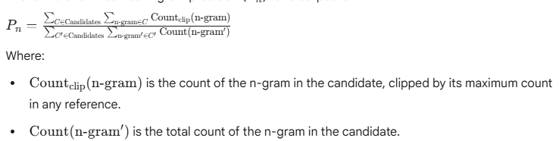

1. Brevity Penalty (BP): BLEU penalizes translations that are too short compared to the reference translations. This is because a very short translation could have high precision if all its few words are present in the reference, but it might miss a lot of information. The brevity penalty prevents this.

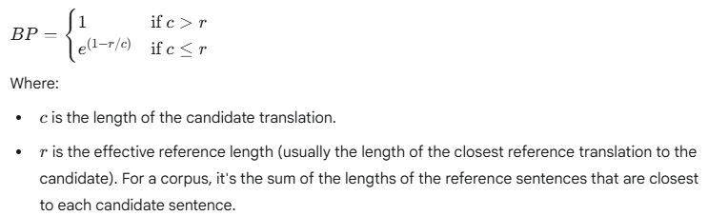

1. Geometric Mean: The individual modified n-gram precisions (typically for n=1 to 4) are combined using a geometric mean. This ensures that if any single n-gram precision is zero (meaning no match for that specific n-gram length), the overall score becomes zero, which is desirable.

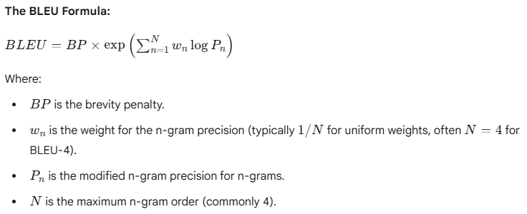

## Example and Step-by-Step Calculation:

Let’s consider a simple example with one candidate translation and one reference translation. For real-world scenarios, BLEU is typically calculated over a corpus (multiple sentences) and often with multiple reference translations.

Candidate Translation ( C ): “The cat sat on the mat”

Reference Translation ( R ): “A cat was sitting on the mat”

### Step 1: Tokenization

First, tokenize the sentences (convert them into lists of words). Punctuation is usually removed or treated as separate tokens, and casing is often normalized (e.g., lowercase everything).

C: [“the”, “cat”, “sat”, “on”, “the”, “mat”] (length = 6)

R: [“a”, “cat”, “was”, “sitting”, “on”, “the”, “mat”] (length = 7)

### Step 2: Calculate Modified N-gram Precisions (for N=1 to 4)

Unigram (n=1) Precision (P1):

**Count of unigrams in C:**

“the”: 2

“cat”: 1

“sat”: 1

“on”: 1

“mat”: 1

Total unigrams in C: 6

**Count of unigrams in R:**

“a”: 1

“cat”: 1

“was”: 1

“sitting”: 1

“on”: 1

“the”: 1

“mat”: 1

**Clipped Count of unigrams in C (based on R):** For each unigram in C, count how many times it appears in C, but don’t exceed its maximum count in R.

“the”: Max count in R is 1. In C it’s 2. So, clipped count is min(2,1) = 1

“cat”: Max count in R is 1. In C, it’s 1. So, clipped count is min(1,1) = 1

“sat”: Max count in R is 0. In C, it’s 1. So, clipped count is min(1,0) = 0

“on”: Max count in R is 1. In C, it’s 1. So, clipped count is min(1,1) = 1

“mat”: Max count in R is 0. In C, it’s 1. So, clipped count is min(1,0) = 1

Total clipped unigram matches = 1 + 1 + 0 + 1 + 1 = 4



**Bigram (n=2) Precision (P2)**

**Bigrams in C:**

“the cat”: 1

“cat sat”: 1

“sat on”: 1

“on the”: 1

“the mat”: 1

Total bigrams in C: 5

**Bigrams in R:**

“a cat”: 1

“cat was”: 1

“was sitting”: 1

“sitting on”: 1

“on the”: 1

“the mat”: 1

**Clipped Count of bigrams in C (based on R):**

“the cat”: Max count in R is 0. Clipped: min(1,0) = 0

“cat sat”: Max count in R is 0. Clipped: min(1,0) = 0

“sat on”: Max count in R is 0. Clipped: min(1,0) = 0

“on the”: Max count in R is 1. Clipped: min(1,1) = 1

“the mat”: Max count in R is 1. Clipped: min(1,1) = 1

Total clipped bigram matches = 0 + 0 + 0 + 1 + 1 = 2



**Trigram (n=3) Precision (P3):**

**Trigrams in C:**

“the cat sat”: 1

“cat sat on”: 1

“sat on the”: 1

“on the mat”: 1

Total trigrams in C: 4

**Trigrams in R:**

“a cat was”: 1

“cat was sitting”: 1

“was sitting on”: 1

“sitting on the”: 1

“on the mat”: 1

**Clipped Count of trigrams in C (based on R):**

“the cat sat”: Max count in R is 0. Clipped: min(1,0) = 0

“cat sat on”: Max count in R is 0. Clipped: min(1,0) = 0

“sat on the”: Max count in R is 0. Clipped: min(1,0) = 0

“on the mat”: Max count in R is 0. Clipped: min(1,1) = 1

Total clipped trigram matches = 0 + 0 + 0 + 1 = 1



**4-gram (n=4) Precision (P4):**

**4-grams in C:**

“the cat sat on”: 1

“cat sat on the”: 1

“sat on the mat”: 1

Total 4-grams in C: 3

**4-grams in R:**

“a cat was sitting”: 1

“cat was sitting on”: 1

“was sitting on the”: 1

“sitting on the mat”: 1

**Clipped Count of 4-grams in C (based on R):**

“the cat sat on”: Max count in R is 0. Clipped: min(1,0) = 0

“cat sat on the”: Max count in R is 0. Clipped: min(1,0) = 0

“sat on the mat”: Max count in R is 0. Clipped: min(1,0) = 0

Total clipped 4-gram matches = 0 + 0 + 0 = 0



### Step 3: Calculation Brevity Penalty (BP)

Length of Candidate ( C ) = 6

Length of Reference ( R ) = 7 (This is the length of the closest reference. Since there is only one, its 7)

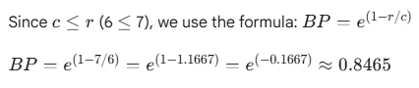

### Step 4: Calculate the BLEU Score

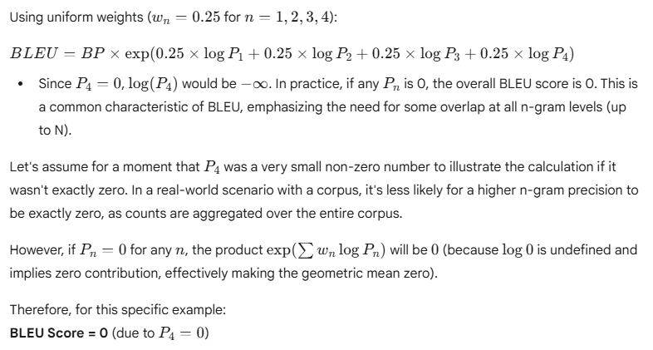

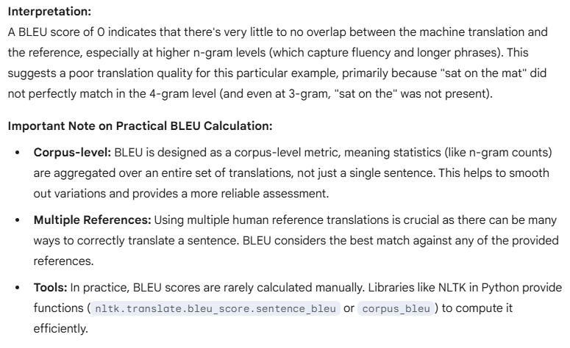

## ROUGE (Recall-Oriented Understudy for Gisting Evaluation)

ROUGE is a set of metrics used for evaluating the quality of summaries and translations generated by machines, primarily in Natural Language Processing (NLP). Unlike BLEU, which focuses on precision (how much of the candidates is in the reference), ROUGE focuses on recall (how much of the reference is captured by the candidate). This makes it particularly well-suited for summarization tasks, where the goal is often to include as much important information from the original text as possible in the summary.

ROUGE compares an automatically produced summary or translation against a set of human-produced reference summaries or translations. Scores range from 0 to 1, with higher scores indicating greater similarity.

There are several types of ROUGE metrics, each focusing on a different aspect of overlap:

1. **ROUGE-N:** Measures the overlap of n-grams between the candidate and reference summaries.
   1. ROUGE-1: Overlap of unigrams (single words). This captures word-level similarity.
   2. ROUGE-2: Overlap of bigrams (pair of consecutive words). This captures the fluency and short phrase matches.
   3. ROUGE-3, ROUGE-4, etc.: Overlap of trigrams, 4-grams and so on. Higher N-grams capture longer consecutive matches, indicating better fluency and adherence to the reference phrasing.

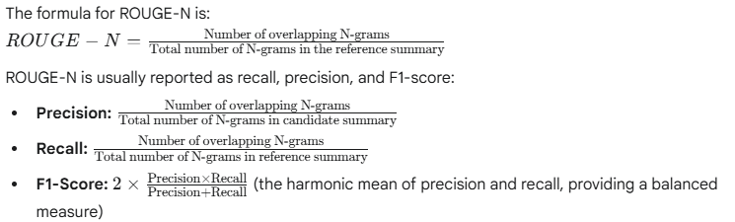

1. **ROUGE-L:** Measures the Longest Common Subsequence (LCS) between the candidate and reference summaries. The LCS is the longest sequence of words that appear in both texts, in the same order, but not necessarily consecutively. This metric naturally accounts for sentence-level structure and word order, even if words are interrupted.

The formula for ROUGE-L is also typically based on Precision, Recall, and F1-score of the LCS length:

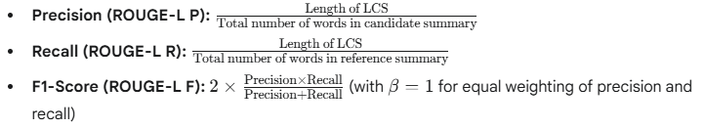

1. **ROUGE-S (Skip-bigram):** Measures the overlap of “skip-bigrams”. A skip-bigram is any pair of words in sentence order, allowing for arbitrary gaps between them. For example, in “the quick brown fox,” “the fox” is a skip-bigram with a skip distance of 2. This is useful for capturing paraphrasing or when word order might change slightly but the core concepts are still present.

## Example and Step-by-Step Calculation:

Let’s calculate ROUGE-1, ROUGE-2, and ROUGE-L for the following

Candidate Summary ( C ): “The cat sat on the mat”

Reference Summary ( R ): “A cat was sitting on the mat”

**Step-1: Tokenization and Normalization**

Convert sentences to lists of words (tokens) and typically lowercase them and remove punctuation for consistent comparison.

C : [“the”, “cat”, “sat”, “on”, “the”, “mat”] (length = 6 words)

R : [“a”, “cat”, “was”, “sitting”, “on”, “the”, “mat”] (length = 7 words)

**Calculation of ROUGE-1 (Unigram Overlap):**

**Step-2a: Identify Overlapping Unigrams**

Count the common unigrams (words) between C and R

Common words: “cat”, “on” “the”, “mat”

“the” appears twice in C, once in R. For overlap, we count the minimum occurrences. So, “the contributes 1 to the overlap.

Total overlapping unigrams: 4 (“cat”, “on”, “the” (1st instance), “mat”)

**Step-2b: Calculate Precision, Recall, and F1-score**

Total unigrams in Candidate ( C ): 6 (“the”, “cat”, “sat”, “on”, “the”, “mat”)

Total unigrams in Reference ( R ): 7 (“a”, “cat”, “was”, “sitting”, “on”, “the”, “mat”)

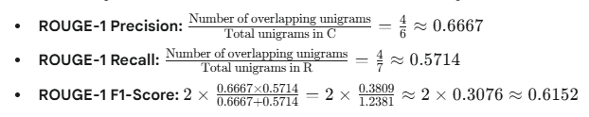

**Calculation of ROUGE-2 (Bigram Overlap)**

**Step-3a: Extract Bigrams**

**Bigrams in C:**

(“the”, “cat”)

(“cat”, “sat”)

(“sat”, “on”)

(“on”, “the”)

(“the”, “mat”)

Total bigrams in C: 5

**Bigrams in R:**

(“a”, “cat”)

(“cat”, “was”)

(“was”, “sitting”)

(“sitting”, “on”)

(“on”, “the”)

(“the”, “mat”)

Total bigrams in R: 6

**Step-3b: Identify Overlapping Bigrams**

Common bigrams: (“on”, “the”), (“the”, “mat”)

Total overlapping bigrams: 2

**Step-3c: Calculate Precision, Recall, and F1-Score**

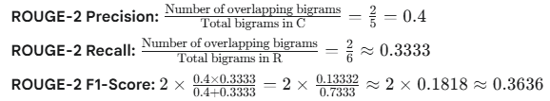

**Calculation of ROUGE-L (Longest Common Subsequence – LCS):**

**Step-4a: Find the Longest Common Subsequence (LCS)**

The LCS is the longest sequence of words that appear in both sentences in the same order, but not necessarily contiguously.

C: [“the”, “cat”, “sat”, “on”, “the”, “mat”]

R: [“a”, “cat”, “was”, “sitting”, “on”, “the”, “mat”]

Let’s trace:

“cat” is common.

After “cat”, “sat” in C does not match “was”, “sitting” in R.

“on” is common

“the” is common

“mat” is common

The LCS is: “cat”, “on”, “the”, “mat”

Length of LCS = 4 words.

**Step-4b: Calculate Precision, Recall, and F1-Score**

Total words in Candidate ( C ): 6

Total words in Candidate ( R ): 7

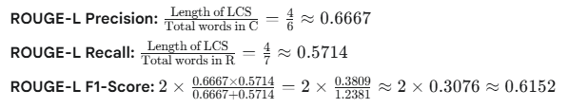

**Summary of Scores for this example:**

**ROUGE-1 F1**: 0.6152

**ROUGE-2 F1:** 0.3636

**ROUGE-L F1:** 0.6152

**Interpretation:**

* A ROUGE-1 score of around 0.62 indicates a decent word overlap
* A lower ROUGE-2 score of around 0.36 suggests that while many individual words matches, the specific two-word phrase did not align as well, indicating some difference in sentence structure or phrasing.
* ROUGE-L being similar to ROUG-1 implies that the common words were largely in the correct relative order, even if there were insertions or deletion that affected consecutive n-grams.

Like BLEU, ROUGE is typically computed over a large corpus and often against multiple reference summaries to provide a more robust evaluation. Python libraries like rouge_score or evaluate (from Hugging Face) are commonly used for practical calculations.

## Ethical Foundation and Governance in Generative AI

Generative AI (GenAI) presents immense opportunities but also unique ethical challenges due to its ability to create new content. Establishing strong ethical foundations and robust governance strategies is crucial for its responsible development deployment.

### Ethical Foundations in Generative AI

The ethical foundations of GenAI are rooted in broader AI ethics, but with specific emphasis on aspects related content generation. Key principles include:

1. **Transparency and Explainability**

Disclosure: Users should be informed when content is AI generated (e.g., text, images, audio, video). This helps maintain trust and prevents deception.

Traceability: Where feasible, AI systems should provide insights into their logic or justifications, especially in high-stakes contexts. This helps users understand capabilities, limitations and intended use.

Documentation: Clear documentation of training data, model architecture, and deployment decisions is essential for understanding how the system works

1. **Fairness and Non-discrimination**

Bias Mitigation: GenAI models must be trained on diverse and representative datasets to avoid perpetuating or amplifying harmful biases related to race, gender, culture, or socio-economic status.

Regular Auditing: Continuous testing and auditing are needed to detect and mitigate algorithmic bias, ensuring equitable outcomes and preventing the marginalization of vulnerable groups.

Inclusivity: AI systems should be designed to empower everyone and engage all people, regardless of their backgrounds and reflect a vast range of human identities and experiences.

1. **Accountability and Human Oversight**

Huma-in-the-loop: In sensitive domains (e.g., healthcare, education, finance), mechanisms for human oversight and intervention are critical. Humans must be able to monitor generated content and intervene when necessary.

Responsibility: Clear designation of responsibility for managing AI outcomes, including legal and ethical implications, is vital. Organizations and individuals must be accountable for the AI systems they develop and deploy.

Audit Trails: Logging prompts, model responses, user interventions, and decision rationales ensures transparency and accountability.

1. **Data Privacy and Informed Consent**

Ethical Data Sourcing: GenAI should only use data that has been ethically sourced with explicit consent.

Output Privacy: Systems must be designed not to produce outputs that compromise individual privacy. Techniques like differential privacy and federated learning can enhance data protection.

Secure Handling: Implementing robust data security and privacy standards to mitigate risks from breaches, unauthorized access, and non-compliance.

1. **Safety and Robustness**

Harm Prevention: GenAI systems should be designed to prevent the generation of harmful outputs, such as misinformation, hate speck, or inappropriate material.

Vulnerability Testing: Rigorous testing for vulnerabilities like adversarial prompts, phishing potential, or disinformation generation is essential.

Reliability: AI systems should perform reliably and safely under various conditions, with mechanisms to override, repair, or decommission them if they pose undue harm.

1. **Intellectual Property and Creative Integrity**

Copyright Compliance: Users and developers must comply with copyright laws and avoid plagiarizing original work.

Attribution: When referencing existing works, proper attribution should be provided.

Acknowledging AI Use: Users should clearly acknowledge when AI is used to produce work fostering trust and credibility.

1. **Environment Impact**

Energy Consumption: Acknowledging the high power consumption required for training large GenAI models and exploring methods for energy efficient AI development.

### Governance Strategies in Generative AI

Governance strategies translate ethical principles into actionable frameworks and practices. They involve defining policies, roles and processes to ensure responsible AI development and deployment.

1. **Establishing a Comprehensive AI Governance Framework**

Policy Development: Create clear, organization-wide policies defining acceptable and prohibited uses of GenAI, aligned with organizational values, legal constraints, and industry standards.

Risk Assessment and Management: Implement structured frameworks to identify asses, and mitigate operational, technical, and reputational risks associated with GenAI. This includes continuous monitoring for biases, security vulnerabilities, and ethical violations

Clear Roles and Responsibilities: • Define specific roles and responsibilities for individuals and teams involved in the GenAI lifecycle, from development to deployment and monitoring.

**Governance Committee/Board:** Establish an interdisciplinary committee (including legal, compliance, data science, product, and operations) to oversee GenAI initiatives and vet new deployments.

1. **Lifecycle Management and Monitoring**

Model Monitoring: Continuously track model performance, behavioral drift, and output accuracy over time.

Audit Trails and Documentation: Maintain detailed logs of prompts, model responses, user interventions, and decision rationales to ensure transparency, accountability, and compliance readiness.

Continuous Improvement: Implement mechanisms for ongoing evaluation and improvement of AI models, adapting to changing circumstances, new risks, and evolving ethical standards.

1. **Data Governance**

Quality and Integrity: Focus on the availability of high-quality, well-annotated data to minimize errors and biases in GenAI outputs.

Access Control: Implement strict access control policies, including role-based access, to sensitive tools and data used for training and inference.

Encryption and Anonymization: Utilize data encryption and anonymization techniques to protect sensitive information.

Data Lineage: Implement tools to track the lineage of data used in GenAI models.

1. **Regulatory Compliance**

Stay Updated: Continuously monitor and align with evolving regional and international AI regulations and standards (e.g., EU AI Act, NIST AI Risk Management Framework, OECD AI Principles, GDPR).

Legal Risk Assessment: Conduct regular assessments to identify and address potential legal risks associated with GenAI use, including copyright infringement and privacy violations.

1. **Organizational Culture and Training**

Ethical AI Education: Provide regular training for all employees involved with GenAI on ethical considerations, bias awareness, responsible use, and compliance policies.

Culture of Responsibility: Foster a culture within the organization that prioritizes ethical AI development and deployment, encouraging open discussion and reporting of concerns.

Stakeholder Engagement: Engage diverse stakeholders, including the public, in discussions about AI policy decisions and the direction of technological developments to ensure governance frameworks reflect societal values.

1. **External Auditing and Red Teaming**

Independent Audits: Conduct independent audits for high-impact or large-scale GenAI deployments to verify compliance with ethical guidelines and identify potential issues.

Red Teaming: Proactively test GenAI systems for vulnerabilities and potential misuse by simulating adversarial attacks to identify weaknesses and implement safeguards.

By integrating these ethical foundations and governance strategies, organizations can work towards building and deploying generative AI systems that are not only innovative and powerful but also responsible, fair, and beneficial to society.

## Lab: Build a mini GPT-like transformer using Hugging Face

Building a “mini GPT-like transformer” from scratch with Hugging Face to understand the core components of large language models. The Hugging Face transformers library make this process much more accessible than implementing everything from scratch.

Here’s a step by step guide to building and training a simple, small causal language model (like GPT) using Hugging Face. We will focus on the essential Components:

**Tokenizer, Model Configuration, Model Architecture, Dataset Preparation, and Training.**

**Prerequisites:**

Make sure you have necessary libraries installed.

pip install transformers datasets accelerate tokenizers torch

accelerate is good for efficient training, and tokenizers is for custom tokenizer training. torch is the backend of our model.

Step-1: Prepare Your Dataset

Step 2: Train a Custom Tokenizer

Step 3: Configure Your Mini GPT Model

Step 4: Preprocess the Dataset for Training

Step 5: Set up Training Arguments and Trainer

Step 6: Generate Text with Your Mini GPT

