DATA SCIENCE MINOR PROJECT REPORT

DATA SCIENCE MINOR PROJECT
PROJECT REPORT

HDFC BANK STOCK ANALYSIS AND NEXT-DAY PRICE PREDICTION

Submitted by
[STUDENT NAME]
Registration No.: [ENTER REGISTRATION NUMBER]
Programme and Section: B.Tech CSE – [ENTER SECTION]
Course Code: [ENTER COURSE CODE]

Under the Guidance of
[FACULTY COORDINATOR NAME, U.ID AND DESIGNATION]

Discipline of Computer Science and Engineering
Lovely School of Technology
Lovely Professional University, Phagwara, Punjab
Project Semester: [ENTER YOUR PROJECT SEMESTER]

DECLARATION
I, [STUDENT NAME], student of B.Tech Computer Science and Engineering under the Discipline of Computer Science and Engineering at Lovely Professional University, Punjab, hereby declare that the project report entitled “HDFC Bank Stock Analysis and Next-Day Price Prediction” is based on the work carried out by me for academic learning.
The analysis, code implementation, visualizations, model comparisons, and interpretations presented in this report are prepared for educational purposes. Any external dataset source, software library, documentation, or reference used in the project must be acknowledged in the references section. The dataset supplied for this work is identified as HDFCBANK.NS.csv; its original download source and access date should be verified and completed before final submission.
I understand that the report should represent my own understanding and that I am responsible for reviewing the calculations, running the notebook, checking the results, and ensuring that all screenshots included in the final submission are genuine.
Date: [DD/MM/YYYY]
Signature: ______________________________
Name: [STUDENT NAME]
Registration No.: [REGISTRATION NUMBER]

CERTIFICATE
This is to certify that [STUDENT NAME], bearing Registration No. [REGISTRATION NUMBER], has completed the Data Science Minor Project titled “HDFC Bank Stock Analysis and Next-Day Price Prediction” under my guidance and supervision.
To the best of my knowledge, the present work is the result of the student's project development, effort, analysis, and study. The work includes data preprocessing, exploratory data analysis, feature engineering, implementation of machine learning regression models, and evaluation of model performance.
Signature and Name of the Supervisor: ______________________________
Designation of the Supervisor: _____________________________________
School of: _______________________________________________________
Lovely Professional University, Phagwara, Punjab.
Date: __________________
Note: This certificate page is a template. It must be reviewed and signed by the authorized project supervisor. Do not submit it as an already signed certificate.

ACKNOWLEDGEMENT
I would like to express my sincere gratitude to Lovely Professional University for providing the academic environment and learning resources required to complete this Data Science Minor Project. The project provided an opportunity to apply concepts of Python programming, data analysis, data visualization, and machine learning to a real-world financial dataset.
I would like to thank my project supervisor, [FACULTY NAME], for guidance, feedback, and support during the planning and development of this work. I also acknowledge the faculty members of the Computer Science and Engineering discipline for helping me build the programming and analytical foundations used in this project.
I acknowledge the developers and maintainers of Python and its open-source libraries, especially pandas, NumPy, Matplotlib, and scikit-learn. These tools made it possible to perform data cleaning, statistical analysis, visualization, feature construction, and model evaluation in a reproducible workflow.
Finally, I thank my family and friends for their encouragement. I am responsible for validating the project outputs and for completing the source attribution and institutional details before submission.

TABLE OF CONTENTS
Declaration ii
Certificate iii
Acknowledgement iv
Table of Contents v
List of Figures and Tables vi
1. Introduction 1
2. Source of Dataset 5
3. EDA Process 8
4. Analysis on Dataset 12
4.1 Stock Price Trend Analysis 12
4.2 Trading Volume Analysis 15
4.3 Daily Returns and Volatility 18
4.4 Correlation Analysis 21
4.5 Year-End Price Analysis 24
4.6 Feature Engineering 26
4.7 Machine Learning Models and Evaluation 28
5. Conclusion 34
6. Future Scope 36
7. References 38
Appendices and Screenshot Evidence 39

LIST OF FIGURES AND TABLES
- Figure 1. Adjusted closing price over time
- Figure 2. Daily trading volume
- Figure 3. Distribution of daily adjusted-price returns
- Figure 4. Year-end adjusted closing price
- Figure 5. Correlation matrix of market variables
- Figure 6. Model comparison by RMSE
- Figure 7. Actual versus predicted next-day adjusted close
- Table 1. Dataset attributes
- Table 2. Data quality checks
- Table 3. Engineered features
- Table 4. Machine learning model performance
The final page numbers should be refreshed in Microsoft Word after all student details, screenshots, and any institution-specific edits are completed.

1. INTRODUCTION
Data science combines data collection, preparation, exploration, statistical reasoning, visualization, and predictive modeling to extract useful information from datasets. Machine learning is a part of this broader process in which algorithms learn patterns from historical examples and use those patterns to generate predictions or classifications. A complete data science project should not begin and end with model training. It should establish a clear problem, understand the source and limitations of the data, prepare the records carefully, investigate patterns, build appropriate features, compare models fairly, and communicate findings with suitable visual evidence.
The present project focuses on historical market data for HDFC Bank. The supplied file, HDFCBANK.NS.csv, contains date-wise market fields such as opening price, high price, low price, closing price, adjusted closing price, and trading volume. These fields allow a student to study how the observed market price changes over time, how trading activity varies, how daily returns are distributed, and how price-related variables move together.
The machine learning component frames the task as a regression problem. The target is the adjusted closing price in the next available trading-day row. Historical prices and derived indicators are used as predictors. The project compares five regression algorithms and selects the model with the lowest root mean squared error on a chronologically later test period.
The project is educational. A historical stock-price model cannot guarantee future returns or provide a reliable trading instruction. Financial markets are influenced by company announcements, economic conditions, interest rates, policy decisions, global events, liquidity, investor expectations, and other factors that are not necessarily represented in a price-and-volume CSV file.

1.1 Background and Motivation
Financial datasets are useful for demonstrating time-series analysis because observations have a natural order. Unlike many ordinary tabular problems, a future observation must not be used to predict an earlier observation. This makes chronological splitting, lag construction, and leakage prevention especially important. A random train-test split can place later records in the training set and earlier records in the test set, creating an evaluation that does not resemble the intended forecasting situation.
HDFC Bank is used as the subject of this case study because the provided dataset is identified by the ticker-style filename HDFCBANK.NS.csv. The project does not attempt to explain every movement in the bank's share price. Instead, it demonstrates a repeatable analysis pipeline using the fields available in the supplied file.
The motivation is to gain practical experience with Python libraries and with the decisions required during an end-to-end machine learning workflow. These include how to handle missing values, how to detect duplicate records, how to calculate returns, how to create moving averages, how to select a target variable, and how to compare regression models using more than one metric.

1.2 Problem Statement
The problem addressed in this project is to analyze historical HDFC Bank market observations and investigate whether selected historical price, volume, rolling-statistic, and calendar features can estimate the next available trading day's adjusted closing price. The analysis must also describe the dataset's structure and quality, identify patterns through visualizations, and compare multiple regression models using a time-ordered test set.
The prediction problem is defined at the row level: for each date t, the target is the adjusted closing price in the next available record t+1. This is a next-trading-observation target, not necessarily the next calendar day, because stock exchanges do not trade on every calendar date. The model's error is measured in the same units as the adjusted closing price.

1.3 Objectives of the Project
- To load and inspect the HDFC Bank historical dataset and understand its columns and date coverage.
- To clean the data by parsing dates, converting numeric fields, removing duplicate rows, and handling missing or invalid values.
- To analyze the long-term adjusted closing-price trend.
- To study changes in daily trading volume and identify periods of comparatively high or low activity.
- To calculate daily returns and examine their distribution as a simple view of historical variability.
- To study correlations among open, high, low, close, adjusted close, and volume.
- To compare year-end adjusted closing prices across the available years.
- To engineer lag, return, moving-average, volatility, price-range, and calendar features.
- To train and compare at least four machine learning regression models.
- To evaluate model performance with MAE, RMSE, and R-squared on a chronological test set.

1.4 Scope and Limitations
The scope is limited to the historical records contained in the supplied CSV. The analysis does not incorporate financial statements, market indices, news, macroeconomic indicators, corporate announcements, or sector-level information. The project uses the available OHLC, adjusted close, and volume fields. The modeling target is a numeric price level rather than a buy/sell recommendation.
The period in the supplied file extends from 1 January 1996 to 21 January 2022. This is the date range observed after parsing the supplied dataset. The project should therefore not be described as a current-market analysis. If the assignment requires recent data, the dataset should be refreshed from a verified source and all results should be regenerated.
The cleaning workflow interpolates or carries values for selected missing feature fields. Such imputation can make a student workflow run consistently, but it may not be appropriate for every market-data gap. The final report should disclose this choice. The model scores are dependent on the specific data period, features, split point, and model settings.

2. SOURCE OF DATASET
The project dataset is the file HDFCBANK.NS.csv supplied for analysis. The filename uses the ticker-style suffix “.NS”, which is commonly associated with National Stock Exchange listings in Yahoo Finance-style ticker conventions. However, the exact download provider cannot be conclusively established from the CSV filename alone. Before submission, the student must confirm the actual website or repository from which the file was obtained and enter the exact URL and access date in this section.
The dataset is a structured time-series table. Each row represents one date's market observation. The fields used in this project are Date, Open, High, Low, Close, Adj Close, and Volume. Date provides temporal ordering. Open, High, Low, and Close describe the reported trading price range and closing value. Adj Close is the adjusted closing price field used for the principal trend and target. Volume represents the reported number of shares traded.

2.1 Dataset Description
Attribute | Description | Role in project
Date | Date associated with each market observation | Sort order and calendar features
Open | Opening price | Input feature
High | Highest reported price in the period | Input feature and range feature
Low | Lowest reported price in the period | Input feature and range feature
Close | Closing price | Input feature
Adj Close | Adjusted closing price | Trend analysis and prediction target
Volume | Reported trading volume | Input feature and activity analysis
The supplied dataset initially contains 6,567 rows. After date parsing, duplicate removal, invalid-record handling, and required-field filtering, the cleaned table contains 6,560 rows. The observed date range is 1996-01-01 to 2022-01-21.

2.2 Data Quality and Preprocessing Summary
Check | Observed / applied result
Initial row count | 6,567
Cleaned row count | 6,560
Missing cells before cleaning | 42
Duplicate rows removed | 0 in the recorded run
Date handling | Converted to datetime; invalid dates excluded
Numeric handling | OHLC, adjusted close, and volume converted to numeric
Invalid volume | Negative values changed to missing
Invalid range | Rows with High below Low treated as invalid for those fields
Remaining feature gaps | Interpolated and forward/backward filled for selected fields
The reported missing-cell count is taken from the recorded project execution. The exact number of missing values per column should be regenerated if the notebook is rerun on a changed copy of the source CSV.

2.3 Data Source Verification and Reproducibility
A reliable academic report should allow another reader to locate the same data. The source citation should therefore include the provider name, ticker symbol, historical-data page or download endpoint, date accessed, and any relevant data terms. If the original file was downloaded from Yahoo Finance, the student may cite the HDFC Bank historical-data page for the HDFCBANK.NS ticker, but should only do so after confirming that this was the actual source used.
The original dataset is retained separately from the cleaned dataset. This is important because preprocessing changes the records. Keeping the original file makes it possible to reproduce the cleaning steps, compare row counts, and audit the treatment of missing or invalid values.
For reproducibility, the notebook should be run from top to bottom in a clean Python environment. The package versions, source CSV, and output directory should be retained. The report's numerical results should match the output of the notebook included with the submission.

3. EDA PROCESS
Exploratory Data Analysis (EDA) is the process of examining a dataset before drawing conclusions or fitting predictive models. It uses descriptive statistics, tabular inspection, and visualization to understand data types, ranges, missing values, unusual observations, distributions, and relationships. EDA helps identify whether additional cleaning or feature construction is required.
In this project, EDA begins with reading the CSV and inspecting the first rows, shape, and column names. The Date column is parsed into a datetime representation and the market fields are converted to numeric types. The dataset is sorted chronologically because time order is essential for both analysis and forecasting.

3.1 Data Cleaning Workflow
- Load the CSV with pandas read_csv and inspect the first records.
- Parse Date using pandas to_datetime with invalid date values coerced to missing.
- Sort observations by Date to establish chronological order.
- Remove exact duplicate rows using drop_duplicates.
- Convert Open, High, Low, Close, Adj Close, and Volume to numeric values.
- Treat negative trading volume as invalid and set it to missing.
- Treat a High value below Low as an invalid range.
- Remove rows that lack Date, Close, or Adj Close because these fields are essential to the analysis.
- Interpolate remaining selected feature gaps and apply forward/backward filling where required.
- Save the cleaned result as HDFCBANK_cleaned.csv.
The workflow is designed to be transparent. Each operation has a reason: dates must be valid to sort the series; numeric conversion is required for arithmetic; duplicate removal avoids counting the same observation more than once; and essential fields are required for the target definition.

3.2 Descriptive Statistics
Statistic | Open | High | Low | Close | Adj Close | Volume
count | 6,560.000 | 6,560.000 | 6,560.000 | 6,560.000 | 6,560.000 | 6,560.000
mean | 337.150 | 340.553 | 333.371 | 337.044 | 328.144 | 4,941,708.714
std | 428.941 | 432.702 | 424.684 | 428.706 | 426.935 | 5,711,678.379
min | 2.435 | 2.435 | 2.395 | 2.435 | 1.976 | 0.000
25% | 23.800 | 24.099 | 23.310 | 23.654 | 20.443 | 1,563,007.500
50% | 134.425 | 138.075 | 130.505 | 133.783 | 122.550 | 3,427,885.000
75% | 513.463 | 518.425 | 509.062 | 513.737 | 495.121 | 6,361,122.500
max | 1,705.000 | 1,725.000 | 1,671.000 | 1,688.700 | 1,688.700 | 201,129,980.000
The descriptive-statistics table summarizes central tendency, dispersion, and range for each numeric variable. The mean and median provide different views of a typical value. Standard deviation describes the spread in the observed values, while minimum and maximum show the range. These statistics are useful for understanding scale differences, especially between price fields and volume.

3.3 EDA Questions and Analytical Approach
The EDA is organized around five main objectives. First, the adjusted closing-price chart is used to observe the long-term direction and changes in price level. Second, the trading-volume chart is used to examine activity over time. Third, daily percentage returns are calculated to put price changes on a relative scale and to inspect their distribution. Fourth, a correlation matrix is used to summarize linear association among numeric market fields. Fifth, year-end adjusted close values are extracted to compare the closing level at the end of each calendar year.
Each chart answers a different question. A line chart is appropriate for a date-indexed series because it preserves temporal order. A histogram is appropriate for a distribution because it shows how frequently values fall into intervals. A correlation heatmap provides a compact visual summary of pairwise linear correlation. The year-end line chart compresses daily observations into an annual comparison.

4. ANALYSIS ON DATASET
This chapter presents the analysis objectives individually. For each analysis, the report explains the purpose, general description, functions or formulas used, observed results, and visualization. The five EDA objectives are followed by feature engineering and model evaluation.

4.1 STOCK PRICE TREND ANALYSIS

4.1.1 Introduction
The first analysis investigates how HDFC Bank's adjusted closing price changes over the available historical period. A time-series line chart is used because the date order is meaningful. The adjusted closing price is selected as the main series for this objective.

4.1.2 General Description
A price trend chart plots Date on the horizontal axis and Adj Close on the vertical axis. The chart makes it possible to identify broad upward or downward movements, extended periods of stability, and intervals with larger changes. It does not, by itself, explain why a movement occurred. Interpretation should remain descriptive unless supported by additional company or market information.

4.1.3 Specific Requirements, Functions and Formula
The pandas functions used include read_csv, to_datetime, sort_values, and the plotting function from Matplotlib. The core formula is simply the chronological plot of the adjusted closing price P_t against date t. A return measure is not required for the line chart because the purpose is to show the price level.
Python implementation: plt.plot(df['Date'], df['Adj Close']); plt.title(...); plt.xlabel('Date'); plt.ylabel('Adjusted Close Price'). The figure is saved to the output directory for inclusion in the report.

4.1.4 Analysis Results
The cleaned data contains 6,560 observations over the period 1996-01-01 to 2022-01-21. The minimum adjusted closing price in the supplied cleaned dataset is 1.976, while the maximum is 1688.700. These values describe the observed sample only. The chart should be read as a historical record rather than as evidence that the same direction will continue.

4.1.5 Visualization
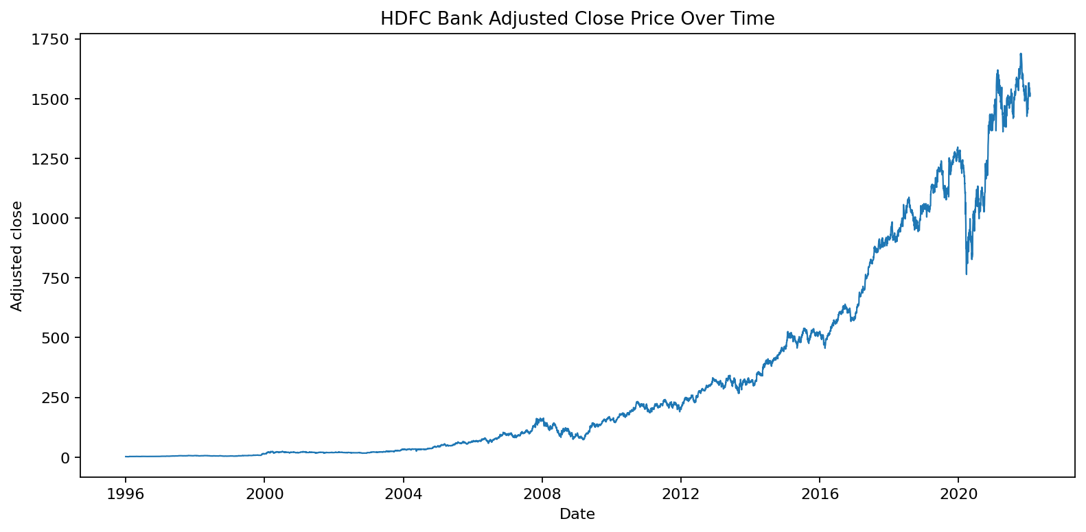
Figure 1. HDFC Bank adjusted closing price over time.

4.1.6 Interpretation and Discussion
The price chart provides a broad view of the historical trajectory. A long date range can contain multiple market regimes, including periods of gradual appreciation, correction, and rapid repricing. Since the vertical axis represents a nominal adjusted price level, a movement of a fixed number of currency units has a different proportional meaning at different price levels. For that reason, the price chart should be considered together with percentage returns and volatility.
The adjusted close series is used rather than treating the raw closing price as the only historical measure. Adjusted-price series are commonly used in historical analysis to account for certain corporate actions, depending on the data provider's methodology. The report should not infer the provider's exact adjustment methodology without checking its documentation.
The analysis answers the first objective by providing a visual summary of price movement and reporting the minimum and maximum values. It does not identify causal factors. To explain particular rises or falls, additional information such as corporate announcements, market-index movements, and macroeconomic events would be required.

4.2 TRADING VOLUME ANALYSIS

4.2.1 Introduction
The second analysis examines daily trading volume. Volume is a measure of trading activity and can provide context for price movements. Periods of higher volume may reflect greater market participation, but volume alone does not indicate whether investors are buying or selling for a particular reason.

4.2.2 General Description
A line chart is created with Date on the horizontal axis and Volume on the vertical axis. The chart preserves the order of trading observations and highlights changes in the scale of daily activity. Since volume can vary substantially, the chart may contain spikes that make smaller changes less visible.

4.2.3 Specific Requirements, Functions and Formula
The main functions are pandas column selection and Matplotlib plot. Average volume is calculated as the arithmetic mean of the volume column: average volume = sum of daily volume observations divided by the number of valid observations. The chart is generated with plt.plot(df['Date'], df['Volume']).

4.2.4 Analysis Results
The mean daily volume in the cleaned dataset is approximately 4,941,709 shares/units as represented in the source file. This is a sample-wide average and may be influenced by periods with unusually high activity. The daily chart should be inspected for spikes and sustained changes rather than relying only on the average.

4.2.5 Visualization
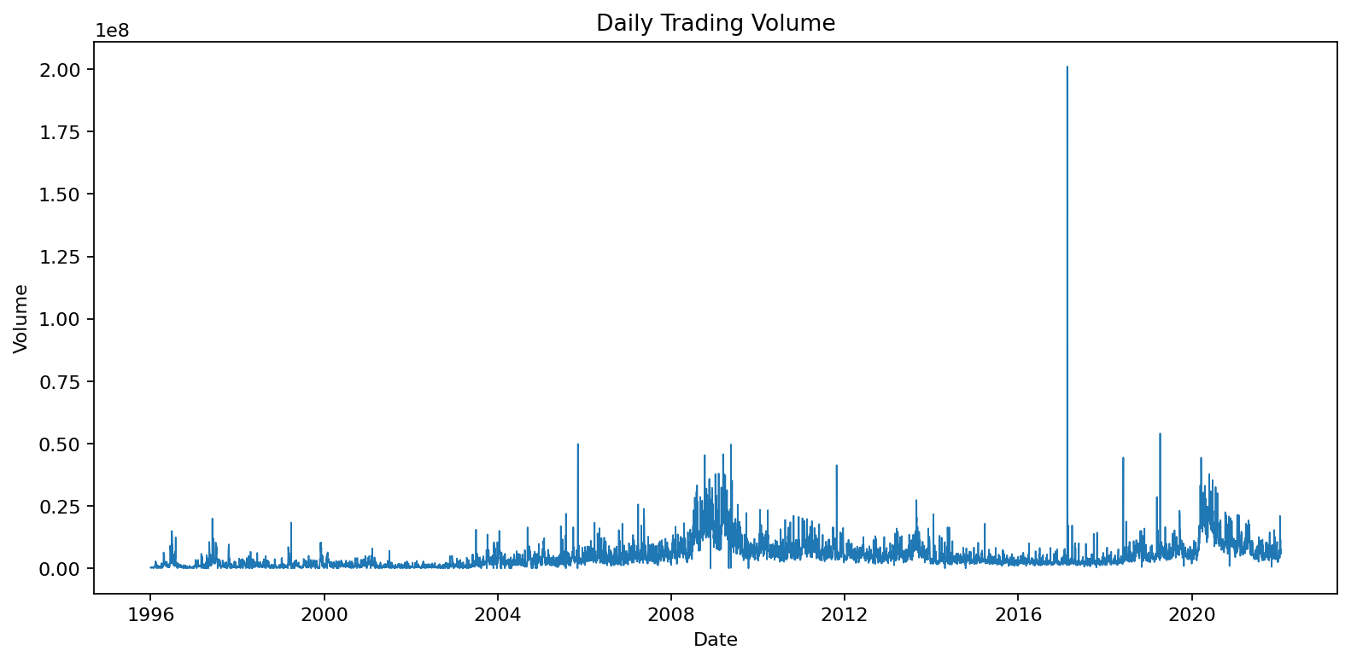
Figure 2. Daily trading volume across the dataset.

4.2.6 Interpretation and Discussion
Trading volume is useful as a contextual variable because a price movement accompanied by unusually high activity may be different from a movement during quiet trading. However, the dataset's volume field does not identify investor categories, order direction, or the reason for the transaction. It should therefore be interpreted as an activity measure only.
The volume series may be highly skewed. A small number of unusually active sessions can influence the mean and dominate the vertical scale. For a deeper investigation, the student could calculate median volume, volume percentiles, rolling averages, and year-wise summaries. A logarithmic vertical axis may also help when the range is very wide, although the current report uses a straightforward line chart.
This objective is completed by plotting daily volume and calculating its average. The chart supports visual identification of unusually active periods, while the average provides a single summary statistic.

4.3 DAILY RETURNS AND VOLATILITY ANALYSIS

4.3.1 Introduction
The third analysis studies daily adjusted-price returns. Price levels can trend over time and are not always directly comparable across different periods. Percentage returns express the change relative to the previous observation and provide a scale-independent measure of daily movement.

4.3.2 General Description
The daily return is calculated as the percentage change in adjusted close between consecutive available observations. The return series is then summarized by its mean and standard deviation and visualized using a histogram. To make the central distribution easier to inspect, the displayed histogram clips values at the first and ninety-ninth percentiles. This clipping is only for visualization; it does not modify the original return data used in the reported mean and standard deviation.

4.3.3 Specific Requirements, Functions and Formula
The formula is R_t = (P_t / P_(t-1)) - 1, where P_t is the adjusted close for the current observation and P_(t-1) is the adjusted close for the previous available observation. In pandas, pct_change() computes this relative change. The mean is returns.mean() and the sample standard deviation is returns.std(). Matplotlib hist() creates the histogram.

4.3.4 Analysis Results
The mean daily adjusted-price return in this run is 0.12141%. The standard deviation of daily returns is 2.15914%. These figures describe the average and dispersion of the one-observation return series in the supplied historical period. They are not estimates of future return or future risk.

4.3.5 Visualization
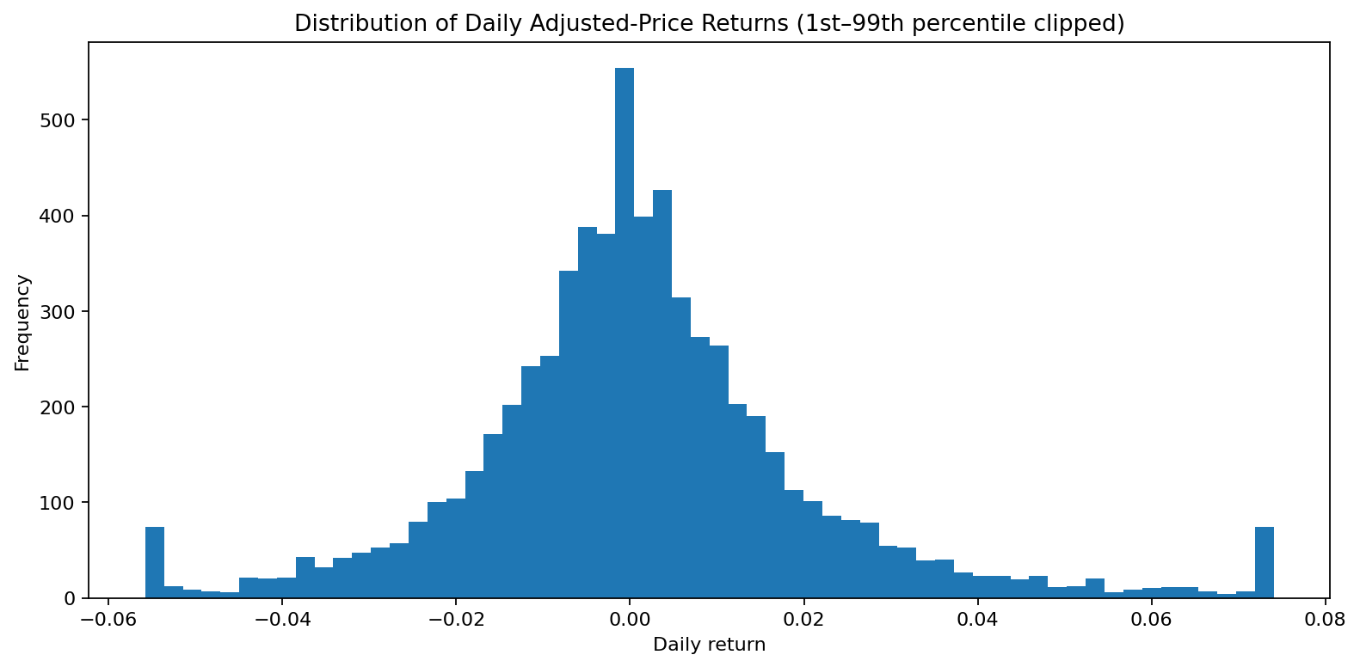
Figure 3. Distribution of daily adjusted-price returns; display tails clipped at the 1st and 99th percentiles.

4.3.6 Interpretation and Discussion
A return histogram can reveal whether most observations are concentrated near zero, whether the distribution is asymmetric, and whether there are relatively rare large positive or negative movements. Financial returns often contain outliers and may not follow a normal distribution. The histogram is therefore a descriptive tool, not a complete statistical model of risk.
The standard deviation provides a simple measure of historical dispersion. It does not capture every form of risk, such as drawdown, liquidity risk, event risk, or changing volatility regimes. A more advanced study could calculate rolling volatility, maximum drawdown, downside deviation, and conditional tail measures.
The return analysis complements the price trend analysis. The price chart shows the path of the asset's value, while the return histogram focuses on the size and frequency of relative changes between adjacent observations.

4.4 CORRELATION ANALYSIS

4.4.1 Introduction
The fourth analysis investigates pairwise linear relationships among Open, High, Low, Close, Adj Close, and Volume. Correlation is used as a descriptive statistic to summarize how two numeric variables move together in the observed sample.

4.4.2 General Description
The Pearson correlation coefficient ranges from -1 to +1. A value near +1 indicates a strong positive linear association, a value near -1 indicates a strong negative linear association, and a value near zero indicates little linear association. Correlation does not establish causation and may be affected by common trends, outliers, and the scale or construction of the variables.

4.4.3 Specific Requirements, Functions and Formula
The pandas DataFrame.corr() method calculates the correlation matrix for numeric columns. The Pearson coefficient between variables X and Y is cov(X,Y) divided by the product of their standard deviations. Matplotlib imshow() displays the matrix as a heatmap, while colorbar() adds a scale and text annotations show the coefficient values.

4.4.4 Analysis Results
The correlation matrix is generated from the cleaned numeric market fields. Price fields are related by definition because they describe values from the same trading session. The exact coefficients are displayed in Figure 5 and can be inspected directly in the notebook output. Volume may show a different relationship from the price fields, and its association should be interpreted from the computed matrix rather than assumed in advance.

4.4.5 Visualization
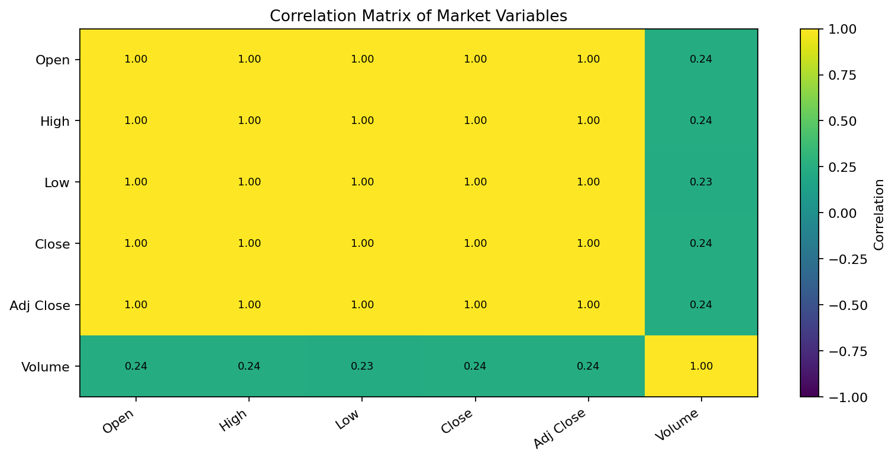
Figure 5. Correlation matrix for the numeric market variables.

4.4.6 Interpretation and Discussion
A correlation heatmap is useful for identifying groups of variables that contain similar information. Strong correlations among OHLC price fields are expected because the values are measured on the same date and describe related aspects of the same trading session. This may create redundancy when all fields are supplied to a predictive model.
Correlation is a linear measure. A low correlation does not prove that two variables are independent, because a nonlinear relationship may still exist. Similarly, a high correlation does not mean that one variable causes another. The heatmap should therefore guide further investigation rather than serve as a causal explanation.
The correlation analysis completes the fourth EDA objective. The matrix also motivates the feature-engineering stage, where lagged values and rolling summaries are created to represent recent market history.

4.5 YEAR-END PRICE ANALYSIS

4.5.1 Introduction
The fifth EDA objective compares the adjusted closing price at the end of each calendar year. Annual aggregation reduces the number of plotted points and makes longer-term comparisons easier to read.

4.5.2 General Description
The daily adjusted closing-price series is indexed by Date and resampled to year-end frequency. The last available observation in each year is retained. The resulting annual series is plotted as a line chart with markers.

4.5.3 Specific Requirements, Functions and Formula
The implementation uses set_index('Date'), resample('YE').last(), and Matplotlib plot(). For each year y, the selected value is the adjusted close from the last available trading observation in that year. It is not necessarily a value from 31 December because the exchange may not have traded on that date.

4.5.4 Analysis Results
The year-end series provides one adjusted closing-price observation for each year represented in the dataset. The chart should be used to compare annual closing levels and broad changes between year-end observations. It does not show the path or volatility within each year.

4.5.5 Visualization
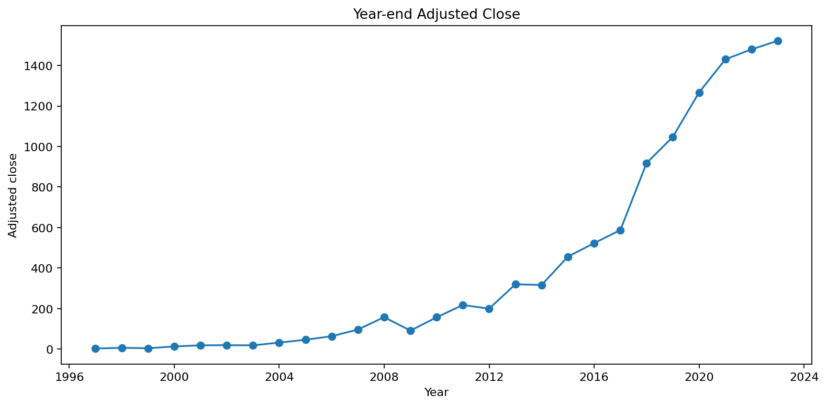
Figure 4. Year-end adjusted closing-price series.

4.5.6 Interpretation and Discussion
Annual aggregation is effective for communicating long-term price levels but removes information about intra-year movements. Two years may have similar year-end values despite having very different paths during the year. The annual chart should therefore be read alongside the daily price chart and return distribution.
The fifth objective is completed by generating the year-end series and plotting its values. A future extension could calculate annual return, annualized volatility, maximum drawdown, and the difference between each year's first and last available adjusted closing price.

4.6 FEATURE ENGINEERING
Feature engineering transforms raw columns into variables that may better represent the structure of the prediction problem. In a time-series setting, the features should be calculated using only information available at or before the prediction date. The target in this project is the adjusted close in the next available trading observation.

4.6.1 Engineered Features
Feature | Definition | Purpose
Return_1d | One-observation percentage change | Recent short-term movement
Return_5d | Five-observation percentage change | Short-term cumulative movement
MA_5 / MA_10 / MA_20 | Rolling means of adjusted close | Smoothed price levels
Volatility_10d | Rolling standard deviation of daily returns | Recent variability
Range_pct | (High - Low) / Close | Intraday range relative to close
Day_of_week | Date weekday encoded 0-6 | Calendar pattern
Month / Year | Month and year from Date | Calendar context
AdjClose_lag_1/2/3/5 | Prior adjusted closing-price values | Recent historical levels
Target | Next row's adjusted close | Regression target
Rolling features require enough prior observations. As a result, the first rows may contain missing values until the rolling window is complete. The final row does not have a next-row target and is excluded from model training.

4.6.2 Prevention of Time-Series Leakage
Time-series leakage occurs when a model is trained using information that would not have been available at the prediction time. The target is shifted by one row to represent the next trading observation. Lag and rolling features are based on current or past adjusted closing prices. The data is then split chronologically: the earlier 80 percent is used for training and the later 20 percent is used for testing.
The imputer is included inside a scikit-learn Pipeline. This ensures that the median values used for missing-feature imputation are learned from the training portion and then applied to the test portion. Fitting preprocessing steps on the entire dataset before splitting could allow information from the test period to influence the training process.
After feature creation and removal of rows without complete feature history or a next-row target, the modeling table contains 6,540 records. The chronological split uses 5,232 training rows and 1,308 testing rows in the recorded run.

4.7 MACHINE LEARNING MODELS AND EVALUATION
The project compares five regression models. Each model receives the same engineered input features and is evaluated on the same chronological test set. This makes the comparison more meaningful than evaluating each model on a different subset of observations.

4.7.1 Linear Regression
Linear Regression models the target as a weighted sum of input features plus an intercept. It provides a simple baseline and is relatively easy to interpret. It can perform well when the relationship between features and target is approximately linear. However, it may be sensitive to multicollinearity, outliers, and nonlinear patterns.

4.7.2 Ridge Regression
Ridge Regression is a regularized linear model. It adds an L2 penalty to the linear regression objective, discouraging excessively large coefficients. Regularization can help when input variables are correlated or when a model is at risk of overfitting. The alpha parameter controls the strength of the penalty.

4.7.3 Random Forest Regressor
Random Forest is an ensemble method that trains multiple decision trees on randomized samples and feature subsets. Predictions are combined across trees. It can model nonlinear relationships and interactions without requiring a linear functional form. Its performance depends on settings such as number of trees, maximum depth, and minimum leaf size.

4.7.4 Gradient Boosting Regressor
Gradient Boosting builds an additive sequence of weak learners, commonly shallow decision trees. Each new learner attempts to reduce the errors made by the current ensemble. The learning rate, number of estimators, and tree depth influence the balance between fit and generalization. Boosting can capture nonlinear patterns but may overfit if complexity is not controlled.

4.7.5 Extra Trees Regressor
Extra Trees, or Extremely Randomized Trees, is an ensemble of randomized decision trees. It introduces additional randomness when selecting split thresholds and combines predictions across trees. This can reduce variance in some settings, although its performance depends on the data and hyperparameters.

4.7.6 Model Training Procedure
The model-training loop creates a Pipeline for each algorithm. The pipeline first applies median imputation and then fits the estimator. The model is trained on the first 80 percent of the chronological modeling table. Predictions are generated for the remaining 20 percent. The same test target values are used to calculate all three evaluation metrics.

4.7.7 Evaluation Metrics
Mean Absolute Error (MAE) is the average absolute difference between actual and predicted target values. It is measured in the same units as the adjusted closing price. Lower MAE indicates smaller average absolute prediction error.
Root Mean Squared Error (RMSE) is the square root of the average squared prediction error. It penalizes larger errors more heavily than MAE. Lower RMSE indicates a smaller squared-error scale.
R-squared (R²) compares model error with the variability of the target around its mean. A value closer to 1 indicates that the model explains a larger share of variation in the test target under the metric's definition. A negative R² means the model performs worse than a constant mean predictor on that test set. R² should not be interpreted alone.

4.7.8 Model Performance Results
Model | MAE | RMSE | R²
Linear Regression | 13.1117 | 19.5296 | 0.9949
Ridge Regression | 13.1314 | 19.5327 | 0.9949
Extra Trees | 466.4015 | 538.8825 | -2.8519
Random Forest | 469.3221 | 541.6142 | -2.8910
Gradient Boosting | 475.6073 | 547.2583 | -2.9725
The lowest RMSE in the recorded run belongs to Linear Regression. Its MAE is 13.1117, RMSE is 19.5296, and R² is 0.9949. This makes it the best-fit model under the project's stated selection rule: minimum RMSE on the chronological test set.
The results show a substantial performance difference between the linear models and tree-ensemble models in this particular run. Such differences should prompt further investigation rather than an assumption that one model family is always superior. Price-level targets are strongly related to recent price levels, and the evaluation can reward a model for tracking the prevailing level. A naïve baseline should be added to determine whether the fitted models improve on simply using the current adjusted close as the next-observation prediction.

4.7.9 Model Comparison Visualization
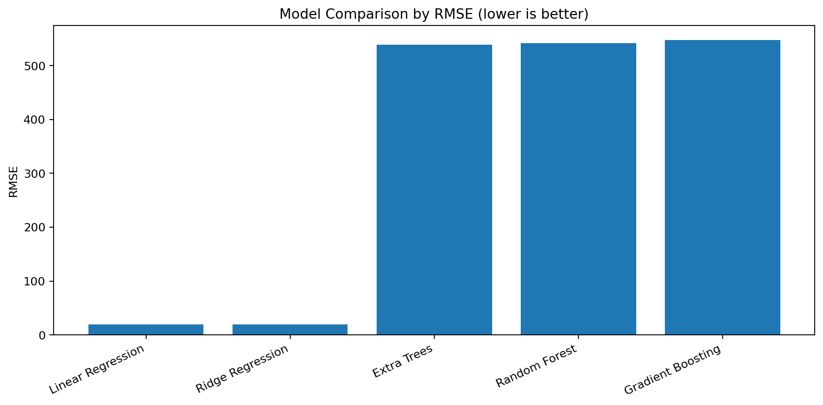
Figure 6. Comparison of model RMSE values; lower values indicate lower test error.
The bar chart compares the RMSE values from the five models. Because RMSE is measured in adjusted-price units, it is directly comparable across these models on the same test set. The chart is intended to communicate relative model performance clearly.

4.7.10 Actual versus Predicted Visualization
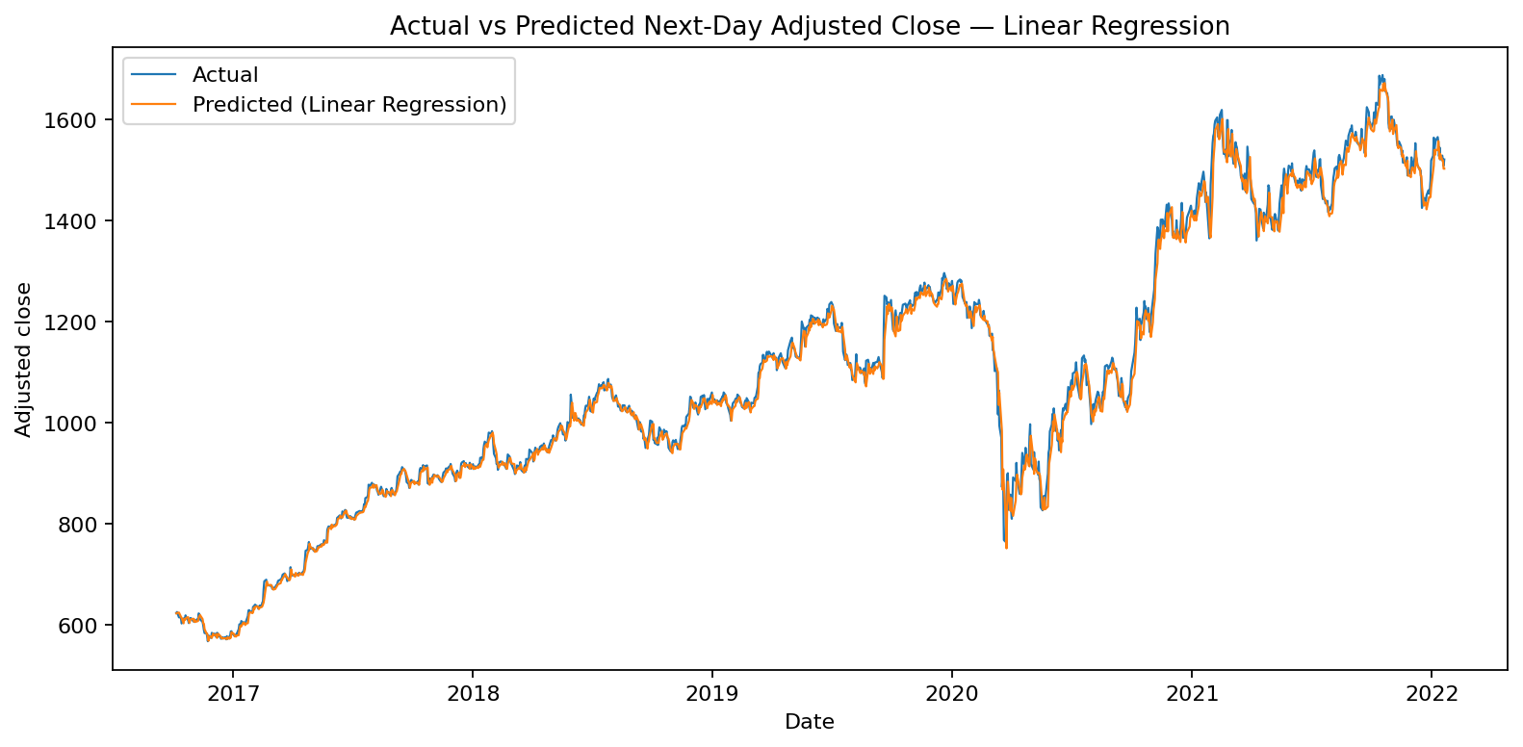
Figure 7. Actual and predicted next-observation adjusted closing price for the selected model.
The actual-versus-predicted chart shows whether the selected model follows the broad movement of the held-out target series. Visual agreement in the general level does not necessarily imply accurate prediction of daily changes. A useful extension is to plot prediction residuals and compare predicted returns with actual returns.

5. CONCLUSION
This project completed an end-to-end data science workflow using the supplied HDFC Bank historical market dataset. The work included dataset inspection, date parsing, numeric conversion, duplicate checks, invalid-value handling, missing-value treatment, exploratory analysis, visualization, feature engineering, chronological model splitting, regression training, and performance evaluation.
Five EDA objectives were addressed: historical adjusted-price trend, daily trading volume, daily returns and volatility, correlation among market variables, and year-end adjusted-price comparison. These objectives provided different views of the same dataset and helped establish context before machine learning.
The feature-engineering stage created historical returns, moving averages, rolling volatility, relative daily range, calendar fields, and lagged adjusted closing prices. The target was the adjusted close in the next available trading observation. A chronological split was used to reduce the risk of training on future observations and evaluating on earlier ones.
Five models were compared: Linear Regression, Ridge Regression, Random Forest, Gradient Boosting, and Extra Trees. Under the minimum-RMSE selection criterion, Linear Regression achieved the best score in the recorded run. Its MAE was 13.1117, RMSE was 19.5296, and R² was 0.9949.
The main learning outcome is that model selection must be based on a clearly defined evaluation design. A high R² on a price-level target does not prove that a model can forecast market direction or generate profitable trading decisions. The project should be treated as an academic demonstration of data science and machine learning methods.

6. FUTURE SCOPE
- Refresh the dataset with a verified and more recent download, then rerun the entire notebook.
- Record the exact source URL, provider, ticker, download date, and data licensing information.
- Add a naïve persistence baseline in which the next adjusted close is predicted as the current adjusted close.
- Use walk-forward or expanding-window validation to assess model stability across multiple test periods.
- Predict returns or direction in addition to price levels, and evaluate directional accuracy where appropriate.
- Perform hyperparameter tuning using time-series-aware validation rather than random cross-validation.
- Add residual analysis, error distributions, and error comparisons across market regimes.
- Explore additional explanatory variables such as benchmark index returns, sector indices, company fundamentals, and macroeconomic indicators where permitted and properly sourced.
- Investigate feature importance and explainability methods while being careful about correlated predictors.
- Package the notebook and report with a reproducible environment file and a clear README.
Future extensions should preserve chronological integrity. Any additional features must be available at the prediction time. External information should be timestamped and aligned with the market observation date to avoid accidental leakage.

7. REFERENCES
- McKinney, W. (2022). Python for Data Analysis: Data Wrangling with pandas, NumPy, and Jupyter. 3rd edition. O'Reilly Media.
- pandas documentation. https://pandas.pydata.org/docs/ (accessed [ENTER DATE]).
- NumPy documentation. https://numpy.org/doc/ (accessed [ENTER DATE]).
- Matplotlib documentation. https://matplotlib.org/stable/ (accessed [ENTER DATE]).
- scikit-learn documentation. https://scikit-learn.org/stable/ (accessed [ENTER DATE]).
- Dataset: HDFCBANK.NS.csv, supplied for this project. Original provider and URL: [VERIFY AND ENTER THE ACTUAL SOURCE]. Access date: [ENTER DATE].
- Yahoo Finance historical data page for HDFCBANK.NS: https://finance.yahoo.com/quote/HDFCBANK.NS/history/ — cite only if this is confirmed as the actual dataset source.
The references above include software documentation and a dataset-source placeholder. Replace access-date placeholders and verify the dataset provider before final submission. Do not cite a source that was not actually used.

APPENDIX A: PROJECT FILES AND REPRODUCIBILITY
- HDFCBANK.NS.csv — original dataset supplied for the project.
- HDFCBANK_cleaned.csv — cleaned dataset produced by the preprocessing workflow.
- HDFCBANK_Stock_Analysis_ML.ipynb — notebook containing the complete analysis and model code.
- model_results.csv — model metrics generated from the recorded run.
- PNG files — saved visualizations for EDA and model evaluation.
- README.md — instructions for running the project.
To reproduce the work, install Python and the required packages, place the original CSV in the notebook working directory, and execute the notebook cells in order. The final outputs should be checked against the results table in this report.

APPENDIX B: SCREENSHOT EVIDENCE TO BE ADDED
The assignment format requires screenshots as part of the final submission. Screenshots must be captured from the student's own working environment and accounts. The report template intentionally leaves space for genuine evidence rather than generating or fabricating screenshots.

Screenshot 1 — Dataset preview
Capture the notebook showing the first rows, dataset shape, and column names.
[INSERT YOUR AUTHENTIC SCREENSHOT HERE]

Screenshot 2 — Data cleaning
Capture the missing-value and duplicate checks and the cleaned dataset output.
[INSERT YOUR AUTHENTIC SCREENSHOT HERE]

Screenshot 3 — EDA visualizations
Capture the price trend, volume, return distribution, correlation matrix, and year-end chart.
[INSERT YOUR AUTHENTIC SCREENSHOT HERE]

Screenshot 4 — Machine learning results
Capture the model comparison table showing MAE, RMSE, and R².
[INSERT YOUR AUTHENTIC SCREENSHOT HERE]

Screenshot 5 — Prediction plot
Capture the actual-versus-predicted chart.
[INSERT YOUR AUTHENTIC SCREENSHOT HERE]

Screenshot 6 — GitHub repository
Capture the actual repository page showing the uploaded project files.
[INSERT YOUR AUTHENTIC SCREENSHOT HERE]

Screenshot 7 — LinkedIn post
Capture the published LinkedIn project post from the student's own profile.
[INSERT YOUR AUTHENTIC SCREENSHOT HERE]

APPENDIX C: LINKEDIN PROJECT DESCRIPTION
I am pleased to share my Data Science and Machine Learning project: HDFC Bank Stock Analysis and Next-Day Price Prediction. In this project, I used Python, pandas, NumPy, Matplotlib, and scikit-learn to analyze historical stock-market data. The workflow included data cleaning, exploratory data analysis, feature engineering, and comparison of five regression models using MAE, RMSE, and R-squared. This project helped me understand chronological train-test splitting, time-series features, model evaluation, and the limitations of forecasting financial data. This is an educational analysis and not investment advice.
Suggested hashtags: #DataScience #MachineLearning #Python #EDA #DataAnalytics #StudentProject
After publishing the post, insert a genuine screenshot of the LinkedIn post in Appendix B.

APPENDIX D: IMPORTANT TECHNICAL LIMITATIONS
The supplied file ends on 21 January 2022. Results therefore represent a historical period and should not be described as current stock-market performance. The source provider and download date must be confirmed. The adjusted-close series may have provider-specific adjustment conventions. The report uses the fields as supplied and does not independently validate them against an exchange data feed.
The project evaluates the next available row's adjusted closing price. This is not always the next calendar day. The tree models performed poorly relative to the linear models in the recorded run, but that outcome may change with a different sample period, feature set, parameter configuration, or validation method.
The project does not include a transaction-cost model, slippage, trading strategy, portfolio construction, or risk management. Consequently, the prediction results cannot be translated into a claim about investment profitability.

APPENDIX E: FINAL SUBMISSION CHECKLIST
- Complete student name, registration number, programme section, course code, and semester on the cover page.
- Ask the supervisor to verify and sign the certificate.
- Complete the declaration date and signature.
- Confirm the dataset source URL and access date.
- Run the notebook from beginning to end and verify all outputs.
- Refresh the table of contents and page numbers in Word after editing.
- Insert genuine notebook, GitHub, and LinkedIn screenshots.
- Check that the report uses A4 pages, Times New Roman 12 pt, and 1.5 line spacing.
- Check that all figures have captions and are discussed in the text.
- Ensure the final page count meets the required 30–80 page range after final formatting.
This report has been structured to follow the uploaded university format: cover page, declaration, certificate, acknowledgement, table of contents, introduction, source of dataset, EDA process, individual analyses with introduction/general description/functions and formulas/results/visualization, conclusion, future scope, and references.

