**M7.1: The TCP protocol**

**Task description:**

1. Using netstat command list out all the ports that are currently being used in your computer.

Ans: 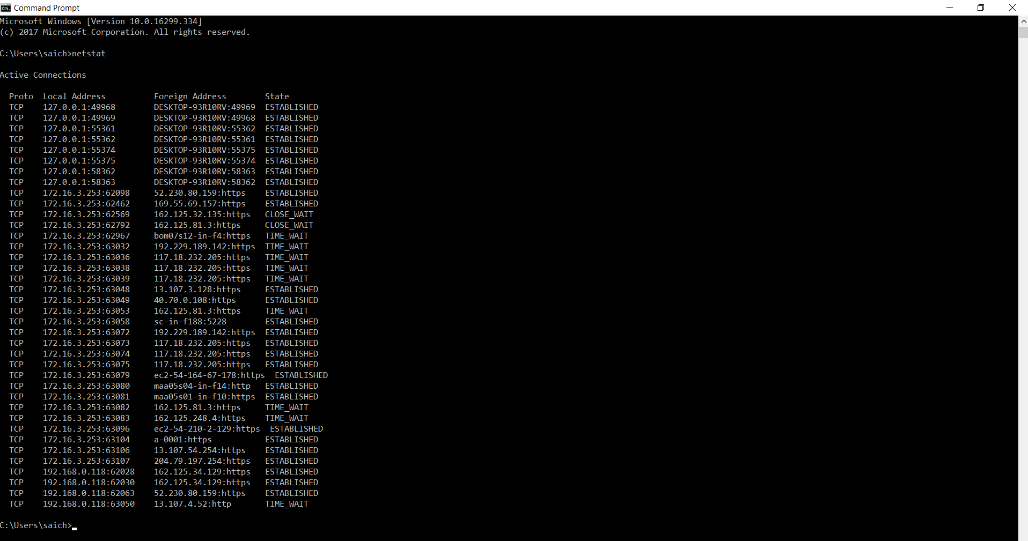

1. What are well known ports assigned for popular internet applications like browsing, ftp, messaging, email and others.

## Ans: *List of Well-Known Ports*

Port numbers range from 0 to 65535, but only port numbers 0 to 1023 are reserved for privileged services and designated as well-known ports. The following list of well-known port numbers specifies the port used by the server process as its contact port.

|  |  |
| --- | --- |
| Port Number --- | Description |
| 1 | [TCP](https://www.webopedia.com/TERM/T/TCP.html) Port Service Multiplexer (TCPMUX) |
| 5 | Remote Job Entry (RJE) |
| 7 | ECHO |
| 18 | Message Send Protocol (MSP) |
| 20 | [FTP](https://www.webopedia.com/TERM/F/ftp.html) -- Data |
| 21 | FTP -- Control |
| 22 | [SSH](https://www.webopedia.com/TERM/S/SSH.html) Remote Login Protocol |
| 23 | [Telnet](https://www.webopedia.com/TERM/T/Telnet.html) |
| 25 | [Simple Mail Transfer Protocol](https://www.webopedia.com/TERM/S/SMTP.html) (SMTP) |
| 29 | MSG ICP |
| 37 | Time |
| 42 | Host Name Server (Nameserv) |
| 43 | WhoIs |
| 49 | Login Host Protocol (Login) |
| 53 | [Domain Name System](https://www.webopedia.com/TERM/D/DNS.html) (DNS) |
| 69 | [Trivial File Transfer Protocol](https://www.webopedia.com/TERM/T/TFTP.html) (TFTP) |
| 70 | [Gopher](https://www.webopedia.com/TERM/G/gopher.html) Services |
| 79 | [Finger](https://www.webopedia.com/TERM/F/finger.html) |
| 80 | [HTTP](http://www.webopedia.com/TERM/H/HTTP.html) |
| 103 | [X.400](https://www.webopedia.com/TERM/X/X_400.html) Standard |
| 108 | SNA Gateway Access Server |
| 109 | POP2 |
| 110 | [POP3](https://www.webopedia.com/TERM/P/POP3.html) |
| 115 | Simple File Transfer Protocol (SFTP) |
| 118 | SQL Services |
| 119 | Newsgroup ([NNTP](https://www.webopedia.com/TERM/N/NNTP.html)) |
| 137 | [NetBIOS](https://www.webopedia.com/TERM/N/NetBIOS.html) Name Service |
| 139 | NetBIOS Datagram Service |
| 143 | Interim Mail Access Protocol (IMAP) |
| 150 | NetBIOS Session Service |
| 156 | [SQL Server](https://www.webopedia.com/TERM/S/SQL_Server.html) |
| 161 | [SNMP](https://www.webopedia.com/TERM/S/SNMP.html) |
| 179 | [Border Gateway Protocol](https://www.webopedia.com/TERM/B/BGP.html) (BGP) |
| 190 | Gateway Access Control Protocol (GACP) |
| 194 | [Internet Relay Chat](https://www.webopedia.com/TERM/I/IRC.html) (IRC) |
| 197 | Directory Location Service (DLS) |
| 389 | [Lightweight Directory Access Protocol](https://www.webopedia.com/TERM/L/LDAP.html) (LDAP) |
| 396 | Novell Netware over IP |
| 443 | [HTTPS](https://www.webopedia.com/TERM/H/HTTPS.html) |
| 444 | Simple Network Paging Protocol (SNPP) |
| 445 | Microsoft-DS |
| 458 | Apple [QuickTime](https://www.webopedia.com/TERM/Q/QuickTime.html) |
| 546 | [DHCP](https://www.webopedia.com/TERM/D/DHCP.html) Client |
| 547 | DHCP Server |
| 563 | SNEWS |
| 569 | MSN |
| 1080 | Socks |

* Well-known ports range from 0 through 1023.
* Registered ports are 1024 to 49151.
* Dynamic ports (also called private ports) are 49152 to 65535.

1. List out ranges of Well know ports, registered ports, and private (or dynamic) ports.

Ans:

Ports with numbers 0–1023 are called *system or well-known ports*; ports with numbers 1024-49151 are called *user or registered ports*, and ports with numbers 49152-65535 are called *dynamic and/or private ports*.[[2]](https://en.wikipedia.org/wiki/Registered_port#cite_note-2) Both system and user ports are used by transport protocols (TCP, UDP, DCCP, SCTP) to indicate an application or service.

* **Ports 0–1023** – system or [well-known ports](https://en.wikipedia.org/wiki/Well-known_port)
* **Ports 1024–49151** – user or registered ports
* **Ports >49151** – dynamic / private ports

1. Write down how TCP maintains connection oriented communication? What are TCP handshakes, how do they help in connection oriented communication?
   1. What is the role of sequence number, acknowledgement number in TCP packet?
   2. What are TCP flags? how are they useful in connection oriented communication?
2. What is a finite state machine, explain [TCP finite state machine](http://upload.wikimedia.org/wikipedia/commons/thumb/a/a2/Tcp_state_diagram_fixed.svg/796px-Tcp_state_diagram_fixed.svg.png).

Ans: The TCP finite state machine, it can be considered to describe different stages of a connection or life stages. if there is no connection between two TCP device then they both will be in null state and then proceeds through a series of states util a connection is established. Different states cycle of TCP finite machine can be seen in this attached image. It first establish the connections and then it closed when gets signal or something that causes the connection to be closed then proceeds to another state and returns to closed state.

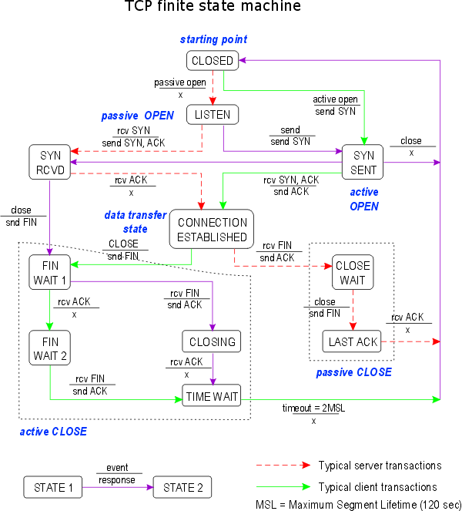

1. Here is a [animation demo](http://www2.rad.com/networks/2004/sliding_window/demo.html) of sliding window protocol. Using this demo, If window size is 4, retransmit timer is 50ms, round trip time is 100ms, at a speed of 10Kbps, and loss % of 5. How many seconds does it take to deliver 19 packets?

Ans: 30seconds

1. Write down difference between full close & half close for TCP to end connection.

Ans:

TCP provides the ability for one end of the connection to terminate its output, while still receiving data from the other end. This is called a *half-close*. 