
U21ADP05 – EXPLORATORY DATA ANALYSIS AND VISUALIZATION
III year B.Tech. Artificial Intelligence and Data Science
Assignment II – Case Study Report
Breathing Beijing: Exploratory Analysis and LSTM Forecasting of PM2.5 from Multi-Site Air-Quality Records (2013–2017)
Naveena B (24AD070)
Academic Year: 2026 - 27

ABSTRACT
Fine particulate matter (PM_{2.5}) is the pollutant most closely tied to premature death, and Beijing has long been one of its hotspots. This case study explores 420,768 hourly records from twelve monitoring sites (UCI dataset 501, March 2013 to February 2017) and builds a short-term forecaster. After auditing gaps and removing 290 sensor spikes, the analysis reveals a falling but uneven trend, a strong winter-night maximum, a right-skewed distribution best matched by gamma and Weibull laws, and pollution episodes lasting far longer than a memoryless model allows. Wind direction is the dominant weather control: strong northerly winds cut median PM_{2.5} from 71 to about 11 µg/m³, while southerly winds barely help. A residual LSTM using the previous 48 hours achieves a mean absolute error of 10.8 µg/m³ one hour ahead and outperforms persistence at every horizon from one to six hours.
Keywords: PM_{2.5}; air quality; exploratory data analysis; time-series smoothing; beta-binomial; long short-term memory; forecasting; Beijing.
CONTENTS
CHAPTER 1: INTRODUCTION AND OBJECTIVES 1
1.1 Why PM_{2.5} Matters 1
1.2 Problem Statement 1
1.3 Objectives of the Study 1
1.4 Scope and Organisation 2
CHAPTER 2: LITERATURE REVIEW 3
2.1 Statistical Studies of Beijing's Air Quality 3
2.2 Distributional Models for Pollutant Concentrations 3
2.3 Deep Learning for Air-Quality Forecasting 3
2.4 Research Gap Addressed 3
CHAPTER 3: DATASET DESCRIPTION 4
3.1 Source 4
3.2 Monitoring Network and Period 4
3.3 Variables 4
3.4 Descriptive Statistics 5
CHAPTER 4: EDA AND PREPROCESSING 6
4.1 Structural Checks 6
4.2 Missing Values 6
4.3 Outliers and Physical Consistency 7
4.4 Imputation Strategy 8
4.5 Feature Engineering and Transformation 9
4.6 Chronological Split 9
4.7 Insights from Preprocessing 9
CHAPTER 5: DATA VISUALIZATION AND STATISTICAL ANALYSIS 10
5.1 Fry's Seven Stages in This Study 10
5.2 Long-Term Behaviour and Smoothing 10
5.3 Trend and Seasonality: Classical Decomposition 11
5.4 The Diurnal-Seasonal Pattern 12
5.5 Continuous Distribution of PM_{2.5} 12
5.6 Discrete Distributions: Exceedance Hours and Episode Lengths 13
5.7 Spatial Variation across Sites 14
5.8 The Role of Wind Direction 15
5.9 Wind Speed with a Third Variable 15
5.10 Correlation Structure 16
5.11 Co-emission and the Particle Size Mix 17
5.12 Seasons and the Heating Effect 17
5.13 Temporal Dependence: ACF and PACF 18
5.14 Interact: The Beijing Air Explorer Dashboard 19
CHAPTER 6: DEEP LEARNING MODEL 20
6.1 Why an LSTM 20
6.2 Problem Framing 20
6.3 Architecture 20
6.4 Training Parameters 21
6.5 Hyperparameter Tuning 21
6.6 Feature Importance 22
CHAPTER 7: RESULT VISUALIZATION AND INTERPRETATION 23
7.1 Learning Curves 23
7.2 Forecasts during a Severe Episode 24
7.3 Predicted versus Observed 24
7.4 Error Distribution 25
7.5 Skill against Baseline Forecasts 25
7.6 Air-Quality Category Confusion Matrices 26
7.7 Exceedance Alerts: ROC and AUC 27
CHAPTER 8: CONCLUSION AND FUTURE SCOPE 28
8.1 Summary of Findings 28
8.2 Model Performance 28
8.3 Challenges 28
8.4 Future Scope 29
REFERENCES 30
APPENDIX A: REPOSITORY STRUCTURE AND REPRODUCTION 31
APPENDIX B: SOURCE CODE LISTINGS 32

LIST OF FIGURES
Figure 4.1. Percentage of missing hours for every site and variable 6
Figure 4.2. Missing values by variable and the length distribution of PM2.5 gaps 7
Figure 4.3. A flagged single-hour spike at Dongsi and the PM2.5-PM10 consistency check 7
Figure 4.4. Time-based linear interpolation of a 14-hour carbon monoxide gap at Dongsi 8
Figure 5.1. Daily city-wide PM2.5 with a moving average, a resistant running median and the two reference limits 10
Figure 5.2. Additive decomposition of monthly mean PM2.5 into trend, seasonal and irregular parts 11
Figure 5.3. Mean PM2.5 by hour of day and month (all sites, 2013-2017) 12
Figure 5.4. Fitted lognormal, gamma and Weibull densities and a Q-Q comparison for hourly PM2.5 12
Figure 5.5. Daily count of hours above 75 µg/m³ with binomial and beta-binomial fits, and survival of exceedance episodes 13
Figure 5.6. Distribution of hourly PM2.5 at the twelve sites, ordered by median 14
Figure 5.7. Mean PM2.5 for each of the 16 wind directions and how often each direction occurs 15
Figure 5.8. Median PM2.5 and interquartile band against wind speed, split by northerly and southerly sectors 15
Figure 5.9. Spearman rank correlations among pollutants and weather variables 16
Figure 5.10. Log-log relation between CO and PM2.5, and the PM2.5/PM10 ratio by season 17
Figure 5.11. PM2.5 by season and by central-heating period (log scale) 17
Figure 5.12. Autocorrelation and partial autocorrelation of hourly log PM2.5 at Dongsi 18
Figure 5.13. The interactive dashboard (dashboard/index.html) showing Dongsi PM2.5 19
Figure 6.1. Architecture of the residual LSTM forecaster 20
Figure 6.2. Validation MAE of the six LSTM configurations 21
Figure 6.3. Permutation importance: increase in validation RMSE when each input is shuffled 22
Figure 7.1. Training and validation loss per epoch 23
Figure 7.2. Training and validation MAE per epoch (µg/m³, averaged over six horizons) 23
Figure 7.3. Observed PM2.5 and LSTM forecasts at Dongsi, 12-26 December 2016 24
Figure 7.4. Forecast against observed PM2.5 on log axes, one and six hours ahead 24
Figure 7.5. Forecast-error distribution and error by concentration band 25
Figure 7.6. Test MAE by forecast horizon for the LSTM, persistence and the same hour on the previous day 25
Figure 7.7. Row-normalised confusion matrices of forecast against observed air-quality category 26
Figure 7.8. ROC curves for forecasting exceedance of 75 µg/m³ one, three and six hours ahead 27

LIST OF TABLES
Table 3.1. Fields of the Beijing multi-site dataset 4
Table 3.2. Descriptive statistics of the eleven numerical variables (after removing instrument caps and sensor spikes) 5
Table 4.1. Structural data-quality checks 6
Table 4.2. Share of hours flagged by Tukey's fences on the raw and on the log scale 8
Table 4.3. Model inputs (19 features) 9
Table 4.4. Chronological train, validation and test periods for the Dongsi site 9
Table 5.1. Fry's seven stages of visualization as applied here 10
Table 5.2. Maximum-likelihood fits to 411,738 hourly PM2.5 values (location fixed at zero) 12
Table 5.3. Discrete-distribution summary for exceedances of the 75 µg/m³ limit 13
Table 5.4. PM2.5 (µg/m³) by season and heating period 17
Table 6.1. Layer-by-layer summary of the selected network 20
Table 6.2. Training configuration 21
Table 6.3. Grid search over look-back window and hidden size (selected: #6) 21
Table 7.1. Test-period error by forecast horizon (µg/m³) 26
Table 7.2. Performance as a 75 µg/m³ exceedance alert (operating point: forecast above 75) 27

CHAPTER 1: INTRODUCTION AND OBJECTIVES

1.1 Why PM_{2.5} Matters
PM_{2.5} denotes airborne particles no larger than 2.5 micrometres across. Because they are small enough to travel deep into the lungs and into the bloodstream, they are the pollutant the World Health Organization treats as the most serious for health, and its 2021 guidelines lowered the recommended 24-hour limit to 15 µg/m³ (World Health Organization, 2021). China's national standard is far looser, with a Grade II 24-hour limit of 75 µg/m³ (Ministry of Environmental Protection of the People's Republic of China, 2012a). Beijing, a megacity on the northern edge of the North China Plain, has repeatedly breached both thresholds during winter haze episodes, which makes it a natural laboratory for studying how pollution behaves in time, in space and under different weather.
Hourly monitoring data contain a great deal of information, but raw tables hide it. They have gaps when instruments fail, implausible spikes, strongly skewed values and several overlapping cycles (daily, weekly and seasonal). Making sense of such data before any model is built is the purpose of exploratory data analysis, and turning the understanding into an early warning is the purpose of forecasting.

1.2 Problem Statement
Using four years of hourly pollutant and weather observations from twelve Beijing sites, this case study asks three linked questions. How is PM_{2.5} distributed, and which probability models describe its concentrations and its exceedance episodes? Which temporal, spatial and meteorological factors explain high and low pollution? Can a recurrent neural network, given only the most recent hours of data, forecast PM_{2.5} up to six hours ahead better than the naive rule that tomorrow resembles today?

1.3 Objectives of the Study
- To audit the dataset for missing values, duplicate keys, impossible readings and isolated sensor spikes, and to clean it in a way that preserves genuine pollution episodes.
- To characterise PM_{2.5} through descriptive statistics, smoothing, classical decomposition and a diurnal-seasonal profile.
- To fit and compare continuous (lognormal, gamma, Weibull) and discrete (binomial, beta-binomial, geometric) probability models.
- To relate PM_{2.5} to location, wind direction, wind speed, humidity, co-emitted gases and the heating season, including the effect of a third variable.
- To build an interactive dashboard and present every visual through Fry's seven stages of visualization.
- To design, tune and evaluate an LSTM forecaster against persistence and seasonal-naive baselines, including an air-quality alert task.

1.4 Scope and Organisation
The exploratory analysis uses all twelve sites. The forecasting model is trained for the Dongsi site in central Beijing, chosen because it has the highest median PM_{2.5} of the network and because a single site keeps the forecasting problem easy to interpret. Chapter 2 reviews the literature and Chapter 3 describes the data. Chapter 4 covers cleaning and preprocessing, and Chapter 5 presents the visual and statistical analysis. Chapter 6 explains the deep learning model, Chapter 7 interprets its results and Chapter 8 concludes.

CHAPTER 2: LITERATURE REVIEW

2.1 Statistical Studies of Beijing's Air Quality
The dataset used here was released with work by Song Xi Chen's group at Peking University. Liang et al. (2015) assessed the severity of Beijing's PM_{2.5} pollution and examined how meteorology, the emission controls of the 2014 APEC summit and the winter heating season shape concentrations. A key lesson of that work is that weather must be accounted for before a change in pollution is credited to policy. Zhang et al. (2017), the paper that introduced the multi-site data, applied this reasoning to the officially reported drop in PM_{2.5} for 2016. Their meteorologically adjusted analysis suggested that 2016 was less clean than the headline figure implied, which is why they presented their findings as cautionary tales. Both papers motivate Chapter 5.

2.2 Distributional Models for Pollutant Concentrations
The skewness of pollution data has been studied for decades. Ott (1990) gave a physical argument for lognormal concentrations: pollutants undergo successive random dilutions, and the product of many random factors tends to a lognormal law. Real series often depart from that ideal, which is why the gamma and Weibull families are routinely compared with the lognormal. For counts of exceedances, the binomial model assumes independent hours, while Skellam's (1948) beta-binomial lets the exceedance probability vary from day to day and therefore allows the strong clustering seen in haze episodes.

2.3 Deep Learning for Air-Quality Forecasting
Long short-term memory networks (Hochreiter & Schmidhuber, 1997) add gated memory cells to recurrent networks, which suits pollution that builds up over hours and days. Li et al. (2017) developed an extended LSTM that accounts for spatiotemporal correlations and evaluated it on hourly PM_{2.5} from twelve Beijing stations. It outperformed statistics-based models, and adding meteorological and timestamp inputs improved it further. Huang and Kuo (2018) combined convolutional layers with an LSTM to forecast PM_{2.5} in a smart-city setting. Forecasting texts stress that any such model must be judged against simple benchmarks, notably the naive (persistence) and seasonal-naive forecasts (Hyndman & Athanasopoulos, 2021).

2.4 Research Gap Addressed
Published deep-learning studies tend to report error metrics without a thorough exploratory account of missingness, sensor artefacts and distribution shape, and they sometimes omit the persistence benchmark, which is notoriously hard to beat one hour ahead. This study combines the two: a full exploratory analysis that follows the course's single-variable, bivariate and multivariate methods (Marsh & Elliott, 2008), and a forecasting model that is explicitly designed and evaluated against persistence.

CHAPTER 3: DATASET DESCRIPTION

3.1 Source
The Beijing Multi-Site Air-Quality dataset (Chen, 2017) was downloaded from the UCI Machine Learning Repository (dataset 501, DOI 10.24432/C5RK5G) under the CC BY 4.0 licence. The pollutant concentrations come from the Beijing Municipal Environmental Monitoring Center, and each site's meteorological values come from the nearest weather station of the China Meteorological Administration. The archive holds twelve CSV files, one per site. The project code reads them directly from the original zip file, so the raw data are never modified.

3.2 Monitoring Network and Period
Each site contributes 35,064 hourly records from 1 March 2013 to 28 February 2017, giving 420,768 rows and 18 fields. Eight sites are urban (Dongsi, Tiantan, Guanyuan, Wanshouxigong, Aotizhongxin, Nongzhanguan, Wanliu and Gucheng) and four are suburban (Changping, Dingling, Huairou and Shunyi), which allows urban and suburban air to be compared directly.

3.3 Variables
Table 3.1. Fields of the Beijing multi-site dataset
Field | Type | Unit | Meaning
No, year, month, day, hour | Integer | - | Row number and timestamp parts
PM2.5, PM10 | Continuous | µg/m³ | Fine and inhalable particulate matter
SO2, NO2, CO, O3 | Continuous | µg/m³ | Sulphur dioxide, nitrogen dioxide, carbon monoxide, ozone
TEMP, DEWP | Continuous | °C | Air temperature and dew-point temperature
PRES | Continuous | hPa | Air pressure
RAIN | Continuous | mm | Hourly precipitation
wd | Categorical (16) | compass point | Wind direction
WSPM | Continuous | m/s | Wind speed
station | Categorical (12) | - | Monitoring site name

3.4 Descriptive Statistics
Table 3.2. Descriptive statistics of the eleven numerical variables (after removing instrument caps and sensor spikes)
Variable | n | Mean | SD | Min | Q1 | Median | Q3 | Max | Skew | CV
PM2.5 | 411,738 | 79.8 | 80.8 | 2.0 | 20.0 | 55.0 | 111 | 957 | 2.01 | 1.01
PM10 | 414,316 | 105 | 91.7 | 2.0 | 36.0 | 82.0 | 145 | 995 | 1.88 | 0.88
SO2 | 411,747 | 15.8 | 21.6 | 0.3 | 3.0 | 7.0 | 20.0 | 500 | 3.01 | 1.37
NO2 | 408,652 | 50.6 | 35.1 | 1.0 | 23.0 | 43.0 | 71.0 | 290 | 1.05 | 0.69
CO | 400,011 | 1,230 | 1,156 | 100 | 500 | 900 | 1,500 | 9,900 | 2.54 | 0.94
O3 | 407,473 | 57.3 | 56.3 | 0.2 | 11.0 | 45.0 | 82.0 | 500 | 1.46 | 0.98
TEMP | 420,370 | 13.5 | 11.4 | -19.9 | 3.1 | 14.5 | 23.3 | 41.6 | -0.10 | 0.84
PRES | 420,375 | 1,011 | 10.5 | 982 | 1,002 | 1,010 | 1,019 | 1,043 | 0.11 | 0.01
DEWP | 420,365 | 2.5 | 13.8 | -43.4 | -8.9 | 3.1 | 15.1 | 29.1 | -0.19 | 5.54
RAIN | 420,378 | 0.1 | 0.8 | 0.0 | 0.0 | 0.0 | 0.0 | 72.5 | 30.04 | 12.73
WSPM | 420,450 | 1.7 | 1.2 | 0.0 | 0.9 | 1.4 | 2.2 | 13.2 | 1.63 | 0.72

Table 3.2 shows a typical urban air-quality profile. PM_{2.5} averages 79.8 µg/m³, more than five times the WHO 24-hour guideline, yet its median is only 55. Mean above median, skewness 2.01 and a maximum of 957 reveal a long upper tail of severe episodes. Every pollutant shares that shape. The weather variables are roughly symmetric, apart from rain, which is zero in 96% of hours, and wind speed. The coefficient of variation of about 1 for PM_{2.5} means that its standard deviation is as large as its mean, so hour-to-hour conditions vary enormously.

CHAPTER 4: EDA AND PREPROCESSING
The filter stage asks a simple question: which readings can be trusted? The answers below were reached with charts as well as counts, and every rule was checked against the risk of deleting real pollution.

4.1 Structural Checks
Table 4.1. Structural data-quality checks
Check | Result
Exact duplicate rows | 0
Duplicate (station, timestamp) keys | 0
Hourly index complete for every site | Yes: 35,064 hours per site, no missing timestamps
Rows with at least one missing value | 9.17%
Instrument caps (PM2.5 ≥ 999, PM10 ≥ 999, CO = 10,000, O3 > 500) | 1, 3, 56 and 18 readings
Hours with PM2.5 greater than PM10 | 21,312 of 411,813 (5.18%)

The dataset has no duplicates and no missing timestamps, which is unusual for sensor data and simplifies the time-series work. The problems are missing values, instrument ceilings and physical inconsistencies.

4.2 Missing Values
Figure 4.1. Percentage of missing hours for every site and variable
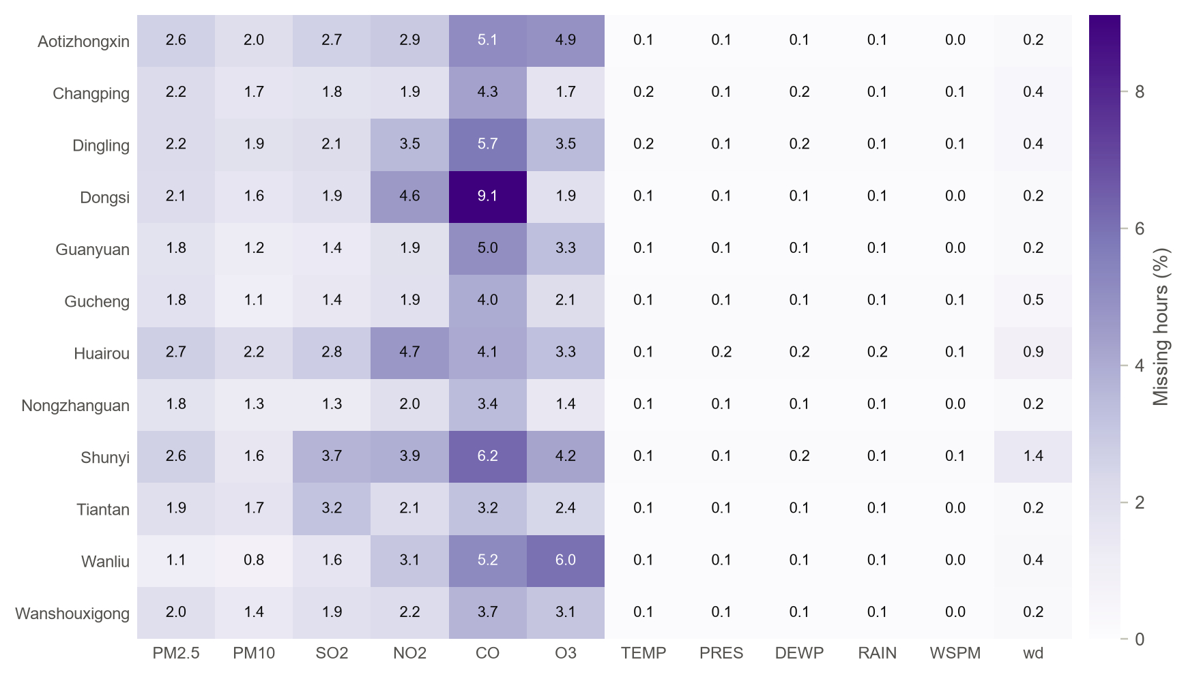
- What the chart shows: A heat map of missing-data percentages, with sites as rows and variables as columns. Darker cells mean more gaps.
- Why it was drawn: Missingness is rarely uniform. Showing it by site and variable together reveals whether gaps come from a particular instrument (one column), a particular site (one row) or both.
- Key insight: The gas analysers fail most often: carbon monoxide is missing in 4.92% of all hours and 9.1% at Dongsi, the worst cell in the table. The meteorological variables are almost complete (about 0.1%). The pattern is instrument-driven rather than site-driven, so gaps in one pollutant usually leave the others usable.
Figure 4.2. Missing values by variable and the length distribution of PM2.5 gaps
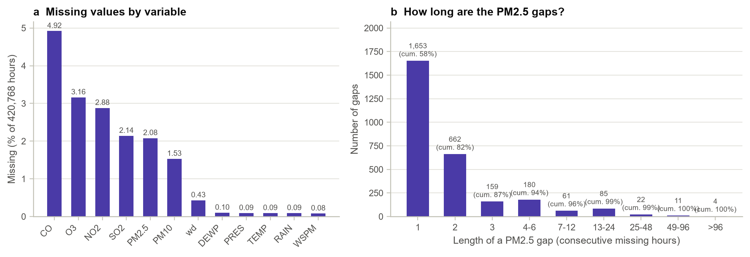
- What the chart shows: Panel (a) ranks variables by their overall share of missing hours; panel (b) counts PM_{2.5} gaps by their length and labels each bar with the cumulative share of gaps.
- Why it was drawn: How long the gaps are decides how they can be filled. A one-hour gap can be interpolated safely; a two-week gap cannot.
- Key insight: There are 2,837 PM_{2.5} gaps. The median gap lasts 1 hour, 87.2% last three hours or less and 98.7% last a day or less. The few long outages (up to 343 hours) still contain 27.9% of all missing hours. This shaped the rule used below: interpolate gaps of up to 24 hours and leave longer ones missing.

4.3 Outliers and Physical Consistency
Figure 4.3. A flagged single-hour spike at Dongsi and the PM2.5-PM10 consistency check
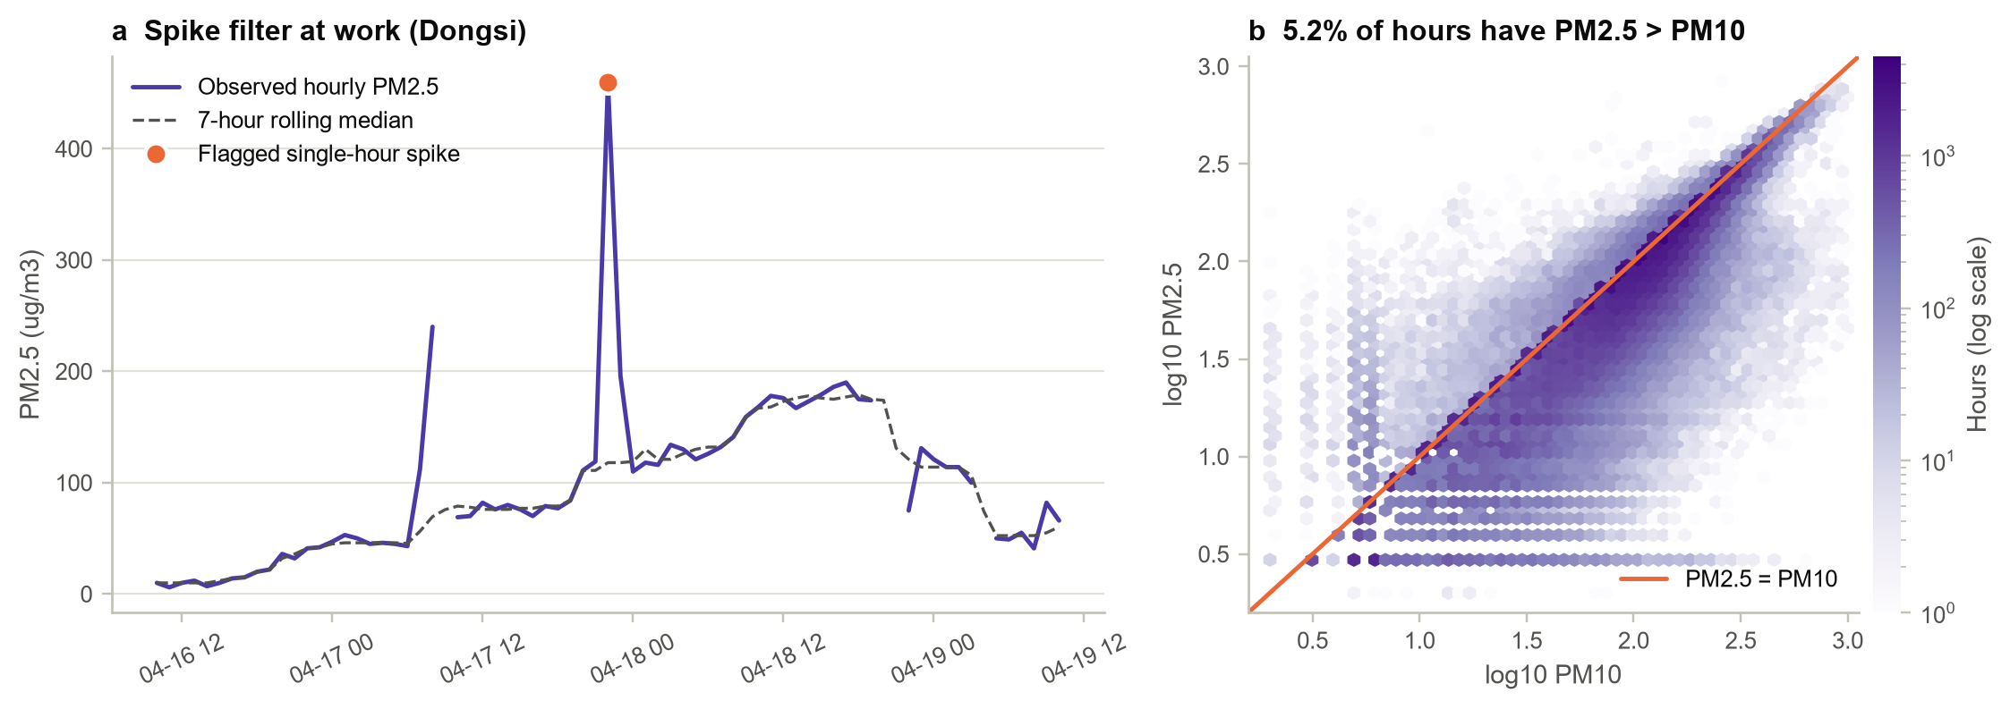
- What the chart shows: Panel (a) shows three days at Dongsi with the observed series, its 7-hour rolling median and the one reading flagged by the spike filter. Panel (b) is a hexagonal-bin plot of log PM_{2.5} against log PM₁₀ with the line PM_{2.5} = PM₁₀.
- Why it was drawn: Pollution data contain two kinds of extreme value: genuine haze episodes, which must be kept, and instrument glitches, which must be removed. The charts show how the two were told apart.
- Key insight: A Hampel filter (Hampel, 1974) on log concentrations flags a reading only when it is more than four robust standard deviations and more than a factor of two from the 7-hour median, more than 25 µg/m³ away from it, and jumps away from both neighbouring hours. Fireworks nights (Lunar New Year's Eve and the Lantern Festival) are exempt. Only 290 readings (0.07%) were removed. The example is 460 µg/m³ at 2015-04-17 22:00, against a local median of 118, which returned to normal the next hour. Panel (b) shows a physical inconsistency: because PM_{2.5} is part of PM₁₀ it should never exceed it, yet it does in 5.2% of hours. These rows were kept but flagged, because nothing in the data shows which of the two instruments is wrong.
Table 4.2. Share of hours flagged by Tukey's fences on the raw and on the log scale
Variable | IQR outliers, raw scale (%) | IQR outliers, log scale (%)
PM2.5 | 4.65 | 0.00
PM10 | 3.54 | 0.20
SO2 | 8.64 | 0.01
NO2 | 1.72 | 1.61
CO | 7.01 | 0.31
O3 | 4.07 | 0.00
RAIN | 3.93 | 3.93
WSPM | 5.49 | 1.11

Table 4.2 shows why the classical rule was not used to delete data. On the raw scale Tukey's fences flag 4.65% of PM_{2.5} hours, which are exactly the winter haze hours this study needs. On the log scale almost nothing is flagged. The extremes are a natural feature of a right-skewed variable, not errors, and rain stays flagged at 3.93% on either scale only because it is zero most of the time.

4.4 Imputation Strategy
Figure 4.4. Time-based linear interpolation of a 14-hour carbon monoxide gap at Dongsi
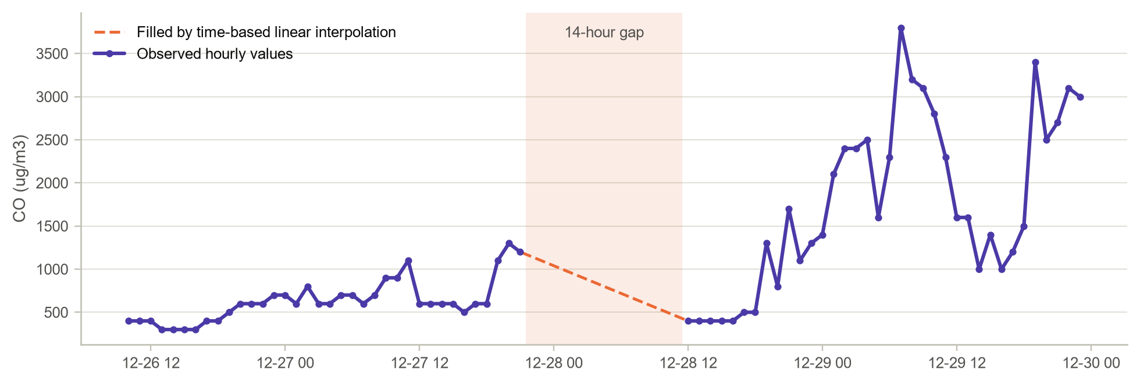
- What the chart shows: Observed hourly CO around an isolated gap, with the values filled by time-based linear interpolation.
- Why it was drawn: Imputation should be judged visually as well as numerically. A filled value that looks out of place in its context is a warning sign.
- Key insight: The filled segment joins the readings on either side smoothly and does not invent a peak. Interpolation was applied per site and per variable only to gaps of up to 24 hours. Across the network it filled 6,595 PM_{2.5} and 10,046 CO values, and wind direction was carried forward across 1,822 short gaps. At Dongsi, 3,658 hours still contain at least one missing input, and every forecasting window touching such an hour is skipped rather than guessed.

4.5 Feature Engineering and Transformation
Table 4.3. Model inputs (19 features)
Feature group | Construction | Reason
Log concentrations | log(1 + x) for PM2.5, PM10, SO2, NO2, CO, O3 and rain | Removes skew; errors become relative
Wind vector | u = −WSPM·sin(θ), v = −WSPM·cos(θ) from the 16 directions | Joins speed and direction; north and north-north-west become neighbours
Cyclical time | sin and cos of hour, month and day of week | 23:00 and 00:00 become adjacent
Weather | TEMP, PRES, DEWP and WSPM unchanged | Already roughly symmetric
Scaling | z-scores with training-period mean and SD | Comparable input ranges; no leakage

4.6 Chronological Split
Shuffling would let the model see the future, so the Dongsi series was split by date into pollution years running from March to February: two years for training, the next year for validation and the final year for testing. Because the validation and test periods each span a complete year, both contain every season, including a full heating season. A model chosen on the validation year is therefore chosen for the conditions it will meet in the test year.
Table 4.4. Chronological train, validation and test periods for the Dongsi site
Subset | From | To | Hours
Training | 2013-03-01 | 2015-02-28 | 17,520
Validation | 2015-03-01 | 2016-02-29 | 8,784
Test | 2016-03-01 | 2017-02-28 | 8,760

4.7 Insights from Preprocessing
- Data quality problems are concentrated in the gas analysers, especially CO at Dongsi, not in the particle monitors or weather data.
- Most gaps are short, so time interpolation is safe for 98.7% of them. The rare long outages are left missing.
- A narrowly defined spike filter removes 0.07% of PM_{2.5} readings; a generic outlier rule would have removed real haze.
- Physical consistency checks (PM_{2.5} above PM₁₀) expose measurement noise that summary statistics never show.

CHAPTER 5: DATA VISUALIZATION AND STATISTICAL ANALYSIS

5.1 Fry's Seven Stages in This Study
Table 5.1. Fry's seven stages of visualization as applied here
Stage (Fry, 2008) | Implementation in this case study
Acquire | UCI zip archive read directly by load_raw(); no manual editing
Parse | Datetime index built from year, month, day and hour; units and roles assigned
Filter | Caps, spike filter, physical checks, gap-length-aware interpolation
Mine | Smoothing, decomposition, distribution fitting, rank tests, autocorrelation, LSTM
Represent | Line, heat map, histogram, Q-Q, survival, box, polar, hexbin and band charts
Refine | Log scales, reference limits (75 and 15 µg/m³), colour-blind-safe palette, annotations
Interact | Offline dashboard with site, pollutant and date-range controls (Section 5.14)

5.2 Long-Term Behaviour and Smoothing
Figure 5.1. Daily city-wide PM2.5 with a moving average, a resistant running median and the two reference limits
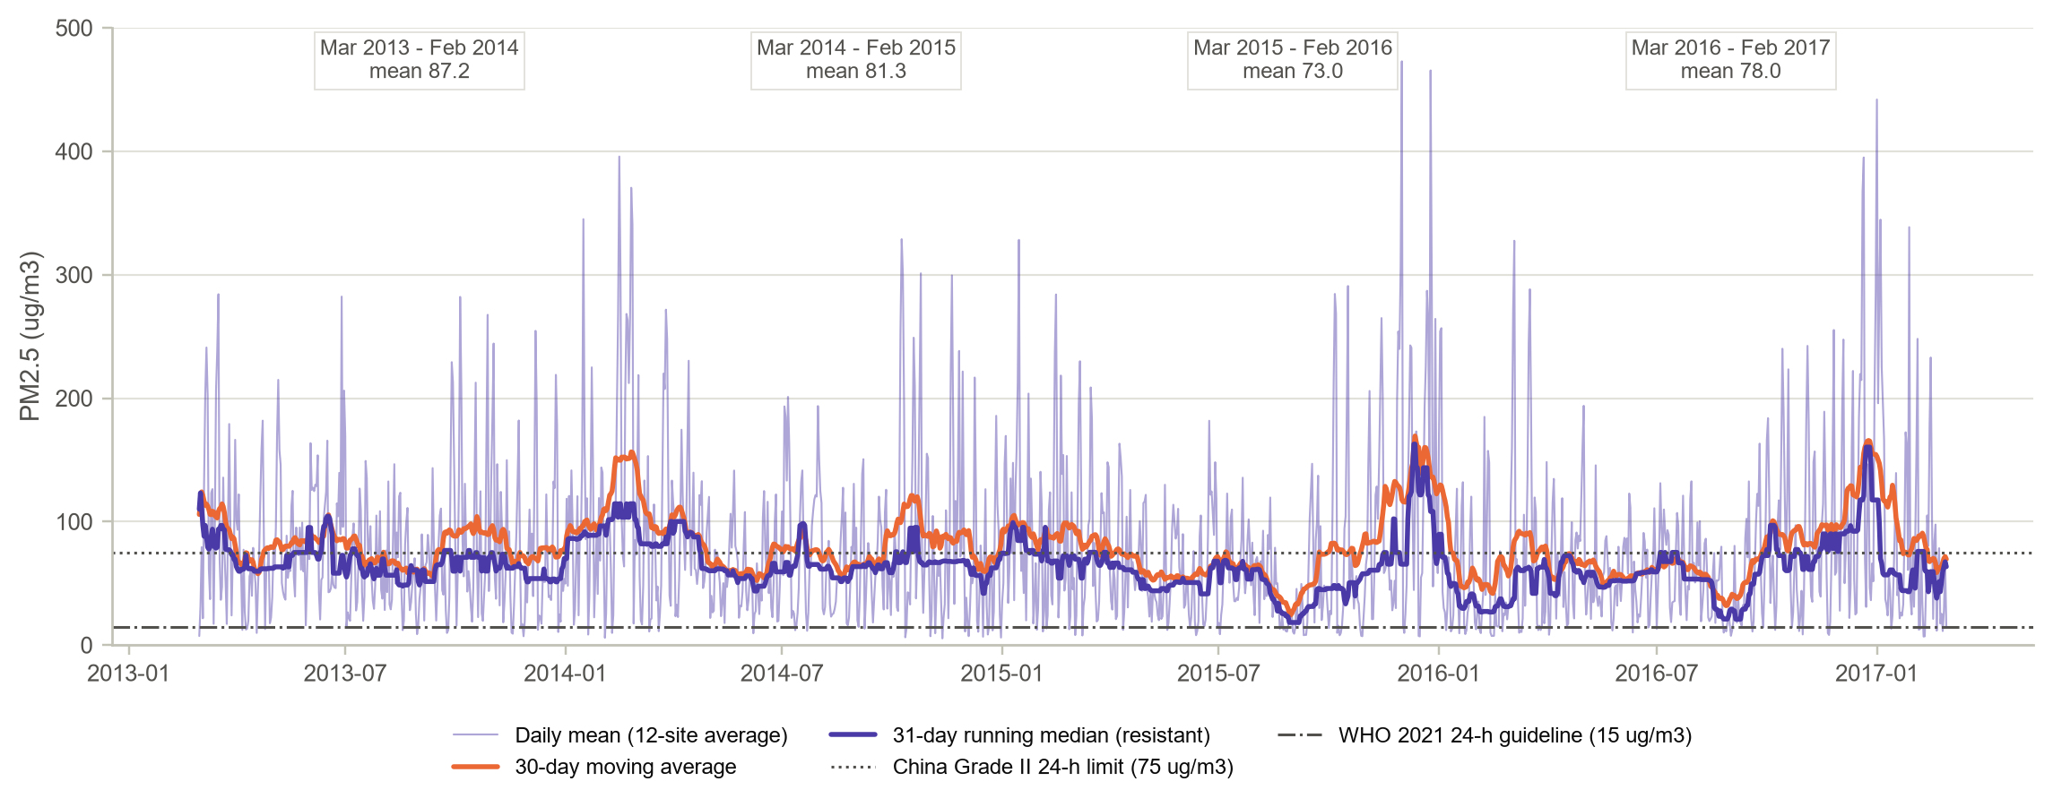
- What the chart shows: The daily mean of the twelve sites over four years, smoothed in two ways: a 30-day moving average and a 31-day running median. The China and WHO limits are drawn as reference lines, and the mean of each March-to-February year is printed at the top.
- Why it was drawn: Smoothing separates signal from day-to-day noise (Marsh & Elliott, 2008). Comparing a mean-based smoother with a resistant median-based one shows how much the few extreme days pull the picture.
- Key insight: Annual means fell from 87.2 (2013-14) to 81.3 and 73.0, then rose again to 78.0 µg/m³ in 2016-17, so the improvement was real but not monotonic, the pattern Zhang et al. (2017) warned about. The moving average sits above the running median in every winter: a few extreme days inflate the mean. The city-wide daily mean exceeded the Chinese limit on 40.4% of days and the WHO guideline on 91.7%. The worst day was 2015-12-01 (473 µg/m³). The cleanest day, 2014-11-12 (5.4 µg/m³), fell immediately after the November 2014 APEC summit, when strict emission controls were in force.

5.3 Trend and Seasonality: Classical Decomposition
Figure 5.2. Additive decomposition of monthly mean PM2.5 into trend, seasonal and irregular parts
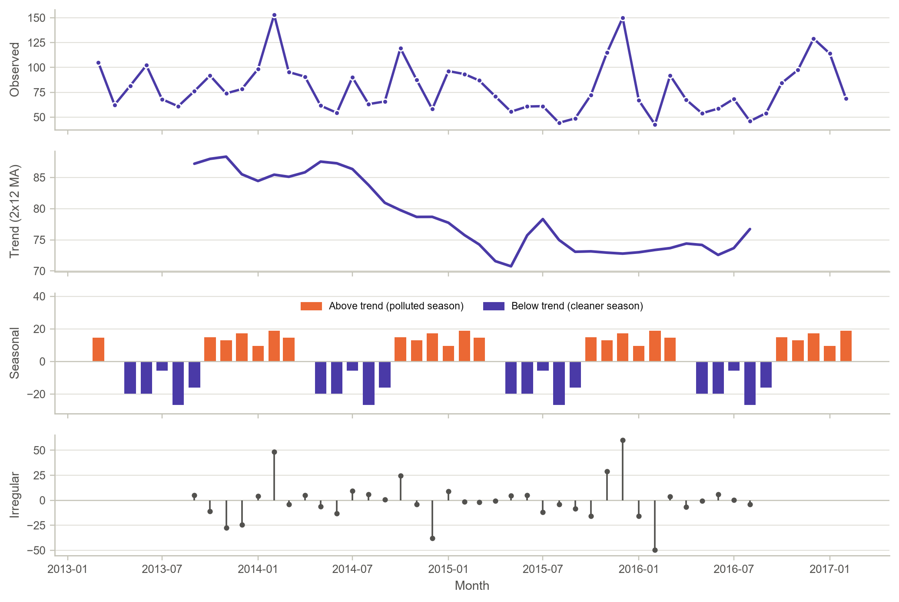
- What the chart shows: The monthly series (top) split into a 2x12 centred moving-average trend, a fixed seasonal pattern (orange for months above trend, violet below) and the irregular remainder.
- Why it was drawn: Decomposition answers the question that a raw series cannot: how much of a high month is just the season and how much is unusual?
- Key insight: The trend falls from 87.2 µg/m³ in 2013-09 to about 76.7 by 2016-08, a decline of roughly 12%. The seasonal component spans more than 45 µg/m³, from +18.9 in February and +17.2 in December down to -26.6 in August. The largest irregular value, +60 in December 2015, coincides with Beijing's first red-alert haze period, which no seasonal pattern can explain.

5.4 The Diurnal-Seasonal Pattern
Figure 5.3. Mean PM2.5 by hour of day and month (all sites, 2013-2017)
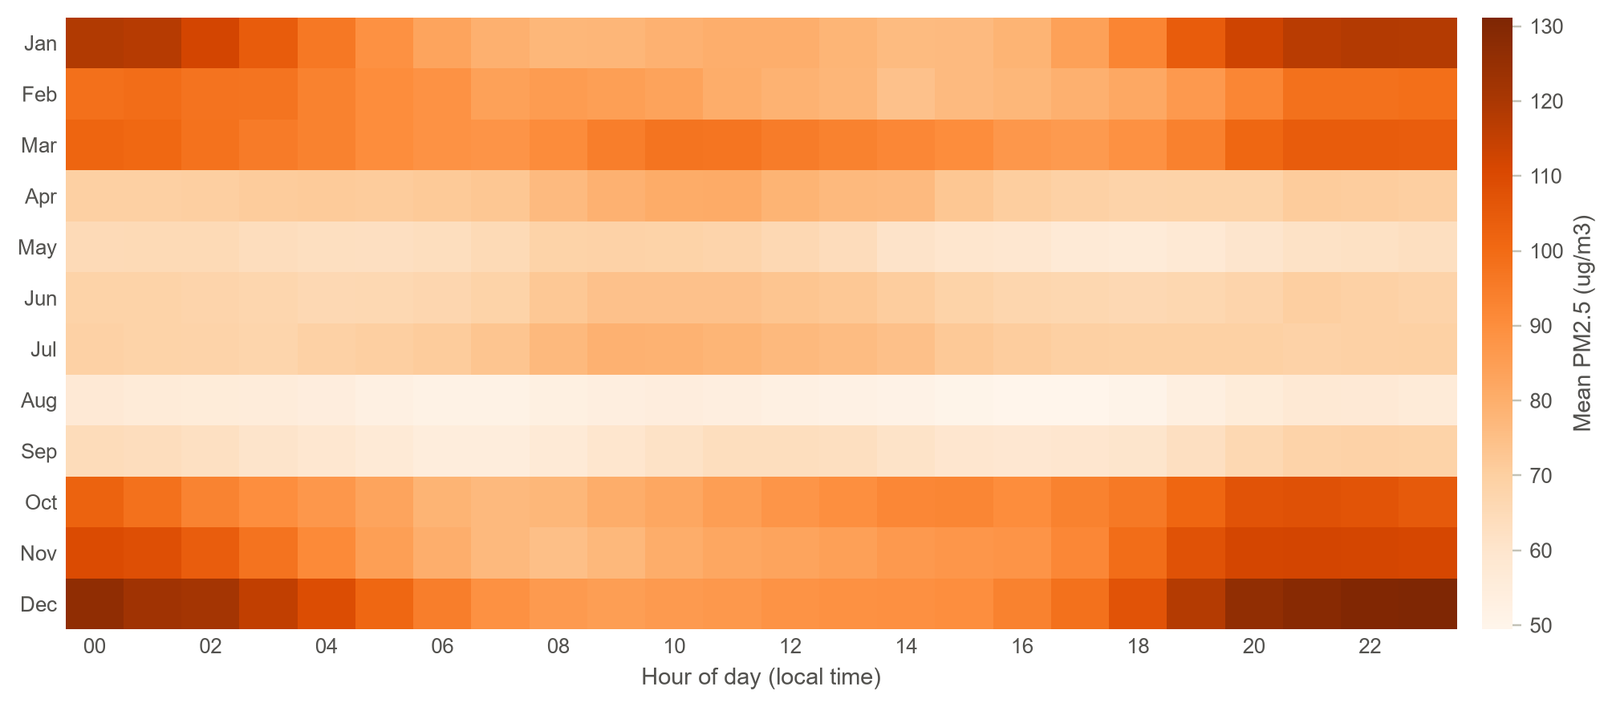
- What the chart shows: A 12 x 24 grid of mean PM_{2.5} for every month and hour of day, with darker orange for higher concentrations.
- Why it was drawn: Two cycles interact. A heat map shows the interaction at once, which separate daily and monthly charts cannot.
- Key insight: The worst cell is December at 23:00 (131 µg/m³) and the cleanest is August at 17:00 (49). In winter, night-time air (21:00 to 00:00) averages 124 against 84 in the afternoon, about 48% more. In summer the daily cycle almost disappears (69 against 71). Shallow night-time boundary layers trap evening emissions, including domestic heating, in winter, whereas summer convection mixes the air all day.

5.5 Continuous Distribution of PM_{2.5}
Figure 5.4. Fitted lognormal, gamma and Weibull densities and a Q-Q comparison for hourly PM2.5
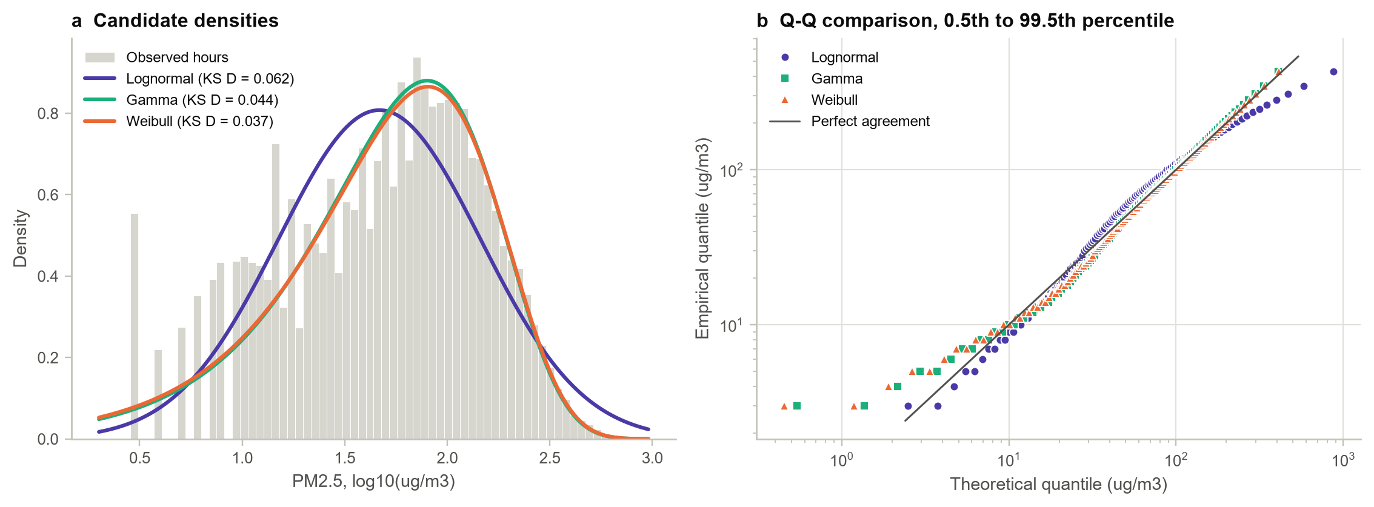
Table 5.2. Maximum-likelihood fits to 411,738 hourly PM2.5 values (location fixed at zero)
Model | Shape | Scale (µg/m³) | AIC | KS distance D
Gamma | k = 1.069 | 74.6 | 4,428,701 | 0.0438
Weibull | k = 1.022 | 80.5 | 4,429,530 | 0.0370
Lognormal | sigma = 1.137 | 46.7 | 4,439,325 | 0.0617

- What the chart shows: Panel (a) draws the histogram of log₁₀ PM_{2.5} with three fitted densities; panel (b) plots empirical against theoretical quantiles for each model on log axes.
- Why it was drawn: Distribution choice matters for exceedance probabilities and for the loss function of the model. Ott's (1990) dilution theory predicts a lognormal, so that hypothesis was tested against two common rivals.
- Key insight: The lognormal is clearly the worst fit (KS D = 0.062). It is too peaked in the middle and too heavy in both tails, as the bending circles in panel (b) show. Gamma (best AIC) and Weibull (best KS distance) are close, and both have a shape parameter near 1 (k = 1.07 and 1.02), which means hourly PM_{2.5} behaves almost like an exponential variable with mean about 80 µg/m³. A plausible reason is that Beijing's air alternates between clean northerly regimes and stagnant polluted regimes, and mixing two regimes flattens the single bell shape that pure dilution would give.

5.6 Discrete Distributions: Exceedance Hours and Episode Lengths
Figure 5.5. Daily count of hours above 75 µg/m³ with binomial and beta-binomial fits, and survival of exceedance episodes
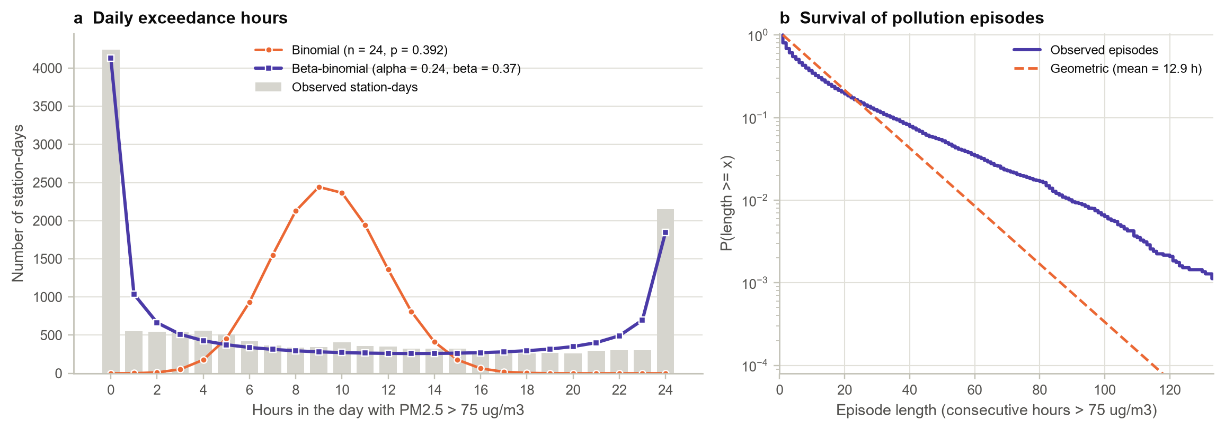
Table 5.3. Discrete-distribution summary for exceedances of the 75 µg/m³ limit
Quantity | Value
Complete station-days analysed | 14,908
Mean exceedance hours per day (p̂) | 9.42 (0.392)
Observed variance vs binomial variance | 82.3 vs 5.72 (14.4 times)
Beta-binomial alpha, beta (intra-day correlation) | 0.244, 0.365 (0.62)
AIC binomial vs beta-binomial | 299,993 vs 82,426
Days with 0 / 24 exceedance hours: observed | 4,244 / 2,148
Same, expected under binomial / beta-binomial | 0.1 / ~0 and 4,130 / 1,848
Episodes; mean and median length | 12,492; 12.9 h and 6 h
Episodes lasting 72 h or more: observed vs geometric | 2.19% vs 0.32%

- What the chart shows: Panel (a) counts station-days by how many of their 24 hours exceeded 75 µg/m³ and overlays the binomial and beta-binomial predictions. Panel (b) is the survival curve of exceedance-episode lengths on a log scale, compared with a geometric (memoryless) model of the same mean.
- Why it was drawn: Exceedances are counts, so discrete models apply. The binomial assumes that hours are independent and the geometric assumes that an episode is equally likely to end at any hour. Both are natural null models to test.
- Key insight: Independence fails dramatically. The observed counts are U-shaped: 4,244 days had no exceedance and 2,148 days exceeded the limit in all 24 hours, while the binomial expects almost none of either. The beta-binomial, with both parameters below 1, reproduces the U-shape and cuts AIC by 217,567. Its intra-day correlation of 0.62 says that a polluted hour almost guarantees a polluted day. Episodes also persist: those lasting three days or more are 7 times more common than a memoryless process allows. This persistence is exactly the structure a recurrent network can exploit.

5.7 Spatial Variation across Sites
Figure 5.6. Distribution of hourly PM2.5 at the twelve sites, ordered by median
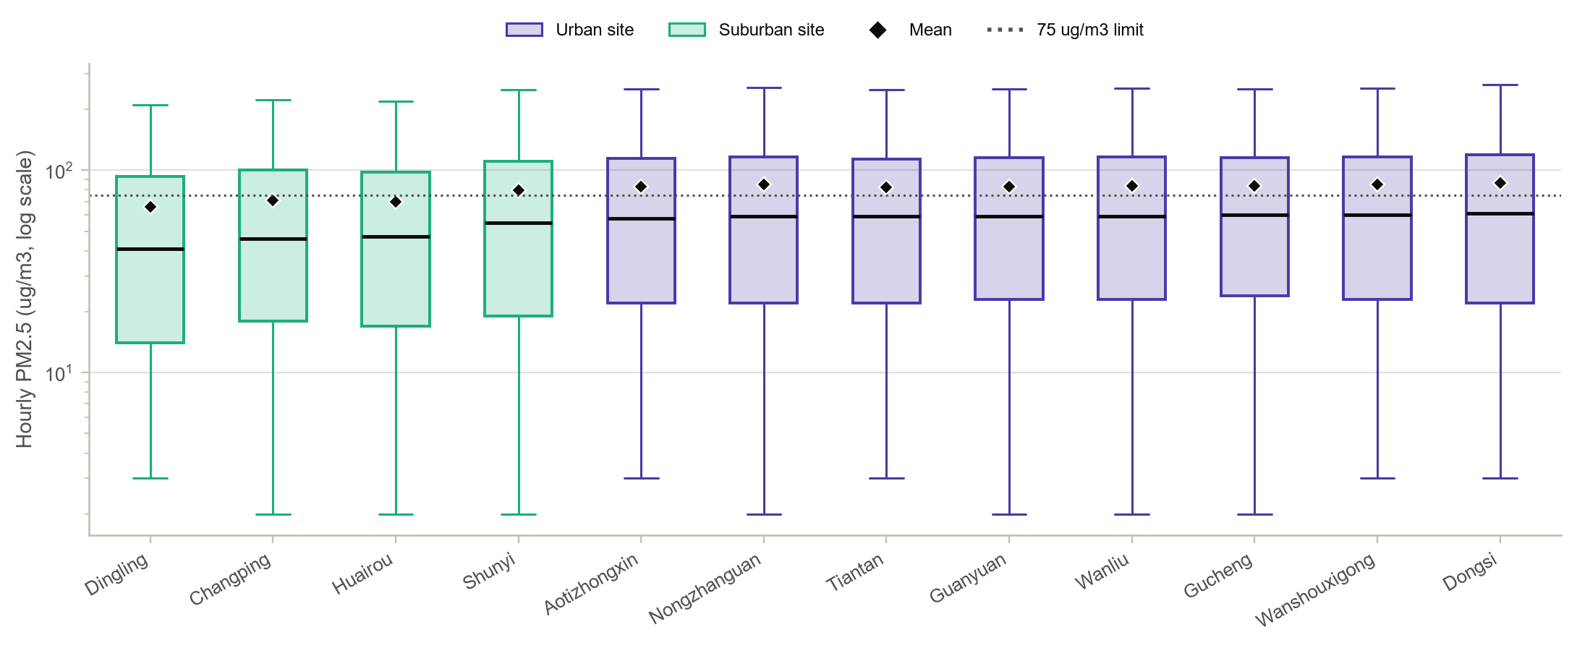
- What the chart shows: Box plots of hourly PM_{2.5} on a log scale for each site, with means as diamonds, urban sites in violet and suburban sites in green.
- Why it was drawn: Comparing several batches side by side is the classic way to judge whether location matters, and the urban-suburban colouring tests one specific explanation.
- Key insight: All four suburban sites form the cleanest group (medians 41 to 55 µg/m³), led by Dingling, while the eight urban sites sit within a narrow band (58 to 61). Dongsi has the highest median. The Kruskal-Wallis test is highly significant (H = 3,561), but the effect size is small (epsilon² = 0.0086). Every box overlaps the 75 µg/m³ line, so pollution in Beijing is regional rather than local: the city-wide weather decides most of the variation and location adds a modest urban surplus (mean 83.9 against 71.5).

5.8 The Role of Wind Direction
Figure 5.7. Mean PM2.5 for each of the 16 wind directions and how often each direction occurs
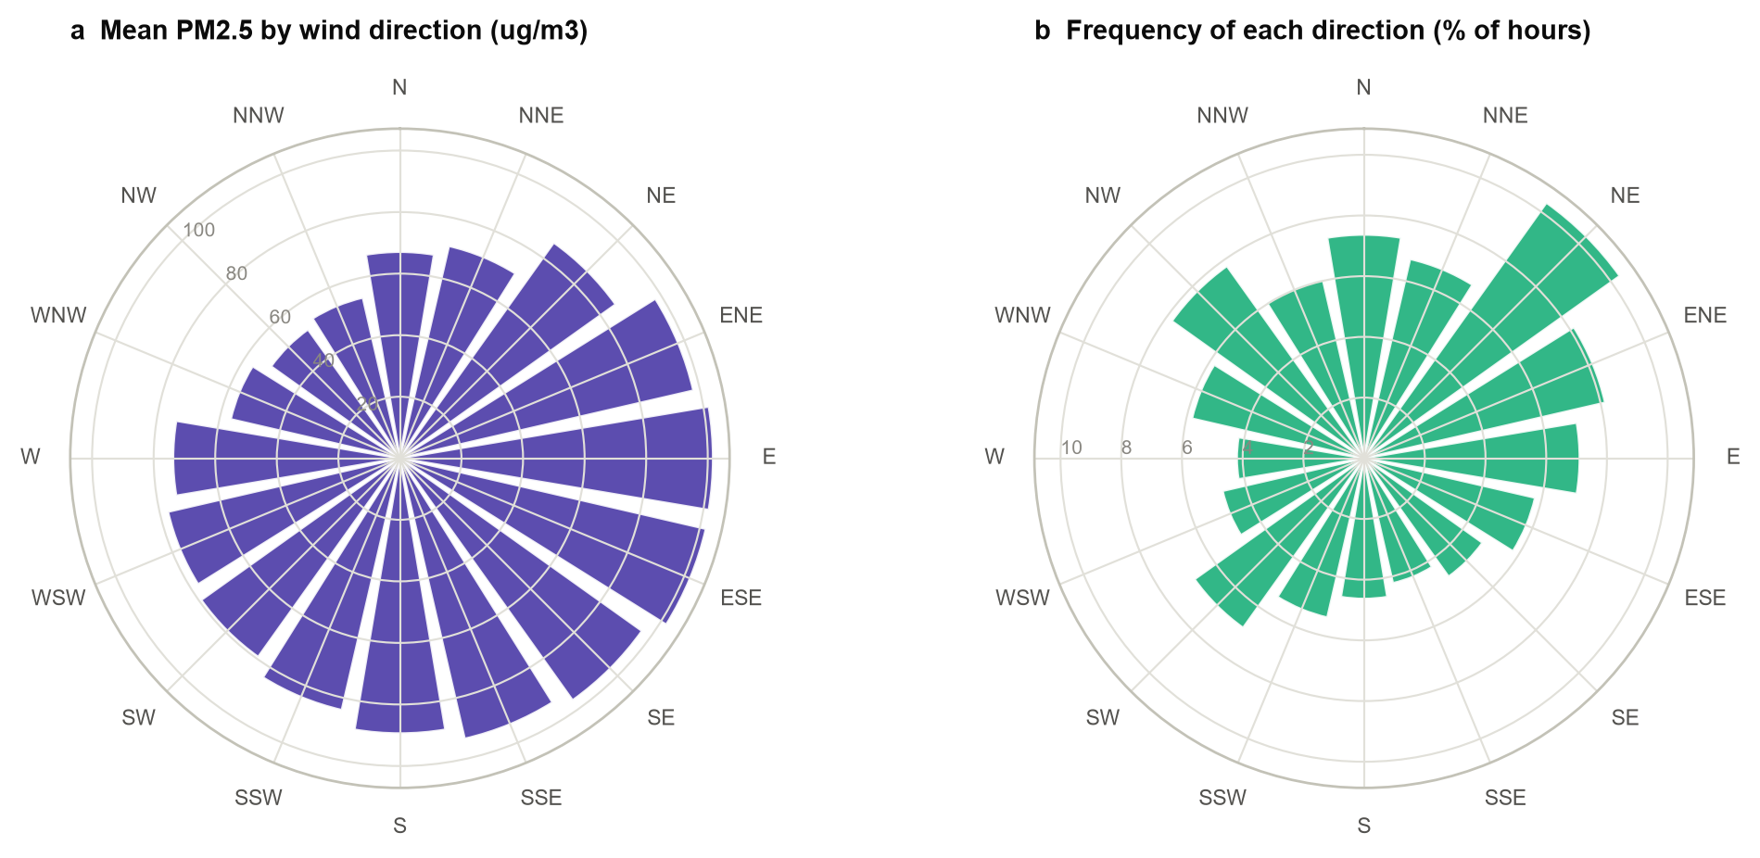
- What the chart shows: Two polar bar charts: the length of each wedge is (a) the mean PM_{2.5} when the wind blows from that direction and (b) the share of hours with that wind direction.
- Why it was drawn: Direction is a circular variable, so a polar layout keeps north next to north-north-west, which a bar chart would place at opposite ends.
- Key insight: The dirtiest winds come from the east and south-east (ESE 102, E 102 µg/m³), the direction of the industrial North China Plain. The cleanest come from the north-west (NW 51, NNW 54), from the Mongolian plateau, a twofold difference. North-easterly winds are the most frequent (10.3% of hours), but the clean north-westerlies are frequent enough to flush the city regularly.

5.9 Wind Speed with a Third Variable
Figure 5.8. Median PM2.5 and interquartile band against wind speed, split by northerly and southerly sectors
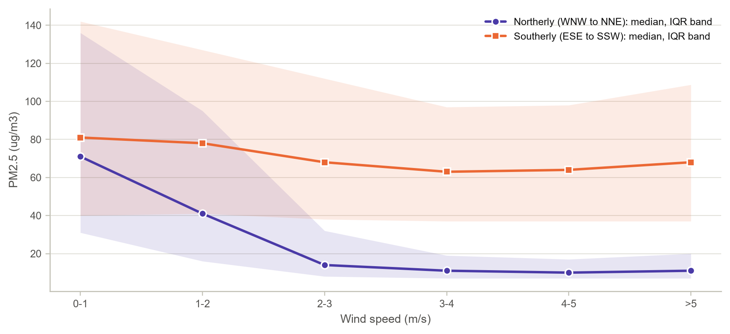
- What the chart shows: Median PM_{2.5} (lines) and interquartile range (shaded bands) for wind-speed bands, drawn separately for northerly and southerly winds.
- Why it was drawn: Wind speed alone correlates only modestly with PM_{2.5} (Spearman rho = -0.33). Introducing wind direction as a third variable tests whether that weak overall association hides two different relationships.
- Key insight: It does. Under northerly winds the median falls from 71 µg/m³ in calm air to 14 at 2 to 3 m/s and about 10 above 4 m/s, a reduction of about 85%. Under southerly winds the median barely moves (81 to 63), because a stronger southerly wind brings in more polluted air from the south rather than clean air. The overall correlation mixes these two regimes, which is a textbook case of why the third variable must be introduced.

5.10 Correlation Structure
Figure 5.9. Spearman rank correlations among pollutants and weather variables
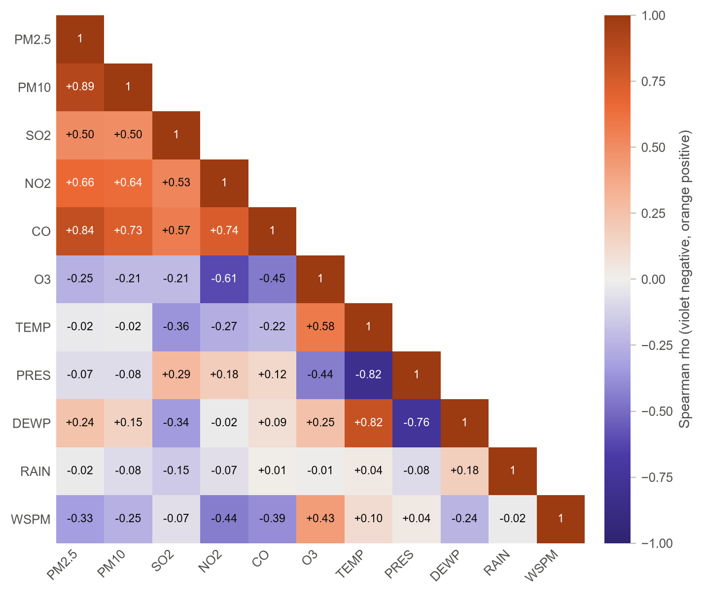
- What the chart shows: The lower triangle of the Spearman correlation matrix on a diverging scale, with violet for negative and orange for positive association. The sign and value are printed in each cell.
- Why it was drawn: Rank correlation suits skewed variables, and the matrix identifies which inputs carry overlapping information before they are given to a model.
- Key insight: PM_{2.5} moves with PM₁₀ (rho = +0.89), CO (+0.84) and NO₂ (+0.66), the signature of shared combustion sources, and against ozone (-0.26) and wind speed (-0.33). Temperature alone is unrelated (-0.02), but dew point is positive (+0.24): humid, stagnant air favours particle growth. Among the weather variables, temperature, dew point and pressure are strongly inter-related (|rho| ≈ 0.8). Ozone's negative link with NO₂ (-0.61) reflects titration, the destruction of ozone by fresh NO emissions.

5.11 Co-emission and the Particle Size Mix
Figure 5.10. Log-log relation between CO and PM2.5, and the PM2.5/PM10 ratio by season
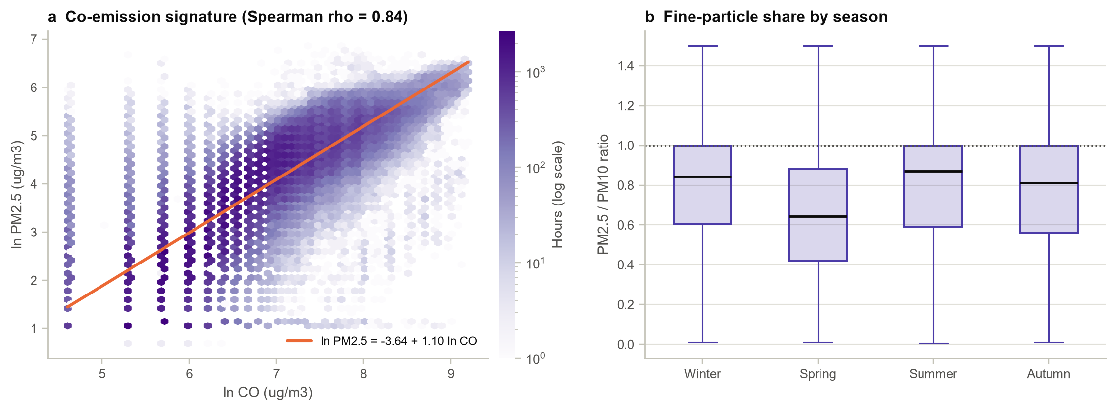
- What the chart shows: Panel (a) is a hexbin of ln PM_{2.5} against ln CO with a fitted line; panel (b) shows the share of PM₁₀ made up of fine particles in each season.
- Why it was drawn: CO is a tracer of incomplete combustion, so a tight relation suggests combustion-driven particles. The PM_{2.5}/PM₁₀ ratio separates fine combustion aerosol from coarse dust.
- Key insight: The log-log slope is 1.10 (rho = 0.84): PM_{2.5} rises roughly in proportion to CO, consistent with a common combustion source. The fine fraction drops to a median of 0.64 in spring, against 0.84 in winter and 0.87 in summer, which is the fingerprint of spring dust storms that add coarse particles.

5.12 Seasons and the Heating Effect
Figure 5.11. PM2.5 by season and by central-heating period (log scale)
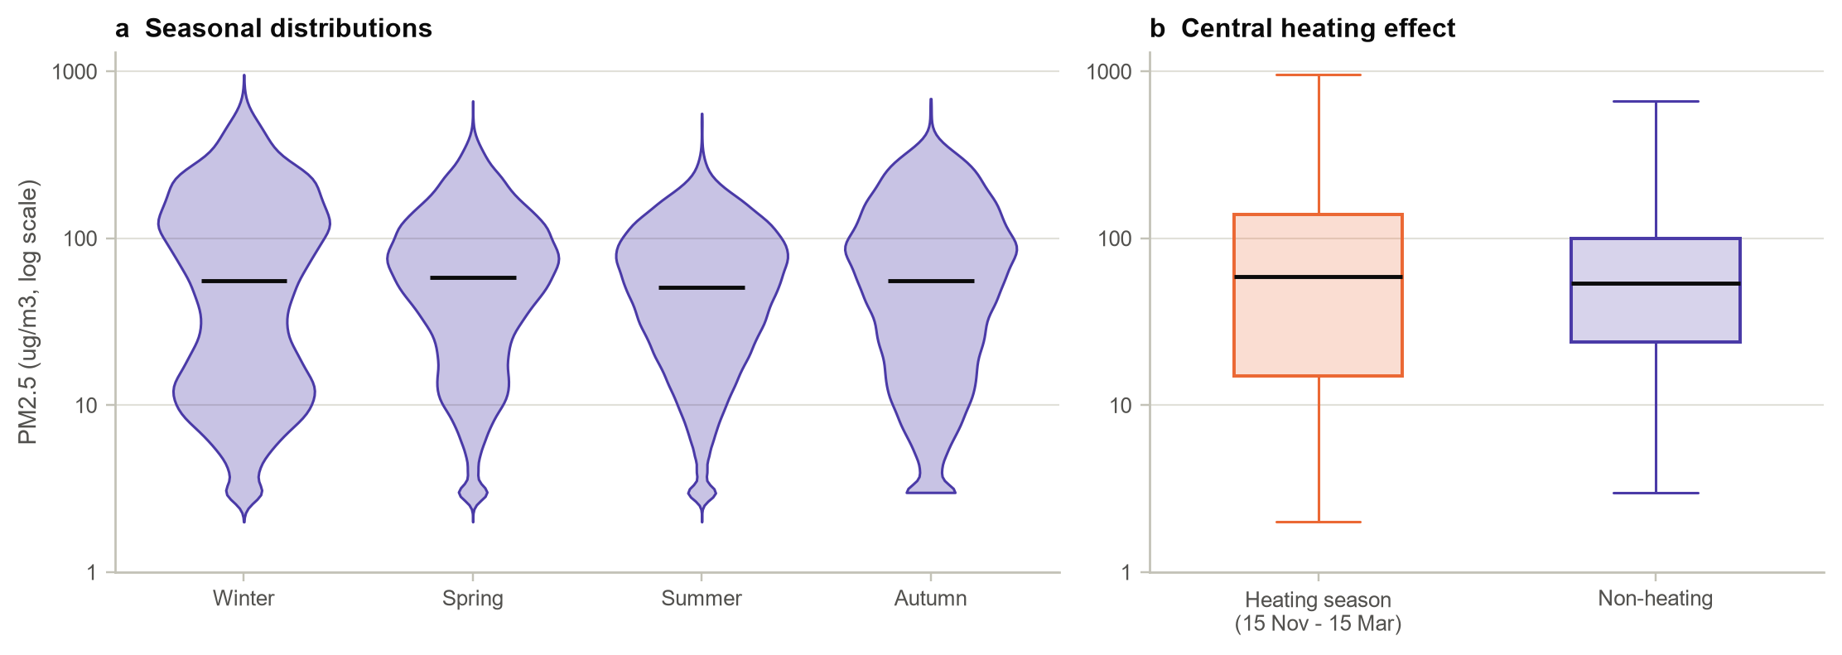
Table 5.4. PM2.5 (µg/m³) by season and heating period
Group | Median | Mean | 90th percentile
Winter (Dec-Feb) | 56 | 95.5 | 241
Spring (Mar-May) | 58 | 76.9 | 169
Summer (Jun-Aug) | 51 | 64.7 | 137
Autumn (Sep-Nov) | 56 | 82.3 | 201
Heating season (15 Nov-15 Mar) | 59 | 94.8 | 238
Non-heating period | 54 | 72.3 | 159

- What the chart shows: Violin plots of log PM_{2.5} by season, and box plots comparing the heating season with the rest of the year.
- Why it was drawn: Beijing's district heating runs from 15 November to 15 March, and coal combustion for heating is a long-suspected driver of winter smog (Liang et al., 2015).
- Key insight: Medians hardly differ (51 to 58), but the upper tail does: the 90th percentile is 241 in winter against 137 in summer, and the heating-season mean is 94.8 against 72.3. The winter violin is visibly bimodal, with a clean mode and a haze mode. Kruskal-Wallis (H = 746) and Mann-Whitney tests are significant, but the rank effect is tiny (probability of superiority 0.515). Heating does not raise the typical hour; it raises the frequency and severity of extreme episodes.

5.13 Temporal Dependence: ACF and PACF
Figure 5.12. Autocorrelation and partial autocorrelation of hourly log PM2.5 at Dongsi
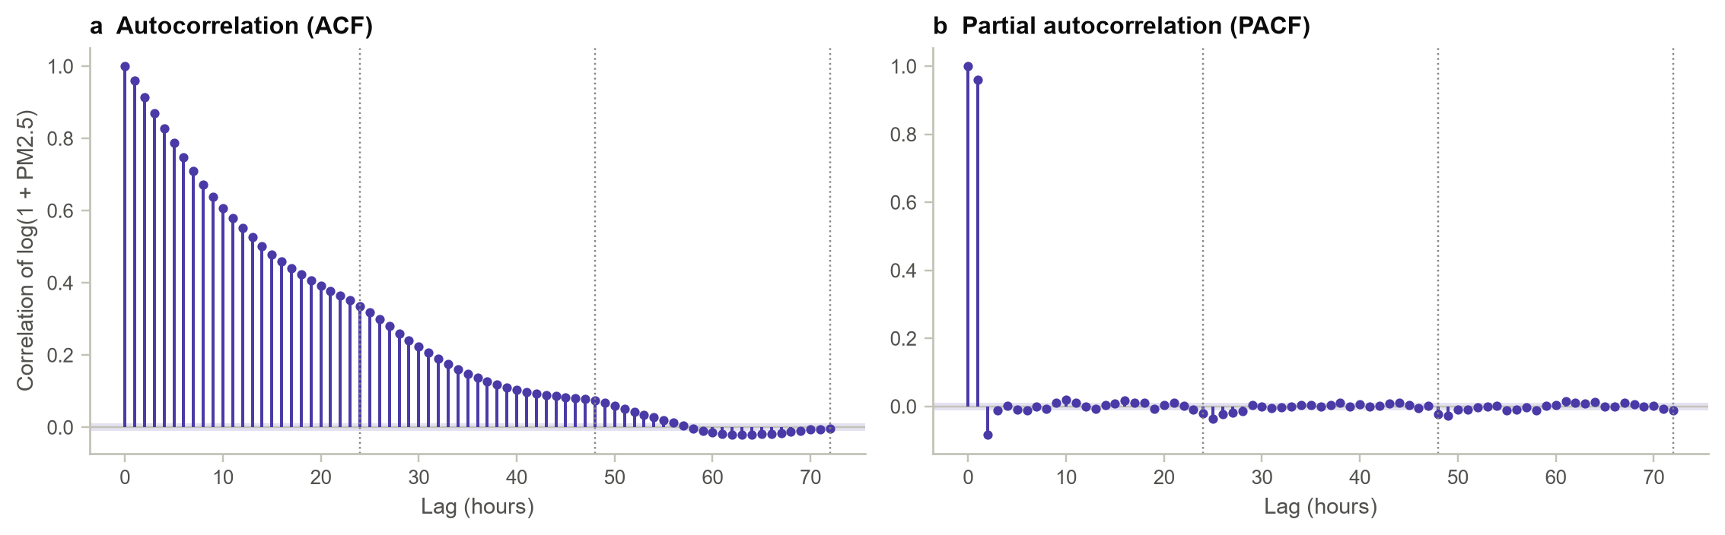
- What the chart shows: Autocorrelation (left) and partial autocorrelation (right) of the cleaned Dongsi series for lags up to 72 hours, with the 95% band for white noise shaded.
- Why it was drawn: Dependence over time determines how much past information a forecaster needs, so these charts guide the look-back window of the LSTM.
- Key insight: Memory is long but fading: the correlation is 0.96 after one hour, 0.75 after six, 0.34 after a day and essentially zero after three days (-0.004). The partial autocorrelation is dominated by lag 1 (0.96) with a small negative lag 2 (-0.08), an AR(1)-like process with a weak daily echo. This means that persistence will be a strong baseline and that look-back windows of 12 to 48 hours cover the useful memory.

5.14 Interact: The Beijing Air Explorer Dashboard
Figure 5.13. The interactive dashboard (dashboard/index.html) showing Dongsi PM2.5
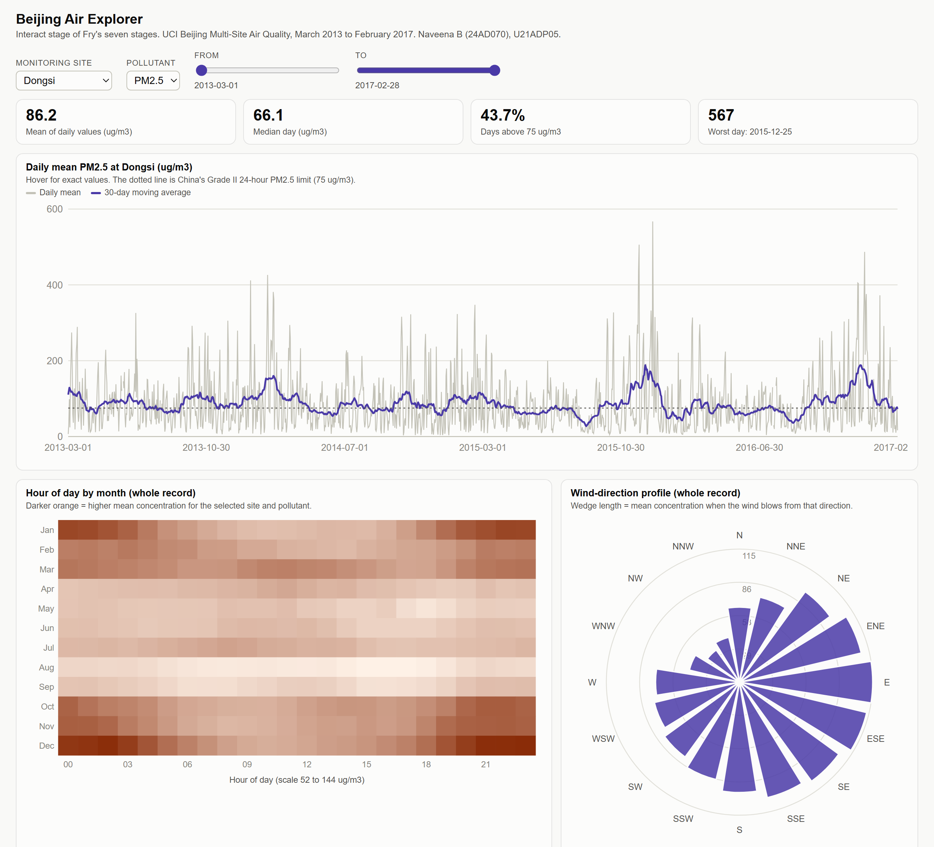
- What the chart shows: A self-contained web page with controls for site (or all sites), pollutant and date range. It redraws the daily series with its 30-day average, the hour-by-month heat map and the wind-direction profile, and offers hover read-outs and a table view.
- Why it was drawn: Interaction is the final stage of Fry's process. A reader can test, for example, whether ozone follows the same wind pattern as PM_{2.5} without running any code.
- Key insight: Switching the pollutant to O₃ largely inverts the heat map: ozone peaks on summer afternoons (171 µg/m³ in July at 16:00, against about 19 on winter nights), when PM_{2.5} is near its lowest. Across the 288 hour-month cells the two pollutants correlate at -0.54, consistent with Section 5.10. Switching to the suburban Dingling site keeps the pattern (its heat map correlates 0.78 with Dongsi's) at about 77% of the level, which confirms that the patterns are regional.

CHAPTER 6: DEEP LEARNING MODEL

6.1 Why an LSTM
The previous chapter showed long, decaying memory (an autocorrelation of 0.34 after a day), pollution episodes that persist far longer than chance, and strong dependence on recent wind, humidity and co-emitted gases. A model therefore needs a sequence of recent hours, not a single snapshot. The LSTM (Hochreiter & Schmidhuber, 1997) handles sequences with input, forget and output gates that decide what its memory cell keeps or discards at every step:
c_{t} = f_{t} ⊙ c_{t−1} + i_{t} ⊙ tanh(W_{c}[h_{t−1}, x_{t}] + b_{c}), h_{t} = o_{t} ⊙ tanh(c_{t})

6.2 Problem Framing
At each forecast origin t, the network receives the previous L hours of the 19 standardised inputs from Table 4.3 and predicts log PM_{2.5} for the next six hours, t + 1 to t + 6, in a single pass. Windows whose inputs or targets contain a missing hour are skipped, and no target window is allowed to cross a split boundary, so nothing leaks from validation or test data into training.

6.3 Architecture
Figure 6.1. Architecture of the residual LSTM forecaster
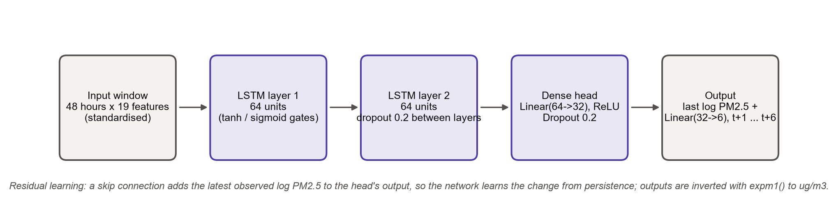
Table 6.1. Layer-by-layer summary of the selected network
Layer | Output | Details | Parameters
Input | 48 x 19 | standardised window | 0
LSTM layer 1 | 48 x 64 | tanh / sigmoid gates | 21,760
LSTM layer 2 | 64 | dropout 0.2 between layers; last time step kept | 33,280
Dense | 32 | ReLU, dropout 0.2 | 2,080
Dense (change) | 6 | linear | 198
Skip connection | 6 | adds the latest observed log PM2.5 to each output | 0
Total |  |  | 57,318

The final skip connection is the key design choice. The dense head predicts the change from the latest observed value instead of the level itself. An untrained network therefore starts as the persistence forecast, and training only has to learn how pollution will deviate from it. A first version without this connection, trained with squared error, lost to persistence at short horizons and under-predicted systematically, which is what motivated the change (Section 8.3).

6.4 Training Parameters
Table 6.2. Training configuration
Setting | Value
Framework | PyTorch 2.13.0+cpu on CPU; seed 2024; deterministic algorithms
Loss | Huber (smooth L1, beta = 0.05) on standardised log(1 + PM2.5), targeting the conditional median
Optimiser | Adam, learning rate 1e-3, weight decay 1e-5, gradient clipping at norm 1
Batch size / maximum epochs | 256 / 40
Early stopping | Validation loss, patience 6 epochs, best weights restored
Learning-rate schedule | ReduceLROnPlateau: factor 0.5, patience 3
Model selection | Lowest validation MAE (µg/m³, averaged over the six horizons)

6.5 Hyperparameter Tuning
Table 6.3. Grid search over look-back window and hidden size (selected: #6)
# | Look-back L | Hidden H | Train windows | Epochs | Best epoch | Val MAE | Val RMSE | Params | Time (s)
1 | 12 | 32 | 13,910 | 13 | 7 | 21.07 | 41.13 | 15,862 | 37
2 | 12 | 64 | 13,910 | 12 | 6 | 20.98 | 41.70 | 57,318 | 32
3 | 24 | 32 | 13,814 | 13 | 7 | 21.12 | 40.99 | 15,862 | 54
4 | 24 | 64 | 13,814 | 10 | 4 | 20.76 | 40.87 | 57,318 | 50
5 | 48 | 32 | 13,622 | 12 | 6 | 21.14 | 41.23 | 15,862 | 79
6 | 48 | 64 | 13,622 | 12 | 6 | 20.73 | 40.74 | 57,318 | 112

Figure 6.2. Validation MAE of the six LSTM configurations
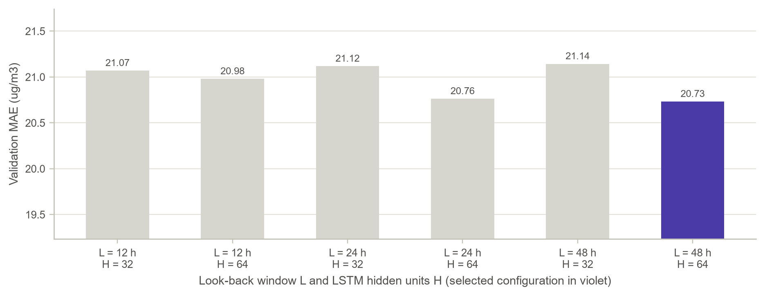
- What the chart shows: One bar per configuration of look-back window L and hidden units H; the selected model is highlighted.
- Why it was drawn: The look-back window encodes how much history the model is allowed to use, and the ACF suggested a range of 12 to 48 hours. Tuning tests that suggestion empirically.
- Key insight: All six configurations lie within 0.41 µg/m³ of each other. The best uses L = 48 hours and H = 64 units (validation MAE 20.73). The longest window wins only narrowly, consistent with the ACF, which fades to almost nothing by 48 hours. The whole search took 6 minutes on a laptop CPU.

6.6 Feature Importance
Figure 6.3. Permutation importance: increase in validation RMSE when each input is shuffled
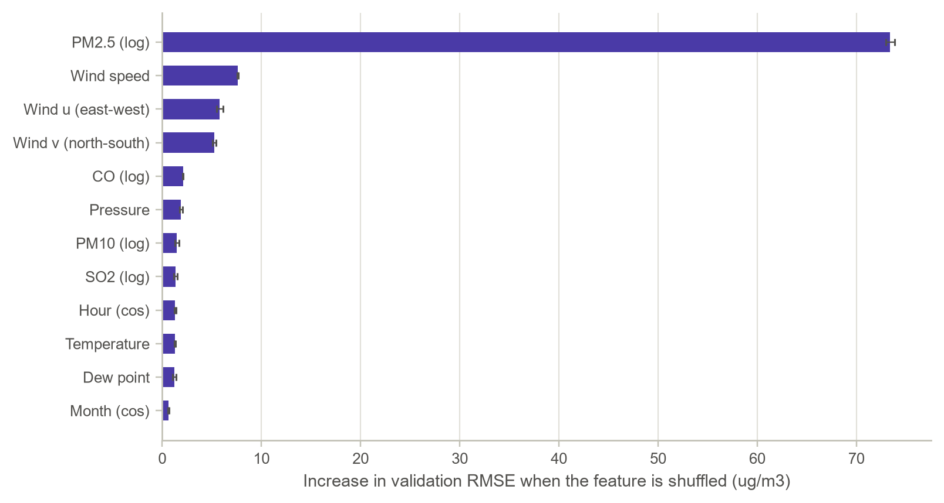
- What the chart shows: For each input, its whole history inside every window was shuffled across windows, and the resulting increase in validation RMSE (averaged over five repetitions) was recorded.
- Why it was drawn: Permutation importance reveals what the trained network actually relies on and checks that it learned physically sensible drivers.
- Key insight: Recent PM_{2.5} dominates (+73.4 µg/m³ when shuffled), as the autocorrelation implied. The next three inputs are all wind variables: wind speed (+7.6), the east-west component (+5.8) and the north-south component (+5.2), followed by CO and pressure. This matches the wind analysis of Sections 5.8 and 5.9: the network has learned that the wind decides whether polluted or clean air arrives. Day-of-week, month and ozone inputs matter least, because their information is either weak or already contained in the recent observations.

CHAPTER 7: RESULT VISUALIZATION AND INTERPRETATION
All results in this chapter come from the untouched test year (March 2016 to February 2017): 8,444 complete forecast windows covering every season, including the severe winter of 2016-17. Errors are in µg/m³ after reversing the log transform.

7.1 Learning Curves
Figure 7.1. Training and validation loss per epoch
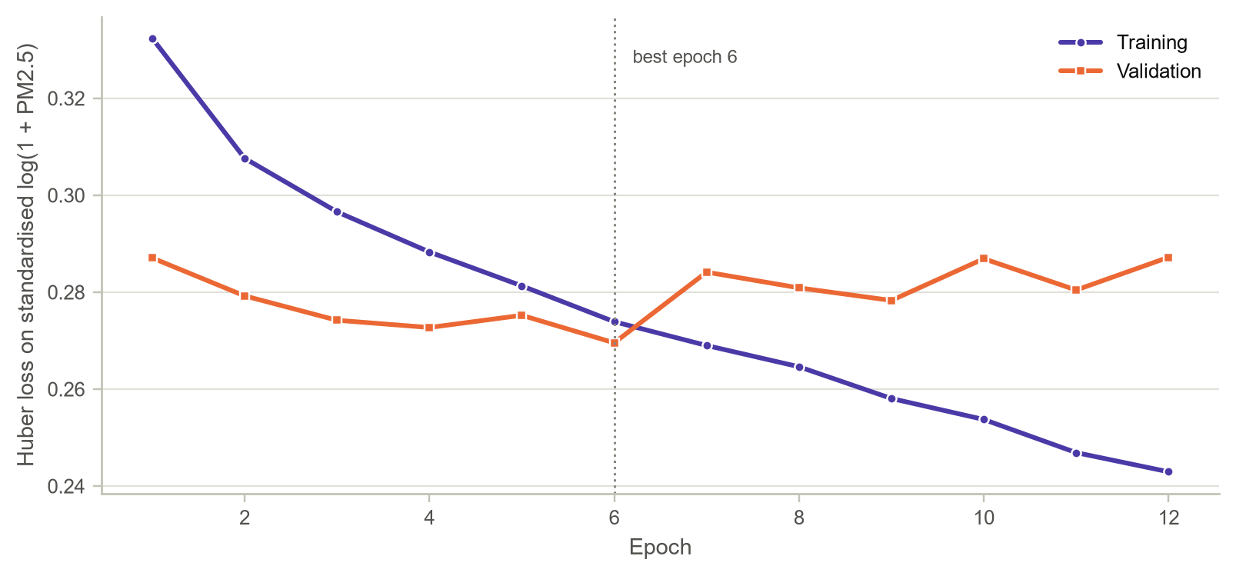
Figure 7.2. Training and validation MAE per epoch (µg/m³, averaged over six horizons)
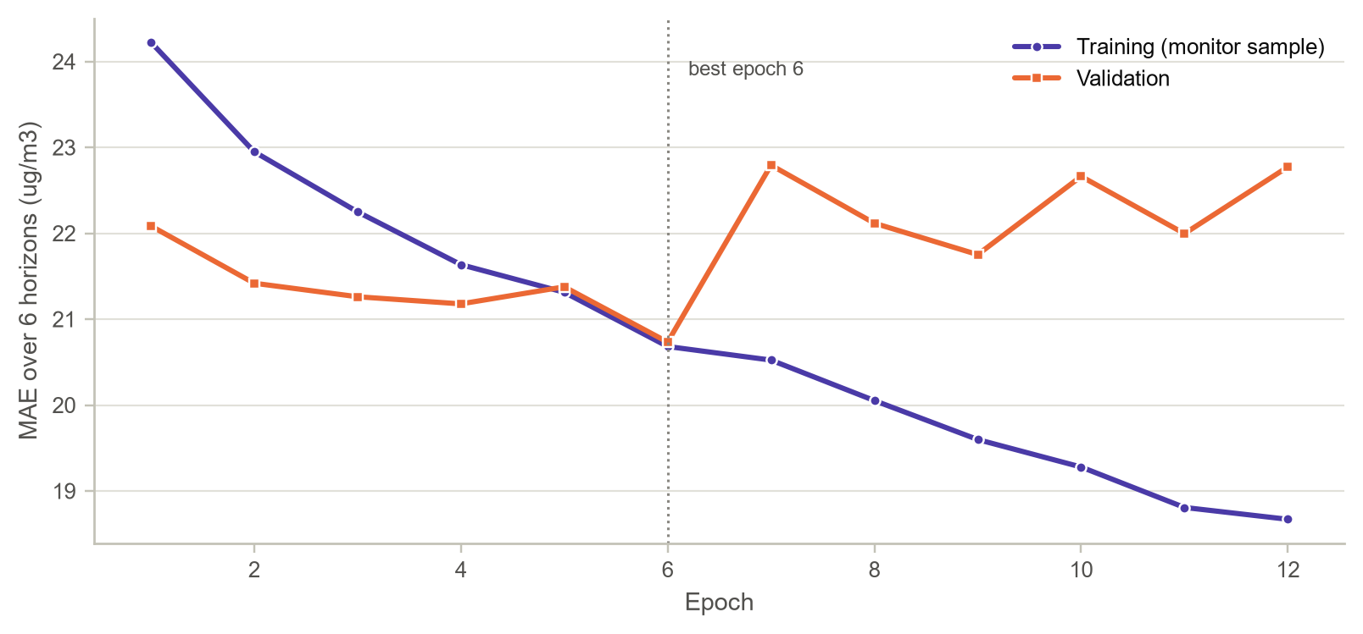
- What the chart shows: The Huber loss (Figure 7.1) and the MAE in µg/m³ (Figure 7.2) for every epoch, with the restored epoch marked.
- Why it was drawn: Learning curves are the standard check of convergence and overfitting. The MAE curve is the regression counterpart of an accuracy-versus-epoch chart.
- Key insight: Both curves fall quickly. Validation loss is lowest at epoch 6, after which it no longer improves while the training loss keeps falling, so early stopping restored the epoch-6 weights. At that point the validation MAE is 20.73 µg/m³ against 20.68 on the training sample. The small gap between training and validation errors shows that the network generalises to a year it has never seen.

7.2 Forecasts during a Severe Episode
Figure 7.3. Observed PM2.5 and LSTM forecasts at Dongsi, 12-26 December 2016
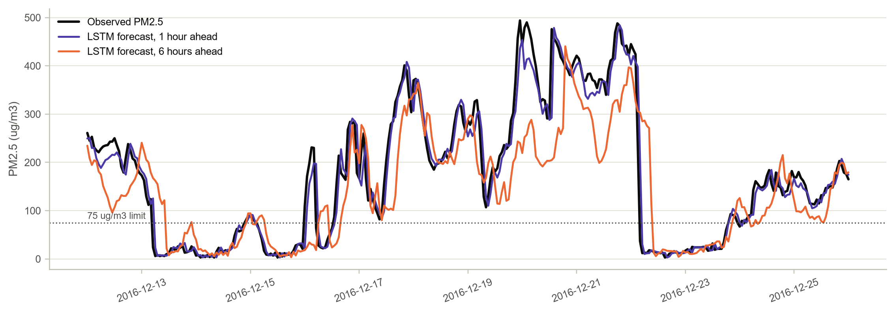
- What the chart shows: Two weeks of the test period, including the 16-21 December 2016 red-alert haze, with the observed series and the forecasts made one and six hours in advance.
- Why it was drawn: Average error statistics can hide how a model behaves in the situations that matter most. A close-up of the worst episode shows that behaviour directly.
- Key insight: The one-hour forecast tracks the build-up and the collapse of the episode closely. The six-hour forecast follows the broad shape of the episode but lags its sharpest rises, smooths the peaks and reacts late to the sudden clean-out on 22 December, when northerly winds swept the haze away within a few hours. Abrupt regime changes are the hardest part of the problem, because the information that announces them, the arrival of a weather front, is only partly visible in local observations.

7.3 Predicted versus Observed
Figure 7.4. Forecast against observed PM2.5 on log axes, one and six hours ahead
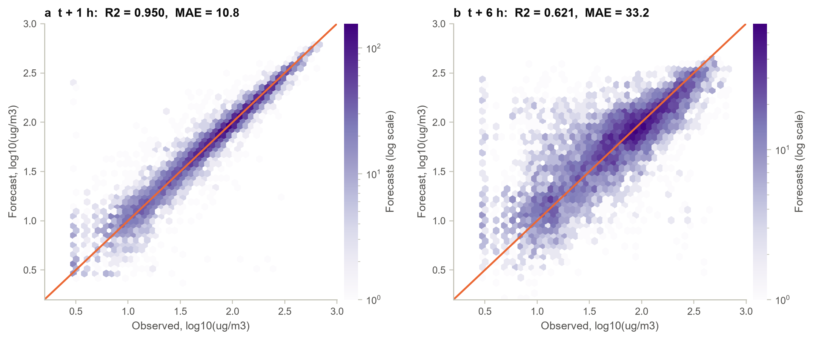
- What the chart shows: Hexagonal-bin density of forecast against observed values on log axes, with the line of perfect agreement.
- Why it was drawn: A scatter of predictions against observations shows bias, spread and saturation across the full range of concentrations at once.
- Key insight: At t + 1 the cloud hugs the diagonal (R² = 0.950). By t + 6 it widens (R² = 0.621) and the highest concentrations fall below the diagonal: severe hours are under-predicted (Section 7.4). Pulling extreme forecasts towards typical values is the expected behaviour of any forecaster when the future is uncertain.

7.4 Error Distribution
Figure 7.5. Forecast-error distribution and error by concentration band
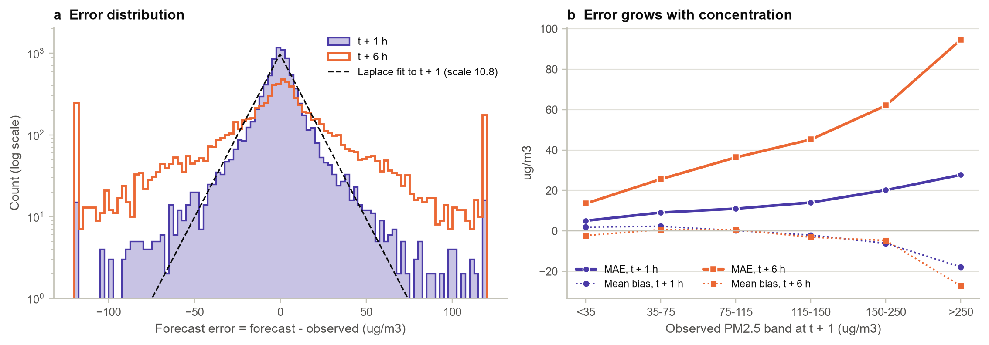
- What the chart shows: Panel (a) is the histogram of forecast errors at t + 1 and t + 6 (log counts) with a Laplace fit; panel (b) shows the MAE and mean bias within bands of observed concentration.
- Why it was drawn: For regression models the error distribution is the main diagnostic. It shows whether errors are centred, symmetric and constant across the range of the target.
- Key insight: Errors are centred near zero with sharp peaks and heavy tails, closer to a Laplace (scale 10.8) than a normal distribution. The median absolute error is only 5.5 µg/m³ at t + 1 and 17.6 at t + 6. Errors grow with concentration: at t + 1 the MAE rises from 5.0 in clean air to 27.8 above 250 µg/m³, and the most severe hours are under-predicted (bias -18 at t + 1, -27 at t + 6). The errors are roughly proportional to the level, which justifies the log-scale training.

7.5 Skill against Baseline Forecasts
Figure 7.6. Test MAE by forecast horizon for the LSTM, persistence and the same hour on the previous day
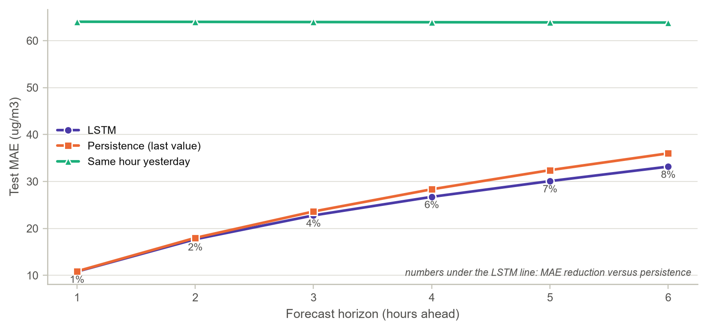
Table 7.1. Test-period error by forecast horizon (µg/m³)
Horizon | LSTM MAE | LSTM RMSE | LSTM R² | Persistence MAE | Same-hour-yesterday MAE | MAE gain vs persistence
t + 1 | 10.81 | 20.34 | 0.950 | 10.88 | 64.03 | +0.6%
t + 2 | 17.70 | 32.33 | 0.873 | 17.99 | 64.00 | +1.6%
t + 3 | 22.78 | 40.42 | 0.802 | 23.61 | 63.97 | +3.5%
t + 4 | 26.73 | 46.49 | 0.738 | 28.34 | 63.93 | +5.7%
t + 5 | 30.09 | 51.45 | 0.679 | 32.42 | 63.89 | +7.2%
t + 6 | 33.17 | 55.93 | 0.621 | 36.00 | 63.86 | +7.9%

- What the chart shows: MAE for horizons of one to six hours for the LSTM and two naive benchmarks, with the LSTM's percentage improvement over persistence printed under its line. Table 7.1 gives the full numbers.
- Why it was drawn: A forecasting model is only useful if it beats the simple rule of carrying the last value forward (Hyndman & Athanasopoulos, 2021). This chart is the decisive test.
- Key insight: The LSTM beats persistence at every horizon from one to six hours. The margin grows with the horizon, from 1% at t + 1 to 8% at t + 6, because persistence degrades quickly while the network uses wind and humidity to anticipate change. Averaged over the six horizons the MAE is 23.5 against 24.9 for persistence. The same-hour-yesterday forecast is far worse (MAE about 64), confirming that one day of memory carries little predictive power for the following hours.

7.6 Air-Quality Category Confusion Matrices
Figure 7.7. Row-normalised confusion matrices of forecast against observed air-quality category
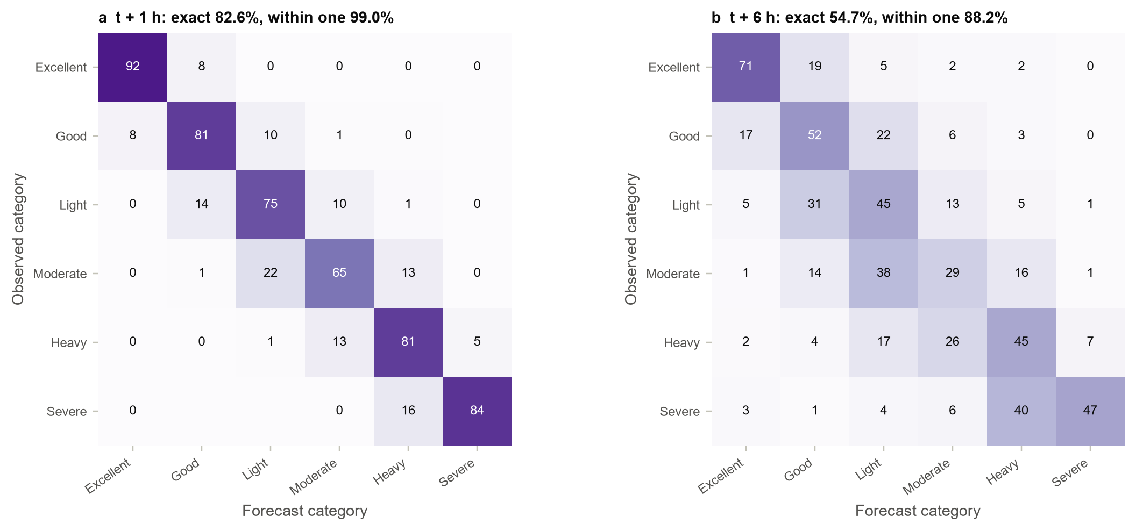
- What the chart shows: Each cell shows the percentage of hours in an observed category (rows) that the forecast placed in each category (columns), using the Chinese AQI breakpoints for PM_{2.5} (35, 75, 115, 150 and 250 µg/m³; Ministry of Environmental Protection of the People's Republic of China, 2012b).
- Why it was drawn: The public sees air quality as categories, not numbers, so a categorical confusion matrix measures what a citizen would actually experience from the forecast.
- Key insight: One hour ahead the forecast assigns the exact category 82.6% of the time and is within one category 99.0% of the time. Six hours ahead the figures are 54.7% and 88.2%. One hour ahead almost every miss lands in a neighbouring category; six hours ahead most still do, and gross errors such as forecasting Excellent for a Heavy hour stay rare (under 2% of Heavy hours).

7.7 Exceedance Alerts: ROC and AUC
Figure 7.8. ROC curves for forecasting exceedance of 75 µg/m³ one, three and six hours ahead
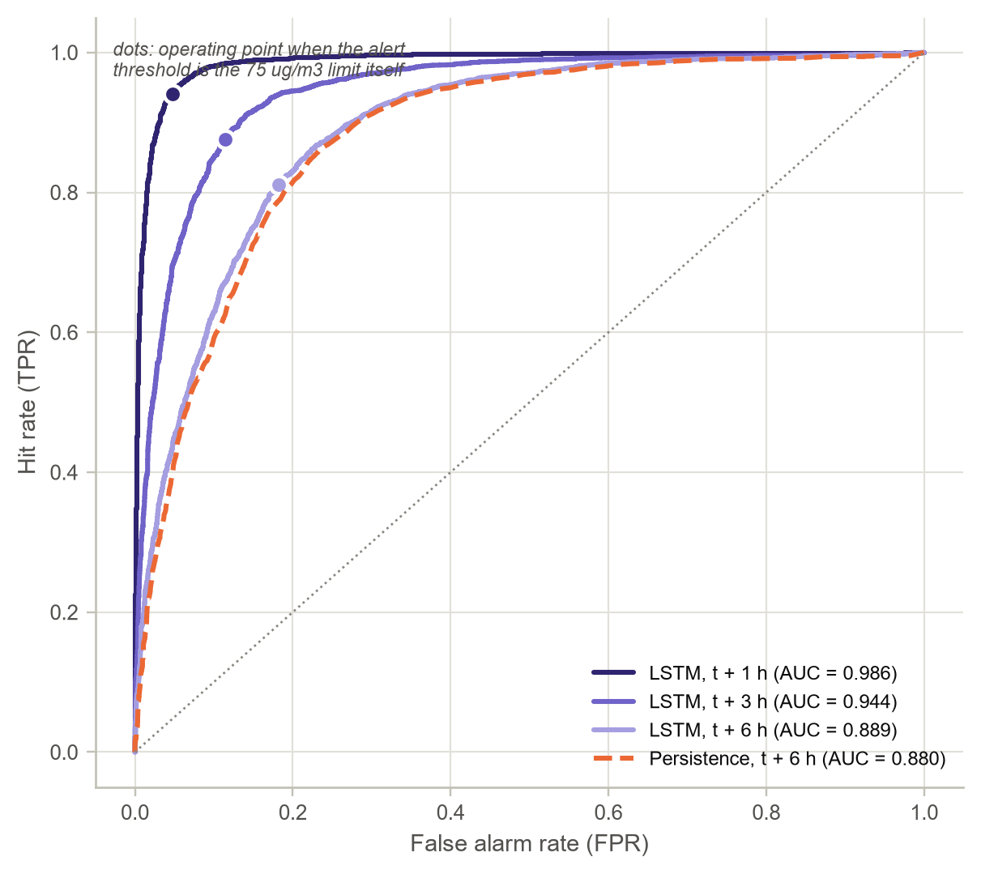
Table 7.2. Performance as a 75 µg/m³ exceedance alert (operating point: forecast above 75)
Alert horizon | AUC | Hit rate (TPR) | False-alarm rate | Precision
t + 1 | 0.986 | 94.0% | 4.7% | 93.4%
t + 3 | 0.944 | 87.6% | 11.4% | 84.6%
t + 6 | 0.889 | 81.1% | 18.2% | 76.2%
t + 6, persistence | 0.880 | - | - | -

- What the chart shows: ROC curves obtained by using the forecast concentration as an alert score, with the operating point at which the alert threshold equals the limit itself. Persistence at six hours is shown for comparison.
- Why it was drawn: Many users only need a yes-or-no warning: will the air exceed the national limit? Treating the forecast as an alert turns the regression into a binary classifier with a ROC curve and AUC.
- Key insight: The alert is excellent one hour ahead (AUC 0.986, 94% of exceedances caught with 5% false alarms) and still useful six hours ahead (AUC 0.889, against 0.880 for persistence).

CHAPTER 8: CONCLUSION AND FUTURE SCOPE

8.1 Summary of Findings
- Beijing's PM_{2.5} fell from 87 to 73 µg/m³ between 2013-14 and 2015-16 but rose again in 2016-17 (78). The city-wide daily mean still exceeded the national limit on 40% of days.
- Pollution is seasonal and nocturnal: winter nights average about 48% more than winter afternoons, and December is the worst month after adjusting for the trend.
- Hourly concentrations are right-skewed and closer to gamma or Weibull laws with shape about 1 than to the classical lognormal.
- Exceedances cluster within days (beta-binomial correlation 0.62) and episodes last far longer than a memoryless model predicts, which is the persistence that makes forecasting possible.
- Weather dominates location. Northerly winds clean the air, but only when they are strong, while southerly winds keep it polluted at any speed. The urban surplus over suburbs is real but modest.
- Combustion is the common source (PM_{2.5} tracks CO with slope 1.10), while spring dust storms lower the fine fraction of particles.

8.2 Model Performance
The residual LSTM (48-hour look-back, 64 hidden units, 57,318 parameters) forecast PM_{2.5} with a test MAE of 10.8 µg/m³ one hour ahead (R² = 0.950) and 33.2 six hours ahead (R² = 0.621). It beat persistence at every horizon from one to six hours, with the largest gain (8%) at six hours. As an exceedance alert it reached an AUC of 0.986 at one hour and 0.889 at six. Permutation importance showed that it relies on recent PM_{2.5} and on the wind components, the same drivers that the exploratory analysis identified.

8.3 Challenges
- Missing gas data (up to 9% of CO hours at Dongsi) forced a careful gap-length rule; longer outages remain a limitation.
- Separating sensor spikes from genuine haze needed a domain-aware filter, including an exemption for fireworks nights.
- Persistence is a very strong baseline at short horizons. A first LSTM trained on the level with squared error lost to it and under-predicted systematically. Residual learning (a skip connection from the last observation) and a median-targeting Huber loss fixed both problems.
- An early 70/15/15 split by date validated on a mostly spring-summer period and tested on winter. The model selected on that validation set did not carry over to the test winter. Re-splitting into complete March-to-February years, so that validation and test both contain every season, removed the mismatch.

8.4 Future Scope
- Feed the network all twelve sites at once (or a graph neural network over the site network) so that upwind sites can act as early indicators.
- Add numerical weather-prediction forecasts of wind and humidity, the variables that announce regime changes.
- Produce probabilistic forecasts (quantile loss or ensembles) so that alerts carry a confidence level.
- Extend the horizon to 24-72 hours for public-health planning, and retrain regularly to follow policy-driven trends.
- Attribute changes to emissions after adjusting for weather, in the spirit of Zhang et al. (2017).

REFERENCES
Chen, S. (2017). Beijing multi-site air quality [Data set]. UCI Machine Learning Repository. https://doi.org/10.24432/C5RK5G
Fry, B. (2008). Visualizing data: Exploring and explaining data with the Processing environment. O’Reilly Media.
Hampel, F. R. (1974). The influence curve and its role in robust estimation. Journal of the American Statistical Association, 69(346), 383–393.
Hochreiter, S., & Schmidhuber, J. (1997). Long short-term memory. Neural Computation, 9(8), 1735–1780. https://doi.org/10.1162/neco.1997.9.8.1735
Huang, C.-J., & Kuo, P.-H. (2018). A deep CNN-LSTM model for particulate matter (PM_{2.5}) forecasting in smart cities. Sensors, 18(7), Article 2220. https://doi.org/10.3390/s18072220
Hyndman, R. J., & Athanasopoulos, G. (2021). Forecasting: Principles and practice (3rd ed.). OTexts. https://otexts.com/fpp3/
Li, X., Peng, L., Yao, X., Cui, S., Hu, Y., You, C., & Chi, T. (2017). Long short-term memory neural network for air pollutant concentration predictions: Method development and evaluation. Environmental Pollution, 231, 997–1004.
Liang, X., Zou, T., Guo, B., Li, S., Zhang, H., Zhang, S., Huang, H., & Chen, S. X. (2015). Assessing Beijing’s PM_{2.5} pollution: Severity, weather impact, APEC and winter heating. Proceedings of the Royal Society A, 471(2182), Article 20150257. https://doi.org/10.1098/rspa.2015.0257
Marsh, C., & Elliott, J. (2008). Exploring data: An introduction to data analysis for social scientists (2nd ed.). Polity Press.
Ministry of Environmental Protection of the People’s Republic of China. (2012a). Ambient air quality standards (GB 3095-2012).
Ministry of Environmental Protection of the People’s Republic of China. (2012b). Technical regulation on ambient air quality index (on trial) (HJ 633-2012).
Ott, W. R. (1990). A physical explanation of the lognormality of pollutant concentrations. Journal of the Air & Waste Management Association, 40(10), 1378–1383.
Paszke, A., Gross, S., Massa, F., Lerer, A., Bradbury, J., Chanan, G., Killeen, T., Lin, Z., Gimelshein, N., Antiga, L., Desmaison, A., Köpf, A., Yang, E., DeVito, Z., Raison, M., Tejani, A., Chilamkurthy, S., Steiner, B., Fang, L., Bai, J., & Chintala, S. (2019). PyTorch: An imperative style, high-performance deep learning library. In Advances in Neural Information Processing Systems 32 (pp. 8024–8035). Curran Associates.
Skellam, J. G. (1948). A probability distribution derived from the binomial distribution by regarding the probability of success as variable between the sets of trials. Journal of the Royal Statistical Society: Series B, 10(2), 257–261.
World Health Organization. (2021). WHO global air quality guidelines: Particulate matter (PM2.5 and PM10), ozone, nitrogen dioxide, sulfur dioxide and carbon monoxide.
Zhang, S., Guo, B., Dong, A., He, J., Xu, Z., & Chen, S. X. (2017). Cautionary tales on air-quality improvement in Beijing. Proceedings of the Royal Society A, 473(2205), Article 20170457. https://doi.org/10.1098/rspa.2017.0457

APPENDIX A: REPOSITORY STRUCTURE AND REPRODUCTION
All code, the executed notebook, figures, results and this report are organised in the GitHub repository https://github.com/Naveena0702/beijing-pm25-eda-lstm. The layout separates reusable modules from the narrative notebook:
beijing-pm25-eda-lstm/
|-- README.md overview, key results, how to run
|-- requirements.txt numpy, pandas, scipy, matplotlib, scikit-learn, torch
|-- data/PRSA2017_Data_20130301-20170228.zip original UCI archive (read directly)
|-- notebooks/beijing_pm25_analysis.ipynb executed analysis notebook
|-- notebooks/beijing_pm25_analysis.py same notebook as a script (jupytext pair)
|-- src/airq/config.py paths, thresholds, plotting style
|-- src/airq/data.py loading, audit, spike filter, interpolation, features
|-- src/airq/stats_tools.py distribution fitting, ACF/PACF, smoothing, decomposition
|-- src/airq/model.py windowing, residual LSTM, training, evaluation
|-- src/airq/viz.py, viz_results.py all figures
|-- src/dashboard_template.html dashboard template
|-- dashboard/index.html self-contained interactive dashboard
|-- figures/ 28 figures used in the report
|-- results/ results.json, CSV tables, lstm_best.pt
`-- report/ this report (DOCX and PDF)

To reproduce every number, install the requirements and execute the notebook. The full run, including the six-model search, takes about 9 minutes on a laptop CPU:
pip install -r requirements.txt
jupyter nbconvert --to notebook --execute --inplace notebooks/beijing_pm25_analysis.ipynb

APPENDIX B: SOURCE CODE LISTINGS
The listings reproduce the core of the analysis package exactly as it appears in the repository. Plotting functions are omitted for space.
B.1 Loading the twelve station files (data.py)
def load_raw(zip_path=DATA_ZIP):
"""Read every station CSV straight from the UCI zip archive and add a datetime column."""
frames = []
with zipfile.ZipFile(zip_path) as z:
for name in sorted(z.namelist()):
if name.endswith(".csv"):
with z.open(name) as fh:
frames.append(pd.read_csv(fh))
df = pd.concat(frames, ignore_index=True)
df["datetime"] = pd.to_datetime(df[["year", "month", "day", "hour"]])
return df.sort_values(["station", "datetime"]).reset_index(drop=True)

B.2 Single-hour spike filter (data.py)
FIREWORK_EVENINGS = ["2014-01-30", "2014-02-14", "2015-02-18", "2015-03-05",
"2016-02-07", "2016-02-22", "2017-01-27", "2017-02-11"]

def firework_mask(index):
m = np.zeros(len(index), dtype=bool)
for day in FIREWORK_EVENINGS:
t0 = pd.Timestamp(day) + pd.Timedelta(hours=18)
m |= (index >= t0) & (index <= t0 + pd.Timedelta(hours=12))
return m

def hampel_flags(series, window=7, n_sigmas=4.0, min_ratio=2.0, min_abs=25.0):
"""Flag single-hour glitches in PM2.5.

A reading is flagged only when ALL of the following hold (computed on log(1 + x)):
1. Hampel rule: it lies more than `n_sigmas` robust SDs (1.4826 x MAD) from the
centred `window`-hour rolling median;
2. it differs from that median by more than a factor of `min_ratio` and by more
than `min_abs` ug/m3 (so low-level sensor noise is ignored);
3. it jumps away from BOTH neighbouring hours in the same direction (a one-hour
spike or dip) - genuine haze episodes build up over several hours and are kept;
4. it is not on a fireworks evening.
"""
s = series.astype(float)
x = np.log1p(s)
med = x.rolling(window, center=True, min_periods=3).median()
mad = (x - med).abs().rolling(window, center=True, min_periods=3).median()
dev = x - med
lr = np.log(min_ratio)
robust = dev.abs() > n_sigmas * 1.4826 * mad
big = (dev.abs() > lr) & ((s - np.expm1(med)).abs() > min_abs)
single = ((x - x.shift(1) > lr) & (x - x.shift(-1) > lr)) | ((x.shift(1) - x > lr) & (x.shift(-1) - x > lr))
return robust & big & single & ~firework_mask(s.index)

B.3 Cleaning and feature engineering (data.py)
def fill_short_gaps(s, max_gap=MAX_INTERP_GAP):
"""Time-based linear interpolation for gaps of at most `max_gap` hours only."""
isna = s.isna().to_numpy()
if not isna.any():
return s, 0
lengths = np.zeros(len(s), dtype=int)
d = np.diff(np.r_[0, isna.astype(int), 0])
for a, b in zip(np.where(d == 1)[0], np.where(d == -1)[0]):
lengths[a:b] = b - a
interp = s.interpolate(method="time", limit_area="inside")
fill = isna & (lengths <= max_gap) & interp.notna().to_numpy()
out = s.copy()
out[fill] = interp[fill]
return out, int(fill.sum())

def clean_station(df_station, max_gap=MAX_INTERP_GAP):
"""Clean one station: remove instrument caps, de-spike PM2.5, interpolate short gaps."""
st = df_station.sort_values("datetime").set_index("datetime").copy()
log = {}
caps = {"PM2.5": st["PM2.5"] >= 999, "PM10": st["PM10"] >= 999, "CO": st["CO"] >= 10000, "O3": st["O3"] > 500}
for col, m in caps.items():
log[f"cap_removed_{col}"] = int(m.sum())
st.loc[m, col] = np.nan
spikes = hampel_flags(st["PM2.5"])
log["hampel_spikes_PM2.5"] = int(spikes.sum())
st.loc[spikes, "PM2.5"] = np.nan
for col in NUMERIC:
st[col], n = fill_short_gaps(st[col], max_gap)
log[f"interpolated_{col}"] = n
# wind direction is categorical: carry the last observed direction across short gaps
wd_missing = st["wd"].isna()
st["wd"] = st["wd"].ffill(limit=max_gap)
log["ffilled_wd"] = int((wd_missing & st["wd"].notna()).sum())
log["remaining_missing_any"] = int(st[NUMERIC + ["wd"]].isna().any(axis=1).sum())
return st, log

# --------------------------------------------------------------------------- transform
def add_features(st):
"""Physically meaningful encodings: wind vector components and cyclical calendar terms."""
st = st.copy()
angle = np.deg2rad(st["wd"].map({d: 22.5 * i for i, d in enumerate(WIND_DIRS)}).astype(float))
# meteorological convention: direction the wind blows FROM, so the flow vector is reversed
st["wind_u"] = -st["WSPM"] * np.sin(angle)
st["wind_v"] = -st["WSPM"] * np.cos(angle)
idx = st.index
for name, value, period in [("hour", idx.hour, 24), ("month", idx.month - 1, 12), ("dow", idx.dayofweek, 7)]:
st[f"{name}_sin"] = np.sin(2 * np.pi * value / period)
st[f"{name}_cos"] = np.cos(2 * np.pi * value / period)
for col in POLLUTANTS + ["RAIN"]:
st[f"log_{col}"] = np.log1p(st[col])
return st

B.4 Beta-binomial fit, ACF and PACF (stats_tools.py)
def fit_betabinom(k, n):
"""MLE of a beta-binomial(n, a, b) for counts k out of n trials."""
k = np.asarray(k)

def nll(theta):
a, b = np.exp(theta)
return -stats.betabinom.logpmf(k, n, a, b).sum()

m = k.mean() / n
res = optimize.minimize(nll, [np.log(m + 1e-3), np.log(1 - m + 1e-3)], method="Nelder-Mead",
options={"xatol": 1e-8, "fatol": 1e-8, "maxiter": 5000})
a, b = np.exp(res.x)
return float(a), float(b), float(-res.fun)

# --------------------------------------------------------------------------- dependence over time
def acf(x, nlags):
x = np.asarray(x, dtype=float) - np.mean(x)
denom = np.dot(x, x)
return np.array([1.0] + [np.dot(x[:-k], x[k:]) / denom for k in range(1, nlags + 1)])

def pacf_from_acf(r, nlags):
"""Durbin-Levinson recursion: partial autocorrelations from autocorrelations."""
pac = np.zeros(nlags + 1)
pac[0] = 1.0
phi = np.zeros((nlags + 1, nlags + 1))
phi[1, 1] = r[1]
pac[1] = r[1]
for k in range(2, nlags + 1):
num = r[k] - np.dot(phi[k - 1, 1:k], r[1:k][::-1])
den = 1 - np.dot(phi[k - 1, 1:k], r[1:k])
phi[k, k] = num / den
phi[k, 1:k] = phi[k - 1, 1:k] - phi[k, k] * phi[k - 1, 1:k][::-1]
pac[k] = phi[k, k]
return pac

B.5 Classical decomposition (stats_tools.py)
def classical_decomposition(monthly):
"""Additive decomposition of a monthly series: 2x12 centred moving-average trend,
month-specific seasonal indices (centred to sum to zero) and the remaining irregular part."""
w = np.r_[1 / 24, np.full(11, 1 / 12), 1 / 24] # 2x12 MA weights over 13 months
trend = monthly.rolling(13, center=True).apply(lambda v: float(np.dot(v, w)), raw=True)
detr = monthly - trend
idx = detr.groupby(detr.index.month).mean()
idx = idx - idx.mean()
seasonal = pd.Series(monthly.index.month.map(idx).to_numpy(), index=monthly.index)
resid = monthly - trend - seasonal
return trend, seasonal, resid, idx

B.6 Windowing and the residual LSTM (model.py)
def valid_origins(feat_ok, target_ok, lookback, horizon, lo, hi):
"""Forecast origins t in [lo, hi) whose input window (t-L+1 .. t) and target window
(t+1 .. t+H) contain no missing values and whose targets stay before `hi`, so that no
target leaks across a train / validation / test boundary."""
bad_in = np.r_[0, np.cumsum(~feat_ok)]
bad_out = np.r_[0, np.cumsum(~target_ok)]
t = np.arange(max(lo, lookback - 1), hi - horizon)
ok_in = (bad_in[t + 1] - bad_in[t + 1 - lookback]) == 0
ok_out = (bad_out[t + 1 + horizon] - bad_out[t + 1]) == 0
return t[ok_in & ok_out]

def make_windows(feats, target, origins, lookback, horizon=HORIZON):
"""X has shape (N, lookback, n_features); Y has shape (N, horizon)."""
idx_in = origins[:, None] + np.arange(-lookback + 1, 1)[None, :]
idx_out = origins[:, None] + np.arange(1, horizon + 1)[None, :]
return feats[idx_in].astype(np.float32), target[idx_out].astype(np.float32)

# --------------------------------------------------------------------------- network
class LSTMForecaster(nn.Module):
"""Two stacked LSTM layers followed by a small dense head that emits all horizons at once.

With `anchor_idx` set, the network uses residual learning: the most recent observed value of
that input channel (standardised log PM2.5) is added to the head's output, so the LSTM only has
to learn the change from the persistence forecast instead of the whole level.
"""

def __init__(self, n_features, hidden=64, layers=2, dropout=0.2, horizon=HORIZON, anchor_idx=None):
super().__init__()
self.anchor_idx = anchor_idx
self.lstm = nn.LSTM(n_features, hidden, num_layers=layers, batch_first=True,
dropout=dropout if layers > 1 else 0.0)
self.head = nn.Sequential(nn.Linear(hidden, hidden // 2), nn.ReLU(), nn.Dropout(dropout),
nn.Linear(hidden // 2, horizon))

def forward(self, x):
out, _ = self.lstm(x) # out: (batch, time, hidden)
delta = self.head(out[:, -1, :]) # use the state after the most recent hour
if self.anchor_idx is None:
return delta
return x[:, -1, self.anchor_idx].unsqueeze(1) + delta # skip connection: persistence + learned change

@torch.no_grad()
def predict(model, X, batch=4096):
model.eval()
return np.concatenate([model(torch.from_numpy(X[i:i + batch])).numpy() for i in range(0, len(X), batch)])

B.7 Training loop with early stopping (model.py)
def train(Xtr, Ytr, Xva, Yva, inv, hidden=64, lr=1e-3, epochs=40, batch=256, patience=6, seed=SEED, verbose=True,
anchor_idx=None):
"""Mini-batch Adam on a Huber (smooth L1) loss in standardised log space, with early stopping on
validation loss. An L1-type loss targets the conditional median, which is what MAE rewards and which
is unchanged by the expm1() back-transform. `inv` converts predictions back to ug/m3 for the MAE curves."""
set_seed(seed)
model = LSTMForecaster(Xtr.shape[2], hidden=hidden, anchor_idx=anchor_idx)
opt = torch.optim.Adam(model.parameters(), lr=lr, weight_decay=1e-5)
sched = torch.optim.lr_scheduler.ReduceLROnPlateau(opt, factor=0.5, patience=3)
loss_fn = nn.SmoothL1Loss(beta=0.05)
loader = DataLoader(TensorDataset(torch.from_numpy(Xtr), torch.from_numpy(Ytr)), batch_size=batch,
shuffle=True, generator=torch.Generator().manual_seed(seed))
monitor = np.random.default_rng(seed).choice(len(Xtr), min(6000, len(Xtr)), replace=False)
hist = {"train_loss": [], "val_loss": [], "train_mae": [], "val_mae": [], "lr": [], "seconds": []}
best, best_state, wait = np.inf, None, 0
for ep in range(epochs):
t0 = time.time()
model.train()
total, n = 0.0, 0
for xb, yb in loader:
opt.zero_grad()
loss = loss_fn(model(xb), yb)
loss.backward()
nn.utils.clip_grad_norm_(model.parameters(), 1.0) # guards against exploding gradients
opt.step()
total += loss.item() * len(xb)
n += len(xb)
p_va = predict(model, Xva)
v_loss = float(loss_fn(torch.from_numpy(p_va), torch.from_numpy(Yva)))
p_tr = predict(model, Xtr[monitor])
hist["train_loss"].append(total / n)
hist["val_loss"].append(v_loss)
hist["train_mae"].append(mae(inv(p_tr), inv(Ytr[monitor])))
hist["val_mae"].append(mae(inv(p_va), inv(Yva)))
hist["lr"].append(opt.param_groups[0]["lr"])
hist["seconds"].append(time.time() - t0)
sched.step(v_loss)
if verbose:
print(f"epoch {ep + 1:02d} train {total / n:.4f} val {v_loss:.4f} val MAE {hist['val_mae'][-1]:.2f} ug/m3")
if v_loss < best - 1e-5:
best, best_state, wait = v_loss, copy.deepcopy(model.state_dict()), 0
else:
wait += 1
if wait >= patience:
break
model.load_state_dict(best_state)
hist["best_epoch"] = int(np.argmin(hist["val_loss"]) + 1)
return model, hist

B.8 Evaluation and permutation importance (model.py)
def horizon_table(y_true, y_pred):
"""MAE, RMSE, R^2 and mean bias for every forecast horizon (inputs in ug/m3)."""
rows = []
for h in range(y_true.shape[1]):
yt, yp = y_true[:, h], y_pred[:, h]
ok = ~np.isnan(yp)
yt, yp = yt[ok], yp[ok]
e = yp - yt
rows.append({"horizon_h": h + 1, "MAE": mae(yp, yt), "RMSE": rmse(yp, yt),
"R2": float(1 - np.sum(e ** 2) / np.sum((yt - yt.mean()) ** 2)), "Bias": float(e.mean()),
"n": int(ok.sum())})
return rows

def permutation_importance(model, X, Y, inv, names, repeats=5, seed=SEED):
"""Increase in validation RMSE (ug/m3, averaged over horizons) when one input channel is
shuffled across windows; the whole 24-hour history of that feature is permuted together."""
rng = np.random.default_rng(seed)
truth = inv(Y)
base = rmse(inv(predict(model, X)), truth)
out = []
for j, name in enumerate(names):
incs = []
for _ in range(repeats):
Xp = X.copy()
Xp[:, :, j] = X[rng.permutation(len(X)), :, j]
incs.append(rmse(inv(predict(model, Xp)), truth) - base)
out.append({"feature": name, "rmse_increase": float(np.mean(incs)), "sd": float(np.std(incs))})
return base, sorted(out, key=lambda d: -d["rmse_increase"])

