**Project Title: To Supply Leftover Food to Poor.**



# Project Overview

The "To Supply Leftover Food to the Poor" project addresses the urgent challenges of food waste and hunger by establishing a streamlined system for redistributing surplus food to those in need. Leveraging Salesforce’s robust platform, the project creates an efficient network linking food donors, volunteers, and drop-off points to ensure that surplus food from restaurants, event venues, and other sources reaches underprivileged communities in a timely manner. Through automation and real-time tracking, Salesforce simplifies the coordination of tasks, communication, and data management, making food collection and distribution faster and more reliable. This initiative not only reduces food waste but also builds a community-focused support system by engaging local organizations and volunteers in a collaborative effort. By providing data-driven insights and improving resource allocation, the project contributes to a sustainable approach to hunger relief, demonstrating how technology can drive impactful social change.

# Objectives

**Business Goals**: The primary goal of the **"Supplying Leftover Food to the Poor"** project is to create a sustainable system to reduce food waste while addressing hunger in underprivileged communities. Using Salesforce as the foundation, the project aims to establish a streamlined, tech-enabled process that effectively connects food donors, volunteers, and distribution points. The business goal is to make food redistribution efficient, accurate, and reliable, contributing to the organization’s commitment to social responsibility and community welfare. Additionally, by automating and standardizing these processes, the project seeks to create a replicable model that other communities and organizations can adopt to address similar issues.

**Specific Outcomes**:

* **Reduction of Food Waste**: Minimize food wastage by optimizing food redistribution, ensuring that surplus food reaches those in need before it becomes unusable.
* **Generate Monthly Reports on Key Metrics**: Implement automated reporting in Salesforce to generate monthly analytics on food quantities distributed, volunteer participation, and task completion rates.
* **Volunteer Engagement and Retention**: Grow the volunteer base by 50% and maintain a minimum engagement rate of 80%, measured by task completion and volunteer hours logged within Salesforce.
* **Enhance Data Accuracy and Accessibility**: Maintain a data accuracy rate of 95% in Salesforce records for venues, volunteers, and drop-off points, ensuring that all stakeholders can access up-to-date information.

# Salesforce Key Features and Concepts Utilized

* **Custom Objects and Fields**: The project uses custom objects in Salesforce (e.g., Venue, Volunteer, Task, Drop-Off Point) to manage and track essential information for each area, including locations, food quantities, task details, and volunteer availability. Custom fields like geolocation and automated distance calculation are also utilized for precise food redistribution logistics.
* **Automation with Flows and Triggers**: To streamline operations, Salesforce Flow is used to automate record creation, task assignments, and notifications, ensuring timely coordination. Triggers are set up to automatically update distances and statuses, enhancing data accuracy and reducing manual workload.
* **Analytics and Reporting**: Salesforce’s reporting and dashboard tools provide critical insights into food collection, distribution rates, and volunteer engagement. Monthly reports and dashboards enable continuous monitoring and evaluation of project outcomes, supporting data-driven decision-making for improvement.

# Detailed Steps to Solution Design

* **Data Model**

**Define Objects**: Venue, Task, Volunteer, Drop-Off Point, Execution Details.

**Relationships**: Use Master-Detail and Lookup to connect objects (e.g., Task to Venue, Volunteer to Drop-Off).

**Screenshot**:

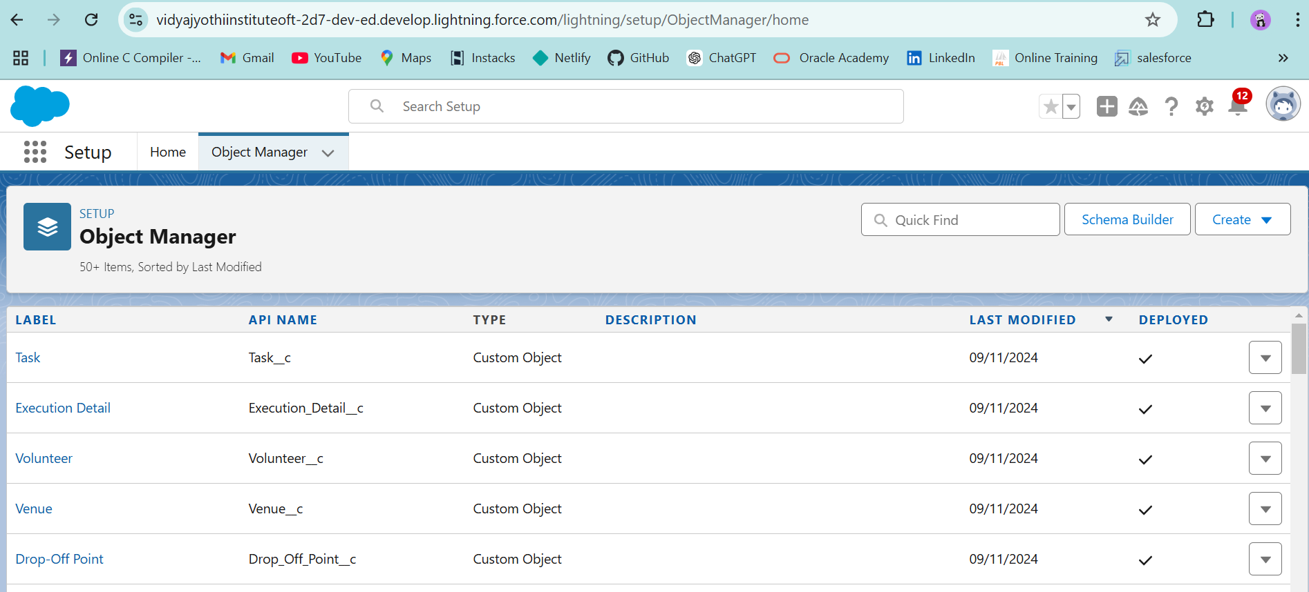

* **User Interface (UI)**

**Custom Tabs**: Create tabs for key objects (e.g., Venue, Task, Volunteer).

**Screen Flow**: Design a flow for easy record creation (e.g., Venue details input screen).

**Dashboards & Reports**: Build dashboards to track metrics like food collection and volunteer tasks.

**Screenshots**:

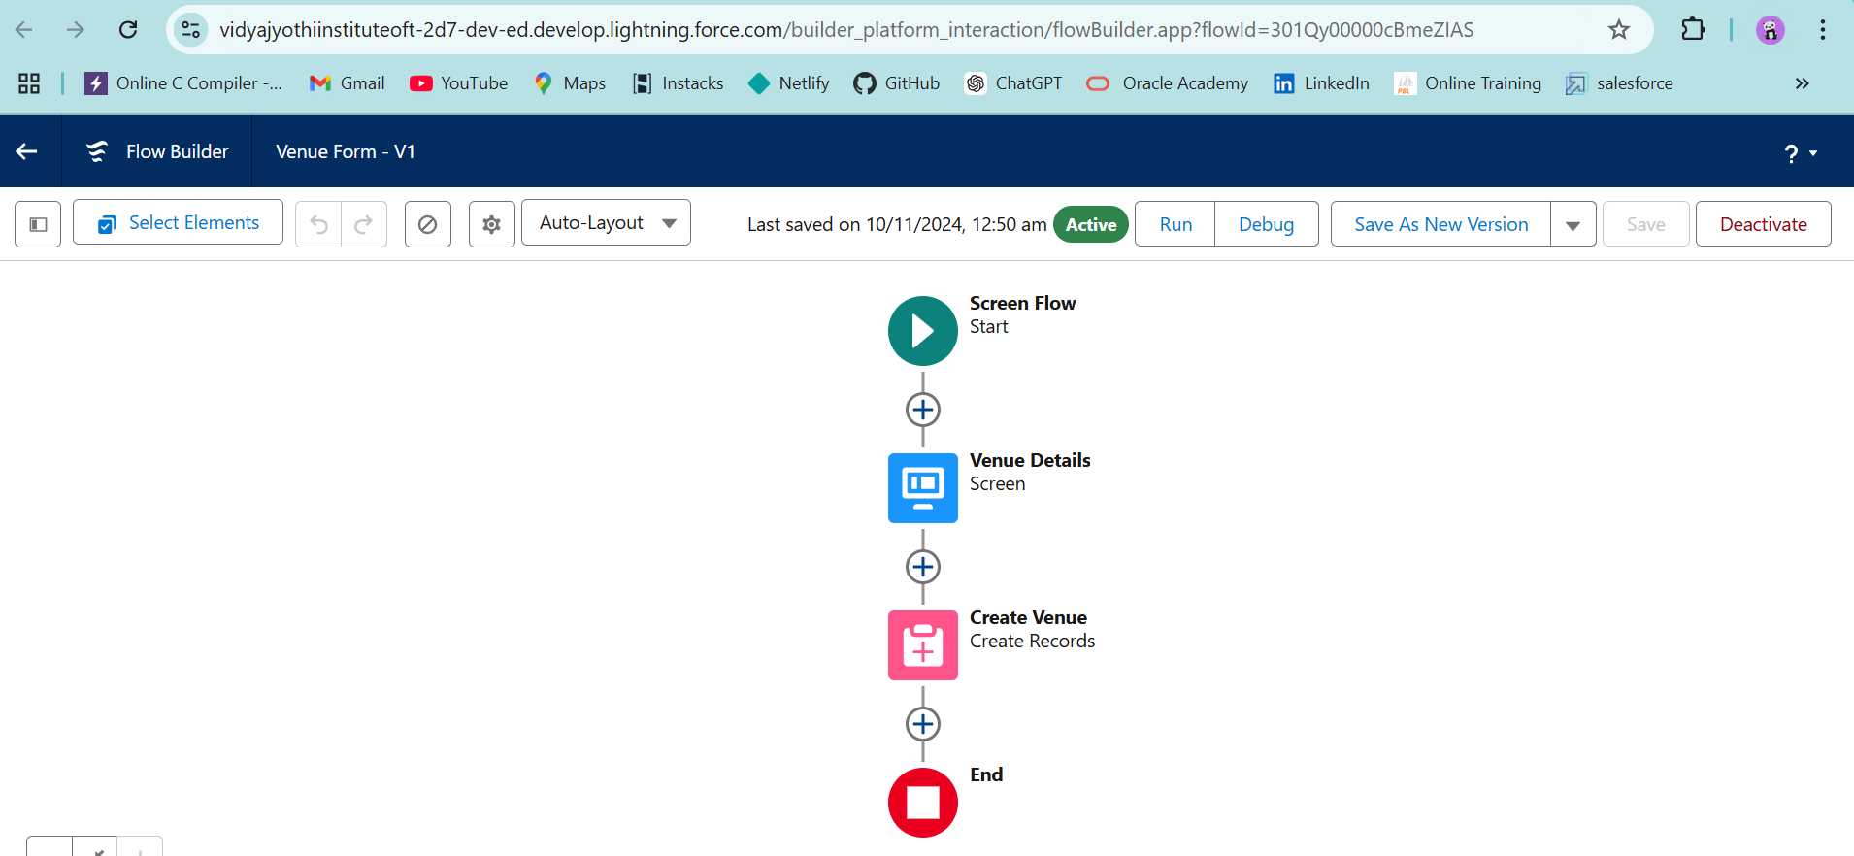

* **Business Logic**

**Triggers**: Implement triggers for calculations (e.g., Distance between Venue and Drop-Off Point).

**Automation Flows**: Set up flows for task assignments and notifications.

**Sharing Rules**: Configure rules based on distance for selective data access.

**Screenshots**:

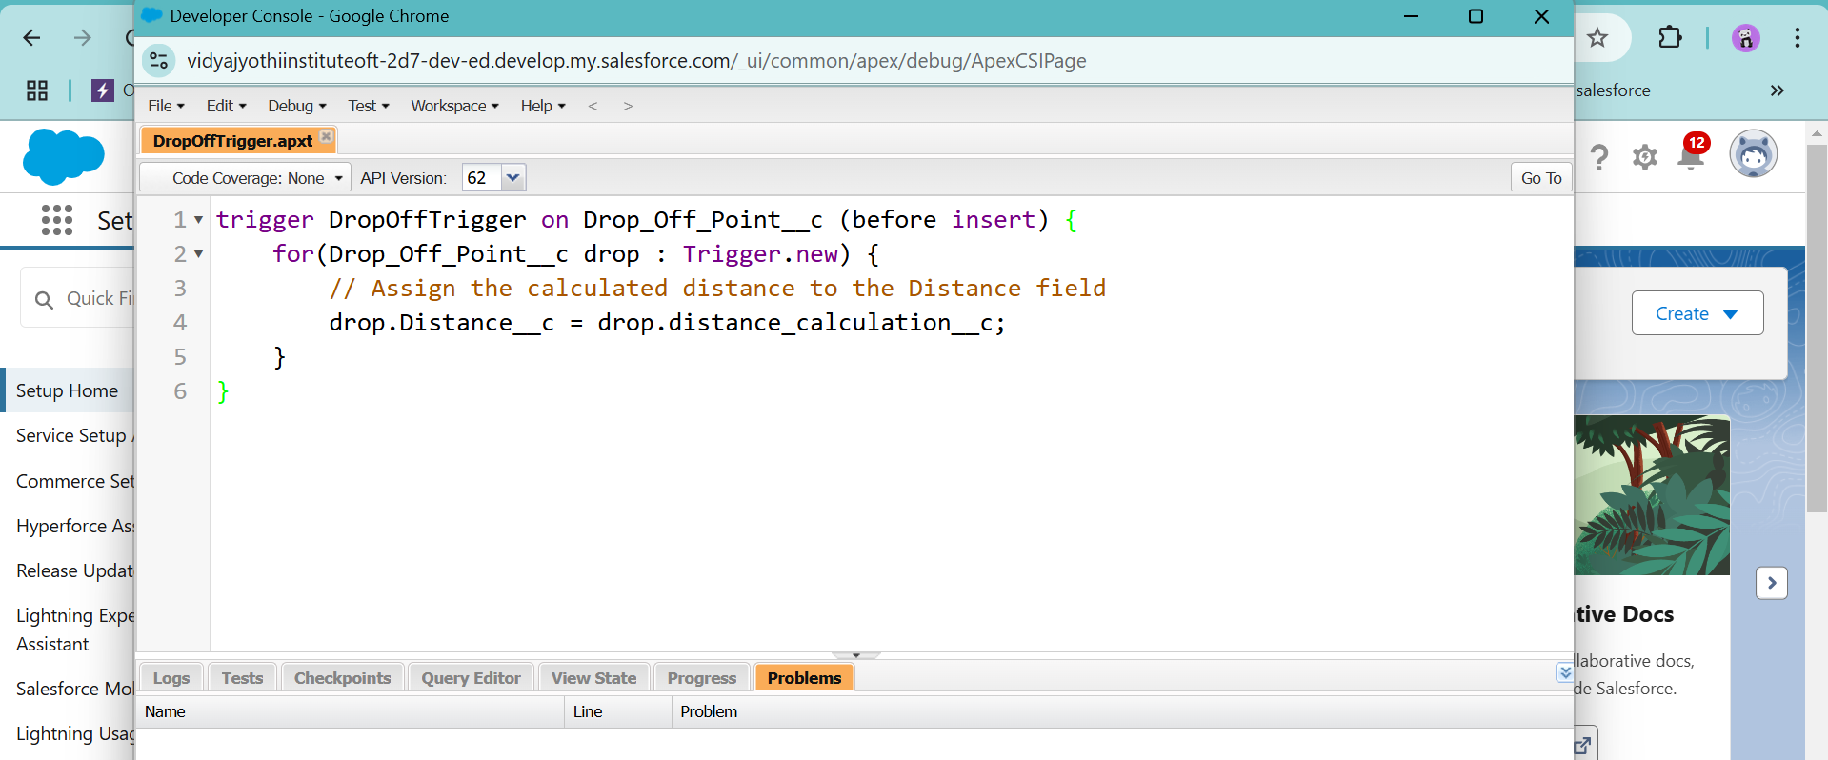

# Testing and Validation

**Objective**: Ensure all functionalities work as intended through structured testing: unit testing for backend logic and user interface testing for frontend interaction.

1. **Unit Testing**

* **Apex Classes & Triggers**: Develop test classes to cover at least 75% of Apex code, focusing on the core logic of triggers and classes.
  + **Trigger Testing**: Validate functions like distance calculations in the Drop-Off Point trigger.
  + **Assertions**: Check that calculations, automated updates, and field values meet expectations.
* **Sample Test Code**:

@isTest

public class DropOffTriggerTest {

static testMethod void testDistanceCalculation() {

Drop_Off_point__c dropOff = new Drop_Off_point__c();

insert dropOff;

System.assertEquals(expectedDistance, dropOff.Distance__c, 'Distance should be calculated correctly');

}}

#### **User Interface Testing**

* **Screen Flow Testing**: Verify each flow (e.g., Venue creation, Volunteer assignment) allows accurate data entry and creates records as expected.
* **Custom Tabs**: Test that custom tabs for Venue, Task, and Volunteer load correctly and display accurate data.
* **Dashboards & Reports**: Ensure dashboards display relevant metrics and that users can interact with report data (e.g., filter views, review volunteer tasks).

# Key Scenarios Addressed by Salesforce in the Implementation Project

1. **Volunteer Coordination and Task Management**

* **Scenario**: Assign and manage volunteers based on their availability and proximity to food collection points.
* **Salesforce Solution**: The Volunteer object helps automate task assignments and send reminders, while the Task object tracks task details and progress, ensuring timely completion.

1. **Food Collection and Drop-Off Point Management**

* **Scenario**: Track venues providing leftover food and manage drop-off locations for redistribution
* **Salesforce Solution**: Custom Venue and Drop-Off Point objects store key details like location, capacity and contact info, facilitating efficient logistics.

1. **Real-Time Reporting and Data Sharing**

* **Scenario**: Monitor progress and share data securely among volunteers and organizers.
* **Salesforce Solution**: Custom reports and dashboards provide insights into food volumes and volunteer activities, while sharing rules manage secure access to data based on proximity or group affiliation.

# Conclusion

**Summary of Achievements:**

Salesforce has successfully streamlined the "To Supply Leftover Food to Poor" project by optimizing key processes such as volunteer coordination, task management, and food distribution logistics. Through automation, real-time reporting, and efficient data management, the platform has improved resource allocation, minimized travel time, and ensured better coordination among all parties involved. This has resulted in a more effective and transparent system for redistributing leftover food to those in need.