1. To Add the Task

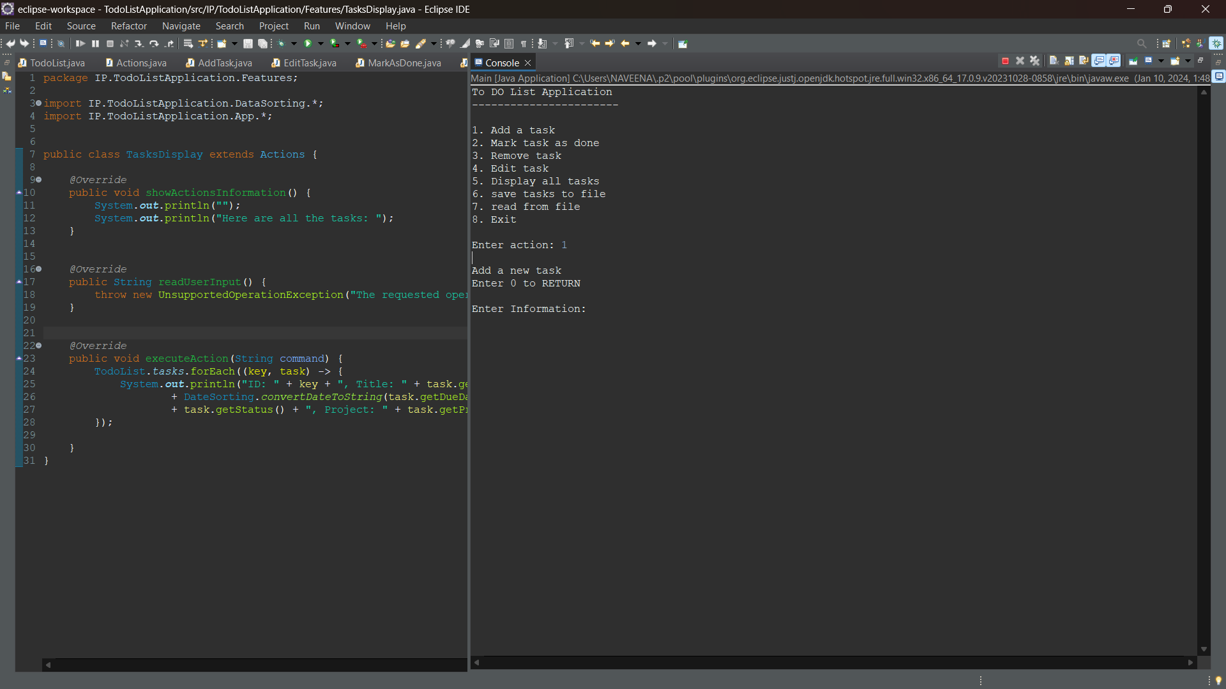

1. After Adding the task we need to save the task to the file. It will ask the path where to save.

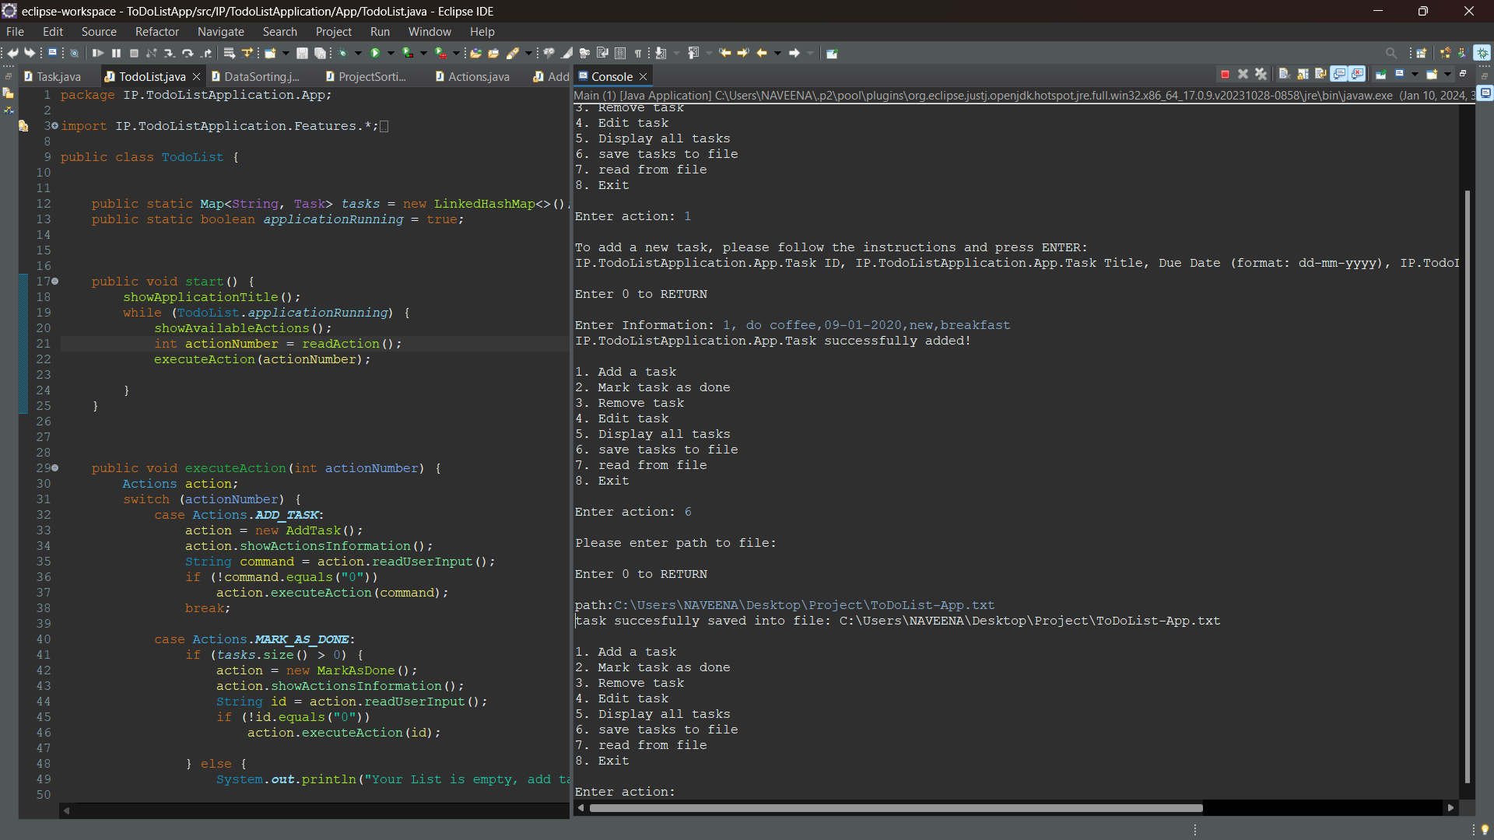

1. After creating tasks and saving the tasks in the path then we need to select option 2 which tells that the task is done.

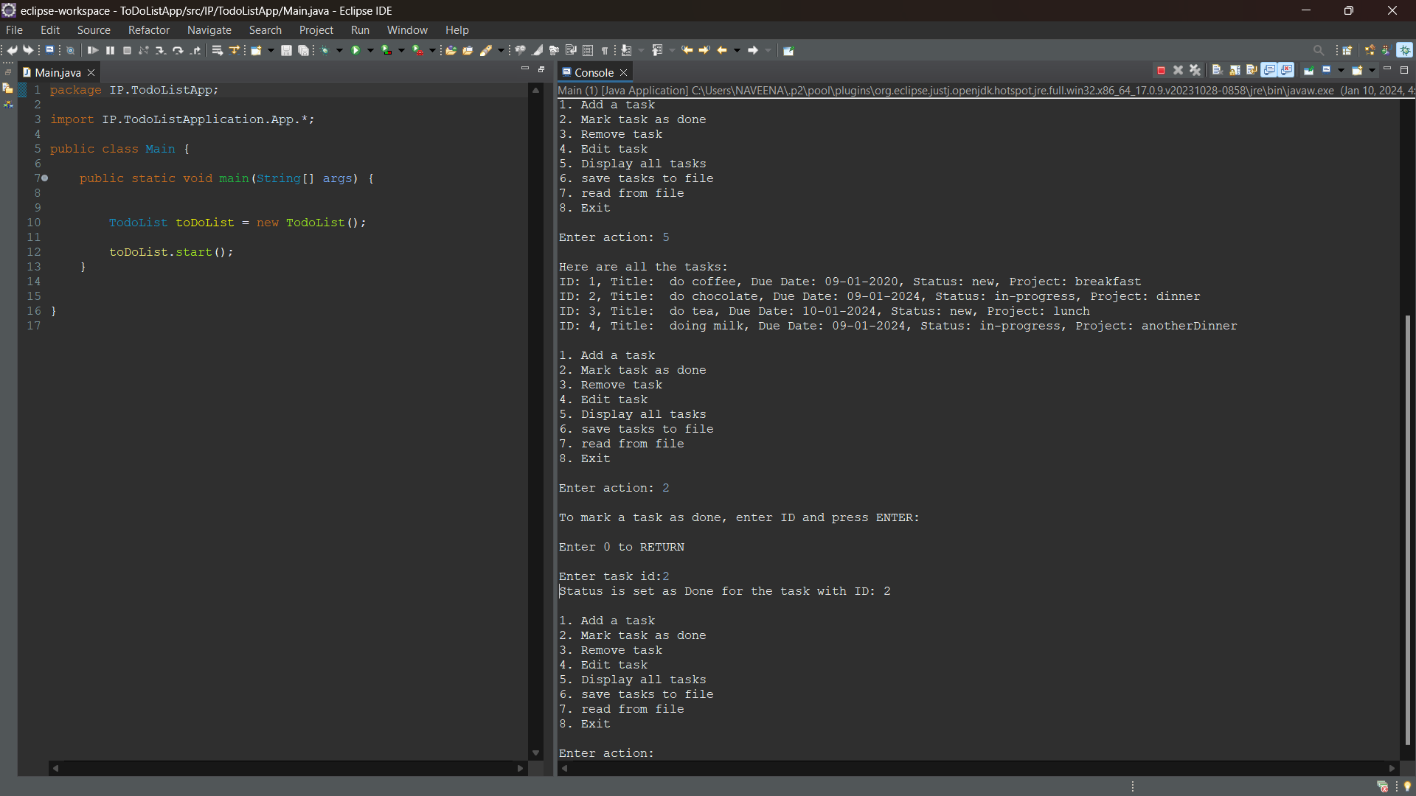

1. After task is done select option 3 to remove the tasks

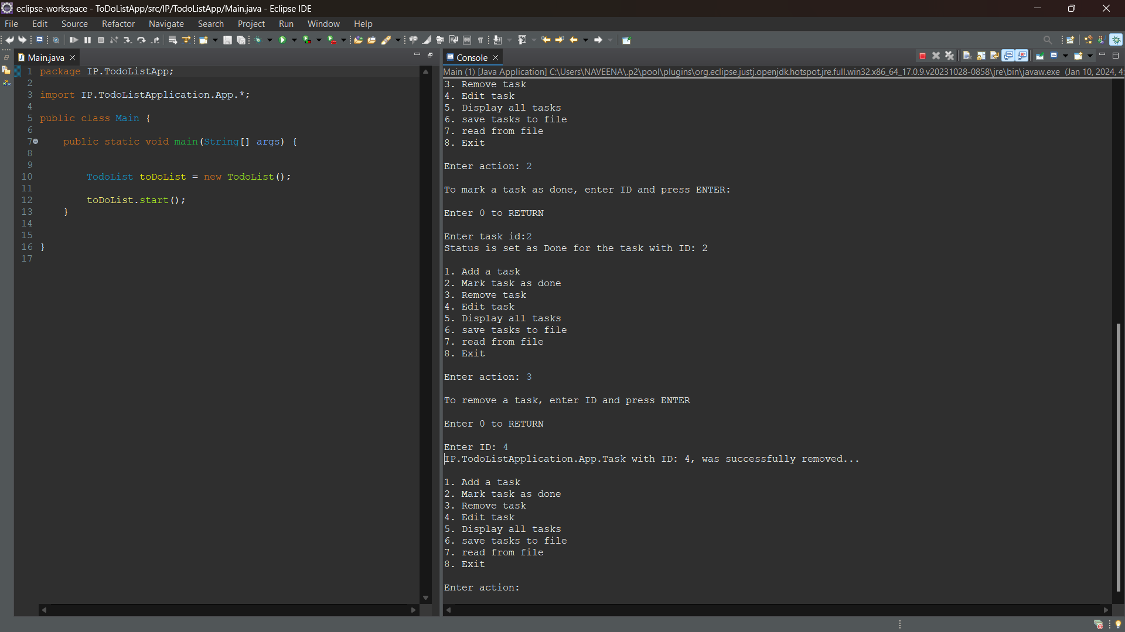

1. When we select option 5 it will display all the tasks in the file.

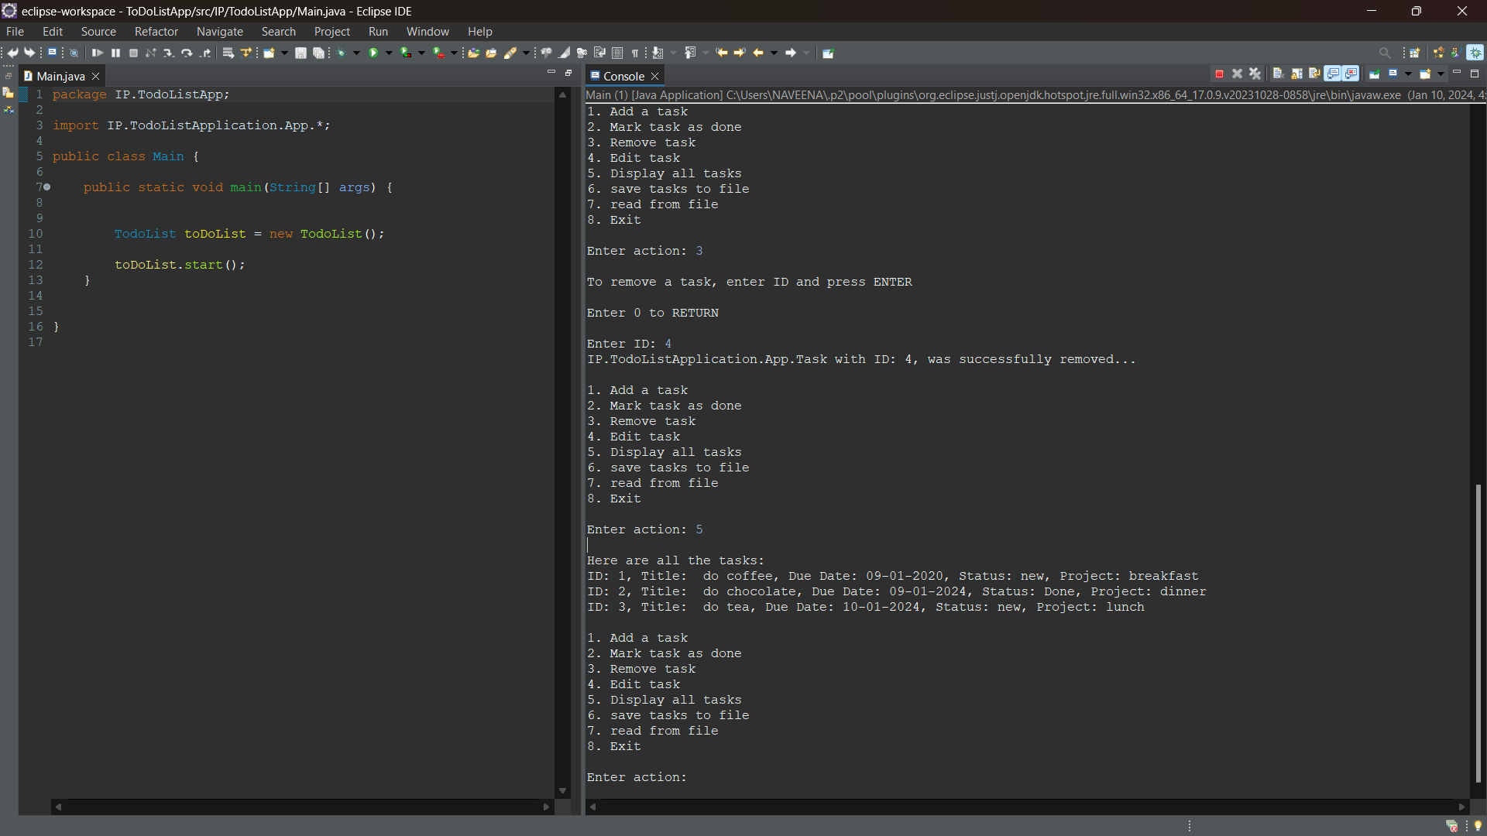

1. We can save all the tasks in file by selecting option 6
2. We can read the tasks from the file by selecting option 7
3. Lastly we can exit from console by selecting option 8

Output:

