**NAVEENAN M**

KONGU ENGINEERING COLLEGE

**Project Overview**

This project focuses on processing a collection of images of people captured in real-world conditions. These images exhibit significant variations in pose, background, occlusions, and perspective. The primary objective is to cluster images belonging to the same individual, even when they appear in multiple images with varying conditions.

**Objective**

The goal of this project is to develop a robust clustering pipeline that can accurately group images of the same person despite differences in:

* Pose and perspective
* Background elements
* Partial occlusions
* Lighting conditions

**Dataset Description**

* The dataset consists of **25,259** images.
* Images are stored in Google Drive at a designated dataset path.
* The dataset contains individuals appearing in one or multiple images.

**Methodology**

1. **Data Preprocessing:**

* Load images from the dataset.
* Normalize and resize images for consistency.
* Apply data augmentation techniques to enhance model robustness.

1. **Feature Extraction:**

* Use deep learning models (e.g., CNNs, Vision Transformers) to extract image embeddings.
* Consider pre-trained models such as ResNet, EfficientNet, or FaceNet for feature representation.

1. **Clustering Algorithm:**

* Use unsupervised clustering methods such as K-Means, DBSCAN, or hierarchical clustering.
* Explore metric learning techniques like contrastive or triplet loss for better feature discrimination.

1. **Evaluation & Validation:**

* Use silhouette score, Davies-Bouldin index, or cluster purity metrics to assess clustering quality.
* Manually validate sample clusters to ensure real-world applicability.

5 **. Results & Performance Analysis**

* The performance of the project is evaluated based on:
* **Face Clustering Accuracy** – How well the system groups similar faces.
* **Object Detection Efficiency** – Faster R-CNN’s precision in identifying objects.
* **Visualization of Clusters & Detections** – How effectively the results are presented.

**OUTPUT:1. Clusters**

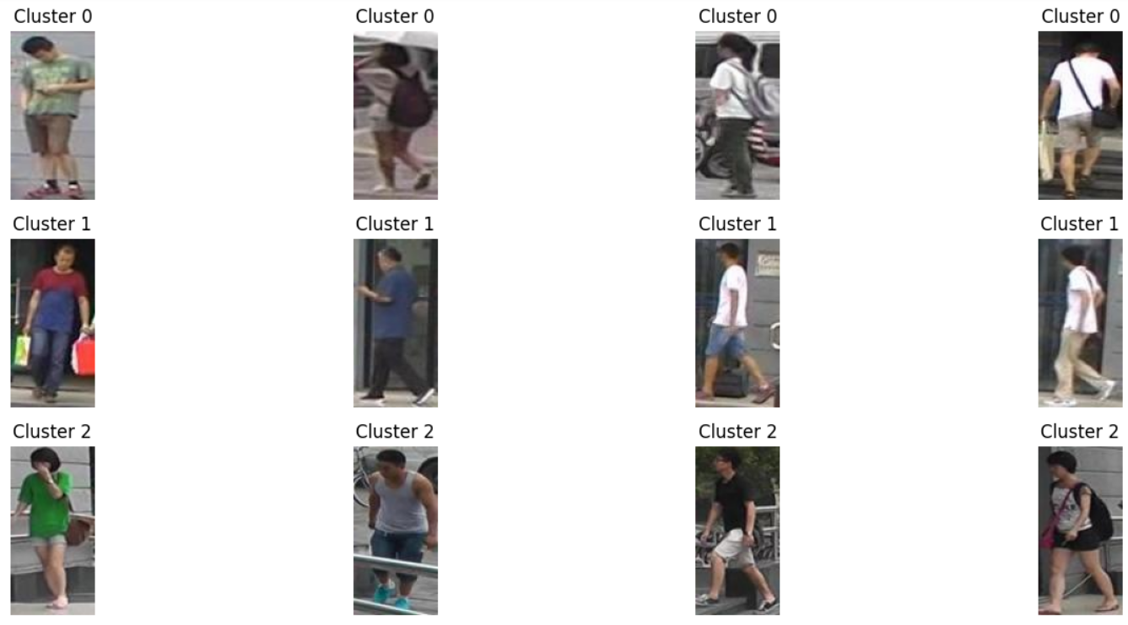

**2.**

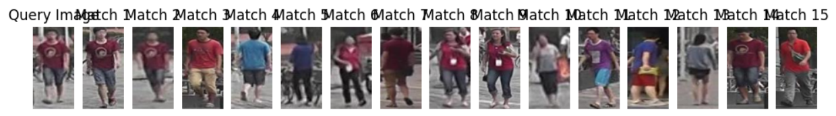

**3.**

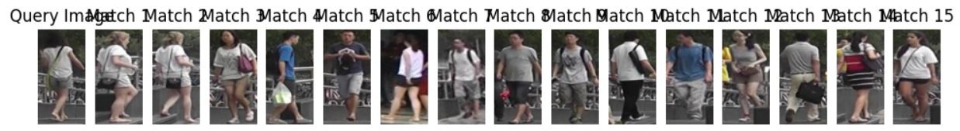

1. **2D Plot**

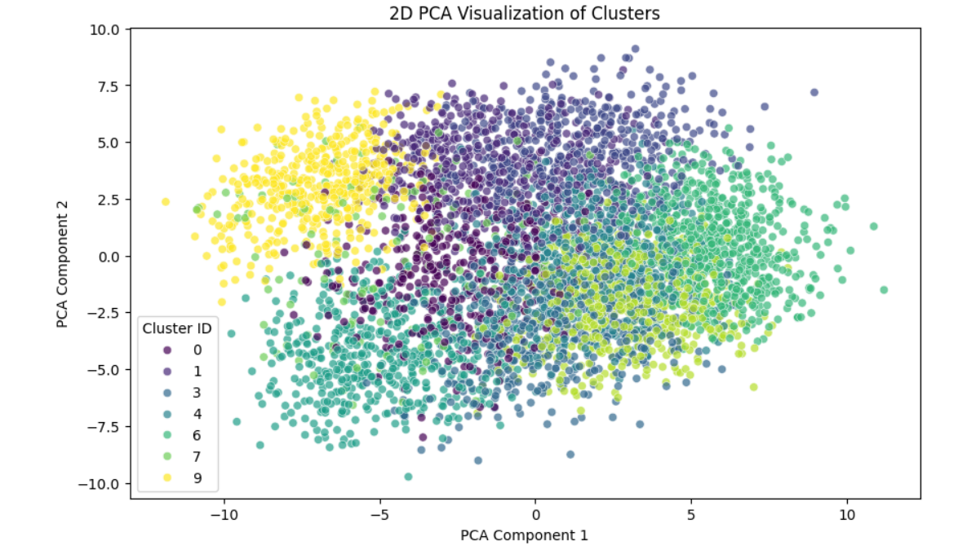

1. **3D Plot**

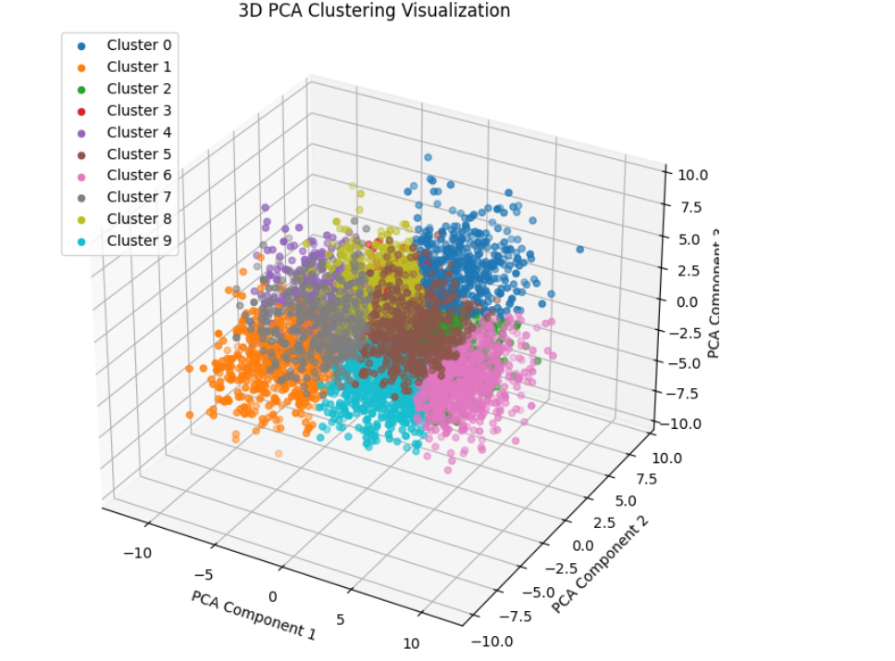

1. **Object detection**

