WGAN VS. WGAN-GP: COMPARATIVE STUDY ON CIFAR-10
Katravath Naveen | Roll No. 24CS3027 | Assignment DL-078
B.Tech Computer Science and Engineering
Reference paper: Gulrajani et al., “Improved Training of Wasserstein GANs” (2017).

Abstract
Generative Adversarial Networks (GANs) can be difficult to train because the generator and critic are optimized together. This project compares Wasserstein GAN (WGAN) with critic weight clipping and WGAN with Gradient Penalty (WGAN-GP). Both methods were run for three epochs using the CIFAR-10 training set of 50,000 images. The submitted run reports approximate Inception-feature FID values of 222.05 for WGAN clipping and 197.23 for WGAN-GP, using 500 real and 500 generated images. WGAN-GP produced the lower approximate FID in this run. Because training duration and evaluation sample count are limited, this is a preliminary comparison.

Index Terms
Generative Adversarial Networks, Wasserstein GAN, WGAN-GP, Gradient Penalty, CIFAR-10, FID.

I. Introduction
GANs learn to generate samples through competition between a generator and a discriminator/critic. WGAN uses a critic-based Wasserstein estimate intended to provide a more useful training signal. The original WGAN enforces a Lipschitz constraint through weight clipping, which can restrict critic capacity. WGAN-GP instead penalizes deviations of the critic's input-gradient norm from one.

II. Problem Statement and Objectives
Problem statement: investigate how weight clipping and gradient penalty affect GAN training signals and generated-image quality on CIFAR-10.
- Implement WGAN with weight clipping.
- Implement WGAN-GP with gradient penalty.
- Train both methods on the full 50,000-image CIFAR-10 training split for three epochs.
- Compare critic/generator loss curves, generated samples, and approximate FID.

III. Dataset and Preprocessing
CIFAR-10 contains 32×32 RGB images across ten object categories. Its training split contains 50,000 images and its test split contains 10,000 images. Training images are converted to tensors and normalized to [-1, 1]. For FID-style evaluation, the notebook uses CIFAR-10 test images as the real reference and 500 real and 500 generated images. Therefore, these approximate FID values should not be directly compared with scores computed using a larger sample count or a different implementation.

IV. Methodology
The generator maps a 100-dimensional latent vector to a 32×32 RGB image using transposed convolutions, batch normalization, ReLU activations, and a final Tanh activation. The critic uses convolutional layers and returns one scalar score per image.
WGAN clipping uses RMSprop with learning rate 5×10⁻⁵ and clips critic parameters to [-0.01, 0.01]. WGAN-GP uses Adam with learning rate 1×10⁻⁴, β=(0, 0.9), five critic updates per generator update, and gradient-penalty coefficient λ=10. Both main runs use batch size 64 and three epochs.
The notebook also includes an optional one-epoch WGAN-GP ablation with λ=5. This supplementary run is not an equal-duration comparison with the two main methods.

V. Experimental Results
Table I reports the final values in the submitted results CSV.
Method | Epochs | Final critic loss | Final generator loss | Approx. FID
WGAN with weight clipping | 3 | -22.8178 | 16.5960 | 222.05
WGAN-GP | 3 | -4.0736 | -13.3430 | 197.23
TABLE I. Final metrics reported by the submitted run.
The approximate FID difference is 24.82 points in favour of WGAN-GP for this run (lower is better). Critic and generator losses are optimization signals and should not be interpreted alone as image-quality scores.
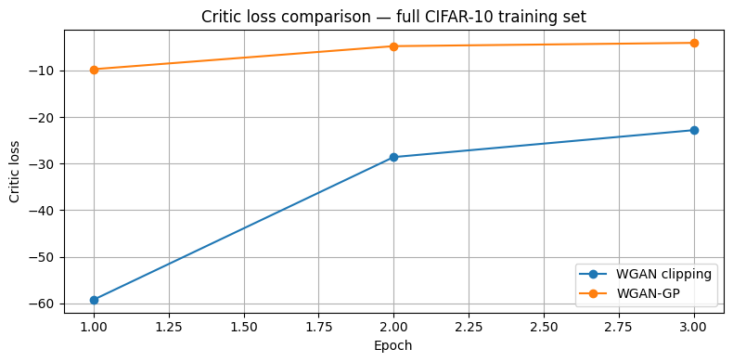
Fig. 1. Critic loss comparison across three epochs.
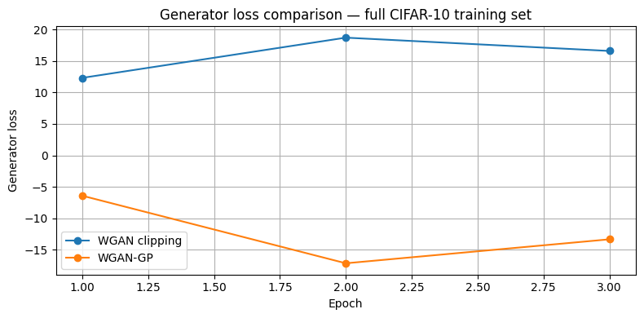
Fig. 2. Generator loss comparison across three epochs.
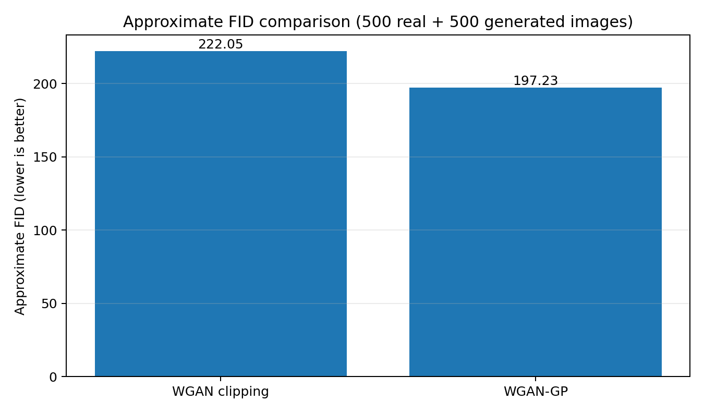
Fig. 3. Approximate FID comparison using 500 real and 500 generated images.
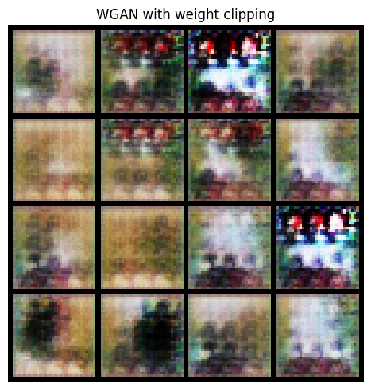
Fig. 4. Generated samples from WGAN with weight clipping.
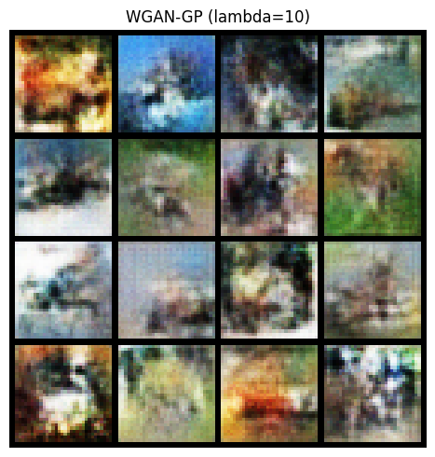
Fig. 5. Generated samples from WGAN-GP (λ=10).

VI. Discussion
For this run, WGAN-GP achieved a lower approximate FID than weight clipping. This is consistent with the motivation for gradient penalty: it encourages the critic to satisfy the Lipschitz constraint without hard clipping of all critic parameters. However, only three epochs were completed and FID used 500 samples per distribution. Randomness, architecture, optimization settings, and the small evaluation sample can affect results. Longer training, repeated random seeds, and more evaluation samples would provide stronger evidence.

VII. Conclusion
This project implemented and compared WGAN weight clipping and WGAN-GP on the full CIFAR-10 training split. In the submitted experiment, WGAN-GP had the lower approximate FID (197.23 vs. 222.05). The result is preliminary because training was limited to three epochs and FID used only 500 real and 500 generated images.

Limitations and Future Work
- Increase training duration and repeat experiments with multiple random seeds.
- Evaluate FID with a larger sample count and a validated standard implementation.
- Track fixed-noise samples consistently across epochs for direct visual comparison.
- Report runtime and hardware for reproducibility.

References
[1] I. Gulrajani, F. Ahmed, M. Arjovsky, V. Dumoulin, and A. Courville, “Improved Training of Wasserstein GANs,” Advances in Neural Information Processing Systems (NeurIPS), 2017. https://arxiv.org/abs/1704.00028
[2] A. Krizhevsky, “Learning Multiple Layers of Features from Tiny Images,” CIFAR-10 dataset.

