Adding Study Notes
Python · C · C++
Step-by-step guide for adding lessons manually
Includes a lesson plan for each language and ready-to-paste example lessons
Version 1.0 — September 2026
Contents
1. Where your files are 3
2. Before you start 4
2.1 How notes are organised 4
3. Step by step: add a course 6
4. Step by step: add a lesson (your notes) 7
4.1 Check it on the website 8
4.2 Edit, reorder, hide or delete 8
5. Writing notes: Markdown and a lesson template 10
5.1 Lesson template (copy for every lesson) 10
5.2 Adding PDF notes or images 11
6. Recommended lesson plan 12
6.1 Python 12
6.2 C 13
6.3 C++ 13
7. Example lesson: Python – Variables 15
8. Example lesson: C – Your first C program 17
9. Example lesson: C++ – Classes and objects 19
10. Extra: interview questions and quizzes 21
11. Checklist and troubleshooting 22
Checklist for every lesson 22
Troubleshooting 22

1. Where your files are
File | Location | How to open
Main user guide (HTML) | D:\user\programming\Naveen\docs\Portfolio-Platform-User-Guide.html | Double-click it in File Explorer; it opens in your browser.
Main user guide (Word) | D:\user\programming\Naveen\docs\Portfolio-Platform-User-Guide.docx | Double-click to open in Word.
This notes guide (Word) | D:\user\programming\Naveen\docs\Study-Notes-Guide-Python-C-CPP.docx | Double-click to open in Word.
Uploaded PDFs and files | D:\user\programming\Naveen\backend\media\study\ | Files you attach to lessons are stored here automatically.

Tip: In VS Code, right-click any file in the Explorer panel and choose Reveal in File Explorer to jump to its folder.

2. Before you start
- Start the server: open a terminal and run cd D:\user\programming\Naveen\backend, then .venv\Scripts\activate, then python manage.py runserver.
- Start the website: open a second terminal and run cd D:\user\programming\Naveen\frontend, then npm run dev.
- Open the Content manager at http://localhost:8000/django-admin/ and log in with your admin email and password.
- Keep the website http://localhost:3000/study-materials open in another browser tab to check your lessons as you add them.
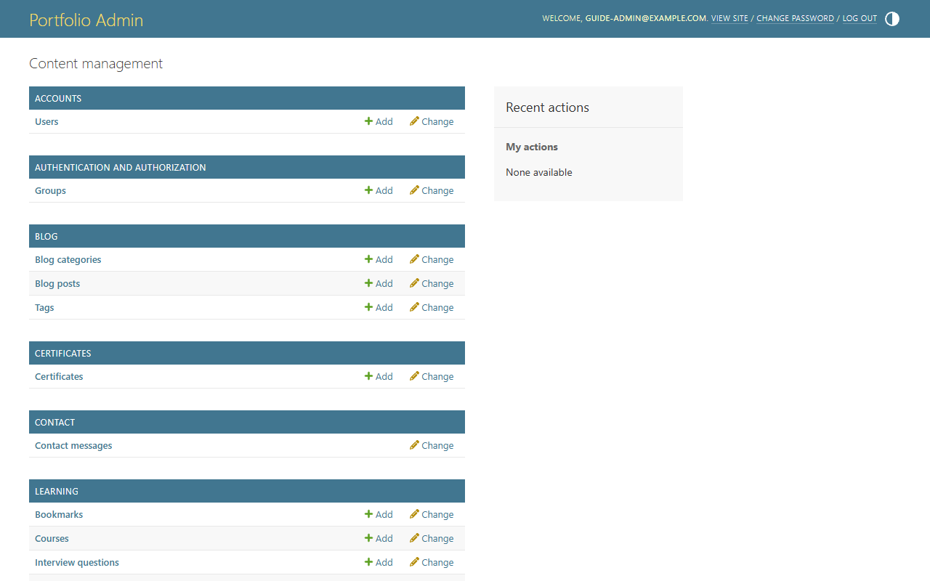
Figure 1 – Content manager home. The Learning section is where all notes are added.

2.1 How notes are organised
Every note belongs to a Lesson. Lessons are grouped into Courses, and each course belongs to a Subject at one level.
Level | Example for Python | What it is | Web address
Subject (Study category) | Python | Already created for you: Python, C and C++ exist. | /study-materials/python
Course | Python Beginner | A group of lessons at one level (Beginner, Intermediate, Advanced…). | Shown as a section on the subject page
Lesson | Variables | One page of notes: text, code, tables, images, video. | /study-materials/python/variables
Study material (file) | Variables-notes.pdf | Optional downloadable file attached to a lesson or course. | Download button on the lesson

Subject | Address on the website
Python | http://localhost:3000/study-materials/python
C | http://localhost:3000/study-materials/c
C++ | http://localhost:3000/study-materials/cpp

3. Step by step: add a course
Create one course per level. For each language, create at least Beginner, Intermediate and Advanced (section 6 lists them all).
- In the Content manager, click Learning → Courses → + Add.
- Category: choose the subject (Python, C or C++).
- Title: include the language, for example Python Beginner, C Beginner, C++ Beginner.
- Slug: fills in automatically from the title. For C++ courses type it yourself, for example cpp-beginner (otherwise “C++ Beginner” and “C Beginner” would both become c-beginner).
- Level: Beginner, Intermediate, Advanced, Interview Preparation, Projects or Practice Questions.
- Description: one or two sentences, for example “Start here if you have never programmed before.”
- Order: 1 for Beginner, 2 for Intermediate, 3 for Advanced.
- Tick Is published.
- Click Save.
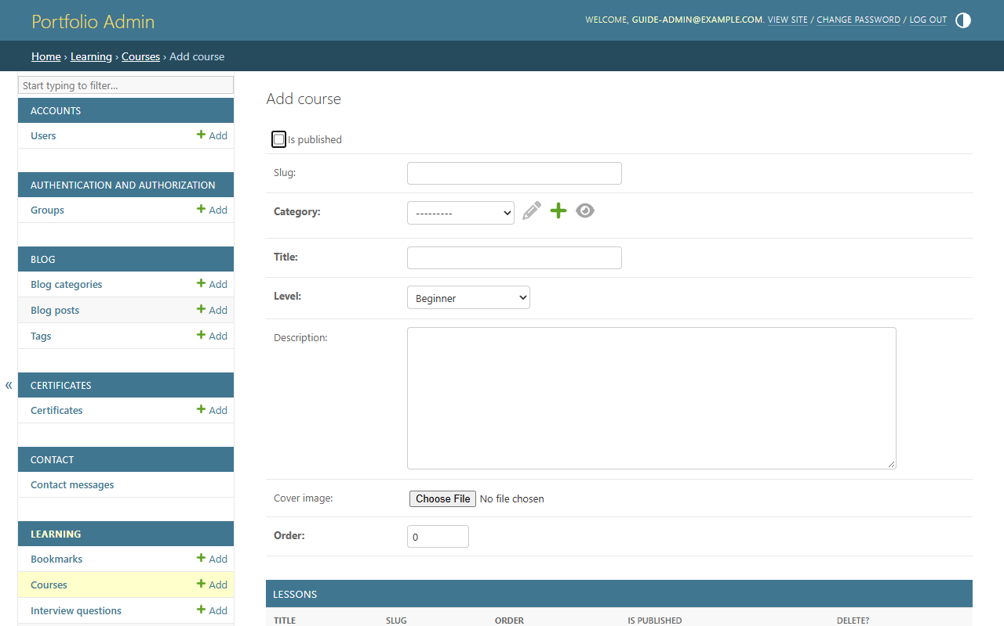
Figure 2 – Adding a course
Important: Courses and lessons are hidden from the website until Is published is ticked on both the course and the lesson.

4. Step by step: add a lesson (your notes)
- Click Learning → Lessons → + Add.
- Course: choose the course, e.g. Python Beginner.
- Title: the topic, e.g. Variables.
- Slug: leave it; it becomes variables. This is the last part of the web address.
- Summary: one line shown under the title, e.g. “Store and reuse values with names.”
- Content: paste or type your notes in Markdown. Use the lesson template in section 5 and the example lessons in sections 7–9.
- Video url (optional): a YouTube link to a video for this lesson.
- Estimated minutes: reading time, e.g. 10.
- Order: position in the course. 1 = first lesson, 2 = second… This controls the Previous / Next buttons.
- Optional files: in the Study materials table at the bottom, type a Title, choose the Kind (PDF, Notes, Code…), then Choose File. Click Add another Study material for more files.
- Tick Is published.
- Click Save and add another to go straight to the next lesson, or Save to finish.
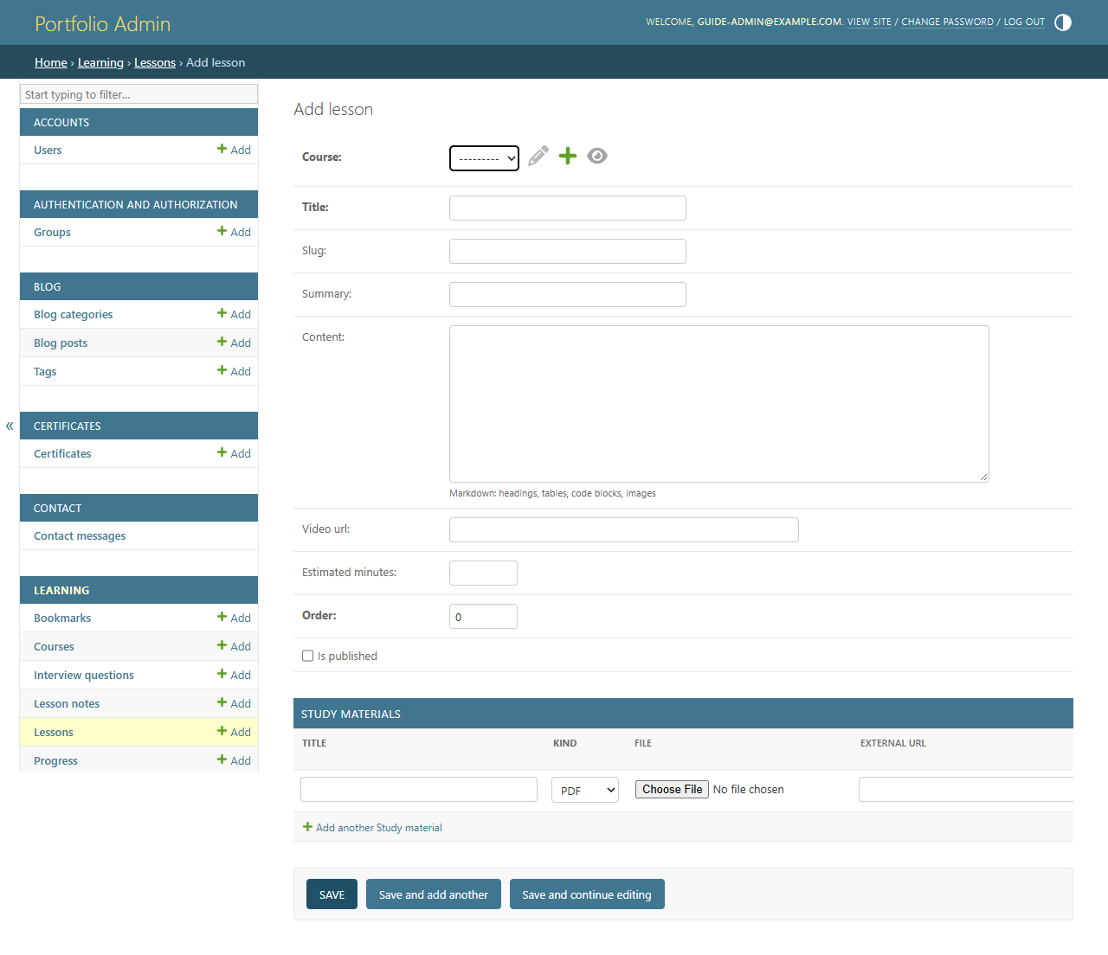
Figure 3 – The lesson form. Content is where your notes go; files go in the table at the bottom.

4.1 Check it on the website
- Open the subject page, e.g. http://localhost:3000/study-materials/python.
- Your course appears with its lessons numbered in order. Click a lesson to read it.
- If it doesn’t show, wait up to a minute and refresh, and check both Is published boxes.
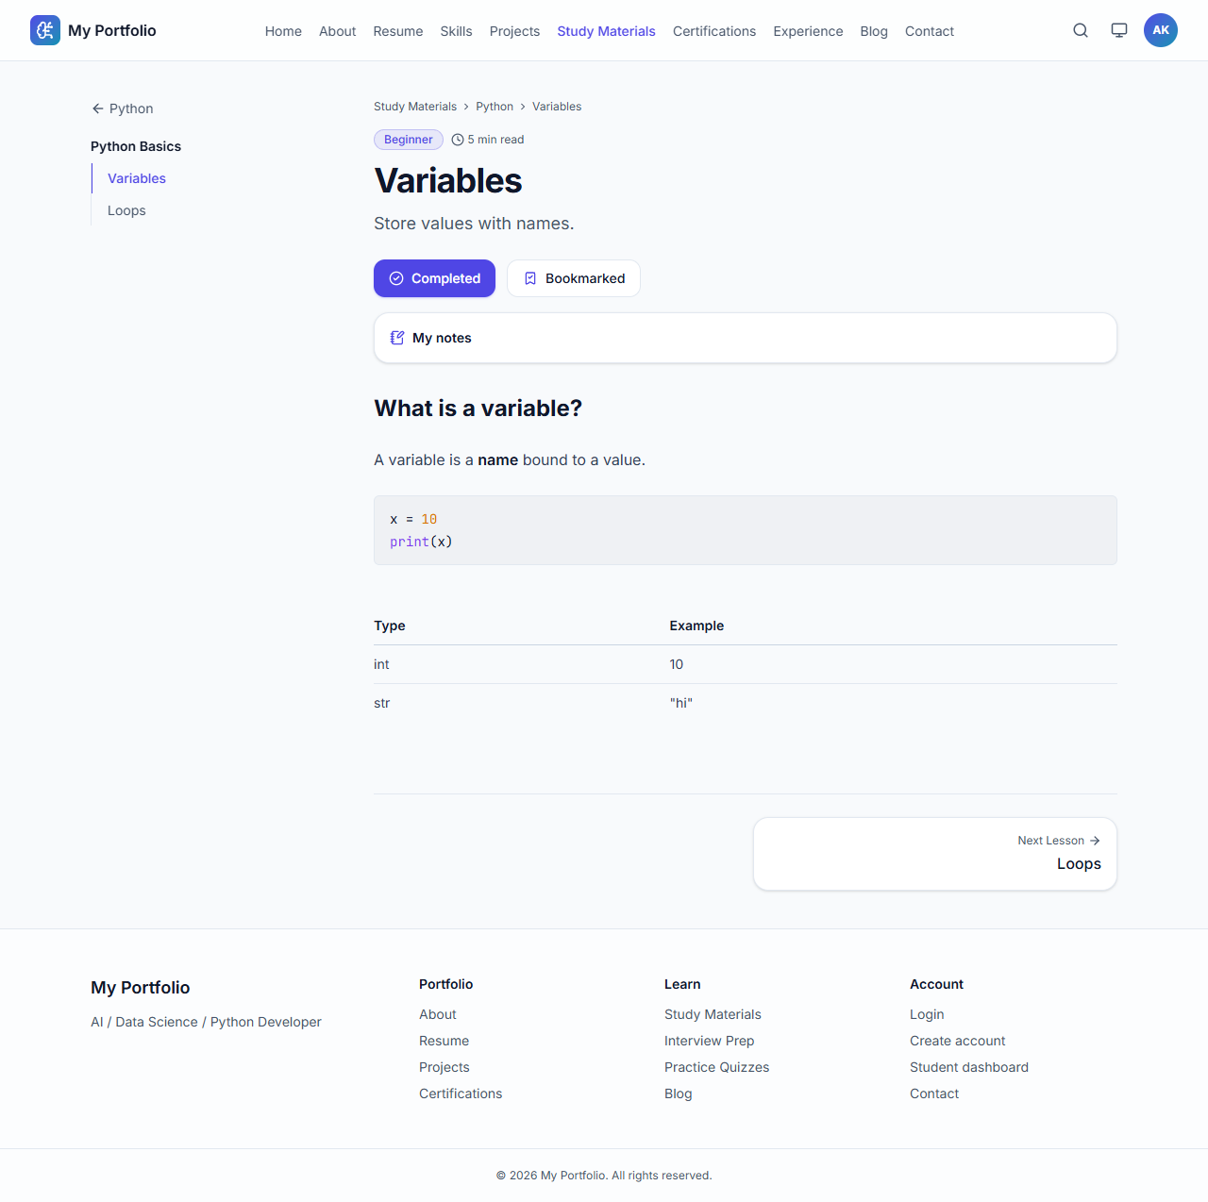
Figure 4 – How a finished lesson looks: code with colours, tables, and Previous / Next buttons

4.2 Edit, reorder, hide or delete
Task | How
Fix a mistake | Learning → Lessons → click the lesson title → edit → Save.
Change the order | In the Lessons list, change the numbers in the Order column, then click Save at the bottom of the list.
Hide a lesson for now | Untick Is published (in the list or the lesson form) and Save.
Publish many at once | Tick the lessons in the list → Action: “Publish selected items” → Go.
Find lessons quickly | Use the search box, or the filter panel on the right (by subject, level, published).
Delete a lesson | Open it and click Delete at the bottom left, then confirm.
Add lessons from the course page | Open the course; the Lessons table at the bottom lets you add titles and order quickly. Click “Change” on a row to write its content.

5. Writing notes: Markdown and a lesson template
The Content box uses Markdown, a simple way to format text. You type symbols and the website turns them into headings, lists, code boxes and tables.
You type | You get
## Heading | Big section heading
### Smaller heading | Smaller heading
**important** | Bold text
*note* | Italic text
- point | Bullet point (one per line)
1. step | Numbered list
> Tip: … | Highlighted note box
[Python docs](https://docs.python.org) | Clickable link
![diagram](https://…/image.png) | Image from a web address
A line with three backticks and the language, the code, then a line with three backticks | Code box with colours (language: python, c or cpp)
| Col 1 | Col 2 | then |---|---| then rows | Table

Important: For code, the language after the three backticks matters: write python for Python, c for C and cpp for C++. This gives the right colours.

5.1 Lesson template (copy for every lesson)
Using the same structure in every lesson makes your notes easy to follow. Copy this into the Content box and replace the parts in brackets:
## Introduction
[What is this topic and why is it useful? 2-3 sentences.]

## Syntax
```python
[general form of the code]
```

## Example
```python
[a short, complete example]
```

**Output:**
```
[what the example prints]
```

## How it works
1. [explain line by line]
2. [...]

## Common mistakes
- [mistake and how to avoid it]

## Practice questions
1. [question]
2. [question]

## Summary
- [key point]
- [key point]
Tip: For C lessons change python to c, and for C++ lessons change it to cpp.

5.2 Adding PDF notes or images
- PDF / Word / slides / code files: attach them in the lesson’s Study materials table. They appear under “Downloadable notes & resources” with a Download button. Maximum 100 MB per file.
- Tick Requires login on a file if only logged-in users should download it.
- Images inside the text: the Content box only accepts image web addresses. Upload the image somewhere public (for example your GitHub repository) and use ![description](image-address). Or attach the image as a study material file instead.

6. Recommended lesson plan
Below is a complete, ordered plan for each language. Create each course in section 3, then add the lessons in this order (the number is the Order value). You don’t have to add everything at once; publish lessons as you finish them.

6.1 Python
Course (title / level / order) | Lessons in order
Python Beginner  Beginner · Order 1 | 1 Introduction to Python  2 Installing Python and your first program  3 Variables  4 Data types  5 Operators  6 Input and output  7 Conditions (if, elif, else)  8 Loops (for, while)  9 Strings  10 Lists  11 Tuples and sets  12 Dictionaries
Python Intermediate  Intermediate · Order 2 | 1 Functions  2 Arguments and return values  3 Lambda, map and filter  4 List and dictionary comprehensions  5 Modules and packages  6 Exception handling  7 File handling  8 OOP: classes and objects  9 Inheritance and polymorphism
Python Advanced  Advanced · Order 3 | 1 Iterators  2 Generators  3 Decorators  4 Context managers (with)  5 Special methods and dataclasses  6 Regular expressions  7 Working with JSON and CSV  8 Virtual environments and pip  9 Type hints  10 Advanced Python: threads and async basics
Python Interview Preparation  Interview Preparation · Order 4 | 1 Most asked Python concepts  2 Mutable vs immutable  3 Shallow vs deep copy  4 *args and **kwargs  5 GIL and memory management
Python Practice Questions  Practice Questions · Order 5 | 1 Basics practice set  2 Strings and lists practice  3 Functions practice  4 OOP practice

6.2 C
Course (title / level / order) | Lessons in order
C Beginner  Beginner · Order 1 | 1 Introduction to C  2 Installing a C compiler (GCC)  3 Your first C program  4 Variables and data types  5 Operators  6 Input and output (printf, scanf)  7 Conditions (if, else)  8 switch statement  9 Loops (for, while, do-while)
C Intermediate  Intermediate · Order 2 | 1 Functions  2 Recursion  3 Arrays  4 Strings  5 Pointers  6 Pointers and arrays  7 Structures  8 Unions and enums
C Advanced  Advanced · Order 3 | 1 Dynamic memory (malloc, calloc, free)  2 File handling  3 Preprocessor and macros  4 Header files and multi-file programs  5 Bit manipulation  6 Linked lists  7 Stacks and queues
C Interview Preparation  Interview Preparation · Order 4 | 1 Pointers interview questions  2 Memory layout (stack vs heap)  3 Common output-prediction questions

6.3 C++
Remember to type the Slug yourself for C++ courses: cpp-beginner, cpp-intermediate, cpp-advanced, cpp-interview.
Course (title / level / order) | Lessons in order
C++ Beginner  Beginner · Order 1 · slug cpp-beginner | 1 Introduction to C++  2 Installing a C++ compiler (g++)  3 Your first C++ program  4 Variables and data types  5 Operators  6 Input and output (cin, cout)  7 Conditions and switch  8 Loops  9 Functions and function overloading
C++ Intermediate  Intermediate · Order 2 · slug cpp-intermediate | 1 Arrays and std::string  2 References and pointers  3 Classes and objects  4 Constructors and destructors  5 Inheritance  6 Polymorphism and virtual functions  7 Operator overloading
C++ Advanced  Advanced · Order 3 · slug cpp-advanced | 1 Templates  2 STL containers (vector, map, set)  3 STL algorithms  4 Exception handling  5 File streams  6 Smart pointers and memory  7 Lambdas and modern C++ (C++17/20)  8 Move semantics
C++ Interview Preparation  Interview Preparation · Order 4 · slug cpp-interview | 1 OOP concepts in C++  2 C vs C++ differences  3 Virtual functions and vtables

Tip: Lesson titles only need to be unique within a subject. “Variables and data types” can exist in both C and C++; their addresses are /study-materials/c/variables-and-data-types and /study-materials/cpp/variables-and-data-types.

7. Example lesson: Python – Variables
A complete lesson ready to paste. It is lesson 3 of Python Beginner.
Field | Value to enter
Course | Python Beginner
Title | Variables
Summary | Store and reuse values by giving them a name.
Estimated minutes | 10
Order | 3
Is published | Ticked

Content (copy everything in the box):
## Introduction
A **variable** is a name that refers to a value. Variables let you store data
once and use it many times in your program.

## Syntax
```python
variable_name = value
```

## Example
```python
name = "Asha"
age = 21
height = 5.4
is_student = True

print(name, "is", age, "years old")
age = age + 1 # a variable can change
print("Next year:", age)
```

**Output:**
```
Asha is 21 years old
Next year: 22
```

## How it works
1. `=` stores the value on the right in the name on the left.
2. Python works out the type automatically (text, whole number, decimal, True/False).
3. `age = age + 1` reads the old value, adds 1 and stores the result back.

## Naming rules
| Rule | Valid | Invalid |
|---|---|---|
| Start with a letter or _ | `total`, `_count` | `2total` |
| Only letters, digits, _ | `user_name` | `user-name` |
| Case-sensitive | `Age` and `age` are different | |
| Not a keyword | `my_class` | `class` |

## Common mistakes
- Using a variable before giving it a value (`NameError`).
- Writing `=` when you mean to compare (`==`).

## Practice questions
1. Create variables for your name, city and year of birth, and print them in one sentence.
2. Swap the values of `a = 5` and `b = 10` using one line: `a, b = b, a`.

## Summary
- A variable is a name for a value.
- Use `=` to assign; the value can change later.
- Follow the naming rules and use clear names like `total_marks`.

8. Example lesson: C – Your first C program
Lesson 3 of C Beginner.
Field | Value to enter
Course | C Beginner
Title | Your first C program
Summary | Write, compile and run Hello World in C.
Estimated minutes | 15
Order | 3
Is published | Ticked

Content:
## Introduction
Every C program starts running from a function called `main`. In this lesson
you will write, compile and run your first program.

## Example
```c
#include <stdio.h>

int main(void) {
printf("Hello, World!\n");
return 0;
}
```

**Output:**
```
Hello, World!
```

## How it works
1. `#include <stdio.h>` adds the standard input/output library, which provides `printf`.
2. `int main(void)` is where the program starts; `int` means it returns a number.
3. `printf` prints text. `\n` moves to a new line.
4. `return 0;` tells the operating system the program finished successfully.
5. Every statement ends with a semicolon `;`.

## Compile and run
Save the code as `hello.c`, open a terminal in that folder and run:
```
gcc hello.c -o hello
hello
```
(On macOS/Linux use `./hello` to run.)

## Common mistakes
- Forgetting the semicolon `;` at the end of a statement.
- Missing `#include <stdio.h>`, so `printf` is unknown.
- Writing `Main` instead of `main` (C is case-sensitive).

## Practice questions
1. Print your name and college on two separate lines.
2. Print this pattern using three `printf` calls:
```
*
**
***
```

## Summary
- A C program starts in `main`.
- `printf` from `stdio.h` prints output.
- Compile with `gcc file.c -o name`, then run the program.

9. Example lesson: C++ – Classes and objects
Lesson 3 of C++ Intermediate.
Field | Value to enter
Course | C++ Intermediate (slug cpp-intermediate)
Title | Classes and objects
Summary | Group data and functions together with classes.
Estimated minutes | 20
Order | 3
Is published | Ticked

Content:
## Introduction
A **class** is a blueprint that groups data (member variables) and functions
(member functions). An **object** is a real thing created from that blueprint.

## Syntax
```cpp
class ClassName {
public:
// member variables
// member functions
};
```

## Example
```cpp
#include <iostream>
#include <string>
using namespace std;

class Student {
public:
string name;
int marks;

void display() {
cout << name << " scored " << marks << endl;
}
};

int main() {
Student s1;
s1.name = "Ravi";
s1.marks = 88;
s1.display();
return 0;
}
```

**Output:**
```
Ravi scored 88
```

## How it works
1. `class Student { ... };` defines the blueprint. Note the semicolon after `}`.
2. `public:` means the members can be used from outside the class.
3. `Student s1;` creates an object named `s1`.
4. The dot `.` accesses members: `s1.name`, `s1.display()`.

## Class vs object
| Class | Object |
|---|---|
| Blueprint / design | Real instance |
| Defined once | Many can be created |
| `class Student` | `Student s1, s2;` |

## Common mistakes
- Forgetting the `;` after the closing `}` of the class.
- Accessing `private` members from outside the class.

## Practice questions
1. Create a `Rectangle` class with `length`, `width` and an `area()` function.
2. Create two `Student` objects and print which one has higher marks.

## Summary
- A class groups data and functions; an object is created from a class.
- Use `public:` for members that should be accessible outside.
- Access members with the dot operator.
Compile and run C++ code with: g++ students.cpp -o students and then students.

10. Extra: interview questions and quizzes
Besides lessons, you can add Python, C and C++ interview questions and quizzes. They appear on the Interview Prep and Practice pages.

Interview question
- Learning → Interview questions → + Add.
- Category: Python, C or C++.
- Fill Question and Short answer (required), plus optional Detailed answer, Example, Code, Code language (python, c, cpp) and Interview tip.
- Choose Difficulty, tick Is published, Save.

Quiz
- Quizzes → Quizzes → + Add. Title, e.g. C Basics Quiz; Category C; Time limit e.g. 10.
- In the questions table add each question. For multiple choice: Type Multiple choice, Options ["%d", "%f", "%s"], Correct option 0 (counting starts at 0).
- For output questions: Type Output prediction, Code the program, Accepted answers ["Hello, World!"].
- Tick Is published and Save.

11. Checklist and troubleshooting

Checklist for every lesson
- Course chosen correctly (right language and level).
- Clear title and one-line summary.
- Content follows the template; code blocks use python, c or cpp.
- Output shown for each example.
- Order number set so Previous / Next work.
- Files attached (optional).
- Is published ticked on the lesson and its course.
- Checked on the website.

Troubleshooting
Problem | Solution
Lesson not on the website | Tick Is published on both the lesson and the course. Wait a minute and refresh.
Code shows as plain text | The three backticks must be on their own lines, with the language right after the opening ones (e.g. three backticks then cpp).
Table doesn’t appear | Put an empty line before the table, and keep the |---|---| line under the header.
Lessons in the wrong order | Change the Order numbers (1, 2, 3…) in the Lessons list and Save.
C++ course address looks wrong | Edit the course and set the Slug to cpp-beginner, cpp-intermediate, etc.
File upload rejected | Allowed: PDF, images, videos, code files, docx, pptx, xlsx, zip, csv; maximum 100 MB.
Content manager won’t open | The server isn’t running. Start it (section 2, step 1).

