**Bootstrap**

**Questions**

1. What is CDN? (64. Installing bootstrap – 3.00)
2. What are the three ways of adding bootstrap?
3. What are wireframes? And why we need wireframe?
4. What is mockup?
5. What are the differences between container and fluid container? (74 bootstrap containers)

**Answers**

1. .container has one fixed width for each screen size in bootstrap (xs,sm,md,lg); .container-fluid expands to fill the available width.

**Notes**

1. JavaScript is responsible for any behavior or anything that your website can do, and the CSS is only for the style or the appearance of the website.
2. Divs don’t appear if they don’t have content.

**Answers**

1. Wireframes are low fidelity representation of our design. This is meant to be done with a pencil, a piece of paper and it’s meant to be really quick. Essentially we will be want to settle on a design before we go ahead and implement it. That’s where wireframing is perfect for.

These wireframes can be expressed further by taking an example of building a house. If we started to build a house without a plan, there will be problems of the parts of the house that has problems, which will cost more time and money to fix. Therefore, its best best practice to have a wireframe.

1. 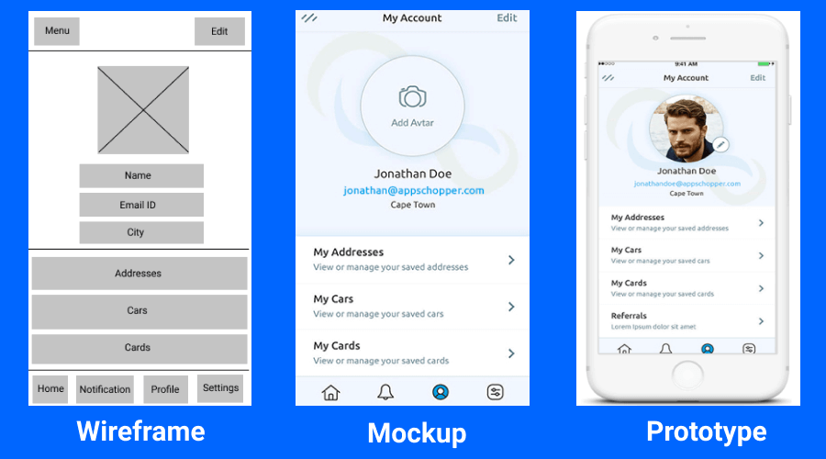Mockup is the opposite of the wireframe. Mock-up is meant to be high fidelity representation of your app or your website’s design. it's almost like you've gone into the future, you've taken a screenshot of what it looks like while it's in action, and you've brought it back into the present to try and show people what it looks like. Now the great thing about mock-ups is that they are really pretty much what you see is what you're going to end up getting.