**CSS**

**\*Tip: Best way to find your required settings is change them temporarily in the developer tools (can get this by pressing Ctrl+Shift+i ) and then applying those in local editor (Video 44 – 4:29)**

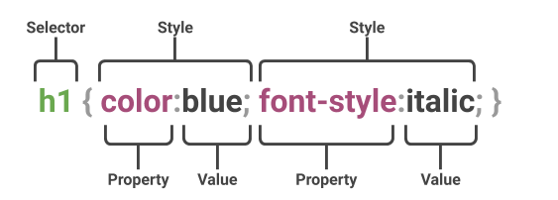

Section 4: Introduction to CSS

1. Where in an HTML document is the correct place to refer to an internal style sheet?
2. Which HTML tag is used to define an internal style sheet?
3. What is the reason of using selectors?
4. Why we use ID/Classes instead of selectors?
5. What’s the difference between ID and a class?
6. What are pseudo classes, and what do they do?
7. 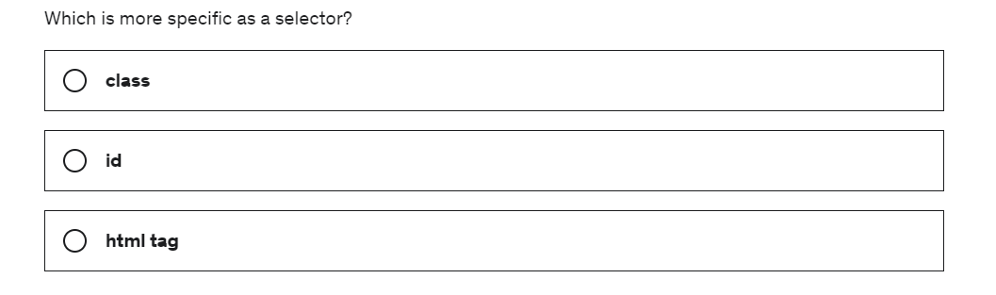

Section 5: Intermediate CSS

1. What is Favicon or Favorite icon?
2. What is divs of CSS?
3. Differentiate Padding, Border, and Margin. This box model appear every time we inspect a html element in google. i.e. select box model
4. What are the 4 display properties?
5. What element in “display” would take whole length of the page?
6. What are the common block elements in css?
7. What are the common “inline” elements in css?
8. What type of “display” we use if we wanted to change the width and required inline property (as in “span” / but we can’t change the width in “span”) at same time?
9. What is the difference between display:none and visibility:hidden ?
10. What are the three default rules of HTML?
11. What are the 4 values of “Position” property?
12. Difference between position:relative and position:absol ?

Position:absolute;

Left:100px;

Position:relative;

Left:100px;

1. Where should we put text-align property?

Answers

1. . (Video 47 – CSS static and relative positioning)We have to get a good knowledge about these rules to change everything.
   1. Content is everything. I.e. if you have a span that has short word, it takes short width. It that span has longer word, it takes long width. Even with block elements like h1, paragraphs height is determined by the height of the content (they take 100% as width). Most of the time height determines by the font size. If you have smaller fonts your height will be small, larger fonts will take larger height. This is despite any CSS.
   2. Order of the elements on the screen comes from the HTML code. Page is rendered according to this order.i.e.

<p></p>

<h1></h1>

<img>

<h1></h1>

**Is different from**

<p></p>

<img>

* 1. Children sits top/in front of their parents. i.e. if I add span inside of the div like below, span comes on top of that to div. More towards user and less towards computer. -> Concept of Z-index.

<div></div> (Parent)

This is on TOP

<div>

<span>This is on TOP.</span>

</div>

<Span></span> (Child)

1. Text-align property should be placed within parent container.