**(16/04/2025) Day – 1: Intro to HTML, CSS and Javascript**

**HTML(HyperText Markup Language):**

* Browser rendering information , width size and zoom



* Basic Html tags (<html><head><body><title><h1><p><a href><script><style><div><form><input>)

**CSS(Cascading Style Sheets):**

* Inline css:



* Internal CSS:

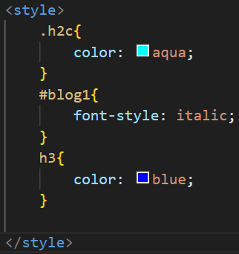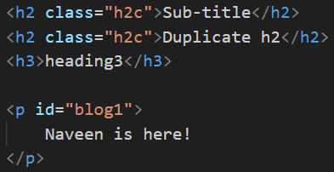

* External CSS:



**Javascript:**

**Inline js:**

<button onclick="alert('Hello, World!')">Click Me</button>

**Internal js:**

<script>

document.getElementById('myButton').onclick = function() {

alert('Hello from Internal JS!');

};

</script>

**External js:**

<script src="script.js" ></script>

**Syntax for variable:**

let a = 5; // var a = 5;

let b = 6;

//const c = 45;

//console.log(c);

console.log("Sum of "+ a + " & " + b + " is "+ (a + b));

console.log("Subtraction is ",a - b);

console.log(`Product of ${a} & ${b} is ${a * b}`);

console.log(`Division of ${a} & ${b} is ${a / b}`);

console.log(`Remainder of ${a} & ${b} is ${a % b}`);*/

let val = true;

//console.log(!val);

**Syntax for func:**

* function function_name(){

body of func

}

* function add(a,b=10){

// console.log(a+b);

}

add(5,20);

* function rec(a) { **//Recursion** **Func**

if(a == 10) {

// termination

}

rec(a + 1)

}

rec(1);

**For Loop:**

* for(let i = 0; i<arr.length; i++){

    //console.log(arr[i]);

}

* for(const name in arr){

    //console.log(arr[name]);

}

* for(const name of arr){

    //console.log(name);

}

* arr.forEach(

    function(e){

        //console.log(e)

       // process.stdout.write(e + " ");

    }

);

**ARRAYS:**

* let arr = ["Naveen", "adsd", true, 23,0,"nav"];

//console.log(arr);

* arr.push("meow")

//arr.forEach((e) => console.log(e));

* arr.pop();//remove last element

//arr.forEach((e) => console.log(e));

* //arr.filter((e) => e.toString().startsWith('N'))

// .forEach((e) => console.log(e));

* arr

.filter((e) => Number.isInteger(e))

.map((e) => e*2)

//.forEach((e) => console.log(e));

**Javascript Object Notation:**

* // JSON --> Javascript Object Notation

let obj = {

    name: "Naveen",

    role: "Trainee",

    exp: "2",

    lang: ["Java", "Python", "C"]

}

//obj.lang.push("playwright")

//console.log(obj.lang);

**Spread Operator:**

* console.log([...obj.lang, "playwright"])// spread operator

console.log(obj);

**GitHub Commands:**

git init 🡪 git add<filename> 🡪 git commit -m ‘feature added’🡪 git push origin<branch>