**Dissecting the Digital Landscape:AComprehensive**

**Analysis of Social Media**

Category: Data Analytics

From Aditya College Of Engineering

**Team ID** : LTVIP2023TMID0430

**Team Leader** : Ardhani Ramya kavya

**Team member** : Chekka Hadassa

**Team member** : Gopu Naveen Kumar

**Team member** :Oleti Abhishek

**Documentation Index**

|  |  |  |
| --- | --- | --- |
| **S.NO** | **Learning Outcome** | **Page count** |
| **1** | INTRODUCTION | 2-5 |
| **2** | LITERATURE SURVEY | 5-6 |
| **3** | THEORITICAL ANALYSIS  ➔ DIAGRAMMATIC VIEW OF PROJECT  ➔ REQUIREMENTS OF PROJECT | 6-10 |
| **4** | RESULT | 11-13 |
| **5** | ADVANTAGES AND DISADVANTAGES OF PROJECT | 14 |
| **6** | CONCLUSION | 14- 15 |
| **7** | FUTURE SCOPE | 15 |

**INTRODUCTION**:

**Project Description :**

Dissecting the Digital landscape : A Comprehensive

Analysis of Social Media is a research article or paper that

Provides a detailed and in-depth analysis of various social media platforms, including Facebook, Twitter, Instagram, YouTube, and LinkedIn. The analysis covers a wide range of topics related to social media, such as the history and evolution of social media, the demographics of social media users, the impact of social media on communication and society, the role of social media in politics and activism, and the  
challenges and opportunities of social media for businesses and organizations.

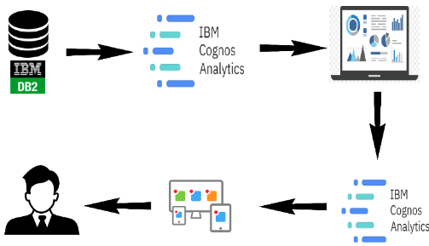  
The paper draws on a wide range of research studies, surveys, and data sources to provide a  
comprehensive overview of the digital landscape and its implications for individuals, organizations, and society as a whole. Overall, the paper aims to provide a comprehensive and up-to-date understanding of the complex and dynamic world of social media(twitter as an example), and to inform future research, policy, and practice in this rapidly evolving field.

**PURPOSE OF THE PROJECT** :

The purpose of “Dissecting the Digital Landscape : A Comprehe

-nsive Analysis of Social Media “ project is to conduct an in-depth

and thorough examination of the social media land scape . This analysis

aims to gain a comprehensive under- standing of various aspects related to social media platforms, their impact on society, and their implications for individuals, businesses, and governments. The project may involve studying multiple social media platforms, such as Facebook, Twitter, Instagram, LinkedIn, YouTube, TikTok, etc., and could cover several key areas:

User Behavior and Engagement: Understanding how users interact with social media platforms, the patterns of content consumption, and the factors that influence engagement.

Content Analysis: Analyzing the types of content shared on different platforms, the prevalence of misinformation, hate speech, and other potentially harmful content.

Societal Impact: Examining the effects of social media on society, including its role in shaping public opinion, political discourse, and social movements.

Privacy and Data Security: Investigating the privacy policies and data

security practices of various social media platforms, and how user data is

collected, stored, and used.

Business and Marketing: Assessing the impact of social media on businesses

and marketing strategies, including influencer marketing, brand reputation

management, and customer engagement.

Mental Health and Well-being: Exploring the relationship between social

media usage and mental health issues, such as anxiety, depression, and self-esteem.

Regulatory and Ethical Considerations: Investigating the regulatory

landscape and ethical dilemmas surrounding social media, including

discussions about content moderation, data privacy laws, and freedom of expression.

Future Trends: Identifying emerging trends in social media, such as the rise of

new platforms, the adoption of augmented reality (AR) and virtual reality

(VR) technologies, and potential shifts in user behavior.

By conducting a comprehensive analysis of these aspects, the project aims to

provide valuable insights that can help individuals, businesses, policymakers,

and other stakeholders make informed decisions regarding social media

usage, regulation, and their overall approach to navigating the digital

landscape. It may also contribute to academia and further research in the

field of social media studies.

|  |
| --- |
|  |

**LITERATURE SURVEY :**

Literature Survey on the Dissecting the Digital landscape : A Comprehensive

Analysis of Social Media

**PROBLEM SOLUTION** :

Problem Statement

**Idea/Solution Description**

-sentiment analysis :displays the sentiment of social media data , showing proportion of positive , negative sentiment in conversation.

-Heat Maps:displays geographic distribution of social media data , showing

Where Conversation and engagement are happening In real time.This can

Help to identify regional trends.

**Customer Satisfaction** :

-By analyzing the behaviour of the user on the platform , business organizations targets their customer based on their interests.

**Business Model :**

-By analysis social media engagement and user behaviour , business can optimize their advertising campaigns to reach their target audience more

Effectively.

**THEORETICAL ANALYSIS** : 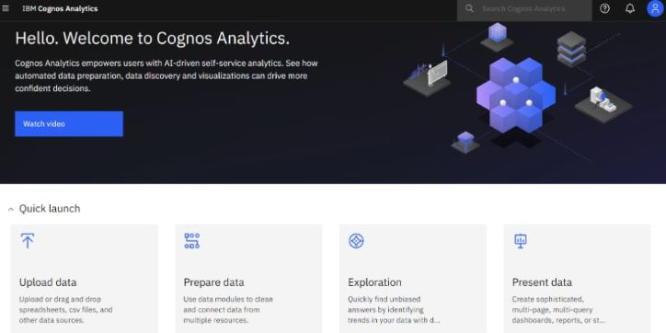.

**Dataset:**

The Dataset is taken from the social are import the in IBM database

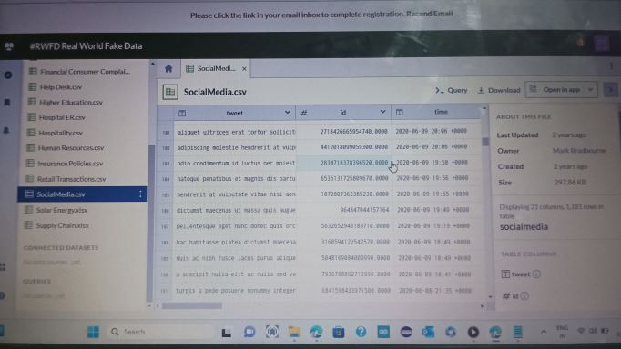

CONNECT DB2 WITH COGNOS:

To connect IBM DB2 and IBM Cognos Analytics, you'll need to set up a data source connection in Cognos Analytics to access the DB2 database. Here's a step-by-step guide on how to do it: Ensure Prerequisites:

● Make sure you have the necessary credentials (username and password) to access the DB2 database.

● Obtain the DB2 database connection details, including the hostname or IP address, port number, and database name.

● Launch IBM Cognos Analytics:

● Log in to IBM Cognos Analytics with your credentials.

**Access the Administration Console**:

● In the Cognos Analytics user interface, click on the "Hamburger" menu icon (three horizontal lines) in the top-left corner.

● From the menu, select "Mange."

● In the Administration Console, expand the "Configuration" section in the left

pane. Click on "Data server" under "Configuration."

**Add a New Server**:

● On the "Data Server" page, click the "Add" button to create a new data source connection

● In the "Select the type of data source" window, choose "IBM DB2" from the list of available data sources.

● Click "Next" to proceed.

Provide Connection Details:

Fill in the required connection details for the DB2 database:

● Enter a name for the data source connection (e.g., "My DB2 Connection").

● Specify the hostname or IP address of the DB2 server.

● Enter the port number on which DB2 is listening.

● Provide the database name.

● Input your DB2 username and password for authentication.

**Test the Connection**:

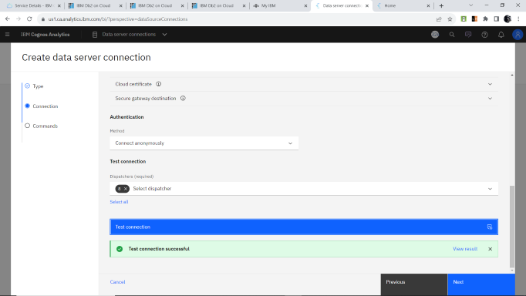

➢ Click the "Test" button to verify if the connection to the DB2 database is successful. Cognos Analytics will attempt to establish a connection using the provided details.

➢ If the test is successful, select command type and click "create" to createthe Data server connection.

**Prepare The Data For Visualization:**

To prepare the data for visualization in IBM Cognos Analytics, you need to perform certain data preparation steps to ensure the data is in the right format and structure for effective visualization. Here's a guide to prepare the data:

**Data Source Connection:** Connect IBM Cognos Analytics to the data source where your data is stored. This could be a relational database like IBM DB2, a data warehouse, Excel files, or other data repositories.

**Data Import:**

Import the required data into Cognos Analytics. This involves creating a new data module or importing data directly from the data source. The data module allows you to combine data from different sources if needed.

**Data Quality Check**:

Perform data quality checks to identify and handle any missing values, anomalies, or inconsistencies in the data. Clean the data by handling missing values appropriately (e.g., inputting, removing, or leaving)

**DATA VISUALIZATION**

Data visualization is the process of creating graphical representations of data in order to help people understand and explore the information. The goal of data visualization is to make complex data sets more accessible, intuitive, and easier to interpret. By using visual elements such as charts, graphs, and maps, data visualizations can help people quickly identify patterns, trends, and outliers in the data

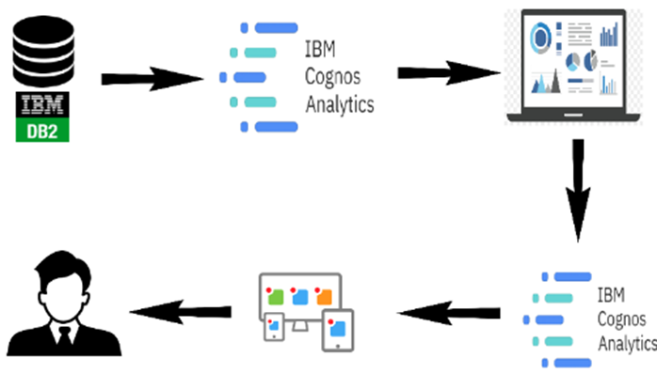

**HARDWARE USED**:

Laptop, Smart Phone.

**SOFTWARE USED**:

IBM COGNOS, ANACONDA,PYTHON.

**RESULT :**

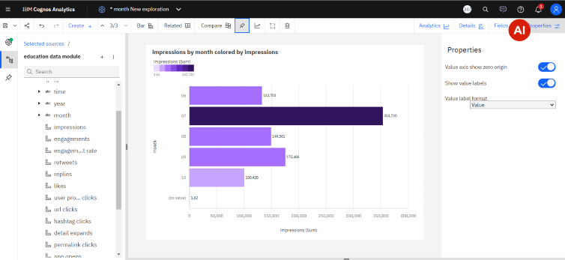

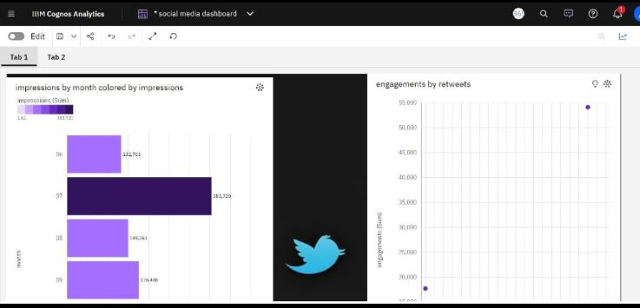

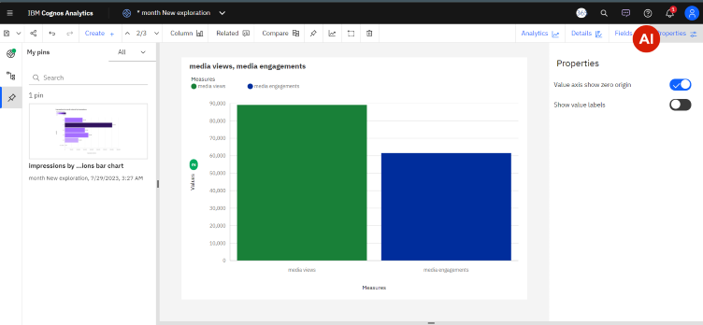

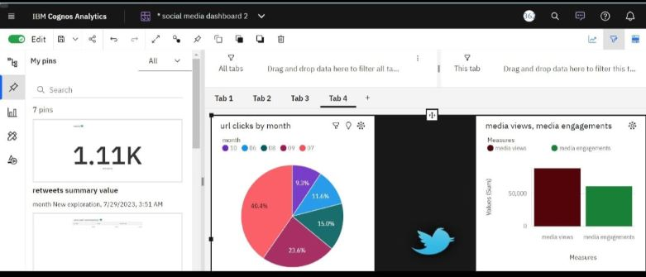

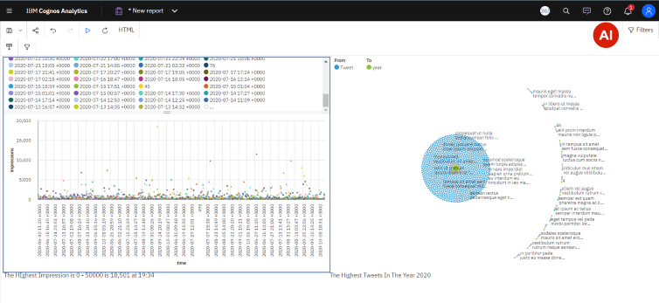

**ADVANTAGES** :

* Under standing user behaviour
* Audience segmentation
* Identifying trends
* Competitive analysis
* Brand reputation management
* Influencer identification
* Measuring campaign effectiveness

**DISADVANTAGES** :

* Information overload
* Privacy concern
* Bias and misinterpretation
* Rapidly evoling landscape
* Incomplete data picture
* Resourse intensive
* Negative feedback amplification
* Ethical consideration
* Lack of context

**CONCLUSION** :

The analysis of social media within the context of digital marketing

strategies reveals its significant impact and potential for businesses.

Business should also be mindful of the ethical implications and

challenges that comes with social media marketing.

Businesse Organizations must stay updated on emerging trends ,

Algorithm changes , and user behavior to adapts theirs strategies effectively.

**FUTURE SCOPE**:

The Future scope of dissecting the digital landscape and conducting a

Comprehensive anlaysis of social media is promising , as business and organizations increasingly recognize the impotance of leveraging social

Media data for strategic decision - making. Here are some potential

Areas of future growth and development.

-Integration of Multiple Data Sources.

-Advanced Data Visualization and Reporting .

-Deep Learning and Natural Language processing

- Predictive Analysis and Trend Forecasting

-Integration with AI -Powered chat bots and Virtual assistants