CONTENTS

DESCRIPTION PAGENO

ABSTRACT
INTRODUCTION
ORGANIZATION PROFILE
TYPES OF AUCTION:

OVERVIEW

PROPOSED SYSTEM

ONLINE AUCTIONS

SYSTEM DESIGN

TERMINOLOGY

DATA FLOW DIAGRAMS

FLOW CHART

DATABASE TABLE DESIGN

TESTING

OVERVIEW OF JAVA TECHNOLOGY

SOFTWARE & HARDWARE REQUIREMENTS

CONCLUSION
REFERENCES

BIBLIOGRAPHY

ABSTRACT

Auctions are among the oldest economic institutions in place. They have been used since antiquity to sell a wide variety of goods, and their basic form has remained unchanged. In this dissertation, we explore the efficiency of common auctions when values are interdependent- the value to a particular bidder may depend on information available only to others-and asymmetric. In this setting, it is well known that sealed-bid auctions do not achieve efficient allocations in general since they do not allow the information held by different bidders to be shared.

Typically, in an auction, say of the kind used to sell art, the auctioneer sets a relatively low initial price. This price is then increased until only one bidder is willing to buy the object, and the exact manner in which this is done varies. In my model a bidder who drops out at some price can “reenter” at a higher price.

With the invention of E-commerce technologies over the Internet the opportunity to bid from the comfort of ones own home has seen a change like never seen before. Within the span of a few short years, what may have began as an experimental idea has grown to an immensely popular hobby, and in some cases, a means of livelihood, the online auction gathers tremendous response everyday, all day. With the point and click of the mouse, one may bid on an item they may need or just want, and in moments they find that either they are the top bidder or someone else wants it more, and you’re outbid! The excitement of an auction all from the comfort of home is a completely different experience.

The levels of comfort may rise in the near future but the rules to be followed remain the same. Infact may rise with the new technologies.

Society cannot seem to escape the criminal element in the physical world, and so it is the same with online auctions. This is one area wherein a question can be raised as to how safe online auctions.

INTRODUCTION

Here we'll talk about the three different types of auctions you can come across. But before we go into that, here's a brief introduction to auctions.

Auction:

An auction is a sale in which a seller presents his product on a public platform/ forum. The selling price in an auction is determined by the bids made by interested buyers. The price they bid is based on their own valuation of, and need for, the product. The product is sold to the highest bidder. A potential buyer participates by bidding on an item that a seller has listed. The person who has offered the highest bid at close of auction wins the right to purchase the item at that price.

Bid:

A bid is the amount of money proffered for an item that has been put on sale in an auction. The bidder competes with other potential buyers, keeping in mind that the buyer with the highest bid is obliged to complete the purchase with the seller. In other words, your bid tells other buyers, "I want to buy this item at this price."

Win:

You win an auction by placing the winning (read highest) bid and obtaining the item on auction. The person with the highest bid is the winner of the auction. Now that you're familiar with how an auction generally works.

ORGANIZATION PROFILE:
TYPES OF AUCTION:

There are three different types of auctions.

Straight Auction:

The price of the product on auction increases with every incremental bid. The price increases as per the minimum bid increment set by the seller. The seller must sell the item to the highest bidder at the close of the auction. For example, if a seller has put up product 'A' for sale with a reserve price of Rs.10 and five buyers bid for it with the highest bid coming in from buyer 'B' who bids Rs.12, the product is sold to 'B' for Rs.12.

Dutch Auction:

This is an auction where the number of units of a particular product for sale is more than one. This simply means that a number of identical products have been put up for sale by the seller. In an auction like this, there will obviously be more than one winner. Buyers can also bid for more that one unit of that product. At the end of the auction all the bidders pay the same price - the lowest winning bid amount (subject to the reserve price being met) for the product. This is a perfect auction type for those who wish to sell many units of the same product. Here is how it works: The Seller starts by listing a minimum price or starting bid for a product and the quantity or number of units for sale. Bidders specify both a bid price and the quantity they wish to buy. All winning bidders pay the same price per item - the lowest successful bid. If there are more buyers than items, the earliest successful bids get the goods. Higher bidders are more likely to get the quantity they asked for. Bidders can refuse partial quantity. For example, if you place a bid for 10 items and only 8 are available after the auction, you are not obliged or bound to buy any of them. Example Case: A seller places 10 pens on auction at Re.1 each. 10 people bid Re. 1 for one pen each. In this case, all 10 bidders will win a pen for Rs. 1. However if, let's say, five people bid Rs. 1.25 for a pen each and 10 others bid Re. 1. The minimum bid for the pen will be raised to Rs. 1.25 because demand exceeds supply. Because the Rs. 1.25 bidders bid higher than the Re. 1 bidders, they will be guaranteed a pen. The other 5 pens will go to the earliest Re. 1 bidders. The final price for each pen will be Re. 1 (even though some participants placed a higher bid of Rs. 1.25) since all winning bidders pay the same price - which is the lowest successful bid. In this format at the time of allocation of the quantities the preference is given to the buyer who puts in the highest bid and he/she will get the quantity he bid for and this flows progressively down the bidding value stream.

Note: Even for a multiple quantity Auction, the winning bid amount displayed is for single quantity. The winner has to pay an amount which is equal to the winning bid amount multiplied by the quantities (units) he has bid for.

Sealed Auction:

As the name suggests, a Sealed Auction is an auction in which the bid prices are hidden or undisclosed. It's almost like making a 'Tender' wherein one party doesn't know the price offered by any other party.

OVERVIEW

The World Wide Web is an attractive target to many attackers. It has a lot of valuable information that can easily be accessed to a person with the right knowledge. With the increasing number of electronic commerce sites popping up everyday, we are very concerned with the security of transactions.

There are several different payment methods to use for online purchases. Some of these include; credit cards, micropayments, smart cards, and online billing. However, "the top three credit cards companies handle over 98% of all purchases made on the Web." (174, Korper) We wanted to address some of the security issues that web developers should take to safeguard their sites. Specifically, we are interested in the protection of credit card numbers and data that users transmit over the Web.

In this site we will address some of the security issues and solutions for web developers to implement when creating ecommerce sites. We have discussed ways to secure your server, protect the network from outside intrusion, and the use of digital certificates to secure transactions. We have also listed some software solutions we recommend that can be beneficial to your site.

PROPOSED SYSTEM

The opportunity to shop from the comfort of ones own home has seen a change like never seen before. Within the span of a few short years, what may have began as an experimental idea has grown to an immensely popular hobby, and in some cases, a means of livelihood, the online auction gathers tremendous response everyday, all day. With the point and click of the mouse, one may bid on an item they may need or just want, and in moments they find that either they are the top bidder or someone else wants it more, and you’re outbid! The excitement of an auction all from the comfort of home.
With this opportunity to buy sight unseen also comes the opportunity to be scammed sight unseen as well. There are over 30 million ‘hits’ each month on the online auction sites, and that is opportunity waiting to be taken for those with the criminal intent of defrauding others.
However with a little care and caution, one can have a positive experience doing business on an online auction, and each party can leave satisfied with their ‘deal’, whether they are the buyer, the seller, or the conveyance that brought it all together.

ONLINE AUCTIONS

BEFORE AN AUCTION:
The process of an online auction is much the same as a live auction. This means that users place bids for items, and the goods get sold to the highest bidder. You are notified through email on the status of your bids, which is when you place a bid, when you've been outbid and when you've won an item.
To bit for an item, there is a bidding form through which you may place bids on the item. To bid on an item, enter your bid amount. While entering your bid, you need to consider the bid increment. The bid increment is the amount by which each bid increases. The seller sets this amount. The bid amount should be one bid increment or more above the current leading bid specified on the item page.
Automatic Bids and manual bids need not be exact multiples of the bid increment amount. Bids will only have to be one increment or more above the current bid to be accepted.

Example:
Bid increment amount - Rs. 20
Lets say the starting price is Re.1
Current highest bid is Rs. 21
Now in order to bid: -You can bid at anywhere above or equal to the current highest bid amount for your bid to be accepted, i.e. you can bid at anywhere between Rs. 21 to Rs. 41 (or more) for your bid to be accepted. -This means that you can bid at say Rs. 23 and the next current minimum bid will get adjusted to Rs. 43 (since the Bid Increment level is set to 20).
If you wish to place a higher bid, you may do so. For eg. - You can place a bid of Rs. 45. This would incorporate the current bid at Rs. 21 and the minimum bid increment of Rs. 20. The remaining Rs. 4 is the additional amount you have bid. Therefore the user who bids after you would have to bid atleast Rs. 65 (Rs. 45 of your bid and Rs. 20 of the bid increment)
The amount of the next minimum acceptable bid will be displayed in the "Bid Amount per item" text box.
To find more information about the product the description of that product has to be referred. A description of every item is put up on the item page. To know more about the item and its features, you can make use of the "Ask the seller or Read Q&A" facility provided on every item page. This way you can acquire more information about the item. If it is convenient for you and the seller, you can also arrange to personally inspect the item.
Bidding can be carried out automatically by enabling the automatic bidding feature. Automatic Bid features bids on a particular item for you up to the maximum amount that you have specified. This amount is the maximum amount that you, the buyer, are willing to pay for an item. It is kept confidential. To activate the Automatic Bid, just enter your maximum bid amount in the "Enter Automatic Bid amount" box and click on the "Bid Now" button.
Automatic Bid is an optional facility. If you activate Automatic Bid, you need not be online to bid for and win an item you desire. The system will bid for you if necessary by the specified bid increment amount to the limit of your Automatic Bid. Please note that the Automatic Bid system will only bid for you when you have been outbid or to meet the reserve price at the end of the auction. You will receive an email notification every time the Automatic Bid bids for you.

To bid on a multiple items is considered to be a special auction where a seller has more than one quantity of the item he or she wants to sell/bid. The seller selects the starting bid amount and indicates how many of these items are available for the auction.
An auction is a multiple auction or not can be known by checking the quantity box of the item. If there is number of quantities displayed is more than 1, then it is a MQA (Multiple Quantity Auction)
After an Auction:
At the end of every auction, you would receive an email (if your bid is the highest at that point of time) with your seller's contact details. You would then need to contact your seller to arrange for the delivery and complete the deal offline.
A bidder can know about the item he/she won in an auction once the auction of an item you have bid on has ended. You will receive an auto-generated email if your bid was the highest and the reserve price (if any) had been met. The mail will include item details and the seller's contact details. The seller too will receive an email providing them with your contact details. You will need to contact your seller to inspect the goods and arrange delivery and payment.
Once the auction is ended, both the seller and the buyer are notified through email and given each other's contact details. They need to contact each other and work out payment as per the terms of payment mentioned by the seller on the item page.
Transaction:
The transaction between the buyer and the seller can be carried out manually if the buyer and seller are in a reachable distance. In other case the transaction is carried out over the net via E-commerce Secured transaction systems.
Society cannot seem to escape the criminal element in the physical world, and so it is the same with online auctions.
One of the concepts that the online auctions were started with was the idea that people could police themselves, but those with the intent to take advantage of others have found the means to bypass this mild safeguard as well. It was envisioned that with the opportunity to give ‘feedback’ on each other as buyers and sellers, honesty would remain intact. However some have found a way to inflate their ratings which makes them appear trustworthy to do business with.

There are steps to take to reduce the risk of being scammed by a less-than-honest individual in an online transaction, and the first step is to deal only with reputable establishments. At least if there is a problem with the transaction, whether as the buyer or the seller, one stands a better chance of resolving the problem satisfactorily for everyone. So do your homework as to where it is safe to do business. Establish the top price that you are willing to give, keeping in mind how much more than the bid price you will have to give to cover shipping, insurance and tax. If possible, establish the identity of whom you are dealing with. Have they been operating with this auction service for an acceptable length of time? Do they have any comments about them, either positive or negative? These things must be considered in an attempt to protect oneself from the risk of being scammed.
Another safeguard to consider is, “how will one pay for the goods?” There are payment services available such as PayPal or Billpoint. Many of these services offer some form of assurance and insurance against fraud. Or one may want to consider an Escrow service to handle the transaction. Many of the auction sites have an escrow service to offer their clients, however there is usually an extra fee associated with these services as well.
Whatever the means one chooses to minimize the risk of loss due to fraud, in the end it still comes down to the individual consumer and the choices they make. Until the goods are received and all parties satisfied, one should keep record of any and all transactions, whether they are the buyer or the seller. It may help provide proof of what took place, and help get ones money or goods back, if one has the misfortune of being the victim of online auction fraud.

SYSTEM DESIGN

People tend to frequent seized property auctions because goods can be purchased at a low price relative to market value. This is good for the buyer, but not for the debtor whose budget and credit record are dependent on this money. A limited audience who will not pay the full value of the items up for bidding attends the auctions. The body appointed to seize and auction property operates it.
When debtors must liquidate their assets, they must first open an account with the Collection Authority. The Collection Authority is housed inside the sheriff’s office or the organization responsible for public auctions of seized property and assets. It is a combination of customer service counters and an inventory/shipping warehouse. Seized goods and items brought in by a debtor are inventoried at the Collection Authority where daily shipments are made for the items sold. Once the item is sold, the buyer makes the payment to the Collection Authority, which then transfers the balance owed to the creditor, minus shipping costs and a percentage charged by the Collection Authority.
All items going through site , either seized or brought in by the debtor, use the Item Profiler to create a standard description page to post items on the on-line auction site. The page layout includes digital images representing the orthographic views of the item plus a text section detailing its make, model, year, history, etc. with an additional line worded by the debtor.

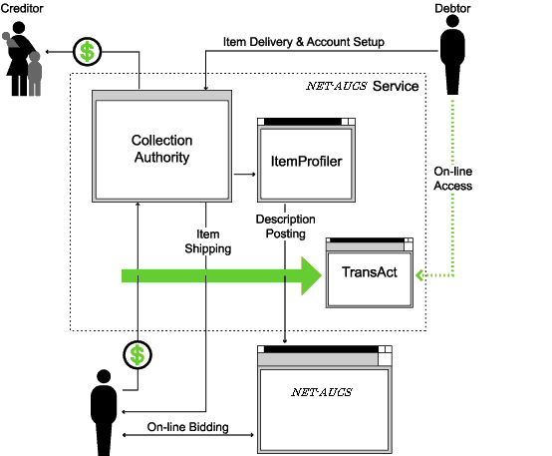

The item’s description is logged under the appropriate category on the auction site. People shopping at this site can view items and bid on the goods similar to any other item listed on the site. The only discernible difference is the consistent layout between the posted items and a line attached by the Collection Authority stating that the item is being sold to resolve a debt.
TransAct records all of the items posted for auction by item number and account number, and records the sales made on these items. Beyond the bookkeeping value of these records, summary and status statements can be provided for the debtor to present to the court if a question of compliance arises; an account number enables the system to summarize the debtor’s TransAct ion to show remaining debt to the creditor as well as prove to the court that an effort is being made to pay the debt.

Scenario

Open Multithreaded Transactions form an advanced transaction model that provides features for controlling and structuring not only accesses to objects, as usual in transaction systems, but also threads taking part in transactions. The model allows several threads to enter the same transaction in order to perform a joint activity. It provides a flexible way of manipulating threads executing inside a transaction by allowing them to be forked and terminated, but it restricts their behavior in order to guarantee correctness of transaction nesting and isolation among transactions. In addition, transactions are exception handling contexts, and the model therefore provides forward and backward error recovery. In this paper we show that the model is indeed powerful, and that a complex application, i.e. an online auction system, can be designed and implemented in a very elegant way.

FEASIBILITY STUDY

There are very few situations in which auctions cannot be performed due to existing market conditions (e.g. in the case of a monopoly). It is more likely that the combination of different (legitimate) interests of the internally involved parties will lead to a situation in which an auction would seem inappropriate. By means of thorough and systematic preparation with all responsible internal parties involved, we help establish a framework in which an auction can be carried out, allowing the realization of the underlying savings potential. At the same time, we make sure that the company's main sourcing targets are reached. Many of our clients initially thought that commitment to the outcome of an auction would reduce their flexibility. They very soon came to the conclusion that systematic preparation only shifts the required flexibility to a position closer to the beginning. If a certain result is not to be supported, we make sure - by systematic preparation and careful auction design - that it will never occur.

TERMINOLOGY

Cryptography: Cryptography is the study of encryption. This is a process for coding data so unauthorized people cannot understand it. Many products use encryption to code information. There are two different methods for encrypting data. One way is asymmetric. This requires a public key to encrypt the data and a private key to decrypt. The alternative is through symmetric encryption. This uses a private key to encrypt and decrypt the information. Encryption is done through the use of algorithms.

Firewalls: Firewalls can be implemented through either hardware or software. It filters the incoming and outgoing packets and determines if it wants to transport them to their destination. It prohibits unauthorized connections into the network from certain ports.

Smart Cards: Smart Cards are small credit card like products that contain a small microchip on them. These microchips store data. The cards can be either disposable or reloadable. Reloadable cards have the option to add additional information or applications at a later time. Cards are usually loaded with cybercash, encryption information, and much more.

Digital Signatures: Digital Signatures are used to ensure that only authorized people are able to read a certain message. It is used as an electronic substitute to a manual signature. It consists of a sequence of bits that are encrypted with a sender's private key. When the recipient receives the message it is decrypted by the use of their public key. This enables the receiver to verify who sent it and whether the data has been altered in any way. The use of a time stamp can be used with the digital signature to confirm the time of the signature.

Digital Certificates: Digital Certificates have encoded personal information about the owner of the certificate. It is similar to Digital signatures in it allows the recipient of the message to verify the authenticity of the message. It secures information between browsers and servers, customer and merchants, or between two email partners. A third party, known as a certificate authority, distributes them. They are tamper proof and cannot be forged.

Common standards used in business transactions:
EDI- Electronic Data Interchange: It allows for transmission of information between private networks.

OBI- Open Buying on the Internet: Formed by the Internet Purchasing Roundtable, OBI makes communication possible between all ecommerce systems.

OTP- Open Trading Protocol: It's the standardization of payment transactions and was created to compete against the OBI standard.

OPS- Open Profiling Standard: It holds information about users likes and interests and distributes it to merchants.

SSL- Secure Socket Layer: This allows data to be transmitted securely by use of public key encryption. It was created by Netscape and is now public domain.

SET- Secure Electronic Transactions: Created by Visa and MasterCard, it encrypts credit card numbers located on servers.
Introduction: Related Terms
Cryptography: Cryptography is the study of encryption. This is a process for coding data so unauthorized people cannot understand it. Many products use encryption to code information. There are two different methods for encrypting data. One way is asymmetric. This requires a public key to encrypt the data and a private key to decrypt. The alternative is through symmetric encryption. This uses a private key to encrypt and decrypt the information. Encryption is done through the use of algorithms.

Firewalls: Firewalls can be implemented through either hardware or software. It filters the incoming and outgoing packets and determines if it wants to transport them to their destination. It prohibits unauthorized connections into the network from certain ports.

Smart Cards: Smart Cards are small credit card like products that contain a small microchip on them. These microchips store data. The cards can be either disposable or reloadable. Reloadable cards have the option to add additional information or applications at a later time. Cards are usually loaded with cybercash, encryption information, and much more.

Digital Signatures: Digital Signatures are used to ensure that only authorized people are able to read a certain message. It is used as an electronic substitute to a manual signature. It consists of a sequence of bits that are encrypted with a sender's private key. When the recipient receives the message it is decrypted by the use of their public key. This enables the receiver to verify who sent it and whether the data has been altered in any way. The use of a time stamp can be used with the digital signature to confirm the time of the signature.

Digital Certificates: Digital Certificates have encoded personal information about the owner of the certificate. It is similar to Digital signatures in it allows the recipient of the message to verify the authenticity of the message. It secures information between browsers and servers, customer and merchants, or between two email partners. A third party, known as a certificate authority, distributes them. They are tamper proof and cannot be forged.

Common standards used in business transactions:
EDI- Electronic Data Interchange: It allows for transmission of information between private networks.

OBI- Open Buying on the Internet: Formed by the Internet Purchasing Roundtable, OBI makes communication possible between all ecommerce systems.

OTP- Open Trading Protocol: It's the standardization of payment transactions and was created to compete against the OBI standard.

OPS- Open Profiling Standard: It holds information about users likes and interests and distributes it to merchants.

SSL- Secure Socket Layer: This allows data to be transmitted securely by use of public key encryption. It was created by Netscape and is now public domain.

SET- Secure Electronic Transactions: Created by Visa and MasterCard, it encrypts credit card numbers located on servers.
Solutions:
Here we have included some solution practices that we recommend for implementing into your ecommerce site. They cover solutions for data transactions, web servers, and the network. On an additional page we have included a list of recommended vendors that can supply these products.
Securing Your Server
Securing the web server from intrusion is a major concern. One method to securing the web server is to make sure only authorized personnel have access to it. Keep the server in a secure location. Limit the number of users who can log on and don't use your web server as the mail server. You can limit the number of people who have access to the machine by using two separate computers for these functions.
Securing Transactions:
SSL
A large concern has been protecting information as it travels over the Internet. One way to secure data while transmitting over the Internet is through the use of SSL (Secure Socket Layer). SSL encrypts credit card numbers, usernames, passwords, and other valuable information before it is sent over the wire and then it is decrypted when received.
Digital Certificates
Another method for doing this will be through the use of Digital Certificates. They work using a public key and a private key. No two keys are ever identical this allows for complete anonymity to its users. To keep your data secure you can install a digital certificate onto your computer or server that will safeguard your information. After downloading your certificate your server will contain the private key. Any given person who chooses to trade secured data with you can receive a public key. The two types of Digital Certificates available to web sites are server certificates and personal certificates.
Server Certificates are a great way to ensure confidentiality of the information exchanged between the vendor and the consumer. By using this kind of certificate, customers can feel secure that their personal information, such as credit card numbers, will be encrypted in the process of transmission to your site. Also, the certificate will enable the customer to recognize the authenticity of your site.

Personal Certificates can give businesses the advantage of allowing their customers, suppliers and partners controlled access to specified content on their web sites as well as disallowing access to to specific areas. By implementing this advantage you can offer different levels of service for premiere customers or request a fee.

Firewalls
In order to protect the network from outside intrusion you may want to install a firewall. Firewalls separate the company's network from the Internet. Implementing a firewall will ensure that unauthorized users cannot access information on the network.

DATA FLOW DIAGRAMS
Data flow diagram is a structure analysis tool that is used for graphical representation of Data processes through any organization . the data flow approach emphasis on the logic underlying the system, by using combination of only 4 symbols. It follows a top down approach. A full description of a system actually consists of set of DFD s , which comprises of various levels. And initial over view model is exploded lower level diagrams that show additional feature of the system. Further each process can be broken down into a more detailed DFD. This occurs repeatedly until sufficient details is described.
DFD symbols
square

it defines a source (originator ) or destination of system data.

Arrow

It indicates data flow-data in motion. It is a pipeline through which information flows.

Circle or Bubble

It represents a process that transforms incoming data flow(s) into outgoing data flow(s).

Open Rectangle



it is a data store-data at rest, or a temporary repository of data. Here I am giving only the Data Flow Diagram.

They are explained by
- GANE and SARON method
- DEMACRO YORDAN method

GANE AND SARSON NOTATION

DATA FLOW

DATA STRUCTURE

EXTERNAL ENTITY
OR DATA LINK

PROCESS

DATA BASE

DEMACRO YORDAN NOTATION

DATA FLOW

DATA STRUCTURE

EXTERNAL ENTITY
OR DATA LINK

PROCESS

DATA BASE 

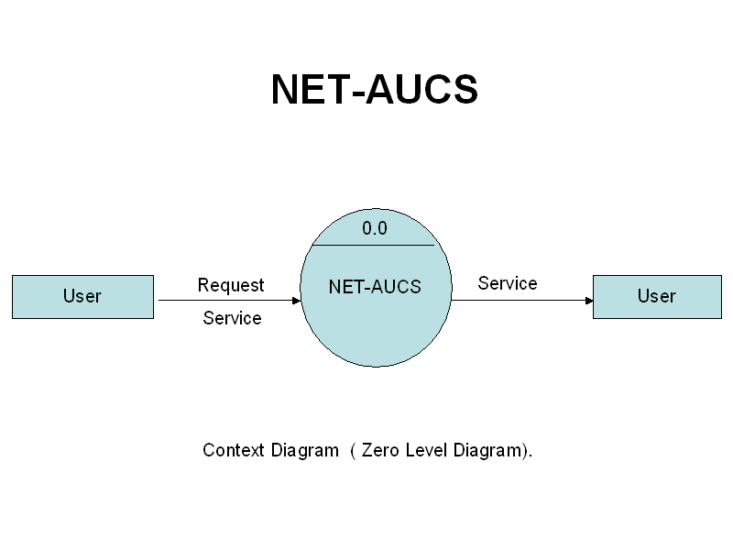
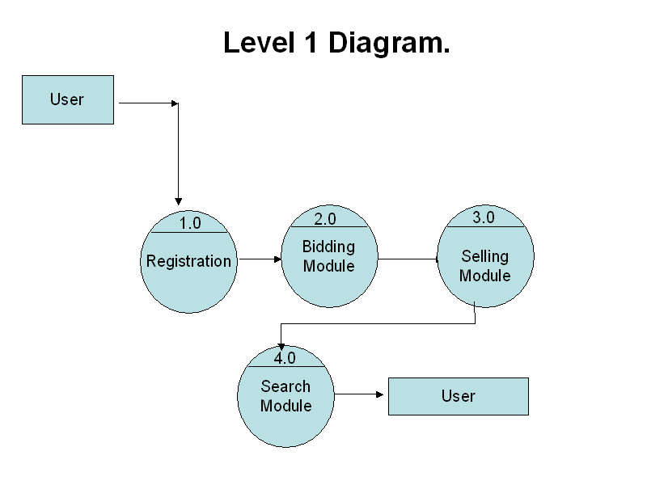

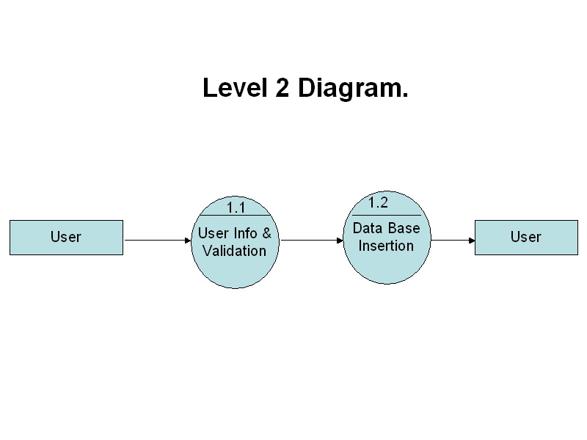

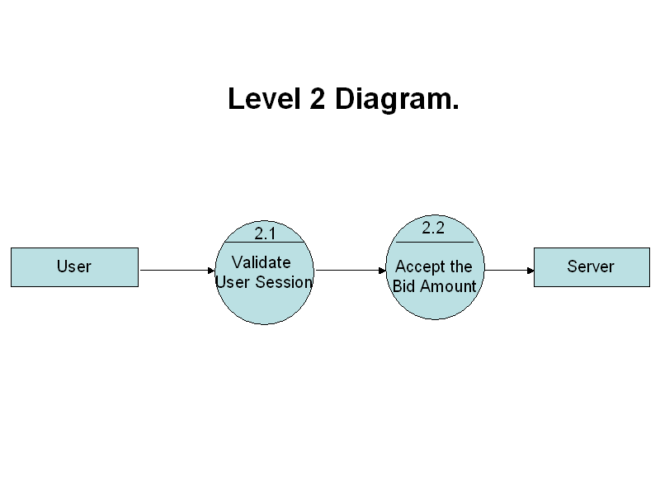

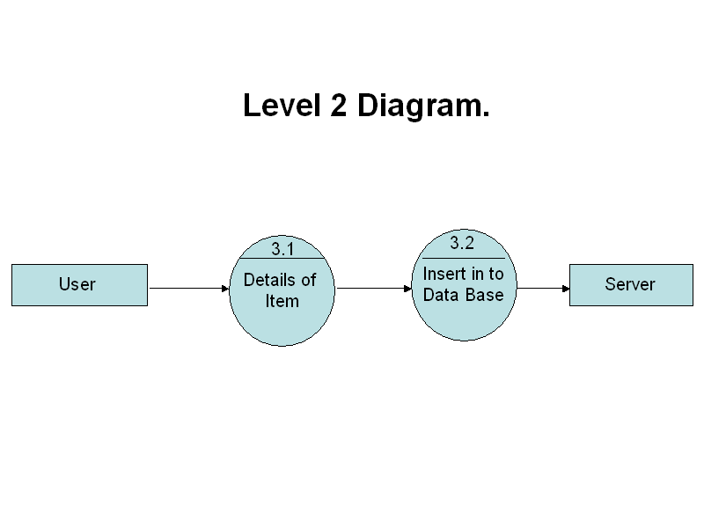
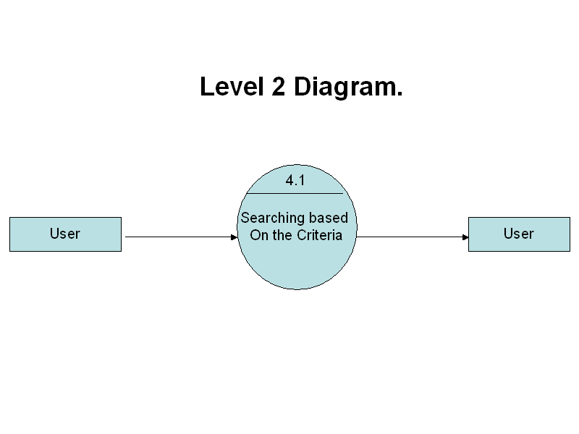

FLOWCHART

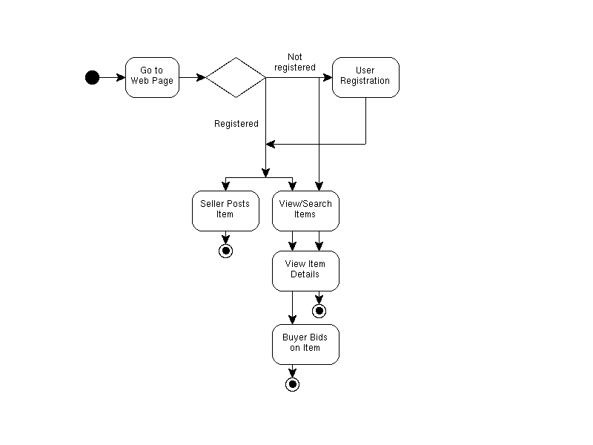

USER CASE DIAGRAM

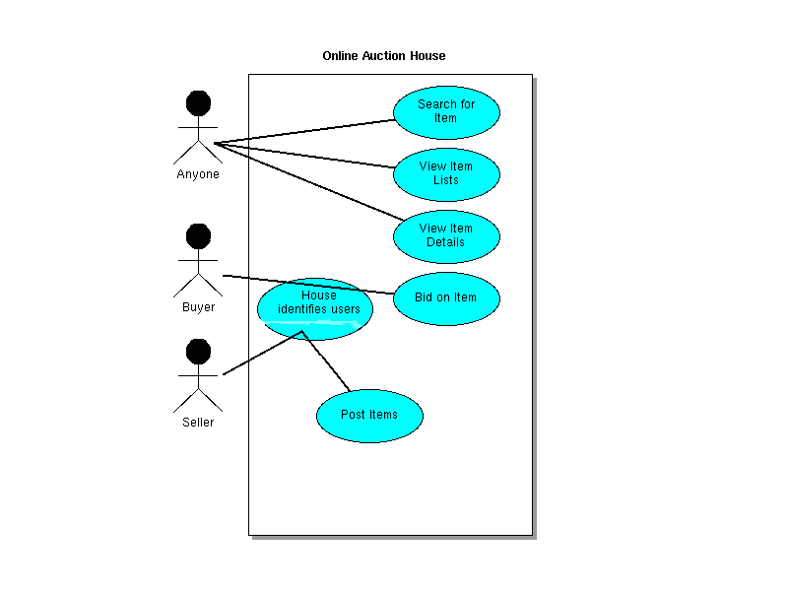

DATABASE TABLE DESIGN

Table uinfo_master
uname | varchar2(20) primary key,
pwd | varchar(10) not null,
fname | varchar2(10),
lname | varchar2(10),
email | varchar2(25) not null,
phno | varchar2(15),
address | varchar2(50),
city | varchar2(15),
state | varchar2(15),
pin | varchar2(6),
country | varchar2(20),
ccardno | number(16)

Table category_master

catid | varchar2(10) primary key,
cat_name | varchar2(20)

Table item_master

itemid |  | number(6) primary key,
catid |  | varchar2(10) references category_master(catid),
itemname | varchar2(20),
description | varchar2(200),
summary |  | varchar2(50),
startprice | number(8,2),
incr_price | number(5),
stdate |  | date,
enddate |  | date,
sellerid |  | varchar2(20) references uinfo_master(uname),
bidcnt |  | number(4)

Table bidding_info
bidderid | varchar2(20) references uinfo_master(uname),
bamt | number(8,2),
itemid | number(6) references item_master(itemid),
biddate | date

TESTING

Testing is a process, which reveals errors in the program. It is the major quality measure employed during software development. During software development. During testing, the program is executed with a set of test cases and the output of the program for the test cases is evaluated to determine if the program is performing as it is expected to perform.
In order to make sure that the system does not have errors, the different levels of testing strategies that are applied at differing phases of software development are:
- Unit Testing
Unit Testing is done on individual modules as they are completed and become executable. It is confined only to the designer's requirements.
Each module can be tested using the following two strategies:

i) Black Box Testing:
In this strategy some test cases are generated as input conditions that fully execute all functional requirements for the program. This testing has been uses to find errors in the following categories:
- Incorrect or missing functions
- Interface errors
- Errors in data structure or external database access
- Performance errors
- Initialization and termination errors.
In this testing only the output is checked for correctness. The logical flow of the data is not checked.

- White Box testing
In this the test cases are generated on the logic of each module by drawing flow graphs of that module and logical decisions are tested on all the cases.
It has been uses to generate the test cases in the following cases:
- Guarantee that all independent paths have been executed.
- Execute all logical decisions on their true and false sides.
- Execute all loops at their boundaries and within their operational bounds.
- Execute internal data structures to ensure their validity.

2. Integrating Testing
Integration testing ensures that software and subsystems work together as a whole. It tests the interface of all the modules to make sure that the modules behave properly when integrated together.

3. System Testing
Involves in-house testing of the entire system before delivery to the user. It's aim is to satisfy the user the system meets all requirements of the client's specifications.

- Acceptance Testing
It is a pre-delivery testing in which entire system is tested at client's site on real world data to find errors.
validation
The system has been tested and implemented successfully and thus ensured that all the requirements as listed in the software requirements specification are completely fulfilled. In case of erroneous input corresponding error messages are displayed.

OVERVIEW OF JAVA TECHNOLOGY

HISTORY OF JAVA
Java language was developed by James Gosling and his team at sun micro systems and released formally in 1995. Its former name is oak. Java Development Kit 1.0 was released in 1996. to popularize java and is freely available on Internet.
Overview of Java
Java is loosely based on C++ syntax, and is menat to be Object-Oriented Structure of java is midway between an interpreted and a compiled language . java programs are compiled by the java compiler into Byte Codes which are secure and portable across different platforms . these byte codes are essentially instructions encapsulated in single type, to what is known as ajava virtual machine (JVM) which resides instandard browser.
Jvm verifies these byte codes when downloaded by the browser for integrity. Jvms available for almost all OS. JVM converts these byte codes into machine specific instructions at runtime.
FEATURES OF JAVA
- java is object-oriented language and supports encapsulation, inheritance , polymorphism and dynamic binding , but does not support multiple inheritance.every thing in java is an object except some primitive datatypes .
- java is portable architecture neutral that is java programs once compiled can be executed on any machine that is enabled.
- JAVA is distributed in its approach and used for internet programming.
- Java is robust, secured, high performing and dynamic in nature.
- Java supports multithreading. There for different parts of the program can be executed at the same time

JAVA AND INTERNET
Java is strongly associated with internet and known as internet programming language. Internet users can use java to create applet programs and run them locally using java enabled browser search as hot java. Applets can be downloaded from remote machine via internet and run it on local machine .

JAVA AND WORLD WIDE WEB
World wide web is an open ended information retrieval system designed to be used in the distributed environment. This system contains web pages that provide both information and controls. We can navigate to a new web page in any direction. This is made possible worth HTML java was meant to be used in distributed environment such as internet. So java could be easily incorporated into the web system and is capable of supporting animation graphics , games and other special effect. The web has become more dynamic and interactive with support of java. We can run a java program on remote machine over internet with the support of web .

JAVA ENVIRONMENT
Java environment includes a large no.of tools which are part of the system known as java development kit (JDK) and hundreds of classes, methods, and interfaces grouped into packages forms part of java standard library(JSL).

JAVA ARCHITECTURE
Java architecture provides a portable , robust , high performing environment for development. Java provides portability by compiling the byte codes for the java virtual machine which are then interpreted on each platform by the runtime environment . java also provides stringent compile and runtime checking and automatic memory management in order to ensure solid code .

JAVA VIRTUAL MACHINE
When we compile the code, java compiler creates machine code (byte code) for a hypothetical machine called java virtual machine (jvm). The jvm will execute the byte code and overcomes the issue of portability . the code is written and compile for one machine and interpreted all other machines . this machine is called java virtual machine .

PARADIGM OF JAVA
- Dynamic down loading applets(small application programs);
- Elimination of flatware phenomenon that is providing those features of a product that user needs at a time. The remaining features of a product can remain in the server.
- Changing economic model of the software
- Up-to-date software availability
- Supports network entire computing
- Supports CORBA & DCOM

ABOUT HTML
HTML (hyper text markup language) is a language used to create hyper text documents that have hyper links embedded in them . it consists of tags embedded in the text of a document with HTML. We can build web pages or web document s. it is basically a formatting language and not a programming language. The browser reading the document interprets mark up tags to help format the document for subsequent display to a reader. HTML is a language for describing structured documents. HTML is a platform independent. WWW(world wide web) pages are written using HTML. HTML tags control in part the representation of the WWW page when view with web browser. The browser interpretes HTML tags in the web document and displays it. Different browsers show data differently. Examples of browsers used to be web pages include:
- Netscape
- Internet Explorer

JAVA SCRIPT
Java script is a general purpose , prototype based , object oriented scripting language developed jointly by sun and netscape and is meant for the WWW . it is designed to be embedded in diverse applications and systems , with out consuming much memory . java script borrows most of its syntax from java but also inherits from awk and perl , with some indirect influence from self in its object prototype system.
Java scripts dynamically typed that is programs donot declare variable types, and the type of variable is unrestricted and can change at runtime . source can be generated at run time and evaluated against an arbitrary scope. Typical implementations compile by translating source into a specified byte code format, to check syntax and source consistency. Note that the availability to generate and interprate programs at runtime implies the presence of a compiler at runtime.
Java script is a high level scripting language that does not depend on or expose particular machine representations or operating system services. It provides automatic storage management, typically using a garbage collector.

FEATURES:
- Java script is embedded into HTML documents and is executed with in them.
- Java script is browser dependent
- Javascript is an interpreted languaged that can be interpreted by the browser at run time .
- Java script is loosely typed language
- Java script is an object based language.
- Java script is an Eent-Driven language and supports event handlers to specify the functionality of a button.

ADVANTAGES
  - java script can be used for client side application
  - java script provides means to contain multiframe windows for presentation of the web.
  - java script provides basic data validation before it is sent to the server. Eg : login and password checking or whether the values entered are correct or whether all fields in a from are filled and reduced network traffic
  - it creates interactive forms and client side lookup tables .

JavaDataBaseConnectivity(JDBC)

Overview of New Features

Result set enhancements

The JDBC 1.0 API provided result sets that had the ability to scroll in a forward direc-tiononly. Scrollable result sets allow for more flexibility in the processing of results by
providing both forward and backward movement through their contents. In addition,
scrollable result sets allow for relative and absolute positioning. For example, it’s pos-sible to move to the fourth row in a scrollable result set directly, or to move directly to
the third row following the current row, provided the row exists. The JDBC API allows result sets to be directly updatable, as well.

Batch updates

The batch update feature allows an application to submit multiple update statements
(insert/update/delete) in a single request to the database. This can provide a dramatic
increase in performance when a large number of update statements need to be executed.

Advanced data types
Increased support for storing persistent Java programming language objects (Java ob-jects)
and a mapping for SQL99 data types such as binary large objects, and structured
types, has been added to the JDBC API. An application may also customize the map-ping
of SQL99 structured types into Java programming language classes.

Rowsets

As its name implies, a rowset encapsulates a set of rows. A rowset may or may not
maintain an open database connection. When a rowset is ‘disconnected’ from its data
source, updates performed on the rowset are propagated to the underlying database us-ing
an optimistic concurrency control algorithm.Rowsets add support to the JDBC API for the JavaBeans component model. A rowset object is a bean. A rowset implementation may be serializable. Rowsets can be created at design time and used in conjunction with other JavaBeans components in a visual builder tool to construct an application.

JNDI for naming databases

The Java Naming and Directory Interface (JNDI) API can be used in addition to a
JDBC technology-based driver manager (JDBC driver manager) to obtain a connection
to a database. When an application uses the JNDI API, it specifies a logical name that
identifies a particular database instance and JDBC driver for accessing that database.
This has the advantage of making the application code independent of a particular
JDBC driver and JDBC technology URL.

Connection Pooling

The JDBC API contains ‘hooks’ that allow connection pooling to be implemented on
top of the JDBC driver layer. This allows for a single connection cache that spans the
different JDBC drivers that may be in use. Since creating and destroying database con-nectionsis expensive, connection pooling is important for achieving good performance,
especially for server applications.

Distributed transaction support

Support for distributed transactions has been added as an extension to the JDBC API.
This feature allows a JDBC driver to support the standard 2-phase commit protocol
used by the Java Transaction Service (JTS) API.

Other new features

Support for character streams has been added. This means that character data can be re-trieved and sent to the database as a stream of internationalized Unicode characters.
Methods to allow java.math.BigDecimal values to be returned with full precision
have also been added. Support for time zones has been added.

What’s Actually Changed

A New Package

The JDBC API has been factored into two complementary components. The first com-ponent is API that is core to the Java platform (the core JDBC 2.1 API ) and comprises
the updated contents of the java.sql package. This document contains the specifica-tion for the core JDBC 2.1 API. The second component, termed the JDBC 2.0 Optional
Package API, comprises the contents of a new package, javax.sql, which as its name
implies will be delivered as an optional package to the Java platform (formerly Java
Standard Extension). The JDBC 2.0 Optional Package API is described in a separate
document. The java.sql package contains all of the additions that have been made to the existing interfaces and classes, in addition to a few new classes and interfaces. The new jav-ax.sql package has been introduced to contain the parts of the JDBC API which are closely related to other pieces of the Java platform that are themselves Optional Pack-ages. such as the Java Naming and Directory Interface (JNDI), and the Java Transaction Service (JTS).

In addition, some advanced features that are easily separable from the core JDBC API, such as connection pooling and rowsets, have also been added to jav-ax.sql. Putting these advanced facilities into an optional package instead of into core will help keep the core JDBC API small and focused. Since optional packages are downloadable, it will always be possible to deploy an ap-plication which uses the features in the JDBC Optional Package that will “run any-where,” since if an optional package isn’t installed on a client machine, it can be downloaded along with the application that uses it.

Changes to Classes and Interfaces

The list below contains all of the JDBC 2.1 API core classes and interfaces. Interfaces
and classes that are new are listed in bold type. All of the interfaces and classes present
in the JDBC 1.0 API are also present in the core JDBC 2.1 API, however, some of the
JDBC 1.0 technology interfaces have gained additional methods. The interfaces that
contain new methods are listed in italics and those that have not changed are in normal
type.

java.sql.Array
java.sql.BatchUpdateException
java.sql.Blob
java.sql.CallableStatement
java.sql.Clob
java.sql.Connection
JDBC 2.1 Core API
java.sql.DatabaseMetaData
java.sql.DataTruncation
java.sql.Date
java.sql.Driver
java.sql.DriverManager
java.sql.DriverPropertyInfo
java.sql.PreparedStatement
java.sql.Ref
java.sql.ResultSet
java.sql.ResultSetMetaData
java.sql.SQLData
java.sql.SQLException
java.sql.SQLInput
java.sql.SQLOutput
java.sql.SQLWarning
java.sql.Statement
java.sql.Struct
java.sql.Time
java.sql.Timestamp
java.sql.Types
The separate core JDBC 2.1 API documentation contains the Java programming lan-guage definitions of the java.sql interfaces and classes listed above. The figure below
shows the more important core interfaces and their relationships. The important rela-tionships between interfaces have not changed with the introduction of the new JDBC
API.
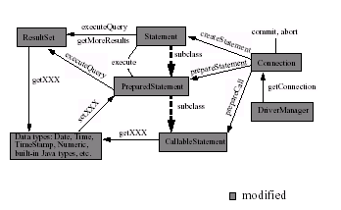

The list below contains the classes and interfaces that comprise the javax.sql pack-age.
A detailed specification of these new types is contained in a separate document.

javax.sql.ConnectionEvent
javax.sql.ConnectionEventListener
javax.sql.ConnectionPoolDataSurce
javax.sql.DataSource
javax.sql.PooledConnection
javax.sql.RowSet
javax.sql.RowSetEvent
javax.sql.RowSetInternal
javax.sql.RowSetListener
javax.sql.RowSetMetaData
javax.sql.RowSetReader
javax.sql.RowSetWriter
javax.sql.XAConnection
javax.sql.XADataSource

modified
Connection
DriverManager
PreparedStatement
Statement ResultSet
Data types: Date, Time,
TimeStamp, Numeric, CallableStatement
commit, abort
createStatement
getXXX
subclass
subclass
executeQuery
prepareStatement
getXXX
getConnection
prepareCall setXXX
getMoreResults
execute
built-in Java types, etc.
executeQuery

Result Set Enhancements
This chapter discusses the new functionality that has been added to result sets. The goal
of the enhancements is to add two new basic capabilities to result sets: scrolling and up-datability.Several methods have also been added to enable a JDBC driver to deliver im-proved performance when processing results. A variety of examples are included to
illustrate the new features.

Scrolling

A result set created by executing a statement may support the ability to move backward
(last-to-first) through its contents, as well as forward (first-to-last). Result sets that sup-portthis capability are called scrollable result sets. Result sets that are scrollable also
support relative and absolute positioning. Absolute positioning is the ability to move
directly to a row by specifying its absolute position in the result set, while relative po-sitioning gives the ability to move to a row by specifying a position that is relative to
the current row. The definition of absolute and relative positioning in the JDBC API is
modeled on the X/Open SQL CLI specification.

Result Set types

The JDBC 1.0 API provided one result set type—forward-only. The JDBC 2.1 core API
provides three result set types: forward-only, scroll-insensitive, and scroll-sensitive. As
their names suggest, the new result set types support scrolling, but they differ in their
ability to make changes visible while they are open.

A scroll-insensitive result set is generally not sensitive to changes that are made while
it is open. A scroll-insensitive result set provides a static view of the underlying data it
contains. The membership, order, and column values of rows in a scroll-insensitive re-sultset are typically fixed when the result set is created. On the other hand, a scroll-sensitive result set is sensitive to changes that are made while it is open, and provides a ‘dynamic’ view of the underlying data. For example, when using a scroll-sensitive result set, changes in the underlying column values of rows are visible. The membership and ordering of rows in the result set may be fixed—this is implementation defined.

Concurrency types

An application may choose from two different concurrency types for a result set: read-only and updatable. A result set that uses read-only concurrency does not allow updates of its contents. This can increase the overall level of concurrency between transactions, since any number of read-only locks may be held on a data item simultaneously.
A result set that is updatable allows updates and may use database write locks to me-diate access to the same data item by different transactions. Since only a single write
lock may be held at a time on a data item, this can reduce concurrency. Alternatively,
an optimistic concurrency control scheme may be used if it is thought that conflicting accesses to data will be rare. Optimistic concurrency control implementations typically
compare rows either by value or by a version number to determine if an update conflict
has occurred.

Performance

Two performance hints may be given to a JDBC 2.1 technology-enabled driver to make
access to result set data more efficient. Specifically, the number of rows to be fetched
from the database each time more rows are needed can be specified, and a direction for
processing the rows—forward, reverse, or unknown—can be given as well. These val-ues
can be changed for an individual result set at any time. A JDBC driver may ignore
a performance hint if it chooses.

Creating a result set

The example below illustrates creation of a result set that is forward-only and uses read-only concurrency. No performance hints are given by the example, so the driver is free
to do whatever it thinks will result in the best performance. The transaction isolation
level for the connection is not specified, so the default transaction isolation level of the
underlying database is used for the result set that is created. Note that this code is just
written using the JDBC 1.0 API, and that it produces the same type of result set that
would have been produced by the JDBC 1.0 API.

Connection con = DriverManager.getConnection("jdbc:my_subprotocol:my_subname");
Statement stmt = con.createStatement();
ResultSet rs = stmt.executeQuery("SELECT emp_no, salary FROM mployees");

The next example creates a scrollable result set that is updatable and sensitive to
updates. Rows of data are requested to be fetched twenty-five at-a-time from the database.

Connection con = DriverManager.getConnection("jdbc:my_subprotocol:my_subname");
Statement stmt = con.createStatement(ResultSet.TYPE_SCROLL_SENSITIVE,
ResultSet.CONCUR_UPDATABLE);

stmt.setFetchSize(25);
ResultSet rs = stmt.executeQuery("SELECT emp_no,salary FROM employees");

The example below creates a result set with the same attributes as the previous example,
however, a prepared statement is used to produce the result set.

PreparedStatement pstmt = con.prepareStatement("SELECT emp_no, salary FROM employees where emp_no = ?",
ResultSet.TYPE_SCROLL_SENSITIVE,
ResultSet.CONCUR_UPDATABLE);

pstmt.setFetchSize(25);
pstmt.setString(1, "100010");
ResultSet rs = pstmt.executeQuery();

The method DatabaseMetaData.supportsResultSetType() can be called to see
which result set types are supported by a JDBC driver. However, an application may
still ask a JDBC driver to create a Statement, PreparedStatement,or CallableStatement object using a result set type that the driver does not support. In this case, the driver should issue an SQLWarning on the Connection that produces the
statement and choose an alternative value for the result set type of the statement accord-ing to the following rules:

1. If an application asks for a scrollable result set type the driver should use a
scrollable type that it supports, even if this differs from the exact type requested
by the application.
2. If the application asks for a scrollable result set type and the driver does not
support scrolling, then the driver should use a forward-only result set type.
Similarly, the method DatabaseMetaData.supportsResultSetConcurrency() can
be called to determine which concurrency types are supported by a driver. If an appli-cation asks a JDBC driver for a concurrency type that it does not support then the driver
should issue an SQLWarning on the Connection that produces the statement and
choose the alternative concurrency type. The choice of result set type should be made
first if an application specifies both an unsupported result set type and an unsupported
concurrency type.

In some instances, a JDBC driver may need to choose an alternate result set type or con-currency type for a ResultSet at statement execution time. For example, a SELECT
statement that contains a join over multiple tables may not produce a ResultSet that is
updatable. The JDBC driver should issue an SQLWarning in this case on the Statement,
PreparedStatement,orCallableStatement that produces the ResultSet and
choose an appropriate result set type or concurrency type as described above. An appli-cation may determine the actual result set type and concurrency type of a ResultSet
by calling the ResultSet.getType() and getConcurrency() methods, respectively.

Updates
A result set is updatable if its concurrency type is CONCUR_UPDATABLE. Rows in an
Updatable result set may be updated, inserted, and deleted. The example below updates the first row of a result set. The ResultSet.updateXXX() methods are used to modify the value of an individual column in the current row, but do not update the underlying
database. When the ResultSet.updateRow() method is called the database is updated.
Columns may be specified by name or number.

rs.first();
rs.updateString(1, "100020");
rs.updateFloat(“salary”, 10000.0f);
rs.updateRow();

The updates that an application makes must be discarded by a JDBC driver if the appli-cationmoves the cursor from the current row before calling updateRow(). In addition,
an application can call the ResultSet.cancelRowUpdates() method to explicitly
cancel the updates that have been made to a row. The cancelRowUpdates() method
must be called after calling updateXXX() and before calling updateRow(), otherwise
it has no effect.

The following example illustrates deleting a row. The fifth row in the result set is de-leted
from the database.

rs.absolute(5);
rs.deleteRow();

The example below shows how a new row may be inserted into a result set. The JDBC
API defines the concept of an insert row that is associated with each result set and is
used as a staging area for creating the contents of a new row before it is inserted into
the result set itself. The ResultSet.moveToInsertRow() method is used to position
the result set’s cursor on the insert row. The ResultSet.updateXXX()and ResultSet.
getXXX() methods are used to update and retrieve individual column values from
the insert row. The contents of the insert row is undefined immediately after calling
ResultSet.

moveToInsertRow(). In other words, the value returned by calling a ResultSet.
getXXX() method is undefined after moveToInsertRow() is called until the
value is set by calling ResultSet.updateXXX(). Calling ResultSet.updateXXX() while on the insert row does not update the underlying database or the result set.
Once all of the column values are set in the insert row, ResultSet.insertRow() is called to update the result set and the database simulta-neously.
If a column is not given a value by calling updateXXX() while on the insert
row, or a column is missing from the result set, then that column must allow a null value.
Otherwise, calling insertRow() throws an SQLException.

rs.moveToInsertRow();
rs.updateString(1, "100050");
rs.updateFloat(2, 1000000.0f);
rs.insertRow();
rs.first();

A result set remembers the current cursor position “in the result set” while its cursor is
temporarily positioned on the insert row. To leave the insert row, any of the usual cursor
positioning methods may be called, including the special method Result-Set.
moveToCurrentRow() which returns the cursor to the row which was the current
row before ResultSet.moveToInsertRow() was called. In the example above,
ResultSet.first() is called to leave the insert row and move to the first row of the
resultset.
Due to differences in database implementations, the JDBC API does not specify an ex-act
set of SQL queries which must yield an updatable result set for JDBC drivers that
support updatability. Developers can, however, generally expect queries which meet
the following criteria to produce an updatable result set:

1. The query references only a single table in the database.
2. The query does not contain any join operations.
3. The query selects the primary key of the table it references.
In addition, an SQL query should also satisfy the conditions listed below if inserts are
to be performed.
4. The query selects all of the non-nullable columns in the underlying table.
5. The query selects all columns that don’t have a default value.

Cursor movement examples

A result set maintains an internal pointer called a cursor that indicates the row in the
result set that is currently being accessed. A result set cursor is analogous to the cursor
on a computer screen which indicates the current screen position. The cursor main-tained
by a forward-only result set can only move forward through the contents of the
result set. Thus, rows are accessed sequentially beginning with the first row.
Iterating forward through a result set is done by calling the ResultSet.next() method,
as with the JDBC 1.0 API. In addition, scrollable result sets—any result set whose type
is not forward only—implement the method, beforeFirst(), which may be called to
position the cursor before the first row in the result set.
The example below positions the cursor before the first row and then iterates forward
through the contents of the result set. The getXXX() methods, which are JDBC 1.0 API
methods, are used to retrieve column values.

rs.beforeFirst();
while ( rs.next()) {
System.out.println(rs.getString("emp_no")+ " " +rs.getFloat("salary"));
}

Of course, one may iterate backward through a scrollable result set as well, as is shown
below.

rs.afterLast();
while (rs.previous()) {
System.out.println(rs.getString(“emp_no”) +
“ “ + rs.getFloat(“salary”));
}

In this example, the ResultSet.afterLast() method positions the scrollable result
set’s cursor after the last row in the result set. The ResultSet.previous() method is
called to move the cursor to the last row, then the next to last, and so on. Result-Set.
previous() returns false when there are no more rows, so the loop ends after all
of the rows have been visited.
After examining the ResultSet interface, the reader will no doubt recognize that there
is more than one way to iterate through the rows of a scrollable result set. It pays to be
careful, however, as is illustrated by the following example, which shows one alterna-tive
that is incorrect.

// incorrect!!!

while (!rs.isAfterLast()) {
rs.relative(1);
System.out.println(rs.getString("emp_no") +
" " + rs.getFloat("salary"));
}

This example attempts to iterate forward through a scrollable result set and is incorrect
for several reasons. One error is that if ResultSet.isAfterLast() is called when the
result set is empty, it will return a value of false since there is no last row, and the loop
body will be executed, which is not what is wanted. An additional problem occurs when
the cursor is positioned before the first row of a result set that contains data. In this case
calling rs.relative(1) is erroneous since there is no current row.
The code sample below fixes the problems in the previous example. Here a call to
ResultSet.first() is used to distinguish the case of an empty result set from one which contains data. Since ResultSet.isAfterLast() is only called when the result set is non-empty the loop control works correctly, and ResultSet.relative(1) steps
through the rows of the result set since ResultSet.first() initially positions the
cursor on the first row.

if (rs.first()) {
while (!rs.isAfterLast()) {
System.out.println(rs.getString("emp_no") +
" " + rs.getFloat("salary"));
rs.relative(1); } }

Detecting and viewing changes

So far, we have introduced the different result set types and shown a few examples of
how a result set of a particular type can be created, updated, and traversed. This section
goes into more detail on the differences between result set types, and what these
differencesmean for an application that uses result sets. The different result set types—forward-only, scroll-insensitive, and scroll-sensitive provided by the JDBC API vary greatly in their ability to make changes in the underlying data visible to an application. This aspect of result sets is particularly interesting for the result set types which support scrolling, since they allow a particular row to be visited. multiple times while a result set is open.

Visibility of changes

We begin the discussion of this topic by describing the visibility of changes at the trans-action level. First, note the seemingly obvious fact that all of the updates that a transac-tion makes are visible to itself. However, the changes (updates, inserts, and deletes)
made by other transactions that are visible to a particular transaction are determined by
the transaction isolation level. The isolation level for a transaction can be set by calling
con.setTransactionIsolation(TRANSACTION_READ_COMMITTED);
where the variable con has type Connection. If all transactions in a system execute at
the TRANSACTION_READ_COMMITTED isolation level or higher, then a transaction will
only see the committed changes of other transactions. The changes that are visible to a
result set’s enclosing transaction when a result set is opened are always visible through
the result set. In fact, this is what it means for an update made by one transaction to be
visible to another transaction.
But what about changes made while a result set is open? Are they visible through the
result set by, for example, calling ResultSet.getXXX()? Whether a particular result
set exposes changes to its underlying data made by other transactions, other result sets
that are part of the same transaction (We refer to these two types of changes collectively
as ‘other’s changes’.), or itself while the result set is open depends on the result set type.

Other’s changes

A scroll-insensitive result set does not make any changes visible that are made by
Others -- other transactions and other result sets in the same transaction — once the result set is opened. The content of a scroll-insensitive result set with respect to changes made by others is static the membership, ordering, and row values are fixed. For example, if
another transaction deletes a row that is contained in a static result set while it is open,
the row remains visible. One way to implement a scroll-insensitive result set is to create
a private copy of the result set’s data. Scroll-sensitive result sets lie at the opposite end of the spectrum. A scroll-sensitive resultset makes all of the updates made by others that are visible to its enclosing transaction visible. Inserts and deletes may not be visible, however. Let us define carefully what it means for updates to be visible. If an update made by another transaction affects where a row should appear in the result set—this is in effect a delete followed by an insert—the row may not move until the result set is reopened. If an update causes a row to fail to qualify for membership in a result set—this is in effect a delete—the row may remain visible until the result set is reopened. If a row is explicitly deleted by another transaction, a scroll-sensitive result set may maintain a
placeholder for the row to permit logical fetching of rows by absolute position. Updated
column values are always visible, however.

The DatabaseMetaData interface provides a way to determine the exact capabilities
that are supported by a result set. For example, the new methods: othersUpdatesAre-Visible, othersDeletesAreVisible, and othersInsertsAreVisible may be used
for this purpose. A forward-only result set is really a degenerate case of either a scroll-insensitive or scroll-sensitive result set— depending on how the DBMS evaluates the query that produces the result set. Most DBMSs have the ability to materialize query results incre-mentally for some queries. If a query result is materialized incrementally, then data values aren’t actually retrieved until they are needed from the DBMS and the result set will behave like a sensitive result set. For some queries, however, incremental materialization isn’t possible. For example, if the result set is sorted, the entire result set may need to be produced a priori before the first row in the result set is returned to the application by the DBMS. In this case a forward-only result set will behave like an insen-sitive result set.
For a TYPE_FORWARD_ONLY result set the othersUpdatesAreVisible, othersDelete-sAreVisible, and othersInsertsAreVisible methods determine whether inserts,
updates, and deletes are visible when the result set is materialized incrementally by the
DBMS. If the result of a query is sorted then incremental materialization may not be
possible and changes will not be visible, even if the methods above return true.

A result set’s own changes

We have pointed out that the visibility of changes made by others generally depends on
a result set’s type. A final point that concerns the visibility of changes via an open result
set is whether a result set can see its own changes (inserts, updates, and deletes). A
JDBC technology application can determine if the changes made by a result set are vis-ible to the result set itself by calling the DatabaseMetaData methods:
ownUpdate-sAreVisible, ownDeletesAreVisible, and ownInsertsAreVisible. These methods are needed since this capability can vary between DBMSs and JDBC drivers.
One’s own updates are visible if an updated column value can be retrieved by calling
getXXX() following a call to updateXXX(). Updates are not visible if getXXX() still
returns the initial column value after updateXXX() is called. Similarly, an inserted row
is visible if it appears in the result set following a call to insertRow(). An inserted row
is not visible if it does not appear in the result set immediately after insertRow() is
called—without closing and reopening the result set. Deletions are visible if deleted
rows are either removed from the result set or if deleted rows leave a hole in the result
set.
The following example, shows how an application may determine whether a
TYPE_SCROLL_SENSITIVE result set can see its own updates.

DatabaseMetaData dmd;
...
if (dmd.ownUpdatesAreVisible(ResultSet.TYPE_SCROLL_INSENSITIVE))
{
// changes are visible
}

Detecting changes
The ResultSet.wasUpdated(), wasDeleted(), and wasInserted() methods can be
called to determine whether a row has been effected by a visible update, delete, or insert
respectively since the result set was opened. The ability of a result set to detect changes
is orthogonal to its ability to make changes visible. In other words, visible changes are
not automatically detected. The DatabaseMetaData interface provides methods that allow an application to determine whether a JDBC driver can detect changes for a particular result set type. For example,

boolean bool = dmd.deletesAreDetected(
ResultSet.TYPE_SCROLL_SENSITIVE);
If deletesAreDetected returns true, then ResultSet.wasDeleted() can be used to
detect ‘holes’ in a TYPE_SCROLL_SENSITIVE result set.

Refetching a row

Some applications may need to see up-to-the-second changes that have been made to a
row. Since a JDBC driver can do prefetching and caching of data that is read from the
underlying database (see ResultSet.setFetchSize()), an application may not see
the very latest changes that have been made to a row, even when a sensitive result set
is used and updates are visible. The ResultSet.refreshRow() method is provided to
allow an application to request that a driver refresh a row with the latest values stored
in the database. A JDBC driver may actually refresh multiple rows at once if the fetch
size is greater than one. Applications should exercise restraint in calling refre-shRow(),
since calling this method frequently will likely slow performance.

JDBC API compliance

Although we expect most JDBC drivers to support scrollable result sets, we have made
them optional to minimize the complexity of implementing JDBC drivers for data
sources that do not support scrollability. The goal is that it be possible for a JDBC driver
to implement scrollable result sets using the support provided by the underlying data-base
system for systems that have such support. If the DBMS associated with a driver
does not support scrollability then this feature may be omitted, or a JDBC driver may
implement scrollability as a layer on top of the DBMS. Its important to note that JDBC
technology rowsets, which are part of the JDBC Optional Package API, always support
scrollability, so a rowset can be used when the underlying DBMS doesn’t support
scrollable results.

Batch Updates

The batch update facility allows multiple update operations to be submitted to a data
source for processing at once. Submitting multiple updates together, instead of individ-ually,can greatly improve performance. Statement, PreparedStatement, and Call-ableStatement objects can be used to submit batch updates.

Description of batch updates

Statements

The batch update facility allows a Statement object to submit a set of heterogeneous
update commands together as a single unit, or batch, to the underlying DBMS. In the
example below all of the update operations required to insert a new employee into a fic-titious company database are submitted as a single batch.

// turn off autocommit
con.setAutoCommit(false);
Statement stmt = con.createStatement();
stmt.addBatch("INSERT INTO employees VALUES (1000, 'Joe Jones')");
stmt.addBatch("INSERT INTO departments VALUES (260, 'Shoe')");
stmt.addBatch("INSERT INTO emp_dept VALUES (1000, 260)");
// submit a batch of update commands for execution
int[] updateCounts = stmt.executeBatch();
In the example, autocommit mode is disabled to prevent the driver from committing the
transaction when Statement.executeBatch() is called. Disabling autocommit allows
an application to decide whether or not to commit the transaction in the event that an
error occurs and some of the commands in a batch cannot be processed successfully.
For this reason, autocommit should always be turned off when batch updates are done.
The commit behavior of executeBatch is always implementation defined when an
Error occurs and autocommit is true. To keep our discussion of batch updates general, we define the term element to refer to an individual member of a batch. As we have seen, an element in a batch is just a simple command when a Statement object is being used. Although we are focusing on using Statement objects to do batch updates in this section, the discussion that follows applies to PreparedStatment and CallableStatement objects, as well.

In the new JDBC API, a Statement object has the ability to keep track of a list of
commands— or batch—that can be submitted together for execution. When a Statement
object is created, its associated batch is empty—the batch contains no elements. The
Statement.addBatch() method adds an element to the calling statement’s batch. The
method Statement.clearBatch() (not shown above) can be called to reset a batch if the application decides not to submit a batch of commands that has been constructed
for a statement.

Successful execution

The Statement.executeBatch() method submits a statement’s batch to the underlying
data source for execution. Batch elements are executed serially (at least logically)
in the order in which they were added to the batch. When all of the elements in a batch
execute successfully, executeBatch() returns an integer array containing one entry
for each element in the batch. The entries in the array are ordered according to the order
in which the elements were processed (which, again, is the same as the order in which
the elements were originally added to the batch). An entry in the array may have the
following values:

1. If the value of an array entry is greater than or equal to zero, then the batch
element was processed successfully and the value is an update count indicating
the number of rows in the database that were effected by the element’s
execution.
2. A value of -2 indicates that a element was processed successfully, but that the
number of effected rows is unknown.
Calling executeBatch() closes the calling Statement object’s current result set if one
is open. The statement’s internal list of batch elements is reset to empty once execute-Batch() returns. The behavior of the executeQuery, executeUpdate,orexecute
methods is implementation defined when a statement’s batch is non-empty.
ExecuteBatch() throws a BatchUpdateException if any of the elements in the batch
fail to execute properly, or if an element attempts to return a result set. Only DDL and
DML commands that return a simple update count may be executed as part of a batch.
When a BatchUpdateException is thrown, the BatchUpdateException.getUpdate-Counts() method can be called to obtain an integer array of update counts that
Describes the outcome of the batch execution.

Handling failures during execution

A JDBC driver may or may not continue processing the remaining elements in a batch
once execution of an element in a batch fails. However, a JDBC driver must always provide the same behavior when used with a particular DBMS. For example, a driver cannot continue processing after a failure for one batch, and not continue processing for
another batch.

If a driver stops processing after the first failure, the array returned by BatchUpdate-Exception.getUpdateCounts() will always contain fewer entries than there were
Elements in the batch. Since elements are executed in the order that they are added to the
batch, if the array contains N elements, this means that the first N elements in the batch
were processed successfully when executeBatch() was called. When a driver continues processing in the presence of failures, the number of elements, N, in the array returned by BatchUpdateException.getUpdateCounts()is always equal to the number of elements in the batch.

The following additional array value is returned when a BatchUpdateException is thrown and the driver continues processing after a failure:

3. A value of -3 indicates that the command or element failed to execute successfully. This value is also returned for elements that could not be processed for some reason—such elements fail implicitly. JDBC drivers that do not continue processing after a failure never return -3 in an update count array. Drivers of this type simply return a status array containing an entry for each command that was processed successfully.
A JDBC technology based application can distinguish a JDBC driver that continues
processing after a failure from one that does not by examining the size of the array
returned by BatchUpdateException.getUpdateCounts(). A JDBC driver that continues processing always returns an array containing one entry for each element in the
batch. A JDBC driver that does not continue processing after a failure will always re-turn
an array whose number of entries is less than the number of elements in the batch.

PreparedStatements
An element in a batch consists of a parameterized command and an associated set of
parameters when a PreparedStatement is used. The batch update facility is used with
a PreparedStatement to associate multiple sets of input parameter values with a single
PreparedStatement object. The sets of parameter values together with their associat-ed
parameterized update command can then be sent to the underlying DBMS engine for
execution as a single unit.
The example below inserts two new employee records into a database as a single batch.The PreparedStatement.setXXX() methods are used to create each parameter- set (one for each employee), while the PreparedStatement.addBatch() method adds a
set of parameters to the current batch.

// turn off autocommit
con.setAutoCommit(false);
PreparedStatement stmt = con.prepareStatement(
"INSERT INTO employees VALUES (?, ?)");
stmt.setInt(1, 2000);
stmt.setString(2, "Kelly Kaufmann");
stmt.addBatch();
stmt.setInt(1, 3000);
stmt.setString(2, "Bill Barnes");
stmt.addBatch();
// submit the batch for execution
int[] updateCounts = stmt.executeBatch();

Finally, PreparedStatement.executeBatch() is called to submit the updates to the
DBMS. Calling PreparedStatement.executeBatch() clears the statement’s associated list of batch elements. The array returned by PreparedStatement.executeBatch()
contains an element for each set of parameters in the batch, similar to the case
for Statement. Each element either contains an update count or the generic ‘success’
indicator (-2). Error handling in the case of PreparedStatement objects is the same as error handling in the case of Statement objects. Some drivers may stop processing as soon as an error occurs, while others may continue processing the rest of the batch. As for
Statement, the number of elements in the array returned by BatchUpdateException.
getUpdateCounts() indicates whether or not the driver continues processing
after a failure. The same three array element values are possible, as for Statement.
The order of the entries in the array is the same order as the order in which elements were added to the batch.

Callable Statements

The batch update facility works the same with CallableStatement objects as it does
with PreparedStatement objects. Multiple sets of input parameter values may be
associated with a callable statement and sent to the DBMS together. Stored procedures
invoked using the batch update facility with a callable statement must return an update
count, and may not have out or inout parameters.
The CallableStatement.executeBatch() method should throw an exception if this restriction is violated. Error handling is analogous to PreparedStatement.

Introduction to Servlets
Servlets provide a Java^{(TM)}-based solution used to address the problems currently associated with doing server-side programming, including inextensible scripting solutions, platform-specific APIs, and incomplete interfaces.
Servlets are objects that conform to a specific interface that can be plugged into a Java-based server. Servlets are to the server-side what applets are to the client-side -- object bytecodes that can be dynamically loaded off the net. They differ from applets in that they are faceless objects (without graphics or a GUI component). They serve as platform-independent, dynamically-loadable, pluggable helper bytecode objects on the server side that can be used to dynamically extend server-side functionality.

What is a Servlet?
Servlets are modules that extend request/response-oriented servers, such as Java-enabled web servers. For example, a servlet might be responsible for taking data in an HTML order-entry form and applying the business logic used to update a company's order database.
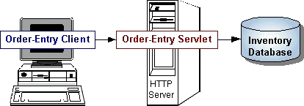
Servlets are to servers what applets are to browsers. Unlike applets, however, servlets have no graphical user interface.
Servlets can be embedded in many different servers because the servlet API, which you use to write servlets, assumes nothing about the server's environment or protocol. Servlets have become most widely used within HTTP servers; many web servers support the Servlet API.

Use Servlets instead of CGI Scripts!
Servlets are an effective replacement for CGI scripts. They provide a way to generate dynamic documents that is both easier to write and faster to run. Servlets also address the problem of doing server-side programming with platform-specific APIs: they are developed with the Java Servlet API, a standard Java extension.
So use servlets to handle HTTP client requests. For example, have servlets process data POSTed over HTTPS using an HTML form, including purchase order or credit card data. A servlet like this could be part of an order-entry and processing system, working with product and inventory databases, and perhaps an on-line payment system.

Other Uses for Servlets
Here are a few more of the many applications for servlets:
- Allowing collaboration between people. A servlet can handle multiple requests concurrently, and can synchronize requests. This allows servlets to support systems such as on-line conferencing.
- Forwarding requests. Servlets can forward requests to other servers and servlets. Thus servlets can be used to balance load among several servers that mirror the same content, and to partition a single logical service over several servers, according to task type or organizational boundaries.

Architecture of the Servlet Package
The javax.servlet package provides interfaces and classes for writing servlets. The architecture of the package is described below.

The Servlet Interface
The central abstraction in the Servlet API is the Servlet interface. All servlets implement this interface, either directly or, more commonly, by extending a class that implements it such as HttpServlet.
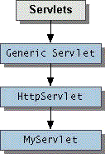
The Servlet interface declares, but does not implement, methods that manage the servlet and its communications with clients. Servlet writers provide some or all of these methods when developing a servlet.

Client Interaction
When a servlet accepts a call from a client, it receives two objects:
- A ServletRequest, which encapsulates the communication from the client to the server.
- A ServletResponse, which encapsulates the communication from the servlet back to the client.
ServletRequest and ServletResponse are interfaces defined by the javax.servlet package.

The ServletRequest Interface
The ServletRequest interface allows the servlet access to:
- Information such as the names of the parameters passed in by the client, the protocol (scheme) being used by the client, and the names of the remote host that made the request and the server that received it.
- The input stream, ServletInputStream. Servlets use the input stream to get data from clients that use application protocols such as the HTTP POST and PUT methods.
Interfaces that extend ServletRequest interface allow the servlet to retrieve more protocol-specific data. For example, the HttpServletRequest interface contains methods for accessing HTTP-specific header information.

The ServletResponse Interface
The ServletResponse interface gives the servlet methods for replying to the client. It:
- Allows the servlet to set the content length and MIME type of the reply.
- Provides an output stream, ServletOutputStream, and a Writer through which the servlet can send the reply data.
Interfaces that extend the ServletResponse interface give the servlet more protocol-specific capabilities. For example, the HttpServletResponse interface contains methods that allow the servlet to manipulate HTTP-specific header information.

Additional Capabilities of HTTP Servlets
The classes and interfaces described above make up a basic Servlet. HTTP servlets have some additional objects that provide session-tracking capabilities. The servlet writer can use these APIs to maintain state between the servlet and the client that persists across multiple connections during some time period. HTTP servlets also have objects that provide cookies. The servlet writer uses the cookie API to save data with the client and to retrieve this data.

A Simple Servlet
The following class completely defines servlet:
public class SimpleServlet extends HttpServlet
{
/**
* Handle the HTTP GET method by building a simple web page.
*/
public void doGet (HttpServletRequest request,
HttpServletResponse response)
throws ServletException, IOException
{
PrintWriter out;
String title = "Simple Servlet Output";

// set content type and other response header fields first
response.setContentType("text/html");

// then write the data of the response
out = response.getWriter();

out.println("<HTML><HEAD><TITLE>");
out.println(title);
out.println("</TITLE></HEAD><BODY>");
out.println("<H1>" + title + "</H1>");
out.println("<P>This is output from SimpleServlet.");
out.println("</BODY></HTML>");
out.close();
}
}
That's it!
The classes mentioned in the Architecture of the Servlet Package section are shown in the example in bold:
- SimpleServlet extends the HttpServlet class, which implements the Servlet interface.
- SimpleServlet overrides the doGet method in the HttpServlet class. The doGet method is called when a client makes a GET request (the default HTTP request method), and results in the simple HTML page being returned to the client.
- Within the doGet method,
  - The user's request is represented by an HttpServletRequest object.
  - The response to the user is represented by an HttpServletResponse object.
  - Because text data is returned to the client, the reply is sent using the Writer object obtained from the HttpServletResponse object.

Servlet Lifecycle
Each servlet has the same life cycle:
- A server loads and initializes the servlet
- The servlet handles zero or more client requests
- The server removes the servlet

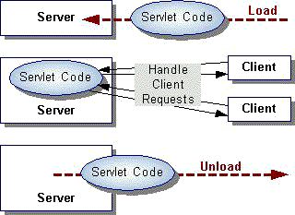

Initializing a Servlet
When a server loads a servlet, the server runs the servlet's init method. Initialization completes before client requests are handled and before the servlet is destroyed.
Even though most servlets are run in multi-threaded servers, servlets have no concurrency issues during servlet initialization. The server calls the init method once, when the server loads the servlet, and will not call the init method again unless the server is reloading the servlet. The server can not reload a servlet until after the server has destroyed the servlet by calling the destroy method.
The init Method
The init method provided by the HttpServlet class initializes the servlet and logs the initialization. To do initialization specific to your servlet, override the init() method following these rules:
- If an initialization error occurs that renders the servlet incapable of handling client requests, throw an UnavailableException.
An example of this type of error is the inability to establish a required network connection.
- Do not call the System.exit method
Here is an example init method:
public class BookDBServlet ... {

private BookstoreDB books;

public void init() throws ServletException {

// Load the database to prepare for requests
books = new BookstoreDB();
}
...
}

The init method is quite simple: it sets a private field.
If the BookDBServlet used an actual database, instead of simulating one with an object, the init method would be more complex. Here is pseudo-code for what the init method might look like:
public class BookDBServlet ... {

public void init() throws ServletException {

// Open a database connection to prepare for requests
try {
databaseUrl = getInitParameter("databaseUrl");
... // get user and password parameters the same way
connection = DriverManager.getConnection(databaseUrl,
user, password);
} catch(Exception e) {
throw new UnavailableException (this,
"Could not open a connection to the database");
}
}
...
}

Initialization Parameters
The second version of the init method calls the getInitParameter method. This method takes the parameter name as an argument and returns a String representation of the parameter's value.
The specification of initialization parameters is server-specific. In the Java Web Server, the parameters are specified with a servlet is added then configured in the Administration Tool. For an explanation of the Administration screen where this setup is performed, see the Administration Tool: Adding Servlets online help document.
If, for some reason, you need to get the parameter names, use the getParameterNames method.

Destroying a Servlet
Servlets run until the server are destroys them, for example at the request of a system administrator. When a server destroys a servlet, the server runs the servlet's destroy method. The method is run once; the server will not run that servlet again until after the server reloads and reinitializes the servlet.
When the destroy method runs, another thread might be running a service request. The Handling Service Threads at Servlet Termination section shows you how to provide a clean shutdown when there could be long-running threads still running service requests.

Using the Destroy Method
The destroy method provided by the HttpServlet class destroys the servlet and logs the destruction. To destroy any resources specific to your servlet, override the destroy method. The destroy method should undo any initialization work and synchronize persistent state with the current in-memory state.
The following example shows the destroy method that accompanies the init method shown previously:
public class BookDBServlet extends GenericServlet {
private BookstoreDB books;
... // the init method
public void destroy() {
// Allow the database to be garbage collected
books = null;
}
}

A server calls the destroy method after all service calls have been completed, or a server-specific number of seconds have passed, whichever comes first. If your servlet handles any long-running operations, service methods might still be running when the server calls the destroy method. You are responsible for making sure those threads complete. The next section shows you how.
The destroy method shown above expects all client interactions to be completed when the destroy method is called, because the servlet has no long-running operations.

Handling Service Threads at Servlet Termination
All of a servlet's service methods should be complete when a servlet is removed. The server tries to ensure this by calling the destroy method only after all service requests have returned, or after a server-specific grace period, whichever comes first. If your servlet has operations that take a long time to run (that is, operations that may run longer than the server's grace period), the operations could still be running when destroy is called. You must make sure that any threads still handling client requests complete; the remainder of this section describes a technique for doing this.
If your servlet has potentially long-running service requests, use the following techniques to:
- Keep track of how many threads are currently running the service method.
- Provide a clean shutdown by having the destroy method notify long-running threads of the shutdown and wait for them to complete
- Have the long-running methods poll periodically to check for shutdown and, if necessary, stop working, clean up and return.

Tracking Service Requests
To track service requests, include a field in your servlet class that counts the number of service methods that are running. The field should have access methods to increment, decrement, and return its value. For example:
public ShutdownExample extends HttpServlet {
private int serviceCounter = 0;
...
//Access methods for serviceCounter
protected synchronized void enteringServiceMethod() {
serviceCounter++;
}
protected synchronized void leavingServiceMethod() {
serviceCounter--;
}
protected synchronized int numServices() {
return serviceCounter;
}
}
The service method should increment the service counter each time the method is entered and decrement the counter each time the method returns. This is one of the few times that your HttpServlet subclass should override the service method. The new method should call super.service to preserve all the original HttpServlet.service method's functionality.
protected void service(HttpServletRequest req, HttpServletResponse resp)
throws ServletException, IOException
{
enteringServiceMethod();
try {
super.service(req, resp);
} finally {
leavingServiceMethod();
}
}

Providing a Clean Shutdown
To provide a clean shutdown, your destroy method should not destroy any shared resources until all the service requests have completed. One part of doing this is to check the service counter. Another part is to notify the long-running methods that it is time to shut down. For this, another field is required along with the usual access methods. For example:
public ShutdownExample extends HttpServlet {
private boolean shuttingDown;
...
//Access methods for shuttingDown
protected setShuttingDown(boolean flag) {
shuttingDown = flag;
}
protected boolean isShuttingDown() {
return shuttingDown;
}
}
An example of the destroy method using these fields to provide a clean shutdown is shown below:
public void destroy() {

/* Check to see whether there are still service methods running,
* and if there are, tell them to stop. */
if (numServices() > 0) {
setShuttingDown(true);
}

/* Wait for the service methods to stop. */
while(numServices() > 0) {
try {
Thread.sleep(interval);
} catch (InterruptedException e) {
}
}
}

Creating Polite Long-running Methods
The final step in providing a clean shutdown is to make any long-running methods behave politely. Methods that might run for a long time should check the value of the field that notifies them of shut downs, and interrupt their work if neceesary. For example:
public void doPost(...) {
...
for(i = 0; ((i < lotsOfStuffToDo) && !isShuttingDown()); i++) {
try {
partOfLongRunningOperation(i);
} catch (InterruptedException e) {
}
}
}

Servlet-client Interaction

Handling HTTP Clients
An HTTP Servlet handles client requests through its service method. The service method supports standard HTTP client requests by dispatching each request to a method designed to handle that request. For example, the service method calls the doGet method shown earlier in the simple example servlet.

Requests and Responses
Methods in the HttpServlet class that handle client requests take two arguments:
- An HttpServletRequest object, which encapsulates the data from the client
- An HttpServletResponse object, which encapsulates the response to the client

HttpServletRequest Objects
An HttpServletRequest object provides access to HTTP header data, such as any cookies found in the request and the HTTP method with which the request was made. The HttpServletRequest object also allows you to obtain the arguments that the client sent as part of the request.
To access client data:
- The getParameter method returns the value of a named parameter. If your parameter could have more than one value, use getParameterValues instead. The getParameterValues method returns an array of values for the named parameter. (The method getParameterNames provides the names of the parameters.)
- For HTTP GET requests, the getQueryString method returns a String of raw data from the client. You must parse this data yourself to obtain the parameters and values.
- For HTTP POST, PUT, and DELETE requests,
  - If you expect text data, the getReader method returns a BufferedReader for you to use to read the raw data.
  - If you expect binary data, the getInputStream method returns a ServletInputStream for you to use to read the raw data

Note: Use either a getParameter[Values] method or one of the methods that allow you to parse the data yourself. They can not be used together in a single request.

HttpServletResponse Objects
An HttpServletResponse object provides two ways of returning data to the user:
- The getWriter method returns a Writer
- The getOutputStream method returns a ServletOutputStream
Use the getWriter method to return text data to the user, and the getOutputStream method for binary data.
Closing the Writer or ServletOutputStream after you send the response allows the server to know when the response is complete.

HTTP Header Data
You must set HTTP header data before you access the Writer or OutputStream. The HttpServletResponse class provides methods to access the header data. For example, the setContentType method sets the content type. (This header is often the only one manually set.)

Handling GET and POST Requests
The methods to which the service method delegates HTTP requests include,
- doGet, for handling GET, conditional GET, and HEAD requests
- doPost, for handling POST requests
- doPut, for handling PUT requests
- doDelete, for handling DELETE requests
By default, these methods return a BAD_REQUEST (400) error. Your servlet should override the method or methods designed to handle the HTTP interactions that it supports. This section shows you how to implement methods that handle the most common HTTP requests: GET and POST.
The HttpServlet's service method also calls the doOptions method when the servlet receives an OPTIONS request, and doTrace when the servlet receives a TRACE request. The default implementation of doOptions automatically determines what HTTP options are supported and returns that information. The default implementation of doTrace causes a response with a message containing all of the headers sent in the trace request. These methods are not typically overridden.

Threading Issues
HTTP servlets are typically capable of serving multiple clients concurrently. If the methods in your servlet that do work for clients access a shared resource, then you can handle the concurrency by creating a servlet that handles only one client request at a time. (You could also synchronize access to the resource, a general topic in the Java Programming Language that is note covered in this tutorial.)
To have your servlet handle only one client at a time, have your servlet implement the SingleThreadModel interface in addition to extending the HttpServlet class.
Implementing the SingleThreadModel interface does not involve writing any extra methods. You merely declare that the servlet implements the interface, and the server makes sure that your servlet runs only one service method at a time.
For example, the ReceiptServlet accepts a user's name and credit card number, and thanks the user for their order. If this servlet actually updated a database, for example one that kept track of inventory, then the database connection might be a shared resource. The servlet could either synchronize access to that resource, or it could implement the SingleThreadModel interface. If the servlet implemented the interface, the only change in the code from the previous section is the one line shown in bold:
public class ReceiptServlet extends HttpServlet
implements SingleThreadModel {

public void doPost(HttpServletRequest request,
HttpServletResponse response)
throws ServletException, IOException {
...
}
...
}

Servlet Descriptions
In addition to handling HTTP client requests, some applications, such as the Java Web Server's Administration Tool, get descriptive information from the servlet and display it. The servlet description is a string that can describe the purpose of the servlet, its author, its version number, or whatever the servlet author deems important.
The method that returns this information is getServletInfo, which returns null by default. You are not required to override this method, but applications are unable to supply a description of your servlet unless you do.
The following example shows the description of the BookStoreServlet:
public class BookStoreServlet extends HttpServlet {
...
public String getServletInfo() {
return "The BookStore servlet returns the " +
"main web page for Duke's Bookstore.";
}
}

Writing Your First Servlet
Servlets are also easy to develop. This document discusses the following minimum steps needed to create any servlet:
- Write the servlet
  - Import the necessary Java packages
  - Inherit from GenericServlet or the HTTP convenience class HttpServlet
  - Override the service method (this is where the actual work is done by the servlet)
  - Save the file with a .java filename extension
- Compile the servlet
  - Make sure jws.jar is included in your classpath
  - Invoke javac
- Install the servlet
  - Use the Java Web Server's Administration Tool to install it, and optionally configure it.
- Test the servlet
  - Invoke the servlet from a JDK1.1-compatible browser.
We'll discuss each one of these steps in its simplest form.
There are also lots of servlet examples complete with working code.

Write the servlet
The following class completely defines a servlet:
//Import needed Java packages

import java.io.*;
import javax.servlet.*;
import javax.servlet.http.*;

// Create a class which inherits from GenericServlet or HttpServlet.

public class MyFirst extends HttpServlet
{
/**
* Override the service method.
* Here we handle the HTTP GET method by building a simple web page.
*/

public void doGet (HttpServletRequest request,
HttpServletResponse response)
throws ServletException, IOException
{
PrintWriter out;
String title = "MyFirst Servlet Output";

// set content type and other response header fields first
response.setContentType("text/html");

// then write the data of the response
out = response.getWriter();

out.println("<HTML><HEAD><TITLE>");
out.println(title);
out.println("</TITLE></HEAD><BODY>");
out.println("<H1>" + title + "</H1>");
out.println("<P>This is output from MyFirst servlet.");
out.println("</BODY></HTML>");
out.close();
}
}
Don't forget to save the file with the name of the class and a .java filename extension -- in this case, we'll use MyFirst.java.

Compile the servlet
Make sure the compiler will be able to find the jws.jar file. The jws.jar file contains Java Web Server's implementation of the Servlet API. Ensuring the compiler can find the file is easy to do using the cp option to the compiler, as we do below. (You can also modify the classpath environment variable temporarily from a command line or permanently in your system setttings.)
Use javac, located in the Java Web Server's jre/bin directory, to compile the .java file. You'll need to copy the resulting .class file to the servlets directory of the Java Web Server so the web server will automatically find it. To skip the copying step, simply invoke javac with the -d option to direct the resulting .class file to the target directory.
For example, the following command compiles MyFirst.java and stores the resulting MyFirst.class file in the servlets directory:
javac -cp server_root/lib/jws.jar -d server_root/servlets MyFirst.java
where server_root is the directory of the installed Java Web Server.

Install the servlet
The process for installing a servlet into a web server varies from web server to webserver. For the Java Web Server, the procedure is as follows:
- Start the Java Web Server, if it is not already running
- Log in to the Java Web Server on the administration port.
By default, the administration port is 9090 and the username/password is admin/admin. If you are successful, you should see the services page of the AdminTool applet.
- Select the WebPage Service then click the Manage button. This should bring up the Web Service window.
- Click the Servlets button, then select the Add entry in the list in the lefthand pane. You should now see the Add a New Servlet fields in the righthand pane.
- Fill in the fields as follows:
  - Servlet Name: Choose any name you like, it need not be related to the filename. This will be the name used to invoke the servlet. We'll use FirstServlet.
  - Servlet Class: Provide the actual name of the servlet class, not file, you created -- for this example the real name is MyFirst.
  - Click the Add button and you will see your servlet name appear in the list of servlets in the lefthand pane under Configure. The righthand pane will have changed to two tabbed panels -- Configuration and Properties. We won't need these for our simple example so simply close the window.

Test the servlet
If you successfully compiled MyFirst.java and added it to the Java Web Server as described above, you should be able to invoke it from a JDK1.1-compatible browser. Use a URL of the following form:
http://host_name:port/servlet/servlet_name
For example:
http://schnauzer:8080/servlet/FirstServlet
That's it! You've just developed your first servlet.

About Session Tracking
Session T tracking is a flexible, lightweight mechanism that enables stateful programming on the web. Its general implementation serves as a basis for more sophisticated state models, such as persistent user profiles or multi-user sessions.
A session is a series of requests from the same user that occur during a time period. This transaction model for sessions has many benefits over the single-hit model. It can maintain state and user identity across multiple page requests. It can also construct a complex overview of user behavior that goes beyond reporting of user hits.

Server-Side Session Objects and Users
Session tracking gives servlets and other server-side applications the ability to keep state information about a user as the user moves through the site. Server-side applications can use this facility to create more stateful user experiences and to track who's doing what on the site.
Java Web Server maintains user state by creating a Session object for each user on the site. These Session objects are stored and maintained on the server. When a user first makes a request to a site, the user is assigned a new Session object and a unique session ID. The session ID matches the user with the Session object in subsequent requests. The Session object is then passed as part of the request to the servlets that handle the request. Servlets can add information to Session objects or read information from them.

Session Endurance
After the user has been idle for more than a certain period of time (30 minutes by default), the user's session becomes invalid, and the corresponding Session object is destroyed.
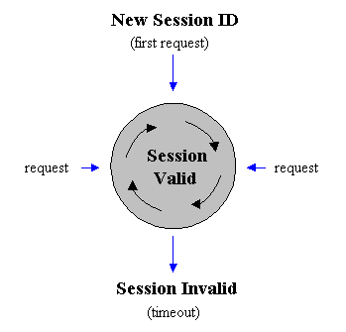
A session is a set of requests originating from the same browser, going to the same server, bounded by a period of time. Loosely speaking, a session corresponds to a single sitting of a single anonymous user (anonymous because no explicit login or authentication is required to participate in session tracking).

Using Session Tracking from a Servlet
The following example uses the doGet method from a servlet that prints the number of times users access a particular servlet.
public void doGet (HttpServletRequest request, HttpServletResponse response)
throws ServletException, IOException
{

// Obtain the Session object
HttpSession session = request.getSession (true);

// Get the session data value
Integer ival = (Integer)
session.getValue ("sessiontest.counter");
if (ival == null) ival = new Integer (1);
else ival = new Integer (ival.intValue () + 1);
session.putValue ("sessiontest.counter", ival);

// Output the page
response.setContentType("text/html");
ServletOutputStream out = response.getOutputStream();
out.println("<html>");
out.println("<head><title>Session Tracking Test</title></head>");
out.println("<body>");
out.println("<h1>Session Tracking Test</h1>");
out.println ("You have hit this page " + ival + " times");
out.println("</body></html>");
}
The first part of the doGet method associates the Session object with the user making the request. The second part of the method gets an integer data value from the Session object and increments it. The third part outputs the page, including the current value of the counter.
When run, this servlet should output the value of the counter that increments every time you reload the page. You must obtain the Session object before you actually write any data to the servlet's output stream. This guarantees that the session tracking headers are sent with the response.

Storing and Retrieving Data From the Session Object
You obtain the session data value with the following:
Integer ival = (Integer)
session.getValue ("sessiontest.counter");
if (ival == null) ival = new Integer (1);
else ival = new Integer (ival.intValue () + 1);
session.putValue ("sessiontest.counter", ival);
The Session object has methods similar to java.util.Dictionary for adding, retrieving, and removing arbitrary Java objects. In this example, an Integer object is read from the Session object, incremented, then written back to the Session object.
Any name, such as sessiontest.counter, may be used to identify values in the Session object. When choosing names, remember that the Session object is shared among any servlets that the user might access. Servlets may access or overwrite each other's values from the Session. Thus, it is good practice to adopt a convention for organizing the namespace to avoid collisions between servlets, such as:
servletname.name

Session Invalidation
Sessions can be invalidated automatically or manually. Session objects that have no page requests for a period of time (30 minutes by default) are automatically invalidated by the Session Tracker sessionInvalidationTime parameter. When a session is invalidated, the Session object and its contained data values are removed from the system.
After invalidation, if the user attempts another request, the Session Tracker detects that the user's session was invalidated and creates a new Session object. However, data from the user's previous session will be lost.
Session objects can be invalidated manually by calling Session.invalidate(). This will cause the scession to be invalidated immediately, removing it and its data values from the system.

Handling Non-Cookie Browsers (URL Rewriting)
s The Session Tracker uses a session ID to match users with Session objects on the server side. The session ID is a string that is sent as a cookie to the browser when the user first accesses the server. On subsequent requests, the browser sends the session ID back as a cookie, and the server uses this cookie to find the session associated with that request.
There are situations, however, where cookies will not work. Some browsers, for example, do not support cookies. Other browsers allow the user to disable cookie support. In such cases, the Session Tracker must resort to a second method, URL rewriting, to track the user's session.
URL rewriting involves finding all links that will be written back to the browser, and rewriting them to include the session ID. For example, a link that looks like this:
<a href="/store/catalog">
might be rewritten to look like this:
<a href="/store/catalog;$sessionid$DA32242SSGE2">
If the user clicks on the link, the rewritten form of the URL will be sent to the server. The server's Session Tracker will be able to recognize the ;$sessionid$DA32242SSGE2 and extract it as the session ID. This is then used to obtain the proper Session object.
Implementing this requires some reworking by the servlet developer. Instead of writing URLs straight to the output stream, the servlet should run the URLs through a special method before sending them to the output stream. For example, a servlet that used to do this:
out.println("<a href=\"/store/catalog\">catalog</a>");
should now do this:
out.print ("<a href=\"");
out.print (response.encodeUrl ("/store/catalog"));
out.println ("\">catalog</a>");
The encodeUrl method performs two functions:
- Determine URL Rewriting: The encodeUrl method determines if the URL needs to be rewritten. Rules for URL rewriting are somewhat complex, but in general if the server detects that the browser supports cookies, then the URL is not rewritten. The server tracks information indicating whether a particular user's browser supports cookies.
- Return URL (modified or the same): If the encodeUrl method determined that the URL needs to be rewritten, then the session ID is inserted into the URL and returned. Otherwise, the URL is returned unmodified.
In addition to URLs sent to the browser, the servlet must also encode URLs that would be used in sendRedirect() calls. For example, a servlet that used to do this:
response.sendRedirect ("http://myhost/store/catalog");
should now do this:
response.sendRedirect
(response.encodeRedirectUrl ("http://myhost/store/catalog"));
The methods encodeUrl and encodeRedirectUrl are distinct because they follow different rules for determining if a URL should be rewritten.
Multiple Servlets
URL conversions are required only if the servlet supports session tracking for browsers that do not support cookies or browsers that reject cookies. The consequences of not doing these conversions is that the user's session will be lost if the user's browser does not support cookies and the user clicks on an un-rewritten URL. Note that this can have consequences for other servlets. If one servlet does not follow these conventions, then a user's session could potentially be lost for all servlets.

Using Session Tracking with the Page Compiler
Page compilation is a feature of the Java Web Server that allows HTML pages containing Java code to be compiled and run as servlets. Page compilation also simplifies the task of supporting session tracking. To that end, if URL rewriting is enabled, page compilation automatically adds the encodeUrl call to links in the HTML page.
For example, the Access Count Example could be rewritten as a .jhtml file like this:
<html>
<head><title>Session Tracking Test</title></head>
<body>
<h1>Session Tracking Test</h1>

<java type=import>javax.servlet.http.*</java>

<java>
HttpSession session = request.getSession (true);

// Get the session data value
Integer ival = (Integer)
session.getValue ("sessiontest.counter");
if (ival == null) ival = new Integer (1);
else ival = new Integer (ival.intValue () + 1);
session.putValue ("sessiontest.counter", ival);
</java>

You have hit this page <java type=print>ival</java> times.

<p>Click here to go to the <a href="/store/catalog">catalog</a>

</body></html>
This example is similar to the servlet code in the previous example, except that the Java code has been inserted directly into the HTML source. In this example, the /store/catalog link will be detected by the Page Compiler and will automatically call encodeUrl.
Note: The Page Compiler will not detect URLs in the Java code. If the Java code outputs URLs, then the Java code must still run those URLs through encodeUrl.

Additional APIs
In addition to the Session object, there are a few more classes that may interest the servlet developer.
Description | Class
HttpSessionContext | The HttpSessionContext is the object that contains all existing and valid sessions. The HttpSessionContext can be obtained by calling getSessionContext() on the Session object. The HttpSessionContext lets you find other Session objects by their IDs and list the IDs of all valid sessions.
HttpSessionBindingListener | HttpSessionBindingListener is an interface that can be implemented by objects placed into a Session. When the Session object is invalidated, its contained values are also removed from the system. Some of these values may be active objects that require cleanup operations when their session is invalidated. If a value in a Session object implements HttpSessionBindingListener, then the value is notified when the Session is invalidated, thereby giving the object a chance to perform any necessary cleanup operations.

Session Swapping and Persistence
An Internet site must be prepared to support many valid sessions. A large site, for example, might have hundreds, or even thousands, of simultaneously valid sessions. Because each session can contain arbitrary data objects placed there by the application servlets, the memory requirements for the entire system can grow prohibitively large.
To alleviate some of these problems, the session tracking system places a limit on the number of Session objects that can exist in memory. This limit is set in the session.maxresidents property. When the number of simultaneous sessions exceeds this number, the Session Tracker swaps the least recently-used sessions out to files on disk. Those sessions are not lost: they will be reloaded into memory if further requests come in for those sessions. This system allows for more sessions to remain valid than could exist in memory.
Session invalidation is not affected by session swapping. If a session goes unused for longer than the normal invalidation time, the session is invalidated, whether it is in memory or on disk. Session invalidation is set in the session.invalidationinterval property.
Sessions are written to and read from disk using Java serialization. For this reason, only serializable objects put into the Session object will be written to disk. Any objects put into the Session object that are not serializable will remain in memory, even if the rest of the Session object has been written to disk. This does not affect session tracking, but does reduce the memory savings that the Session Tracker gets from swapping a session to disk. For this reason, the servlet developer should try to put only serializable objects into the Session object. Serializable objects are those that implement either java.io.Serializable or java.io.Externalizable.
The session-swapping mechanism is also used to implement session persistence, if the session persistence feature is enabled. When the server is shut down, sessions still in memory are written to the disk as specified in the session.swapdirectory property. When the server starts again, sessions that were written to disk will once again become valid. This allows the server to be restarted without losing existing sessions. Only serializable data elements in the session will survive this shutdown/restart operation.
Note: Session persistence is intended for preserving sessions across server restarts. It is not meant to be used as a general long-term session persistence mechanism.

Customizing Session Tracking
Session-tracking interfaces are in the javax.servlet.http package.

Properties
You can customize properties in the Session Tracker. The properties are kept in the server.properties files at:
<server_root>/properties/server/javawebserver/server.properties
where <server_root> is the directory into which you installed the Java Web Server product.
Note: These property settings are applied to all sessions, and cannot be tuned for individual sessions.
Parameter | Description | Default
session.invalidationinterval | Time interval when Java Web Server checks for sessions that have gone unused long enough to be invalidated. Value is an integer, specifying the interval in milliseconds. | 10000  (10 seconds)
session.swapinterval | Time interval when Java Web Server checks if too many sessions are in memory, causing the overflow of sessions to be swapped to disk. Value is an integer, specifying the interval in milliseconds. | 10000  (10 seconds)
session.persistence | Boolean value specifying if Java Web Server keeps session data persistent. If true, sessions are swapped to disk when Java Web Server shuts down and are revalidated from disk when it restarts. If false, Java Web Server removes session swap files every time it starts. | true
session.swapdirectory | Name of directory that the Java Web Server uses to swap out session data. No other data should be kept in this directory. | sessionSwap
session.maxresidents | Number of sessions allowed to remain in memory at once. If the number of sessions exceeds this number, sessions will be swapped out to disk on a least recently used basis to reduce the number of resident sessions. | 1024
session.invalidationtime | Amount of time a session is allowed to go unused before it is invalidated. Value is specified in milliseconds. | 1800000  (30 minutes)
enable.sessions | Boolean value specifying whether Session Tracking is active. If false, then the Java Web Server performs no function for extracting or inserting session IDs into requests. | true
enable.cookies | Boolean value indicating whether Java Web Server uses cookies as a vehicle for carrying session ID. If true, session IDs arriving as cookies are recognized and the Java Web Server tries to use cookies as a means for sending the session ID. | true
enable.urlrewriting | Boolean value indicating whether Java Web Server uses rewritten URLs as a vehicle to carry the session ID. If true, then session IDs arriving in the URL are recognized, and the Java Web Server rewrites URLs if necessary to send the session ID. | false
enable.protocolswitchrewriting | Boolean value indicating whether the session ID is added to URLs when the URL dictates a switch from "http" to "https" or vice-versa. | false
session.cookie.name | Name of the cookie used to carry the session ID, if cookies are in use. | jwssessionid
session.cookie.comment | Comment of the cookie used to carry the session ID, if cookies are in use. | Java Web Server Session Tracking Cookie
session.cookie.domain | If present, this defines the value of the domain field that is sent for session cookies. | null
session.cookie.maxage | If present, this defines the value of the maximum age of the cookie. | -1
session.cookie.path | If present, this defines the value of the path field that will be sent for session cookies. | "/"
session.cookie.secure | If true, then session cookies will include the secure field. | false

SOFTWARE REQUIREMENTS
- Jdk 1.3.
- ODBC Drivers installed
- JDBC Drivers installed
- Fully Functional Html Editor
- Weblogic Server
- Database (oracle or Sql server)

HARDWARE REQUIREMENTS:
- Personal computer with 80486 or higher processor
- 2.1 GB hard disk space
- 64 MB RAM

CONCLUSION

The efficiency of any system designed to suit an organization depends cooperation during the implementation stage and also flexibility of the system to adopt itself to the organization. “Net-Aucs” has been developed to overcome the problems with traditional Auction systems.
As evidence of the success of this mission, there are millions of items listed each day in thousands of different categories. There are items for almost any interest that one could imagine, from sheet music to automobiles to hand tools to real estate. And the variety doesn’t stop there. Need a computer? One may find it listed in the proper category, in any configuration from very old and obsolete to the latest greatest machine available. What about antiques? One can find an antique quilt that is up for highest bid, or maybe an old violin, whose beautiful tones have enchanted many though its years. Tickets. Maybe a ticket to the next concert of ones favorite artist or play production. One can even find that special bottle of wine, some aged, exotic cheese, and the perfect ‘mood’ music for that special occasion.

Reliability

For a business of this nature, the need to be available is all-important. After all, when the only means of access is via ‘online’, it is of utmost importance to have and maintain an accessible web presence.

REFERENCES:

eBay, Sellers Guide, retrieved 11 April 2002 from:
http://pages.ebay.com/help/sellerguide/after-whatnow.html
eBay, Company Overview, retrieved 11 April 2002 from:
http://pages.ebay.com/community/aboutebay/overview/index.html)
(Mulrean, J., 5 steps to avoiding auction rip-offs,
retrieved 12 April 2002 from MSN Money,
http://money.msn.com/articles/smartbuy/dollarwise/9013.asping ground for fraud.)

http://www.newsfactor.com/perl/story/16387.html

<http://auctions.indiatimes.com/webapp/commerce/command/ExecMacro/TIL/macros/Logon.d2w/report>

https://www.baazee.com/jsp/UserRegistration.jsp

http://www.fabmart.com/HTML/faq.asp

http://www.baazee.com/static/help/User-agreement.html

BIBLIOGRAPHY

H.M.DIETEL.P.J.DIETEL, Java How to Program, PhL, Second Edition

Gray Cornett, Horstmann, CorelJava, Sunsoft Press, 1996.

Patrick Naughton & Herbert Schildt, Java : The Complete Reference, Tata McGraw-Hill, Macrch 1997.

Grady Booch, Object Oriented Analysis and Design with Applications, the Benjimin/Cummings, 1994.

Ashenfelter] , Orley, "How Auctions Work for Wine and Art", Journal of Economic Perspectives, Volume 3, Number 3 (Summer, 1989) pp. 23-36.
[Boyes] , William J., and Stephen K. Happel, "Auctions as an Allocation Mechanism in Academia: The Case of the Faculty Offices", Journal of Economic Perspectives, Volume 3, Number 3 (Summer, 1989) pp. 37-40.
[Brough] , James, Auction! (Indianapolis and New York: Bobbs-Merrill, 1963), pp. 26-27.
[Cassady] , Ralph, Auctions and Auctioneering. Berkeley: University of California Press, 1967.
[Chari] , V.V. and Robert J. Weber, "How the U.S. Treasury Should Auction Its Debt", Federal Reserve Bank of Minneapolis Quarterly Review (Fall, 1992) pp. 3-12).
[Domowitz] , Ian, "Automating the Continuous Double Auction in Practice: Automated Trade Execution Systems in Financial Markets", The Double Auction Market: Institutions, Theories, and Evidence--Proceedings of the Workshop on Double Auction Markets held June, 1991, Santa Fe, New Mexico. (Addison-Wesley Publishing Company, 1991).
[Feldman] , Robert A. and Rajnish Mehra (September, 1993), "Auctions Theory and Applications", IMF Staff Papers, pp. 485-511.
[Feldman] , Robert A. and Rajnish Mehra (September, 1993), "Auctions: A Sampling of Techniques", Finance Development, pp. 32-35.
[Franklin] , Matthew K. and Michael K. Reiter, "The Design and Implementation of a Secure Auction Service". franklin,reiter@research.att.com
[Friedman, Daniel] and John Rust eds., The Double Auction Market: Institutions, Theories, and Evidence Proceedings of the Workshop on Double Auction Markets held June, 1991, Santa Fe, New Mexico. (Addison-Wesley Publishing Company, 1991)
[Friedman, Milton] , 1991. "How to Sell Government Securities". Wall Street Journal (August 28): A8
[Henriques] , Diana B. 1991. "Treasury's Troubled Auctions" New York Times (September 15):143.
[Ketchum] , Jr., William C., Auction! (New York: Sterling Publishing Co., Inc.), 1980
[McCabe] , K. A., S. J. Rassenti, and V. L. Smith. "Designing Auction Institutions: Is Double-Dutch the Best?" Economic Jour. (1992).
[Mead] , Walter J., "Natural Resource Disposal Policy: Oral Auction Versus Sealed Bids", Natural Resources Journal, Vol. 7 (April, 1987), pp. 195-224.
[Milgrom-3] , Paul R., "The Economics of Competitive Bidding: A Selective Survey", Social Goals and Social Organization: Essays in Memory of Elisha Puzner (Cambridge: Cambridge University Press, 1985).
[Robinson] , Marc S., "Collusion and the Choice of Auction", Rand Journal of Economics, Vol. 16, No. 1 (Spring, 1985), pp 141-145.

WEB-SITES
http://java.sun.com

