# **Cloud Understand Migration with GCP**

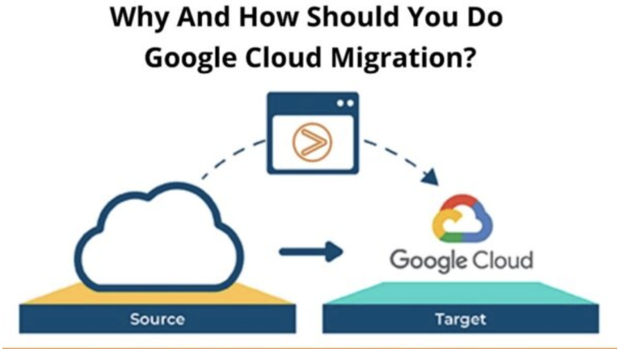

Google stands 3rd in cloud hosting services as Google offers great advantages for enterprises and individual holders. It also offers IaaS, infrastructure as a service. It’s important to understand the importance of each cloud as cloud migration can become difficult so before you are ready to migrate, you know the drawbacks and the advantages beforehand.

**What Do We Understand By Google Migration?**

GCP is a public cloud service and supports the same virtual machines as AWS and Azure. GCP is more focused on container workloads and also the ability to run the machine learning models efficiently.

**Some Of The Cloud Services Advantages Of Google Are:**

* No commitment and good discounts as google charges per second, but the good thing is that the prices are less as compared to others.
* One virtual machine is all it takes to migrate the workload seamlessly minus the downtime.
* You get the same security measure services as Gmail, Docs, and Search.

**5 Steps Of Google Cloud Migration.**

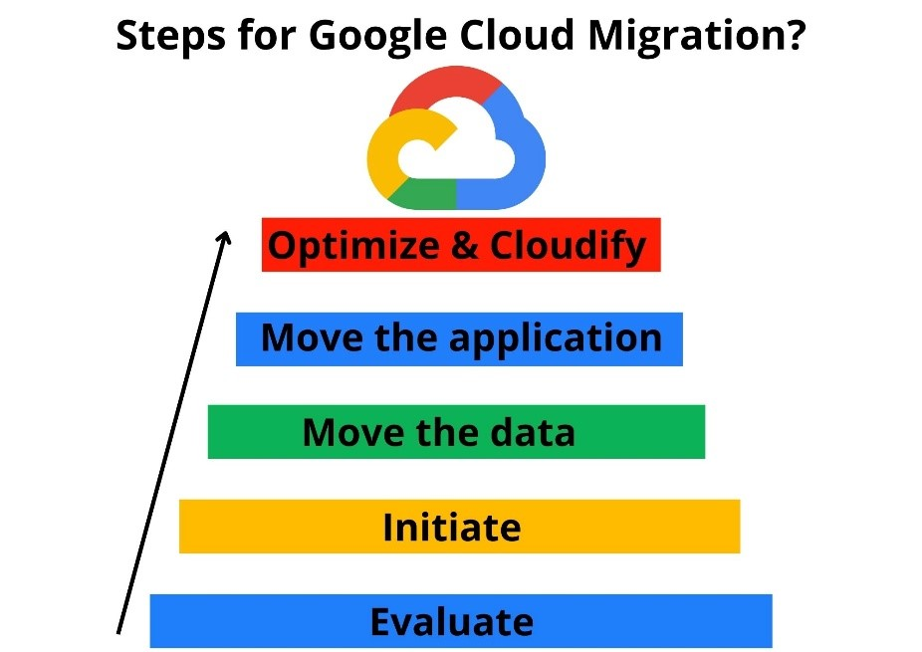

When you plan to migrate to GCP then google asks you to follow these steps:

**Evaluate**

**In this step, you must evaluate the applications and the workload, and the primary considerations are:**

* Hardware and performance
* Licensing issues and number of users
* Accordance
* Dependencies between applications

**Then you divide these applications into 3 categories:**

* Easy moving
* Hard moving
* No moving at all

**Initiate**

Use the applications that are easy to move and migrate. To measure performance, you have to run the applications in production. If you plan to scale up your workload or add up more applications, then you should understand the licensing requirements. In case the migration fails, have a backup plan ready; you can go for on-premise or other cloud migration.

**Move The Data**

Moving the data to the cloud first and moving the rest of the applications is what Google suggests. The storage tiers given by [Google Cloud Storage](https://zindagitech.com/planning-to-configure-microsoft-365-for-your-business-here-is-a-step-by-step-guide/), SSDs vs. hard disks and Google Cloud SQL, Datastore etc. are to be considered. You have to plan on how you can move the data physically.

**Move The Applications**

It’s better to perform “lift and shift” but if not then rebuilt the application with a mixture of GCP and VMs infrastructure services.

**Optimize And Cloudify**

Now, all the applications are running in the cloud, these ways will make it much better:

* Making apps redundant across available GCP Zone.
* DR planning using Cloud backup
* Elasticity setup with autoscaling groups
* Monitoring workloads with Google Stackdriver
* Moving all static assets to cold storage
* Launch and scale new instances by Google Deployment manager.

**GCP Services**

Effective integration of public cloud capabilities is fundamental to an enterprise's digital transformation journey. A well-designed digital transformation strategy should do much more than keep you competitive

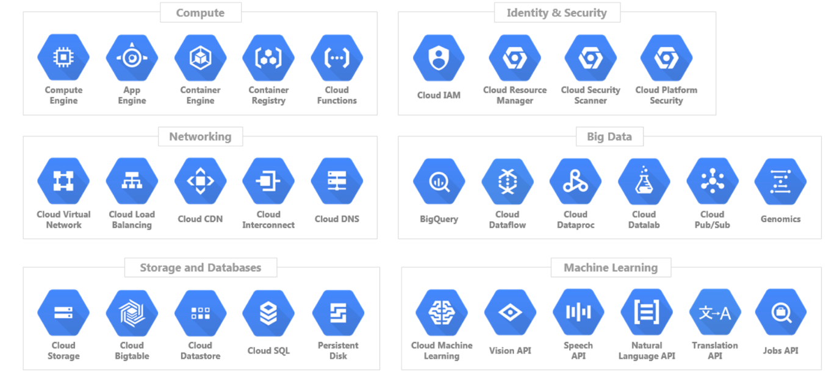

**Where to Begin**

Understanding your starting point is essential to planning and executing a successful application migration strategy. Take a comprehensive approach, including not only technical requirements, but also consideration of your business goals (both present and future), any critical timelines, and your own internal capabilities. Depending on your situation you might fall in any of the below categories as it relates to time-to-value. There is no one size fits all approach to migration but the key here is to know that whichever path you choose, there is always a way to build on top of that and continue to take more advantages of the cloud in an incremental fashion.

[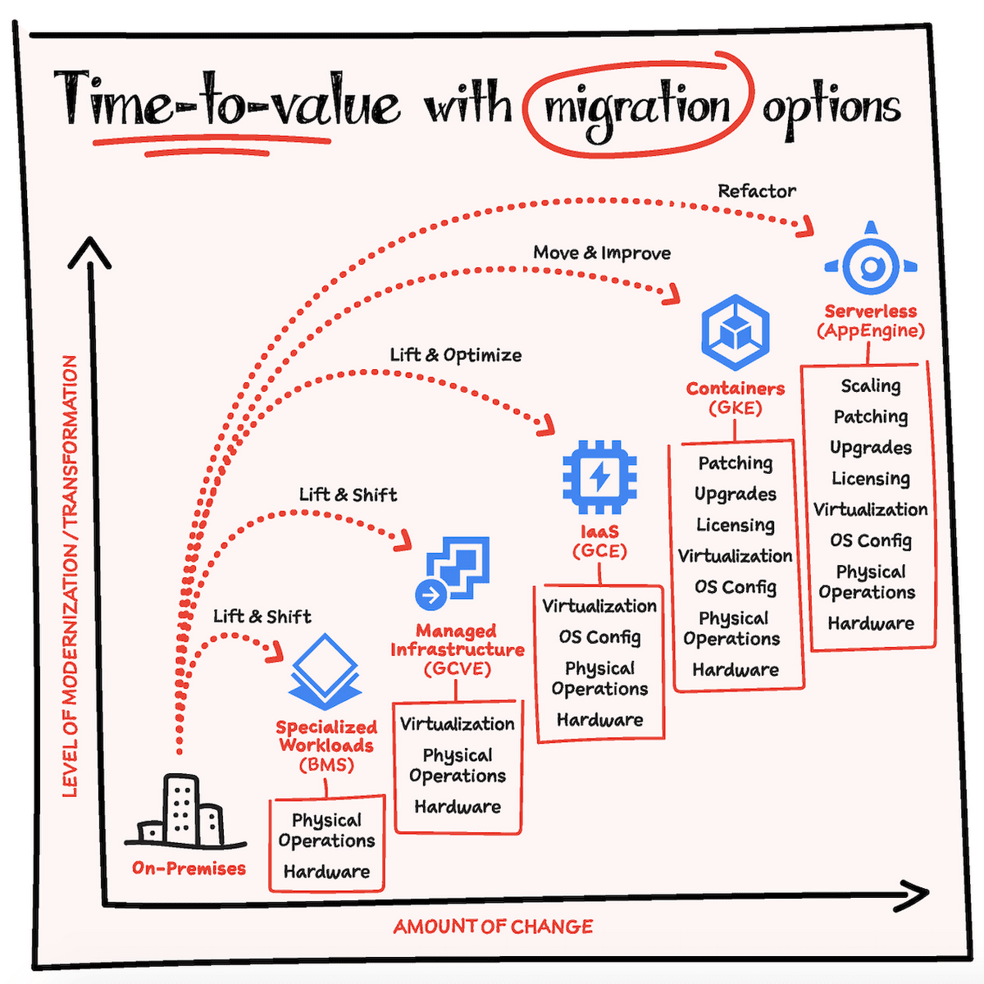](https://storage.googleapis.com/gweb-cloudblog-publish/images/blog-migrationoptions.max-2800x2800.png)

**The SIX R’s of Cloud Migration**

Using them as a framework to create a solid foundation for your changes.

**Rehost**

**Replatform**

**Repurchase**

**Refactor**

**Retain**

**Retire**

**Cloud Migration Methods**

The process, approach, and tools for [migrating workloads to cloud](https://cloud.netapp.com/migrating-enterprise-workloads-to-the-cloud) are greatly dependent on the targeted cloud migration models: IaaS, PaaS or SaaS.

Let’s take a closer look at each of these migration methods.

**Iaas (rehost, replatform)**: Moving applications to an Infrastructure-as-a-Service model means moving an existing application or workload from on-prem deployment to a cloud-provider’s infrastructure. With this method there are no significant architecture changes to make. The easiest way to migrate applications to IaaS is rehosting using “lift and shift” or as-is migration approach. We’ll discuss this option further below.

**Paas (refactor, rebuild)**: The Platform-as-a-Service approach uses cloud-provider configured platform to run your application’s code. As such, this method requires applications to be significantly refactored or modernized to fit into the target cloud platform. This migration method will include code rewrites, library updates, deployment pipeline modifications, and more for the workload to fit into the PaaS application framework. In some situations, the application may have to be totally rebuilt from scratch. In either case, the modifications mean spending considerable amounts of time and money before you can be cloud ready.

**Saas (replace)**: Adopting a Software-as-a-Service offering means replacing functionalities or components of your existing workload with a SaaS service provided by another company. It’s faster than a PaaS migration, but it involves all the challenges of adopting a new technology, such as, restructuring parts of the architecture, create new interfaces, educating your teams on its use, and more. Other concerns include the complications of data migration, access management, vendor lock-in, etc.  Of all these options, the easiest and fastest way to get an existing app to the cloud is with a lift and shift, IaaS migration. Let’s take a closer look at what this method offers and why you should consider it for your application.

**Lift and Shift**

The[lift and shift migration approach](https://learn.cloud.netapp.com/cloud-migration-strategy-aws-azure-gcp-cvo-plp-2?__hstc=177456119.dd25f1fb6c36af788922876d75ecd129.1665392415105.1665392415105.1665392415105.1&__hssc=177456119.14.1665392415105&__hsfp=2953660494)is about migrating your application and associated data to the cloud with minimal or no changes. Applications are effectively “lifted” from the existing environments and “shifted” as-is to a new hosting premises; i.e. in the cloud. As such, there are often no significant changes to make in the application architecture, data flow, or authentication mechanisms.  The major considerations in a lift and shift migration are the compute, storage, and network requirements of the application. They should be mapped from what is currently available in source infrastructure to the matching resources in the cloud provider. There is scope for significant cost savings during the migration, where over-provisioned on-prem resources can be analyzed and mapped to optimal resource SKUs in the cloud. As most of the cloud service providers offer on-the-fly upgrades, you can start with a smaller product and then move to a bigger one. This is a minimal-risk approach to get maximum ROI.

**Advantages of Lift and Shift**

Let us examine some of the key benefits of using Lift & Shift approach for workload migration to the cloud:

* The[lift and shift cloud migration](https://learn.cloud.netapp.com/cloud-migration-strategy-aws-azure-gcp-cvo-plp-2?__hstc=177456119.dd25f1fb6c36af788922876d75ecd129.1665392415105.1665392415105.1665392415105.1&__hssc=177456119.14.1665392415105&__hsfp=2953660494)approach does not demand any application-level changes as it is merely being rehosted on the cloud.
* Workloads that demand specialized hardware, say for example, graphical cards or HPC, can be directly moved to specialized VMs in cloud, which will provide similar capabilities.
* A lift and shift allows you to migrate your on-premises identity services components such as Active Directory to the cloud along with the application.
* Security and compliance management in a lift and shift cloud migration is relatively simple as you can translate the requirements to controls that should be implemented against compute, storage, and network resources.
* The lift and shift approach uses the same architecture constructs even after the migration to the cloud takes place. That means there are no significant changes required in terms of the business processes associated with the application as well as monitoring and management interfaces.

**Lift and Shift vs Other Migration Methods**

The drivers for choosing the cloud migration approach could be anything from using the least-disruptive approach, application compatibility, risk management, ROI, performance and HA requirements etc. The different components in the application architecture and how they interact with each other over different interfaces should be considered while deciding the approach.

**Lift and Shift vs. PaaS migrations**: PaaS migrations involve significant effort in refactoring the application to fit into the platform offered by service provider. Architecture changes might be required to place new components or replace old components. Lift and shift data center migration on the other hand is straightforward and can be done after an analysis of the infrastructure support matrix in cloud.

**Lift and Shift vs. SaaS migrations**: Migrating to a SaaS is even more challenging, as it is more about migrating from one application experience to another than it is about migrating to the cloud. All aspects, including access control, data management, security, etc., must be reconsidered and adapted to the constructs of the SaaS. A lift and shift provides the original application experience and most often can use the same authentication and security mechanisms that were used on-premises.