# **Cloud Migration with GCP**

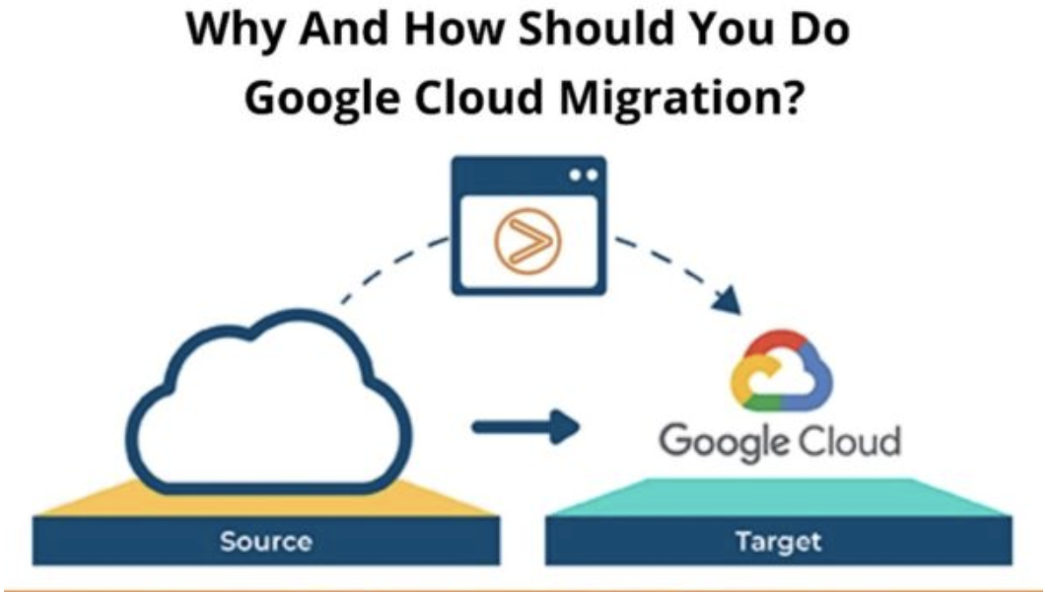

Google stands 3rd in cloud hosting services as Google offers great advantages for enterprises and individual holders. It also offers IaaS, infrastructure as a service. It’s important to understand the importance of each cloud as cloud migration can become difficult so before you are ready to migrate, you know the drawbacks and the advantages beforehand.

**What Do We Understand By Google Migration?**

GCP is a public cloud service and supports the same virtual machines as AWS and Azure. GCP is more focused on container workloads and also the ability to run the machine learning models efficiently.

**Some Of The Cloud Services Advantages Of Google Are:**

* No commitment and good discounts as google charges per second, but the good thing is that the prices are less as compared to others.
* One virtual machine is all it takes to migrate the workload seamlessly minus the downtime.
* You get the same security measure services as Gmail, Docs, and Search.

**5 Steps Of Google Cloud Migration.**

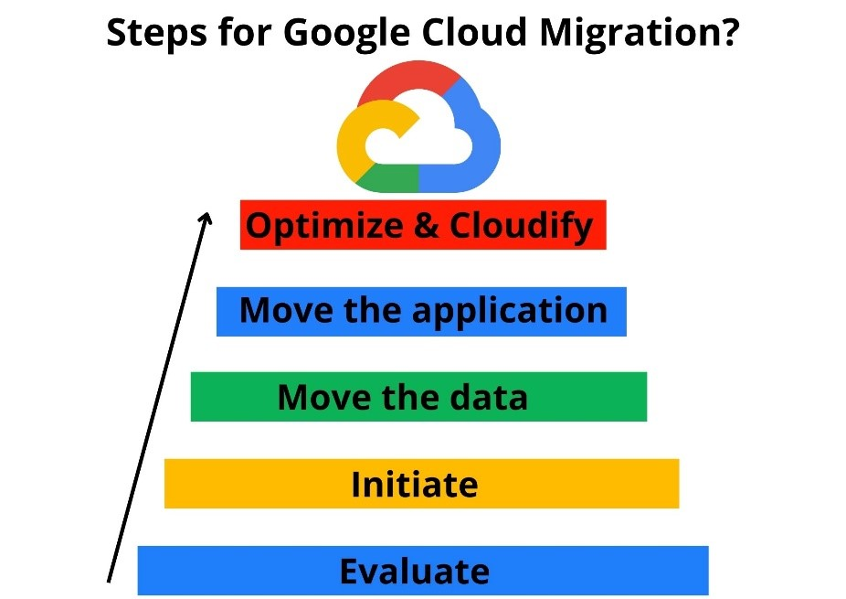

When you plan to migrate to GCP then google asks you to follow these steps:

**Evaluate**

**In this step, you must evaluate the applications and the workload, and the primary considerations are:**

* Hardware and performance
* Licensing issues and number of users
* Accordance
* Dependencies between applications

**Then you divide these applications into 3 categories:**

* Easy moving
* Hard moving
* No moving at all

**Initiate**

Use the applications that are easy to move and migrate. To measure performance, you have to run the applications in production. If you plan to scale up your workload or add up more applications, then you should understand the licensing requirements. In case the migration fails, have a backup plan ready; you can go for on-premise or other cloud migration.

**Move The Data**

Moving the data to the cloud first and moving the rest of the applications is what Google suggests. The storage tiers given by [Google Cloud Storage](https://zindagitech.com/planning-to-configure-microsoft-365-for-your-business-here-is-a-step-by-step-guide/), SSDs vs. hard disks and Google Cloud SQL, Datastore etc. are to be considered. You have to plan on how you can move the data physically.

**Move The Applications**

It’s better to perform “lift and shift” but if not then rebuilt the application with a mixture of GCP and VMs infrastructure services.

**Optimize And Cloudify**

Now, all the applications are running in the cloud, these ways will make it much better:

* Making apps redundant across available GCP Zone.
* DR planning using Cloud backup
* Elasticity setup with autoscaling groups
* Monitoring workloads with Google Stackdriver
* Moving all static assets to cold storage
* Launch and scale new instances by Google Deployment manager.

**Where to Begin**

Understanding your starting point is essential to planning and executing a successful application migration strategy. Take a comprehensive approach, including not only technical requirements, but also consideration of your business goals (both present and future), any critical timelines, and your own internal capabilities. Depending on your situation you might fall in any of the below categories as it relates to time-to-value. There is no one size fits all approach to migration but the key here is to know that whichever path you choose, there is always a way to build on top of that and continue to take more advantages of the cloud in an incremental fashion.

[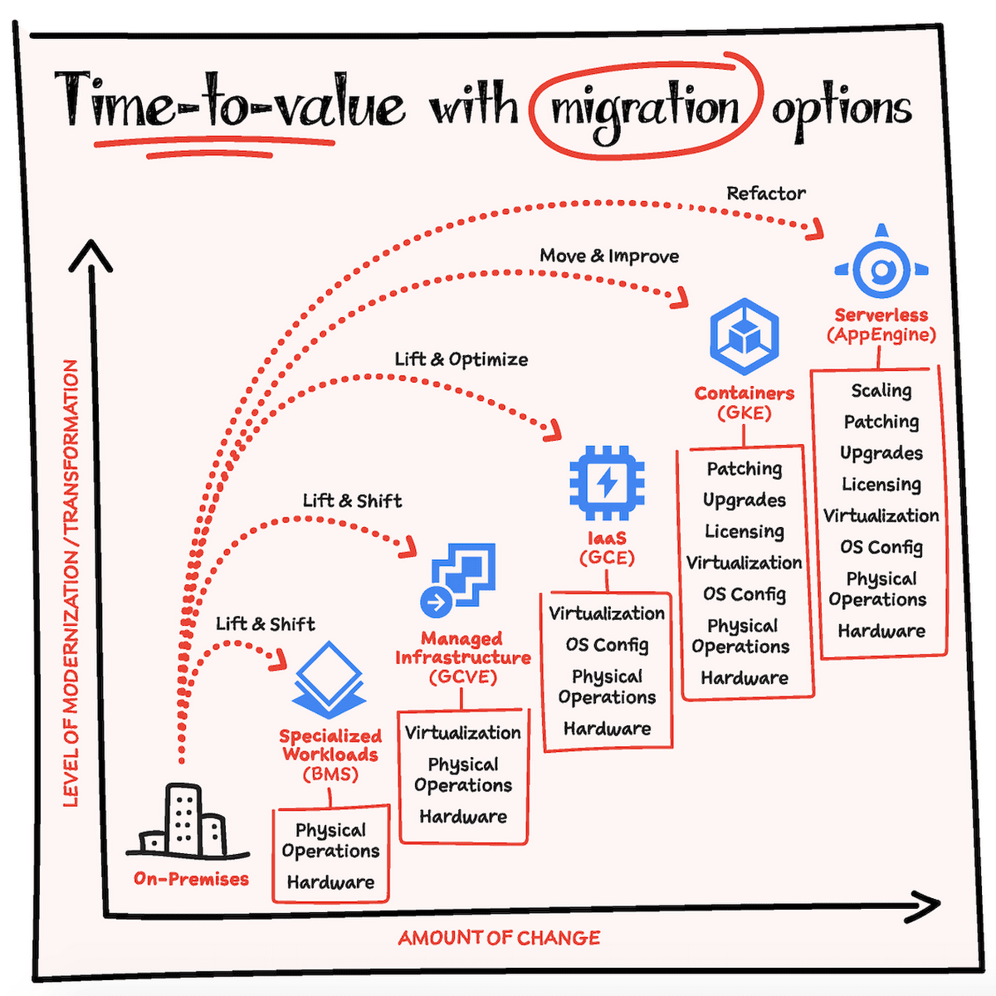](https://storage.googleapis.com/gweb-cloudblog-publish/images/blog-migrationoptions.max-2800x2800.png)

## The 6 R Application Modernization Framework on Google Cloud

Application modernization on the cloud is a dire necessity to revitalize IT operations and scale up delivery, service experiences. However, most enterprises only lift and shift applications and end up with massively limited, degraded performances due to the lack of sufficient app modernization on cloud experts. Cloud4C’s exhaustive cloud strategy, development, full-stack architecture, maintenance, and security engineers act as an extended team to modernize a client’s application environment end-to-end on the Google Cloud.

With the advanced 6 R Methodology, rehash and reboot your applications to unlock extra agility, enhanced performance, and end-user excellence powered by an intelligent GCP backend. Modernize on-premise legacy systems and existing applications. Optimize applications, manage applications with consistent development and reliability engineering to innovate faster according to business needs and customer demands.

repurchase modernization strategy icon in google cloud application modernization services REPURCHASE (Drop and Shop)

REPURCHASE (Drop and Shop)

This phase involves minimalistic transformation to migrate to a cloud-based environment. The enterprise drops the existing on-prem license of the software being used and moves onto the cloud-based version of the same software, essentially repurchasing the license.

 rehost modernization strategy icon in google cloud application modernization services REHOST (Lift and Shift)

Identify the applications and existing workloads to be migrated and lift and shift them to the cloud ecosystem. The migration involves cutting-edge native tools and support services that help move the application stack from the existing on-prem to the cloud environment

 replatform modernization strategy icon in google cloud application modernization services REPLATFORM (Lift, Change, Shift)

This process involves the same methodology as that of rehosting platforms and applications from the on-prem environment to the cloud ecosystem. However, here, some customizations are made to ensure that the platforms run best on the cloud.

refactor modernization strategy icon in google cloud application modernization services REFACTOR/RE-ARCHITECT

This phase or approach involves the most effort and expenses as the existing on-prem applications, databases, and workloads are significantly over-hauled, often at the codebase levels, to move them to the cloud. A common approach in this phase is to break up monolithic structures into microservice architectures for advanced performance on the cloud. Hence, such an approach ensures leveraging the best features of the cloud as the software is redesigned to match the cloud’s native environment.

retire modernization strategy icon in google cloud application modernization services RETIRE

This practice involves the recognition of applications or platforms that are redundant and would cause unnecessary load/overprovisioning on the cloud thereby shooting up operational costs. Under such circumstances, firms might opine to retire and replace the application altogether in favor of a cloud-friendlier version.

retain modernization strategy icon in google cloud application modernization services RETAIN

Businesses might opt to keep some legacy, on-prem applications running as they are delivering high performances and linked to critical projects. In such a case, the other core systems might run from the cloud and the retained on-prem applications might operate standalone or in sync with the cloud apps via APIs.

**Cloud Migration Methods**

The process, approach, and tools for [migrating workloads to cloud](https://cloud.netapp.com/migrating-enterprise-workloads-to-the-cloud) are greatly dependent on the targeted cloud migration models: IaaS, PaaS or SaaS.

Let’s take a closer look at each of these migration methods.

**Iaas (rehost, replatform)**: Moving applications to an Infrastructure-as-a-Service model means moving an existing application or workload from on-prem deployment to a cloud-provider’s infrastructure. With this method there are no significant architecture changes to make. The easiest way to migrate applications to IaaS is rehosting using “lift and shift” or as-is migration approach. We’ll discuss this option further below.

**Paas (refactor, rebuild)**: The Platform-as-a-Service approach uses cloud-provider configured platform to run your application’s code. As such, this method requires applications to be significantly refactored or modernized to fit into the target cloud platform. This migration method will include code rewrites, library updates, deployment pipeline modifications, and more for the workload to fit into the PaaS application framework. In some situations, the application may have to be totally rebuilt from scratch. In either case, the modifications mean spending considerable amounts of time and money before you can be cloud ready.

**Saas (replace)**: Adopting a Software-as-a-Service offering means replacing functionalities or components of your existing workload with a SaaS service provided by another company. It’s faster than a PaaS migration, but it involves all the challenges of adopting a new technology, such as, restructuring parts of the architecture, create new interfaces, educating your teams on its use, and more. Other concerns include the complications of data migration, access management, vendor lock-in, etc.  Of all these options, the easiest and fastest way to get an existing app to the cloud is with a lift and shift, IaaS migration. Let’s take a closer look at what this method offers and why you should consider it for your application.

## Google Cloud Native Tools and Services:

Effective integration of public cloud capabilities is fundamental to an enterprise's digital transformation journey. A well-designed digital transformation strategy should do much more than keep you competitive

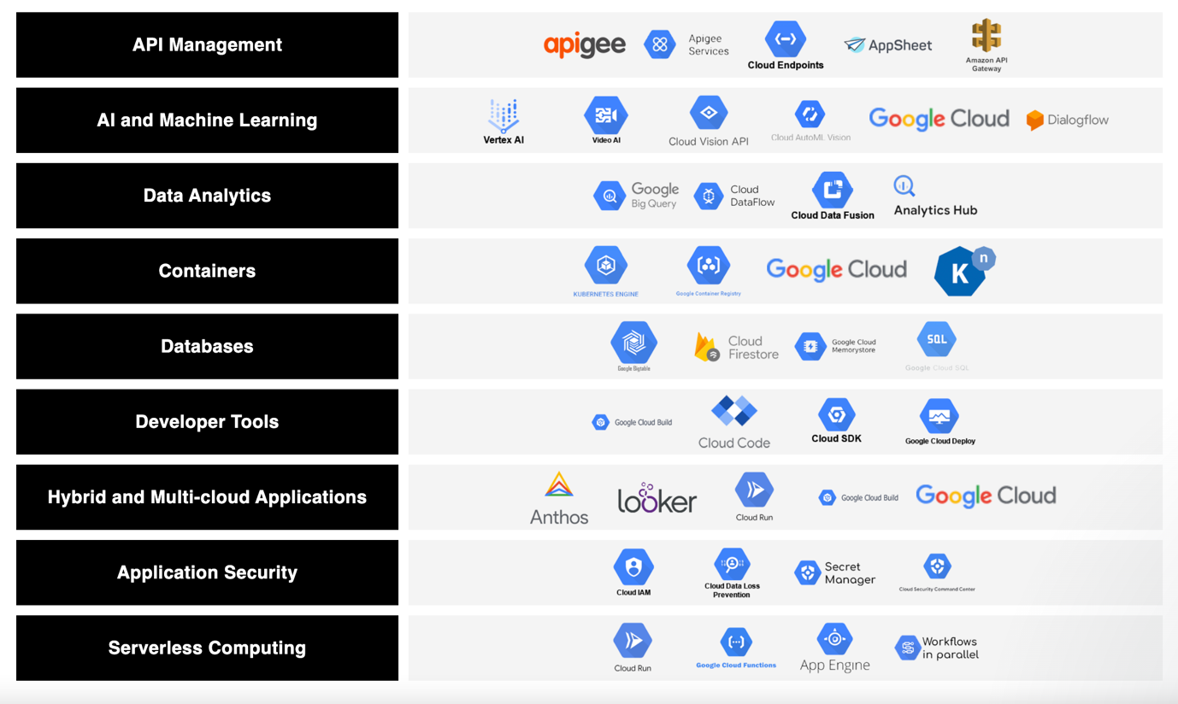

## Google Cloud Pricing Models

Google Cloud Platform provides the pricing models seen here:

https://cloud.google.com/products/calculator

**Pay-as-you-go pricing model**Google Cloud provides a pay-as-you-go on-demand pricing model. This is most suited to individuals who expect to use the cloud intermittently, as it gives you the flexibility to remove or add services as you wish. However, this degree of flexibility incurs a cost, meaning that the pay-as-you-go model is the most expensive option per hour.

**Long-term plan**If you are planning to use the cloud for a long period, and are willing to make an extended-period upfront commitment to your cloud deployment, you can achieve greater savings than you would with the pay-as-you-go model. Google provides long-term pricing terms with upfront obligations of one year or three years. This plan is called Committed Use, and it provides significant savings when compared to an on-demand pricing model—as much as 70% on Compute Engine.

**Free tier option**If you are not at a stage where you are ready to move to a cloud service, Google Cloud provides the free tier option over a wide variety of products. This gives you a predefined resource amount over a specific period, suitable for those looking to try out a service.

Google also provides some “always free” cloud services, which are suitable for organizations that have very low usage requirements and are not fussed if operations are interrupted.

If you choose the GCP Free Tier, you will receive 24 cloud services and products within monthly usage limits.

New Google Cloud customers receive $300 of credit for free, which they can spend on any Google Cloud services or products.

You can use various free products across AI, IoT, database, compute, and storage, and these largely cover the cloud services that are most widely used.

## Google Cloud Compute Pricing

Compute Engine is a modifiable compute service that lets you develop and run virtual machines (VMs) on Google’s infrastructure. In Compute Engine, machine types are curated and grouped according to types of workloads. The main types are accelerator-optimized, general-purpose, compute-optimized, and memory-optimized.

Google charges per actual usage, with the option of sustained use discounts. If you run a VM for more than 25% of a month, you are eligible for discounts between 20-30%.

You can also use short-lived preemptive instances to reduce costs by up to 80%. Such instances are suitable for fault-tolerant workloads and batch jobs.

## Google Cloud Storage Pricing

Google Cloud Storage is known as an enterprise public storage platform, which can retain large unstructured data sets. Organizations can buy the storage for infrequent or primary accessed data.

Cloud Storage pricing is calculated according to the following elements:

* **Data storage—**the volume of data retained in your buckets. Storage rates differ according to the storage class of your data and the place of your buckets.
* **Network usage—**the volume of data read from or moved from one bucket to another.
* **Operation usage—**the activities you undertake in Cloud Storage, including listing the objects in the buckets.
* **Retrieval and early deletion fees—**relate to data retained in the Coldline, Archive, and Nearline storage classes.
* **Inter-region replication—**applies to data replicated over locations.

As a component of the Google Cloud Free Tier, Cloud Storage offers resources at no cost—up to a certain limit. Such usage limits are applicable during and after the free trial time. Monthly Limits for Free Usage are:

* **Network egress—**up to 1 GB for each Google Cloud Platform egress destination from North America (not including Australia or China)
* **Standard storage—**up to five GB-months
* Up to 5,000 Class A operations (active data operations like INSERT and UPDATE)
* Up to 50,000 Class B operations (passive data operations like GET)

In addition, Google Persistent Disks, which offer reliable, high-performance block storage that can be attached to Google Cloud VMs. Persistent Disks cost $0.040 per GB/month for standard magnetic disks, $0.170 per GB/month for SSD, and offer additional options such as additional IOPS and multi-region redundancy.

*Learn more in our detailed guide to*[*Google Cloud Storage pricing*](https://cloud.netapp.com/blog/gcp-cvo-blg-google-cloud-storage-pricing-get-the-best-bang-for-your-buckets)

## Google Cloud Networking Pricing

Here are the pricing models for VPC and Cloud CDN.

### Virtual Private Cloud (VPC)

VPC costs are calculated according to the type of traffic and storage tiers used.

**Ingress traffic**This includes incoming traffic to a Google Cloud resource, including a VM (virtual machine). If you transfer traffic between two virtual machines, then the traffic is deemed egress traffic when departing from one VM and is deemed ingress traffic when it reaches the second VM.

There is no cost for ingress traffic, but you could be charged for the resources that process ingress traffic. Services that use ingress traffic include cloud network address translation (NAT), load balancers and protocol forwarding.

**Egress traffic**This includes traffic departing a Google Cloud resource. Egress traffic is billed according to the following:

* Does the traffic utilize an external or internal IP address?
* Does the traffic cross the boundaries of regions or zones?
* Does the traffic remain inside Google Cloud, or leave it?
* How far does the traffic move before leaving Google Cloud?

There are some instances where information transfers are not billed, which may be useful when you plan your deployments. For example, all egress traffic between your VMs and certain non-cloud Google services (such as Doubleclick, YouTube, and Maps) is free even between distinct regions.

This is also true for egress traffic to a distinct Google Cloud service, providing it is within the same location (the exception being GKE, Cloud SQL, Filestore, and Memorystore for Redis). In both instances, neither an external nor internal IP will incur a charge.

However, there are hidden fees depending on the use case. For example, while egress traffic between VMs within the same zone is free, this is only the case if you use the internal IP address. If you use another IP address, Google will bill you as if the traffic were between distinct zones, charging 0.1$ per GB. This could significantly increase costs, particularly in large-scale deployments.

*Learn more in*[*GCP Network Pricing: How to Beat the Hidden Fees*](https://cloud.netapp.com/blog/gcp-cvo-blg-gcp-network-pricing-how-to-beat-the-hidden-fees)

**Premium and standard tiers**There are two tiers available for information transfers between users and Google Cloud instances:

* **Premium tier—**leverages Google’s global infrastructure with multiple points of presence (PoPs), routing incoming and outgoing user traffic with optimal performance and minimum congestion.
* **Standard tier—**utilizes the public internet and carries traffic with public internet service providers (ISPs). It is only accessible in specific regions and offers similar performance to other cloud service providers.

Although the premium tier is set as the default for egress traffic and provides the best performance, it isn’t necessarily the top option when considering cost. The standard tier is more cost effective and is suitable for deployments in a single region. However, there may be a catch that can affect your costs—if you don’t specifically choose the standard tier, the more expensive premium tier will be utilized by default.

### Cloud CDN Pricing

The Cloud Content Delivery Network (CDN) utilizes Google’s global network of edge PoPs to cache external HTTP or HTTPS load-balanced data near your users. Caching content at the outer regions of Google’s network offers quicker delivery of information to your users while minimizing serving costs.

Cloud CDN items are priced as follows:

* **Requests sent to external backends from Cloud CDN—**according to internet egress rates for Compute Engine
* **Requests for web cache (HTTP/HTTPS) lookup—**$0.0075 for 10,000 requests
* **Cache egress—**between $0.02 and $0.20 per GB
* **Cache fill—**between $0.01 and $0.04 per GB

## Google Cloud SQL Pricing

The [Google Cloud SQL](https://cloud.netapp.com/blog/gcp-cvo-blg-google-cloud-sql-mysql-postgres-and-ms-sql-on-google-cloud) database service is fully managed and can help you set up and maintain relational databases on the Google Cloud Platform.

Pricing for Cloud SQL varies according to your instance type (MySQL and PostgreSQL vs SQL Server). Cloud SQL charges depend on the following elements.

**CPU and memory pricing**For a dedicated-core instance, you select the volume of CPUs and the total memory you require, up to 96 CPUs and 624 GB of memory. Pricing for memory and CPUs vary according to the region where your instance is found. Failover replicas and read replicas are billed at the same rate as stand-alone instances.

**Storage and networking pricing**Networking and storage prices are based on the instance’s location. When network traffic departs a Cloud SQL instance, the fee applied varies according to the traffic’s destination and, in certain instances, the involvement of a partner. Internet egress is network traffic that departs a Cloud SQL instance to a non-Google client—for example, a local server used to read information from Cloud SQL.

**Instance pricing**This is only relevant for shared-core instances. Dedicated-core instances—possessing up to 624 GB of memory and 96 vCPUs—are billed according to the amount of memory and number of cores they have.

Instance pricing is billed for each second that the instance is running, with the activation policy being set to “always”. Cloud SQL regards seconds as the time unit for usage, so every second of usage is part of a full chargeable minute.

*Learn more in our detailed guide to*[*Google Cloud SQL pricing*](https://cloud.netapp.com/blog/gcp-cvo-blg-google-cloud-sql-pricing-and-limits-a-cheat-sheet)

## Google Cloud Serverless Pricing

### Google Cloud Functions

With Google Cloud Functions, developers create their code, and the rest is done by Google. Thus, IT professionals can develop functions without needing to consider the underlying cloud infrastructure.

Cloud Functions pricing is based on how long your functions run, the number of invocations, and the number of resources you set aside for the function. If your function initiates an outbound network request, there will be added information transfer fees. Cloud Functions features an ongoing free tier for invocations to let you learn about the platform free of charge.

**Function invocations**Invocations are billed at a constant rate, irrespective of the invocation source. This encompasses HTTP function invocations via HTTP requests, events forwarded to CloudEvent or background functions, and invocations following on from the call API. The first two million invocations per month are free, and beyond that cost $0.40 per million.

**Compute time**Compute time is calculated from the point your function gets a request to the point it completes, either via a timeout, when you signal completion, or through failure or any type of termination.

Cloud Functions may be provisioned as follows (showing Tier 1 costs, available in specific Google Cloud regions including us-west1 and us-central1):

* **128MB memory, 200 MHz CPU—**$0.00000231 / second
* **256MB memory, 400 MHz CPU—**$0.00000463 / second
* **512MB memory, 800 MHz CPU—**$0.00000925 / second
* **1024MB memory, 4 GHz CPU—**$0.00001650 / second
* **2048MB memory, 4 GHz CPU—**$0.00002900 / second
* **4096MB memory, 8 GHz CPU—**$0.00005800 / second
* **8192MB memory,8 GHz CPU—**$0.00006800 / second

**Networking**Outbound information transfer (information transferred from your function outwards) is calculated in GB and billed at a flat rate. There is no charge for outbound data to different Google APIs in the same region, nor for inbound data. Otherwise, outbound data of up to 5GB per month is free, while outbound egress data is priced at $0.12 per GB.

### Google Cloud Run

Google Cloud Run is used to deploy containerized applications on a fully managed serverless platform.

Cloud Run bills you based on the resources you use, calculated up to the closest 100 milliseconds. Each of these resources possesses a free tier. Your overall Cloud Run costs will be the total of the resources in the pricing table.

If CPU is assigned during request processing alone, pricing is as follows (prices are different if CPU is continually assigned; see the [official pricing page](https://cloud.google.com/run/pricing)).

**Free tier**

* Up to 180,000 free vCPU-seconds per month
* Up to 360,000 free GiB-seconds of memory per month
* Up to two million free requests per month
* Up to 1 GiB free networking egress per month within North America

**Tier 1**Beyond the free tier allowance, this tier charges as follows:

* $0.00000250 if idle
* $0.00002400 per vCPU-second, or $0.00001992 with committed use discount (CUD)
* $0.00000250 per GiB-second of memory ($0.000002075 with CUD and $0.00000250 if idle)
* $0.40 per million requests ($0.332 with CUD)

**Tier 2**Beyond the free tier allowance, this tier charges as follows:

* $0.00000350 if idle
* $0.00003360 per vCPU-second, or $0.000027888 with committed use discount (CUD)
* $0.00000350 per GiB-second of memory ($0.000002905 with CUD and $0.00000350 if idle)
* $0.40 per million requests ($0.332 with CUD)