**AIR QUALITY ANALYSIS IN TAMILNADU**

**PHASE 5: PROJECT DOCUMENTATION AND SUBMISSION**

# PROJECT OBJECTIVE:

# Project's primary objectives revolve around three key aspects. First, it aims to analyze historical air quality data to discern prevalent trends in tamil nadu. Second, it seeks to pinpoint pollution hotspots within the region. Lastly, it endeavors to construct a predictive model to estimate rspm/pm10 levels based on the levels of so2 and no2.

# design thinking

* Data collection and preparation
* Exploratory data analysis (EDA)
* Data analysis
* Feature engineering
* Model Building
* Model Evaluation
* Data Visualization
* Interpretation and Insights
* Reporting and Documentation
* Deployment

# Development phases

* Data preprocessing
* Visualization using IBM cognos

# analysis objective

Common objectives might include:

* Understanding trends in air quality over time.
* Identifying areas with the worst air quality.
* Examining the impact of various pollutants on air quality.

# Data Collection Process

This data is from government agencies, environmental organizations, or research institutions. The data includes key parameters like PM2.5, PM10, NO2, SO2, CO, O3, and other relevant pollutants. Weather data such as temperature, humidity, wind speed, and direction for a comprehensive analysis.

## Data Cleaning and Preparation

Raw data often requires cleaning and pre-processing. This may involve handling missing values, removing duplicates, converting data types, and aggregating data if collected at different time intervals. Python is a powerful tool for this purpose, and libraries like pandas can be particularly helpful.

## These Insights from the analysis can help website owners improve user experience

* **Real-Time Data Updates**
* **Location-Based Information**
* **Forecasting**
* **Visual Representations**
* **Health and Safety Recommendations**
* **Comparison Tools**
* **Integration with Other Services**
* **User Notifications**
* **Educational Content**
* **Community Engagement**
* **Mobile-Friendly Design**
* **Data Sources and Attribution**

**PYTHON CODE INTEGRATION:**

* Here we calculate the final index(AQI) ,which is the maximum of those sub-indices .
* Also we add the quality for the respective AQI values aas follows:

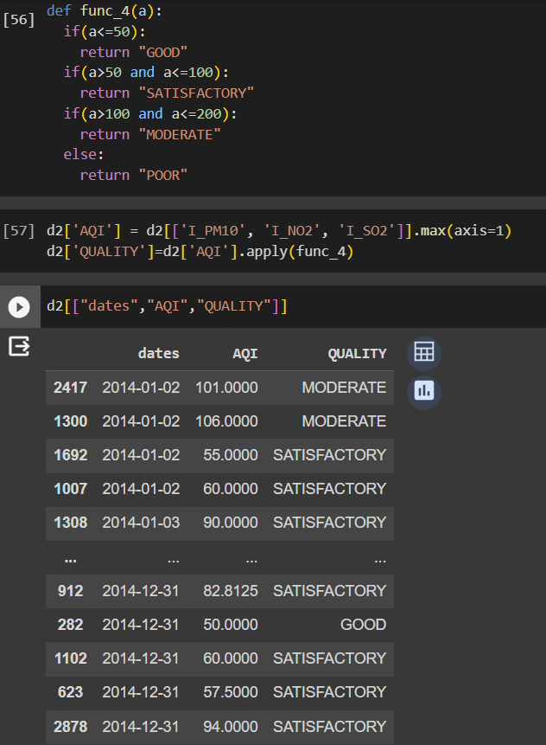

**DATA VISUALIZATION:**

The final visualization of AQI with dates mentioning the Quality and location types, which is given below:

