**AIR QUALITY ANALYSIS IN TAMILNADU**

**PHASE 4: DEVELOPMENT PART 2**

*We are going to build a model for calculating the AQI(Air Quality Index) for given pre-processed dataset.*

***STEP BY STEP PROCESS FOR AQI:***

*We will have to calculate the sub-indices for each pollutant. A subindex is a linear function (two different yet related notions) of the concentration of pollutants.*

**Ip = [IHi – ILo / BPHi – BPLo] (Cp – BPLo) + ILo**

*Where,*

### ***Ip****= index of pollutant p* ***Cp****= truncated concentration of pollutant p* ***BPHi****= concentration breakpoint i.e. greater than or equal to Cp* ***BPLo****= concentration breakpoint i.e. less than or equal to Cp* ***IHi****= AQI value corresponding to BPHi* ***ILo****= AQI value corresponding to BPLo*

### Using the above formula we have build the model and implemented it with the pre-processed dataset.

### We have done it using ‘apply’ function by the pandas which allows us to use a user-defined function on the column.

### Later we convert the sampling dates into datetime datatype for time-series analysis in the later part.

### MODEL FOR CALCULATING SUB-INDICES:

### 

### FOR PARSING DATES:

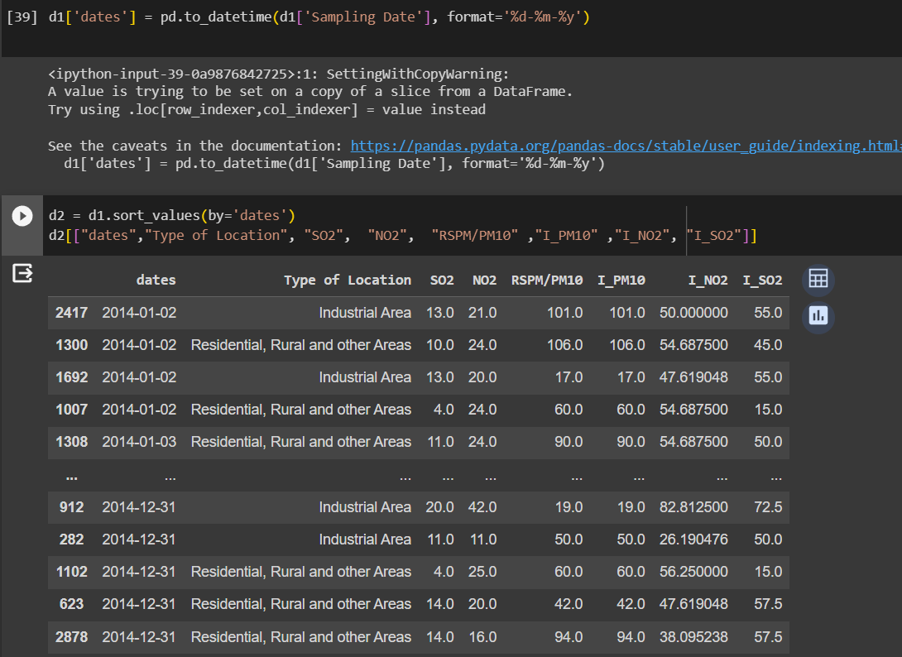

**VIZUALIZATION WITH COGNOS:**

*Lets do the Time-Series Analysis for each of the following pollutants indices such as PM10, SO2, NO2 .*

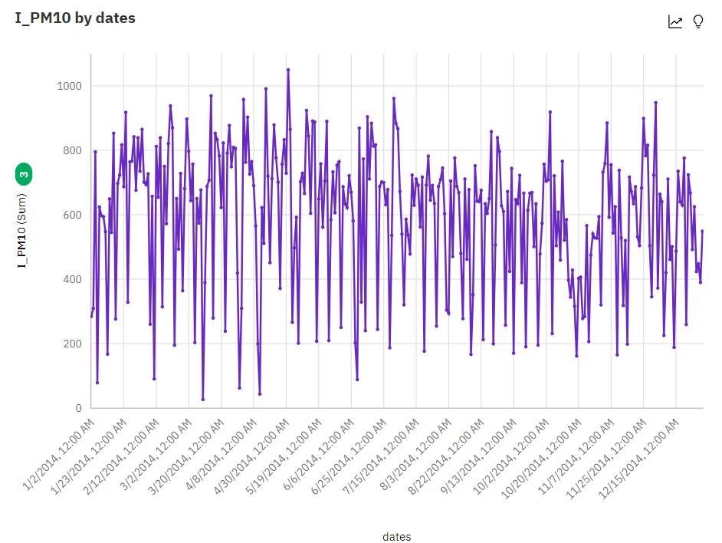

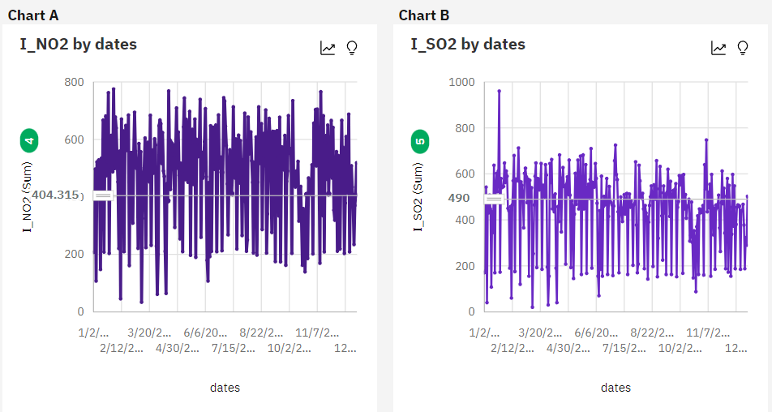

**CONCLUSION:**

Thus index for each pollutant has been computed for calculating the final value in next step and those sub-indices are visualized separately with help of IBM Cognos