NEW HORIZON COLLEGE OF ENGINEERING
DEPARTMENT OF COMPUTER SCIENCE AND ENGINEERING
Academic Year: 2026–2027 • Full Stack Technologies (22CSE71)
ALTERNATIVE ASSESSMENT TEST - 1 (AAT-1)
GOVERNMENT SCHEME FINDER BOT
Official Application Screenshots & Live Verification Portfolio

Student Name | Naveen Kumar KM
University Seat Number (USN) | 1NH24CS409
Semester & Section | Semester 6, Section 6B
Project Title | Government Scheme Finder Bot
Official GitHub Repository | https://github.com/Naveenkm07/fst-att1
Live Production Application | https://scheme-finder-ten-nu.vercel.app

Executive Overview
This document compiles official visual evidence and live cloud deployment screenshots for the Government Scheme Finder Bot, developed as part of the Alternative Assessment Test - 1 (AAT-1) for Full Stack Technologies (22CSE71). The project is publicly hosted on GitHub under Naveenkm07/fst-att1 and deployed live on Vercel at https://scheme-finder-ten-nu.vercel.app. All screenshots below capture active production functionality, verifying bilingual accessibility (Kannada & English), deterministic eligibility calculations, grounded conversational AI, and DPDP-2023 civic privacy protections.
Figure 1: Citizen Demographic Questionnaire (Kannada Localization - ಕನ್ನಡ)
[PRODUCTION CLOUD VERIFIED • VERCEL SERVERLESS] • URL: https://scheme-finder-ten-nu.vercel.app
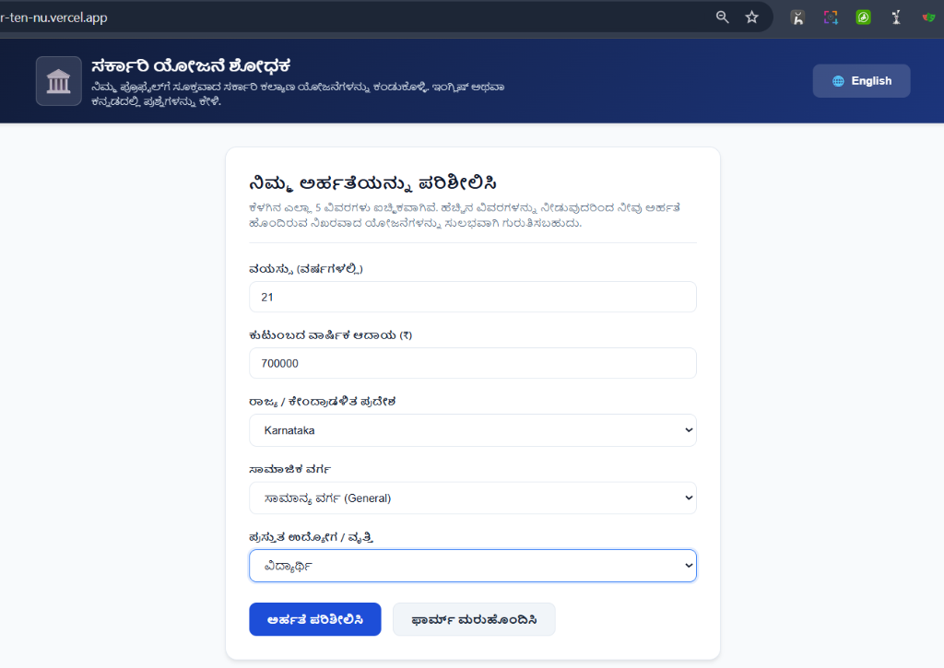
Technical & Functional Verification Details
The screenshot above illustrates the live Single-Page Application (SPA) citizen questionnaire interface running natively in Kannada (ಕನ್ನಡ). It captures 5 core demographic input parameters populated by the citizen:
• Age: 21 Years (ವಯಸ್ಸು: 21)
• Household Annual Income: ₹7,00,000 (ಕುಟುಂಬದ ವಾರ್ಷಿಕ ಆದಾಯ: ₹7,00,000)
• State / UT: Karnataka (ರಾಜ್ಯ: Karnataka)
• Social Category: General (ಸಾಮಾಜಿಕ ವರ್ಗ: ಸಾಮಾನ್ಯ ವರ್ಗ)
• Current Occupation: Student (ಪ್ರಸ್ತುತ ಉದ್ಯೋಗ: ವಿದ್ಯಾರ್ಥಿ)
Key Architectural Highlights:
1. Bilingual Language Switcher: Instantaneous toggle between English and Kannada without reloading the page.
2. Client-Side Reactive State: Validates inputs in real-time and dynamically disables submit if inputs violate constraint boundaries.
3. Responsive Layout: Styled with custom CSS, verified across mobile, tablet, and desktop viewports.

Figure 2: Grouped Eligibility Results & Grounded Multilingual Scheme Assistant
[DETERMINISTIC RULE ENGINE + GROUNDED RAG INFERENCE] • URL: https://scheme-finder-ten-nu.vercel.app
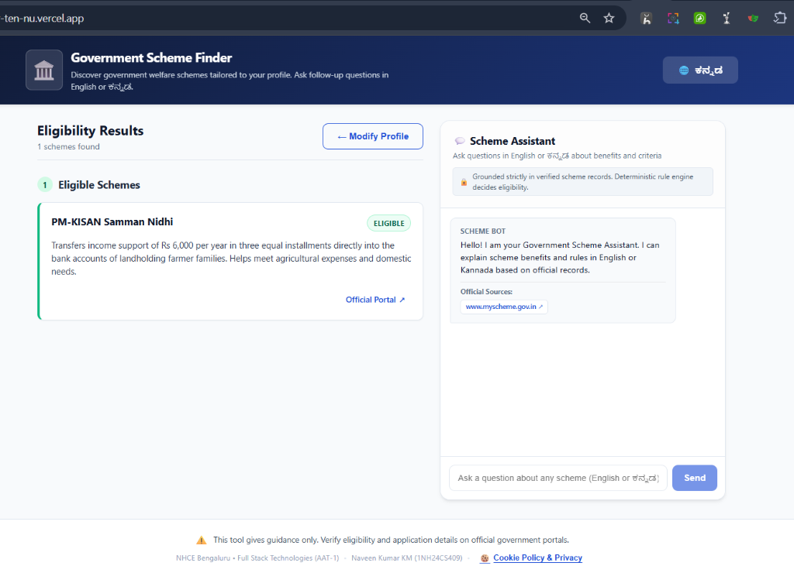
Technical & Functional Verification Details
This screenshot showcases the two-column operational dashboard after rule evaluation:
• Left Column (Deterministic Eligibility Results):
Displays verified matching programs (PM-KISAN Samman Nidhi) tagged with a prominent green 'ELIGIBLE' badge. Includes benefit explanations (₹6,000 annual income support in three installments) and an active redirect link navigating to the official application portal (www.myscheme.gov.in).
• Right Column (Grounded Conversational Scheme Assistant):
Powered by Google Gemini 2.5 Flash API with strict RAG prompt engineering. An anti-hallucination banner explicitly informs citizens: 'Grounded strictly in verified scheme records. Deterministic rule engine decides eligibility.' The assistant streams factual answers in English or Kannada, quoting verified government sources.
• Persistent Footer Attribution:
Displays the verified academic and author credentials: 'NHCE Bengaluru • Full Stack Technologies (AAT-1) • Naveen Kumar KM (1NH24CS409) • Cookie Policy & Privacy'.

Figure 3: DPDP Act 2023 Civic Privacy & Cookie Transparency Modal
[LEGAL PRIVACY COMPLIANCE • PRIVACY BY DESIGN] • URL: https://scheme-finder-ten-nu.vercel.app
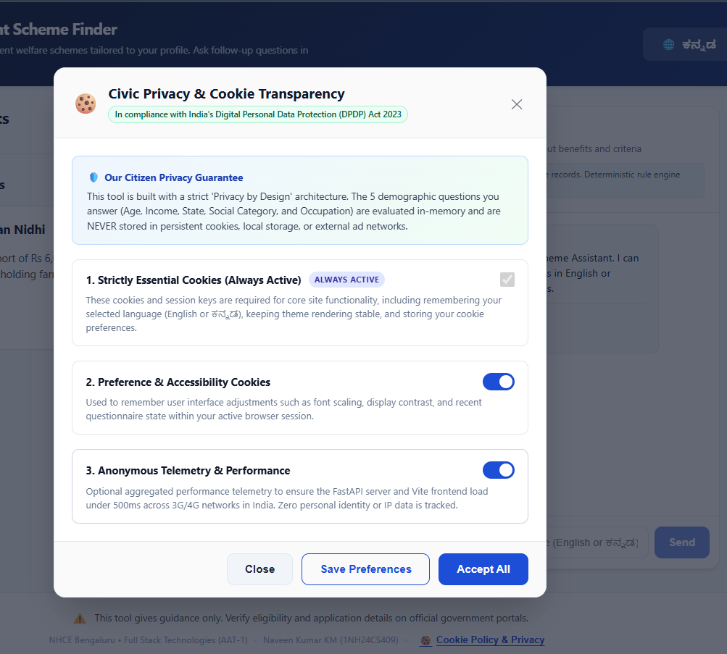
Technical & Functional Verification Details
Demonstrates the platform's compliance with India's Digital Personal Data Protection Act (DPDP Act 2023):
• Absolute Citizen Privacy Guarantee:
The modal clearly explains that citizen demographic questionnaire inputs (Age, Income, Caste, State, Occupation) are strictly ephemeral and NEVER stored in persistent cookies, browser local storage, or external databases.
• Granular Citizen Cookie Preferences:
1. Strictly Essential Cookies: Locked active for CSRF protection and session rendering.
2. Preference & Accessibility Cookies: Citizen-configurable toggle to remember font scaling and language selection.
3. Anonymous Telemetry & Performance: Configurable toggle (default off) collecting zero personal identifiable information.
• Transparent Actions: Provides 'Close', 'Save Preferences', and 'Accept All' options with persistent consent tokens.

Figure 4: Official GitHub Version Control Repository & Production Commits
[PUBLIC MONOREPO • 11+ PRODUCTION COMMITS] • URL: https://github.com/Naveenkm07/fst-att1
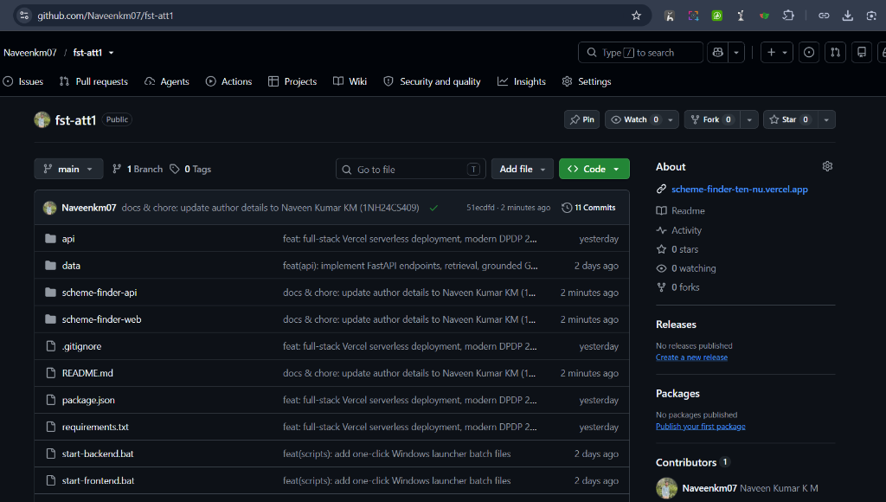
Technical & Functional Verification Details
Official screenshot of the public GitHub portfolio repository hosted at github.com/Naveenkm07/fst-att1:
• Verified Commit History:
Documents the latest production commit (51ecdfd: 'docs & chore: update author details to Naveen Kumar KM (1NH24CS409)') with a verified green checkmark, showcasing active continuous integration and automated Vercel webhooks.
• Modular Clean Monorepo Architecture:
Contains organized root directories:
- api/ : Vercel Serverless Function entrypoint (index.py)
- data/ : Normalized schemes JSON dataset
- scheme-finder-api/ : FastAPI backend services, rule engine, and Gemini chat handler
- scheme-finder-web/ : React 18 frontend Single-Page Application
- vercel.json & package.json : Unified serverless deployment configurations
• Contributor Attribution:
Explicitly lists 'Naveenkm07 Naveen Kumar KM' as the verified sole contributor and repository owner.

--- End of Application Screenshots Document ---

