**Exercise No 8: Trace Route, ping, ifconfig, ipconfig, netstat**

**Trace Route**

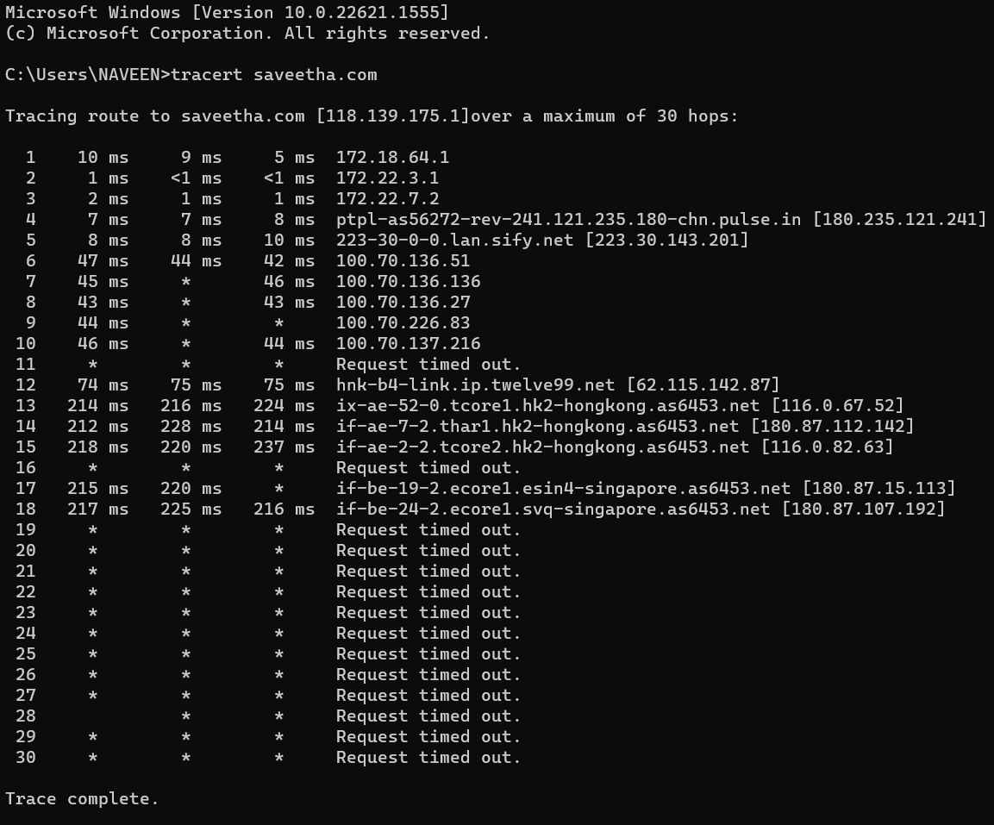

**Ping**

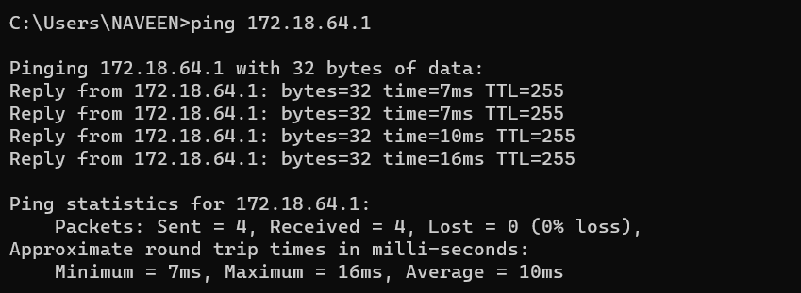

**Ipconfig**

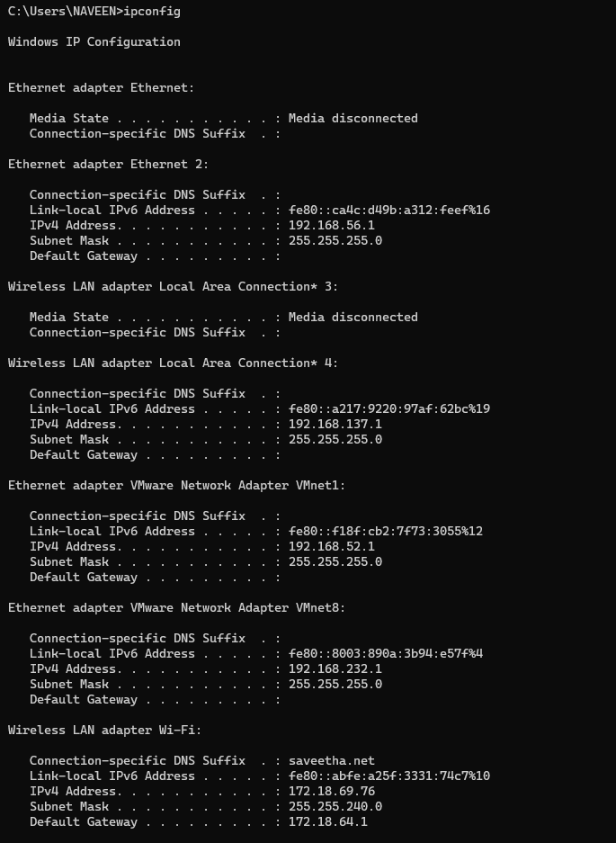

**Netstat**

