CSA0960-JAVA PROGRAMMING

G.Naveen kumar

192325070

**Smart Traffic Signal Optimization**

**Scenario:** You are part of a team working on an initiative to optimize traffic signal management in a busy city to reduce congestion and improve traffic flow efficiency using smart technologies

1. **Data Collection and Modeling** 
   * **Objective:** Define the data structure to collect real-time traffic data from sensors.

**Data Structure Example:**

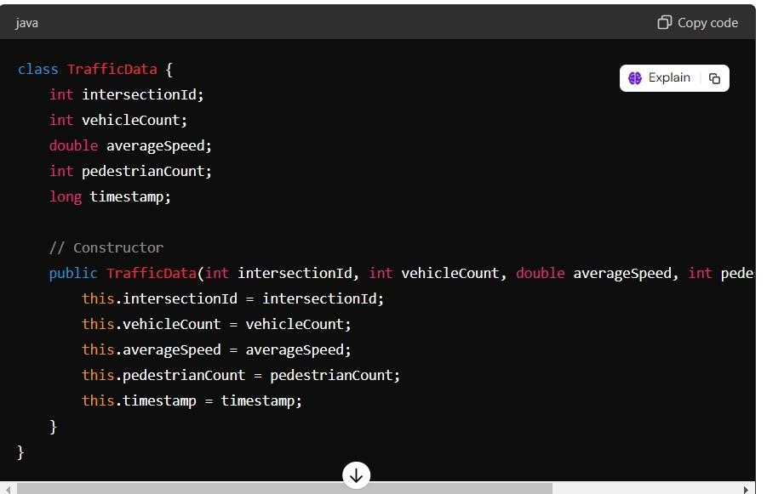

1. **Algorithm Design** 
   * **Objective:** Develop a simple algorithm to analyze the collected data and optimize traffic signal timings dynamically.

**Pseudocode Example:**

Algorithm OptimizeSignalTimings:

Input: trafficData Output: signalTimings for each data

in trafficData: if

data.vehicleCount > 100:

extend green light else if

data.pedestrianCount > 20:

prioritize pedestrian crossing

else:

use default timings

return signalTimings

**3. Implementation**

• **Objective:** Implement a Java application that adjusts signal timings in real-time. **Java Code**

import java.util.List; class TrafficSignalController {

List<TrafficData> trafficDataList; public

TrafficSignalController(List<TrafficData> trafficDataList) { this.trafficDataList = trafficDataList;

}

public void optimizeSignalTimings() { for (TrafficData data : trafficDataList) {

if (data.vehicleCount > 100) {

System.out.println("Extending green light at intersection " + data.intersectionId);

} else if (data.pedestrianCount > 20) {

System.out.println("Prioritizing pedestrian crossing at intersection " + data.intersectionId);

} else {

System.out.println("Using default timings at intersection " + data.intersectionId);

}

}

}

public static void main(String[] args) {

// Example data

List<TrafficData> dataList = List.of( new TrafficData(1,

150, 30.0, 10, System.currentTimeMillis()), new TrafficData(2,

50, 25.0, 30, System.currentTimeMillis()), new TrafficData(3,

80, 20.0, 5, System.currentTimeMillis())

);

TrafficSignalController controller = new TrafficSignalController(dataList); controller.optimizeSignalTimings();

}

}

1. **Visualization and Reporting** 
   * **Objective:** Develop basic visualizations to monitor traffic conditions and signal timings.
   * **Tools:** Use simple console outputs for monitoring.

**Example Console Output:**

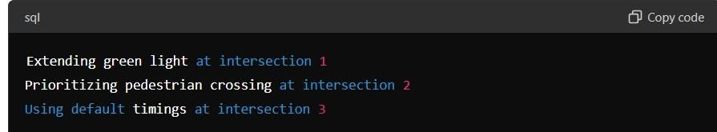

1. **User Interaction** 
   * **Objective:** Provide a basic interface for traffic managers. **Basic Interface Example** class TrafficManagerUI { public static void main(String[] args) {

System.out.println("Traffic Signal Optimization System");

System.out.println("1. Monitor Traffic");

System.out.println("2. Adjust Signal Timings");

// Here is a add code to interact with the user and call appropriate methods

}

}

Deliverables:

1. **Data Flow Diagram:** : Illustrate how real-time traffic data flows from sensors to the optimization algorithms and traffic signals.
2. **Pseudocode and Implementation:**

Provide detailed pseudocode and Java code for the optimization algorithms to manage intersections efficiently.

1. **Documentation:**

Explain the basic design decisions behind the algorithms and data structures used.

1. **User Interface:**

Develop a basic console interface for traffic managers to interact with the system.

1. **Testing:**

Develop comprehensive test cases to validate the system's functionality and effectiveness under various traffic scenarios..

**Testing Example:**

* + **Unit Tests:** Validate individual data processing logic.
  + **Integration Tests:** Ensure data flow and interaction between data collection and signal adjustment.

This simplified version focuses on the core functionality and provides a foundation to build upon for a more comprehensive solution. Adjustments can be made to enhance features and complexity based on specific requirements.

4o