Attachment : <https://dev1.mycanvas.io/api/v1/attachment>

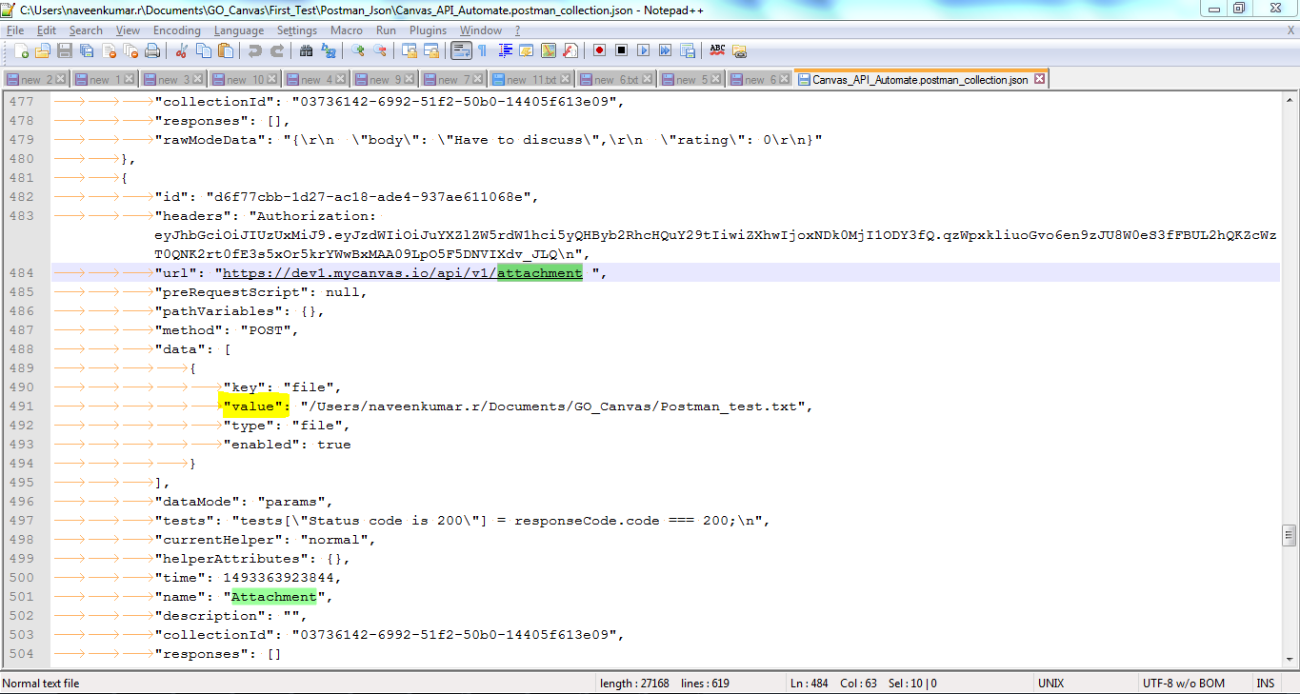

Please help to upload the value, according to your own path.